Q1.(i)(a)

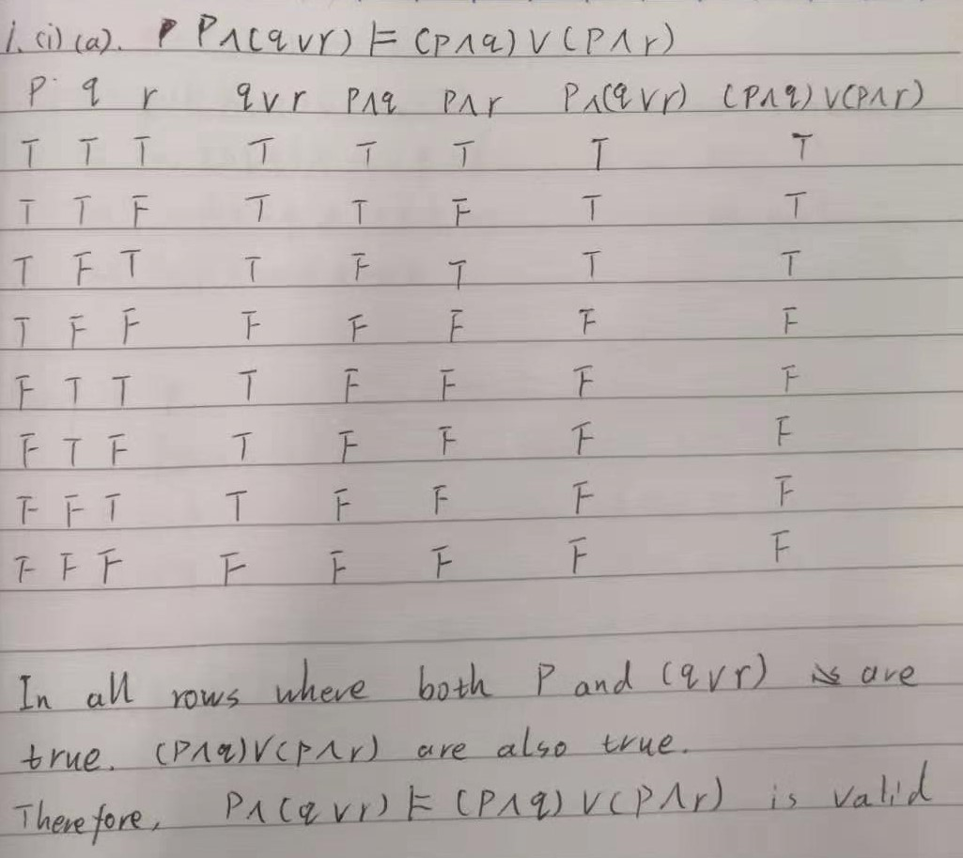

(i)(b)

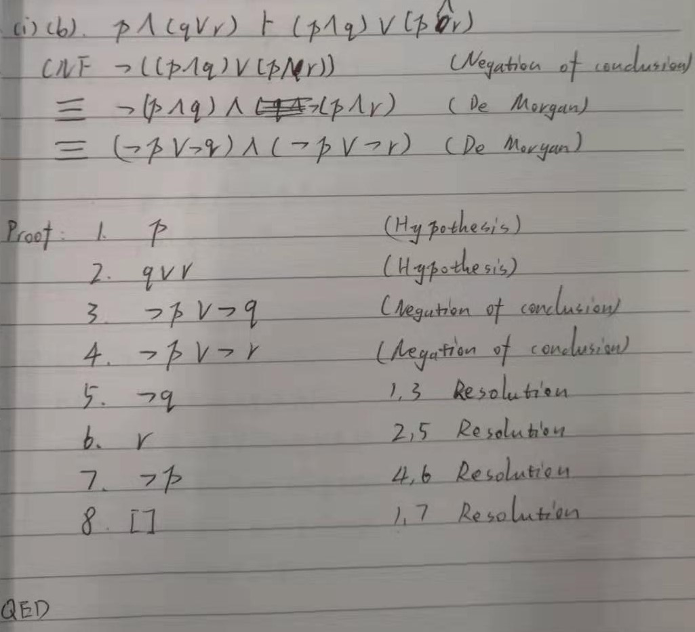

(ii)(a)

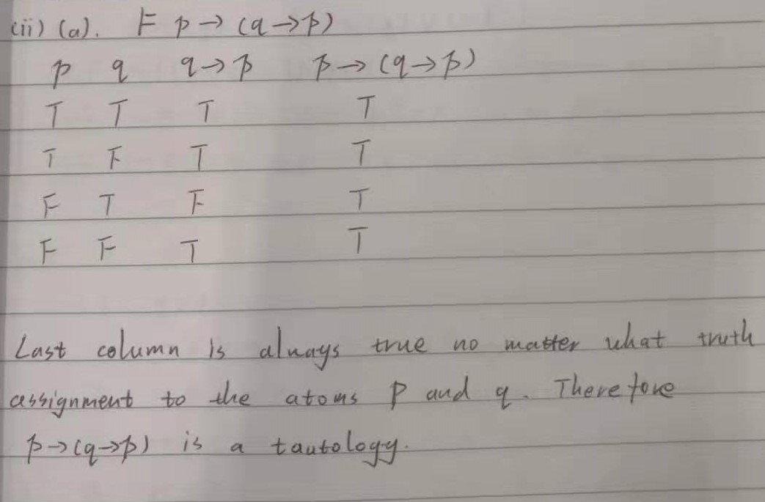

(ii)(b)

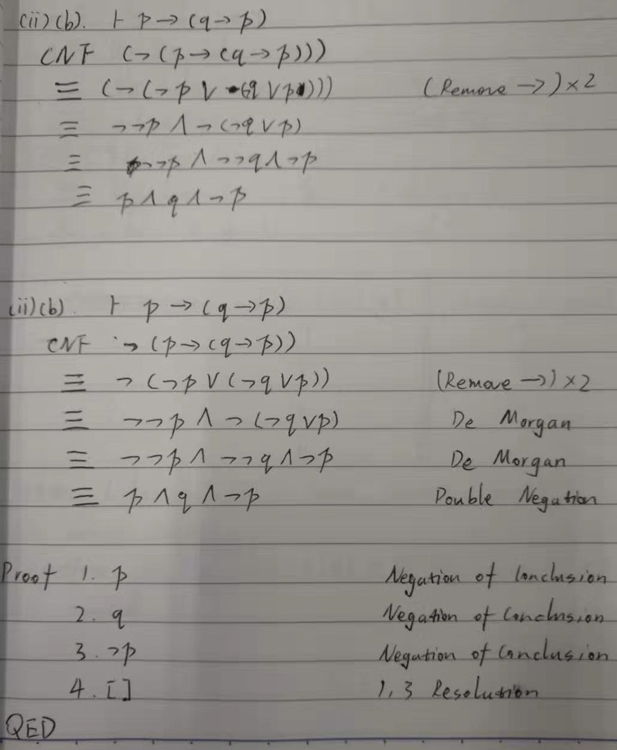

(iii)(a)

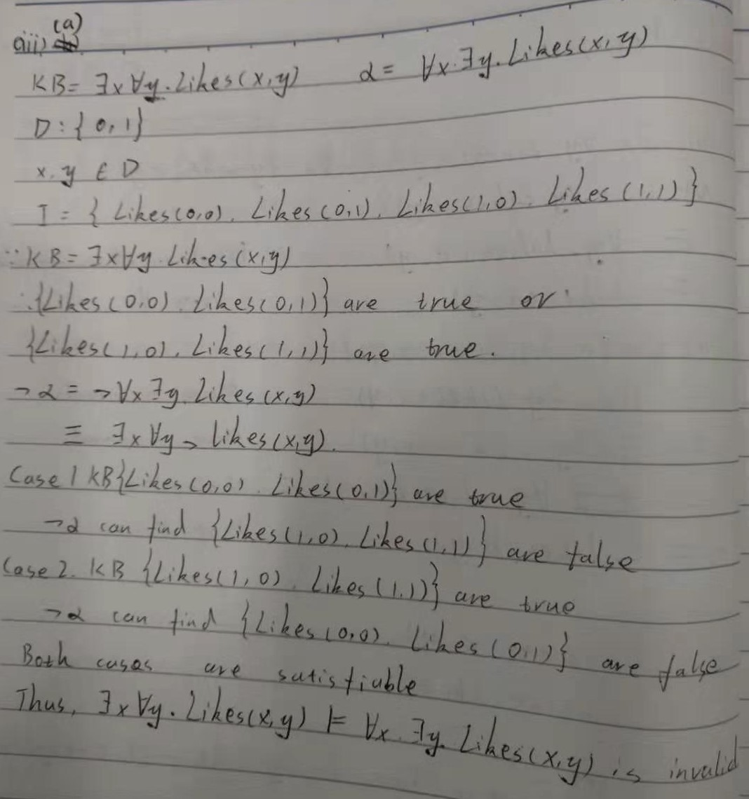

(iii)(b)

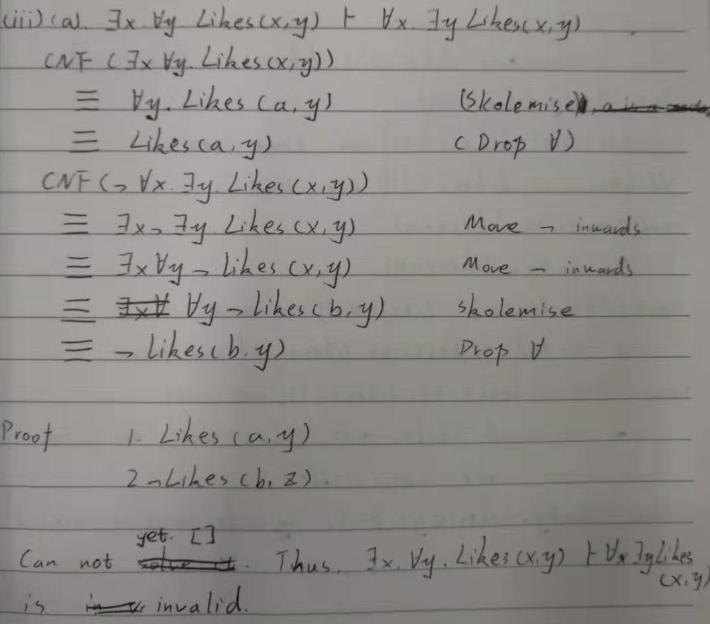

(iv)(a)



(iv)(b)

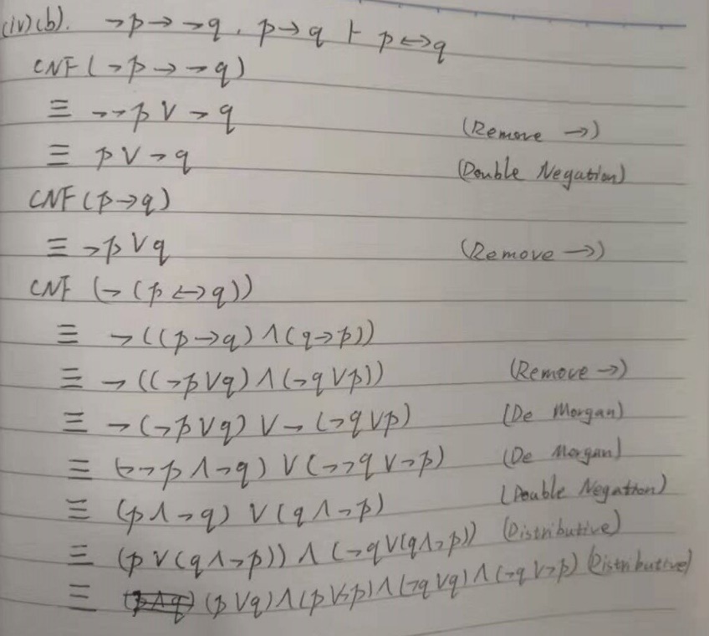

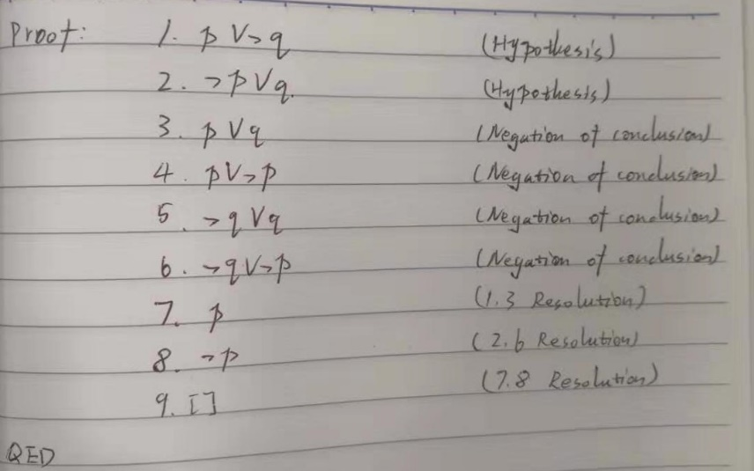

(v)(a)

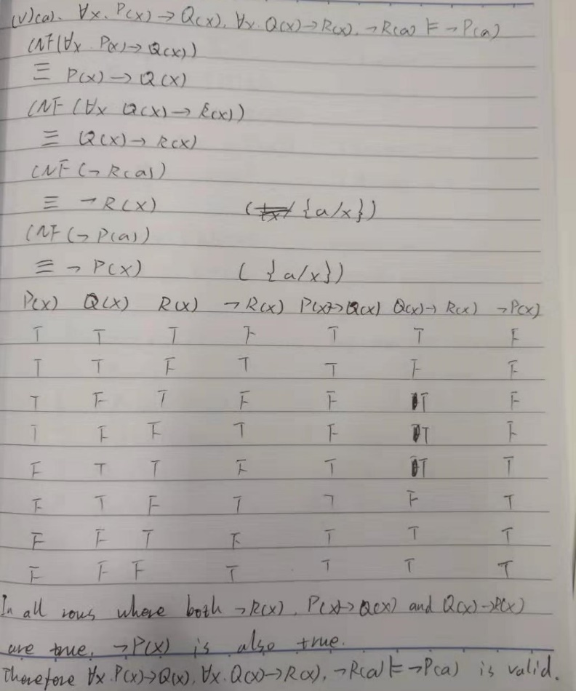

(v)(b)

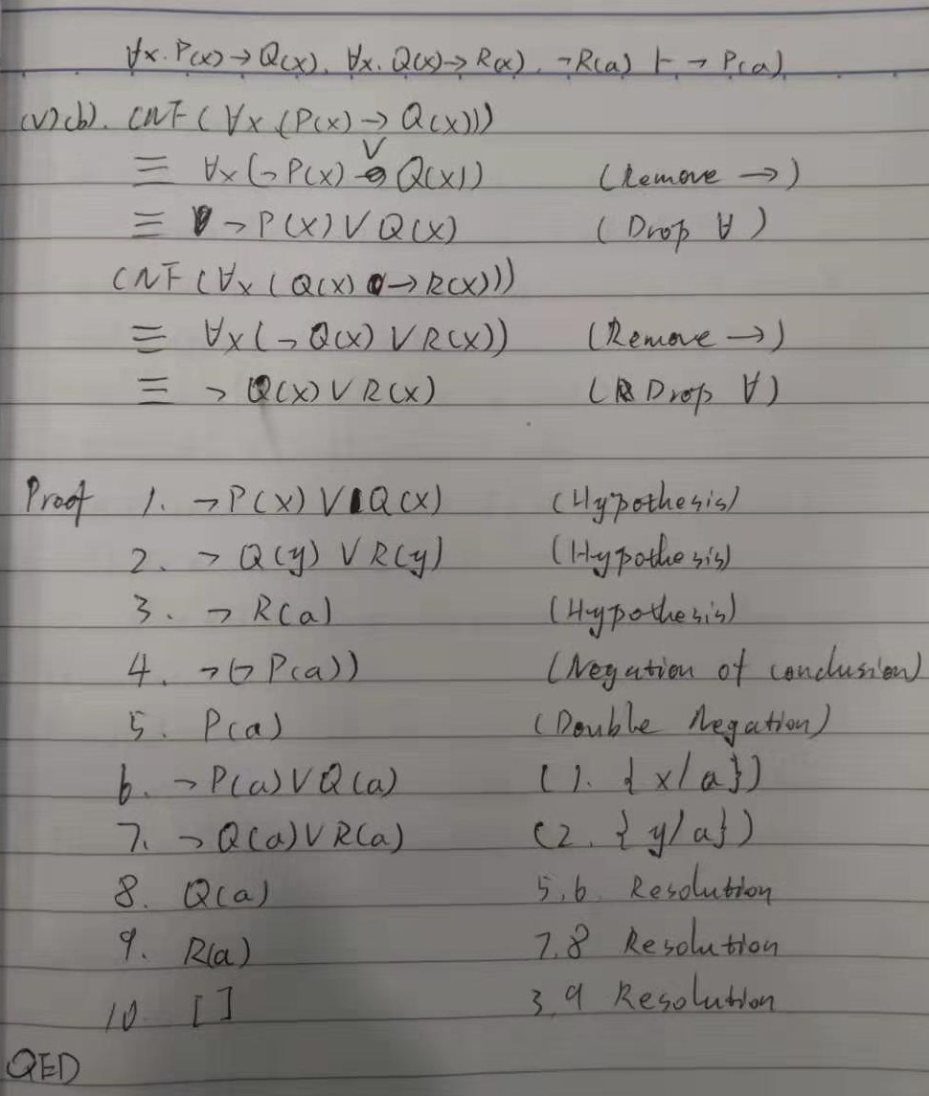

Q2(i)

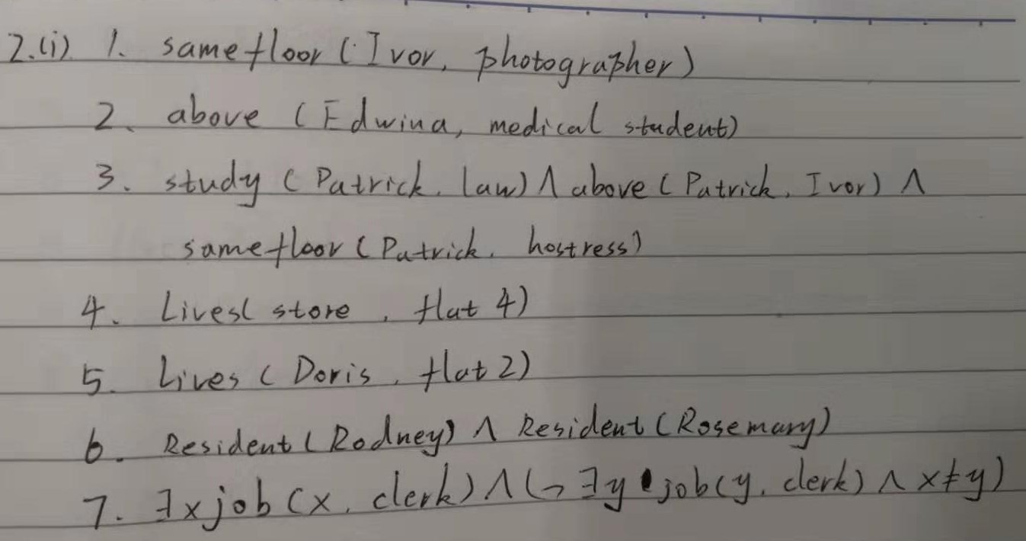

(ii)

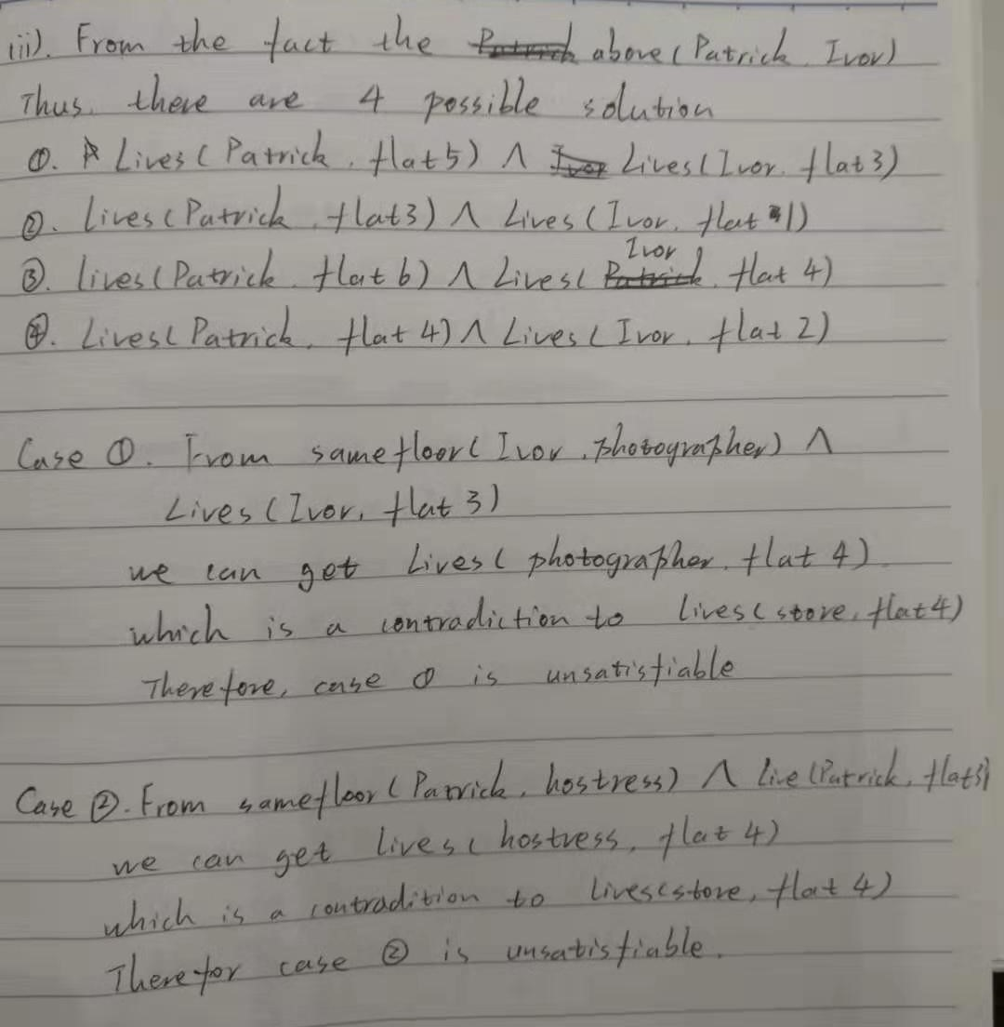

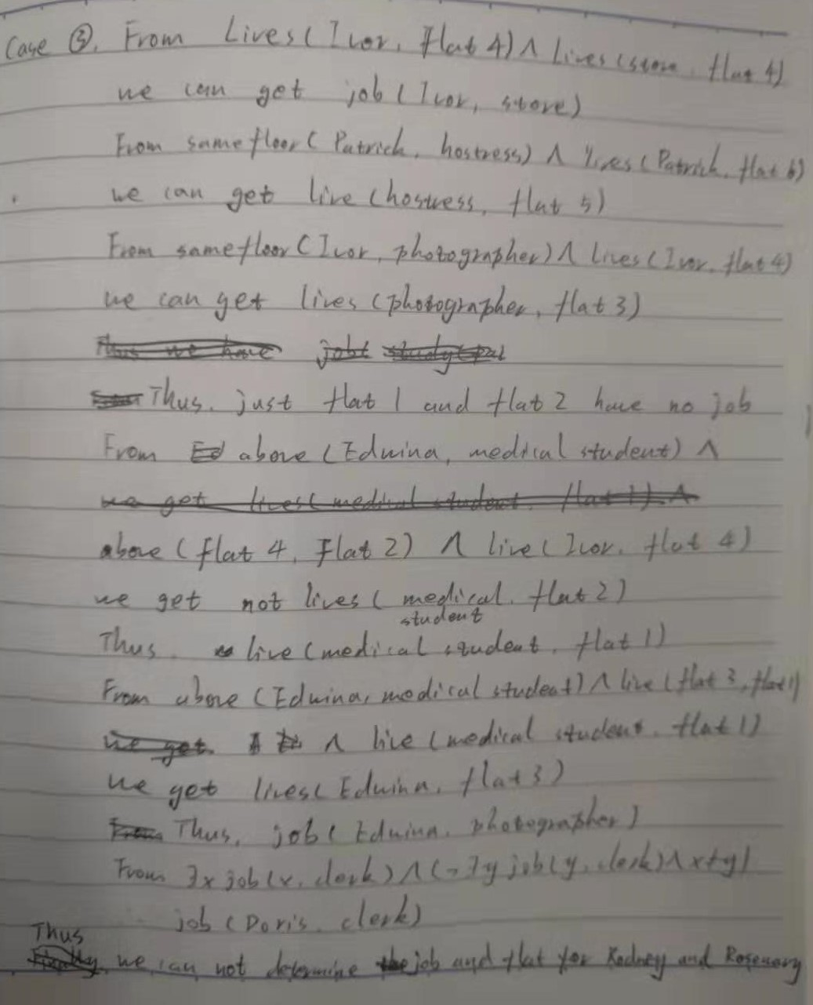

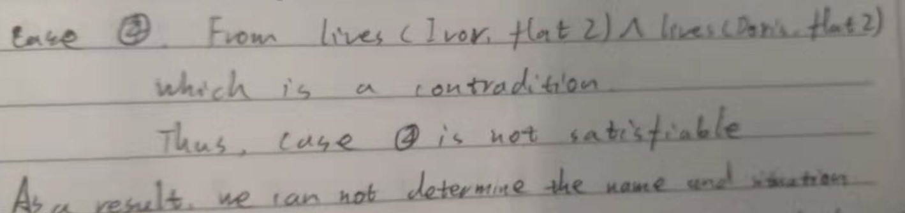

(iii)



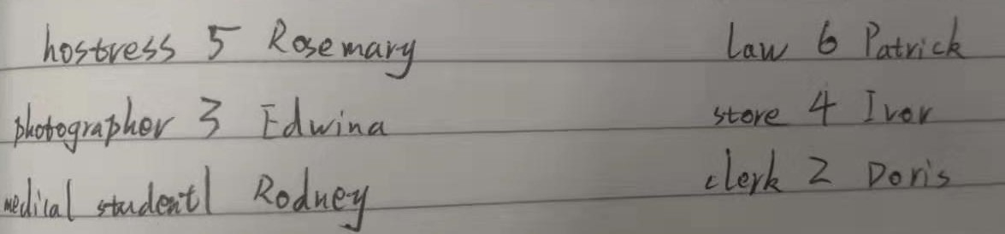

Q3

My code is written by python3, so please type ‘chmod u+x assn1q3’ before testing.

Q4(i). Intelligent reasoning: Applying both the logical view and the psychological view to represent knowledge.

(ii). For logical aspect, first order logic can be used to represent knowledge and various deduction is applied to reasoning.

For psychological view, goals, plans and other complex mental structure can be used to address problems. For example, modern manifestations include work on SOAR as a general mechanism for producing intelligent reasoning and knowledge based systems as a means of capturing human expert reasoning.