Problem 1

(a). Assume {p,q,r} in PROG,

Firstly, we can easily prove that p≡p,

Thus, F is reflexive

Secondly, assume p≡q, then p ↔ q

|  |  |  |  |  |  |
| --- | --- | --- | --- | --- | --- |
| p | q | p → q | q → p | p ↔ q | q ↔ p |
| T | T | T | T | T | T |
| T | F | F | T | T | T |
| F | T | T | F | T | T |
| F | F | T | T | T | T |

As the above truth table, from p ↔ q, we can get q ↔ p,

Thus, F is symmetric

Finally, assume p≡q and q≡r, then p ↔ q and q ↔ r

|  |  |  |  |  |  |  |  |  |  |  |  |
| --- | --- | --- | --- | --- | --- | --- | --- | --- | --- | --- | --- |
| p | q | r | p→q | q→p | q→r | r→q | p→r | r→p | p↔q | q↔r | p↔r |
| T | T | T | T | T | T | T | T | T | T | T | T |
| T | T | F | T | T | F | T | F | T | T | F | F |
| T | F | T | F | T | T | F | T | T | F | F | T |
| T | F | F | F | T | T | T | F | T | F | T | F |
| F | T | T | T | F | T | T | T | F | F | T | F |
| F | T | F | T | F | F | T | T | T | F | F | T |
| F | F | T | T | T | T | F | T | F | T | F | F |
| F | F | F | T | T | T | T | T | T | T | T | T |

As the above truth table, from p ↔ q and q ↔ r, we can get p ↔ r,

Thus, F is transitive.

As a result we can get that the logical equivalence relation, ≡, is an equivalence relation on F .

(b).

|  |  |  |  |  |  |  |
| --- | --- | --- | --- | --- | --- | --- |
| p | q | r | p→q | p→r | p∧q | p∧r |
| T | F | F | F | F | F | F |

As the above truth table, {p→q, p→r, p∧q, p∧r} in [⊥].

(c). (i). v(¬φ) = !v(φ)

= !v(φ’)

= v(¬φ’)

Thus, ¬φ ≡¬φ’

(ii). v(φ∧ψ) = v(φ) && v(ψ)

= v(φ’) && v(ψ’)

= v(φ’∧ψ’)

Thus, φ∧ψ≡φ’∧ψ’

(iii). v(φ∨ψ) = v(φ) || v(ψ)

= v(φ’) || v(ψ’)

= v(φ’∨ψ’)

Thus, φ∨ψ≡φ’∨ψ’

(d). T = {[φ] : φ∈F }

[φ]∧[ψ] : [φ∧ψ]

[φ]∨[ψ]: [φ]∨[ψ]

[φ]’ : [¬φ]

0 : Ø

1 : F

Problem 2

(a).

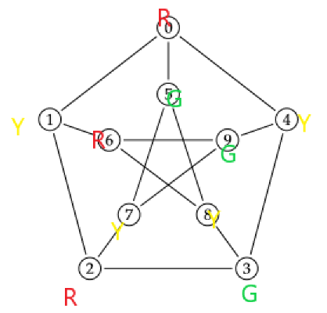

As above picture show,

χ(G) = 3,

∵χ(K5) = 5 and χ(G) ≥ κ(G).

∴The Petersen graph does not contain a subdivision of K5

(b).

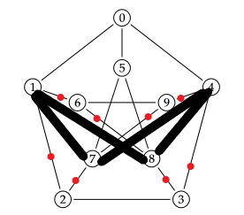

As above picture shows,

Connecting 1 and 7 with replacing 2

Connecting 4 and 8 with replacing 3

Connecting 1 and 8 with replacing 6

Connecting 4 and 7 with replacing 9

Then, we get K3,3

Problem 3

1. (i).

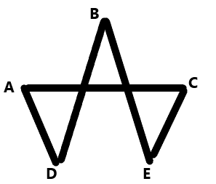

Define Defence against the Dark Arts as A

Define Potions as B

Define Herbology as C

Define Transﬁguration as D

Define Charms as E

Define edge AC as Harry can take A and C both

Define edge AD as Harry can take A and D both

Define edge BD as Harry can take B and D both

Define edge BE as Harry can take B and E both

Define edge CE as Harry can take C and E both

(ii). Find a vertex with maximum edges, which means that vertex has maximum number of classes he can take

1. There five solutions:

① Take both A and C

② Take both A and D

③ Take both B and D

④ Take both B and E

⑤ Take both C and E

Problem 4

1. T(n) :

T(0) = 1

T(1) = 1

T(n) = T(n-1) * (4*n – 2) / (n+1)

1. Assume the layer of full binary tree is k and the number of nodes is n

Count(n):

n = 1 k = 0

n = 1 + 2k k > 0

As 1 is odd and 2k is even,

Thus, 1 + 2k is odd.

As a result, a full binary tree must have an odd number of nodes.

1. T(n) = $\frac{1}{n+1}$ $\left({2n \atop n}\right)$

B(n) = $\frac{1}{T(n)}$ $\left({2n \atop n}\right)$– 1

Problem 5

1. p1(n+1) = (p2(n)+p4(n))/3

p2(n+1) = (p1(n)+p3(n))/2 + p4(n)/2

p3(n+1) = (p2(n)+p4(n))/3

p4(n+1) = (p1(n)+p3(n))/2 + p2(n)/2

1. Let pi(n+1) = pi(n),

Then, we can get

p1(n) = (p2(n)+p4(n))/3 ①

p2(n) = (p1(n)+p3(n))/2 + p4(n)/2 ②

p3(n) = (p2(n)+p4(n))/3 ③

p4(n) = (p1(n)+p3(n))/2 + p2(n)/2 ④

from ① and ③, we get p1(n) = p3(n) ⑤

from ② and ⑤, p2(n) = p1(n) + p4(n)/2 ⑥

from ② and ⑤, p4(n) = p1(n) + p2(n)/2 ⑦

from ⑥ - ⑦, p2(n) = p4(n) ⑧

from ⑥ and ⑧, p2(n) = 2 p1(n) ⑨

p1(n)+ p2(n)+ p3(n)+ p4(n)

= p1(n) + 2 p1(n) + p1(n) + 2 p1(n)

= 6 p1(n) = 1

Then , we get p1(n) = p3(n) = 1/6, p2(n) = p4(n) = 1/3.

1. d(v1-v2) = p2(n)*1 = 1/3

d(v1-v4) = p4(n)*1 = 1/3

d(v1-v3) = p3(n)*2 + p3(n)*2 = (1/6)*2 + (1/6)*2 =2/3