 

Internet And Software Architecture

Report on Weather App

Name: Aarnav Thapa Student ID: 2505898

**Introduction**

The weather application Aarnav Weather App is a web application that displays live weather details of various places. The application is created to enable users to get important weather details such as wind speed, humidity, and temperature to inform their day-to-day decisions.

**Aims:**

* To design a friendly weather application that displays accurate and refreshed live weather details.
* To provide accessibility using various devices such as mobiles or desktops.
* To provide more accurate prediction of weather using reliable weather APIs.

# Objectives:

# To provide a basic interface to display live weather details.

# To provide accurate live weather forecast for various places.

# To provide easy accessibility to live weather details using a web application.

# To use APIs to retrieve live weather details effectively.

# Merits:

# Real-time Weather Update – Displays live weather details of various places.

# Friendly Interface – Easy to use, easy to navigate.

# Accessibility – Is accessible using any device that is connected to Internet.

# Planning Aid – Enables users to plan outings using live weather details.

# Installation-Free – As it is a web application, it needs neither downloads nor

# installation.

# Demerits:

# Internet Dependency – The application is not accessible without Internet

# connectivity.

# API Downtime Possibility – In the event of a failure of the server of the

# weather API, it might fail to obtain live details.

# Limited Features – May fail to display advanced analysis of weather such as

# storm detection, display of radar, or display of hourly forecast.

# Accuracy Fluctuations – The use of API used is a determining point in data

# precision, which is not always 100%.

# Lack of Offline Feature – Weather details cannot be viewed after accessing it

# online.

**Link to the Weather App:** [**https://aarnav2-weather.infinityfreeapp.com/**](https://aarnav2-weather.infinityfreeapp.com/)

# Link to the video: <https://www.youtube.com/watch?v=IAo3ScDa-xo>

# Screen Shot of the Weather App with Local Storage:

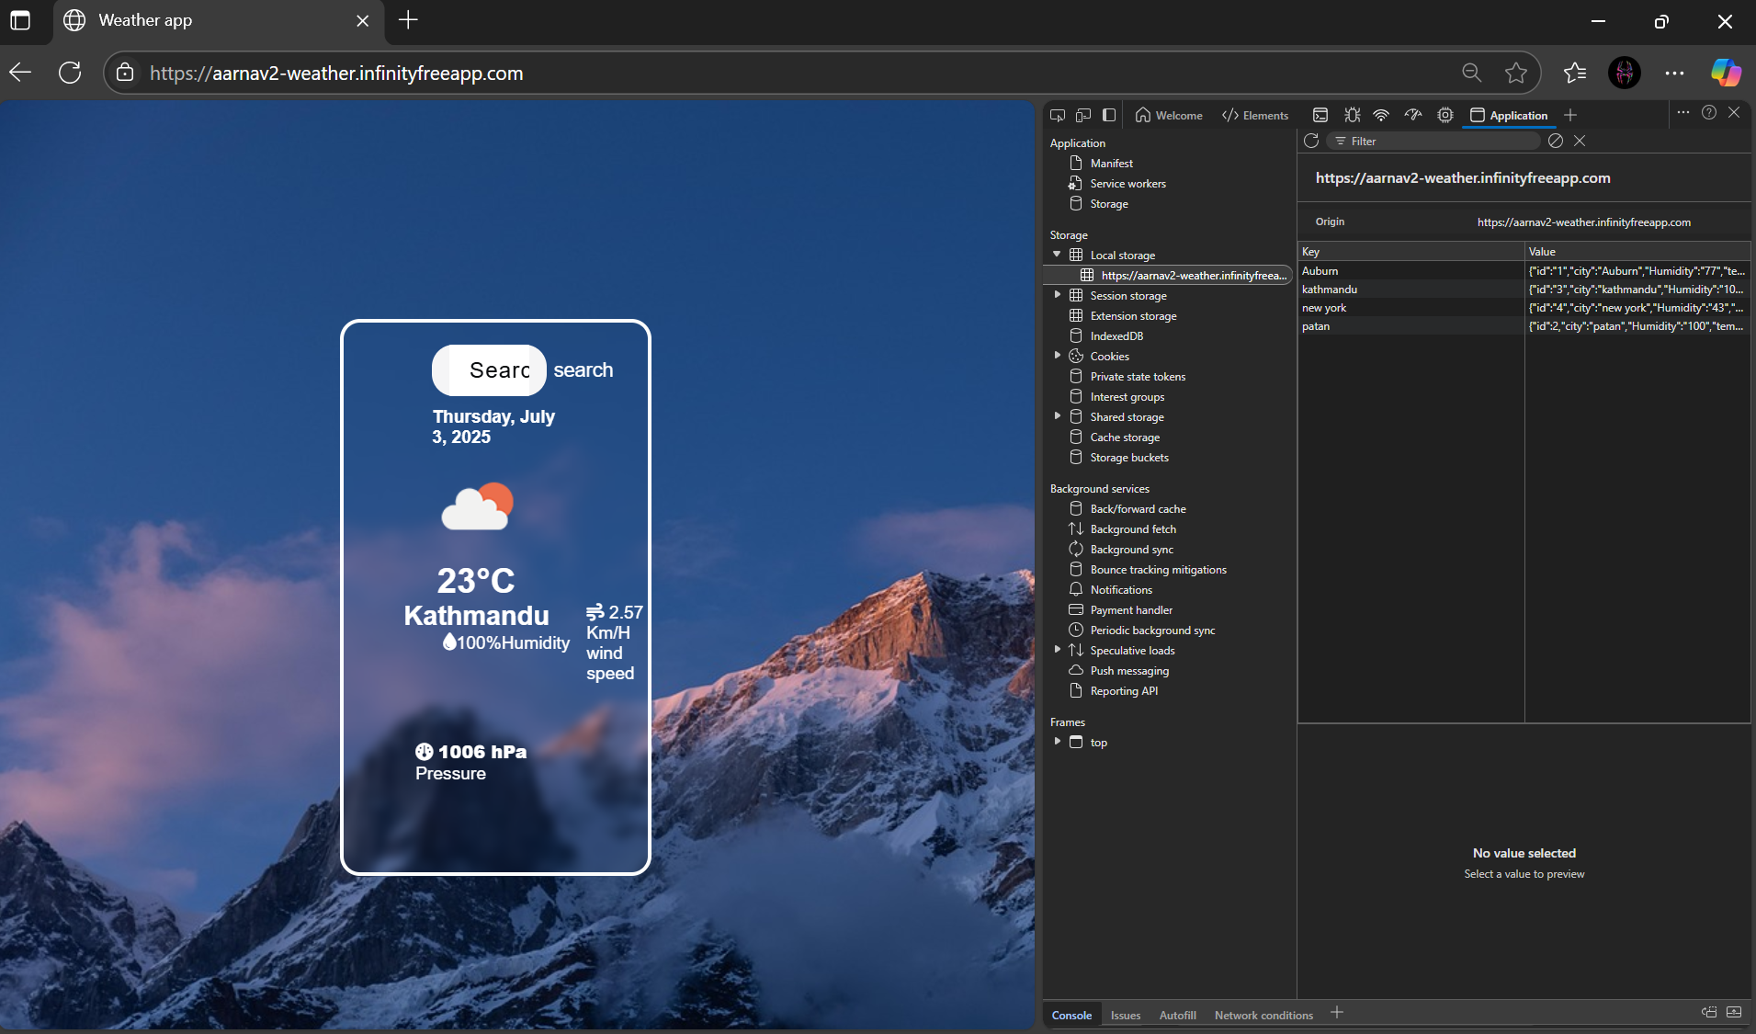

**UML Deployment Diagram:**

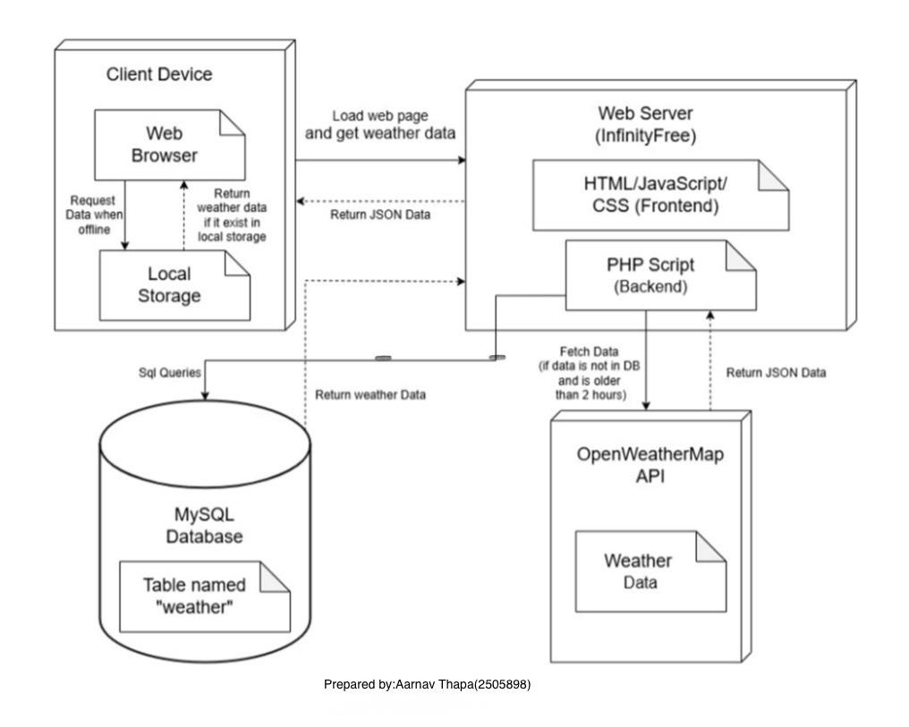

# UML Sequence Diagram

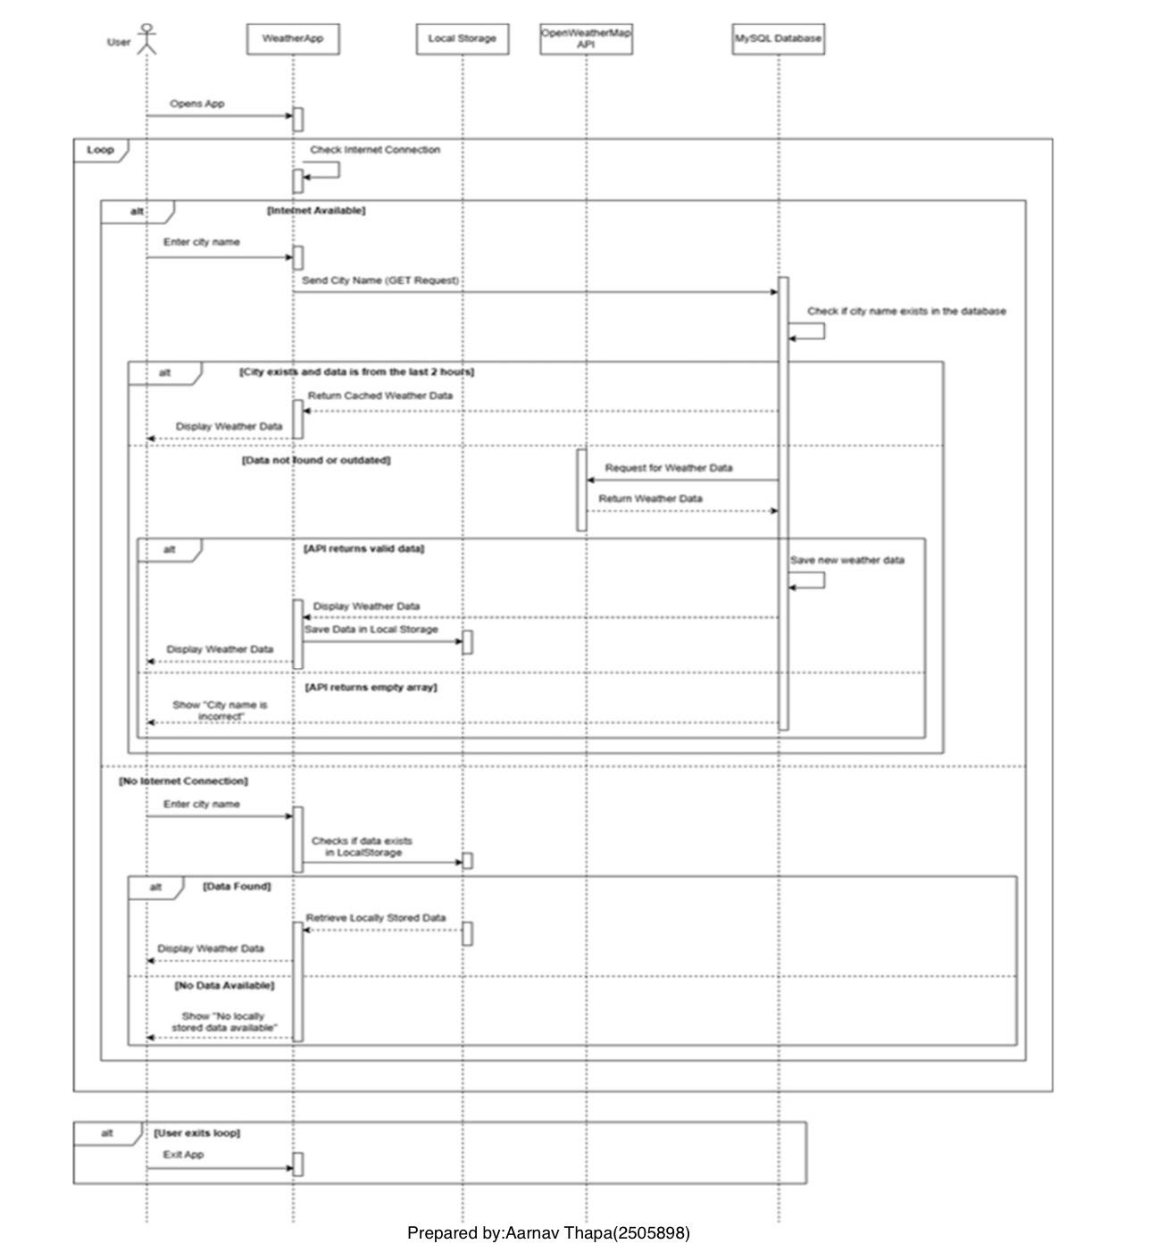

# UML Activity Diagram

