Impensa
Introduction
Most of the household expenditures are not tracked systematically. The basic philosophy of this software is to provide a platform where individuals can track their income, expenditure without much hassle.
The system should be flexible enough for various kind of users with different expenditure habits. It should be easy to use and should provide holistic view of her expenditure. And the system should forecast the future expenditure with higher degree of accuracy.

Though the software would be provided as service, it should also have a desktop based offering where the customer is not expected to be connected to world wide web all the time.

Detailed Requirements
The impensa application would be hosted in a cloud setup. For simplicity, let’s assume it is hosted at www.impensa.com.
A tenant is expected to register herself in the above mentioned website. And thus become eligible to use it. She can either download the desktop version of it or prefer to use it as service. Whatever option she may chose, the very first thing that needs to be accomplished is to finish the initial setup/configuration.
Initial Setup
Let’s digress for a while. Take an example of a small family of four members.
Husband:- Brad
Wife:- Amy
Son:- Andrew
Daughter:- Michelle
Brad wants to keep track of money in/out for his little family. Apart from tracking expenditure on various category, Brad wants to be aware of money spent by each member. Kids , with their true nature , are expected to misuse the software by entering wrong input.
Brad would like Amy to verify the data input by Andrew and Michelle. He would want to setup the expenditure template so that expenditure details can be entered against it. He expects the template to evolve over time. What it means is he or Amy can add more categories to expense template at any time in future. For example, they may decide to buy a house and they want to add new category named loan-houseloan in their template. Brad and Amy wish to be notified whenever balance is beyond certain threshold. Or whenever Amy spends more than 1000$, he wants impensa to alert him for immediate action ☺ . Brad would like to see how much money is spent on telephone last month. Finally Brad wants impensa to forecast the amount of money that would be spent on telephone next 12 months.
This need of Brad’s family is quite generic and common across many families across various societies. So let’s analyze the above need in a more systematic way.
- Brad wants users to be present in impensa
- Brad wants to restrict some users to specific functions only.
- Brad wants to grant higher privileges to some users.
- Brad wants to add an expense template which is flexible for future modifications.
- All the users can enter expenditure against the template.
- Brad can see reports at any time.
- Brad wants to setup rules/incident/notification in the system
- Brad expects impensa to be intelligent.
Let’s focus on 1 , 2 and 3 for a moment.
Here functions are something which will be exposed by impensa to the end user.
In technical terms , this would be some java methods which implement some business feature.
Code snippet
@Function(name=“createTransaction”,description=”This allows an user the authorization to create a transaction”)
public boolean createTxn() throws ImpensaTxnException{
-----
-----
Return true;
}

@Function(name=“rejectTransaction”,description=”This allows an user the authorization to reject a transaction”)
public boolean rejectTxn() throws ImpensaTxnException{
-----
-----
Return true;
}
@Function(name=“approveTransaction”,description=”This allows an user the authorization to approve a transaction”)
public boolean approveTxn() throws ImpensaTxnException{
-----
-----
Return true;
}
@Function(name=“addUser”,description=”This allows an user the authorization to add another user”)
public boolean addUser() throws ImpensaTxnException{
-----
-----
Return true;
}
@Function(name=“viewReports”,description=”This allows an user the authorization to view reports”)
public boolean viewReports() throws ImpensaTxnException{
-----
-----
Return true;
}

So we have 5 functions exposed by impensa. Customer are not expected to add any functions to the system. After all their job is to use the code not to write ☺
Functions:-
createTransaction
rejectTransaction

approveTransaction

addUser

viewReports

Roles:-
Superuser
TxnApprover
TxnRejector
UserMgmtRole
ReportViewer
TxnCreator
TxnAdmin

Roles-Functions Associations

TxnCreator | createTransaction
TxnRejector | rejectTransaction
TxnApprover | approveTransaction
TxnAdmin | createTransaction
TxnAdmin | rejectTransaction
TxnAdmin | approveTransaction
UserMgmtRole | addUser
ReportViewer | viewReport
Superuser | createTransaction
Superuser | rejectTransaction
Superuser | approveTransaction
Superuser | createTransaction
Superuser | rejectTransaction
Superuser | approveTransaction
Superuser | addUser
Superuser | viewReport

Users:-
Brad
Amy
Andrew
Michelle

Tenant | User |  | Role
Impnsa89234 | Brad |  | Superuser
Impnsa89234 | Amy |  | TxnAdmin
Impnsa89234 | Andew |  | TxnCreator
Impnsa89234 | Michelle | TxnCreator

Will stop here… The above thing adds roles to an user and hence user get privileges for various impensa functions. Roles can be assigned to users and orgs. Will add org hierarchy and its relation with users tomorrow. Will add more on the image below. But it should be self explanatory.

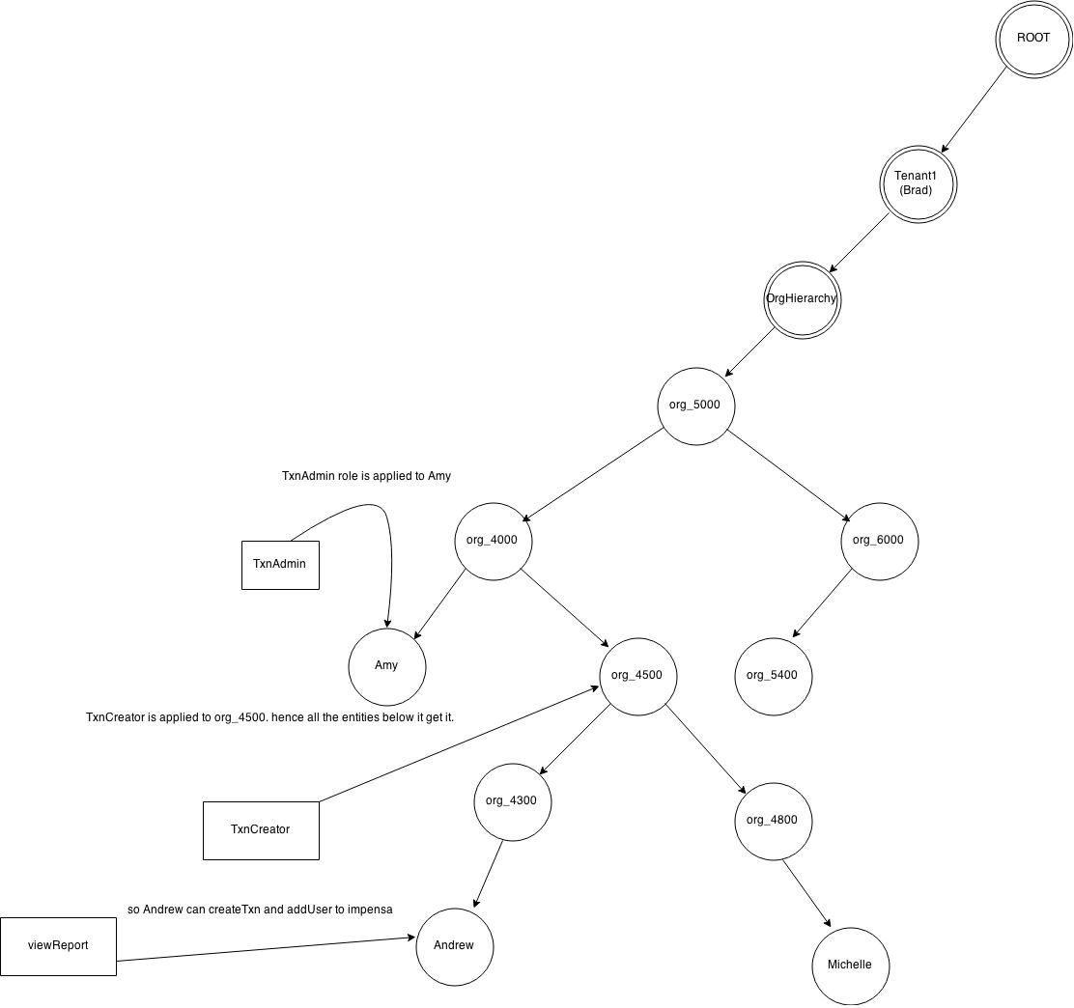

Tenant | OrgName | OrgDescription | Sequence
Impnsa89234 | Org_5000 | This is the root org | 5000
Impnsa89234 | Org_4000 | Put some description here | 4000
Impnsa89234 | Org_6000 | Put some description here | 6000
Impnsa89234 | Org_4500 | Put some description here | 4500
Impnsa89234 | Org_5400 | Put some description here | 5400
Impnsa89234 | Org_4300 | Put some description here | 4300
Impnsa89234 | Org_4800 | Put some description here | 4800

As evident from table, the number assigned to sequence decides the hierarchy of the orgs.
Tenant | User first name | Last name | Org | emailId | mobile
Impnsa89234 | Brad | Swanson | Org_5000 | bs@abc.com | 614-234-8976
Impnsa89234 | Amy | Swanson | Org_4000 | as@abc.com | 614-234-8976
Impnsa89234 | Andrew | Swanson | Org_4300 | asw@abc.com | 614-234-8976
Impnsa89234 | Michelle | Swanson | Org_4800 | ms@abc.com | 614-234-8976
Impnsa89234

To summarize , we have captured the following information from the tenant

- Brad has registered with impensa
- He has created org hierarchy
- He has created roles
- He has downloaded the functions exposed by impensa
- He has mapped roles to functions
- He has created users
- He has mapped users to roles
- He has mapped users to orgs
- He has mapped orgs to roles.
So we have to provide the UI to accomplish the above tasks.
For the first version , we can use only excel/csv file to upload the above mentioned data. We can create attractive UI later.
