**Project: Health care Data Analysis**

**US City report**

**Data Ingestion**

Creating input Directory:

[maverickavitha@ip-10-1-1-204 ~]$ hdfs dfs -mkdir -p prescpipeline/staging/city

[maverickavitha@ip-10-1-1-204 ~]$ hdfs dfs -put us_cities_dimension.parquet prescpipeline/staging/city/

[maverickavitha@ip-10-1-1-204 ~]$ hdfs dfs -ls prescpipeline/staging/city/

**Preprocessing/ Data Cleansing**

Step 1: Creating DF

>>> cityDF=spark.read.option("header",True).option("inferschema",True).parquet ('/user/maverickavitha/prescpipeline/staging/city/us_cities_dimension.parquet')

>>> cityDF.printSchema()

>>> cityDF.show(5)

Step 2:

Select only required Columns in city data file like city, state_id,state_name,county_name,population,zips

>>> cityDF1=cityDF.select('city','state_id','state_name','county_name','population','zips')

>>> cityDF1.printSchema()

>>> cityDF1.show(3)

Step 3:

Convert city, state and county fields to Upper Case

>>> import pyspark.sql.functions as F

>>> cityDF1 = cityDF1.toDF(*[c.upper() for c in cityDF1.columns])

>>> cityDF1.printSchema()

>>> cityDF1.show(3)

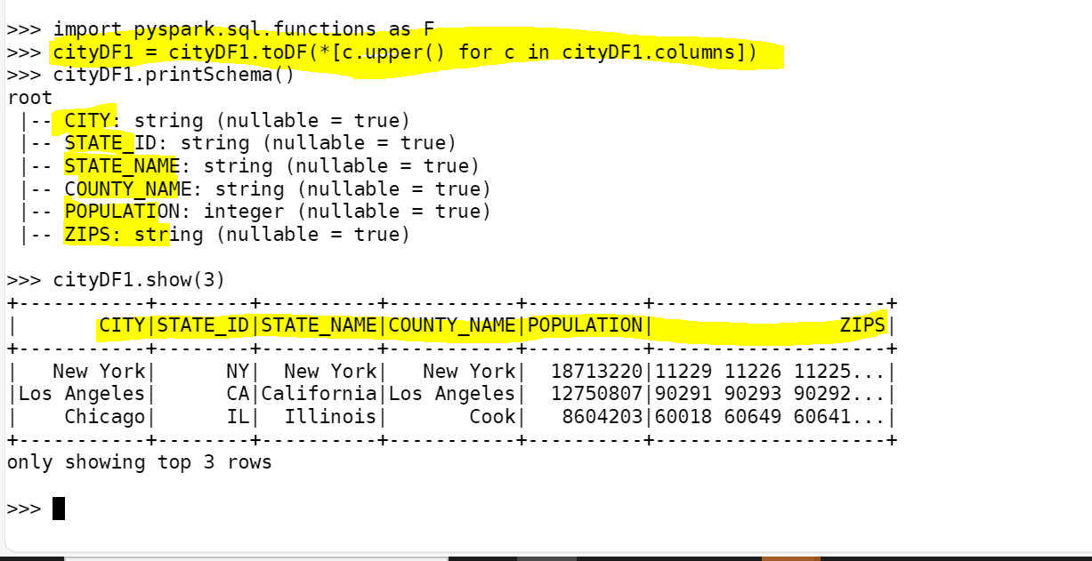

**Transformation :**

Calculate the Number of zips in each city.

>>> from pyspark.sql.functions import col, lit

>>> from pyspark.sql.functions import split, explode , size

>>> split_col=split(cityDF1['ZIPS'],' ')

>>> df_split = cityDF1.withColumn('Zip_Split_cnt',size(split_col))

>>> df_split.createOrReplaceTempView("City_split_df")

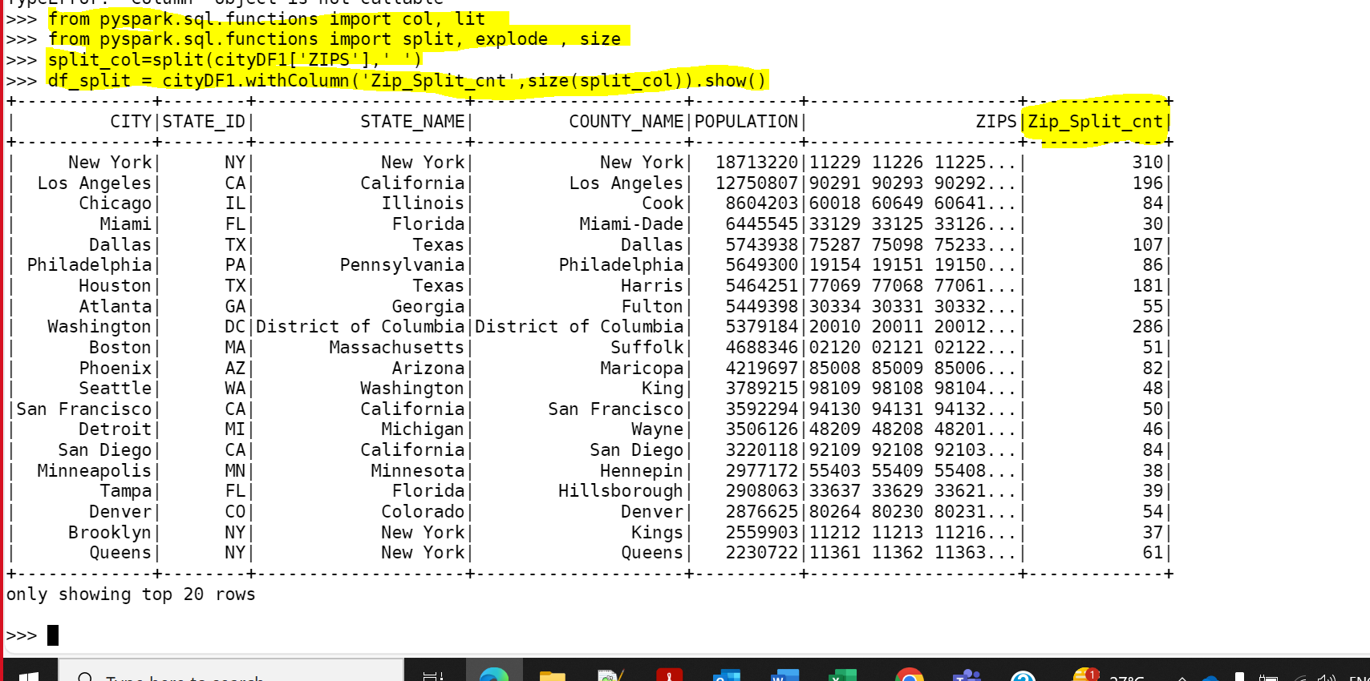

* 1. Calculate the number of distinct Prescribers assigned for each City. Calculate total total_claim_count prescribed for each city.

Step 1:

Calculating the distinct prescriber count and total_claim_count from Prescribers file , grouping City and state.

>>> spark.sql("SELECT count(distinct npi) as Prescriber_Counts ,sum(tot_claim_cnt) as total_claim_counts,np_city, np_state from prescr

iber group by np_city,np_state").show()

Creating Dataframe and view for above prescriber data :

>>> prescriber1_df = spark.sql("SELECT count(distinct npi) as Prescriber_Counts ,sum(tot_claim_cnt) as total_claim_counts,np_city, np_

state from prescriber group by np_city,np_state")

>>> prescriber1_df.createOrReplaceTempView("prescriber1")



Joining the City and Prescriber DF to get City Final Report:

>>> df_split.createOrReplaceTempView("City_split_df")

>>> spark.sql( "SELECT CITY as City_Name,STATE_NAME as State_Name,COUNTY_NAME as County_Name ,POPULATION as City_Population,Zip_Split_cnt as Number_of_Zips,p.Prescriber_Counts,p.total_claim_counts FROM City_split_df c inner join prescriber1 p on upper(c.CITY) = p.np_city and c.STATE_ID = p.np_state where p.Prescriber_Counts != 0")

* 1. Do not report a city in the final report if no prescriber is assigned to it:

>>> spark.sql( "SELECT CITY as City_Name,STATE_NAME as State_Name,COUNTY_NAME as County_Name ,POPULATION as City_Popul

ation,Zip_Split_cnt as Number_of_Zips,p.Prescriber_Counts,p.total_claim_counts FROM City_split_df c inner join prescriber1 p on upper(c

.CITY) = p.np_city and c.STATE_ID = p.np_state where p.Prescriber_Counts != 0")

* 1. A screenshot of a document

     Description automatically generated

City Final Report Data frame:

>>> City_report_df = spark.sql( "SELECT CITY as City_Name,STATE_NAME as State_Name,COUNTY_NAME as County_Name ,POPULATION as City_Popul

ation,Zip_Split_cnt as Number_of_Zips,p.Prescriber_Counts,p.total_claim_counts FROM City_split_df c inner join prescriber1 p on upper(c

.CITY) = p.np_city and c.STATE_ID = p.np_state where p.Prescriber_Counts != 0")

>>> City_report_df.createOrReplaceTempView("City_report")

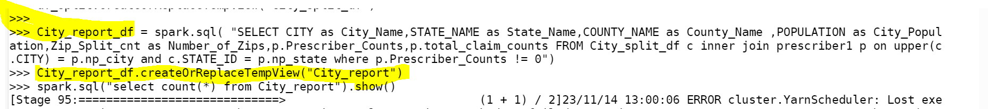

Report Layout:

>>> spark.sql("select * from City_report").show(5)

Report Data count:

>>> spark.sql("select count(*) from City_report").show()

Creating Output Directory in HDFS:

>>> hdfs dfs -mkdir prescpipeline/output/city

Writing the City Report into HDFS in json format with bzip2 compression

>>> from pyspark.sql import SparkSession

>>> spark=SparkSession.builder.appName("Spark Hive").enableHiveSupport().config("spark.sql.warehouse.dir","/user/hive/warehouse").getOrCreate()

>>> spark.sparkContext.setLogLevel("ERROR")

>>> City_report_df = spark.sql( "SELECT CITY as City_Name,STATE_NAME as State_Name,COUNTY_NAME as County_Name ,POPULATION as City_Population,Zip_Split_cnt as Number_of_Zips,p.Prescriber_Counts,p.total_claim_counts FROM City_split_df c inner join prescriber1 p on upper(c.CITY) = p.np_city and c.STATE_ID = p.np_state where p.Prescriber_Counts != 0")

>>> City_report_df.write.mode("overwrite").option("compression","bzip2").json("/user/maverickavitha/prescpipeline/output/city")

City Report Stored in Output file path , in json format with bzip2 compression:

>>> hdfs dfs -ls /user/maverickavitha/prescpipeline/output/city

Writing City_report into Hive table:

>>> City_report_df.write.mode("overwrite").saveAsTable("Final_City_Report")

Hive Table Layout

Data in Hive:

select * from Final_City_Report limit 10;

Hive Count:

select count(*) from Final_City_Report;

