**Project: Health care Data Analysis**

**US Prescriber report**

**Data Ingestion**

Creating input Directory: prescpipeline/staging/prescriber and placed the input file into hdfs input folder

[maverickavitha@ip-10-1-1-204 ~]$ hdfs dfs -mkdir -p prescpipeline/staging/prescriber

[maverickavitha@ip-10-1-1-204 ~]$ hdfs dfs -put USA_Presc_Medicare_Data_12021.csv prescpipeline/staging/prescriber

[maverickavitha@ip-10-1-1-204 ~]$ hdfs dfs -ls prescpipeline/staging/prescriber/



Checking the count in source file :

hdfs dfs -cat prescpipeline/staging/prescriber/USA_Presc_Medicare_Data_12021.csv | wc -l



**Preprocessing / Data Cleansing:**

>>> prescriberDF=spark.read.option("header",True).option("inferschema",True).csv("prescpipeline/staging/prescriber/USA_Presc_Medicare_D

ata_12021.csv")

>>> prescriberDF.show(10)

>>> prescriberDF.printSchema()

>>> prescriberDF.count()

Data Cleansing (Clean Prescriber Data ) :

Step 1:

Select only required fields

>>> pres_step1_df=prescriberDF.select('npi','nppes_provider_last_org_name','nppes_provider_first_name','nppes_provider_city','nppes_pro

vider_state','specialty_description','drug_name','total_claim_count','total_day_supply','total_drug_cost','years_of_exp')

>>> pres_step1_df.printSchema()

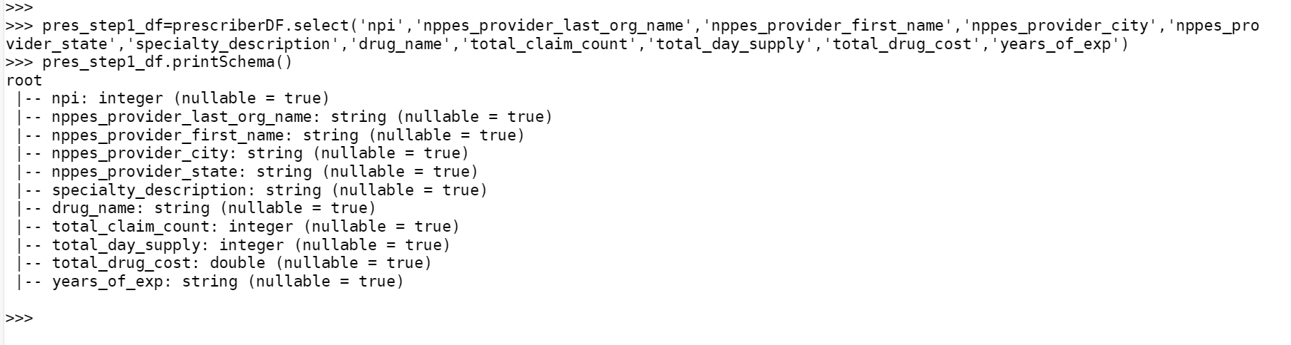

Step 2:

Rename the above fields to shorter names :

>>> pres_step1_df=prescriberDF.select('npi',(prescriberDF.nppes_provider_last_org_name).alias ('np_Lname'),(prescriberDF.nppes_provider

_first_name).alias ('np_Fname'),(prescriberDF.nppes_provider_city).alias ('np_city'),(prescriberDF.nppes_provider_state).alias ('np_sta

te'),(prescriberDF.specialty_description).alias ('spcl_desc'),(prescriberDF.drug_name).alias ('drug_nm'),(prescriberDF.total_claim_coun

t).alias ('tot_claim_cnt'),(prescriberDF.total_day_supply).alias ('tot_day_suply'),(prescriberDF.total_drug_cost) .alias ('tot_drug_cst

'), (prescriberDF.years_of_exp) .alias ('yrs_of_exp'))

>>> pres_step1_df.printSchema()

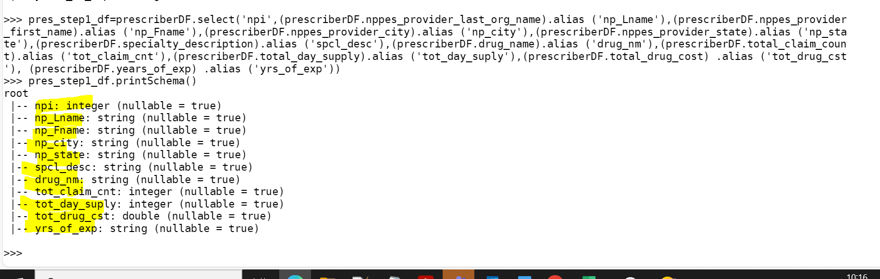

Step 3:

Add a Country Field 'USA' to the above data

>>> from pyspark.sql.functions import col, lit

>>> pres_step1_df=pres_step1_df.withColumn("Country", lit("USA"))

>>> pres_step1_df.printSchema()

>>> pres_step1_df.show(3)

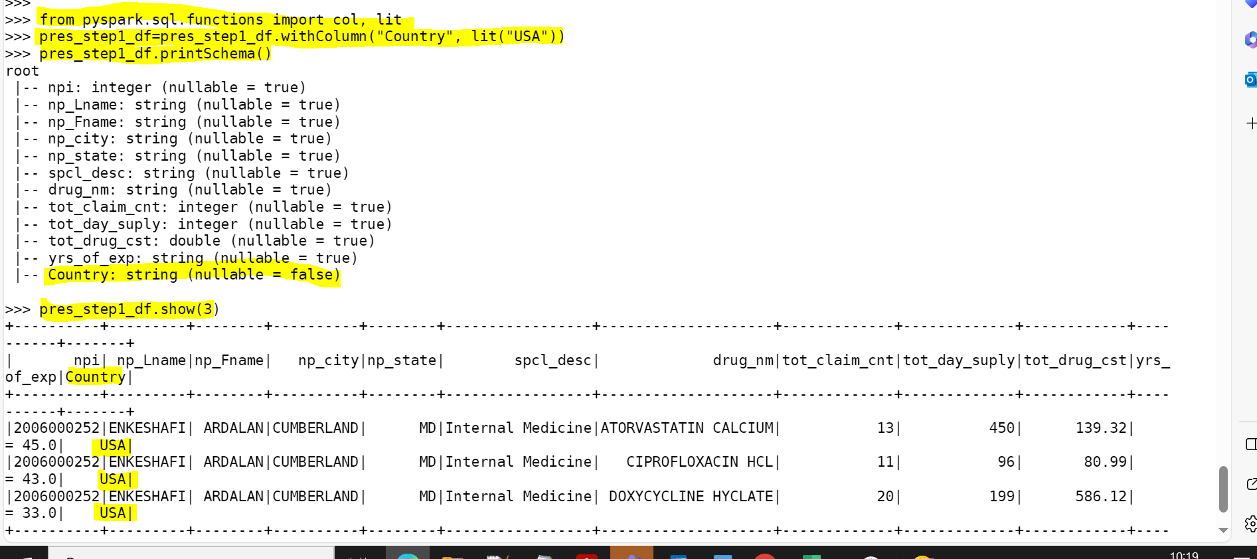

Step 4:

Clean the “years_of_exp” to extract only the numbers.

* 1. Hint : use regexp_extract from the package pyspark.sql.functions

>>> import pyspark.sql.functions as f

>>> pres_step1_df = pres_step1_df.withColumn("yrs_of_exp", f.regexp_extract("yrs_of_exp", r'([0-9]+)', 1))

Step 5:

Convert the years_of_exp field to integer

>>> import pyspark.sql.functions as f

>>> pres_step1_df= pres_step1_df.na.fill(value=0,subset=["yrs_of_exp"])

>>> from pyspark.sql.types import IntegerType

>>> pres_step1_df = pres_step1_df.withColumn("yrs_of_exp", pres_step1_df["yrs_of_exp"].cast(IntegerType()))

>>> pres_step1_df.printSchema()

Step 6:

Combine First Name and Last Name in to a single field and remove the individual columns

>>> from pyspark.sql.functions import concat, concat_ws,col, lit

>>> pres_step1_df = pres_step1_df.withColumn("prsc_fullname",concat_ws(" ", "np_Fname", "np_Lname"))

>>> pres_step1_df.show(3)

Dropping individual columns:

>>> pres_step1_df = pres_step1_df.drop("np_Fname", "np_Lname")

>>> pres_step1_df.printSchema()

>>> pres_step1_df.show(3)

Step 7:

Count the number of null values for each column

>>> from pyspark.sql.functions import col,isnan, when, count

>>> pres_step1_df=pres_step1_df.select([count(f.when(isnan(c) | col(c).isNull(),c)).alias(c) for c in pres_step1_df.columns]).show()

Step 8:

clean all the Null/Nan Values

Delete the records where the PRESC_ID and DRUG_NAME is fields are NULL. Use dropna() of dataframe

>>> pres_step1_df = pres_step1_df.na.drop(subset=["npi"])

>>> pres_step1_df = pres_step1_df.na.drop(subset=["drug_nm"])

>>> pres_step1_df.printSchema()

>>> pres_step1_df=pres_step1_df.select([count(f.when(isnan(c) | col(c).isNull(),c)).alias(c) for c in pres_step1_df.columns]).show()

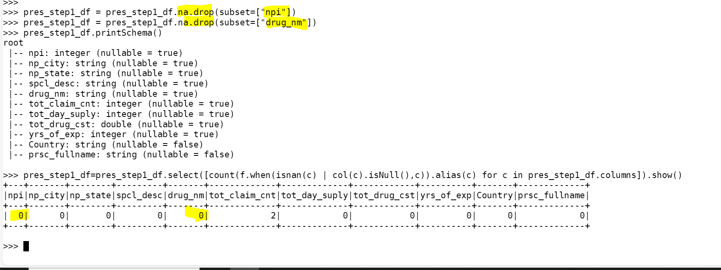

**Transformation:**

Step 1:

Filtering the prescribers only from 20 to 50 years of experience.

* 1. >>> from pyspark.sql import functions as F

>>> pres_step1_df = pres_step1_df.filter(F.col("yrs_of_exp").between(20,50))

>>> pres_step1_df.createOrReplaceTempView("prescriber")

>>>

>>>

>>> spark.sql("SELECT min(yrs_of_exp) , max(yrs_of_exp) from prescriber").show()

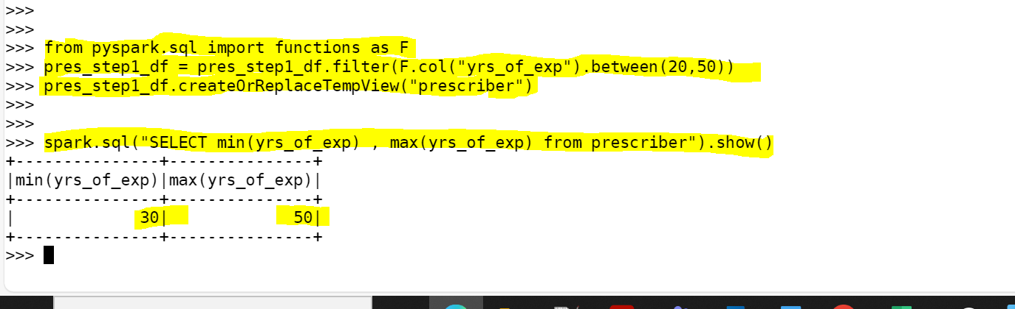

Step 2:

Selecting Top 5 Prescribers with highest total_claim_count per each state.

>>> from pyspark.sql import Window

>>> from pyspark.sql.functions import dense_rank

>>> from pyspark.sql.functions import concat, concat_ws,col, lit

>>> window = Window.partitionBy("np_state").orderBy(col("tot_claim_cnt").desc())

>>> pres_step1_df = pres_step1_df.withColumn("tot_claim_cnt_rank", dense_rank().over(window))

>>> pres_step1_df.createOrReplaceTempView("prescriber")

>>> spark.sql("SELECT * from prescriber where tot_claim_cnt_rank <= 5").show()

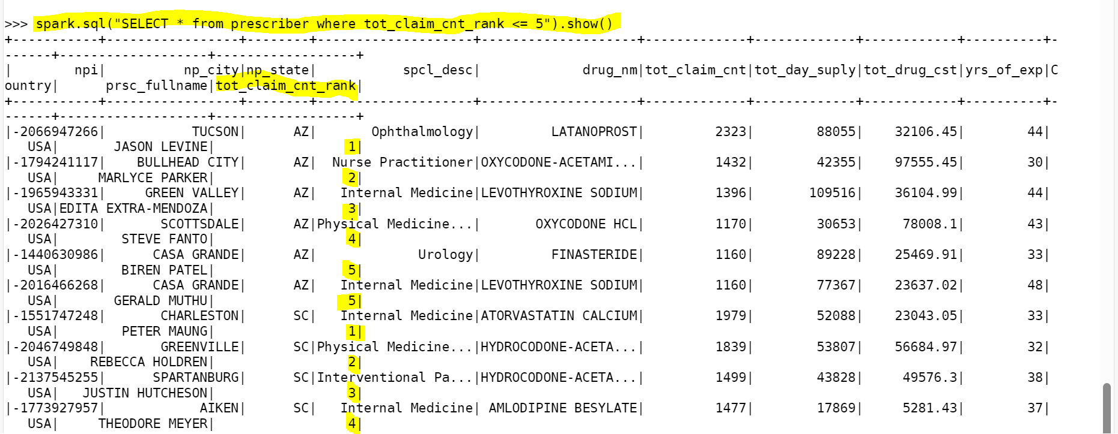

Checking count in final report :

>>> spark.sql("SELECT count(*) from prescriber where tot_claim_cnt_rank <= 5").show()

Selecting the specific columns required for Final report :

>>> spark.sql("SELECT npi as Prescriber_ID , prsc_fullname as Prescriber_Full_Name, np_state as Prescriber_State,Country as Prescriber

_Country, yrs_of_exp as Prescriber_Years_of_Experience,tot_claim_cnt as Total_claim_count,tot_day_suply as Total_Days_Supply,tot_drug_c

st as Total_Drug_Cost from prescriber where tot_claim_cnt_rank <= 5").show()

Report Layout:

Writing the output/ Final report in HDFS and Hive

Creating Output Directory:

[maverickavitha@ip-10-1-1-204 ~]$ hdfs dfs -mkdir -p prescpipeline/output/prescriber

Writing data in .ORC format and snappy compression :

>>> from pyspark.sql import SparkSession

>>> spark=SparkSession.builder.appName("Spark Hive").enableHiveSupport().config("spark.sql.warehouse.dir","/user/hive/warehouse").getOr

Create()

>>> spark.sparkContext.setLogLevel("ERROR")

>>> prescriber_report_DF = spark.sql("SELECT npi as Prescriber_ID , prsc_fullname as Prescriber_Full_Name, np_state as Prescriber_Stat

e,Country as Prescriber_Country, yrs_of_exp as Prescriber_Years_of_Experience,tot_claim_cnt as Total_claim_count,tot_day_suply as Total

_Days_Supply,tot_drug_cst as Total_Drug_Cost from prescriber where tot_claim_cnt_rank <= 5")

>>>

>>> repart_df = prescriber_report_DF.repartition(2)

>>>

>>> repart_df.write.mode("overwrite").option("compression","snappy").orc("/user/maverickavitha/prescpipeline/output/prescriber")

Report generated in HDFS:

hdfs dfs -ls /user/maverickavitha/prescpipeline/output/prescriber/

Writing the data into Hive

>>> repart_df.write.partitionBy("Total_claim_count").mode("overwrite").saveAsTable("Final_Prescriber_Report")

Data in hive

Count in Hive :

