**HBASE_ASSIGNMENT_1_TASK_2**

**Task 2:**

**Access the hbase data from hive**

For the above hbase table create a corresponding hive table and access the data by running queries in hive

Creating Hive tale pointing to hbase:

*hive> CREATE EXTERNAL TABLE comments_tohbase(rowkey String, stock_symbol STRING, commentid STRING,userid string,displayname string,Active string,comment string) STORED BY 'org.apache.hadoop.hive.hbase.HBaseStorageHandler' WITH SERDEPROPERTIES ('hbase.columns.mapping' =':key,cf_stk:stock_symbol,cf_stk:commentid,cf_stk:userid,cf_stk:displayname,cf_stk:Active,cf_stk:comment')TBLPROPERTIES ('hbase.table.name' = 'hbase_asgnmt_db:comments');*

Accessing the data :

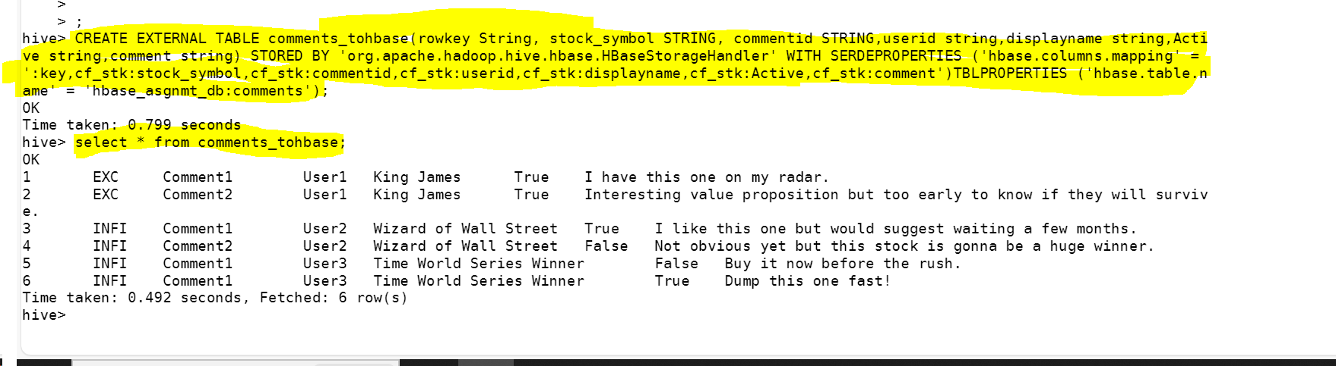

Queries:

What are the various comments given by all the users?

*hive> select userid, comment from comments_tohbase;*

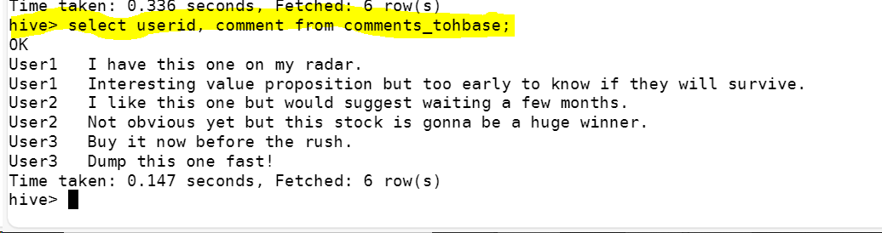

What are the comments by user3?

*hive> select comment from comments_tohbase where userid = 'User3';*

Which users have inactive comments?

*select distinct(userid) from comments_tohbase where active ='False';*

