**HBASE_ASSIGNMENT-1**

**Task 1:**

**Design a Data model comments given by various users on stock symbols**

Columns:

stock_symbol, commented, userid, displayname, active, comment

Sample data

Creating Namespace

*>>create_namespace 'hbase_asgnmt_db'*

Creating Table:

*>>create 'hbase_asgnmt_db:comments','cf_stk'*

Inserting given data:

*>>put 'hbase_asgnmt_db:comments','6','cf_stk:stock_symbol','INFI'*

*>>put 'hbase_asgnmt_db:comments','6','cf_stk:commentid','Comment1'*

*>>put 'hbase_asgnmt_db:comments','6','cf_stk:userid','User3'*

*>>put 'hbase_asgnmt_db:comments','6','cf_stk:displayname','Time World Series Winner'*

*>>put 'hbase_asgnmt_db:comments','6','cf_stk:Active','True'*

*>>put 'hbase_asgnmt_db:comments','6','cf_stk:comment','Dump this one fast!'*

*>>*

*>>put 'hbase_asgnmt_db:comments','5','cf_stk:stock_symbol','INFI'*

*>>put 'hbase_asgnmt_db:comments','5','cf_stk:commentid','Comment1'*

*>>put 'hbase_asgnmt_db:comments','5','cf_stk:userid','User3'*

*>>put 'hbase_asgnmt_db:comments','5','cf_stk:displayname','Time World Series Winner'*

*>>put 'hbase_asgnmt_db:comments','5','cf_stk:Active','False'*

*>>put 'hbase_asgnmt_db:comments','5','cf_stk:comment','Buy it now before the rush.'*

*>>*

*>>put 'hbase_asgnmt_db:comments','4','cf_stk:stock_symbol','INFI'*

*>>put 'hbase_asgnmt_db:comments','4','cf_stk:commentid','Comment2'*

*>>put 'hbase_asgnmt_db:comments','4','cf_stk:userid','User2'*

*>>put 'hbase_asgnmt_db:comments','4','cf_stk:displayname','Wizard of Wall Street'*

*>>put 'hbase_asgnmt_db:comments','4','cf_stk:Active','False'*

*>>put 'hbase_asgnmt_db:comments','4','cf_stk:comment','Not obvious yet but this stock is gonna be a huge winner.'*

*>>*

*>>*

*>>put 'hbase_asgnmt_db:comments','3','cf_stk:stock_symbol','INFI'*

*>>put 'hbase_asgnmt_db:comments','3','cf_stk:commentid','Comment1'*

*>>put 'hbase_asgnmt_db:comments','3','cf_stk:userid','User2'*

*>>put 'hbase_asgnmt_db:comments','3','cf_stk:displayname','Wizard of Wall Street'*

*>>put 'hbase_asgnmt_db:comments','3','cf_stk:Active','True'*

*>>put 'hbase_asgnmt_db:comments','3','cf_stk:comment','I like this one but would suggest waiting a few months.'*

*>>*

*>>put 'hbase_asgnmt_db:comments','2','cf_stk:stock_symbol','EXC'*

*>>put 'hbase_asgnmt_db:comments','2','cf_stk:commentid','Comment2'*

*>>put 'hbase_asgnmt_db:comments','2','cf_stk:userid','User1'*

*>>put 'hbase_asgnmt_db:comments','2','cf_stk:displayname','King James'*

*>>put 'hbase_asgnmt_db:comments','2','cf_stk:Active','True'*

*>>put 'hbase_asgnmt_db:comments','2','cf_stk:comment','Interesting value proposition but too early to know if they will survive.'*

*>>*

*>>put 'hbase_asgnmt_db:comments','1','cf_stk:stock_symbol','EXC'*

*>>put 'hbase_asgnmt_db:comments','1','cf_stk:commentid','Comment1'*

*>>put 'hbase_asgnmt_db:comments','1','cf_stk:userid','User1'*

*>>put 'hbase_asgnmt_db:comments','1','cf_stk:displayname','King James'*

*>>put 'hbase_asgnmt_db:comments','1','cf_stk:Active','True'*

*>>put 'hbase_asgnmt_db:comments','1','cf_stk:comment','I have this one on my radar.'*

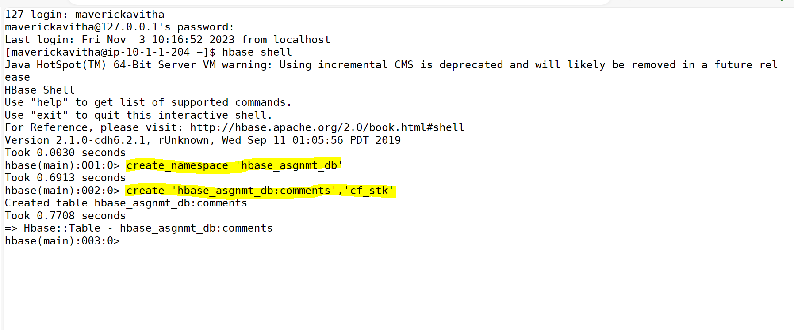

Data inserted successfully:

*hbase(main):069:0> scan 'hbase_asgnmt_db:comments'*

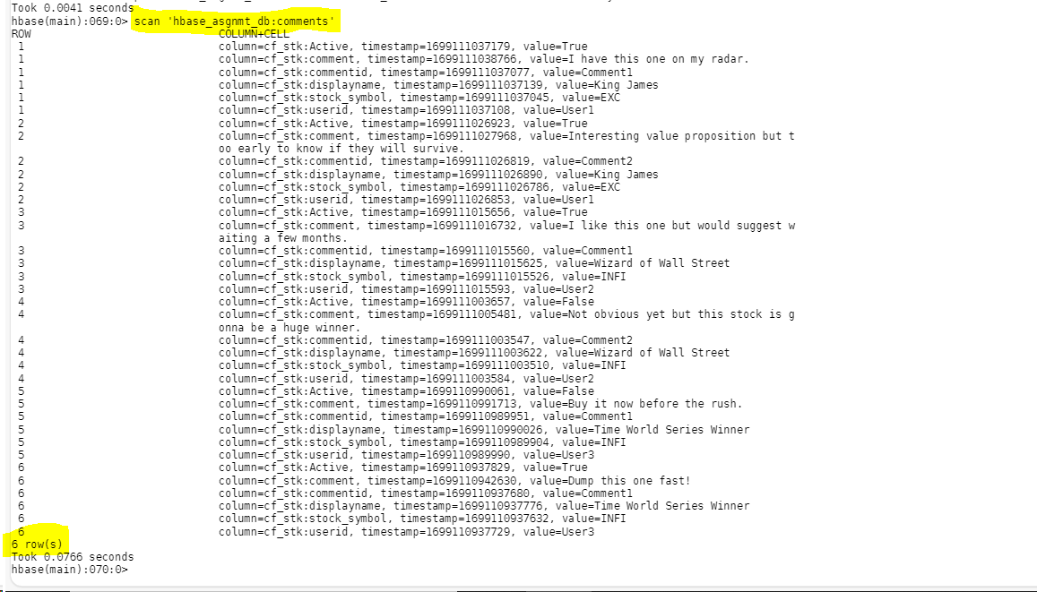

Queries:

What are the various comments given by all the users?

What are the comments by user3?

Which users have inactive comments?

Importing Filters:

What are the various comments given by all the users?

*hbase(main):008:0> scan 'hbase_asgnmt_db:comments', {COLUMNS=>['cf_stk:userid','cf_stk:comment']}*

What are the comments by user3?

Retrieving all the fields for user 3:

*hbase(main):006:0> scan 'hbase_asgnmt_db:comments', { FILTER => SingleColumnValueFilter.new(Bytes.toBytes('cf_stk'), Bytes.toBytes('userid'),CompareFilter::CompareOp.valueOf('EQUAL'),BinaryComparator.new(Bytes.toBytes('User3')))}*

Retrieving only the comments and userid for user 3:

*hbase(main):009:0> scan 'hbase_asgnmt_db:comments',{COLUMNS=>['cf_stk:userid','cf_stk:comment'], FILTER => SingleColumnValueFilter.new(Bytes.toBytes('cf_stk'), Bytes.toBytes('userid'), CompareFilter::CompareOp.valueOf('EQUAL'),BinaryComparator.new(Bytes.toBytes('User3')*

*))}*

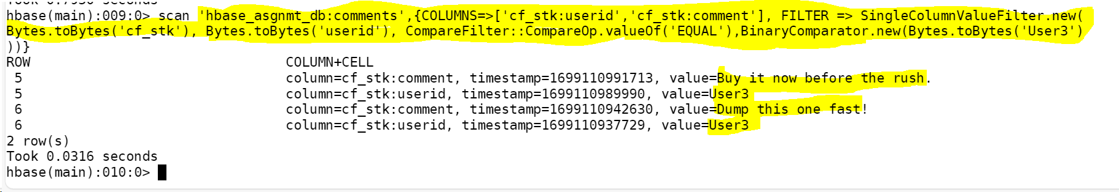

Which users have inactive comments?

*hbase(main):007:0> scan 'hbase_asgnmt_db:comments',{COLUMNS=>['cf_stk:userid','cf_stk:Active'], FILTER => SingleColumnValueFilter.new(Bytes.toBytes('cf_stk'), Bytes.toBytes('Active'), CompareFilter::CompareOp.valueOf('EQUAL'),BinaryComparator.new(Bytes.toBytes('False'))*

*)}*

