**HBASE_ASSIGNMENT_1_Task_3**

**Task 3:**

Create a table album in hive with the following data

|  |  |  |  |
| --- | --- | --- | --- |
| **singer** | **Song** | **Duration** | **Musicdirector** |
| Singer1 | Song1 | 4:35 | AK |
| Singer1 | Song2 | 3:54 | JK |
| Singer1 | Song3 | 2:03 | JK |
| Singer2 | Song4 | 1:54 | AK |
| Singer2 | Song5 | 3:43 | FG |
| Singer3 | Song6 | 2:03 | JK |
| Singer3 | Song1 | 1:54 | AK |
| Singer4 | Song2 | 3:43 | FG |
|  |  |  |  |

**Create Table Hive QL**

*hive> create table kavi_album (row_key int,singer String,Song String,Duration String,Musicdirector String) ROW FORMAT DELIMITED FIELDS TERMINATED BY ',*

*';*



**Inserting Data into hive table:**

*insert into table kavi_album (row_key, singer, song, duration, musicdirector) VALUES (1, 'Singer1','Song1','4:35','AK');*

*insert into table kavi_album (row_key, singer, song, duration, musicdirector) VALUES (2, 'Singer1','Song2','3:54','JK');*

*insert into table kavi_album (row_key, singer, song, duration, musicdirector) VALUES (3, 'Singer1','Song3','2:03','JK');*

*insert into table kavi_album (row_key, singer, song, duration, musicdirector) VALUES (4, 'Singer2','Song4','1:54','AK');*

*insert into table kavi_album (row_key, singer, song, duration, musicdirector) VALUES (5, 'Singer2','Song5','3:43','FG');*

*insert into table kavi_album (row_key, singer, song, duration, musicdirector) VALUES (6, 'Singer3','Song6','2:03','JK');*

*insert into table kavi_album (row_key, singer, song, duration, musicdirector) VALUES (7, 'Singer3','Song1','1:54','AK');*

*insert into table kavi_album (row_key, singer, song, duration, musicdirector) VALUES (8, 'Singer4','Song2','3:43','FG');*

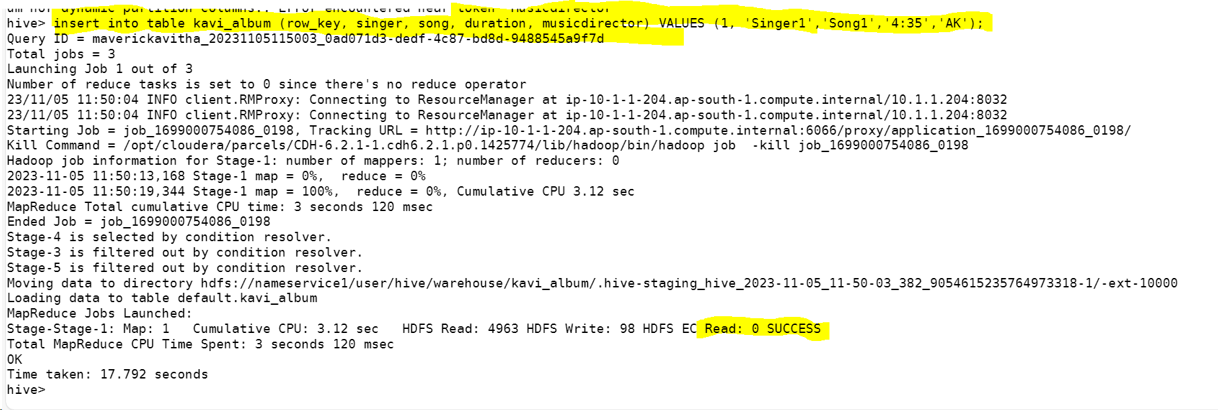

1. Create a table in Hbase (using hive-hbase integration) with proper row key design efficiently to load the data from hive to hbase.

*hive> CREATE TABLE k_albumnToHBase(row_key int,singer String,Song String,Duration String,Musicdirector String) STORED BY 'org.apache.hadoop.hive.hbase.HBaseStorageHandler' WITH SERDEPROPERTIES ('hbase.columns.mapping' = ':key,info:singer,info:Song,info:Duration,info:Musicdirector')*

*TBLPROPERTIES ('hbase.table.name' = 'hbase_asgnmt_db:k_album') ;*

*hive> insert overwrite table k_albumnToHBase select * from kavi_album;*

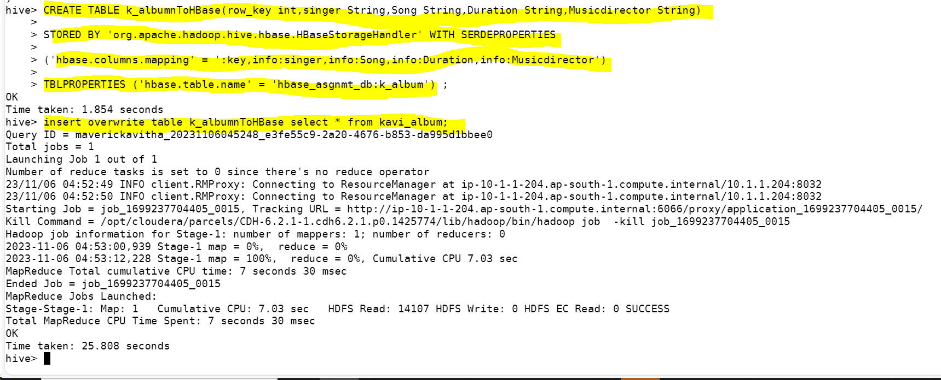

Data in hive

Data in HBase loaded successfully from Hive:

hbase(main):001:0> scan 'hbase_asgnmt_db:k_album'

1. There shoud not be any data loss when moving data from hive to hbase

Data in Hive

Data in Hbase: (No Data loss when moving data from hive to Hbase)

1. Run queries like
2. getall songs sung by a singer

*hbase(main):004:0> scan 'hbase_asgnmt_db:k_album' ,{COLUMN=>['info:singer','info:Song']}*

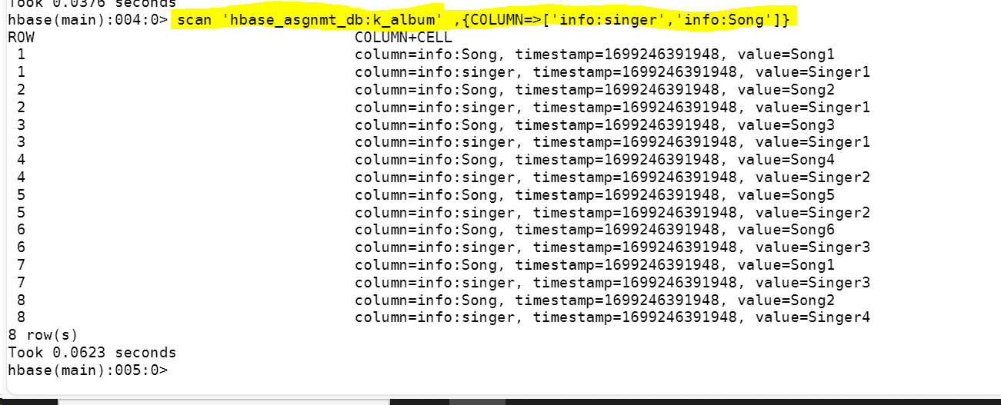

1. Which singer sung for music director AK and what were the songs

*hbase(main):012:0> scan 'hbase_asgnmt_db:k_album', {COLUMNS=>['info:singer','info:Song'],FILTER => SingleColumnValueFilter.new(Bytes.toBytes('info'), Bytes.toBytes('Musicdirector'),CompareFilter::CompareOp.valueOf('EQUAL'),BinaryComparator.new(Bytes.toBytes('AK')))}*

