**Crime Data Analysis**

**Dataset: crime_incidents_2013.csv**

Step 1: Loading data into Dataframe

*>>> Crime_AnlysDF=spark.read.option("header",True) .option("inferschema",True).csv("crime_incidents_2013.csv")*

*>>> Crime_AnlysDF.createOrReplaceTempView ("Crime_Anlys")*

*>>> Crime_AnlysDF.printSchema()*

*>>> Crime_AnlysDF.show()*

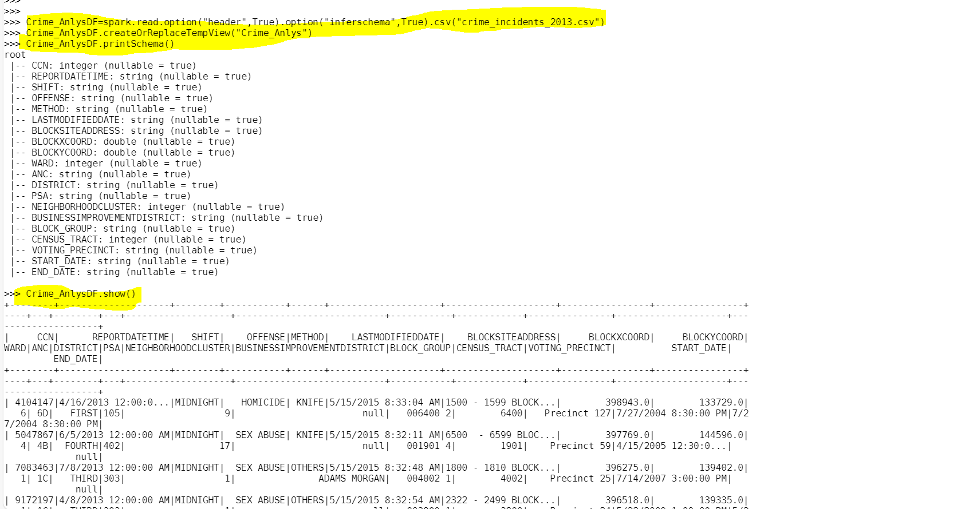

1. How many offenses were there in 2013?

Distinct Offenses happened in 2013

*>>> spark.sql("SELECT count(distinct OFFENSE) from Crime_Anlys").show()*

No of Offenses happened in 2013

*>>> spark.sql("SELECT count(OFFENSE) from Crime_Anlys").show()*

1. How many crimes were committed in each offense?

*>>> spark.sql("SELECT OFFENSE ,count(CCN) from Crime_Anlys group by OFFENSE").show()*

1. How many different methods were used (And their count) in offense “Homicide”

*>>> spark.sql("SELECT METHOD ,count(METHOD) from Crime_Anlys where OFFENSE = 'HOMICIDE' group by METHOD ").show()*

1. Which shift had the maximum crimes?

Evening shift had the maximum crimes.

*>>> spark.sql("SELECT SHIFT ,max(CCN) from Crime_Anlys group by SHIFT order by 2 desc").show()*

*>>> spark.sql("SELECT SHIFT ,max(CCN) from Crime_Anlys group by SHIFT order by 2 desc limit 1").show()*

