**Pyspark Assignment – TASK 3**

**Order Data analysis (Joins)**

1. Problem Statement: What is the daily product revenue for CLOSED or

COMPLETE orders?

**Step 1:**

**Moving the files into HDFS:**

1. Load the required data in to DF like categories, customer,departments,order_items,orders and products

*>>> orderitemsDF=spark.read.option("header",True).option("inferschema",True). csv("order_items.csv")*

*>>> orderitemsDF.createOrReplaceTempView("orderitems")*

*>>> orderitemsDF.printSchema()*

*>>> ordersDF=spark.read.option("header",True).option("inferschema",True).csv("Order.csv")*

*>>> ordersDF.createOrReplaceTempView("orders")*

*>>> ordersDF.printSchema()*

*>>> productsDF=spark.read.option("header",True).option("inferschema",True).csv("products.csv")*

*>>> productsDF.createOrReplaceTempView("products")*

*>>> productsDF.printSchema()*

1. Get the count for each order status

*>>> spark.sql("SELECT order_status, count(order_id) from orders group by order_status").show()*

1. Filter only COMPLETE or CLOSED orders

*>>> spark.sql("SELECT * from orders where order_status in ('CLOSED','COMPLETE')").show()*

1. Join the products , order_items and orders tables and calculate daily product revenue

*>>> spark.sql("SELECT o.order_date, p.product_name ,sum(ot.order_item_subtotal) as revenue from orders o join orderitems ot on o.order_id = ot.order_item_order_id*

*join products p on p.product_id = ot.order_item_product_id where o.order_status in ('CLOSED','COMPLETE') group by o.order_date, p.product_name").show()*

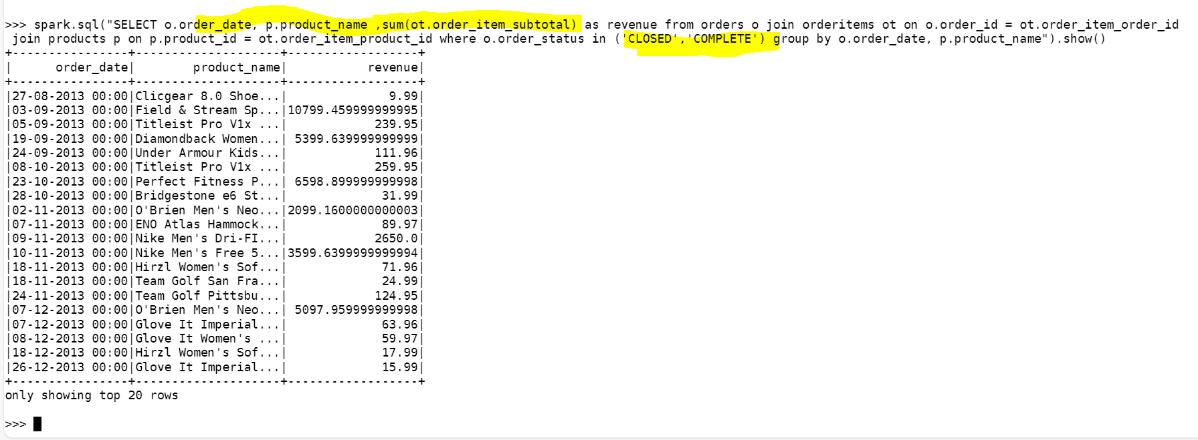

Getting the count for the daily revenue:

*>>> spark.sql("SELECT count(*) from (SELECT o.order_date, p.product_name ,sum(ot.order_item_subtotal) as revenue from orders o join orderitems ot on o.order_id =*

*ot.order_item_order_id join products p on p.product_id = ot.order_item_product_id where o.order_status in ('CLOSED','COMPLETE') group by o.order_date, p.product_n*

*ame)a").show()*

1. Write the data in to the table Daily product revenue in Hive

*>>> from pyspark.sql import SparkSession*

*>>> spark=SparkSession.builder.appName("Spark Hive").enableHiveSupport().config("spark.sql.warehouse.dir","/user/hive/warehouse").getOrCreate()*

*>>> spark.sparkContext.setLogLevel("ERROR")*

*>>> revenuedf = spark.sql("SELECT o.order_date, p.product_name ,sum(ot.order_item_subtotal) as revenue from orders o join orderitems ot on o.order_id = ot.order_i*

*tem_order_id join products p on p.product_id = ot.order_item_product_id where o.order_status in ('CLOSED','COMPLETE') group by o.order_date, p.product_name ")*

*>>> revenuedf.show()*

*>>> revenuedf.write.partitionBy("product_name").mode ("overwrite").saveAsTable("K_daily_product_revenue")*

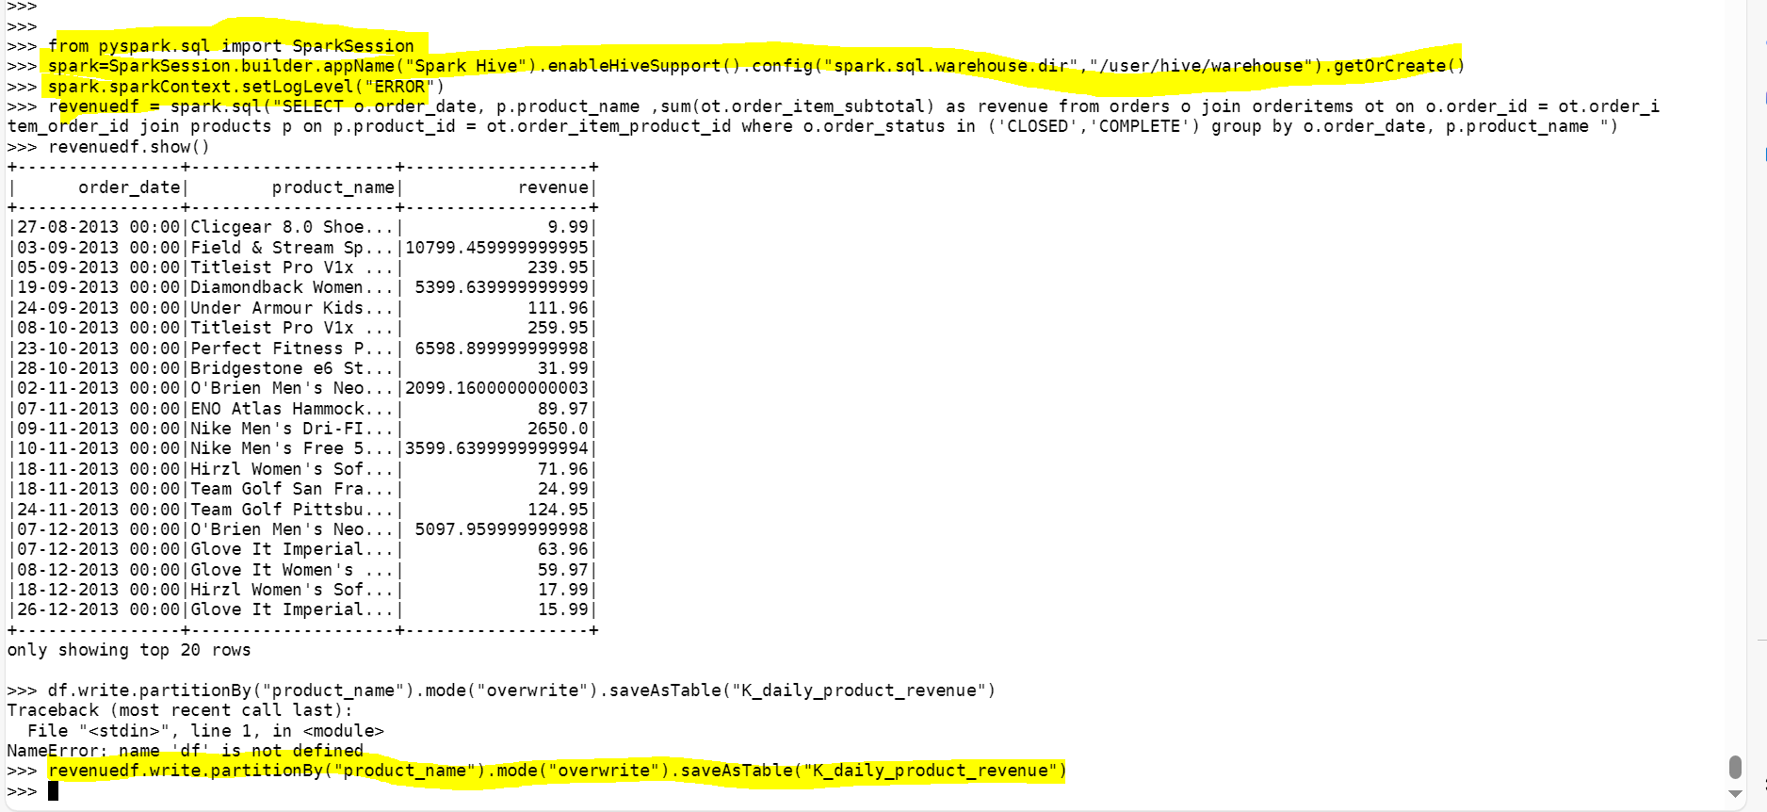

**Checking data in hive :**

hive> select * from K_daily_product_revenue limit 10 ;

hive> select count(*) from K_daily_product_revenue ;

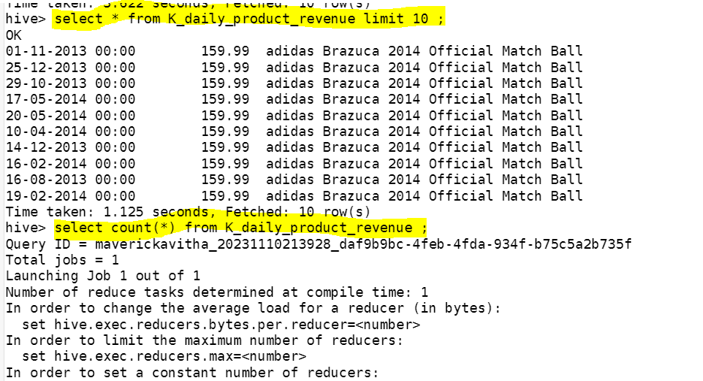

**Count matched for no of records in hive and pyspark SQL :**

Spark count:

*>>> spark.sql("SELECT count(*) from (SELECT o.order_date, p.product_name ,sum(ot.order_item_subtotal) as revenue from orders o join orderitems ot on o.order_id =*

*ot.order_item_order_id join products p on p.product_id = ot.order_item_product_id where o.order_status in ('CLOSED','COMPLETE') group by o.order_date, p.product_n*

*ame)a").show()*

