**Write a Python function that accepts a string and calculates the number of uppercase letters and lowercase letters.**

Sample String: 'The quick Brow Fox'

Expected Output :

No. of Upper case characters : 3

No. of Lower case Characters: 12

**Code:**

def str_case(s):

x={"upr_cas":0, "lwr_cas":0}

for c in s:

if c.isupper():

x["upr_cas"]+=1

elif c.islower():

x["lwr_cas"]+=1

print ("Original String : ", s)

print ("No. of Upper case characters : ", x["upr_cas"])

print ("No. of Lower case Characters : ", x["lwr_cas"])

str_case('Abcd 12Fghlk DTHkdfwark')

Output 1:

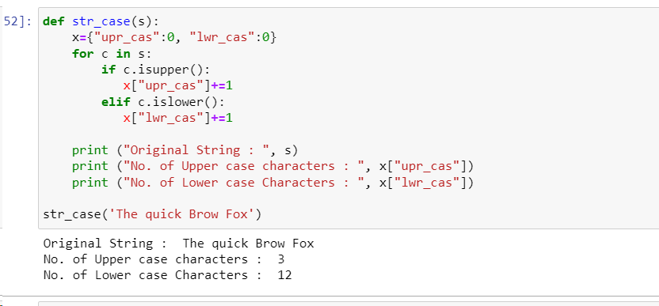

Output 2:

