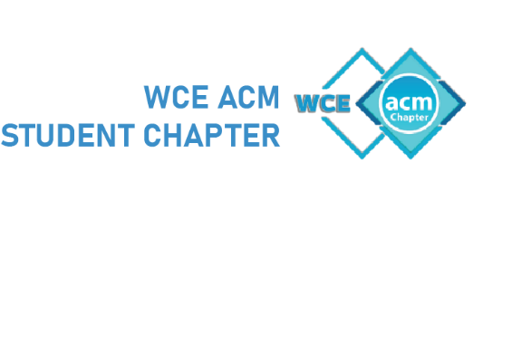

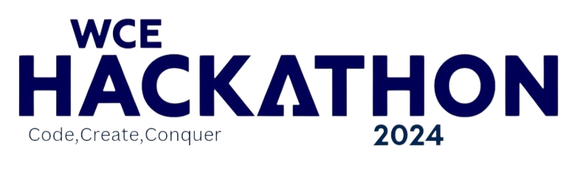

Round 1: Idea Submission

**Team Name: Mavericks**

**Team Leader: Chitransh Agrawal**

**Domain/Theme: Healthcare**

**Problem Statement: Develop a Gamified AI-powered Platform for ADHD Management**

**Track: Healthcare**

(This document should not exceed given pages. Keep the abstract short and precise.)

(THIS PROBLEM STATEMENT IS NOT UNDER OPEN INNOVATION)

**Problem identified:**

ADHD stands for Attention Deficit Hyperactivity Disorder. It's a neurodevelopmental disorder that affects both children and adults and can impact their ability to focus, control impulses, and regulate energy levels.

There are three main subtypes of ADHD:

1. **Predominantly Inattentive Presentation**: Individuals with this subtype struggle primarily with attention and organization. They may have difficulty sustaining attention on tasks, frequently make careless mistakes, have trouble following instructions, and often seem forgetful or easily distracted.
2. **Predominantly Hyperactive-Impulsive Presentation**: People with this subtype exhibit primarily hyperactive and impulsive behaviors. They may fidget or squirm, have difficulty staying seated, talk excessively, interrupt others, and have trouble waiting their turn.
3. **Combined Presentation**: Individuals with the combined presentation display symptoms of both inattention and hyperactivity-impulsivity.

**Market Research:**

* **Target Audience**: Individuals with ADHD, parents, caregivers, and healthcare professionals.
* **Existing Solutions**: Traditional therapy, medication, and mobile apps with limited personalization and support.
* **Competitive Advantage**: Combines AI-powered conversation, gamified meditation, and community support for a more engaging and accessible approach.
* **Market Impact**: Offers a potential alternative to traditional therapy, empowers users, and contributes to data-driven advancements in ADHD management.

**Project Name:** **Gamified AI-powered Platform for ADHD Management**

**Describe your solution:**

This paper presents a novel, gamified platform leveraging **Prompt Engineering and AI** to support individuals with **Attention Deficit Hyperactivity Disorder (ADHD)**. The solution addresses core challenges of inattention, hyperactivity, and emotional dysregulation through a multi-pronged approach:

1. **Conversational AI with Prompt Engineering**: Users engage with a **pre-trained AI model** using **structured prompts** to discuss daily experiences and emotions. The AI, guided by these prompts, offers **personalized suggestions and fosters a supportive environment**, promoting emotional regulation and self-awareness.

2. **Gamified Meditation**: A **built-in timer** encourages daily **mindfulness practice** through meditation, a well-established technique for improving focus and reducing stress.

3. **Global Leaderboard and Point System**: Users earn **fixed points for daily meditation** and **variable points for interacting with the AI**, fostering **healthy competition and engagement** through **a global leaderboard**. This gamified approach aims to **increase user motivation and adherence** to the platform.

4. **Supportive Community**: The platform fosters a **safe and supportive online community** where users can connect, share experiences, and offer encouragement, fostering a sense of belonging and reducing isolation.

This innovative solution combines the power of **AI, gamification, and community support** to provide a **holistic and engaging** approach to **managing ADHD symptoms and promoting overall well-being**. Further research will evaluate the platform's effectiveness in improving focus, reducing hyperactivity, and enhancing emotional regulation in individuals with ADHD.

**Technology Stack:**

**Frontend**

* HTML5
* CSS
* Javascript
* ReactJs

**Backend**

* Database SQL
* NodeJs/Python

**AI Model , Prompt Engineering and API**

**Innovativeness:**

**Imagine: An engaging platform where individuals with ADHD can:**

* Confide in an AI companion using structured prompts, receiving personalized guidance and emotional support.

* Combat inattention through gamified meditation, earning points and climbing a global leaderboard.

* Connect with a supportive community, sharing experiences and fostering a sense of belonging.

**This groundbreaking solution:**

* Marries AI, gamification, and community support for a holistic approach to ADHD management.

* Empowers users to take control of their well-being through personalized interaction and engaging activities.

* Offers a potentially more accessible and effective alternative to traditional methods.

**Show Stoppers:**

**\* AI Bias and Personalization:** Ensuring the AI model remains unbiased and tailors suggestions effectively to individual needs.

**\* Data Privacy and Security:** Implementing robust measures to safeguard user data privacy and security.

**\* Engagement and Long-term Adherence:** Maintaining user motivation and consistent platform usage over time.

**\*** **Clinical Validation and Efficacy:** Conducting rigorous studies to validate the platform's effectiveness in improving ADHD symptoms.

**\*** **Accessibility and Equity:** Ensuring the platform is accessible and inclusive for individuals with diverse needs and backgrounds.

**Prototype:**

(You can add pictures of the prototype/wireframes/UI or provide a video link in which prototype is explained) (This section has maximum weightage)

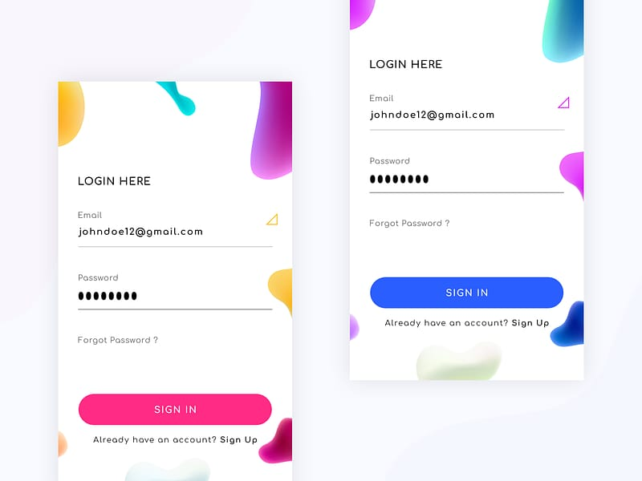 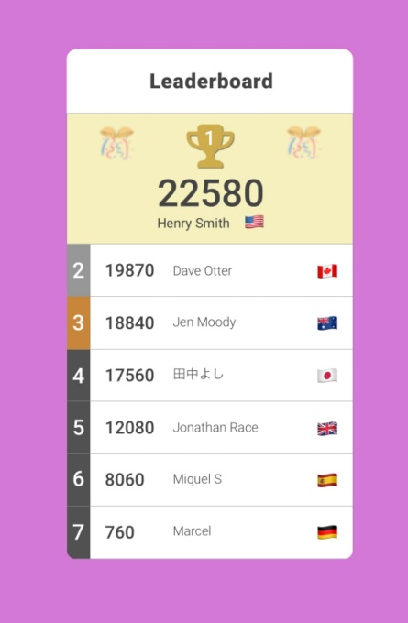

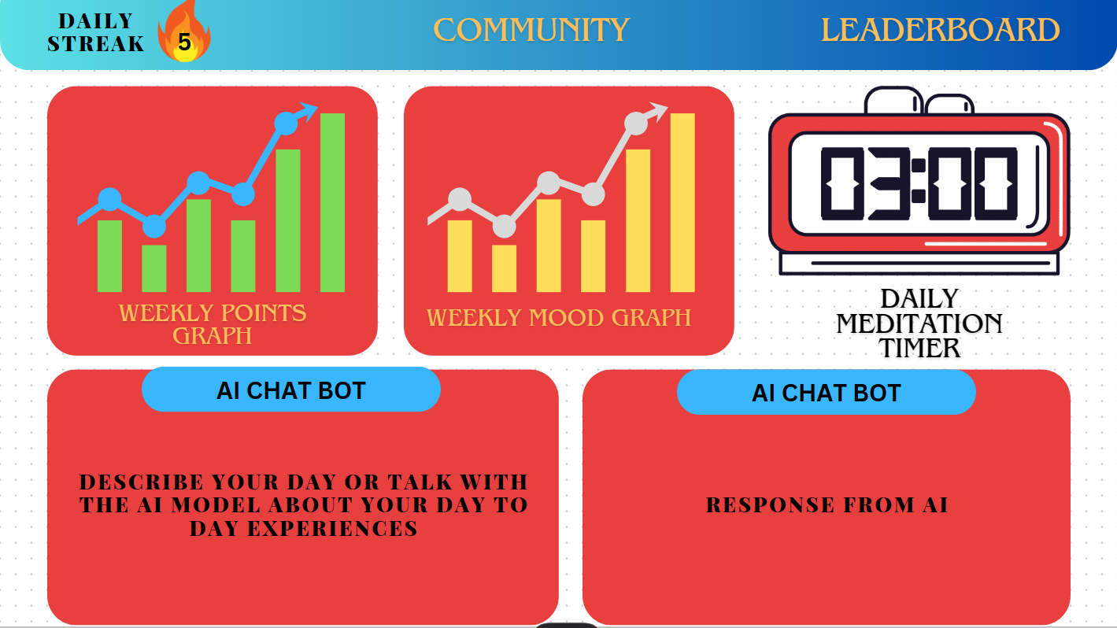

**Use Case Diagram/Flow Diagram:**

