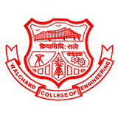

WALCHAND COLLEGE OF ENGINEERING, SANGLI

(Government Aided Autonomous Institute) Vishrambag ,Sangli,416415 (MS)

**VISION 2024**

The highlight of the Vision event is the ACM Hackathon, organized by WCE ACM, promising an exciting showcase of technical innovation and collaboration.

WCE ACM STUDENT CHAPTER

Presents

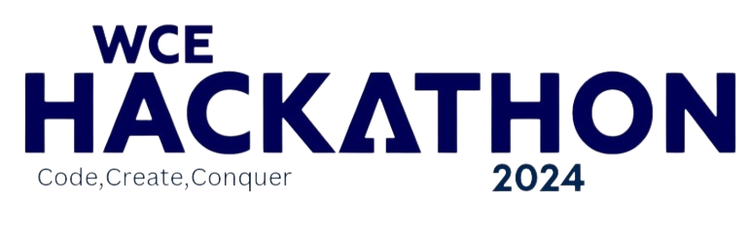

**Celebrating 8 years of WCE ACM**

[https://wcehackathon.in](https://wcehackathon.in/)

**1**

|  |  |  |  |
| --- | --- | --- | --- |
|  | **Content** |  | |
| **PARTICULAR** | **PAGE NO** |  |
| About WCE | 02 |  |
| About ACM, WCE ACM | 03 |  |
| WCE Hackathon 2024 | 04 |  |
| Schedule | 06 |  |
| Structure | 07 |  |
| Prizes | 08 |  |
| Domains/Themes | 09 |  |
| Rules | 10 |  |
| Certification | 10 |  |
| Judging criteria | 11 |  |
| Glimpse of past Hackathons | 12 |  |
|  | Contact us | 14 |  |

# WALCHAND COLLEGE OF ENGINEERING, SANGLI

#### (GOVERNMENT AIDED AUTONOMOUS INSTITUTE)

Walchand College of Engineering Sangli (WCE), established in 1947 and aided by the Government of Maharashtra, is one of the oldest and premier engineering institutions in India. With a rich history of over 70 years and a beautiful campus of over 90-acres, WCE Sangli is providing transformational learning experiences in various disciplines of engineering. The institute is affiliated with Shivaji University Kolhapur and is approved by AICTE, New Delhi. WCE is accredited by NAAC with an "A" grade.

WCE offers 6 UG programs and 10 PG programs in various engineering streams. It also offers Ph.D. programs under Shivaji University, Doctoral Fellowship of AICTE, and under Quality Improvement Program (QIP) scheme of the Ministry of Human Resource Development (MHRD). WCE has shown its consistent performance in the Technical Quality Improvement Program (TEQIP) of MHRD through NPIU for consecutive 3 programs.

Through the Transformational Teaching Learning (TTL) processes, WCE aims at the overall development of students with a focus on Education, Employability, and Employment. The students of WCE get placed in reputed Multinational and Indian Companies such as Google, Microsoft, Linkedin, Amazon, John Deere, Rakuten, P&G, Mahindra, TCS, Infosys, and many other companies. With a high percentage of placements, WCE students also get very good packages, with the highest package being 52 LPA in the year 2022.

WCE also has a vibrant student club culture, having actively involved in various technical and co-curricular student activities. There are also department-wise student associations and professional student chapters, that organize programs to keep up with the current trends in technology and also for enhancing the student personality. With their contribution to the development of the institution, WCE Sangli is strongly marching on the path of excellence in engineering education. No wonder WCE Sangli is

the most preferred destination for engineering education today!

# ABOUT ACM

The Association for Computing Machinery (ACM), the world's largest scientific and educational computing society is an US-based international [learned society](https://en.wikipedia.org/wiki/Learned_society) for [computing](https://en.wikipedia.org/wiki/Computing). The ACM is an [umbrella organization](https://en.wikipedia.org/wiki/Umbrella_organization) for academic and scholarly interests in [computer science](https://en.wikipedia.org/wiki/Computer_science) ([informatics](https://en.wikipedia.org/wiki/Informatics)). Its motto is "Advancing Computing as a Science & Profession".

The ACM India Council was created to recognize and support Indian ACM members and activities. It has 195 student chapters and 16 professional chapters nationwide, including the Special Interest Group and ACM-W chapters, with the dual objective of creating a healthy competition among chapters and working toward a social cause. One of which is the WCE ACM Student Chapter.

# WCE ACM STUDENT CHAPTER

WCE ACM Student Chapter, authorized by ACM INDIA COUNCIL on March 18, 2016, aims to impart knowledge and promote innovation in the field of computer science. Deriving inspiration from the parent organization, ACM, we thrive to achieve the aim by conducting various technical & non-technical activities.

It was formed by the Department of Computer Science & Engineering, WCE Sangli. The chapter mainly consists of students from UG & PG with Computer Science / IT as a major. The chapter officially represents ACM & ACM India in the Sangli - Kolhapur region. We are the only ACM Student Chapter formed in western Maharashtra.

We organize hackathons, research symposiums, boot camps, workshops, coding competitions, technical sessions, and technical talks by experts. WCE ACM Student Chapter has been organizing WCE Hackathon for the last 6 years. Jagruti is a social event organized on International Women's Day. DSA Launchpad, ACM Talks, and WCE RSC are some of the above- mentioned events.

# WCE HACKATHON 2024

#### BY WCE ACM STUDENT CHAPTER

WCE HACKATHON'24 will be conducted entirely in Offline mode. Hackathon'24 is a developing venture in which participants are expected to complete the product development as per the selected problem statements. Here participants will innovate, strategize, code, and beat the odds with some ingenious solutions to the most sought real-life problems.

# PARTICIPANTS

A team of UG Engineering students is eligible to participate in the hackathon. A team should have a minimum of 2 and a maximum of 4 members.

Team members can belong to different colleges, different academic years, different departments.

# REGISTRATION

Registration is taken through unstop.com (formerly Dare2Compete). [Registration](https://dare2compete.com/o/wce-hackathon-2021-hackathon-walchand-college-of-engineering-wce-sangli-168986) link:

## Tracks

Hackathon will consist of 2 tracks i.e. Novice and Expert. The top 3 teams from the Expert track will be declared winners. The top 2 teams from the novice track will be declared winners.

## Novice Track

Only a team of all first academic year students can choose to apply in the Novice track. Teams in the novice track are eligible for mentor allotment. Mentors can be from SY, TY, or B.Tech studying at **WCE only**. Teams can convey their preference for the mentor while registering.

## Expert Track

Teams with 1 or more members from the 2nd, 3rd, or 4th academic year will be considered in the Expert Track.

# SCHEDULE

|  |  |  |
| --- | --- | --- |
|  | START | ENDS |
| Official Announcement | Feb 14, 2024 |  |
| Registration | Feb 14, 2024 | Mar 1, 2024 |
| Round 1-Idea Submission | Feb 14, 2024 | Mar 1, 2024 |
| Round 1- Result Declaration | Mar 6, 2024 |  |
| Round 2- Development Period | Mar 16, 2024 | Mar 17, 2024 |
| Round 3(Final Round) - Result Declaration | Mar 17, 2024 |  |

## Structure

### Round 1: Idea Submission

Registered teams need to submit an abstract of their project based on one of the given problem statements. All submissions shall be in the format provided on the website.

### Round 2: Development

Shortlisted teams will develop the project in the development period of 24 hours.

### Finale

Shortlisted teams will have a final presentation and Q/A session with the judges in presence of all final teams.

## Prizes

## Expert Track

## Teams-

1st Prize – 40000 INR

2nd Prize – 30000 INR

3rd Prize – 20000 INR

## Novice Track

## Teams-

1st Prize – 5000 INR

2nd Prize – 2000 INR

## Mentors-

1st Prize – 2000 INR

2nd Prize – 1000 INR

.

**Domains/Themes**

1. AR/VR Innovativations
2. Renewable Energy
3. Cyber Security
4. Smart Agriculture
5. Fintech
6. Education
7. Digital Twin
8. Health Care

# RULES

 One team can submit only one idea.

 Participants shall obey the code of conduct displayed on the website and that provided by Unstop.

 We encourage you to submit projects only prepared for the duration of the hackathon.

 However, if you decide to submit projects consisting of re-used code, or re-submit a project that you have already submitted previously to any other hackathon, you are to disclose such previous use and its extent with the submission.

 The Intellectual Property (IP) of the product belongs to the developing team, the Industry sponsoring and Walchand College of Engineering, Sangli.

# CERTIFICATION POLICY

All participants and mentors will be provided a certificate of participation.

# JUDGING CRITERIA

Teams will be judged on these four criteria.

During judging, participants should try to describe what they did for each criterion in their project.

 Technology: How technically impressive is the solution? Did it use a particularly clever technique or did it use many different components?

 Design: Did the team put thought into the user experience?

How well designed is the interface?

 Completion: Does the hack work? Did the team achieve everything they wanted?

 Learning: Did the team stretch themselves? Did they try to learn something new? What kind of projects have they worked on before?

# A GLIMPSE OF WCE HACKATHON 2023

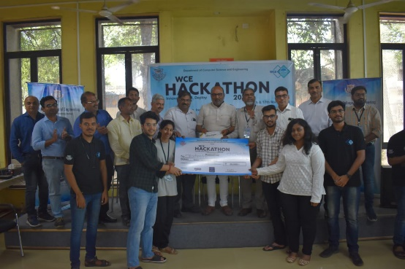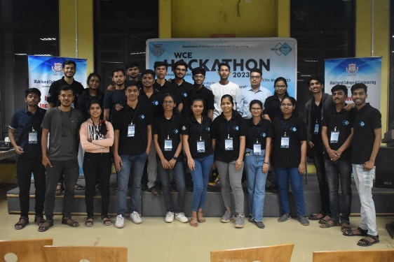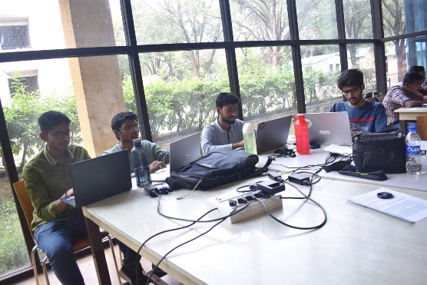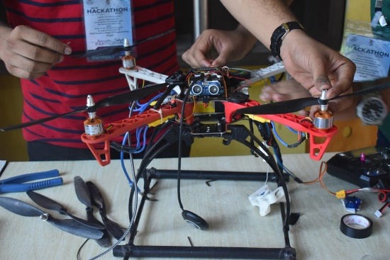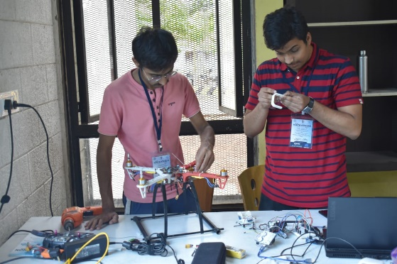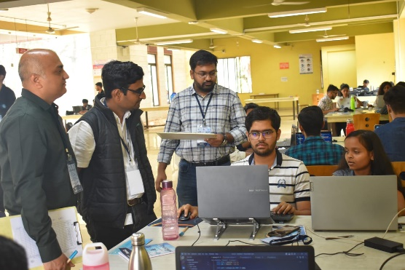

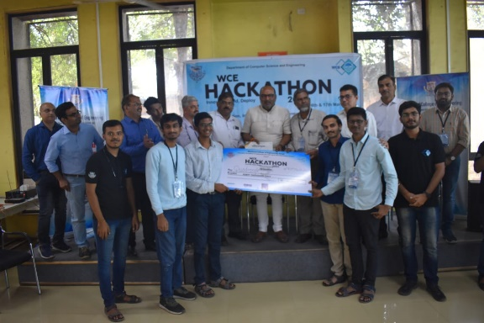

**12**

## Hackathon'23

Last year WCE hackathon was held in the month of March, with great enthusiasm. Around 700+ participants from various colleges across Maharashtra registered themselves for the hackathon. And a total of 188 teams competed for the winner badge.

Basically, the hackathon had 3 rounds:

1. Idea/Abstract submission:-

In the first round, a total of 100+ ideas were submitted of which 25 teams were shortlisted.

1. Development Period:-

It was a 24-hour-long coding venture. Shortlisted 25 teams that developed their prototypes based on their idea and submitted code and video of the project.

1. Finale:-

In the finale, 25 Teams were shortlisted of which 3 teams become winners.

# GUIDED BY:

|  |  |  |  |
| --- | --- | --- | --- |
| **Dr. M.A. Shah**  **HOD (CSE Dept.)**  **Staff Advisor of WCE ACM**  **Student Chapter**  **WCE Sangli** | **Dr. Anil Surve**  **Associate Dean**  **Student Activity and  Development,**  **WCE Sangli** | **Dr. Uday A. Dabade**  **Director I/C,**  **WCE Sangli** |  |

# CONTACT US

[wcehackathon@walchandsangli.ac.in](mailto:wcehackathon@walchandsangli.ac.in) <https://wcehackathon.in>

Viraj Takone Hamza Shaikh

7420098224 9420889797