

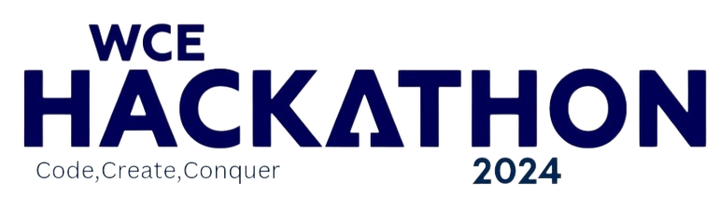

Round 1: Idea Submission

**Team Name:**

**Team Leader:**

**Domain/Theme:**

**Problem Statement:**

**Track:**

(This document should not exceed given pages. Keep the abstract short and precise.)



\*\***( This page is applicable only for Open innovation)\*\***

**Problem identified:**

(Describe the problem you have selected for which you are developing a solution.)

**Market Research:**

(Try answering these questions in this section:

Who are your customers and end-users?

What are the solutions already available in market for your problem? How is your solution better than existing solutions?

What impact will your project make on the current market?)



**Project Name:**

**Describe your solution:**





**Technology Stack:**

(Technologies used for developing the project.)

Example: Frontend- React

Backend- Django

Database- Postgres

**Innovativeness:**

(Innovation aspect of the project and special features that it provides)

**Show Stoppers:**

(Show stoppers are obstacles and risks that may arise in the future and which may come in the way of your solution)

**Prototype:**

(You can add pictures of the prototype/wireframes/UI or provide a video link in which prototype is explained) (This section has maximum weightage)



**Use Case Diagram/Flow Diagram:**

