How To Monitor Spring Boot Microservices Using ELK Stack?

<https://javatechonline.com/how-to-monitor-spring-boot-microservices-using-elk-stack/>

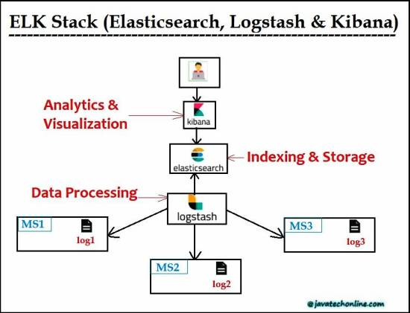

What is ELK(Elasticsearch+Logstash+Kibana) Stack all about?

"ELK"

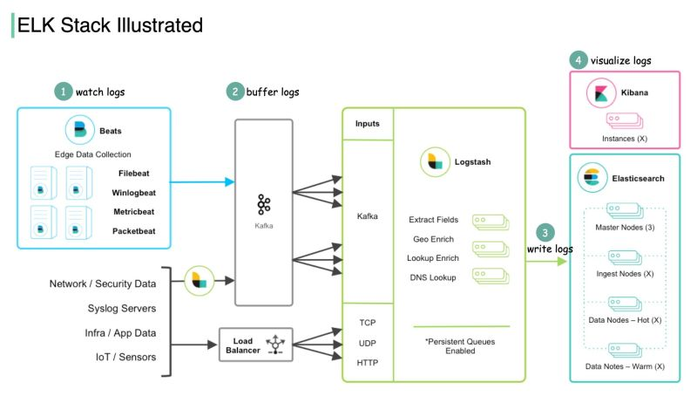

is the acronym for three open source projects: Elasticsearch, Logstash, and Kibana. Elasticsearch is a search and analytics engine. Logstash is a server‑side data processing pipeline that ingests data from multiple sources simultaneously, transforms it, and then sends it to a "stash" like Elasticsearch. Kibana lets users visualize data with charts and graphs in Elasticsearch.  
  
Check out the diagram below that shows how ELK Stack works:  
  
Step 1 - Beats collects data from various data sources. For example, Filebeat and Winlogbeat work with logs, and Packetbeat works with network traffic.  
  
Step 2 - Beats sends data to Logstash for aggregation and transformation. If we work with massive data, we can add a message queue (Kafka) to decouple the data producers and consumers.  
  
Step 3 - Logstash writes data into Elasticsearch for data indexing and storage.  
  
Step 4 - Kibana builds on top of Elasticsearch and provides users with various search tools and dashboards with which to visualize the data.  
  
ELK Stack is pretty convenient for troubleshooting and monitoring. It became popular by providing a simple and robust suite in the log analytics space, for a reasonable price.  
  
notes about how elk stack works are from [Alex Xu](https://www.linkedin.com/in/ACoAAAJcVUEBpKxeVUb94KnEePlKepfIXeP2RM0)  
Image source: <https://lnkd.in/eUqaC7mA>  
  
We are Hiring in [#Brazil](https://www.linkedin.com/feed/hashtag/?keywords=brazil&highlightedUpdateUrns=urn%3Ali%3Aactivity%3A6937760892772077568)  👉 WORK 100% REMOTE!  
  
When you work with Vigil, you get to be part of a company with an open, supportive culture that will help you leverage your skills, learn new techniques and foster your growth.  
  
★ Open positions:  
🔸 Senior Fullstack - JavaScript  
🔸 Senior Backend Engineer - Java  
🔸 Backend Engineer - Scala  
🔸 Agile Delivery Manager  
  
Let's work together!  
  
Send your CV to 📩 [anezka.honke@vigil.global](mailto:anezka.honke@vigil.global) or  
👉 Let's connect! 👈  
  
[#softwaredevelopers](https://www.linkedin.com/feed/hashtag/?keywords=softwaredevelopers&highlightedUpdateUrns=urn%3Ali%3Aactivity%3A6937760892772077568) [#softwareengineer](https://www.linkedin.com/feed/hashtag/?keywords=softwareengineer&highlightedUpdateUrns=urn%3Ali%3Aactivity%3A6937760892772077568)  [#brasil](https://www.linkedin.com/feed/hashtag/?keywords=brasil&highlightedUpdateUrns=urn%3Ali%3Aactivity%3A6937760892772077568) [#vagas](https://www.linkedin.com/feed/hashtag/?keywords=vagas&highlightedUpdateUrns=urn%3Ali%3Aactivity%3A6937760892772077568) [#remotework](https://www.linkedin.com/feed/hashtag/?keywords=remotework&highlightedUpdateUrns=urn%3Ali%3Aactivity%3A6937760892772077568) [#remotejobs](https://www.linkedin.com/feed/hashtag/?keywords=remotejobs&highlightedUpdateUrns=urn%3Ali%3Aactivity%3A6937760892772077568) [#remote](https://www.linkedin.com/feed/hashtag/?keywords=remote&highlightedUpdateUrns=urn%3Ali%3Aactivity%3A6937760892772077568) [#monitoring](https://www.linkedin.com/feed/hashtag/?keywords=monitoring&highlightedUpdateUrns=urn%3Ali%3Aactivity%3A6937760892772077568) [#observability](https://www.linkedin.com/feed/hashtag/?keywords=observability&highlightedUpdateUrns=urn%3Ali%3Aactivity%3A6937760892772077568) [#elkstack](https://www.linkedin.com/feed/hashtag/?keywords=elkstack&highlightedUpdateUrns=urn%3Ali%3Aactivity%3A6937760892772077568) [#elasticsearch](https://www.linkedin.com/feed/hashtag/?keywords=elasticsearch&highlightedUpdateUrns=urn%3Ali%3Aactivity%3A6937760892772077568) [#kibana](https://www.linkedin.com/feed/hashtag/?keywords=kibana&highlightedUpdateUrns=urn%3Ali%3Aactivity%3A6937760892772077568) [#logstash](https://www.linkedin.com/feed/hashtag/?keywords=logstash&highlightedUpdateUrns=urn%3Ali%3Aactivity%3A6937760892772077568)