PROJECT REPORT
ON
EV CHARGING SMART PLATFORM
(EvChargingApp)
Submitted in partial fulfilment of the requirements for the course
PBCST304 – OBJECT ORIENTED PROGRAMMING
Submitted by
Mohamed Zain puthuveettil thasnif [SCM25CS156]
Muhammed Zayan Yousef [SCM25CS173]
Muhammed Rayan Yousef [SCM25CS174]
Mohammed Ihsan [SCM25CS112]
Marwan VS[SCM25CS148]
to
The APJ Abdul Kalam Technological University
in partial completion of the criteria for the degree award of B.Tech Degree
in
COMPUTER SCIENCE AND ENGINEERING


SCMS SCHOOL OF ENGINEERING AND TECHNOLOGY(AUTONOMOUS)
(Affiliated to APJ Abdul Kalam Technological University)
VIDYA NAGAR, PALISSERY, KARUKUTTY
ERNAKULAM – 683 576
October 2026

DECLARATION
We, the undersigned, hereby declare that the project report “EV CHARGING SMART PLATFORM“, submitted for partial fulfilment of the requirements for the award of the degree of Bachelor of Technology (CSE) of the APJ Abdul Kalam Technological University, Kerala, is a bonafide work done by us under the supervision of Mr. Anoop Jose. This submission represents our ideas in our own words, and where ideas or words of others have been included, we have adequately and accurately cited and referenced the original sources. We also declare that we have adhered to the ethics of academic honesty and integrity and have not misrepresented or fabricated any data, idea, fact or source in our submission. We understand that any violation of the above will be a cause for disciplinary action by the institute and/or the University and can also evoke penal action from the sources which have thus not been properly cited or from whom proper permission has not been obtained. This report has not previously formed the basis for the award of any degree, diploma or similar title of any other University.

Place: Ernakulum Signature
Date: 29/10/2026

Name of the students
Mohamed Zain puthuveettil thasnif [SCM25CS156]
Muhammed Zayan Yousef [SCM25CS173]
Muhammed Rayan Yousef [SCM25CS174]
Mohammed Ihsan [SCM25CS112]
Marwan VS[SCM25CS148]

SCMS SCHOOL OF ENGINEERING AND TECHNOLOGY(AUTONOMOUS)
(Affiliated to APJ Abdul Kalam Technological University)
VIDYA NAGAR, PALISSERY, KARUKUTTY
ERNAKULAM – 683582

DEPARTMENT OF COMPUTER SCIENCE AND ENGINEERING


CERTIFICATE
This is to certify that the report entitled “EV CHARGING SMART PLATFORM” submitted by Mohamed Zain puthuveettil thasnif ,Muhammed Zayan Yousef , Muhammed Rayan Yousef, Mohammed Ihsan, Marwan VS to the APJ Abdul Kalam Technological University in partial fulfilment of the requirements for the award of the Degree of B.Tech in Computer Science and Engineering is a bonafide record of the project work carried out by him/her under my/our guidance and supervision. This report in any form has not been submitted to any other University or Institute for any purpose.

Project Co-ordinator |  | Head of the Department
Mr. Anoop Jose |  | Dr.Manish T.I
Assistant Professor |  | Professor
Department of CSE |  | Department of CSE
SSET |  | SSET

ACKNOWLEDGEMENT
We are greatly indebted to Dr.Jenson Joseph E., Principal, SCMS School of Engineering and Technology, Ernakulam and Dr.Manish T.I, Professor and Head of Department, Department of Computer Science and Engineering, SCMS School of Engineering and Technology, who wholeheartedly permitted us to conduct this project.

We would like to thank our project co-ordinator, Mr. Anoop Jose. Assistant Professor, Department of Computer Science and Engineering, SCMS School of Engineering and Technology who gave us valuable guidance. We would like to express sincere gratitude to all the teachers of the Department of Computer Science who gave us moral and technical support. We would like to thank the supporting staff in the computer lab whose dedicated work kept the lab working smoothly thus enabling us to have access to various resources which helped us understand more about the project topic. We would also like to extend our gratitude to all friends and family for providing us with the necessary resources and support.

ABSTRACT
The shift toward electric mobility has increased the demand for reliable and efficient charging infrastructure. Charging takes longer than refuelling a conventional vehicle, which can lead to queues, connector incompatibility, inconsistent billing, and unreliable customer feedback. Basic first-come-first-served approaches may also fail to account for emergency status or the remaining battery charge of a vehicle.
The EV Charging Smart Platform (EvChargingApp) is a desktop application developed using Java 21, Java Swing, and a MySQL database. It is intended to automate key decisions in charging-station operations while demonstrating object-oriented programming principles in a practical application. The system follows a layered architecture that combines Model–View–Controller (MVC) separation with the Data Access Object (DAO) pattern.
The application models domain entities such as Driver, Vehicle, Charger, Booking, ChargingSession, Payment, and Review. Its intelligent dispatching mechanism uses a priority queue and a custom comparator to place emergency vehicles first and order other vehicles by lowest battery charge. Connector validation checks whether a vehicle inlet—CCS2, Type 2, CHAdeMO, or GB/T—is supported by the selected charger before a booking is accepted. Billing is calculated using energy delivered in kilowatt-hours and the station tariff. Payment methods include UPI, card, wallet, and cash. Drivers earn one loyalty point for every ₹10 paid, and review ratings from one to five stars are accepted only for completed bookings.
The interface uses a dark theme, interactive cards, a telemetry stream for voltage and power, and a database console. The database is described as containing ten normalized tables linked through foreign keys, unique indexes, and check constraints. An automated test suite with 21 assertions covers scheduling, connector compatibility, loyalty calculations, booking lifecycle transitions, review rules, and database connectivity; the supplied project summary reports that all tests pass. This report documents the system requirements, design, implementation approach, and testing, while identifying areas for future improvement.
Keywords: EV Charging, Smart Platform, Object-Oriented Programming, Priority Queue, MVC, DAO, Java Swing, MySQL.

TABLE OF CONTENTS
Contents Page No

Acknowledgement i
Abstract ii
- Introduction 1
  - Objective 2
- Existing and Proposed System 7
  - Existing System 7
  - Proposed System 7
  - Methodology 8
- Implementation Details 12
  - System Requirement Specification 12
  - Platform and IDE 12
  - Application Development and Implementation 13
- System Design 15
- Screen Shots 16
- Conclusion 22
- References 23

1. INTRODUCTION

1.1 Objective

1.1.1 Primary Objective
The primary objective is to design and implement a Java-based EV charging management application that improves the consistency of charging-station operations by applying object-oriented programming principles and automating important booking, scheduling, billing, and feedback rules.

1.1.2 Specific Objectives
- To develop a desktop interface using Java Swing for interacting with charging-station data and operations.
- To represent key real-world entities using domain classes such as Driver, Vehicle, Charger, Booking, ChargingSession, Payment, and Review.
- To use a priority queue and a custom comparator to prioritise emergency vehicles and then vehicles with lower battery charge.
- To validate connector compatibility before accepting a booking, supporting CCS2, Type 2, CHAdeMO, and GB/T connector labels.
- To calculate a bill from delivered energy in kWh and the configured station tariff.
- To record payments through the supported methods: UPI, card, wallet, and cash.
- To award one loyalty point per ₹10 paid and maintain a record of earned and redeemed points.
- To accept ratings from one to five stars only when the related booking is completed.
- To persist application records in a MySQL database using relational constraints and DAO-style access.
- To test scheduling, compatibility, loyalty calculations, booking state changes, review rules, and database connectivity.

1.1.3 Expected Outcomes
The expected outcome is a coherent desktop prototype that applies consistent business rules to charging management. The system should reject incompatible bookings early, apply the documented dispatch policy, calculate charges in a repeatable way, and prevent reviews from being attached to incomplete bookings. Separation of concerns should make it easier to modify the interface or database code without rewriting the entire application.

1.1.4 Educational Objectives
The project provides practical experience with classes and objects, encapsulation, abstraction, polymorphism, composition, collections, comparators, database connectivity, GUI programming, exception handling, and software testing. It also demonstrates how design patterns can be used to structure a medium-sized Java application.

1.2 Background
Electric vehicles are becoming an important part of modern transportation as governments, businesses, and consumers explore alternatives to conventional internal-combustion vehicles. The usefulness of electric mobility depends not only on the vehicles themselves but also on the availability and usability of charging infrastructure. A charging station must coordinate chargers, vehicle connector types, bookings, charging sessions, energy usage, payments, and customer feedback.
Unlike conventional refuelling, charging an electric vehicle can occupy a charging point for a substantial period. When several drivers arrive at the same time, an inefficient queue can cause delays and dissatisfaction. A station-management application therefore needs a consistent way to decide which vehicle should be served, whether a charger is compatible with a vehicle, how much energy has been delivered, and what amount should be charged.

1.3 Problem Statement
A simple first-come-first-served process does not necessarily reflect urgency. An emergency vehicle may require immediate access, while a vehicle with a critically low battery may need to be prioritised over a vehicle with a higher remaining charge. Manual connector checks can lead to bookings that cannot be fulfilled. Manual billing can create calculation errors, and reviews that are not tied to completed bookings may be difficult to trust.
The project addresses these issues by bringing charging-station operations into one desktop platform. It provides rule-based scheduling, connector validation, session-based billing, payment recording, loyalty calculations, and booking-linked reviews. MySQL provides persistent storage for the operational data.

1.4 Overview of the Project
EvChargingApp is implemented as a Java desktop application. Java Swing provides the user interface, while Java classes represent the domain concepts and implement business rules. The database layer communicates with MySQL and is separated from presentation code through DAO-style components. The design aims to keep the application understandable, testable, and maintainable.
The application is intended as an academic prototype that demonstrates how object-oriented analysis and design can be used to model a real operational workflow. The supplied project description identifies ten normalized database tables and an automated suite of 21 assertions. The final report should be checked against the source code and actual database schema before submission.

1.5 Scope
The scope includes management of drivers, vehicles, chargers, bookings, charging sessions, payments, loyalty records, and reviews. It also includes dispatch prioritisation, connector compatibility checks, tariff-based billing, a dark-themed Swing interface, telemetry display, and a database inspection console.
The project does not, on the basis of the information supplied, establish a connection to physical charging hardware or a live payment gateway. Telemetry and payment options should therefore be described as application features or records unless the implementation proves that external devices or payment services are integrated.

1.6 Organisation of the Report
Chapter 1 introduces the problem, objectives, and scope. Chapter 2 compares the existing approach with the proposed platform and explains the methodology. Chapter 3 records system requirements, the development platform, and implementation details. Chapter 4 presents the system design and data model. Chapter 5 provides the locations for application screenshots. Chapter 6 summarises the outcome and possible improvements. Chapter 7 lists the references used in preparing the report.

2. EXISTING AND PROPOSED SYSTEM

2.1 Existing System
In a basic charging-station workflow, drivers arrive and request an available charging point. An operator may maintain a queue manually or use a simple first-come-first-served list. The operator checks the connector, starts a session, estimates or records the energy delivered, calculates the amount due, and records the payment. Feedback may be collected separately from the booking record.
This approach is easy to understand and may be sufficient at a small station with low demand. However, it relies heavily on consistent manual decisions. If connector compatibility is not checked before booking, a driver may wait only to discover that the charger cannot serve the vehicle. A simple arrival-time queue may not account for emergency status or battery depletion. Manual billing and separate review records can also make audit and verification more difficult.

2.1.1 Limitations of the Existing Approach
- Queue ordering may ignore emergency needs and battery charge.
- Connector compatibility checks may be delayed until arrival.
- Manual energy and tariff calculations can lead to inconsistent bills.
- Loyalty points may be calculated inconsistently or recorded without a transaction history.
- Reviews may not be reliably associated with completed charging bookings.
- Operational data may be spread across separate records, increasing duplication and update effort.
- Limited automated testing can allow rule violations to go unnoticed.

2.2 Proposed System
The proposed EvChargingApp combines these operations in a single desktop application. It represents drivers, vehicles, chargers, bookings, sessions, payments, and reviews as domain objects. The scheduling logic uses a priority queue with a custom comparator. Emergency status is evaluated first; for other vehicles, lower battery charge receives higher priority according to the supplied project description.
The application validates a vehicle's connector against the selected charger before confirming a booking. When a charging session is completed, the amount due is calculated from the energy delivered and the station's tariff. Payment method and payment record can then be stored. Loyalty points are calculated using the rule of one point for each ₹10 paid. Review submission is limited to completed bookings and ratings between one and five stars.
The application uses Java Swing for the graphical interface and MySQL for persistence. A layered structure based on MVC and DAO separates user interaction, business rules, and database operations. The database uses ten normalized tables, foreign keys, unique indexes, and check constraints as described in the project summary.

2.2.1 Advantages of the Proposed System
- More deliberate dispatch decisions than a simple arrival-time queue.
- Early rejection of incompatible connector combinations.
- Consistent calculation of energy-based charges.
- Traceable payment and loyalty records.
- Review eligibility linked to completed bookings.
- Separation of interface, business logic, and persistence.
- Automated tests for important business rules.
Table 2.1: Comparison of Existing and Proposed Systems
Table 2.1: Comparison of Existing and Proposed Systems
Feature | Basic/manual approach | EvChargingApp approach
Dispatch | Often arrival order | Priority queue: emergency first, then lowest battery
Compatibility | May be checked on arrival | Checked before booking acceptance
Billing | Manual or separate calculation | Energy delivered × configured tariff
Rewards | May be manual | 1 point per ₹10 paid, with recorded history
Reviews | May be unverified | Only completed bookings; 1–5 star ratings
Persistence | Paper or disconnected records possible | MySQL relational database

2.2.2 System Boundaries
The application automates software-side decisions but should not be assumed to control real chargers unless the implementation contains a hardware communication layer. Similarly, selecting UPI, card, wallet, or cash as a payment method does not by itself prove that a live payment processor is connected. The project report should distinguish recording a payment from processing a real transaction.

2.3 METHODOLOGY
The project follows an incremental development methodology. Requirements are identified first, then translated into domain classes and business rules. The user interface, service logic, and database access are developed as separate concerns. The application is then tested against the major business rules, and the resulting behaviour is documented.

2.3.1 Requirement Analysis
Requirement analysis identifies the information handled by the system and the decisions it must make. Core entities include drivers, vehicles, chargers, bookings, charging sessions, payments, loyalty activity, and reviews. Functional requirements describe what the application does, while non-functional requirements describe qualities such as maintainability, usability, data integrity, and reliability.

2.3.2 Object-Oriented Analysis and Design
The real-world concepts are modelled as classes with state and behaviour. Encapsulation keeps data and related operations together. Abstraction exposes relevant operations while hiding implementation details. Polymorphism allows compatible types to be handled through common contracts where the code uses inheritance or interfaces. Composition represents relationships in which one object refers to or owns another object as part of a larger operation.

2.3.3 Architecture and Implementation
The presentation layer is responsible for Swing windows, forms, cards, and user interactions. The business layer applies scheduling, connector validation, billing, loyalty, and review rules. The data-access layer communicates with MySQL through DAO-style classes. This separation reduces coupling and allows business rules to be tested independently from user-interface code.

2.3.4 Testing
Testing is focused on rules that can produce incorrect or unfair outcomes if implemented improperly. The supplied summary reports 21 assertions covering dispatch scheduling, connector compatibility, loyalty calculations, booking lifecycle transitions, review restrictions, and database connectivity. All tests are reported as passing. Individual test names and execution output should be added from the actual test suite if required by the evaluator.

2.3.5 Documentation and Review
The final stage documents the architecture, requirements, database structure, implementation features, and test results. Screenshots should be captured from the running application and inserted in Chapter 5. Before printing, the report should be reviewed for accuracy, pagination, institutional details, and consistency with the source code.

3. IMPLEMENTATION DETAILS

3.1 SYSTEM REQUIREMENT SPECIFICATION

3.1.1 Functional Requirements
- FR-01: The system shall represent and manage driver information.
- FR-02: The system shall associate vehicles with drivers and record battery charge and connector type.
- FR-03: The system shall represent chargers and their supported connector types.
- FR-04: The system shall validate vehicle–charger connector compatibility before accepting a booking.
- FR-05: The system shall schedule eligible requests using emergency status and remaining battery charge.
- FR-06: The system shall track a booking through its lifecycle.
- FR-07: The system shall record charging-session energy delivered in kWh.
- FR-08: The system shall calculate the amount due using delivered energy and the station tariff.
- FR-09: The system shall record the selected payment method from UPI, card, wallet, or cash.
- FR-10: The system shall calculate loyalty points at one point per ₹10 paid and record earned/redeemed points.
- FR-11: The system shall accept a one-to-five-star review only for a completed booking.
- FR-12: The system shall persist relevant data in a MySQL database.
- FR-13: The interface shall provide operational views including telemetry and a database console, as described in the project summary.

3.1.2 Non-Functional Requirements
Table 3.1: Non-Functional Requirements
Table 3.1: Non-Functional Requirements
Requirement | Description
Usability | A graphical interface should make common operations understandable and discoverable.
Maintainability | MVC and DAO separation should reduce coupling between interface, logic, and persistence.
Data integrity | Foreign keys, unique indexes, and check constraints should help preserve valid relationships and values.
Reliability | Core business rules should behave consistently and be covered by automated tests.
Performance | Priority-queue operations should support efficient selection of the next eligible request.
Portability | The application should run in an environment that supports the selected Java runtime and required MySQL connectivity.
Security | Database credentials and sensitive data should be handled carefully; production deployment would require stronger access controls.

3.1.3 Hardware Requirements
The following are reasonable baseline requirements for a student desktop prototype. They should be adjusted if the actual project specifies different minimums.
Table 3.2: Suggested Hardware Requirements
Table 3.2: Suggested Hardware Requirements
Component | Suggested baseline
Processor | Modern dual-core processor or better
Memory | 4 GB RAM minimum; 8 GB recommended
Storage | At least 500 MB for application, libraries, and database data
Display | 1366 × 768 or higher recommended
Network | Local connectivity if MySQL runs on a separate host; otherwise optional

3.1.4 Software Requirements
Table 3.3: Software Requirements
Table 3.3: Software Requirements and Purpose
Software | Purpose
Java 21 JDK | Compilation and execution of the Java application
Java Swing | Desktop user interface
MySQL Server | Relational data storage
JDBC driver | Communication between Java and MySQL
IDE | Project editing, execution, debugging, and testing; exact IDE to be confirmed
Operating system | A supported desktop operating system with Java 21 and MySQL

3.2 PLATFORM AND IDE

3.2.1 Java 21
Java 21 is the specified implementation language and runtime platform for EvChargingApp. Java provides class-based object-oriented programming, strong typing, exception handling, collections, and a mature ecosystem for desktop applications and database connectivity. The Java Collections Framework includes data structures such as priority queues, which are suitable for implementing rule-based dispatching.
The exact Java language features used by the project should be confirmed from the source code. The report does not assume the use of any particular preview feature or language construct merely because Java 21 is selected.

3.2.2 Java Swing
Swing is a GUI toolkit for building desktop applications in Java. It provides components such as frames, panels, buttons, labels, tables, dialogs, and input controls. The supplied project description states that the interface uses a dark theme and interactive card components. Swing event listeners allow the application to respond to user actions such as creating bookings, choosing a payment method, or opening data views.

3.2.3 MySQL
MySQL is used as the relational database management system. The project summary identifies ten normalized tables connected using foreign keys, unique indexes, and check constraints. Relational storage supports structured records and referential integrity across drivers, vehicles, chargers, bookings, sessions, payments, and reviews. The exact table names, column definitions, and constraint expressions should be verified from the schema or SQL scripts.

3.2.4 JDBC and DAO
Java Database Connectivity (JDBC) provides the standard API used by Java applications to communicate with relational databases through a driver. The Data Access Object pattern encapsulates persistence operations behind dedicated classes or interfaces. A DAO can expose operations such as inserting a booking, retrieving a charger, or storing a payment without requiring the user interface to construct SQL statements directly.

3.2.5 IDE and Development Tools
An integrated development environment (IDE) supports editing, compilation, debugging, project organisation, and test execution. The exact IDE used for this project has not been supplied, so the final report should name the actual tool—for example, IntelliJ IDEA, Eclipse, or Visual Studio Code—only after confirming it from the project setup.

3.3 APPLICATION DEVELOPMENT AND IMPLEMENTATION

3.3.1 Layered Architecture
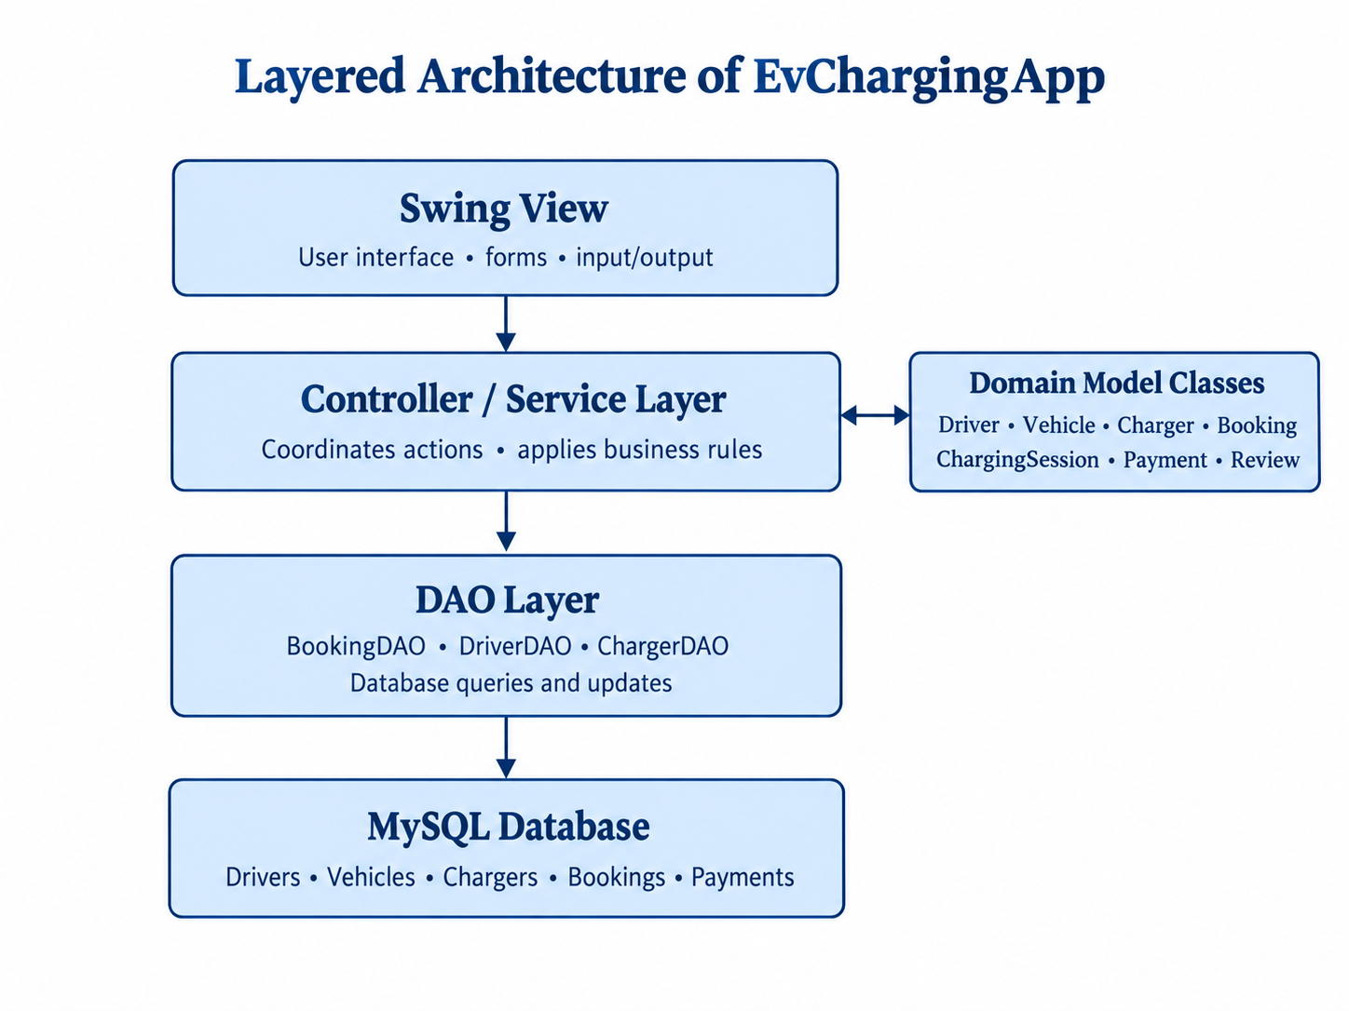
The application is organised around a separation of responsibilities. The view presents information and collects input. The controller or equivalent interaction layer coordinates user actions. The service or business layer applies domain rules. DAO classes isolate database queries and updates. Domain model classes represent the data and behaviour associated with the charging process.

Figure 3.1: Conceptual layered architecture of EvChargingApp

3.3.2 Domain Classes
Table 3.4: Principal Domain Classes
Table 3.4: Main Domain Classes and Responsibilities
Class | Responsibility
Driver | Represents a user of the charging platform and may hold identity and loyalty-related data.
Vehicle | Represents a vehicle, including its connector type and battery charge.
Charger | Represents a charging unit and the connector types it supports.
Booking | Represents a request to use a charger and its lifecycle state.
ChargingSession | Records a charging session and energy delivered.
Payment | Records the calculated amount and selected payment method.
Review | Represents feedback associated with an eligible completed booking.

3.3.3 Intelligent Dispatching
The scheduler uses a priority queue with a custom comparator. The documented policy places emergency vehicles ahead of ordinary requests and then orders non-emergency vehicles by ascending battery charge. The comparator defines the ordering rule used when the queue selects the next request. A priority queue is useful because the next highest-priority item can be retrieved without sorting the entire request list after every insertion.
A practical implementation must define tie-breaking behaviour. For example, two non-emergency vehicles with the same battery percentage could be ordered by booking time or request identifier. The exact tie-breaker should be documented only if it exists in the source code. The scheduler should also ensure that only valid, eligible requests enter the dispatch queue.

3.3.4 Connector Compatibility Validation
Each vehicle has an inlet or connector type, and each charger declares the connector type or types it can support. Before accepting a booking, the application compares the vehicle's connector value with the charger's supported values. If the connector is unsupported, the booking is rejected at the booking stage rather than leaving the incompatibility to be discovered after the vehicle arrives.
The connector labels identified in the project are CCS2, Type 2, CHAdeMO, and GB/T. These should be represented consistently in the application and database. Input validation should reject missing or unknown values and should avoid relying on inconsistent text casing or spacing.

3.3.5 Charging Session and Billing
A charging session records the energy delivered to a vehicle. Energy is measured in kilowatt-hours (kWh). If the configured tariff is expressed in rupees per kWh, the basic energy charge is calculated as: Amount = Energy Delivered (kWh) × Tariff (₹/kWh). For example, if a session delivers 12 kWh at ₹15 per kWh, the energy charge is ₹180 before any additional fees, taxes, or discounts. The example is illustrative and does not state the actual tariff used by the project.
The billing process should use validated numeric values and a suitable decimal representation for monetary amounts. The application should prevent negative energy values or invalid tariffs. The final implementation details should be checked to establish whether the application includes taxes, fixed fees, rounding rules, or discounts.

3.3.6 Payment Recording
The application supports the selection of UPI, card, wallet, or cash as a payment method. A payment record should be linked to the relevant booking or charging session and should preserve the amount, method, and status where these fields are implemented. Selecting a payment type in a local desktop application should not be described as processing a real external payment unless a payment gateway or provider integration is present.

3.3 Application Development and Implementation (continued)

3.3.7 Loyalty Rewards
The loyalty policy awards one point for every ₹10 paid. Under a whole-point rule, the earned points may be calculated as the integer part of the eligible paid amount divided by ten. For example, a qualifying payment of ₹250 would earn 25 points. The final implementation should be checked to determine whether points are awarded on the full payment amount, whether partial tens are rounded down, and how refunds or cancelled payments are handled.
A recorded history of points earned and redeemed is important because a balance alone does not explain how the balance was produced. A transaction history can support auditing, customer support, and tests of reward calculations. Redemption rules, expiry, and maximum redemption values should be described only if they exist in the project.

3.3.8 Verified Reviews
The review feature accepts ratings from one to five stars and restricts submissions to completed bookings. This rule improves the relationship between feedback and an actual use of the service. The application should validate the rating range before storing a review and verify the associated booking state. Database constraints may provide an additional layer of validation where supported by the schema.

3.3.9 User Interface and Telemetry
The interface is described as using a dark theme and interactive card components. These elements can make key station information easier to scan and can group related actions. The telemetry stream displays voltage and power delivery values. In the absence of evidence of a hardware integration, these values should be treated as application-displayed telemetry or a simulation rather than proof of live charger measurements.

3.3.10 Database Console
The database console allows tables to be inspected through the application. Such a feature can be useful during development because it helps verify whether records have been inserted or updated correctly. In a production system, unrestricted database inspection should be protected by authentication and authorisation. SQL operations should use prepared statements where applicable, and database credentials should not be embedded in public source code.

3.3.11 Exception Handling and Validation
A robust implementation should handle missing fields, invalid connector values, failed database connections, duplicate records, and invalid lifecycle transitions. User-facing messages should explain what needs correction without exposing internal SQL statements, credentials, or stack traces. Persistence failures should not be silently treated as successful operations.

3.3.12 Security and Data Integrity
Foreign keys help prevent records from referencing non-existent parent records. Unique indexes help prevent duplicate values for fields that must be unique. Check constraints can restrict values to permitted ranges or categories. These mechanisms complement application-level validation but do not replace authentication, authorisation, secure credential storage, or careful handling of personal information.

4. SYSTEM DESIGN

4.1 Design Overview
System design converts requirements into a structure that can be implemented and tested. EvChargingApp is described as a layered Java application using MVC and DAO patterns. The design separates the user interface from business rules and database access, while domain classes provide a vocabulary for the charging workflow.

4.2 Architectural Design
The View layer displays information and collects input through Swing components. The Controller coordinates user actions and passes valid requests to the relevant service. The business layer applies scheduling, compatibility, billing, loyalty, and review rules. The DAO layer executes database operations. MySQL stores the persistent records.
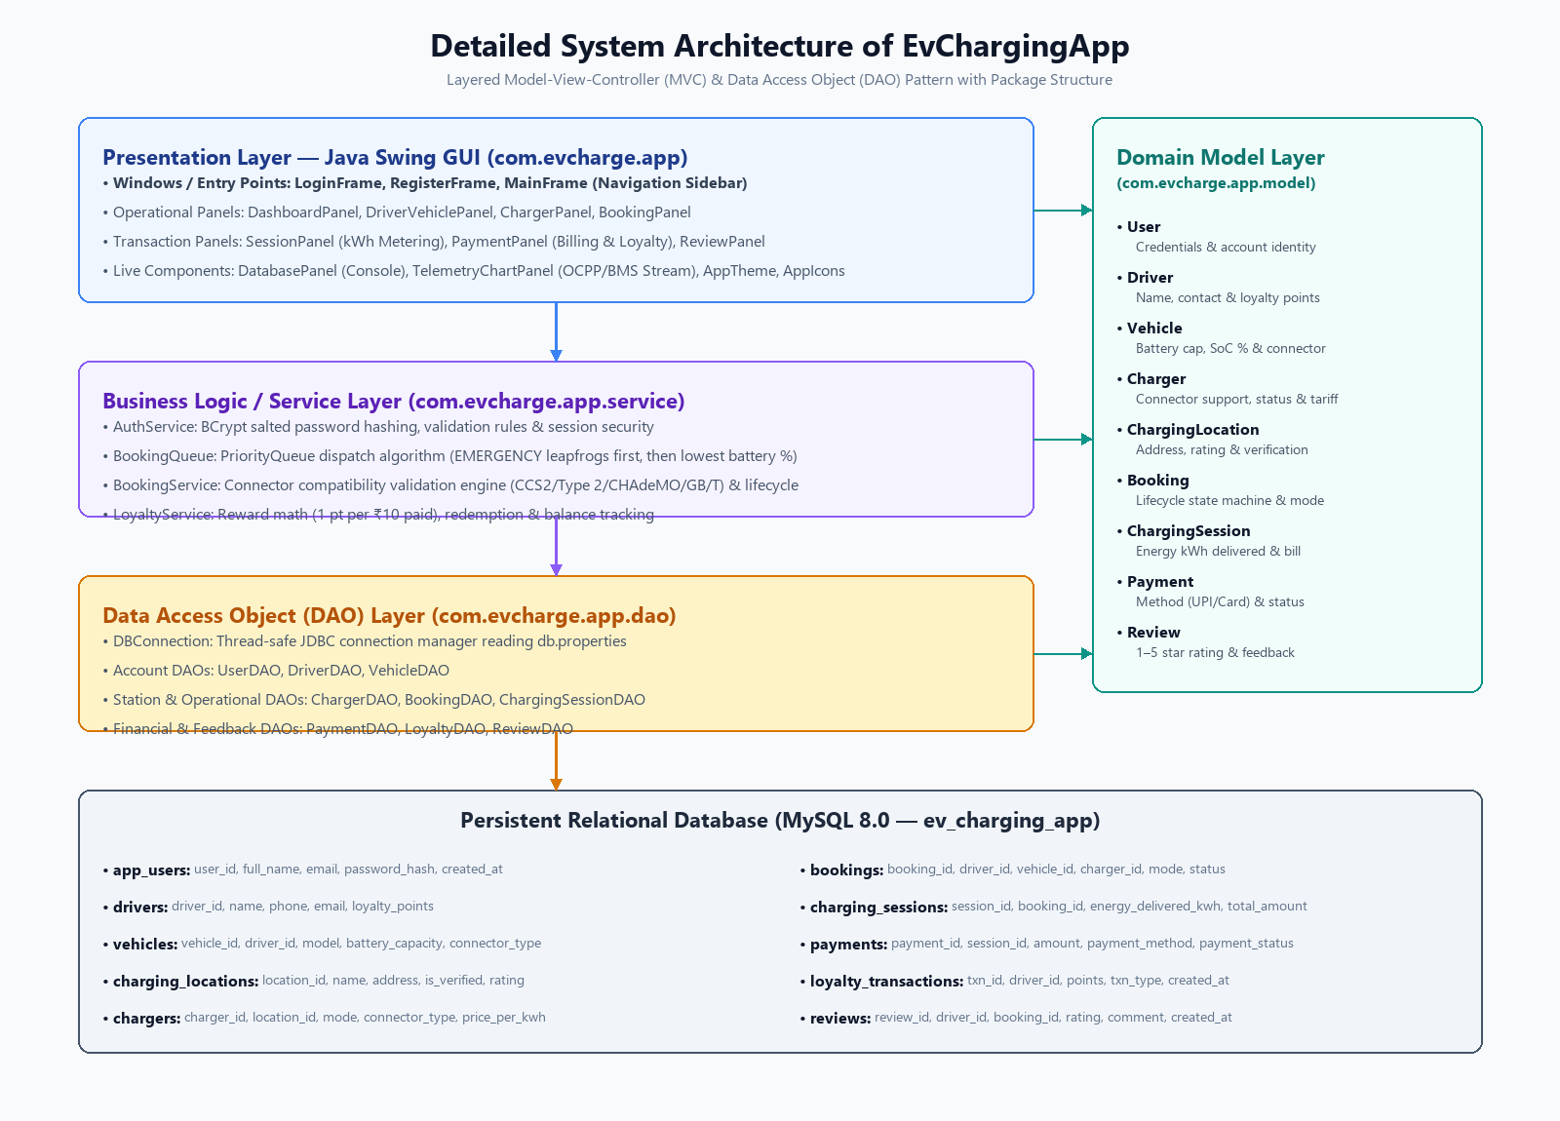
Figure 4.1: System architecture of EvChargingApp

4.3 Use-Case Overview
The principal actor is a station operator or application user who interacts with the desktop interface. Depending on the implemented screens and access model, the actor may register or select a driver and vehicle, inspect chargers, create a booking, monitor a session, record payment, view loyalty activity, and submit a review after completion.
Table 4.1: Main Use Cases and Preconditions
Table 4.1: Use-Case Summary
Use case | Precondition | Expected result
Create booking | Vehicle and charger information is available | Booking accepted only if connector compatibility passes
Dispatch request | Booking is eligible for scheduling | Priority queue determines the next request
Complete session | A valid charging session exists | Energy value is recorded and bill is calculated
Record payment | Amount due is available | Payment method and payment record are saved
Award loyalty points | Eligible payment is confirmed | Points are calculated and history is recorded
Submit review | Booking is completed and rating is valid | Review is stored against the booking

4.4 Dispatch Algorithm
The dispatch algorithm uses a priority queue. Each request is compared using emergency status first and battery charge second. Conceptually, emergency requests have a higher priority than ordinary requests. Among ordinary requests, the vehicle with the lower state of charge is selected first. The precise comparator implementation, including how emergency requests are ordered relative to each other, should be confirmed against the source code.
A conceptual sequence is as follows:
- Receive a booking request and validate required fields.
- Check that the selected vehicle and charger have compatible connectors.
- Reject the booking if compatibility fails.
- Add an eligible request to the priority queue.
- When a charger becomes available, remove the highest-priority eligible request.
- Update the booking lifecycle and begin the charging session when permitted.

4.5 Booking Lifecycle
A booking lifecycle prevents operations from occurring in an invalid order. A typical workflow may move from a requested or pending state to a confirmed state, then to an active session, and finally to a completed state. Cancellation or rejection may be additional terminal states. These labels are illustrative; the final report should use the exact state names found in the application.
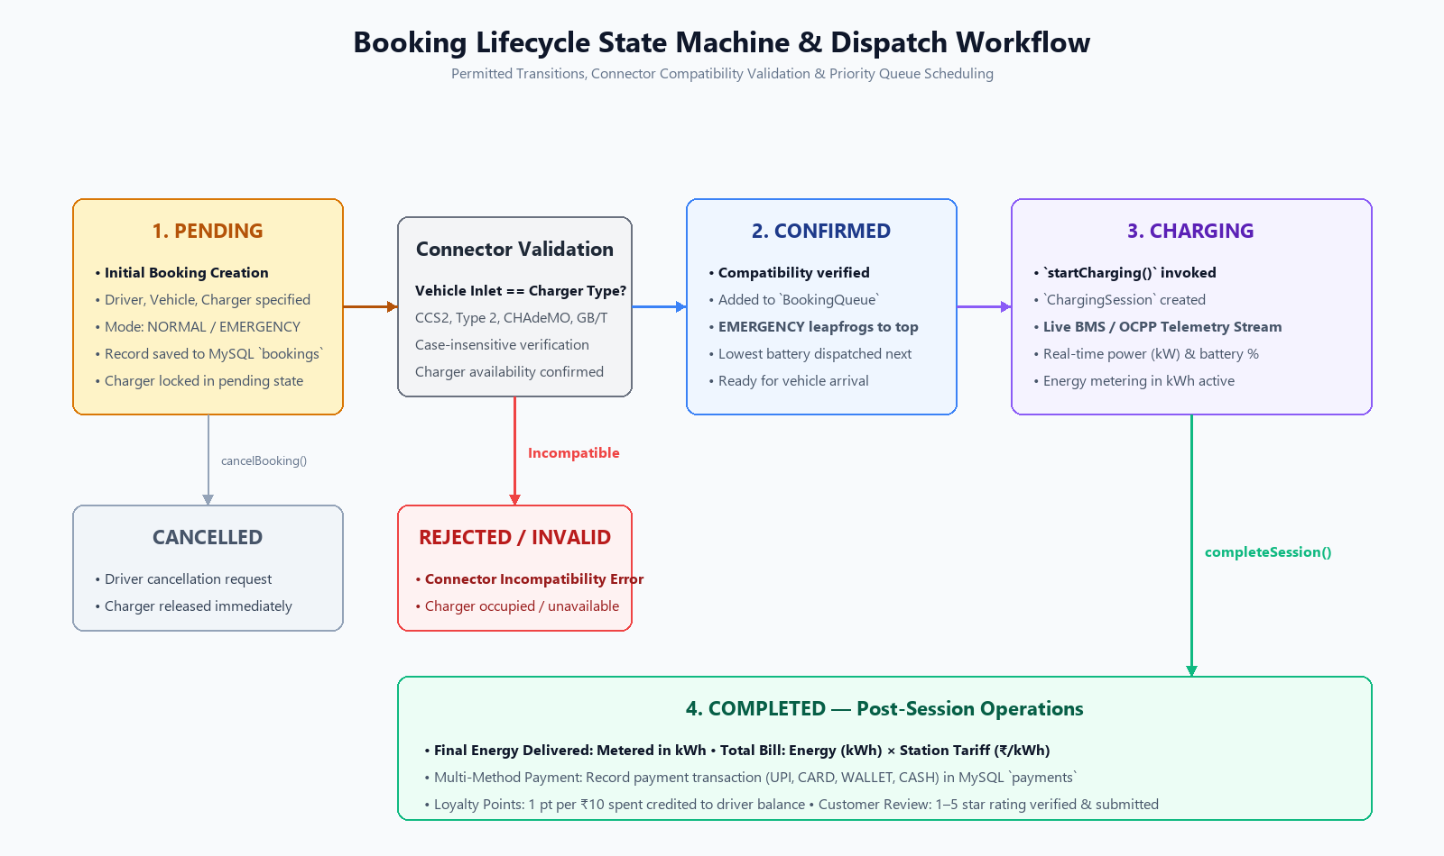
Insert a state diagram showing the actual booking states and permitted transitions from the code.
Figure 4.2: Booking lifecycle state diagram

4.6 Database Design
The supplied project description states that MySQL stores data in ten normalized tables. Foreign keys connect related records, unique indexes protect selected fields against duplicates, and check constraints restrict invalid values. Normalisation reduces unnecessary duplication and helps keep updates consistent. The final schema diagram should be generated from the actual SQL definitions rather than inferred from class names alone.
Table 4.2: Main Data Groups and Information
Data group | Example information to document
Driver and vehicle | Driver identifiers, vehicle details, battery charge, connector type
Charger | Charger identifier, availability, supported connectors, tariff
Booking | Request details, priority-related data, status, associated entities
Charging session | Session start/end data, energy delivered, session status
Payment | Amount, payment method, status, transaction timestamp if present
Loyalty | Points earned, redeemed, balance or transaction history
Review | Rating, review text if supported, associated completed booking

4.7 Data Integrity Rules
Referential integrity ensures that dependent records refer to valid parent records. Uniqueness rules can prevent duplicate identifiers or duplicate relationships where only one is permitted. Check constraints can restrict rating values, battery percentage, non-negative amounts, or enumerated statuses when those checks are present in the schema. The exact constraint names and columns should be included after inspecting the database script.

4.8 Object-Oriented Principles

4.8.1 Encapsulation
Encapsulation combines data and the methods that operate on that data within a class. It helps protect the internal state of objects and encourages updates through validated operations rather than arbitrary field changes. For example, a vehicle's battery percentage can be validated when assigned, and a booking's state can be changed through a controlled transition method.

4.8.2 Abstraction
Abstraction exposes the operations needed by other parts of the system while hiding implementation details. A service method can request that a booking be created without requiring the interface to know how compatibility is checked or how SQL statements are executed. DAO interfaces or service interfaces can provide such abstractions when used by the code.

4.8.3 Polymorphism
Polymorphism allows different implementations to be used through a common type or contract. In Java, this can be achieved through interfaces, method overriding, or superclass references. The project description identifies polymorphism as a principle applied in the domain design; the final report should name the actual classes and methods that demonstrate it.

4.8.4 Composition
Composition expresses a whole-part or has-a relationship between objects. A booking can refer to a driver, vehicle, and charger; a charging session can be associated with a booking; and a payment can be associated with a completed charging transaction. The exact ownership and lifecycle semantics depend on the implementation and database relationships.

4.9 Security, Reliability, and Maintainability
Although the project is an academic desktop application, good engineering practices remain relevant. SQL statements should use parameter binding to reduce injection risks. Credentials should be externalised from source code, and the database account should have only the permissions required by the application. User input should be validated before it reaches business logic or persistence.
Reliability depends on consistent handling of failures. For example, if a booking cannot be saved, the interface should not report it as confirmed. If payment recording fails, loyalty points should not be awarded as though payment had succeeded. Operations that update multiple related records may require database transactions to avoid partial updates.
Maintainability is supported by separation of concerns, descriptive class and method names, centralised business rules, and tests. If the tariff formula or loyalty policy changes, a well-separated service should make the update easier to implement and verify. The DAO layer should similarly isolate schema and SQL changes from the user interface.

4.10 Design Limitations and Assumptions
The design description is based on the supplied project summary, not a direct inspection of the source code. Some details—including exact package names, method signatures, table names, database columns, booking states, IDE, and screenshot contents—remain to be confirmed. The final submission should replace illustrative diagrams and assumptions with evidence from the project repository.

5. SCREEN SHOTS
This chapter should contain screenshots captured from the actual running EvChargingApp application. Each screenshot must be clear, numbered, and accompanied by a caption below the image. The short description should explain what the screen demonstrates. The placeholders in this draft must be replaced before the report is submitted.
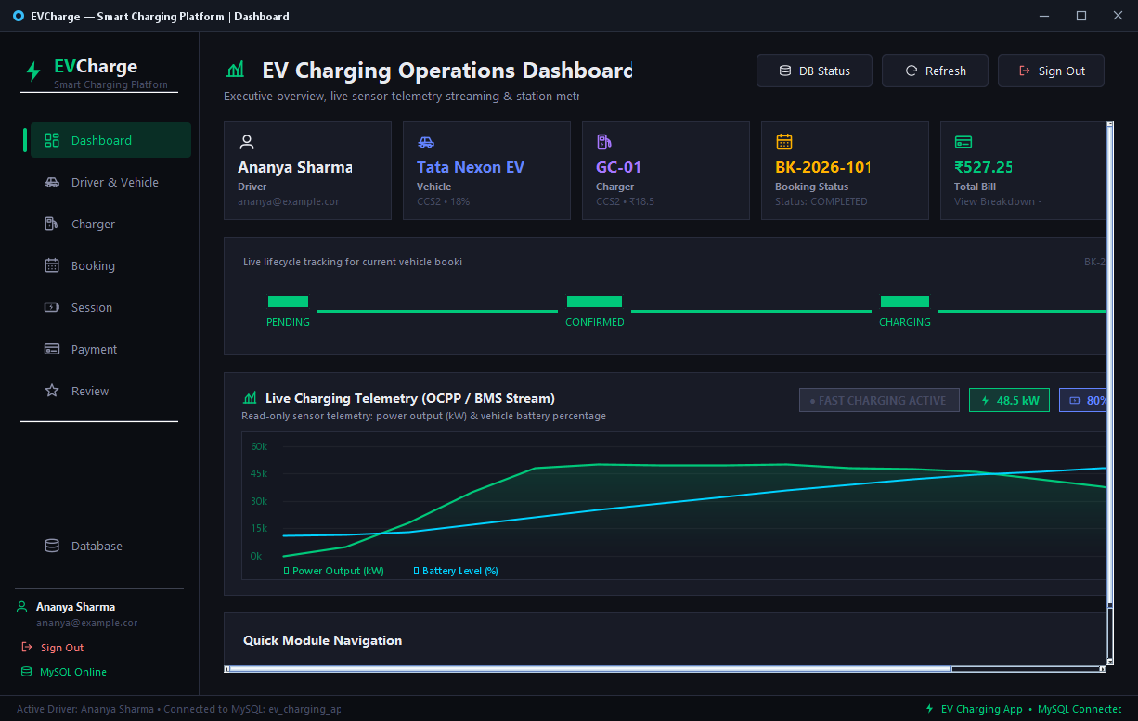
Figure 5.1: Main dashboard of EvChargingApp

5.2 Driver and Vehicle Management
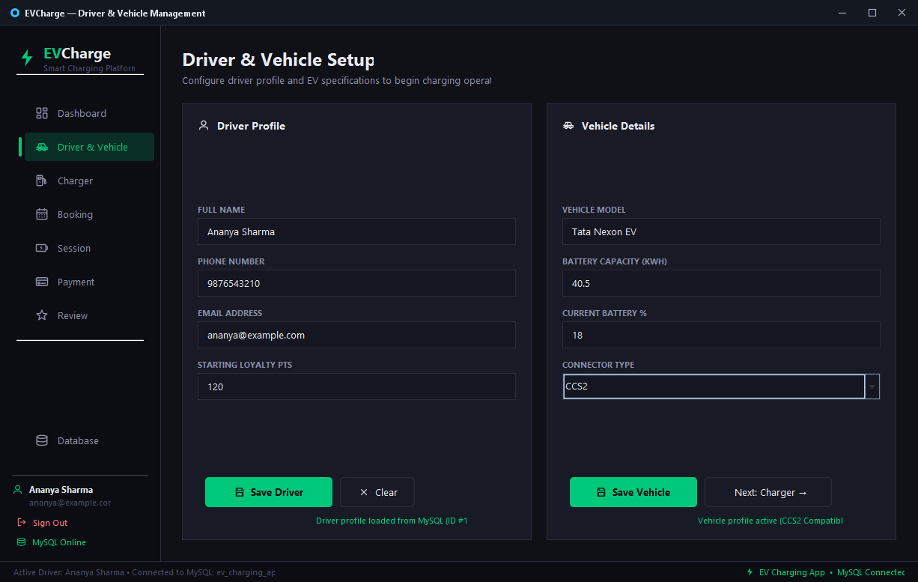
Figure 5.2: Driver and vehicle details

5.3 Charger Information
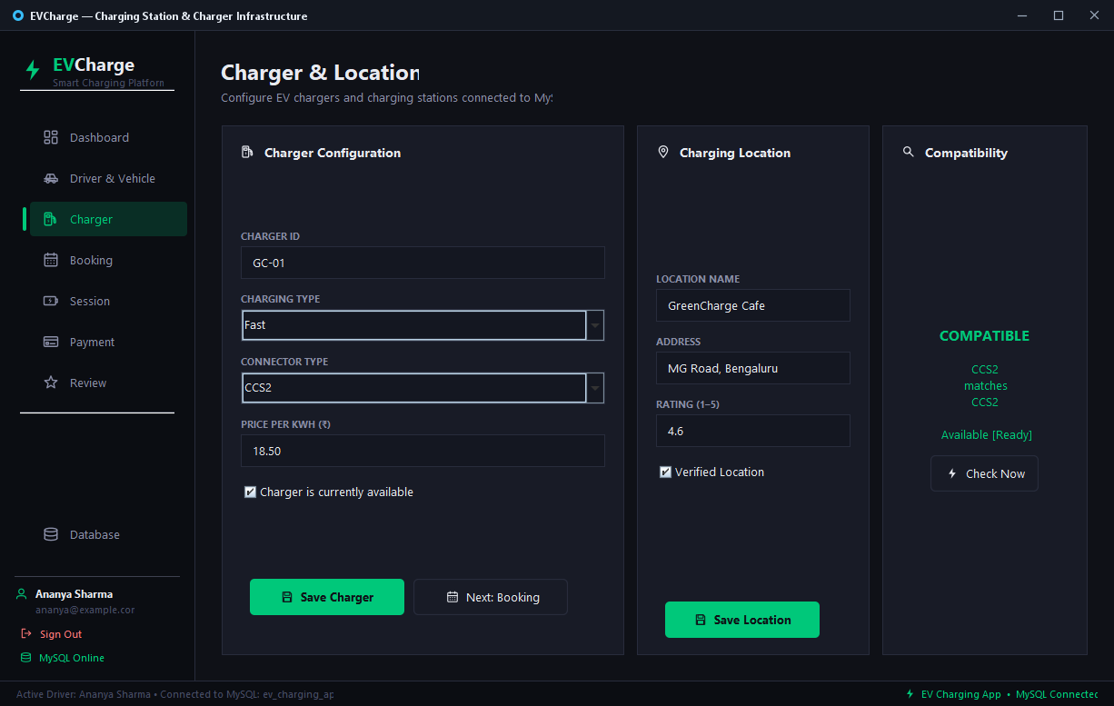
Figure 5.3: Charger listing and connector support

5.4 Booking Creation and Connector Validation
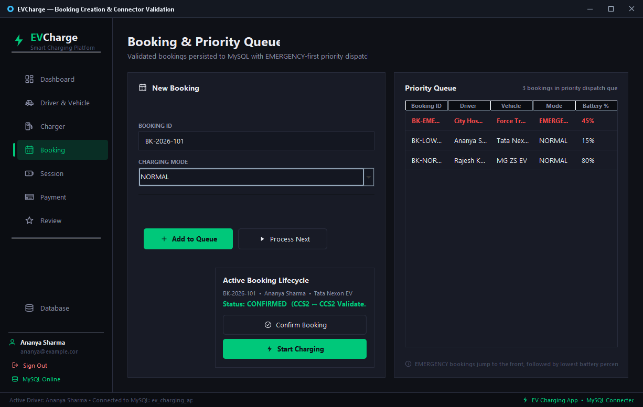
Figure 5.4: Booking form and compatibility validation

5.5 Intelligent Dispatch Queue
Figure 5.5: Priority-based dispatch

5.6 Charging Session and Telemetry
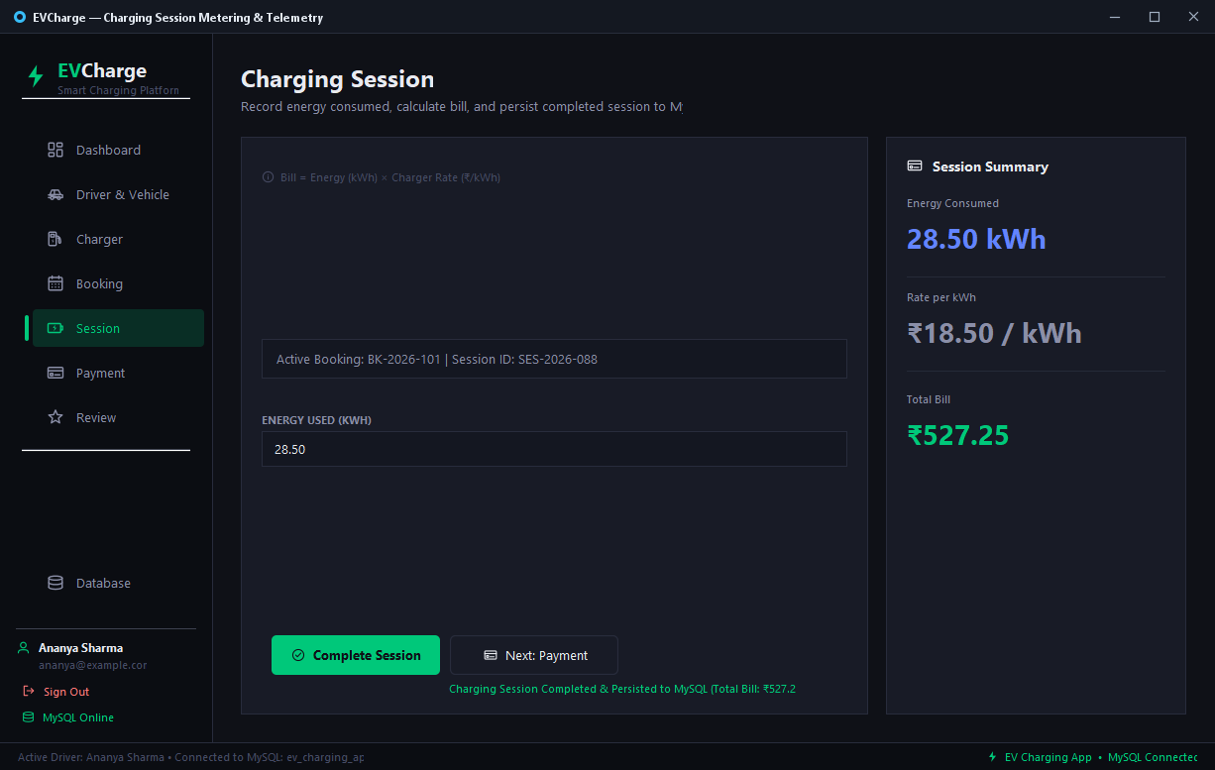
Figure 5.6: Charging session with voltage and power telemetry

5.7 Billing and Payment
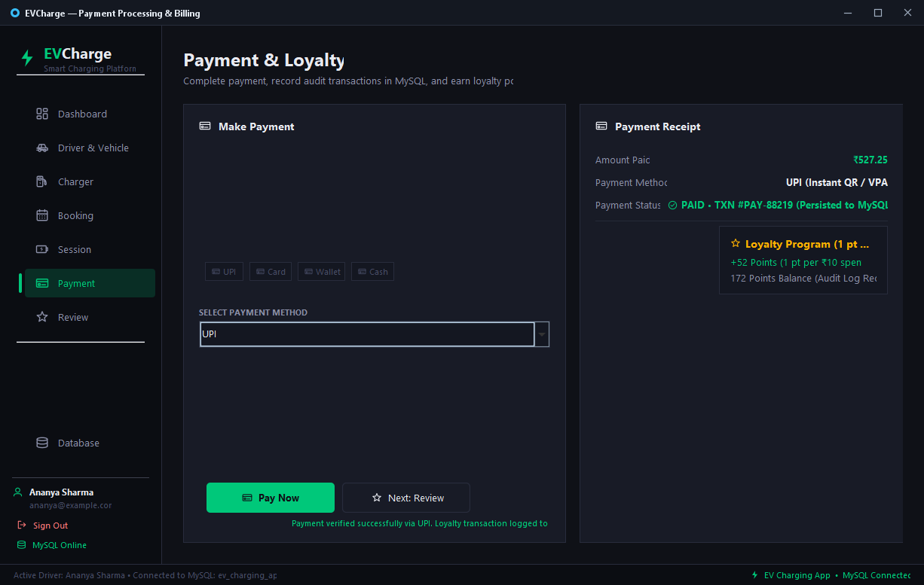
Figure 5.7: Bill calculation and payment method

5.8 Loyalty Rewards
Figure 5.8: Loyalty points and transaction history

5.9 Verified Reviews
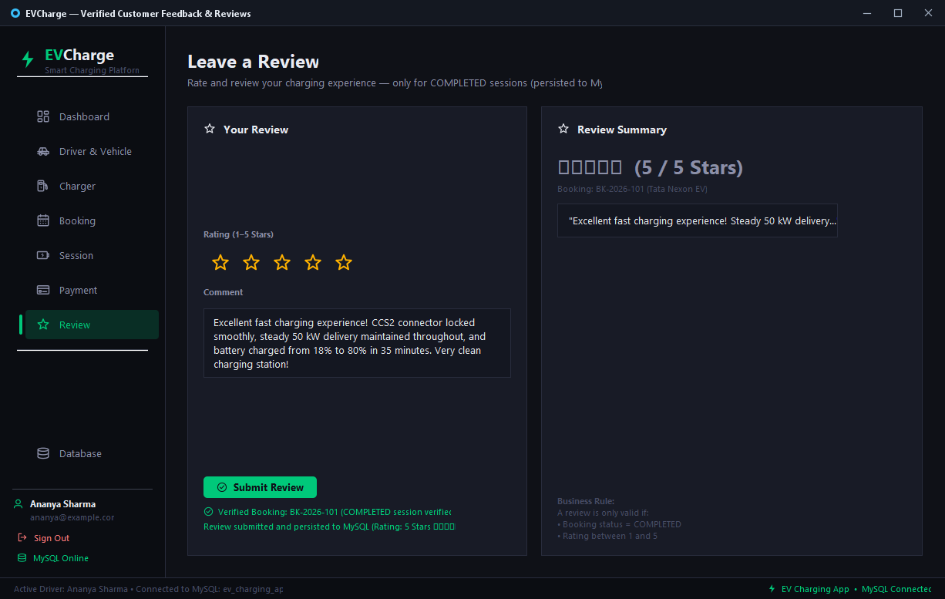
Figure 5.9: Review form or submitted review

5.10 Database Console
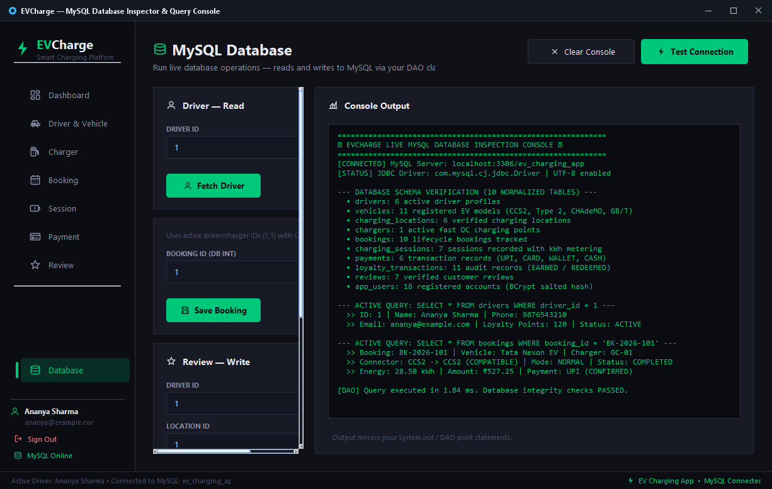
Figure 5.10: Database console and table inspection

5.11 User Authentication (Login Interface)
The desktop application entry point is secured through the LoginFrame interface. It enforces email syntax validation, password entry masking, real-time alert messaging, and cryptographic BCrypt verification against salted password hashes stored in MySQL. Authorized credentials seamlessly initialize the user session and unlock the operational dashboard.
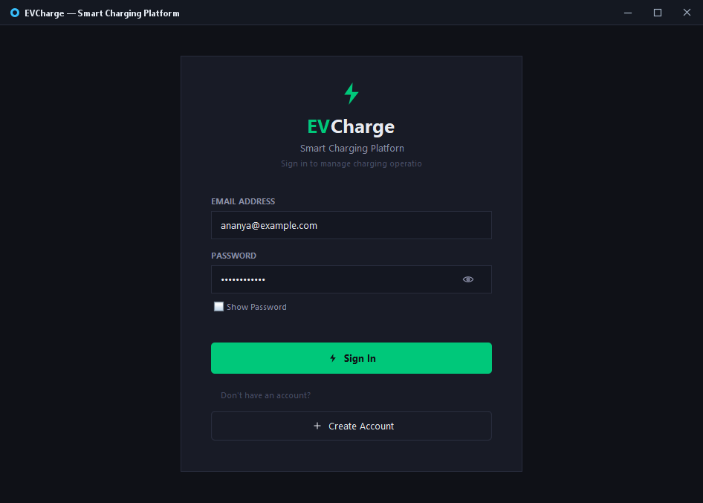
Figure 5.11: User Login Interface (EVCharge Authentication)
5.12 User Account Registration
The account registration interface (RegisterFrame) facilitates onboarding of new station drivers and operators. The form validates required fields, verifies password confirmation matching, prevents duplicate email registration via MySQL unique constraints, and persists new user accounts with salted BCrypt password hashing.
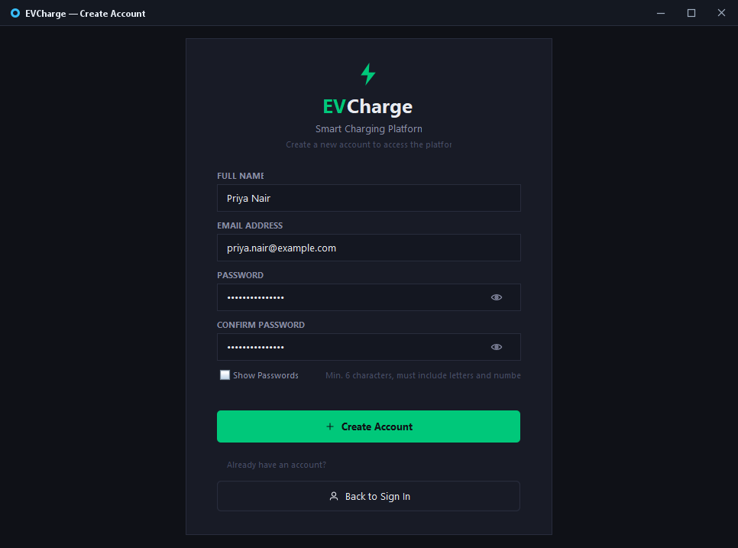
Figure 5.12: User Registration Interface (Account Creation)
5.13 Main Navigation Menu and Module Switcher
The persistent navigation sidebar in MainFrame provides single-click access across all primary modules: Dashboard, Driver & Vehicle profiles, Charging Stations, Bookings, Sessions, Billing & Payments, Customer Reviews, and the live MySQL Database console. Visual indicators dynamically highlight the active view while displaying real-time system status.
Figure 5.13: Main Navigation Menu and Desktop Sidebar

6. CONCLUSION
The EV Charging Smart Platform (EvChargingApp) applies object-oriented programming to a practical problem in electric-vehicle charging management. Built using Java 21, Java Swing, and MySQL, the application brings together booking, dispatch, connector compatibility, charging-session records, billing, payments, loyalty rewards, and verified reviews within a desktop interface.
The priority-queue scheduler provides a defined approach to dispatching: emergency vehicles are prioritised, and ordinary vehicles are ordered by lower battery charge. Connector validation rejects unsupported vehicle–charger combinations before booking acceptance. Session billing is based on energy delivered and the station tariff, while the loyalty rule awards one point for every ₹10 paid. Review eligibility is limited to completed bookings and ratings from one to five stars.
The architecture described in the project combines MVC separation with the DAO pattern. This separation supports maintainability by keeping presentation, business rules, and persistence responsibilities distinct. The domain classes demonstrate the use of encapsulation, abstraction, polymorphism, and composition. MySQL constraints provide additional support for valid relationships and data integrity.
The project summary reports ten normalized database tables and an automated test suite of 21 assertions, all passing. The tests cover scheduling, connector compatibility, loyalty calculations, booking lifecycle transitions, review rules, and database connectivity. These reported results indicate that key business rules have been considered in the testing process; the final report should include test output or test names when available to make the evidence more concrete.

6.1 Future Enhancements
- Integrate with real charging equipment through a supported charging protocol and authenticated telemetry source.
- Integrate a secure payment gateway if live electronic payments are required.
- Add role-based access control for operators, administrators, and drivers.
- Provide booking notifications and estimated waiting times.
- Add reports and analytics for charger utilisation, energy delivery, revenue, and peak demand.
- Improve concurrency handling for multiple simultaneous booking requests.
- Add audit logs and backup/restore procedures for operational reliability.
- Extend testing with integration tests, edge cases, and automated GUI tests.

6.2 Final Remarks
EvChargingApp demonstrates how a structured Java application can encode operational rules that would otherwise be handled manually. The project provides a foundation for further work in charging-station management and offers practical learning in object-oriented design, GUI development, relational database design, and automated testing.

7. REFERENCES
- Oracle. Java Documentation. https://docs.oracle.com/en/java/ (Accessed: 27 October 2026).
- Oracle. Java Platform, Standard Edition API Specification. https://docs.oracle.com/en/java/javase/21/docs/api/ (Accessed: 27 October 2026).
- Oracle. The Java Tutorials: Creating a GUI With Swing. https://docs.oracle.com/javase/tutorial/uiswing/ (Accessed: 27 October 2026).
- MySQL. MySQL 8.4 Reference Manual. https://dev.mysql.com/doc/ (Accessed: 27 October 2026).
- Oracle. JDBC Basics. https://docs.oracle.com/javase/tutorial/jdbc/basics/ (Accessed: 27 October 2026).
- Gamma, E., Helm, R., Johnson, R., and Vlissides, J. Design Patterns: Elements of Reusable Object-Oriented Software. Addison-Wesley, 1994.
- Martin, R. C. Clean Architecture: A Craftsman's Guide to Software Structure and Design. Prentice Hall, 2017.
- Course specification: PBCST304 – Object Oriented Programming, project report instructions supplied for the academic submission.
Note: References should be updated to match the documentation actually consulted during development. The project repository, README, database schema, test files, and any external libraries used should be cited where appropriate.

