2. Choice of vertical axis in funnel plots: case study

The randomized controlled trials of magnesium treatment in the prevention of death following myocardial infarction [(Table 1)](http://www.sciencedirect.com.ezproxy.waikato.ac.nz/science/article/pii/S0895435601003778#TBL1) are a well known example where publication bias, demonstrated by an asymmetrical funnel plot [[5]](http://www.sciencedirect.com.ezproxy.waikato.ac.nz/science/article/pii/S0895435601003778#BIB5) and [[6]](http://www.sciencedirect.com.ezproxy.waikato.ac.nz/science/article/pii/S0895435601003778#BIB6), has been suggested as an explanation for the discrepancy between meta-analyses which showed a clear beneficial effect of magnesium therapy on mortality [[11]](http://www.sciencedirect.com.ezproxy.waikato.ac.nz/science/article/pii/S0895435601003778#BIB11) and [[12]](http://www.sciencedirect.com.ezproxy.waikato.ac.nz/science/article/pii/S0895435601003778#BIB12) and a subsequent large trial which showed no effect [[13]](http://www.sciencedirect.com.ezproxy.waikato.ac.nz/science/article/pii/S0895435601003778#BIB13). [Fig. 1](http://www.sciencedirect.com.ezproxy.waikato.ac.nz/science/article/pii/S0895435601003778#FIG1) shows funnel plots for these 16 trials, using six different choices of vertical axis. In each case, the horizontal axis is the log odds ratio, and the vertical line shows the summary log odds ratio calculated using fixed effects meta-analysis. Calculation of the summary log odds ratio using fixed rather than random-effects meta-analysis is preferable because the random-effects estimate gives greater relative weight to smaller studies, and will therefore be more affected if publication bias is present [[14]](http://www.sciencedirect.com.ezproxy.waikato.ac.nz/science/article/pii/S0895435601003778#BIB14).

Table 1. Mortality results from 16 trials of intravenous magnesium in acute myocardial infarction

| Study (first author) | Year | Magnesium | | Control | |
| --- | --- | --- | --- | --- | --- |
|  |  | Deaths | Total no. of patients | Deaths | Total no. of patients |
| Morton | 1984 | 1 | 40 | 2 | 36 |
| Rasmussen | 1986 | 9 | 135 | 23 | 135 |
| Smith | 1986 | 2 | 200 | 7 | 200 |
| Abraham | 1987 | 1 | 48 | 1 | 46 |
| Feldstedt | 1988 | 10 | 150 | 8 | 148 |
| Schechter | 1989 | 1 | 59 | 9 | 56 |
| Ceremuzynski | 1989 | 1 | 25 | 3 | 23 |
| Bertschat | 1989 | 0 | 22 | 1 | 21 |
| Singh | 1990 | 6 | 76 | 11 | 75 |
| Pereira | 1990 | 1 | 27 | 7 | 27 |
| Schechter & Hod 1 | 1991 | 2 | 89 | 12 | 80 |
| Golf | 1991 | 5 | 23 | 13 | 33 |
| Thögersen | 1991 | 4 | 130 | 8 | 122 |
| LIMIT-2 | 1992 | 90 | 1159 | 118 | 1157 |
| Schechter & Hod 2 | 1995 | 4 | 107 | 17 | 108 |
| ISIS-4 | 1995 | 2216 | 29011 | 2103 | 29039 |
| ISIS-4: Fourth International Study of Infarct Survival. | | | | | |
| 0.5 was added to all cells in the 2 × 2 table to allow calculation of the odds ratio for the Bertschart trial. | | | | | |
| Bibliographic references are available from the authors on request. | | | | | |

[Table options](http://www.sciencedirect.com.ezproxy.waikato.ac.nz/science/article/pii/S0895435601003778)

[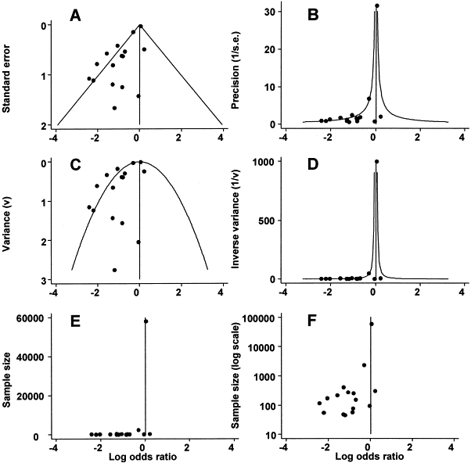](http://www.sciencedirect.com.ezproxy.waikato.ac.nz/science/article/pii/S0895435601003778#gr1)

Fig. 1. Funnel plots for the magnesium trials with different vertical axes. The points correspond to the treatment effects from individual trials, and the diagonal or curved lines show the expected 95% confidence intervals around the summary estimate. Odds ratios are plotted on a logarithmic scale, to ensure that effects of the same magnitude but opposite directions are equidistant from 1.0

[Figure options](http://www.sciencedirect.com.ezproxy.waikato.ac.nz/science/article/pii/S0895435601003778)

[Fig. 1A](http://www.sciencedirect.com.ezproxy.waikato.ac.nz/science/article/pii/S0895435601003778#FIG1) uses standard error (SE) as the vertical axis. The largest studies have the smallest standard errors, so to place the largest trials at the top of the graph, the axis has to be inverted (standard error 0 at the top). The diagonal lines show the expected 95% confidence intervals around the summary estimate, i.e. [summary effect estimate − (1.96 × SE)] and [summary effect estimate + (1.96 × SE)] for each SE on the vertical axis. They indicate the extent of between-trial heterogeneity: in the absence of heterogeneity 95% of the trials should lie within the funnel defined by these straight lines.

[Fig. 1B](http://www.sciencedirect.com.ezproxy.waikato.ac.nz/science/article/pii/S0895435601003778#FIG1) uses precision (defined as 1/SE) as the vertical axis. No inversion of the axis is required, because the larger the study the smaller the standard error and hence the larger the precision. The lines showing expected 95% confidence intervals are derived by calculating the standard error corresponding to the value of the precision on the vertical axis. They are sharply curved and the plot emphasises the difference between the largest studies while smaller studies are compressed at the bottom. [Fig. 1C and D](http://www.sciencedirect.com.ezproxy.waikato.ac.nz/science/article/pii/S0895435601003778#FIG1) use variance (= SE2) and inverse variance (1/variance) respectively for the vertical axis. In [Fig. 1C](http://www.sciencedirect.com.ezproxy.waikato.ac.nz/science/article/pii/S0895435601003778#FIG1), the smaller studies are further apart and the larger studies closer together than for standard error, so that the funnel is flattened at the top.[Fig. 1D](http://www.sciencedirect.com.ezproxy.waikato.ac.nz/science/article/pii/S0895435601003778#FIG1) might be thought informative since the weights in fixed-effects meta-analysis are proportional to the inverse variance. However this plot compresses the smaller studies together even more than [Fig. 1B](http://www.sciencedirect.com.ezproxy.waikato.ac.nz/science/article/pii/S0895435601003778#FIG1), so that the expected 95% confidence intervals are even more sharply curved.

[Fig. 1E and F](http://www.sciencedirect.com.ezproxy.waikato.ac.nz/science/article/pii/S0895435601003778#FIG1) use sample size and log sample size, respectively, for the vertical axis. While [Fig. 1F](http://www.sciencedirect.com.ezproxy.waikato.ac.nz/science/article/pii/S0895435601003778#FIG1) gives a similar impression of asymmetry as [Fig. 1A, Fig. 1E](http://www.sciencedirect.com.ezproxy.waikato.ac.nz/science/article/pii/S0895435601003778#FIG1) compresses the smaller studies at the bottom to an even greater degree than [Fig. 1B](http://www.sciencedirect.com.ezproxy.waikato.ac.nz/science/article/pii/S0895435601003778#FIG1) and in a similar manner to [Fig. 1D](http://www.sciencedirect.com.ezproxy.waikato.ac.nz/science/article/pii/S0895435601003778#FIG1). Because the standard error of the log odds ratio depends on the number of events in each group as well as on the number of patients, it is not possible to calculate expected 95% confidence intervals.

The magnesium trials are unusual in that they include an extremely large trial, the Fourth International Study of Infarct Survival (ISIS-4) which enrolled 58,040 patients [[13]](http://www.sciencedirect.com.ezproxy.waikato.ac.nz/science/article/pii/S0895435601003778#BIB13). This trial is omitted from the funnel plots in[Fig. 2](http://www.sciencedirect.com.ezproxy.waikato.ac.nz/science/article/pii/S0895435601003778#FIG2). However [Fig. 2B](http://www.sciencedirect.com.ezproxy.waikato.ac.nz/science/article/pii/S0895435601003778#FIG2), using precision as the vertical axis, still emphasises the differences between the second Leicester Intravenous Magnesium Intervention Trial (LIMIT-2) [[15]](http://www.sciencedirect.com.ezproxy.waikato.ac.nz/science/article/pii/S0895435601003778#BIB15) (2316 patients) and the remaining trials, and the lines denoting expected 95% confidence limits are still curved. The funnel in [Fig. 2C](http://www.sciencedirect.com.ezproxy.waikato.ac.nz/science/article/pii/S0895435601003778#FIG2) is again rather flattened at its top, while [Fig. 2D and E](http://www.sciencedirect.com.ezproxy.waikato.ac.nz/science/article/pii/S0895435601003778#FIG2) again compress all the other studies at the bottom of the plot. Even when the LIMIT-2 trial is also omitted, the 95% confidence lines for the funnel plot using precision as the vertical axis remain curved [(Fig. 3)](http://www.sciencedirect.com.ezproxy.waikato.ac.nz/science/article/pii/S0895435601003778#FIG3).

[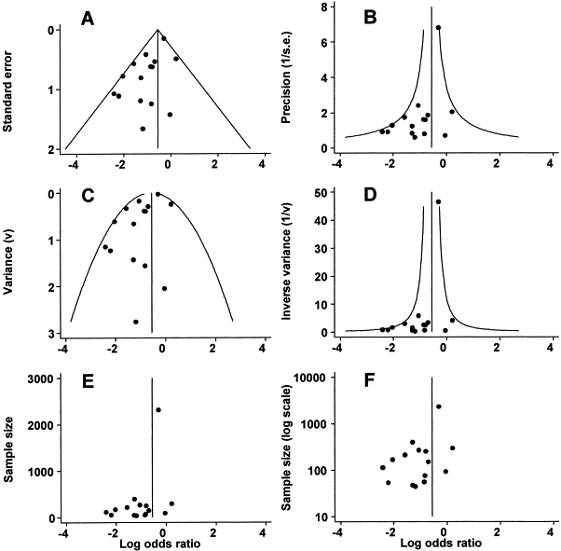](http://www.sciencedirect.com.ezproxy.waikato.ac.nz/science/article/pii/S0895435601003778#gr2)

Fig. 2. Funnel plots for the magnesium trials, excluding the fourth International Study of Infarct Survival (ISIS-4), with different vertical axes. The points correspond to the treatment effects from individual trials, and the diagonal or curved lines show the expected 95% confidence intervals around the summary estimate

[Figure options](http://www.sciencedirect.com.ezproxy.waikato.ac.nz/science/article/pii/S0895435601003778)

[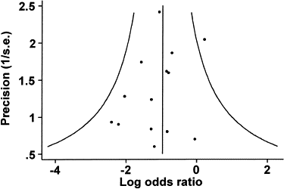](http://www.sciencedirect.com.ezproxy.waikato.ac.nz/science/article/pii/S0895435601003778#gr3)

Fig. 3. Funnel plot for the magnesium trials, using precision as the vertical axis and excluding the fourth International Study of Infarct Survival (ISIS-4) and the second Leicester Intravenous Magnesium Intervention Trial (LIMIT-2). The points correspond to the treatment effects from individual trials, and the diagonal or curved lines show the expected 95% confidence intervals around the summary estimate