Notes from
Sam F. Y. Li

Introduction

Historical Background

CE can be traced back to 100 years ago.

1886 Lodge demonstrates H+ migration in tube of phenolphthalein “jelly”
1892 Smirnow electro-fractionates diptheria toxin solution
1899 Hardy shows globulin movement in “U” tube experiments
1905 Hardy provides detailed study of various “U” tube designs
1930 Tiselius does moving boundary studies of proteins in solution
1937 Tiselius improves apparatus for moving boundaries
1939 Coolidge separates serum proteins in glass wool tubes
1964 Ornstein designs an apparatus to perform disc electrophoresis
1965 Tiselius shows “free zone” electrophoresis of virus particles in 3 mm i.d. capillary
1965 Hjerten et al show particle sieving electrophoresis of ribosomes in polyacrylamide tube gels
1967 Hjerten shows free solution electrophoresis in 3 mm i.d. tubes.
1974 Virtenen shows advantages of small i.d. columns
1979 Mikkers et al show electrophoresis in polymer capillaries
1981 Jorgensen and Lukacs show theoretical and experimental approaches in high resolution electrophoresis in glass capillaries
1983 Hjerten adapts SDS-PAGE to CE
1984 Terabe et al demonstrate how neutral compounds are separated using MEKC
1987 Cohen and Karger show how small i.d. tubing is efficient

In larger scale electrophoretic separations, the current passing through several hundred volts caused severe convecting mixing that required additives to the system to stabilize separated zones: agar, cellulose powder, glass wool, silica gel, and acrylamide. Alternatives to analyze samples without thermal convection problems require free solution electrophoresis being done in tubes of very small internal diameter: they dissipate heat much better and solution temperature as a function of radius is much more constant. Samples migrate without wall effects (as in narrow-bore HPLC) and only diffusion competes with formation of sharp boundaries.

Modes of CE

Several different ways of employing CE

(i) Capillary Zone Electrophoresis (CZE)
Most commonly used. Permits rapid separation. Separation based on size and charge at a given pH. Surface silanol groups on the uncoated fused silica are ionized at pH > 2. Three layers form: (1) negatively charges silanol groups, (2) an immobile layer called the Stern layer or inner Helmholtz plane, (3) a diffuse layer of cations and their sphere of hydration. In an electric field, they migrate toward the cathode and force a flow of solvent called electroendoosmosis (EOF). This EOF is quite significant, exceeding the mobility of analyte ions. In any case, both cations and anions are resolvable in the same run. Overall net flow toward the cathode is such that cations having high charge-to-mass are detected first, then cations of lower charge-to-mass, then neutral components (migrating with only the EOF component as their mobility), then anions of low charge-to-mass, then anions of high charge-to-mass at the last. Adjustsments to pH must be considered as influencing mobilities of ions.

(ii) Capillary gel electrophoresis (CGE)
In this separation, solute size becomes important, with the gel acting as “molecular sieve.” An important advantage is compensation of the effects of thermal convection contributing to diffusion. Moreover, EOF is eliminated and solute adsorption to capillary walls removed. Some disadvantages: with EOF eliminated, neutral molecules do not migrate. Also, gels have pore sizes which makes separations effective only within a limited range. Polyacrylamide and agarose fillings in 150 µm capillaries have been tried, and CGE for micropreparative fractionation of macromolecules has been performed. Up to 30 million plates/meter efficiencies have been achieved with CGC. Capillary gels have been incorporated with SDS for SDS-PAGE separation of proteins, polynucleotides and DNA fragments. Polyacrylamide has a random coil structure which is then bonded to capillary walls using bifunctional reagents. Pore size is a function of gel concentration (bis + monomer divided by total volume and of cross-linking concentration ([bis + monomer]/monomer). EOF is eliminated with gel covalent linking. The advantage of capillary SDS-PAGE over the slab gel is that sample size can be small and sensitivity made high.

(iii) MEKC or MECC--micellar electrokinetic chromatography
This work was advanced largely by Terabe and co-workers in 1984. Separation is possible for neutral as well as charged molecules, which move in the electric field as a result of partitioning in a pseudo-stationary phase formed by micelles of surfactants (ionic detergents). Bushey and Jorgenson have used this approach to resolve isotopically substituted materials (J. Microcol. Sep. 1: 125, 1989). Micelles form when surfactant concentration exceeds a critical concentration (cmc). Micelles are aggregates of surfactant molecules with lifetimes less than 10 µs typically. SDS is the most common surfactant with cmc = 8 mM, aggregate number of 58 at 25°. In uncoated capillaries, SDS micelles, despite being anionic, migrate toward the cathode because of signficant EOF. Movement toward the cathode is slower than for bulk fluid flow because of the electrostatic effect. This makes the micellar phase appear as a pseudo stationary phase. MeOH has little solubility in the micelle and essentially migrates with the velocity of the aqueous phase. Sudan III is very hydrophobic and spends nearly all of its time in the micellar phase; it should migrate with the micelles. Most other compounds would migrate in between.
Many variations of MEKC have been used which include using additives to alter either the mass or charge of analytes (derivatized cyclodextrins, charged colloidal particles, soluble ion-exchangers).

(iv) CEC--capillary electrochromatography
In this case, the capillary is packed with a phase which can retain solutes by normal partitioning equilibria characteristic of chromatography. Hence a special case of CE. The liquid phase is interacting with capillary wall and packing. EOF is not only a consideration of the wall but the effect of the packing. Moreover, the plug flow characteristic of ionic solutes in an electric field is not as for an open tube, and barriers presented by the packing must be considered (still it is more predictable than with pressure-driven flow).

(v) CIEF-capillary isoelectric focusing
Hjerten and coworkers have reported classic experiments using glass capillaries. Protein samples are mixed with pH gradient-producing substances (ampholytes) and run in an electric field with anolyte and catholyte. A pH gradient forms in the length of the capillary and proteins migrate to their isoelectric point. Zones are focused under steady state conditions. Zones can then be mobilized past the detector either by pressure-driven flow or by addition of salt to either anolyte or catholyte, which disrupts the pH and causes molecules to move.

(vi) CITP-capillary isotachophoresis
The main principle is the use of a discontinuous buffer system. Samples are concentrated into narrow zones as they migrate between two solvent-solute systems, a slower leading system and a faster terminating boundary system. CZE is normally carried out in a uniform buffer system and its sample zones change shape and relative position. Peaks in CZE resemble chromatographic separations against the background buffer. The isotachopherogram on the other hand appears as a series of steps, with each step representing an analyte zone. Quantitation with CITP is based largely on measuring zone length rather than peak area: it is a function of the amount of sample present.

Principles of CZE

Migration in tubes
In uncoated capillaries at neutral or alkaline pH, all migration is essentially toward the cathode because of substantial EOF. Injection is either by electromigration or hydrodynamic flow at the anode. Sample migration in the capillary is free from the dispersion effects seen in chromatography. Use of small i.d. tubular capillaries minimizes band broadening due to mass transfer resistance and heating effects. Assuming no EOF, the velocity of migration is:
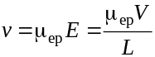
It can be seen that the electric field strength is a calculatable parameter. Solute migration time is determined from the following relation and can be seen to increase four times with capillaries doubled in length with respect to detection:
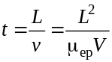

Band broadening because of diffusion
If only longitudinal diffusion is assumed to contribute to band broadening, the migrating zone width variance (σ2) is expressed as:
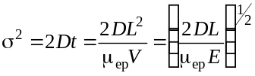
Here D is the diffusion coefficient of the solute. The number of theoretical plates (N) is given by:
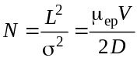
This shows that the separation efficiency is not a function of capillary length but of the applied voltage. Both maximum efficiency and short analysis times are achieved with high voltages and short capillaries.

Electroosmosis
It is useful to look at the chemistry at the silica wall-solution interface. The silica wall produces a negative charge surface which is then covered by positively charged solutes present in buffer systems. There is also a diffuse layer of mobile cations in the region of the double layer of positive-negative charge. The potential across these layers is called the zeta potential given by the Helmholtz equation:
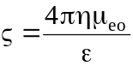
where η is solution viscosity, ε is solution dielectric constant, and µeo is EOF coefficient. The mobile cations in the diffuse layer move toward the cathode in an electric field, causing osmotic bulk flow of solvent to follow them. This bulk flow velocity (that of EOF) is given by the expression:
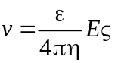
The double layer is very thin (up to several hundred nanometers) relative to the capillary radius (50-100 µm) and EOF originates at the capillary wall. It is for this reason a flat flow profile (unlike with Gaussian dispersion in a pumped system) results. Theory states that a flat flow profile obtains when capillary radius is seven times greater than the double layer thickness.
Although band broadening would not be a function of EOF directly, as EOF does increase the time on the column, it may contribute to efficiency and resolution indirectly. Migration time and velocity are given as functions of applied voltage and capillary length:
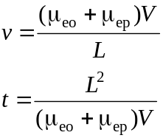
Consequently zone width variance and theoretical plate number are also modified to consider EOF:
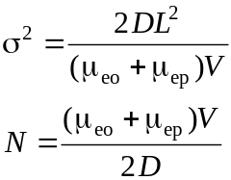
Actually efficiency will be a fraction of this expression, related to the capillary length to the detector (l) and the total length with the effective potential (L), the fraction being l/L:
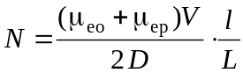
The expression of particle velocity was given above, which is essentially the amount of time the particle moves to the detector:
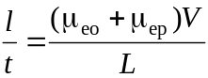
Now resolution (R) is a factor introduced as the separation of two peaks. This separation can be characterized as the difference in the times which these components are detected in the system and related to the width of the peaks at baseline or perhaps at half-height. If the peaks are considered to approximate Gaussian distributions of the amount of substance, then the peak widths at half-height are twice the standard deviation:
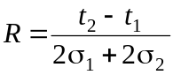
Now we can find expressions for σ and for migration times t in the equations which have preceded to show the relationship between resolution and efficiency (N):
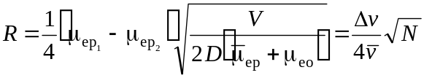
Note in the equation that the averaged true mobilities of two particles is given (µep bar) as well as the averaged particle velocities.

Power Dissipation
Capillary behaves similarly to ohmic conductor when voltage applied across two ends. In the central region, heat develops homogeneously and the temperature variation across the capillary bore is parabolic. Rapid heat dissipation is necessary to maintain separation efficiency. Analyte mobilities can increase by 2% per degree C of heating. Power dissipation can be understood by the following equation:
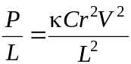
where P is power, L is capillary length, κ is the solution molar conductance, C is buffer concentration, r is column radius, and V applied voltage. The thermal gradient is dependent upon the thermal conductivities of the materials. Heat release per unit volume is:
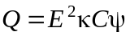
where E is electric field strength, ψ is total medium porosity, and the other parameters as before. Values for ψ are unity for an open tube and range from 0.4 to 0.8 for packed tubes.
The temperature gradient within the core and across the tube wall are given by:
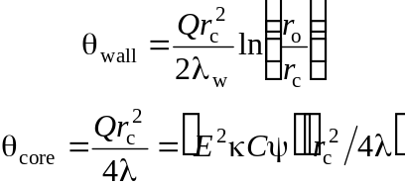
where rc and ro are the inner and outer radii of the tube, resp., and λw or λ are the wall opr core thermal conductivities, resp. With typical operating conditions, θwall and θcore are small (< 1 K) compared to the surrounding ambient medium. From a horizontal tube, heat loss is by convection or forced convection rather than by conduction. A plot of θ (in K) vs capillary diameter, dc (in µm), is presented which show how the temperature gradient is a function of diameter. The several lines plotted vary the conditions of convection: none, or forced air at 0.1, 1, and 10 m/s. In general the line rises as diameter is increased but more gently with increased forced convection.
Any parabolic temperature profile may cause variations in migration rates due to at least three possible effects: (i) changes in buffer viscosity, (ii) changes in the partition ratios (capacity factors, k´), and (iii) changs in rates of kinetic process. Temperature differences between the tube relative to surrounding air do not affect plate height or count directly, but variation in the medium does reduce efficiency. The relationship between the plate height and thermal contributions is given as:
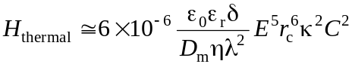
where δ is the thickness of the electrical double layer, ε0 and εr are the permittivity in vacuum and relative permittivity or dielectric constant, resp., and the other parameters are defined elsewhere. Using typical values, H_{thermal} is 0.006 and 0.4 µm for a 100 and 200 µm i.d. capillary, resp. Hence for narrow-bore capillaries, the thermal contribution is negligible. Tight control of the voltage, buffer concentration, and capillary radius will in effect stabilize against thermally-induced losses of resolution.
Many attempts have been used to control heat (power) dissipation. Hjerten used a system to rotate the capillary on the longitudinal axis. Mikkers et al adapted an isotachophoretic system to CE, theoretically evaluating effects on migration of the concentration distribution in free zone electrophoresis. Zones were found unsymmetrical if the concentration gradient induced by differential migration of different solutes produced inhomogeneities in the electric field. Others have shown non-symmetrical broadening in overloaded separations due to variations in velocities resulting from changes in the apparent electric field strength.
Jorgenson and Lukacs demonstrated the primary relationship of separation voltage, capillary diameter and length, and solute concentration in resolution and separation efficiency. Many others have shown how these factors affect Joule heating.

Adsorption
This factor contributes to peak distortion. Irreversible adsorption of a species to the silica is not unknown. The effect on efficiency is observed:
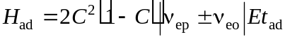
C in this equation is the fractional concentration of free solute and tad is the mean residence time of the adsorbed solute. All other factors are previously defined. It can be seen that free solute concentration increases clearly limit efficiency. Interestingly, voltage also adds to the inefficiency.

Conductivity Differences
Differences in conductivity are observed when solute ions have different mobilities than the primary carrying ions in buffers. Theoretically conductivity difference (Δk) is expressed as a function of the solute ion concentration (C), its electrophoretic velocity (v), and the mobilities of the sample ions (μ), primary carrying ion (μB), and the counter ion of the buffer (μb):
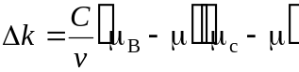
It should be kept in mind that the mobilities are vectors with associated directions which are signed quantities. In addition solute molecules are subject to diffusion across the zone boundary between sample plug and carrier buffer, and so zone broadening will have that added factor. Consider the case where sample ion mobility is less than buffer ion, i.e., | μ | < | μb |. If x0 represents the original zone width of the sample at injection, then the contribution of zone broadening due to conductivity difference during the run will be represented as Δxk, and the total zone width during migration will be x0 + Δxk.
[This section is so poorly written that it will be necessary to consult the references for this section: see S. Hjerten (1991) Electrophoresis 11, 665.]

Comparison of CE to Other Separation Techniques

Comparison with HPLC
CE has the greatest potential to match the methods and techniques used to analyze and prepare materials using HPLC. HPLC has the edge related to preparative methods, able to purify much greater amounts than CE. CE has the advantage in that greater separation efficiencies are achieved as the forces generated by electric fields overcome the frictional forces prevalent in hydrodynamic forces involved in mass transport. All parameters used as measures of separation efficiency improve, i.e., peak capacity, HETP, theoretical plate number N. HPLC offers a large number of stationary and mobile phase to give chemical selectivity, but CE should match such performances as methods using micellar phases in MEKC, or inclusion and complexing agents such as cyclodextrins, chiral additives, and organic modifiers give selectivity to CE as well.
Instrumentation is not as complex with CE as with HPLC. The transparency of the fused silica capillary makes special detection cells unnecessary. No special injector is used to load the capillary. Perhaps a disadvantage of CE is that injection volumes (and therefore sample masses) can not be controlled and therefore known entirely, whereas with HPLC, it is controlled.
For preparative CE, it is necessary to interrupt the electric field to move one of the ends of the capillary to another tube containing conducting buffer. The sample is collected—its collection is really approximated since the site of detection may be a signficant distance from the end of the capillary. Some attempts have been made to prevent interruption of the current (by using a porous glass junction, Olefirowicz and Ewing, while an on-column frit structure has been described by Huang and Zare).
Modes of detection developed for and available to HPLC are all similarly adapted to CE: UV, fluorescence, electrochemical conductivity, Raman, and radioisotopic detection. Interfaces exist to mass spectrometers too. Sensitivity is slightly greater for HPLC than for CE because of path length differences. Sensitivity in CE has been much improved with development of detection technologies such as laser-induced fluorescence and electrochemical conduction, sensitive to sub-attomole (10-18) levels.
Rather than compete as methods, many find HPLC and CE complementary, using the superiority of peak efficiencies in CE (as in DNA fragment analysis) while HPLC can be used for small and neutral molecule analysis.

Comparison with slab gel electrophoresis
CE in all aspects but one has greater advantages over slab gel methods, particularly in separation performance. Perhaps where it lags is in preparative methods, as larger amounts of separated components can be obtained in fewer runs on slab gels where the sample is not highly heterogenous to begin with. For analytical purposes however, slab gels do not compete with CE, even in the amount of time to prepare and analyze components.

Sample Injection Methods

Introduction
Good injection systems will not account for or contribute to significant initial zone broadening. Injections should also be efficient and reproducible. Injection systems which appear to satisfy this criteria are hydrodynamic flow and electomigration techniques.

Effects of sample overloading
Large sample volumes (masses) can have severe effects on efficiency. The mathematical relationships have been described for sample injection volumes and total capillary volume:
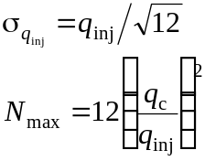
The standard deviation is really an effect of the boundary of the injection zone, increasing with the volume of injection (qinj). It can be seen that efficiency (represented by theoretical plate number) is reduced four times with the doubling of the injection volume, since capillary volume (qc) remains fixed.
There is also a constraint on sample solute concentration as differences in electrical conductivity between sample zone and carrier medium have already been explained. High sample solutes can perturb electrical gradients. Sample solutes lower in concentration are actually better in that sample stacking is observed to narrow analyte zones. Grushka and McCormick have approximated the maximal allowable injection plug volume:
