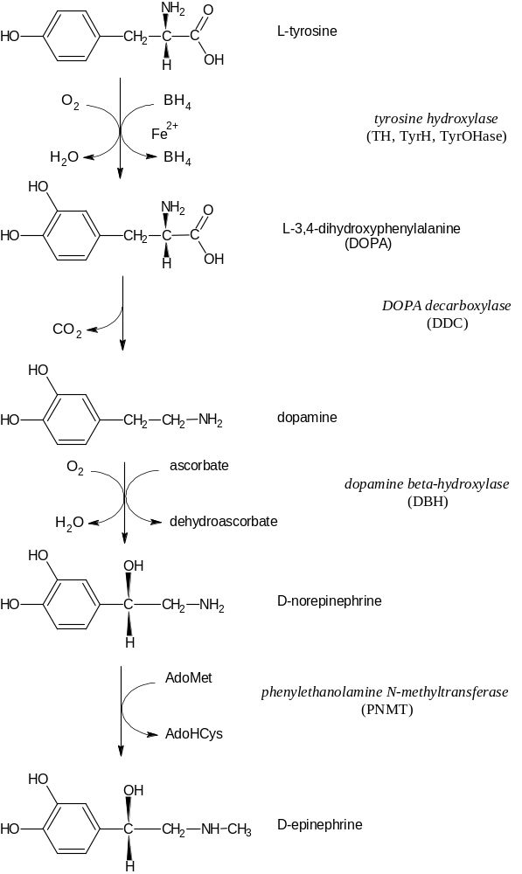
Figure 1. Biosynthesis of Catecholamines

Figure 2. Regulation of Tyrosine Hydroxylase Activity by Various Signaling Systems
In the schematized adrenergic cell shown (membrane thick gray rounded rectangle) intracellular calcium is increased by opening of voltage-dependent calcium channels where membrane depolarization is achieved by artificial exposure to high extracellular potassium or by nicotinic cholinergic receptor activation (the “fast” response). Alternatively, muscarinic cholinergic receptor activation of phospholipase C via G protein control will generate inositol trisphosphate (IP₃) and diacylglycerol (DAG) through hydrolysis phosphatidylinositol-4,5-bisphosphate (PIP₂), the former which increases opens calcium channels in endoplasmic reticuulum membranes, and the latter which, with calcium, activates protein kinase C (PK-C). Calcium also binds to calmodulin (CaM), which in turn with calcium activates Ca – and CaM-dependent protein kinase (Ca/CaM PK II, the neural isoform). Ca/CaM PK II and PK-C have both been identified as phosphorylating TH in vitro and in situ. The muscarinic ACh receptor-G protein complex is also shown activating adenyl cyclase, which increases intracellular cAMP, which in turn activates the cAMP-dependent protein kinase (PK-A). PK-A phosphorylates TH (in situ and in vitro) and strongly activates it. The microtubule-associated protein-2 kinase, also called mitogen-activated protein kinase (MAPK), a member of the extracellularly regulated kinases (ERKs) also phosphorylates and activates TH. The details of the signal pathway from KCl-induced depolarization to increases in intracellular calcium to activation of MAPK are not fully understood, although there is a link. PK-C may also activate MAPK. MAPK is known to be activated by components starting at tyrosine kinase (TK) activities of mitogen receptors, which involve p21ras, Raf-1 kinase, and the protein kinases (MEK) that phosphorylate MAPK directly.
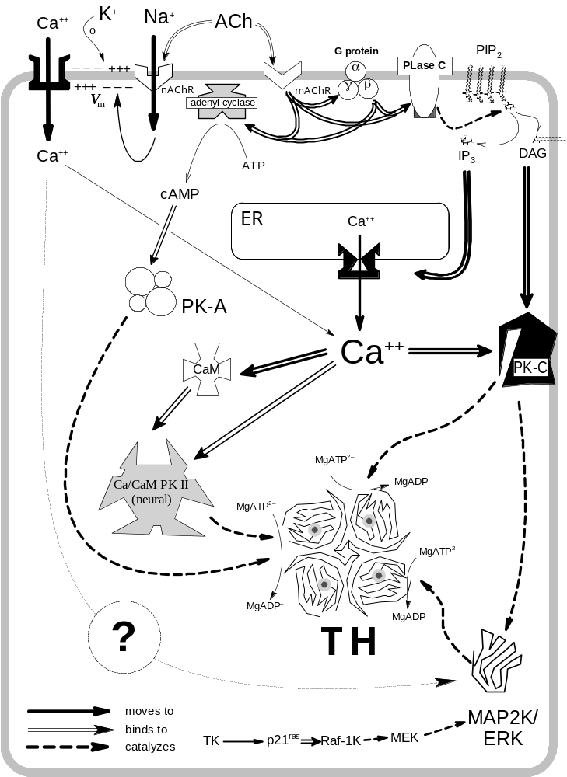
Figure 3. Time course of KCl depolarization of bovine adrenal chromaffin cells for the activation of a TH serine-31-specific peptide kinase
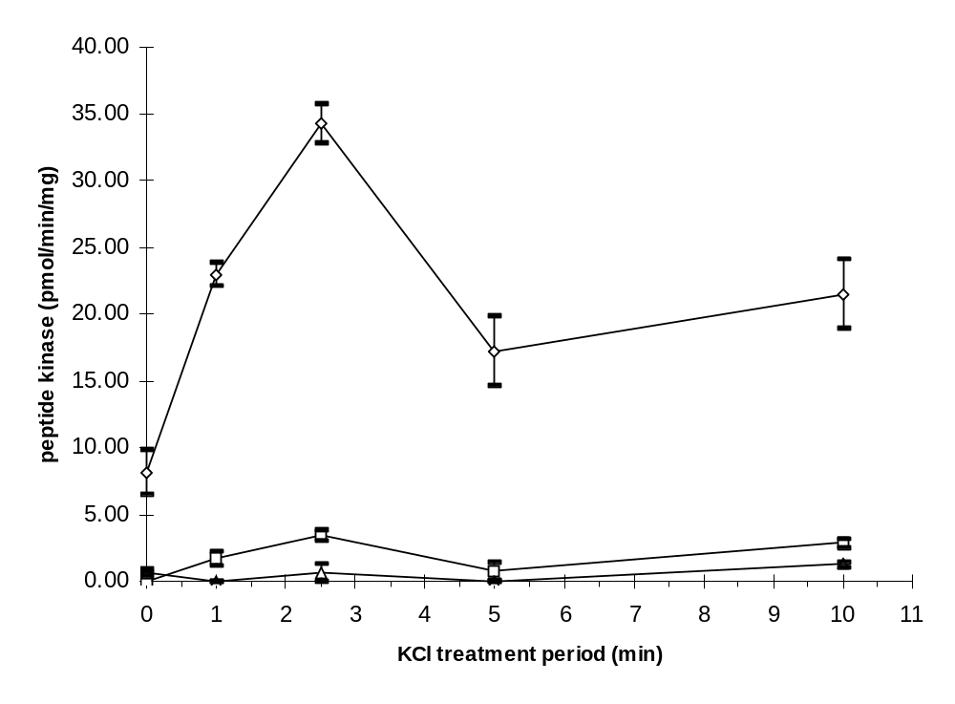
Figure 4. Human TH serine-31 peptide kinase activity eluted from Mono Q HR 5/5
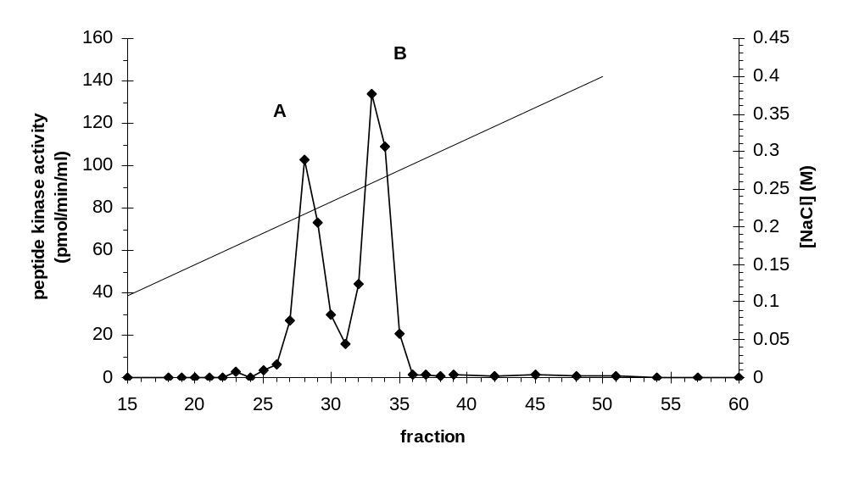
Figure 6. Human TH serine-31 peptide kinase activity elution
from a Superose 12 HR 10/30 column
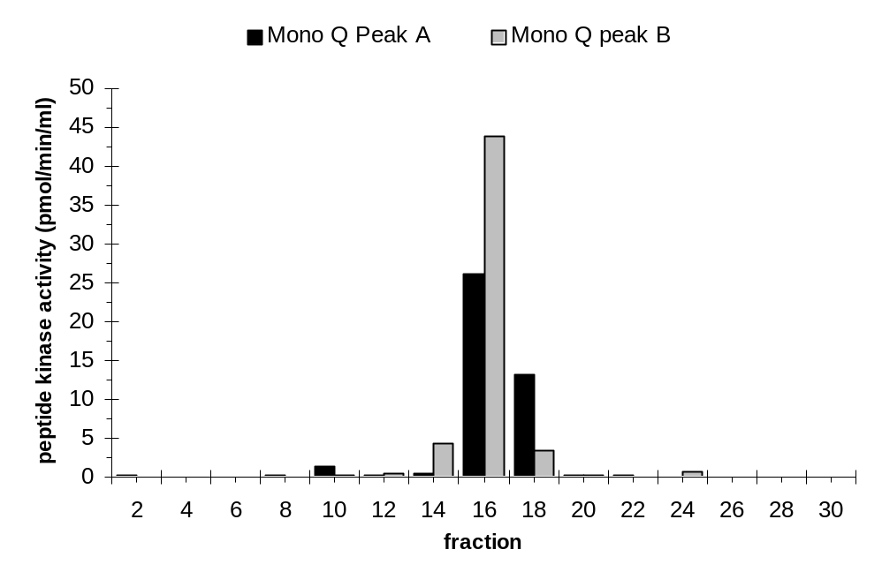
Figure 5. Immunoblot analysis of Mono Q with
antibody to synthetic peptide of rat ERK

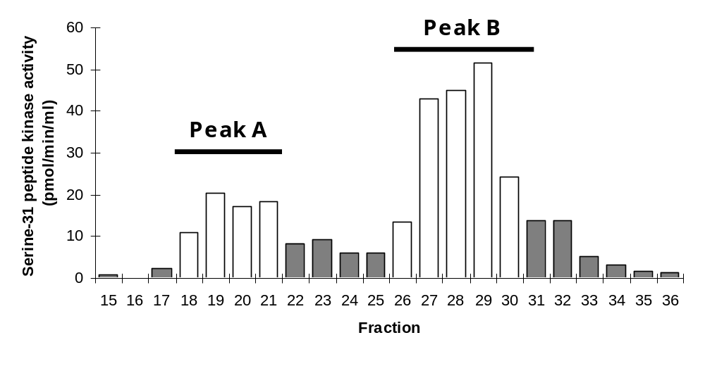

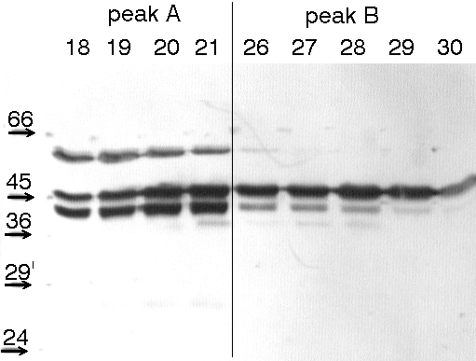

top panel: h31 peptide kinase activity in fraction of a Mono Q chromatographic run

bottom panel: Immunoblot of selected fractions from Mono Q column using antibody to rat ERK1. Numbers along top of blot below peak labels represent fraction numbers, and those along left of blot represent relative molecular masses.
Figure 7. Phenyl-Sepharose chromatography of the
human TH serine-31 peptide kinase
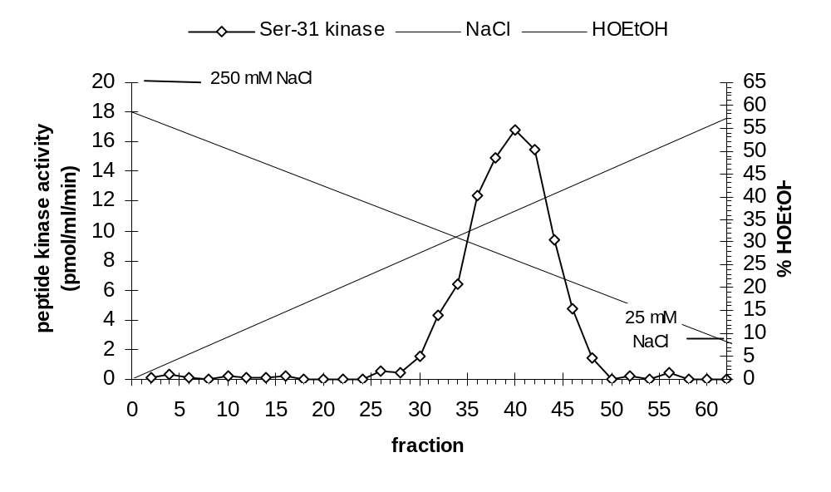
Figure 8. Activation of Bovine TH with Increasing Amounts
of Purified Serine-31 Kinase
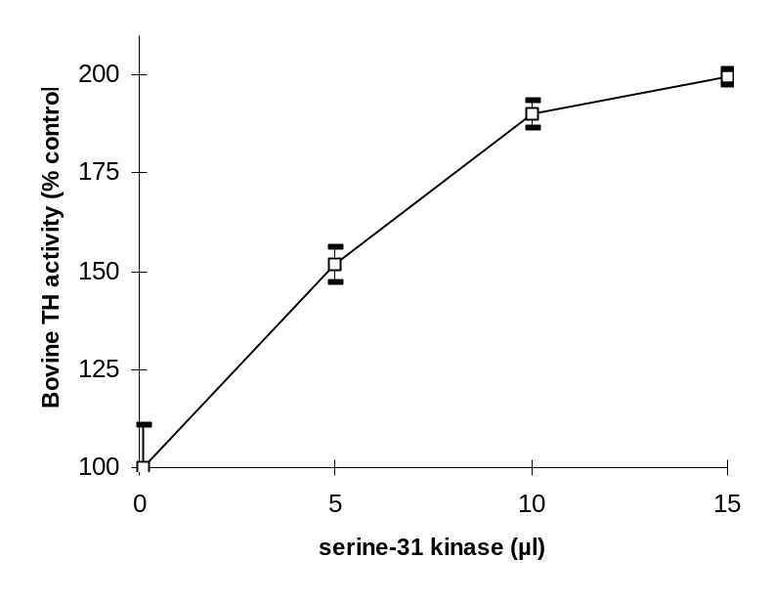

Figure 9. Activation of Bovine TH During Time
of Incubation with Serine-31 Kinase
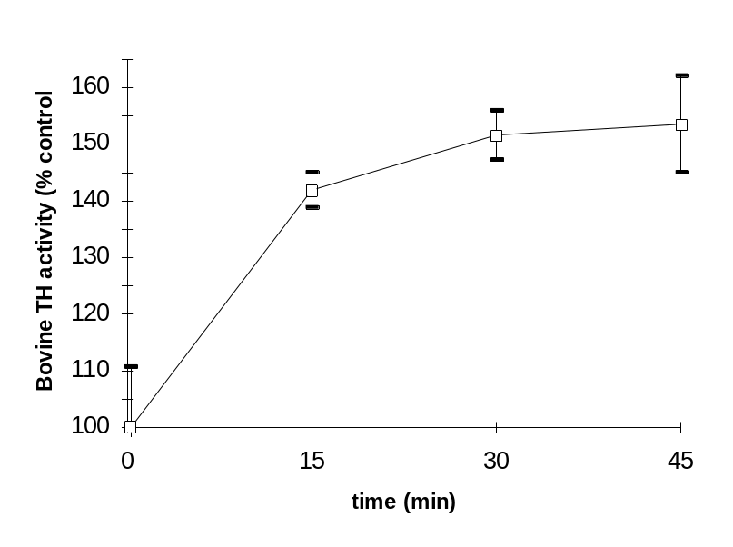

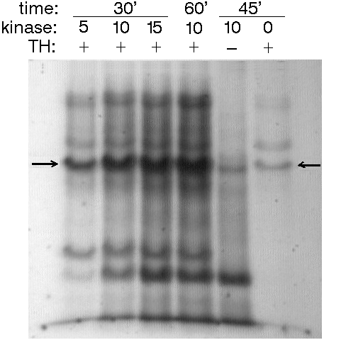
Figure 10. Time- and Dose-Dependent Phosphorylation of Bovine TH by The Serine-31 Kinase.
Bovine TH was treated with the activated chromaffin cell Ser31 protein kinase in the presence of g-[32P]ATP for different times and with varying levels of protein kinase. Samples were separated on 10% SDS-polyacrylamide gels, which were dried and autoradiographed. Above the autoradiograph image, time values are in minutes, kinase levels in microliters added, and the presence of substrate is indicated as present (+) or absent (–).

Figure 11. HPLC Radiochromatograms of Tryptic Phosphopeptides of Bovine TH or Synthetic Peptides Phosphorylated by Protein Kinases
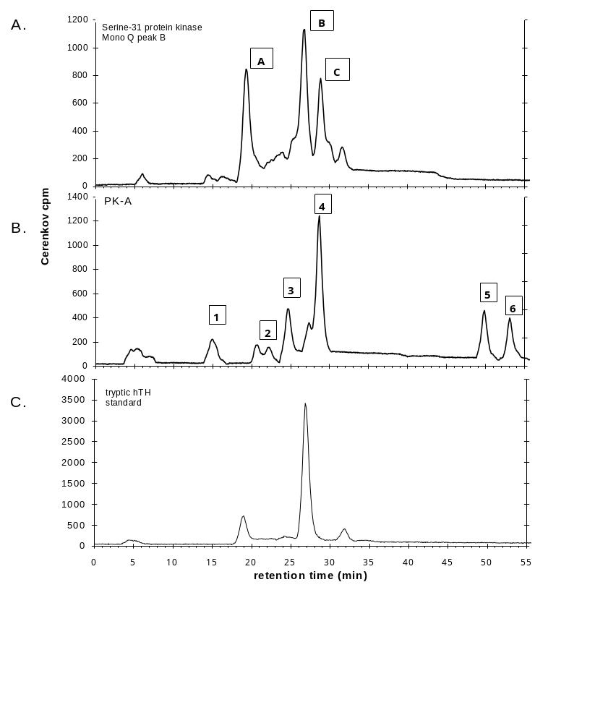

Figure 12. Thin-layer Electrophoresis/Chromatography Comparison of HPLC-Purified Tryptic Phosphopeptides.
Shown are the images of the autoradiographs of eighteen thin-layer plates used to determine identity (to distinguish) between two different samples of ³²P-radiolabeled phosphopeptides. The samples of phosphopeptides represent fractions of peaks from reversed-phase HPLC. Each thin-layer plate is divided into quadrants. Quadrants 1 and 4 (diagonal from one another, being the upper left and lower right, respectively, in the image of each plate) are spotted with either of the samples. Quadrants 2 and 3 (also diagonal from one another, being the upper right and lower left, respectively, in the image of each plate) are spotted with both of the samples. The samples are spotted in the lower right of each quadrant (1 cm from the edges), and many of the autorads of the plates feature a dark spot indicating the sample spot with precipitated radiolabeled material. Electrophoresis from cathode to anode is from right to left in the image of each quadrant; electrophoresis is done on the entire 4-quadrant plate. The plate is then cut in half to separate quadrants 1 and 2 from quadrants 3 and 4, and each half-plate is developed chromatographically, from bottom to top in the image of the half plate. After drying, the half-plates are taped back together on their mylar backings as they were before cutting, and then exposed to xray film. After the necessary exposure period, the location of a spot of a visible indicator dye spotted onto the plate with the samples before the two-dimensional separation is drawn on the film with a marker, shown as an open dashed circle typically in the upper left of the quadrant, and which indicates the extent of the dye spot area. The marker was also used to draw dashed lines on the film to indicates the extent of the quadrant area.
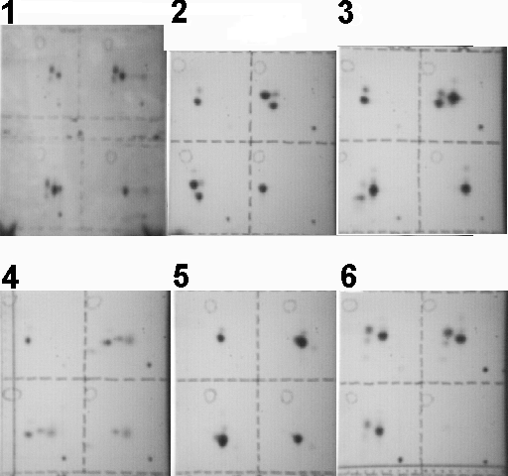

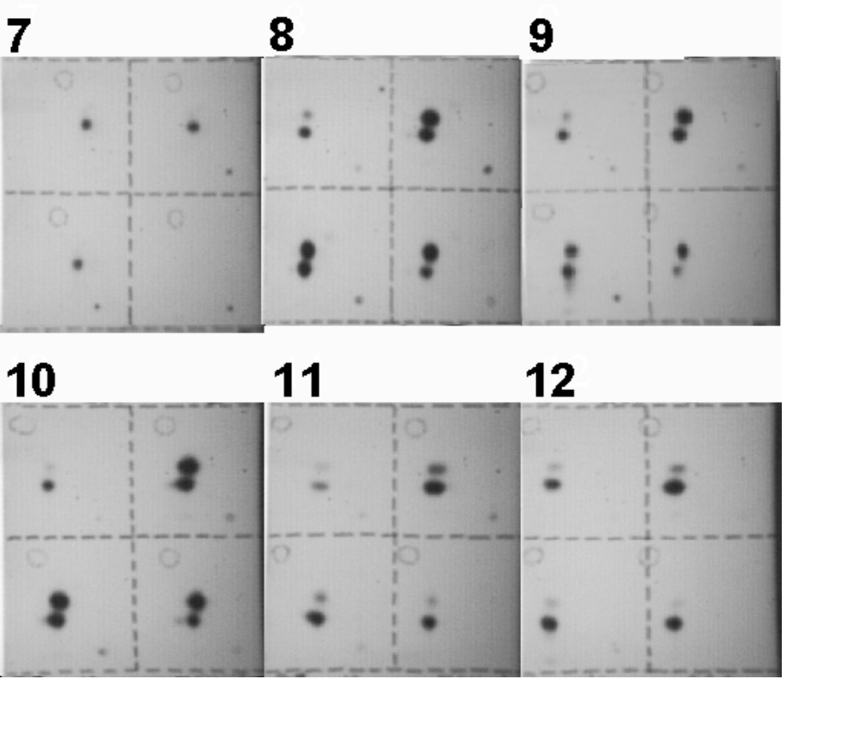

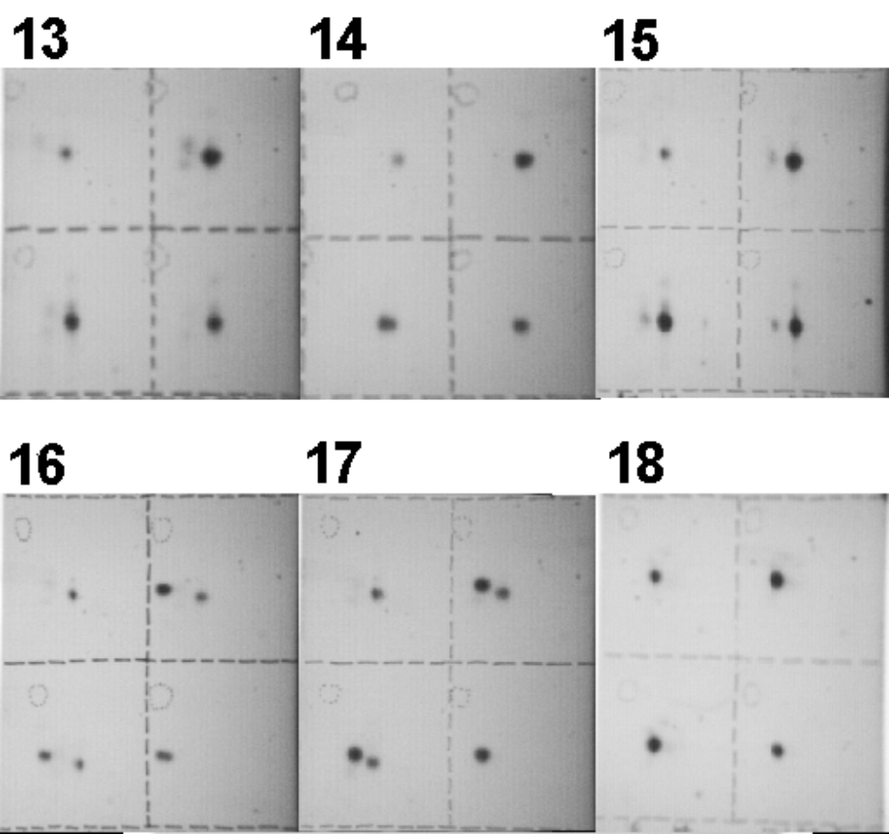

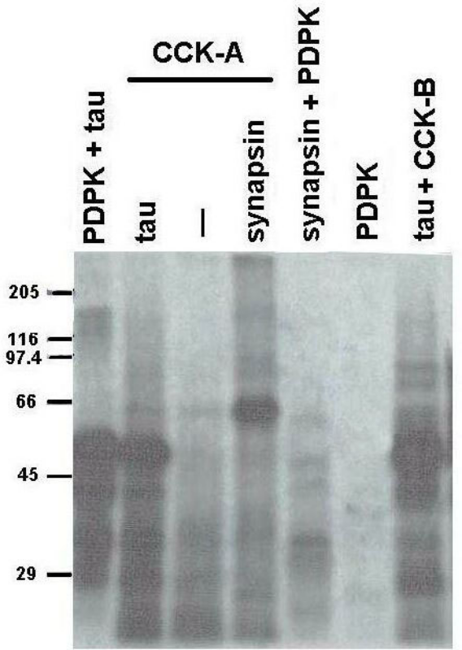
Figure 13. Autoradiogram of synapsin and tau as substrates for PDPK and Mono Q-purified chromaffin cell protein kinase.
Tau (~5 µg) and synapsin (~10 µg) are treated with either PDPK (purified from extracts of FM3A cells) or peak A or B from Mono Q-purified preparations of depolarized chromaffin cells with [γ-³²P]ATP and acid-precipitated pellets are analyzed on 10% SDS-polyacrylamide gel. The values of molecular weight markers in kDa are given.

