REGULATION OF TYROSINE HYDROXYLASE
BY PROTEIN PHOSPHORYLATION
by
STEPHEN MITCHELL HALLORAN
B.S. (University of California, Davis) 1986

DISSERTATION
Submitted in partial satisfaction of the requirements for the degree of
DOCTOR OF PHILOSOPHY
in
Biochemistry
in the
OFFICE OF GRADUATE STUDIES
of the
UNIVERSITY OF CALIFORNIA
DAVIS
Approved:

Committee in Charge
2026
Regulation of Tyrosine Hydroxylase by Protein Phosphorylation
ABSTRACT
Tyrosine hydroxylase (TH) [E.C. 1.14.16.2] is an enzyme and control point in the biosynthesis of catecholamine neurotransmitters. In addition to gene expression controls which regulate the level of TH holoenzyme, the activity of the enzyme is controlled through its phosphorylation. Four phosphorylation sites have been identified in the rat TH subunit, the most studied of all forms of TH. At least two of these sites, serine 19 and 40 of the rat TH subunit, are the target of protein kinases which themselves are the focal point of well-known signaling pathways. The cyclic AMP-dependent protein kinase (PK-A) phosphorylates serine 40, and calcium- and calmodulin-dependent protein kinase (CaMK) found in abundance in neuronal tissues targets serine 19. Serine 8 is reported to be phosphorylated by CDK2 (p34^{cdc2}/p58^{cyclinA}), but the physiological significance of this modification is unknown. The identification of a (or the) protein kinase that phosphorylates the serine at position 31 was reported while this study was in progress. The microtubule-associated protein-2 kinase (MAP2K) is a serine/threonine protein kinase activated by tyrosine phosphorylation and threonine phosphorylation, first identified in insulin-stimulated cultured adipocytes, and found to be identical with an isoforms of the independently studied extracellularly regulated protein kinases (ERK).
In these experiments, TH was purified as a substrate from bovine adrenal medulla and treated with a protein kinase obtained from bovine adrenal chromaffin cells which had been depolarized for an optimal period with potassium chloride, and which had been purified for enzymatic activity able to phosphorylate a synthetic peptide substrate forming the consensus sequence to rat TH serine-31. TH is activated when treated with this protein kinase preparation. Analysis of tryptic phosphopeptides obtained from the serine 31 kinase-treated TH substrate shows that serine 31 of TH was phosphorylated. Immunochemical testing of the purified enzyme indicates the presence of the MAP2K/ERK. These data indicate that MAP2K/ERK is the protein kinase activated in potassium-depolarized chromaffin cells and phosphorylates serine 31 of TH, with concomitant activation.
ACKNOWLEDGEMENTS
I express my appreciation to Dr. Richard Vulliet for his infinite patience in the completion of this program of study. There can never be any dispute that he possesses such patience, given the time he allowed for seeing it done, and its completion came at an especially difficult time for him personally. I can honestly say that I have never met a scientist more enthusiastic about his work, more optimistic about the achievements one can make in pursuit of a goal by adhering to scientific method, more dedicated to his discipline.
I would like to thank many members of my family: my mother Judy, my father Frank, my stepfather Michael, my brother Bryan and my sister Michelle, and countless others who were always encouraging.
Most of all, I cannot possibly show sufficient gratitude to my wife Nilgün and my child Sequoia, who had to endure extraordinary difficulties themselves in the completion of this goal. I can only hope to prove worthy of their expectations.

TABLE OF CONTENTS
Page
LIST OF TABLES vi
LIST OF FIGURES vii
LIST OF ABBREVIATIONS viii
Chapter 1. BACKGROUND & REVIEW OF LITERATURE 1
Features of Catalysis and ROLE OF TYROSINE HYDROXYLASE IN CATECHOLAMINE BIOSYNTHESIS 1
Phosphorylation of Tyrosine hydroxylase As the Molecular Basis of Activation 12
Physiological Activation of Tyrosine Hydroxylase By Cholinergic Signaling 15
Nicotinic vs. Muscarinic Agonism 16
Cyclic Nucleotide-Dependent Phosphorylation 17
Cyclic AMP 17
Cyclic GMP 20
ATP/Adenosine 20
Secretin Family Peptides 21
Calcium-Dependent Phosphorylation 23
The Calcium- and Phospholipid-Dependent Protein Kinase (PK-C) 26
Phosphopeptides 28
Proline-Directed Protein Phosphorylation 29
Microtubule-Associated Protein-2 Kinase/Extracellular Regulated Kinases (MAP2K/ERK) 31
Summary 35
Deactivation of The TH Holoenzyme and The Action of Protein Phosphatases 36
Chapter 2 MATERIALS and METHODS 38
Specific materials 38
Enzyme assays 38
Purification of bovine adrenal medulla tyrosine hydroxylase 39
Culture of bovine adrenal chromaffin cells 41
Purification of the chromaffin cell TH serine-31 protein kinase 42
In vitro phosphorylation of bovine tyrosine hydroxylase by chromaffin cell protein kinase 44
Preparation and Analysis of tryptic phosphopeptides of tyrosine hydroxylase 45
Chapter 3 RESULTS 47
Purification of bovine adrenal TH 47
Identification, purification, and characterization of a peptide kinase for serine-31 48
In vitro phosphorylation of purified bovine adrenal TH with purified chromaffin cell serine-31 protein kinase 59
Identification of Sites Phosphorylated in TH by The Serine-31 Kinase 62
Substrate Specificity of Mono Q- and Superose-purified TH Serine-31 kinase 70
Chapter 4 DISCUSSION 74
Chapter 5 FUTURE STUDIES 78
Other Experimental Efforts 78
Unanswered Questions 81
Chapter 6 BIBLIOGRAPHY 82

LIST OF TABLES
Page
Table 1. Amino Acid Sequences of Amino Terminal Region of Tyrosine Hydroxylase Subunit Among Various Mammalian Species. 6
Table 2. Sequences of Amino Terminal Regions of Four Human TH Types. 8
Table 3. Amino Acid Sequences of Synthetic Peptides 50
Table 4. Substrate Specificity of Purified Chromaffin Cell Serine-31 Kinase 73

LIST OF FIGURES
Page
Figure 1. Biosynthesis of Catecholamines 2
Figure 2. Regulation of Tyrosine Hydroxylase Activity by Various Signaling Systems (next page) 13
Figure 3. Time course of KCl depolarization of bovine adrenal chromaffin cells for the activation of a TH serine-31-specific peptide kinase 52
Figure 4. Human TH serine-31 peptide kinase activity eluted from Mono Q HR 5/5 53
Figure 5. Human TH serine-31 peptide kinase activity elution from a Superose 12 HR 10/30 column 55
Figure 6. Immunoblot analysis of Mono Q with antibody to synthetic peptide of rat ERK 57
Figure 7. Phenyl-Sepharose chromatography of the human TH serine-31 peptide kinase 58
Figure 8. Activation of Bovine TH with Increasing Amounts of Purified Serine-31 Kinase 60
Figure 9. Activation of Bovine TH During Time of Incubation with Serine-31 Kinase 61
Figure 10. Time- and Dose-Dependent Phosphorylation of Bovine TH by The Serine-31 Kinase. 63
Figure 11. HPLC Radiochromatograms of Tryptic Phosphopeptides of Bovine TH or Synthetic Peptides Phosphorylated by Protein Kinases 64
Figure 12. Thin-layer Electrophoresis/Chromatography Comparison of HPLC-Purified Tryptic Phosphopeptides. 66
Figure 13. Autoradiogram of synapsin and tau as substrates for PDPK and Mono Q-purified chromaffin cell protein kinase. 71

LIST OF ABBREVIATIONS

8-Br-cAMP | 8-bromoadenosine-3’:5’-cyclic monophosphate; 8-bromo-cyclic AMP
ACh | acetylcholine
BH₄ | tetrahydrobiopterin
Bt₂-cAMP | dibutyryl cyclic AMP
CaM | calmodulin
CaM MPK | calcium- and calmodulin-dependent multiprotein kinase
cAMP | adenosine 3’:5’-cyclic monophosphate; cyclic AMP
CNBr | cyanogen bromide
DEAE | diethylaminoethyl
6-MPH₄ | 2-amino-4-hydroxy-6-methyltetrahydropteridine
DAG | diacylglycerol
DMPH₄ | 6,7-dimethyltetrahydropteridine
DMPP⁺ | dimethylpiperazinium ion
DOPA | 3,4-dihydroxy-l-phenylalanine
DTT | dl-dithiothreitol
EDTA | (ethylenedinitrilo)tetraacetate
EGTA | ethylene glycol-bis(2-aminoethylether)-N,N,N´,N´-tetraacetate
EGF | epidermal growth factor
ERK1 | extracellularly-regulated kinase isoform 1
HBSS | Hanks’ balanced salt solution
FGF | fibroblast growth factor
HEPES | N-(2-hydroxyethyl)piperazine-N’-(2-ethanesulfonic acid)
HPLC | high-performance liquid chromatography
hTH1 | human tyrosine hydroxylase isoform 1
IGF-I | insulin-like growth factor isoform 1
kDa | kilodalton
KRH | HEPES-buffered Kreb’s-Ringer’s solution
KRH-KCl | high (56 mM) KCl-modified KRH
MAP-2 | microtubule-associated protein-2
MAP2K | microtubule-associated protein-2 kinase
MBP | myelin basic protein
MES | morpholine ethanesulfonic acid
Mr | relative molecular mass
NGF | nerve growth factor
NMR | nuclear magnetic resonance
PAH | phenylalanine hydroxylase
PDBu | phorbol 12,13-dibutyrate
PDPK | proline-directed protein kinase
PK-A | cAMP-dependent protein kinase
PK-C | protein kinase C: calcium- and phospholipid-dependent protein kinase
PK-G | cGMP-dependent protein kinase
PKI | cAMP-dependent protein kinase inhibitor [PKI(6-22)amide]
PMA | phorbol 12-myristate 13-acetate; same as TPA
PLase C | phospholipase C
PMSF | phenylmethylsulfonyl fluoride
PtdIns | phosphatidyl inositol
PtdSer | phosphatidyl serine
rTH | rat tyrosine hydroxylase
SCG | superior cervical ganglia
SDS-PAGE | SDS-polyacrylamide gel electrophoresis
Ser40 | serine at amino acid position 40 of rat tyrosine hydroxylase
Ser31 | serine at amino acid position 31 of rat tyrosine hydroxylase
Ser8 | serine at amino acid position 8 of rat tyrosine hydroxylase
Ser19 | serine at amino acid position 19 of rat tyrosine hydroxylase
TFP | trifluoperazine
TPA | tetradecanoyl phorbol acetate; same as PMA
TH | tyrosine hydroxylase
VIP | vasoactive intestinal peptide
Document style and abbreviations are according to instructions to authors from the Journal of Biological Chemistry of the American Society for Biochemistry and Molecular Biology.

BACKGROUND & REVIEW OF LITERATURE

Features of Catalysis and ROLE OF TYROSINE HYDROXYLASE IN CATECHOLAMINE BIOSYNTHESIS
Catecholamines are an important class of biochemical substances affecting many vital metabolic processes. The major catecholamines, dopamine, norepinephrine, and epinephrine, all serve as signal transmitters, either as agents having a relatively immediate effect in the localized space of a synapse, or as the components mediating the multi-system and multi-organ physiological state change required for acute behavioral responses, as in the “fight-or-flight response” being a well-characterized example ().
For this important physiological process to work effectively and efficiently without inappropriate utilization of resources, which might otherwise be wasteful of vital resources, the catecholamine biosynthetic pathway must be regulated but adaptive to the needs of the body. The sensible point of this regulation, as with most found in nature, is that point in which a particular substance is converted to the first intermediate along a committed pathway (). For catecholamines, that point is the conversion of the amino acid l-tyrosine to 3,4-dihydroxy-l-phenylalanine (DOPA). This enzymatic reaction is catalyzed by tyrosine hydroxylase (TH) [l-tyrosine,tetrahydrobiopterin:oxygen oxidoreductase (3-hydroxylating), E.C. 1.14.16.2] (see figure 1) ().
The native TH holoenzyme is a homotetramer with a slightly ellipsoidal shape (). SDS-polyacrylamide gel electrophoresis shows that the TH monomer subunit has a
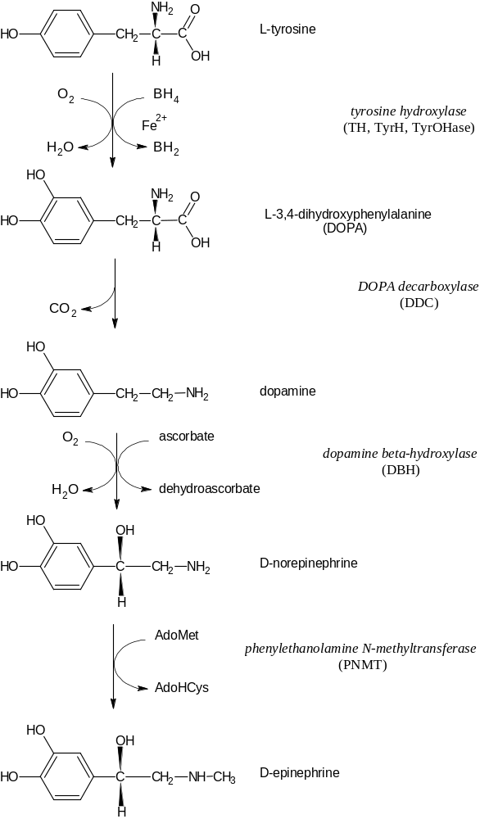
Figure 1. Biosynthesis of Catecholamines
relative mass of between 59,000 and 62,000 Da, which essentially represents the range for all species whose subunits were analyzed.
TH is an iron (Fe²⁺)-dependent monooxygenase related both structurally and functionally to the members of a broad class of oxidizing enzymes, the aromatic amino acid hydroxylases, whose other members are phenylalanine hydroxylase (PAH) and tryptophan hydroxylase. The natural substrates of TH are l-tyrosine, (6R)-l-erythro-1,2-dihydroxypropyltetrahydropterin (also called tetrahydrobiopterin and symbolized BH₄), and oxygen (O₂). The K_{m} values for tyrosine and the pterin coenzyme are 0.5 and 0.1 mM, respectively, for the bovine enzyme (), but these values are comparable among all mammalian forms of the active enzyme. The enzyme is relatively saturated for O₂, as the K_{m} for O₂ is 6% (Error: Reference source not found). Many pterin analogues of BH₄ are also active as cofactors, such as 2-amino-4-hydroxy-6-methyltetrahydropteridine (6-MPH₄) and the 7-methyl analog of 6-MPH₄ (DMPH₄). TH is inhibited by its tyrosine substrate at higher concentrations with the natural pterin as cofactor, but not with analogue pterins as cofactor (). Unlike the other aromatic amino acid hydroxylases in the family, TH shows much broader substrate specificity, able to hydroxylate many compounds with an aromatic ring so long as the substituent on the para position does not hinder it sterically or significantly alter reactivity of the ring (). Phenylalanine is converted to DOPA completely by TH without making a meta-tyrosine intermediate (). The catalytic cycle of TH hydroxylation necessarily involves coupled reactions, in which oxygen and BH₄ form the hydroxylating reactive species with the aid of the iron metal center, and then the reactive hydroxyl intermediate immediately bonds to the substrate within its proximity; “uncoupled” reactions can occur in aromatic amino acid hydroxylases in which the reactive intermediate is formed, with BH₄ (aut)oxidized, but the substrate is not oxidized (). A mechanism whereby dopaminergic neurons are destroyed as a result of the autoxidation of BH₄ cofactor to form damaging reactive oxygen species, leading to Parkinson’s disease, has been proposed ().
TH is subject to inhibition by its product DOPA as well by dopamine, norepinephrine, and epinephrine, the products downstream in the catecholamine biosynthetic pathway and which only inhibit TH if their synthetic enzymes are expressed in the tissue (, ). Molecules with catechol moieties all similarly inhibit TH, coordinating with the iron center (). Inhibition by catechols requires that iron be in the ferric state, and catechols induce the oxidation of the ferrous atom center (). Inhibition of TH by DOPA is noncompetitive with respect to tyrosine and competitive with respect to the pterin cofactor (Error: Reference source not found, ). .
The tissue distribution of TH in mammals includes its expression in the adrenal medulla, adrenergic nerve cell bodies in central nervous system (locus coeruleus, nigrostriatal pathway, hippocampus), and the sympathetic ganglia innervating end organs under autonomic control (). All of these tissues are potential sources of TH for biochemical characterization and study; there are numerous reports on methods for the extraction and purification of TH from various tissues in several species in both native and recombinant form (-).
Limited trypsin treatment, originally used as a tool to enhance recovery of TH enzyme from centrifugal pellets in preparative work, will activate TH (). This limited treatment of TH with the protease hydrolyzes an exposed recognition site in the regulatory domain, making it possible to remove a fragment apparently forming a barrier to active site accessibility (). More extensive treatment however inactivates the enzyme. In addition, TH is activated by the mucopolysaccharide heparin (), which otherwise inhibits TH already activated by limited trypsin digestion (Error: Reference source not found). The activation of TH by heparin is not specific however; rather TH appears to be activated in general by polyanions like heparin (). Conversely, polycationic amines inhibit TH ().
Within the cells of adrenergic tissues, the expression of TH message within the nucleus is under the control of multiple transcription factors that are themselves under the control of multiple signaling factors. The message is translated in the cytoplasmic space (within the soma of neurons). Chromaffin cells of the adrenal medulla which lack axonal processes reveal that a form of TH becomes associated with the membranes on the cytoplasmic surface of the secretory vesicles that store the catecholamines released by these cells (). This association with the membrane is quite strong, as only detergents solubilize the membrane-bound form of TH, and salts and denaturing agents are without effect. Membrane-bound TH is reported to be found in other tissues as well (Error: Reference source not found). Countless histochemical studies, many employing antibodies to TH demonstrate the presence of TH in the nerve terminals. TH is transported axoplasmically perhaps already bound to secretory vesicle membrane. TH is also located in dendrites ().
The primary structure of the TH subunit was first determined from cDNA sequence analysis of a clone obtained from a PC12 library (, ). PC12 cells are a continuous cell line derived from rat pheochromocytoma, a tumor of the adrenal medulla. Sequencing of the rat TH cDNA enabled the rapid cloning of TH message and genes from cDNA and genomic libraries of other species: human (), bovine (, ), monkey (), mouse (), and an avian species (). The TH subunit is coded by a single gene in all species studied. With the exception of primates (as discussed below), the multimeric TH holoenzyme is assembled from the same polypeptide subunit.
Alignments of the TH subunit between species and with PAH reveal that the C-terminal half forms the core catalytic domain. Residues 238-400 in rat subunit and 192-354 in human type 1 subunit have 75% identity, a homology also found at the nucleotide level. The first 150 residues of the TH subunit are not conserved in other aromatic amino acid hydroxylases (). Deletion mutants of rat TH show the binding site for heparin lying between residues 76-90 ( ). As the first 50 residues of rat TH contain all the residues known to be targets of protein kinases which are central to various cellular signaling systems (table 1), and phosphorylation of these residues is associated with modification of the activation state of TH post-translationally, the amino terminal domain is considered a regulatory domain.

Table 1. Amino Acid Sequences of Amino Terminal Region of Tyrosine Hydroxylase Subunit Among Various Mammalian Species
The mouse, bovine, and human type 1 amino terminal sequences are shown aligned and referenced to the first sequenced subunit, rat TH. Where amino acids are identical to the rat sequence, a hyphen is given. The residues (all serines in rat TH) which are phosphorylated in situ in PC12 cells are shown as emboldened characters of larger size. It is not known if all corresponding residues in species other than the rat are the targets of protein kinases (see text).
1 2 3 4
12345678901234567890123456789012345678901234567
Rat (rTH) | MPTPSAPSPQPKGFRRAVSEQDAKQAEAVTSPRFIGRRQSLIEDAR
Mouse (mTH) | ------S---------------T-----------------------
Bovine (bTH) | ----N-A---A---------L-------IM----V-------Q---
Human type 1  (hTH-1) | ----D-TT--A---------L-------IM---------S------

A study of human TH identified four different transcripts, determined to be the result of alternative mRNA splicing from the transcript of the single human gene (table 2) (Error: Reference source not found). Alternative splicing of the transcribed message occurs in the N-terminal region within the regulatory domain of TH. The inclusion or exclusion of certain exons in
spliced variants can result in a TH protein subunit with potentially different modes of post-translational regulation: for example, while the serine at position 31 in human type 1 (which corresponds to serine at position 31 in rat) is within a consensus sequence targeted by proline-directed protein kinases, insertion of the short exon to code for -VRGQ- exactly on the amino side of the phosphorylated residue also creates a consensus site for another well-known protein kinase, the cyclic AMP-dependent protein kinase. It has been proposed that different isoforms for human TH might be for tissue-specific expression, but reports indicate that these different forms appear to be expressed together within tissues, as shown for the brain and adrenal medulla (), and in neuroblastoma (), with the same relative proportions of each form expressed. Non-human primates appear to express two isoforms of the TH subunit rather than four (). Inclusion of the third exon in a splice variant improves binding of the natural inhibitor dopamine, and TH mutant isoforms with this exon deleted have been found in humans with a disorder known as progressive supranuclear palsy, a Parkinson-like condition (). Study of hTH with exon 3 missing also show it to be responsible for the activation seen with polyanions. A finding much later that Drosophila () and the adrenals of rat ( ) expressed multiple TH isoforms through alternative message splicing cast doubt on the suggestion that multiple isoenzymes of TH were necessary to account for greater behavioral and intellectual complexity among organisms.
Experiments with recombinant full-length TH and with the domain corresponding to the catalytic core of bovine TH show little to no difference in enzyme activity or in the spectral characteristics which reveal structure (). This agrees with earlier findings showing the higher-than-basal activity of a 34 kDa fragment generated by limited trypsin

Table 2. Sequences of Amino Terminal Regions of Four Human TH Types
Type 1 human TH aligns with TH subunits from other species. The other types include inserts of either one of two exons (types 2 and 3) or both exons (type 4). Residues in types 2, 3, or 4 identical with type 1 are shown as dashes, and gaps introduced for purposes of alignment show residue positions as periods.
 |  | 1 |  | 2 |  | 3 | 4
 | 1234567890123456789012345678901234567890123456789
hTH-1 | MPTPDATTPQAKGFRRAVSELDAKQAEAIM...................
hTH-2 | ------------------------------VRGQ...............
hTH-3 | ------------------------------....GAPGPSLTGSPWPGT
hTH-4 | ------------------------------VRGQ---------------
 | 5 |  | 6 |  | 7
 | 0123456789012345678901234567
hTH-1 | ............SPRFIGRRQSLIEDAR
hTH-2 | ............----------------
hTH-3 | AAPAASYTPTPR----------------
hTH-4 | ----------------------------

treatment, the fragment representing the carboxyl-side product of digestion at position 158 of the rat enzyme (). The last 20 residues of the carboxyl terminus have been shown to be responsible for intersubunit binding (, ), in contrast to a previous report that a calcium-activated protease (calpain) removes the first 30 amino terminal residues of TH, producing a catalytically active monomeric form (). The mammalian TH sequence reveals the presence of three leucine zippers (which form coiled coils), and one of them is located in the last 20 residues; leucine zippers are generally featured in multimeric association domains. Co-expression of recombinant multimeric aromatic amino acid hydroxylases clearly shows that the intersubunit domain is specific for homo- and not heterotetrameric association (). Bacterial hydroxylases in particular and enzymes in general are typically monomeric, while eukaryotic enzymes typically form homo- and heteromultimeric associations to create efficient systems that involve related activities in a pathway or as a means to provide a finer control over activity relative to the level of substrates (or inhibitors), such as by allosterism. Positive cooperativity observed in the binding of pterin cofactor is evidence of such allosterism ().
The crystal structure of TH co-crystallized with 7,8-dihydrobiopterin reveals a Phe residue at position 300 (F300) forming part of the pterin-binding site. The aromatic ring of F300 is probably involved in a pi-stacking interaction with the aromatic rings of the pterin cofactor (). F300 aromatic ring that has been hydroxylated in the meta (3-) position has been found. It has been proposed that the molecular basis for the activation of TH is because of the hydroxylation of F300, and that the ring hydroxyl group forms a hydrogen bond with the main chain carbonyl of Q310. A more recent report, however, indicates that the hydroxylation of F300 is an artifact of the crystallization process (). Studies of the PAH catalytic domain, crystallized in the presence of catechols, indicate that the catechol inhibitors bind to a glutamate side chain carboxyl and to the ring hydroxyl of a tyrosine residue (). These findings are consistent with the observation that catechol binding is pH-dependent, and the pK_{a} for inhibition was in the range of a carboxylate group. TH is activated within its stability region by acid treatment, which causes a release of inhibitory catecholamine ().
Mutagenesis experiments have revealed the nature of the residues important in substrate binding and recognition. TH can modify a number of substrates that feature a reactive aromatic ring group where other members of the hydroxylase family show a more limited ability; for example, TH can hydroxylate the substrate phenylalanine to form tyrosine while PAH cannot hydroxylate tyrosine. After a suggestion based on crystal structure data from PAH catalytic domain, a rat TH mutant was constructed such that a tyrosine at position 371 was substituted by a phenylalanine (). The kinetic data showed that while there was no change in parameters related with hydroxylation of the Tyr substrate, there was considerable improvement in the ability of TH to hydroxylate Phe. Since the substitution would be presumed to make the TH active site more hydrophobic, it would be expected that a greater count of hydrophobic substrates would be reactive, or that hydrophobic substrates would be more reactive, which is what is observed. In other mutagenesis studies, several positions were altered singly or multiply to examine their effects, and some experiments attempted to make the catalytic domains of PAH and TH more like each other, with altered substrate specificities (-). Chimeric proteins with regulatory domains of one hydroxylase fused to the catalytic domain of the other hydroxylase revealed the nature of the residues controlling substrate specificity as well as the fact that TH has a greater degree of uncoupling than PAH ().
Mössbauer and x-ray absorption spectroscopy studies with recombinant hTH1 catalytic domain reconstituted with ⁵⁷Fe indicate that the high-spin iron atom center of the active site in both the ferrous and ferric states coordinates six ligands of both oxygen and nitrogen atoms with expected octahedral symmetry (). This is consistent three-dimensional structure analysis showing that the side chains of two histidines and a glutamate form three of the ligands for iron; mutagenesis analysis shows that histidines 331 and 336 coordinate to the metal (). The other three ligands are mobile/labile water molecules. During the catalytic cycle, oxygen would be expected to displace one of the water molecules. While TH binds and is inhibited by catecholamine products, a bidentate catechol would occupy two of the iron ligands, displacing two water molecules. Dehydration (lyophilization) of TH causes the iron atom to assume a coordination state having only five ligands, and a large amount of ferrous atom is oxidized to the ferric state. The conditions that are needed for crystallization produce a form of TH holoenzyme similar to the dehydrated state. Spectroscopic studies also confirm that iron binds the catechol inhibitor only when it is in the ferric (Fe³⁺) state. Although other transition metals (Co, Ni, Zn) will bind effectively in the active site of TH, none of these metals makes catalysis possible ().
The molecular events surrounding catalysis are understood based on the study of both PAH and TH. Studies with PAH and tryptophan hydroxylase revealed a mechanism involving migration of aromatic ring substituents, a migration termed the “NIH shift” (-). This mechanism is also characteristic of TH catalysis (), although hydroxylation does not involve an arene epoxide intermediate, as has been proposed for the action of phenylalanine hydroxylase (). The substrates of TH are bound sequentially into the active site: first the pterin cofactor, then oxygen, and finally tyrosine (). While it is possible for the these substrates to react nonenzymatically by their inherent reactivity helped by mere juxtaposition, the TH active site provides a reactive environment a few orders of magnitude greater to form the hydroperoxide (a 4α-carbinolamine) of the pterin (). An early model suggested that the peroxytetrahydrobiopterin intermediate was the hydroxylating species, and that the role of iron was perhaps to activate molecular oxygen for reaction with the pterin cofactor (Error: Reference source not found). This model was also based on a finding that hydrogen peroxide alone in the absence of cofactor could hydroxylate tyrosine with the enzyme present; the ability of TH to utilize H₂O₂ without cofactor has not been supported however (). There were no observed isotope effects when reactions were conducted in deuterated solvents, indicating that any proton movements did not involve solvent exchange (). Proton NMR of cobalt-bound recombinant hTH shows that the metal atom is positioned over C3/C4 of the aromatic ring of the substrate, explaining its flexibility in hydroxylating either position in the ring, and that the metal is the key player in hydroxylation (). (Cobalt binds to TH similarly to iron, but can be exploited for its paramagnetic effect, even though it is inactive.) With TH, there is also considerable uncoupling of the oxidation of cofactor to the hydroxylation of the substrate, with as many as 3 or 4 mol pterin cofactor oxidized per mol substrate hydroxylated (particularly evident with increasing size of the para-substituent of the aromatic ring). Metal-free enzyme is able to oxidize the cofactor, but it can not hydroxylate the aromatic ring (Error: Reference source not found). Kinetic data on the separate reactions within TH support the proposal that a strong cationic intermediate is the hydroxylating species (). Such a species would be a ferryl-oxo molecule ([Fe=O]²⁺), in which ferrous atom is able to bond to oxygen as a result of its activation by the cofactor during formation of the peroxypterin; molecular oxygen is composed of two atoms in a triplet, spin-forbidden state, and peroxide formation eliminates all orbitals occupied only by single electrons.

Phosphorylation of Tyrosine hydroxylase As the Molecular Basis of Activation
TH activity is regulated very closely to the needs of the cell using transcriptional, post-transcriptional, and post-translational mechanisms. The emphasis of this review is primarily on the short-term control of TH through its modification post-translationally by phosphorylation. A visual overview presented in Figure 2 shows the major signaling inputs and downstream protein kinases that directly phosphorylate TH. Posttranslational regulation of TH is determined by a combination of factors which affect the transition of TH from one state of activity to another. The basal state is a TH polypeptide assembled as the holotetramer capable of catalysis with a relatively low turnover number. Four

Figure 2. Regulation of Tyrosine Hydroxylase Activity by Various Signaling Systems (next page)
In the schematized adrenergic cell shown (membrane thick gray rounded rectangle) intracellular calcium is increased by opening of voltage-dependent calcium channels where membrane depolarization is achieved by artificial exposure to high extracellular potassium or by nicotinic cholinergic receptor activation (the “fast” response). Alternatively, muscarinic cholinergic receptor activation of phospholipase C via G protein control will generate inositol trisphosphate (IP₃) and diacylglycerol (DAG) through hydrolysis phosphatidylinositol-4,5-bisphosphate (PIP₂), the former which increases opens calcium channels in endoplasmic reticuulum membranes, and the latter which, with calcium, activates protein kinase C (PK-C). Calcium also binds to calmodulin (CaM), which in turn with calcium activates Ca – and CaM-dependent protein kinase (Ca/CaM PK II, the neural isoform). Ca/CaM PK II and PK-C have both been identified as phosphorylating TH in vitro and in situ. The muscarinic ACh receptor-G protein complex is also shown activating adenyl cyclase, which increases intracellular cAMP, which in turn activates the cAMP-dependent protein kinase (PK-A). PK-A phosphorylates TH (in situ and in vitro) and strongly activates it. The microtubule-associated protein-2 kinase, also called mitogen-activated protein kinase (MAPK), a member of the extracellularly regulated kinases (ERKs) also phosphorylates and activates TH. The details of the signal pathway from KCl-induced depolarization to increases in intracellular calcium to activation of MAPK are not fully understood, although there is a link. PK-C may also activate MAPK. MAPK is known to be activated by components starting at tyrosine kinase (TK) activities of mitogen receptors, which involve p21ras, Raf-1 kinase, and the protein kinases (MEK) that phosphorylate MAPK directly.

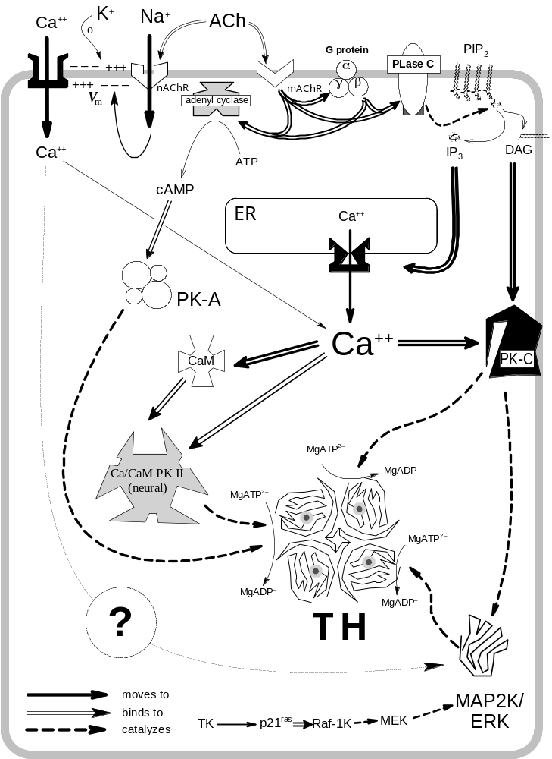

serine residues at positions 8, 19, 31, and 40 in the amino terminal region regulatory domain of the rat TH subunit have been identified as phosphorylation sites in cultured pheochromocytoma cells (). Corresponding serine residues in other species are also confirmed as being phosphorylated.
The mechanism by which activation of TH occurs through its phosphorylation of particular serine residues is well understood. Experiments in which association and dissociation rate constants were independently measured showed clearly that catecholamines dissociate quickly from phosphorylated enzyme with altered pH dependence (, ). Supraphysiological levels of catecholamine are required to inhibit, and only slightly, the ability of specific protein kinases to phosphorylate TH on their target sites (). Therefore at physiological levels in which the catecholamine products would clearly be inhibitory to TH, phosphorylation reduces the strong affinity of catecholamines for TH and permits the accessibility of its substrates, particularly the tetrahydrobiopterin cofactor.

Physiological Activation of Tyrosine Hydroxylase By Cholinergic Signaling
Electrically stimulated adrenergic nerves show increases in both the release and synthesis of the catecholamine neurotransmitters (-). This stimulation of catecholamine synthesis results from an increase in the activity of TH, as would be expected of the rate-limiting step in the biosynthesis of all catecholamines (-). Direct in vivo stimulation of nerves increases TH activity in dendrites and cell bodies of superior cervical ganglion as well as the nerve terminals located at end organs (Error: Reference source not found). Electrical stimulation of neuronal tissue that activates TH is also associated with phosphorylation of the protein which strongly indicates that this is the mechanism of activation (). Four tryptic phosphopeptides separated by two-dimensional thin-layer electrophoresis/chromatography are obtained from the superior cervical ganglia of rats where the preganglionic nerve trunk was given electrical pulsed stimulation for a 5-minute period (). When the splanchnic nerves in rat adrenals are electrically stimulated at high frequency for only 30 seconds, the greatest increases in phosphate incorporation occur at Ser19 and Ser40, but when stimulated ten times longer at a 10-fold lower frequency for 5 min, Ser31 phosphorylation also increases along with Ser19 and Ser40 ().
In addition to nerve stimulation experiments, the treatment of adrenergic tissues with a numerous variety of protein and non-protein substances, typically those known to induce signaling or state changes in other cells and tissues, result in the activation of TH. Most adrenergic tissues are postsynaptic to and under the control of cholinergic tissues, and there exists an association between release and action of cholinergic secretagogues and TH activation (). ACh is directly involved in the activation and phosphorylation of TH in cultured cells, such as chromaffin () and PC12 () cells, and this effect is also observed with cholimimetics such as carbamylcholine (Error: Reference source not found-).

Nicotinic vs. Muscarinic Agonism
The difference in the two broad class of cholinergic receptors is also reflected in nature of TH activation and phosphorylation as well. Nicotine and nicotinic agonists (e.g., DMPP) work through a calcium-dependent mechanism (Error: Reference source not found, Error: Reference source not found, -), and antagonists to this receptor class inhibit or attenuate the release of catecholamines and their increased synthesis. Treatment with nicotinic antagonists is also associated with a decrease in TH activation and phosphorylation (, ). Muscarinic agonists, e.g., bethanecol, also have specific action in particular tissues, such as the superior cervical ganglia (), but not in others, such as adrenal chromaffin cells (Error: Reference source not found, 110). Their action is mediated in a calcium-independent fashion through changes in cyclic AMP. Studies with chromaffin cells show that the pattern of phosphorylation with respect to quantified incorporation and time course of phosphorylation of Ser19, Ser31, and Ser40 is similar between nicotinic treatment and electrical stimulation (110).

Cyclic Nucleotide-Dependent Phosphorylation

Cyclic AMP
Many specialized metabolic functions of tissues are regulated by signal transduction pathways involving second messengers, and the synthesis and release of catecholamines in adrenergic cells is no exception. Evidence for the regulation of catecholamine biosynthesis by cyclic AMP-dependent phosphorylation has been reported using many model systems. Cultured neuronal (neuroblastoma) cells incubated with membrane-permeable cAMP analogs show an increase in the rate of catecholamine biosynthesis, an effect attributable specifically to activation of the TH enzyme (). Drugs which alter catecholamine levels induce changes in intracellular cAMP levels as well (). Results from several in vitro studies where treatment of rat neuronal tissues with cAMP or its membrane-permeable analogues, such as dibutyryl-cAMP or 8-bromo-cAMP, indicate either an increase in catecholamine biosynthesis (-) or activation of TH (-). Kinetic analysis of TH activated 3- to 4-fold by electrical stimulation shows a reduction in the K_{m} for the pterin cofactor by 5- to 8-fold in guinea pig vas deferens (Error: Reference source not found, Error: Reference source not found). Intact (Error: Reference source not found, Error: Reference source not found, Error: Reference source not found, ) and sliced tissues () treated with cAMP or its precursors also alter the affinity of the cofactor in the same manner.
Cyclic AMP is an intracellular second messenger produced as a result of an extracellular signal active via G proteins to increase adenylate cyclase activity. Forskolin increases cAMP through this mechanism (), and tissues and cultured cells treated in situ with forskolin show TH activation (Error: Reference source not found, -), and this is associated with the phosphorylation of its subunit (Error: Reference source not found, 109, 127-). Cholera toxin upregulates adenylate cyclase through its ADP-ribosylation of the G_{s} complex. Toxin-treated PC12 cells show increased TH activity (-), associated with increased levels of intracellular cAMP (Error: Reference source not found, ). The pattern of tryptic TH phosphopeptides obtained from PC12 cells treated with cholera toxin or the permeable cAMP analogue Bt2-cAMP are indistinguishable (Error: Reference source not found, Error: Reference source not found). Changes in cAMP levels are caused by cholinergic stimulation of adrenergic (cervical ganglia) tissue acting through muscarinic receptors, and this is consistent with information that these receptors activate adenyl cyclase via GTP-binding proteins (Error: Reference source not found, Error: Reference source not found, Error: Reference source not found,).
Increases in the intracellular levels of cAMP activate a specific protein kinase, the cAMP-dependent protein kinase (PK-A) (). Partially purified TH incubated with purified PK-A under phosphorylating conditions activates the enzyme 2- to 3-fold (-). Consistent with in vivo findings, Lineweaver-Burk analysis shows that the increase in activity is because of a decrease in the K_{m} for the pterin cofactor (138) with no change in V_{max} or the K_{m} for tyrosine. These kinetic parameters vary depending upon the pH of the assay. At more physiological pH values the phosphorylated enzyme shows a net activation in which cofactor K_{m} increases 2-fold and the V_{max} increases 4-fold at pH 7.0 (Error: Reference source not found). PK-A-phosphorylated TH shows a different pH activity spectrum from the non-phosphorylated form, the latter form having a narrow pH optimum, while the phosphorylated form possesses a wider activity range with the optimum shifted to the slightly alkaline range (Error: Reference source not found). Phosphorylated enzyme cannot be activated by heparin, while the non-phosphorylated form is activated by high ionic strength salts and several other polyanions (Error: Reference source not found, Error: Reference source not found). Phosphorylated enzyme is not inhibited by polycationic amines (Error: Reference source not found). Taken together, these data suggest that phosphorylation has the same effect as placement in a polyanionic environment.
Rat recombinant TH can be phosphorylated by PK-A but will not be further activated if a catecholamine is not present, indicating that the effect of this protein kinase is to relieve TH of its inhibition by catecholamine present at basal levels (). The phosphorylation of TH by PK-A is not affected by the particular state of the TH enzyme, such as its binding to substrate, inhibitor, or cofactor. Experiments with various peptide substrates derived from TH sequences indicate that the PK-A catalytic subunit prefers target sequences without negative charges ().
Numerous studies show that PK-A phosphorylates Ser40 of the TH regulatory domain, and this is the only serine position in the TH subunit containing a well-characterized PK-A consensus site (Error: Reference source not found, 109, Error: Reference source not found, ). Ser40 is phosphorylated within the first minute in chromaffin cells treated by cholimimetics (Error: Reference source not found) or in adrenals innervated by electrically stimulated splanchnic nerves (Error: Reference source not found), and Ser40 phosphorylation is necessary and sufficient to achieve TH activation. Definitive experiments with Ser40-phosphorylated enzyme and with TH mutants where Ser40 has been converted to a glutamate or aspartate residue (a phosphoserine-like substitution) show that the mechanism of Ser40 phosphorylation is to relieve TH of its inhibition by catecholamines (Error: Reference source not found, ). There are similar findings with PAH mutants as well (). Catecholamine binding affinity is not altered in TH where the Ser40 is changed to a nonphosphorylating reside (alanine) and exposed to phosphorylating conditions with PK-A (). At least three, and as much as all four, of the subunits of the TH holotetramer may need to be phosphorylated, and by PK-A alone, for catalytic activation (). Experiments with PC18 cells, a subclone of PC12 with defective voltage-dependent calcium channels, indicate that the cAMP/PK-A-mediated signal is the means by which TH is activated ().
The activation of TH by phosphorylation appears to make the subunit thermolabile. PK-A-treated TH loses activity at a greater rate than does the unphosphorylated enzyme (). This thermolability requires the phosphorylation of all subunits, and not merely a partial modification, indicating that a conformation obtained by the holoenzyme likely causes subunit inactivation rather than any conformational property of the subunit itself.

Cyclic GMP
Cyclic GMP (cGMP) stimulates increased catecholamine biosynthesis through TH activation in PC12 cells treated with nitroprusside or select permeable analogs of cGMP (). Nitroprusside exerts its effects by spontaneous formation of nitrogen oxide radicals which bind to specific guanyl cyclase-activating GTP protein-binding receptors. A cyclic GMP-dependent protein kinase (PK-G), which can be activated by either cGMP or cAMP and which shares substrate selectivity with PK-A, specifically phosphorylates and activates TH, although more slowly than PK-A (). Earlier studies (121, ) failed to detect any effect of cGMP, but it is suggested that these experiments may have been affected by experimental conditions less than favorable in revealing a potential role of this signaling system (Error: Reference source not found). Follow-up experiments with bovine adrenal chromaffin cell homogenates also question the physiological importance of cGMP in regulating the activity of TH (). The cholinergic agonist muscarine has been thought to act via a cGMP-mediated pathway, but TH activated in muscarine-treated superior cervical ganglia is not associated with changes in cGMP levels (Error: Reference source not found).

ATP/Adenosine
ATP may play a role as a neuromodulator as it is released from secretory vesicles along with catecholamines. Secreted ATP might act as an autocrine stimulator via purinergic receptors in the membranes of presynaptic terminals to increase or perhaps augment cAMP levels. The apparent effect is to ensure the activation of the catecholamine biosynthetic system through an even greater activation of TH (109). Exogenously added ATP, ADP, and AMP, in addition to adenosine analogues which show greater activation than adenosine itself, are effective in raising cAMP levels, which in turn are associated with increases in TH activity (). The nucleotides are rapidly converted to adenosine by cell-associated nucleotidases (Error: Reference source not found). Treatment of PC12 cells with adenosine or adenosine analogues stimulates DOPA biosynthesis (), increases intracellular cAMP levels, and enhances incorporation of phosphate into TH (Error: Reference source not found,Error: Reference source not found,). The presence of adenosine deaminase in the extracellular medium of PC12 cell cultures attenuates this effect of adenosine. Adenosine may act via a G-protein complex to activate adenyl cyclase through specific plasma membrane purinergic receptors. The phosphodiesterase inhibitor, theophylline, which normally potentiates TH activation when used as a pre-treatment in cyclic nucleotide in vitro studies, is also an adenosine receptor antagonist. In situ experiments show that it reduces levels of cAMP and TH activity compared to controls, evidence that an adenosine-specific receptor is necessary to mediate adenosine-induced TH phosphorylation (Error: Reference source not found, Error: Reference source not found). The enzyme adenosine kinase, which catalyzes the reversible formation of ADP and AMP from the reaction of adenosine and ATP, is also necessary for adenosine-mediated TH activation since mutant PC12 cells deficient in this enzyme show an inability to cause TH activation upon adenosine treatment (Error: Reference source not found). Adenosine treatment of bovine chromaffin cells has no effect on TH phosphorylation (110).
TH phosphorylation induced by purinergic stimulation is only a fraction of the phosphorylation induced by cholinergic stimulation. The role adenosine may play in regulating TH activity may be one of modulating the level of catecholamine biosynthesis rather than in switching it on or off (Error: Reference source not found). Adenosine analogs are as potent as Bt2cAMP or cholera toxin are in the activation of TH in PC12 cells (Error: Reference source not found).

Secretin Family Peptides
The secretin family of peptide hormones includes secretin, glucagon, and vasoactive intestinal peptide (VIP). Superior cervical ganglia of rats treated by secretin and VIP show increased catecholamine synthesis associated with TH activation (, ). VIP is secreted from splanchnic nerve axon terminals and other sympathetic preganglionic tissues, inducing activation of TH in cultured chromaffin cells (105, ) and in sympathetic nerve terminals innervating end organs such as the iris, salivary gland, and pineal gland (). Secretin does not stimulate cultured adult bovine chromaffin cells (105), and is not produced in adrenal medulla. However, secretin stimulates TH activation in PC12 cells, being more potent than VIP (). VIP treatments of PC12 cells show that TH activation is correlated to phosphorylation of the enzyme (109, 110). TH activity was measured at various pH values, and results show a shift in the pH optimum in the field-stimulated and VIP-treated rat adrenals, but not in the nicotine- or muscarine-treated adrenals (Error: Reference source not found).
Members of the secretin family neuropeptides stimulating TH activation transmit their signal through increases in intracellular cAMP, activating PK-A, which phosphorylates and activates the TH holoenzyme. Studies with cervical ganglia (Error: Reference source not found, ) and PC12 cells (Error: Reference source not found) show changes in intracellular cAMP upon secretin or VIP treatment, and this is correlated with cAMP-dependent protein kinase activation resulting in modification of TH (Error: Reference source not found, ).
Secretin family neuropeptides may not work through cAMP in all tissues however. Conflicting reports about the nature of VIP stimulation of cultured chromaffin cells show a dependence on extracellular calcium with no increase in intracellular cAMP, that combination treatments of forskolin and VIP are additive while phorbol esters and VIP are not, and that the protein kinase C inhibitor H-7 blocks the action of VIP (105). This contrasts with the report that cAMP is elevated in VIP-treated chromaffin cells, identifying Ser40 as the principal phosphorylation site (Error: Reference source not found, Error: Reference source not found).
The pituitary peptide hormone prolactin activates TH in certain dopaminergic neurons of the hypothalamus specifically through protein kinase C-mediated pathways and not through pathways stimulating PK-A or CaM kinase ().

Calcium-Dependent Phosphorylation
Calcium has multiple effects in cellular signaling in catecholaminergic tissues. In adrenergic cells, increases in intracellular calcium resulting from cholinergic action not only initiate the fusion of neurotransmitter storage vesicles to membranes at synapses, but also up-regulate neurotransmitter biosynthesis through the activation of calcium-dependent protein kinases. Cholinergic-mediated transmembrane voltage changes serve to open voltage-dependent calcium channel proteins on the plasma membrane or on the membranes of intracellular storage pools, increasing intracellular calcium with respect to its chemical potential (). The observation that electrical stimulation (field-induced membrane depolarization) and hyperkalemia cause both catecholamine release and enhanced catecholamine synthesis indicates a voltage-dependent membrane channel system is operative (Error: Reference source not found, 91, ). Cultured adrenal chromaffin cells represent a good model of the natural events involving the action of calcium ion, and cholinergic- or high potassium ion-induced depolarization enhances membrane permeability to calcium (, ) which is associated with increased catecholamine secretion ().
The calcium-dependent phosphorylation and activation of TH studied in several cellular/tissue systems (bovine adrenal chromaffin cells, chromaffin cell-derived PC12 pheochromocytoma cells, intact superior cervical ganglia, etc.) in response to acetylcholine and to cholinergic agonists is attributed to the effects of increased intracellular calcium mobilization and signaling systems under the regulation of calcium ion (Error: Reference source not found, Error: Reference source not found, Error: Reference source not found, 106-Error: Reference source not foundError: Reference source not found109110, Error: Reference source not found, 129, Error: Reference source not found, -). TH is phosphorylated, though not activated, when calcium is added to bovine adrenal medulla homogenates at concentrations identical to the concentration of calcium ion in the extracellular space in the presence of ATP (). TH activity is increased in rat SCG incubated in or low-sodium or sodium-free media, an effect dependent on extracellular calcium (). Experiments with blockers of voltage-dependent calcium channels and partial blocking of the ACh receptor protein with tetrodotoxin suggest that polarity changes in the membrane which promote increases in intracellular calcium explain the effect (Error: Reference source not found).
Phosphoinositides, among other mediators, raise intracellular calcium levels from intracellular stores and are produced in SCG following treatment with phospholipase C or muscarine (Error: Reference source not found). Treatment of SCG with these agents activate TH without altering intracellular cAMP (Error: Reference source not found).
Calcium-dependent phosphorylation and activation of TH is clearly distinct from cyclic nucleotide-dependent phosphorylation. An additive activation of TH is seen with combined stimulation of calcium- and cAMP-mediated pathways in vivo (97, Error: Reference source not found, Error: Reference source not found, 127, Error: Reference source not found) and in vitro (Error: Reference source not found). Additive phosphorylation of TH is also observed when calcium-mediated stimulation is combined with cAMP-mediated stimulation (Error: Reference source not found, , ). The time course of phosphorylation between NGF- and potassium-treated PC12 cells is distinct (). Pre-treatment with calcium channel blockers and or EGTA (a calcium chelator) typically abolishes TH phosphorylation and activation in depolarized cells and tissues (Error: Reference source not found). The calcium ionophores, A23187 and ionomycin, can also induce the phosphorylation and activation of TH in both chromaffin and PC12 cells, indicating that cholinergic stimulation is able to rely on intracellular calcium rather than or in addition to other signaling systems (Error: Reference source not found, 106, Error: Reference source not found, 109, 127, Error: Reference source not found, ).
The neurotransmitter acetylcholine is not the only agent to exert a signal via calcium. Bradykinin has a putative neuromodulatory role, and treated PC12 cells show increases in intracellular calcium which arise from intracellular calcium storage pools under the control of inositol phosphate receptors. TH is slowly activated by this treatment, reaching maximal activation after 5 minutes, and kinetic data show that, like the cAMP/PK-A pathway, activation results from a decrease in the pterin cofactor K_{m} for the pterin cofactor (105, ). TH phosphorylation is also enhanced in bovine adrenal chromaffin cells treated with histamine, indicating a physiological role for this biogenic amine through the action of calcium () as well as G-protein coupled receptors ().
There are several isoforms of protein kinases regulated by calcium and by calmodulin (CaM), a protein whose own ligand-binding activity is controlled by calcium. The presence of different protein kinase isoforms is according to tissue specificity. The calcium- and CaM-dependent protein kinase II (CaM-PK II) is abundant in neuronal tissues, and in vitro incubations of the purified kinase with purified brain-derived TH (). In vitro experiments with purified TH and the calcium- and calmodulin-dependent protein kinase show that the kinase can phosphorylate but not activate the TH holoenzyme (; see also Error: Reference source not found, 106, Error: Reference source not found, Error: Reference source not found, ). Purified forms of calcium- and calmodulin-dependent protein kinases from skeletal muscle (the calmodulin-dependent multiprotein kinase) and from cultured PC12 cells phosphorylate TH without concomitant activation, similar to the neuronal forms (, ). Experiments with cultured cells whose membrane permeability to calcium ion is enhanced by physical or chemical treatments show this effect of TH phosphorylation without concomitant activation (Error: Reference source not found, , Error: Reference source not found).
The in vitro activation of TH combined with its phosphorylation by CaM PK II requires the presence of a 70 kDa homodimeric “activator” protein (Error: Reference source not found, ). This activator protein has been shown to be identical to the ubiquitous brain protein 14-3-3 (), a 246-amino acid (28 kDa) polypeptide with an electrically neutral amino terminal region and a very acidic carboxyl terminal region (). The acidic carboxyl terminal region has been shown to interact with CaM-PK II-phosphorylated TH to produce the activation (), and several isoforms of 14-3-3 seem to interact with both phosphorylated Ser19 and Ser40 of TH (). Enzyme kinetic studies show that CaM PK II-mediated phosphorylation changes the V_{max} of the enzyme, with no effect on the K_{m} for either substrate (Error: Reference source not found).

The Calcium- and Phospholipid-Dependent Protein Kinase (PK-C)
The calcium- and phospholipid-dependent protein kinase, also called protein kinase C (PK-C), is activated in the presence of diacylglycerols (DAGs) and calcium (). Increases in DAGs and Ca²⁺ occur through the G protein-mediated activation of phospholipase C (PLase C), whose products are DAGs and inositol trisphosphates (IP₃). IP₃ binds to specific receptors present in the endoplasmic reticulum to open calcium channels which increase intracellular calcium. PK-C is also activated in a calcium-independent fashion by terpenoid phorbol esters, such as tetradecanoylphorbol acetate (TPA; also known as phorbol 12-myristate 13-acetate or PMA). Chromaffin and PC12 cells treated with phorbol esters demonstrate both phosphorylation and activation of TH (105-106Error: Reference source not found, 110, 127, Error: Reference source not found, Error: Reference source not found, Error: Reference source not found, ). The time course of activation of DOPA production by TPA for bovine chromaffin cell TH is seen to have a significant lag relative to other signaling systems (105, Error: Reference source not foundError: Reference source not found). The phorbol ester phorbol-12,13-dibutyrate (PDBu) is also a PK-C activator and activates TH in treated rat superior cervical ganglia (Error: Reference source not found) and in cultured bovine chromaffin cells (Error: Reference source not found, 109, Error: Reference source not found). PDBu also stimulates phosphate incorporation into TH in treated PC12 cells (109) and in freshly prepared rat striatal synaptosomes (). Certain diacylglycerols, required to activate PK-C, induce in situ phosphorylation (106, Error: Reference source not found, 127, ) and activation (127) of TH in cultured cells. Treatment of chromaffin cells with TPA and VIP show no additivity with respect to TH activation, and the PK-C inhibitor H-7 is observed to abolish activation by both these agents, suggesting a common signaling mediator (105). TPA and calcium treatments of detergent-permeabilized chromaffin cells produce an additive response, indicating that calcium and the phorbol ester work in part at least through distinct pathways (Error: Reference source not found).
The effect of phospholipids on the activation of TH cannot rule out the possibility that such effects are mediated by PK-C. Bovine adrenal TH is best activated by phosphatidylserine (PtdSer) treatment relative to other phospholipids tested, and phosphatidylinositol (PtdIns), also activates TH very well (). Although it remains possible that the effect of activation is by a direct, electrostatically-induced conformational alteration (the “heparin effect”) in the TH, these activation phenomena may occur as well by the action of PK-C. PtdSer is a phospholipid more effective than other phospholipids in activating PK-C (Error: Reference source not found), and PtdIns effects mobilization of intracellularly stored calcium (), which can upregulate the activity of PK-C and other calcium-dependent protein kinases.
NGF also stimulates phosphorylation and activation of TH, in part, via PK-C. A single tryptic peptide of TH isolated from NGF-treated PC12 cells contains a site with a greater relative phosphorylation than for other sites (Error: Reference source not found, Error: Reference source not found), and this peptide is phosphorylated to the same degree as TH peptides analyzed from phorbol ester- and diacylglycerol-treated PC12 cells. A decrease in the phosphorylation of this peptide when either chlorpromazine or trifluorperazine (TFP) is present in PC12 cells treated either with NGF or with phorbol esters indicates the involvement of PK-C (Error: Reference source not found). Inhibition by TFP added to chromaffin cell extracts treated with calcium indicates that both PK-C and a requirement for CaM are involved in TH phosphorylation and activation (Error: Reference source not found). Other evidence of PK-C action comes from the ability of the antidepressant drug TFP to inhibit TH activation in treated PC12 (127, Error: Reference source not found) and cultured bovine adrenal chromaffin cells (Error: Reference source not found). TFP binds to calmodulin to inhibit its action, and it similarly inhibits the activation of PK-C. The effect of TFP on PC12 cells is understood not to involve the cAMP-mediated pathway, in which the time course of activation of the cAMP system is altogether distinct from phorbol ester-induced, and by implication, PK-C-mediated events (127).
Purified PK-C can also phosphorylate and activate TH in vitro. PK-C isolated from both rat and sheep brain produces a PtdSer- and calcium-dependent 14-fold increase in the phosphorylation of TH (Error: Reference source not found,). The activation of TH is seen as decrease in the cofactor substrate K_{m}, as seen with PK-A-mediated phosphorylation and activation. The PK-C phosphorylation site of the rat TH is a serine residue, and phosphopeptide maps of PK-A catalytic subunit- and PK-C-treated TH are identical. The time course of TH activation by in vitro kinase treatment appears to peak at 15 min, and this is comparable to the finding that TH phosphorylation of TPA-stimulated chromaffin cells also is maximal at 15 min. Other effects of PK-C may involve regulation of gene expression, such as increasing the stability of TH mRNA ().
The development of PK-C-deficient PC12 cell lines has proven useful in determining what role PK-C plays particularly in catecholamine synthesis. These cells have been tested with a variety of agents thought to work through PK-C. Bradykinin (at 10 µM) and depolarizing potassium concentrations, but not NGF, induce increases in diacylglycerols, which is a factor in PK-C activation (). While the phorbol ester PDBu promotes phosphorylation of TH in a site later identified as serine-31, bradykinin and potassium treatment stimulates phosphorylation such that there is a uniform increase in all four phosphorylation sites (Error: Reference source not found).

Phosphopeptides
The primary target for phosphorylation of bovine TH by rat brain CaM PK II is Ser19 (), although TH with Ser40 phosphorylation in half the amount at Ser19 is found (Error: Reference source not found). Both of these sites contain consensus sequences for this protein kinase (this protein kinase shares some overlap with PK-A consensus sequences). TH isolated from bovine adrenals electrically stimulated or from rat striata depolarized with high potassium concentrations for only seconds produces increases in phosphorylation on Ser19 (Error: Reference source not found, Error: Reference source not found). Experiments following the time course of TH activation and both Ser19 and Ser40 phosphorylation in PC12 cells and pituitary AtT-20 cells expressing wild-type rat TH or a control Leu19 mutant of rTH indicate that Ser40 and not Ser19 is necessary and sufficient for TH activation, and the role of Ser19 phosphorylation may lie elsewhere ().
Phosphopeptide map analysis of bradykinin-treated PC12 cells indicates a combined action of Ca/CaM MPK and PK-C (). Analysis of TH phosphopeptide maps of phorbol ester-treated PC12 cells show differences with maps obtained from potassium-depolarized cells or of cells treated with calcium ionophores ionomycin and A23187, and these maps are also distinguished from forskolin-treated cells (Error: Reference source not found).

Proline-Directed Protein Phosphorylation
Mouse salivary gland nerve growth factor (NGF) is the first peptide growth factor to be identified in TH activation (). TH isolated from NGF-treated PC12 cells shows increased activation and phosphorylation (, ). A protein kinase purified from pheochromocytoma extracts has a 45 kDa mass and associates with the TH protein when centrifuged in sucrose (non-denaturing) gradients (). This association between the protein kinase and TH can apparently be disrupted by increasing ionic strength. The kinase phosphorylates TH specifically, but other substrates include histone H1, synapsin I, and glycogen synthase. Activation of TH by NGF follows a kinetics similar to that observed with phorbol ester treatment, with a slow time course of activation relative to cAMP- or calcium-mediated regulation, and with the activation observed as a change in V_{max} rather than a change in the K_{m} for any substrate, in contrast particularly with cAMP regulation (Error: Reference source not found). No effect of NGF on TH phosphorylation or activation in adult chromaffin cells has ever been demonstrated, but calf chromaffin cells cultured at low density (10,000 cells per cm²) on components of extracellular matrix or purified basic amino acid polymers will show demonstrable TH activation after 5-10 minutes stimulation with supraphysiological levels (800 ng/ml) of NGF ()
The serine 8 position of the rat molecule is the target of PDPK. Use of specific synthetic substrate peptides of TH demonstrates that the protein kinase depends upon a carboxyl-side proline as a necessary but not sufficient condition for phosphorylation, that is, the protein kinase does not phosphorylate all potential phosphorylation sites in the entire native TH molecule with carboxyl-side prolines, presumably because they may be inaccessible or there may be other sequence-dependent factors. PDPK derives its name from the requirement for a carboxyl-side proline. In addition to its presence in pheochromocytoma tissue, PDPK is also found in PC12 cells, which is a cultured cell line nonetheless derived from this tumor tissue. PC12 cells stimulated with NGF show an elevated and maximal serine-8 peptide kinase/PDPK activity within one minute after treatment.
Immunochemical studies show that PDPK is a heterodimer composed of p34^{cdc2} and p58^{cyclinA} (). Both of these polypeptide species have been well characterized as essential elements involved in the control of the cell cycle. The p34^{cdc2} subunit in the dimer possesses a serine/threonine protein kinase activity with the preferred target having a carboxyl-side proline ().
Insulin-like growth factor I (IGF-I) is a peptide hormone which stimulates a specific cell membrane receptor with tyrosine kinase activity (). The members of the NGF receptor family also possess tyrosine kinase activity (, ). IGF-I stimulates the activation of TH in chromaffin cells as measured by DOPA increases with a DOPA decarboxylase inhibitor present (). This increase in TH activity is still double that observed with cells depolarized with high K+. IGF-I also potentiates the effect of DMPP+, 8-Br-cAMP, TPA, and barium ion (Error: Reference source not found). Chromaffin cells treated long-term with phorbol esters to down-regulate PK-C show less enhancement of TH activation by potassium depolarization during treatment with IGF-I, indicating a role for this kinase in this synergy (). Insulin has been shown to affect the catecholamine content and TH activity in cat adrenals ().

Microtubule-Associated Protein-2 Kinase/Extracellular Regulated Kinases (MAP2K/ERK)
Insulin treatment of cultured 3T3-L1 (mouse) adipocytes activates a protein kinase that phosphorylates both serine and threonine residues in the bovine brain microtubule-associated protein-2 [MAP-2] (). This MAP-2 kinase (MAP2K) has been established to be a unique and novel protein kinase (, ). There are at least two isoforms of the protein kinase separated by high-resolution anion-exchange chromatography (Mono Q column), with peaks of activities eluting consistently at 0.25 M and 0.28 M NaCl from the column. On preparative (low resolution) DEAE anion-exchange columns, this kinase elutes with a broad peak of activity between 0.2 to 0.3 M NaCl. The kinase also binds very strongly to and can be purified on hydrophobic columns, such as phenyl-Superose. MAP2K has also been demonstrated to be a physiological activator of the S6 kinase (, ). This activation results from the phosphorylation of the S6 kinase by MAP2K at multiple sites.
The MAP2K is a member of a large family of serine/threonine protein kinases identified as extracellularly regulated kinases, or ERKs. These ERKs were discovered independently in a fibroblast cell line overexpressing a mutant insulin receptor and which maintained a high basal level of tyrosine phosphorylation (). The kinase ERK1 possesses chromatographic and physical properties, in addition to a substrate specificity, which appears virtually identical to the adipocyte MAP2K (). The ERK1 cDNA sequence reveals conserved sequences typical of serine/threonine kinases (sequences involved in the active site), although the differences of the protein kinase are sufficient to place the ERKs in a distinct family (). The cDNA sequence of the adipocyte MAP2K (also called pp42^{mapk}) was independently determined and found to be identical with the ERK1 cDNA sequence (). cDNA sequence analysis also reveals a potential relationship to kinases understood to be involved in controlling cell cycle activity in yeast (). A pp42 isolated from growth factor-activated cells is identical with MAP2K (); growth factors are known mitogens and therefore exert some effect on cell cycle activity. Other members of the MAP-2K/ERK family discovered from cDNA libraries using ERK1 probes include ERK2 (predicted mass of 41 kDa) and ERK3 (predicted mass of greater than 60 kDa) (). Northern blot analyses of extracts of various body tissues and organs indicates the greatest relative expression of ERKs in neuronal tissues, and developmental differences in expression indicate that ERK1 and ERK2 are expressed in greater amounts with age, while ERK3 predominates in younger animals. Antiserum prepared to synthetic peptides corresponding to a selected epitope of ERK1 recognizes purified ERK1, proteins in adult brain tissue and cultured PC12 cells, and a recombinant ERK2 expressed in an E. coli host. ERK1 appears as a polypeptide with a relative mass of 43 kDa on Western blots, while ERK2 shows a smaller relative mass of 41 kDa. ERK4 is yet another member of the family discovered in western blots with relative mass 45 kDa probed with an antibody recognizing ERK1 present in brain and PC12 cells but not cross-reactive with ERK2.
MAP2K has multiple substrates. While one study reported phosphorylation of the MAP-2 projection domain (), it is more likely that the kinase phosphorylates the tubulin-binding domain of MAP-2 (). Other substrates include myelin basic protein (MBP), which it vigorously phosphorylates and is a substrate used routinely for the qualitative and quantitative determination of MAP2K activity (). MBP is phosphorylated at only one site by MAP2K, identified as threonine-97 (). Thr97 has a carboxyl-side proline residue. In studies with model substrates designed for the MAP-2K/ERKs and using various short synthetic peptides with single or multiple residues sensibly modified to determine the most preferable substrate, ERK1 and ERK2 purified from EGF-stimulated A431 cells are able to phosphorylate synthetic peptides containing the consensus sequence site –PLTP- better than other peptides tested (). A protein kinase active during the maturation of the sea star oocyte also phosphorylates a single site in MBP at Thr97 (). This protein kinase, designated p44^{mpk}, has also been established as a member of the MAP-2/ERK family based on its immunochemical, chromatographic, and substrate specificity properties (). A pp44 kinase identified in phorbol ester-treated thymoma cells appears to be identical with the sea star kinase; phorbol ester treatment induces an autotyrosine phosphorylating activity in the MAP2K (Error: Reference source not found).
Phosphoamino acid analysis of purified MAP-2 serine/threonine kinase obtained from EGF-treated fibroblasts indicates the presence of phosphotyrosine and phosphothreonine residues in the protein (Error: Reference source not found), and it is known the certain protein phosphatases, such as the CD45 tyrosine phosphatase and the serine/threonine protein phosphatase 2A will de-activate MAP2K activity (Error: Reference source not found, , ). Okadaic acid, which inhibits major serine/threonine protein phosphatases (), raises levels of MAP2K activity in PC12 cells () and in normal fibroblast cultures (). The phosphorylation of a single tyrosine and threonine residue separated from each other by a single amino acid is both necessary and sufficient for enzymatic activation (). MAP2K is also autophosphorylating as well, as ERK1 and purified recombinant ERK2 incorporate phosphate in both their own tyrosine and threonine residues (), and phosphotyrosine-containing recombinant MAP2K have been isolated from bacterial extracts, although no endogenous tyrosine kinases have ever been shown for bacteria ().
A large set of growth factors in a variety of tissues activates MAP2K: EGF (-), NGF (244-), fibroblast growth factor (FGF), VIP, and IGF, in addition to insulin already mentioned. (See Ref. for a partial list of hormone and other agonists shown to activate MAP2K in particular tissues or cultured cells.) Phorbol esters () and agents known to depolarize electrically sensitive (neuronal-type) cells also activate the kinase. Electrical stimulation of neuronal tissue induces tyrosine phosphorylation in a 40 kDa protein with MAP kinase activity (). Immunoaffinity-purified extracts of bovine adrenal chromaffin cells treated with IGF-I, EGF, or FGF indicate the presence of activated MAP2K (). The protein kinase isolated from PC12 cells is activated when cells are treated with NGF (Error: Reference source not found, Error: Reference source not found, Error: Reference source not found, Error: Reference source not found, , ), EGF (245,), FGF (248, Error: Reference source not found), and bradykinin (Error: Reference source not found), and the signaling mechanism is the same although all these peptide growth factors act via different receptors (Error: Reference source not found, ). Among other things, the protein kinase may be involved in the microtubular rearrangements which influence the outgrowth of neurites in cells stimulated with NGF in particular. Cyclic AMP also activates the MAP2K in these cultured cells, but works by an alternative mechanism (Error: Reference source not found). MAP2K activities resolve into three peaks on anion-exchange chromatography: the first peak (mass of 40 kDa) is more phosphorylated and active than the others when cAMP is the activating agent. The two later-eluting peaks (masses between 45-50 kDa) appear to be better activated by NGF, with the isoenzyme in the last peak having the highest relative activity.
The chromaffin cell MAP2K is also activated by cholinergic agents, suggesting unambiguously a role for the protein kinase in the normal activity of this cell type. SDS polyacrylamide gel-separated proteins from cultured chromaffin cells treated with high potassium, nicotine, or carbachol, and transferred to blots can be stained with anti-phosphotyrosine antibodies, and tyrosine phosphorylation in at least five proteins (). Two of these gel bands are 42 and 45 kDa species, which have similar properties on ion-exchange chromatography columns with MAP2K and which also possess MAP2K substrate activity. The chromaffin cell 42 kDa species behaved in every respect identically to the 42 kDa species isolated from insulin-stimulated adipocytes from which MAP2K was originally discovered. ERK1 and ERK2 (p42 and p46) are activated by nicotinic agonists (). The activation of MAP2K/ERK1-2 protein kinases in chromaffin cells, and perhaps in other cell types too, by signaling systems may be mediated entirely by their upstream activators, such as MEK-1 ().
The site of phosphorylation of the TH subunit by ERK1 protein kinase isolated from NGF-treated PC12 cells has been identified as Ser31 (). Ser31 phosphorylation through ERK1 and 2 has also been shown for bovine adrenal chromaffin cells under the control of angiotensin II (). NGF activates a tyrosine kinase receptor that is effectively inhibited by genistein, and the phosphorylation of Ser31 in TH is effectively stopped by genistein. This inhibitor also prevents increases in Ser31 phosphorylation seen with barium chloride, PDBu, and muscarine, all of which normally enhance modification through various signaling mechanisms.
Human TH presents an interesting complexity. Four isoforms have been found, which result from alternative splicing of the pre-messenger RNA. hTH1 is essentially the equivalent of the rat/bovine TH sequence with respect to number of residues in the critical segment of the amino terminal sequence containing the phosphorylation sites. hTH2 represents an insertion of four extra amino acids immediately before Ser31: it effectively alters the specificity of Ser31 from being a target of MAP-2K/ERK and makes it a target of calcium-dependent protein kinase (e.g., CaM PKII) as the insertion results in a consensus sequence recognized by that kinase. Analysis of phosphopeptides of hTH3 and hTH1 treated in vitro with PK-A and CaM PKII show no differences, indicating that no extra phosphorylation site is created by the additional exon in hTH3 ( ). hTH3 and hTH4 also represent insertions made just before Ser31, but there is no loss of specificity for MAP-2K/ERK, and in vitro experiments show that the protein kinase quantitatively phosphorylates Ser31 in hTH1, hTH3, and hTH4 (). hTH3 and hTH4 are phosphorylated more extensively (slightly more than 1 mol P/mol subunit, indicating that inserted sequences containing –X-S/T-P-X- sites are also targets), and their activities are doubled, while hTH1 is modified to 0.4 mol P/mol subunit, with an increased activation of 40%. (). There is no additivity seen in activation when comparing Ser31 and Ser40 phosphorylation (Error: Reference source not found).

Summary
These reports show in particular the significance of the phosphorylation of Ser19, Ser31, and Ser40 in the activation of TH. Deletion analysis of the N-terminal of hTH-1, a form of TH representative of mammalian forms, indicates the significance of residues 36-38 (Gly-Arg-Arg) in the binding of cofactor and of product inhibitor (), residues located between Ser19, Ser31, and Ser40, the phosphorylation of the latter resulting in the greatest activation of TH. Time course experiments correlating activation with specific site phosphorylation provide some understanding of the roles of residues phosphorylated and the protein kinases which phosphorylate them. Multiple site phosphorylation creates a greater degree of change in the conformation of the N-terminal domain which results in a greater degree of activation (), although multiple site phosphorylation could still serve the purpose changing the dynamics of temporal regulation as well. Under the natural signal of depolarizing conditions in catecholaminergic cells, TH is activated, and its phosphorylation of Ser31 is clearly by MAP2K/ERK and of Ser40 by PK-A (). Ser19 phosphorylation of TH in CNS neurons is associated with 14-3-3 “activator” protein binding. The role of Ser8 phosphorylation remains elusive.

Deactivation of The TH Holoenzyme and The Action of Protein Phosphatases
Many investigations have focused on determining why TH loses activity somewhat rapidly subsequent to its natural activation. One way in which down-regulation of activated TH enzyme occurs is apparently the result of phosphorylation of the enzyme itself. Perhaps a major role in downregulating activated TH may be played by protein phosphatases. Experimental results rule out the hypothesis that calcium enhances TH phosphorylation and activation not so much by stimulation of the protein kinases in which TH is a substrate, but rather by inhibiting protein phosphatases which acted upon TH (Error: Reference source not found). TH in extracts of bovine adrenal medulla and activated by PK-A does lose activity with time, a deactivation which is metal-dependent and inhibitable with use of sodium fluoride, a specific inhibitor of magnesium-dependent protein phosphatases (Error: Reference source not found).
The types and relative quantities of the major protein phosphatases have been identified within bovine adrenal medullary tissue (Error: Reference source not found), although the findings are similar for other tissues as well, such as corpus striatum (). Protein phosphatases 1 and 2A account for nearly all of the protein phosphatase activity dephosphorylating and deactivating TH. Phosphatase 2A is 10-fold more active than phosphatase 1, and this phosphatase accounts for most of the in vitro dephosphorylating action on PK-A phosphorylated TH. The metal-dependent protein phosphatase 2C, present in minute quantities in adrenal medullae, also dephosphorylates the mono-oxygenase. Purified protein phosphatase 2A also dephosphorylates TH treated with CaM MPK II, and so it appears that these protein phosphatases control phosphorylation mediated by a variety of signal transduction mechanisms. This would include MAP2K-phosphorylated TH as well, as protein phosphatase 2A is largely responsible for dephosphorylation of the microtubule-associated protein tau phosphorylated by the action of a recombinant p42 MAP kinase (). Okadaic acid, a known inhibitor of protein phosphatases 1 and 2A, causes a 3-fold increase in the incorporation of phosphate into bovine adrenal chromaffin cell TH. It is of interest that TH phosphorylation induced by okadaic acid treatment shows an activity which doubles at pH 7.0 but which is unchanged at pH 6.0. The presence of the tetrahydrobiopterin (BH4) cofactor apparently stimulates dephosphorylation of TH, an effect blocked by the presence of okadaic acid ().
The early research on the short-term regulation of TH by phosphorylation has been reviewed (), more recent reviews examine structure-function relationships of the enzyme in the non-phosphorylated and phosphorylated state () as well as encompassing the entirety of findings on the subject of tyrosine hydroxylase ().

MATERIALS and METHODS
The experimental methods described below work primarily to achieve the purification of an enzyme and its protein substrate.

Specific materials
Affinity-purified antibodies to a synthetic peptide corresponding to a portion of the carboxyl-terminal domain of p34^{cdc2} (sequence C-DNQIKKM) were a gift from the laboratory of Dr. E. Morton Bradbury. Affinity-purified rabbit polyclonal antibodies to synthetic peptides corresponding to the subdomain III region and the carboxyl terminus of rat brain ERK1 were a gift of Dr. Steven Pelech. The cAMP-dependent protein kinase catalytic subunit was purified from bovine heart muscle (). PKI(6-22)amide was from Peninsula Laboratories. DME:F12 medium and fetal calf serum are from JRH Biosciences.

Enzyme assays
The assay of tyrosine hydroxylase activity was determined according to Reinhard et al. (). This assay determines the amount of tritium released from action of the enzyme on l-[3,5-³H]tyrosine, in which the post-reaction mixture is treated with acidified charcoal to bind unreacted substrate, the solid charcoal phase is centrifuged, and an aliquot of the supernatant counted by liquid scintillation.
Assays of peptide or protein kinase activity follow an established method (). Briefly, the substrate is incubated with the kinase in the presence of radiolabeled ATP ([γ-³²P]ATP) for an appropriate period at the proper temperature. If the substrate is a large polypeptide (protein), it can be precipitated in trichloroacetic acid (TCA), washed to remove soluble (interfering) material, and then counted (by Cerenkov or with scintillant added). If the substrate is a small peptide, the entirety of the volume or an aliquot of the reaction mixture is spotted on to a small square of phosphocellulose paper and then washed several times in phosphoric acid, dried, and the paper square counted by liquid scintillation.

Purification of bovine adrenal medulla tyrosine hydroxylase
The method of Haavik et al. () was used as a basis for the purification procedure. Adrenal glands were obtained from freshly killed animals and transported on ice back to the laboratory within a 60-90 min time period. Whole medullae (about 100-150 g total for a meaningful preparation) were excised, diced, placed into an ice-cold 0.30 M sucrose solution, and then homogenized with a Polytron mixer at a medium setting (five or six) with the vessel placed in ice water to prevent any heating of the solution.
All subsequent procedures were performed at 1-5° C. The medullae extracts were spun in an ultracentrifuge (Beckman L7) using a Ti70 rotor at 40,000 rpm for 1 h. Solid ammonium sulfate was added according to form to the ultraclarified pooled supernatants until the saturation was 35%. After at least 15 min of stirring, high speed centrifugation was done in an SS-34 rotor at 18,000 rpm for 20 min. Pellets were resuspended in a minimum volume of 20 mM Tris-HCl (pH 7.5), 5 mM 2-mercaptoethanol, 0.2 mM PMSF, and 10% (w/v) sucrose (Buffer A) sufficient for reducing the ionic strength estimated to be less than 0.05 M for the purpose of ion-exchange chromatography. A DEAE-Sephacel (5 x 7 cm) column equilibrated in Buffer A was loaded with the protein resuspension, and after loading, was washed until the A₂₈₀ was dropped to a constant level (as for all subsequent chromatographic procedures involving protein loading). Bound protein was eluted with batchwise washings of the column with 2-3 column volumes of successive steps with increasing concentrations of NaCl in buffer: 50, 150, 250, and 500 mM. Activity obtained from the DEAE-Sephacel column was diluted with the appropriate volume of Buffer B (the same as Buffer A except that the PMSF and mercaptoethanol were replaced with 2.5 µg/ml leupeptin and 0.5 mM DTT) to reduce the ionic strength of the pool. A 50 ml column of heparin-agarose was prepared with buffer B and loaded with the pooled fractions of the DEAE eluate. The unbound material is washed from the column with 0.1 M KCl, pH 8.3. The column is then re-equilibrated with buffer B, then washed in successive steps with Buffer B containing 100 mM and 250 mM KCl. The pooled volume containing TH activity eluting from the heparin-agarose column is adjusted to 0.5 M with respect to ammonium sulfate, and this is loaded on to a phenyl-Sepharose column equilibrated in Buffer B with 0.4 M ammonium sulfate. The column is washed with ammonium sulfate-containing buffer, and elution of protein commences with successive steps in which the column is washed with buffers in which ammonium sulfate is gradually reduced: 0.1 M ammonium sulfate in buffer B, 50 mM ammonium sulfate in Buffer B, then Buffer B alone except that TrisHCl was 5 mM instead of 20 mM. TH activity obtained from the phenyl-Sepharose purification is then loaded on to a small (6 ml) heparin-agarose column prepared in Buffer B. After washing unbound material, the column is eluted with buffer using a linearly increasing gradient of KCl from 0 to 0.40 M (total volume 200 ml). Fractions with activity are pooled, diluted with two volumes of Buffer B, then passed over a fresh DEAE-Sephacel column (3-4 ml) prepared in this buffer. A linear gradient of NaCl from 0 to 250 mM (50 ml total volume) is then used to elute TH activity. Active fractions were pooled, then concentrated by centrifugal ultrafiltration (CentriPrep 30, Amicon). The concentrate is then passed through a molecular sizing column of Ultrogel AcA34 (LKB) column (2.5 x 90 cm) equilibrated in buffer B containing 0.1 M NaCl (the loading volume represented no more than 2-3% of the total AcA34 column volume). Activity was from the gel filtration column fractions was pooled, concentrated once again by centrifugal ultrafiltration, rapidly frozen, and then stored at –80° until use.

Culture of bovine adrenal chromaffin cells
The isolation of adrenal medullary chromaffin cells is based on a method by Waymire et al. (see Ref. ). Briefly described, bovine adrenal glands are obtained from a slaughterhouse, transported on ice, and within 60-90 min are trimmed of connective tissue and most of the cortex. The adrenal vein is fitted with a catheter making use of a fascial collar, and then perfused with a commercially prepared mixture of collagenase and other proteases (Collagenase P, Boehringer-Mannheim) using a peristaltic pump with sterilized circuit and fluids pre-warmed to 37°. After 30-45 min, cells are liberated from softened (liquefied) adrenal medullary tissue and passed serially through coarse and fine stainless steel mesh filters to separate them from undigested tissue masses. Tissues and isolated cells are routinely washed in Hanks’ balanced salt solution (HBSS) during digestion and all subsequent isolation procedures. Cells are washed twice in several cell pellet volumes each with HBSS, with centrifugation at 100-200 × g for 5 min. Chromaffin cells are then separated from other contaminating cell types using Renografin step gradients according to the method of Wilson (). The chromaffin cell-enriched fraction is then transferred to tissue culture flasks of uncoated plastic in a preservation medium of serum-free 1:1 Dulbecco’s Modified Eagle’s Medium:Ham’s F-12 [DME/F-12] containing 6 µg/ml cytosine arabinoside, 250 µM ascorbic acid, and a mixture of antibiotics/antimycotics (100 U/ml penicillin G, 100 µg/ml streptomycin sulfate, ). Cells are kept in a humidified incubator with 5% CO₂ atmosphere at 37°. Selection of preservation conditions for chromaffin cells was based on a review (). Non-adherent cells (typically chromaffin cells) are removed after 24-48 h to new flasks: adherent cells usually represent fibroblasts and other contaminating cell types, and this step further enriches the cells. Cell viability is evaluated with 0.2% trypan blue (in PBS) exclusion. Intense neutral red staining of cells is considered to be indicative of cells producing catecholamines; at least 80%, and typically 95%, of all re-plated cells were positive for neutral red. Cultures were generally used for experiments between 3 and 7 days after initial isolation. Cell densities in flasks were estimated to be a minimum of 200,000 cells/cm², but on average 400,000 cells/cm².

Purification of the chromaffin cell TH serine-31 protein kinase
Preparation of the serine-31 protein kinase, from treatment of cells with high KCl concentrations to the purification step of phenyl Sepharose, can be completed in one day (24 hours), including peptide kinase assays used trace activity. Performance of these steps should be done within this period to get the serine-31 protein kinase to a stage of relative stability. Even with inhibitors and other stabilizing agents present within the serine-31 kinase extract, the serine-31 kinase nonetheless loses activity steadily as a result of either proteolytic degradation or more likely as a result of dephosphorylation. The purification procedure described is much faster if peptide kinase assays can be omitted by the use of separation technologies in which the protein kinase reliably elutes at a consistent point.
Chromaffin cells were removed from flasks and preservation medium removed by centrifugation. Cells were then suspended in KRH medium and then stimulated with 56 mM KCl in KRH according to the method for potassium-induced depolarization of PC12 cells used by Mitchell et al. (Error: Reference source not found). Cells were pre-incubated generally for 90 min in the KRH medium, and stimulation with KRH-KCl was for a period between 2.5-3.0 min based on the determination of the optimal period by time course experiments. Potassium depolarization treatment was stopped by addition of two volumes of ice-cold 1.5-strength cell extraction buffer (50 mM Tris acetate pH 8.0, 0.27 M sucrose, 25 mM NaF, 1 mM EDTA, 0.05% 2-mercaptoethanol, 0.2% Triton X-100, 1 mM Na3VO4, 5 mM β-glycerophosphate, 40 mM p-nitrophenyl phosphate, 1 mM PMSF, 5 µg/ml leupeptin, 10 nM microcystin). Flasks were scraped and cell lysates in extraction buffer processed through a Dounce homogenizer (using pestle type ‘A’) on ice for several strokes to ensure thorough homogenization.
Except where noted, the following procedures were done at 2-5°. Lysates were clarified in a SS-34 rotor at 15,000 rpm for 30 min. Supernatants obtained were diluted with one volume of DEAE-cellulose buffer (20 mM Tris HCl pH 7.5, 0.5 mM EDTA, 0.05% 2-mercaptoethanol, 5 nM microcystin, 0.1 mM PMSF, 1 µg/ml leupeptin, 10% glycerol). After loading to DEAE-cellulose (1.5 x 7 cm) prepared in buffer, the ion-exchange column was washed to elute unbound protein (seen as the OD₂₈₀ dropping to a baseline), and protein kinase activity was eluted batchwise with DEAE buffer containing 0.40 M NaCl and 0.5 mM Na₃VO₄. The DEAE column eluate was immediately diluted with 4 volumes of Mono Q chromatography buffer (20 mM Tris, pH 7.5, 50 nM microcystin, 1 µg/ml leupeptin, 0.1 mM EDTA, 0.5 mM PMSF, 1 mM DTT) and then loaded to a Mono Q HR 5/5 column at a flow rate of 1.0 ml/min. The loading, washing, and elution of protein kinase activity from the Mono Q column was necessarily done at room temperature, so all activities planned around the use of the FPLC were optimized to reduce the amount of time necessary to expose the enzyme to room temperature. Once unbound material was completely washed from the Mono Q column, the protein kinase activity was eluted with an increasing gradient of NaCl from 0 to 0.40 M and of Na₃VO₄ from 0 to 0.5 mM in a 25 ml total volume. Selected fractions containing activity were pooled and concentrated by centrifugal ultrafiltration (Centricon C30, Amicon). The concentrate was rapidly frozen in liquid nitrogen, then stored at –80° until taken to the next chromatographic step. With the next step, Mono Q-purified material was thawed and then adjusted with 4 M NaCl to produce a final 250 mM NaCl concentration. Phenyl-Sepharose CL-4B (1 x 4 cm) was prepared by equilibrating it with Mono Q buffer containing 250 mM NaCl and 0.1 mM Na₃VO₄ at room temperature. The protein kinase was loaded on to the column and unbound material washed free. Bound protein was then eluted with a simultaneously decreasing gradient of NaCl (from 250 mM to 25 mM) and increasing gradient of ethylene glycol (from 0 to 60% [v/v]) in a 30 ml total volume according to a method reported elsewhere (Error: Reference source not found). Fractions containing activity were pooled, concentrated by centrifugal ultrafiltration, and stored at –80° after rapid freezing.

In vitro phosphorylation of bovine tyrosine hydroxylase by chromaffin cell protein kinase
Purified bovine adrenal medulla tyrosine hydroxylase was incubated with the serine-31 protein kinase purified from KCl-depolarized chromaffin cell extracts in a mixture containing 0.1 mM γ-[³²P]ATP, 100 mM magnesium acetate, 40 mM HEPES-NaOH, pH 6.8, 4 mM DTT, and 100 nM PKI(6-22)amide for 1 h at 30°. The reaction was stopped by adding denaturing sample buffer to prepare for fractionation using SDS-polyacrylamide gel electrophoresis, and the reaction mixture was immediately heated for 5 min in 95° water. Phosphorylated TH was separated on a preparative 10% SDS-polyacrylamide gel according to established methods (). The gel was stained for location of the TH subunit, and autoradiography done to verify incorporation of label. The stained band corresponding to the TH subunit was excised from the gel, placed in a microcentrifuge tube, and then the gel slice was rinsed first with about 1 ml of 75% methanol at 37°, then with 1 ml of 90% methanol for the period of time necessary to destain the gel. No loss of radioactivity was observed in the washes. The slice was dried using centrifugal vacuum evaporation.
Digestion of the TH protein band within the gel slice follows a method previously described (Error: Reference source not found). Digested peptides were recovered from the macerated gel slice by a series of washings with 0.5 ml volumes of successively increasing methanol solutions (10%, 30%, 60%, 90%) followed by microcentrifugation at the highest speed for 10 min. All supernatants from the washes of the gel pieces were combined. Gel particles were removed from the peptide solution using a centrifugal 0.2 µm Nylon-66 filter assembly. The solution was then dried by centrifugal vacuum evaporation (Speed-Vac) in a single silanized plastic tube.

Preparation and Analysis of tryptic phosphopeptides of tyrosine hydroxylase
Phosphopeptides liberated by in situ digestion of TH subunit in polyacrylamide gels with trypsin were analyzed on a reversed-phase C₁₈ column (2.5 x 46 mm). The dried sample peptides were resuspended in 0.1% (v/v) trifluoroacetic acid, injected into the column equilibrated in 0.1% trifluoroacetic acid containing 5% acetonitrile, and chromatography involved a program in which acetonitrile was increased in a linear gradient by 0.5% per min started 5 min after injection. The column eluate was monitored both for materials (peptides) absorbing in the ultraviolet at 214 and 254 nm, and elution of radioactive phosphopeptides was monitored with a Beckman Model 170 radioisotope detector. Fractions of 0.75 ml were collected and Cerenkov counts of the fractions taken. Peaks of radioactivity were discriminated, fractions corresponding to them pooled when necessary, and any solvent was removed by drying in a centrifugal vacuum evaporator using silanized tubes.
Two-dimensional thin-layer electrophoresis/chromatography for the comparison of tryptic phosphopeptides eluting from the HPLC was based upon a standard method with some modifications (). Where two samples were to be compared for identity, a 20 x 20 cm, 160 µm thin-layer cellulose sheet (Kodak Chromogram #13255) was divided into quadrants. Sample spotting origins in each quadrant were located 2.5 cm from the side which was the cathode and 1.5 cm from the edge which was placed in chromatographic solvent during second dimension development. Before spotting the phosphopeptide sample, 2-3 µl of a 1 mg/ml phenol red dye was spotted to allow tracking. Samples were dissolved in distilled water, with the first sample of a pair to be compared spotted alone in one quadrant, the second sample of the pair spotted by itself in the quadrant diagonal from where the first sample was spotted, and both samples spotted at the origins in the remaining two quadrants. The plates were wetted in a 1% ammonium bicarbonate, pH 8.9, buffer in a manner which concentrated the sample toward the origin. Plates were placed on an LKB Multiphor apparatus cooled to 15°, and then arranged appropriately so that the origins were placed closest to the cathode. Five strips of 0.75 cm wide Whatman 3MM chromatography paper, soaked in buffer and patted dry to remove excess buffer, were placed on one edge of the plate where one electrode would rest. Electrophoresis was started at 400 V constant voltage. It was usually necessary to stop the electrophoresis after about 30 min (or when the current begins to drop off) and to replace the set of wetted paper strips with five fresh paper strips soaked in electrode buffer. After electrophoresis, plates were air-dried until no odor characteristic of the buffer was detectable. The plate is necessarily cut in half along the appropriate midline for resolution by ascending chromatography, and the plate halves placed for the appropriate development time in a tank whose atmosphere was equilibrated with a solvent of n-butanol:pyridine:acetic acid:water (375:250:75:300). Plates were air-dried, wrapped in plastic film, and then directly autoradiographed using Kodak XAR-5 film at –70° with Quanta III intensifying screens to identify the position of the phosphopeptide.
Identification of the radiolabeled phosphoamino acids was possible by thin-layer electrophoresis of phosphoamino acid standards or polypeptide samples very briefly acid-hydrolyzed, followed by ninhydrin staining and then autoradiography ().
HPLC-purified phosphopeptides were separated using isoelectric focusing on thin-layer polyacryamide gels (SERVALYT PRECOTES™, Serva GmbH) according the manufacturer’s directions. Gels were wrapped in plastic film before autoradiography.

RESULTS

Purification of bovine adrenal TH
For the purification of the TH protein to be used as a substrate in these studies, a method reported for the large-scale purification of bovine TH to homogeneity was employed (Error: Reference source not found). It became apparent after many trials that the amounts of TH activity dwindled rapidly with each step or that a particular step did not prove very enriching. A method employing tyrosine-agarose affinity column to improve the purity of TH proved ineffective in our hands.
Attempts were made to clean the partially purified TH preparation with a high resolution step such as Mono Q chromatography, but the TH activity can be seen to elute as a very broad, irregular peak distributed over most of the salt gradient. This observation is likely indicative of broad charge heterogeneity in the native holoenzyme. Two-dimensional polyacrylamide gel electrophoresis studies have already shown charge heterogeneity in the TH subunit monomer, and with different degrees of phosphorylation in each monomer of a tetramer, multiple species are likely to be distributed broadly in eluting from an ion-exchange column.
Even after the multi-step purification of the bovine TH preparation eventually used as substrate for these studies, Coomassie-stained SDS gels showed other bands were present in amounts greater than the TH band (data not shown). The TH preparation subsequently deemed suitable for use as a substrate of the serine-31 kinase was incubated with MgATP followed by SDS-PAGE and direct autoradiography showed a labeled TH band, indicating that among the proteins contaminating the TH preparation was a kinase or kinases capable for phosphorylating TH. Incubation of the TH preparation with rTH³⁴⁻⁴⁶ showed significant phosphorylation of the serine-40 peptide, indicating the possible presence of contaminating amounts of PK-A. Since PK-A is known to phosphorylate and activate TH, it was for this reason that the PK-A inhibitor (PKI[6-22]amide) was included in the steps in which TH was to be treated with the chromaffin cell serine-31 kinase.
This TH preparation was also tested for activation by a purified preparation of PK-A, and treatment with the protein kinase caused the activation of TH to the degree reported in many other studies, indicating that the TH substrate used in these studies seemed to respond in a characteristic fashion (data not shown).

Identification, purification, and characterization of a peptide kinase for serine-31
Synthetic peptides corresponding to the serine-8 and -31 sites with sequences corresponding to the rat or human-type 1 forms of the TH subunit were available as potential substrates for the serine-31 protein kinase to be identified. (The amino acid sequences for the synthetic peptides used in all experiments presented within this volume are presented in Table .) The culturing of chromaffin cells to high densities was considered essential as there is a great deal of evidence that high density cultures produce more tyrosine hydroxylase and that chromaffin cell clusters may produce factors which approximate the true physiological condition for the cell.
Bovine adrenal chromaffin cells were treated with 56 mM KCl at 37° C for various time periods. Incubation was stopped by the addition of an ice-cold detergent-containing buffer to induce immediate cell lysis, and the lysate protein containing TH concentrated by step elution from a DEAE-cellulose column using 0.40 M NaCl. Prior experiments using linear gradients of NaCl in buffer showed that the serine-31 peptide kinase eluted
from DEAE-cellulose between 0.20 and 0.40 M NaCl (data not shown). The

Table 3. Amino Acid Sequences of Synthetic Peptides Used in These Experiments
Peptide | Other Abbreviations Used in Text | Sequence*
human TH22-38 | hTH22-38 | DAKQAEAIMSPRFVGRR
rat TH22-38 | rTH23-38 | AKQAEAVTSPRFIGRR
rat TH2-16 | rTH2-16 | PTPSAPSPQPKGFRR
rat TH2-16: substitution of Pro-9 to Ala-9 | rTH2-16 [Ala9] | PTPSAPSAQPKGFRR
rat TH23-38: substitution of Pro-32 to Ala-32 | rTH23-38 [Ala32] | AKQAEAVTSARFIGRR
*Amino acid one-letter designations are given. Sequences are aligned on the phosphorylated site shown in boldface. Amino acids representing substitutions are italicized.

DEAE-cellulose step eluates were then screened for proline-directed peptide kinase activity using three synthetic peptides: hTH²²⁻³⁸, used to examine for a serine-31 kinase activity; rTH²⁻¹⁶, used to screen for PDPK or a serine-8 kinase activity (Error: Reference source not found); and rTH²³⁻³⁸[Ala32], a peptide which would potentially examine for the proline-directed requirement for a serine-31 kinase. Figure 3 shows that the human peptide incorporated the most phosphate of the peptides examined at all time points, with maximum incorporation at 2.5 min incubation. Subsequent experiments looking at the substrate specificity of this peptide kinase, detailed below, demonstrated that the human peptide was the best of synthetic peptides as a substrate for the kinase. For the purpose of obtaining optimally activated serine-31 peptide kinase during purification steps, chromaffin cells were treated with KCl for a time period of between 2.5 and 3 min. The rTH²⁻¹⁶ peptide did not incorporate significant phosphate compared to the human serine-31 peptide.
Extracts of the KCl-treated bovine chromaffin cells were analyzed on a high-resolution anion-exchange column using Mono Q HR 5/5. Figure 4 shows the Ser-31 peptide kinase activity in selected fractions from the chromatography. (Total protein was monitored spectrophotometrically by OD₂₈₀ using chart recorder, and for this reason, the trace cannot be superimposed in the figure.) Consistent with the finding that the peptide kinase eluted between 0.2 and 0.4 M NaCl off DEAE, the peptide kinase activity eluted from Mono Q in this salt concentration range, and two peaks of activity resolve at baseline. These peaks eluted in the gradient at 0.25 and 0.28 M NaCl. The two peaks were from Mono Q in this salt concentration range, and two peaks of activity resolve at baseline. These peaks eluted in the gradient at 0.25 and 0.28 M NaCl. consistently observed to elute at these points in the gradient in multiple chromatographic runs, although the relative peak areas of enzyme activity were not always the same ratio (the

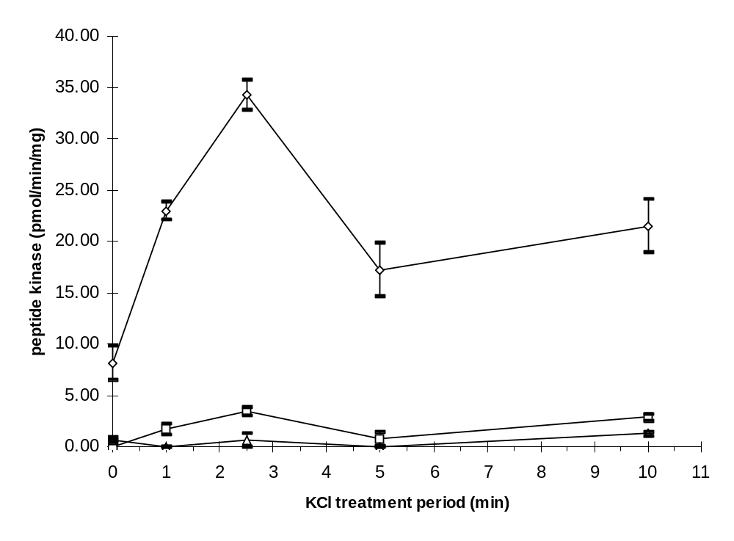
Figure 3. Time course of KCl depolarization of bovine adrenal chromaffin cells for the activation of a TH serine-31-specific peptide kinase

Figure 4. Human TH serine-31 peptide kinase activity eluted from Mono Q HR 5/5
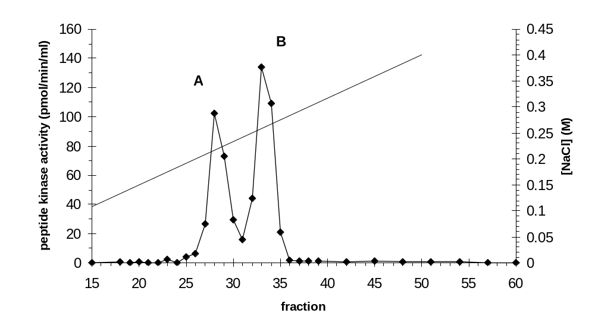
second peak sometimes had greater total activity than the first, and vice-versa).
Fractions corresponding to each of the separable peaks of Mono Q-eluted serine-31 kinase activity were pooled and the pools concentrated by centrifugal ultrafiltration. Each Mono Q peak was then loaded on to a Superose 12 HR 10/30 column which had been externally calibrated with native molecular weight standards. For each of the loaded peaks, the serine-31 kinase activity eluted as a single peak with virtually identical elution volumes (K_{d} values). This elution volume placed them in the molecular mass range of 45-50 kDa (figure 5). PDPK elutes normally with a slightly smaller elution volume, indicating that the Mono Q-resolved serine-31 kinases were at least distinct from the serine-8 phosphorylating PDPK
An additional test was also performed to ensure that PDPK and the Mono Q-resolved serine-31 kinase activities were distinct. Selected peak fractions and the entire pools corresponding to Mono Q peaks A and B serine-31 kinase were analyzed by Western immunoblotting with an affinity-purified antibody prepared to synthetic peptide corresponding to the carboxyl terminus of p34^{cdc2} (the amino acid sequence C-DNQIKKM) and considered definitive in the identification of the cell cycle-controlling protein kinase. Positive controls in which the lanes had been loaded with purified PDPK from FM3A cells had showed a strong signal at M_{r} 35,000 whereas the lanes loaded with peak fractions or pools indicated the presence of no p34^{cdc2} (data not shown). The properties of the serine-31 kinase on Mono Q and Superose columns were similar to properties exhibited by the MAP-2 kinase which had been characterized from insulin-stimulated 3T3-L1 adipocytes and was found to be a member of a class of protein kinases known as ERKs (Error: Reference source not found). Selected fractions of Mono Q-resolved peaks A and B from a preparation different from that shown in figure 4 were analyzed for the presence of the MAP-2K/ERK by Western immunoblotting. The antibody used is affinity-purified

Figure 5. Human TH serine-31 peptide kinase activity elution from a Superose 12 HR 10/30 column
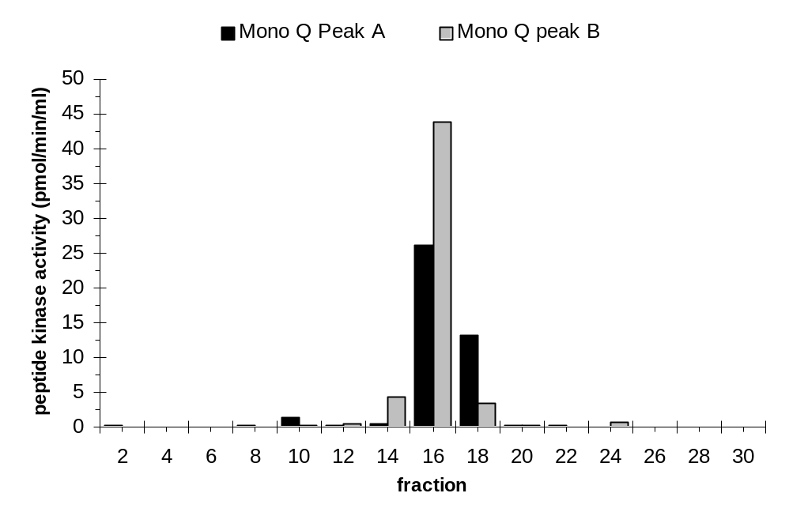

and was prepared to a synthetic peptide corresponding to the carboxyl terminus of rat brain ERK1. The top panel of figure 6 shows the hTH²²⁻³⁸ peptide kinase activity corresponding to the selected fractions of the Mono Q elution used in the Western analysis (fractions in the immunoblot are denoted with an asterisk), and the bottom panel figure 6 shows the immunoblot of the fractions. It can be seen in figure 4B that three immunoreactive bands with relative masses of 43, 47, and 59 kDa were observed in the fractions corresponding to peak A. From the signals, both the 43 and 47 kDa bands appear to be present in equivalent (1:1) amounts, while the 59 kDa band is relatively weak in its signal. The peak B fractions clearly show that the 47 kDa band shows the greatest signal (certainly >90% of the total signal), whereas the 43 kDa band appears to be barely present. Although the 59 kDa band is barely detectable in the fraction labeled 26, this presence is probably due to overlap of activity with peaks A and B in this preparation and for these purposes, the 59 kDa is effectively absent in peak B. A visualization of the total protein in these blots was not available as the protein amounts used were below the limits of detection using standard methods. Antibody to a synthetic peptide prepared to the subdomain III region of rat brain ERK1 and also considered of value in identifying MAP-2K/ERK members was also used in a Western blot of these same fractions, but no immunoreactive bands were found whatsoever (data not shown). The result of this latter immunoblotting was not conclusive however, since no positive control was available that could be used to verify antibody binding. In view of the finding that the multiple species of polypeptides reacting to an anti-MAP-2 kinase antibody were present, a large amount of serine-31 peptide kinase representing peak B activity from a Mono Q purification was available and loaded on to phenyl-Sepharose employing a method known to be effective in purifying and distinguishing the MAP-2 kinase (Error: Reference source not found). Figure 7 shows the elution of a single peak of peptide kinase activity, and
Figure 6. Immunoblot analysis of Mono Q with antibody to synthetic peptide of rat ERK

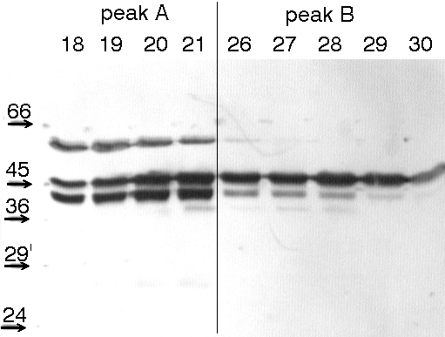

top panel: h31 peptide kinase activity in fraction of a Mono Q chromatographic run

bottom panel: Immunoblot of selected fractions from Mono Q column using antibody to rat ERK1. Numbers along top of blot below peak labels represent fraction numbers, and those along left of blot represent relative molecular mass

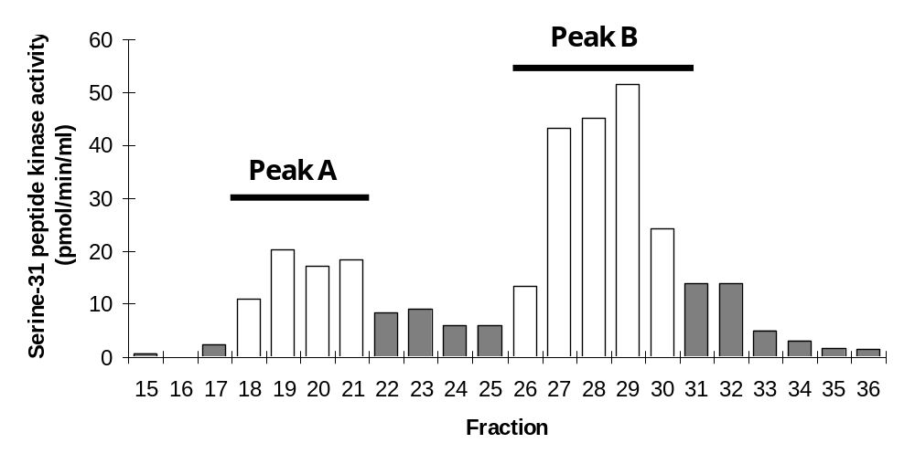

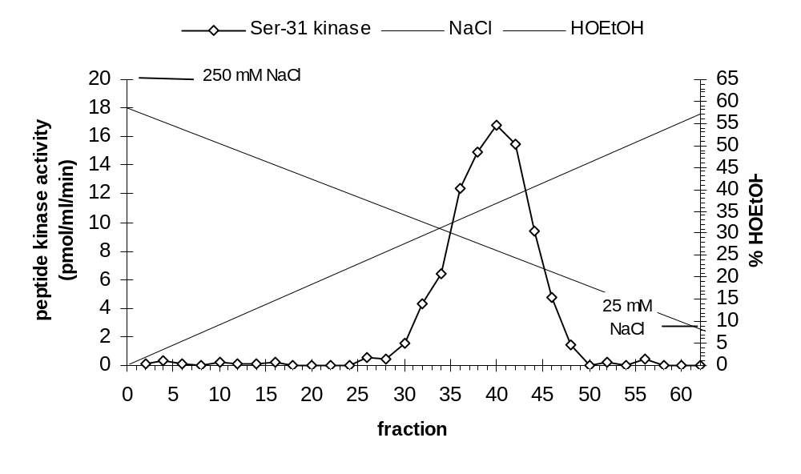
Figure 7. Phenyl-Sepharose chromatography of the human TH serine-31 peptide kinase
the point of elution is virtually identical with what is known for the elution of MAP-2K/ERK from this column. The synthetic peptides rTH¹³⁻²⁴ and rTH³⁴⁻⁴⁶ were used to examine kinase activity for these peptides but no significant phosphorylation of these peptides was observed. These peptides are useful in screening for the presence of protein kinases that would phosphorylate the serine 19 (e.g., CaM MPK) or the serine 40 site (e.g., PK-A). Because the phenyl-Sepharose-purified serine-31 kinase preparation was apparently free of kinases which might phosphorylate these other sites, it was used to investigate the phosphorylation and activation of TH by this serine-31 kinase.

In vitro phosphorylation of purified bovine adrenal TH with purified chromaffin cell serine-31 protein kinase
The ability of the purified serine-31 peptide kinase to phosphorylate and activate TH was examined by adding varying amounts of the kinase to purified bovine adrenal TH substrate or by incubating TH with fixed amounts of protein kinase for varying periods of time. Activation of TH by the serine-31 peptide kinase was observed to be dependent both upon the amount of purified serine-31 kinase added (fig. 8) and the duration of incubation (fig. 9). Additions of the purified kinase appeared to increase activity to a maximum of 1.5- to 2.0-fold. The activity of TH incubated with only MgATP was less than 10% when compared to TH incubated without MgATP.
These activation studies can also be observed in the qualitative increases in specific phosphorylation of TH. Figure 10 shows an autoradiograph of the bovine TH phosphorylated with both varying amounts of the serine-31 kinase and for varying incubation periods. Equal amounts of TH protein are loaded into each lane as shown by a Coomassie stain of the gel (data not shown). The figure shows that TH was found to incorporate phosphate dependent upon both the amount of kinase added and the time of
Figure 8. Activation of Bovine TH with Increasing Amounts of Purified Serine-31 Kinase
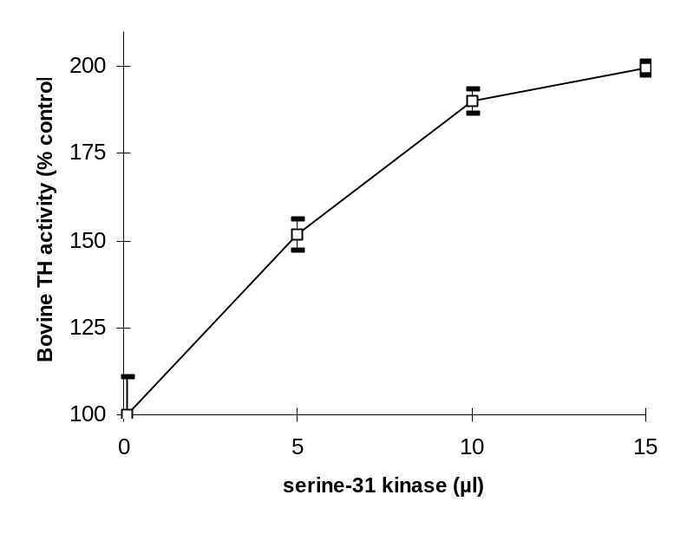

Figure 9. Activation of Bovine TH During Time of Incubation with Serine-31 Kinase
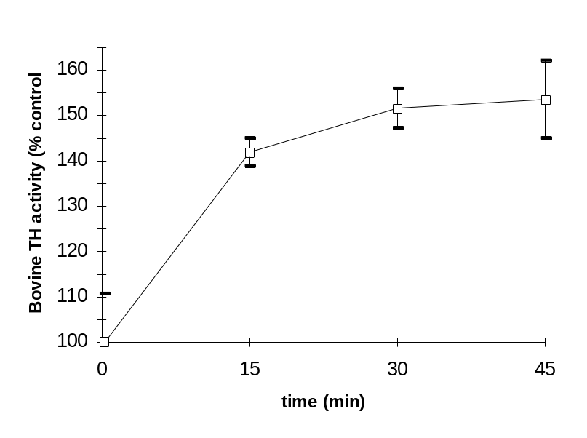

incubation. Some minor labeling is also observed in the lane showing TH incubated only with MgATP. This experiment was performed prior to the finding that addition of the PK-A inhibitor, PKI[6-22]amide, would have been of service. Limiting amounts of kinase and TH substrate made repetition of this experiment using PKI impossible.

Identification of Sites Phosphorylated in TH by The Serine-31 Kinase
TH was incubated with the serine-31 peptide kinase to determine the exact site(s) phosphorylated by the kinase. The PK-A inhibitor, PKI[6-22]amide, was also included to a final 0.1 µM during the incubation in view of the finding that . Preparative SDS-PAGE gel electrophoresis was used to isolate the phosphorylated TH. Slices of the dried polyacrylamide gel containing the phosphorylated TH were incubated with a trypsin solution and the tryptic peptides were analyzed on reversed-phase HPLC. Three major peaks labeled A, B and C (in order of elution) are indicated in the HPLC radiochromatogram (Fig. 5a).
Bovine TH was also phosphorylated using the same phosphorylating conditions by the PK-A catalytic subunit for the purpose of comparing its tryptic peptides to those of the serine-31 peptide kinase-phosphorylated TH tryptic peptides. The tryptic peptides from the PK-A-treated were prepared and separated on HPLC in three injections, with all radiochromatograms identical in appearance; one of the radiochromatograms is shown in fig 11B. Six of the peaks were considered to be the major peaks and are labeled with numbers 1-6.
To determine the identity of the three major peaks (A-C) in the serine-31 kinase-treated TH, a hTH²²⁻³⁸ synthetic peptide was also phosphorylated by a recombinant

Figure 10. Time- and Dose-Dependent Phosphorylation of Bovine TH by The Serine-31 Kinase.
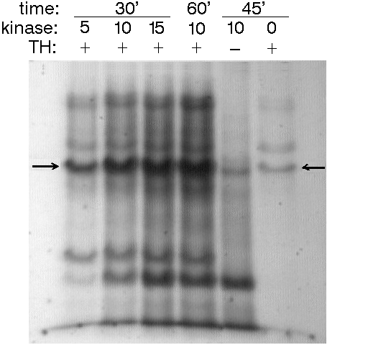
Bovine TH was treated with the activated chromaffin cell Ser31 protein kinase in the presence of g-[32P]ATP for different times and with varying levels of protein kinase. Samples were separated on 10% SDS-polyacrylamide gels, which were dried and autoradiographed. Above the autoradiograph image, time values are in minutes, kinase levels in microliters added, and the presence of substrate is indicated as present (+) or absent (–).

Figure 11. HPLC Radiochromatograms of Tryptic Phosphopeptides of Bovine TH or Synthetic Peptides Phosphorylated by Protein Kinases
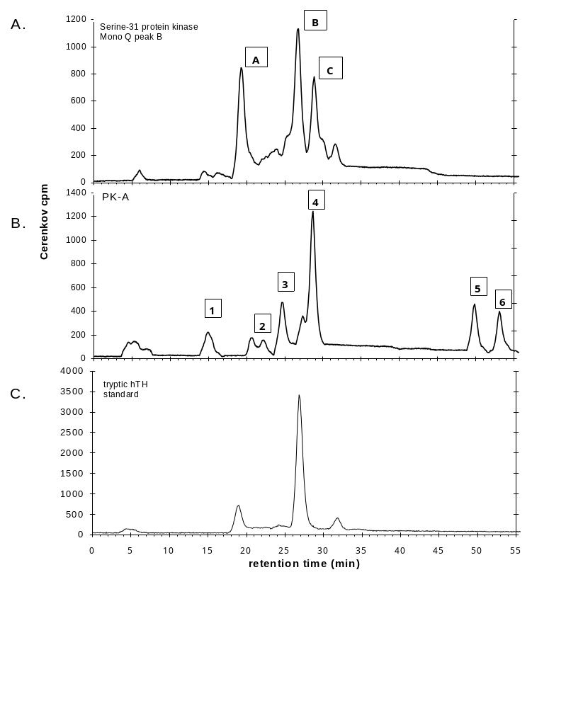

PDPK preparation, digested with trypsin, and then its tryptic phosphopeptide(s) prepared on HPLC using the same program. Although the hTH²²⁻³⁸ does not have the same amino acid sequence as the corresponding bovine TH sequence (bTH²²⁻³⁸), the predicted sequence of an exhaustively trypsin-treated human synthetic standard is in fact identical with the predicted sequence of an exhaustively trypsin-treated intact bovine TH subunit. Hence it should therefore be possible to use the human synthetic peptide as a standard for assessing specific phosphorylation of the serine-31 site. Figure 11C shows the HPLC radiochromatogram of the standard.
Although a single peak corresponding to the tryptic peptide containing the serine-31 site is predicted, the chromatogram shows the presence of two minor contaminants in addition to the large peak which eluted with a retention time predictable for the tryptic serine-31 peptide. HPLC analysis of the undigested phosphorylated hTH²²⁻³⁸ peptide showed a single peak with a longer retention time (data not shown), so none of the peaks in the standard corresponded to undigested peptide. Re-analysis of the standard mixture later showed the two “minor contaminants” had actually increased in proportion relative to the single major peak with retention time 27 min. The exhaustively trypsinized synthetic peptide is known to contain a methionine residue (at position 30, see Table 1), and these residues are notorious for their susceptibility to oxidation (). In addition, the exhaustively trypsinized peptide is predicted to have an amino terminal glutamine, which is susceptible to intramolecular transamidation reactions leading to the formation of a cyclized glutamine (pyroglutamate). If such reactions occur independently, it would
be expected that four radiolabeled species would be found over time: the normal, unmodified peptide; a peptide with a pyroglutamyl amino terminus; a peptide with a methionine sulfoxide (oxidized methionine); and a peptide with both pyroglutamyl and methionine sulfoxide residue. These would be evident as four peaks on HPLC, assuming
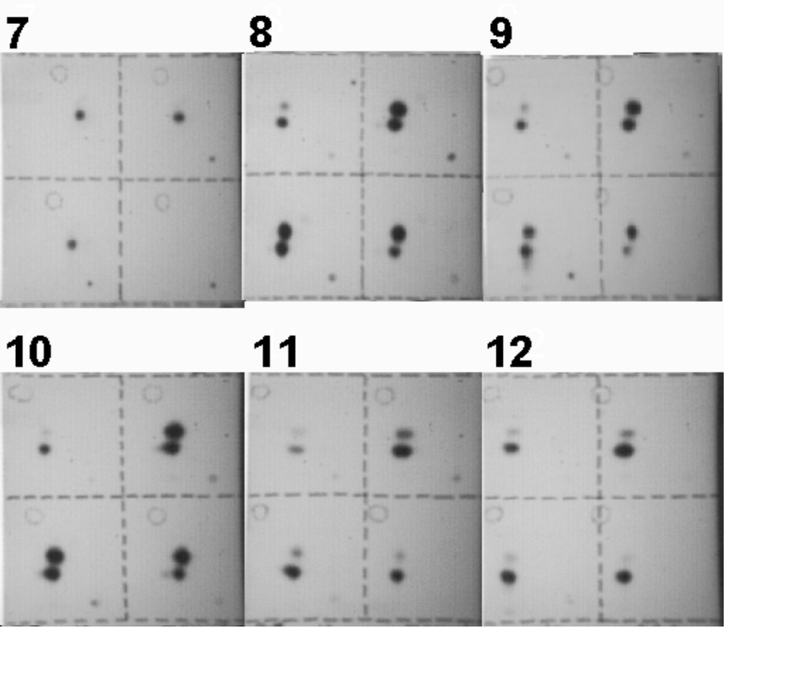Figure 12 (cont.)
Figure 12. Thin-layer Electrophoresis/Chromatography Comparison of HPLC-Purified Tryptic Phosphopeptides.
Shown are the images of the autoradiographs of eighteen thin-layer plates used to determine identity (to distinguish) between two different samples of ³²P-radiolabeled phosphopeptides. The samples of phosphopeptides represent fractions of peaks from reversed-phase HPLC. Each thin-layer plate is divided into quadrants. Quadrants 1 and 4 (diagonal from one another, being the upper left and lower right, respectively, in the image of each plate) are spotted with either of the samples. Quadrants 2 and 3 (also diagonal from one another, being the upper right and lower left, respectively, in the image of each plate) are spotted with both of the samples. The samples are spotted in the lower right of each quadrant (1 cm from the edges), and many of the autorads of the plates feature a dark spot indicating the sample spot with precipitated radiolabeled material. Electrophoresis from cathode to anode is from right to left in the image of each quadrant; electrophoresis is done on the entire 4-quadrant plate. The plate is then cut in half to separate quadrants 1 and 2 from quadrants 3 and 4, and each half-plate is developed chromatographically, from bottom to top in the image of the half plate. After drying, the half-plates are taped back together on their mylar backings as they were before cutting, and then exposed to xray film. After the necessary exposure period, the location of a spot of a visible indicator dye spotted onto the plate with the samples before the two-dimensional separation is drawn on the film with a marker, shown as an open dashed circle typically in the upper left of the quadrant, and which indicates the extent of the dye spot area. The marker was also used to draw dashed lines on the film to indicates the extent of the quadrant area
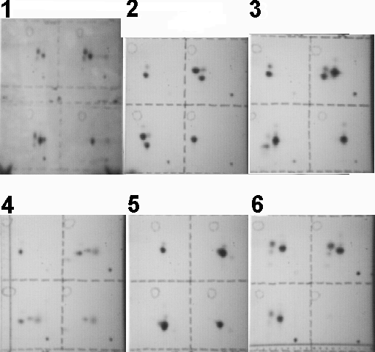
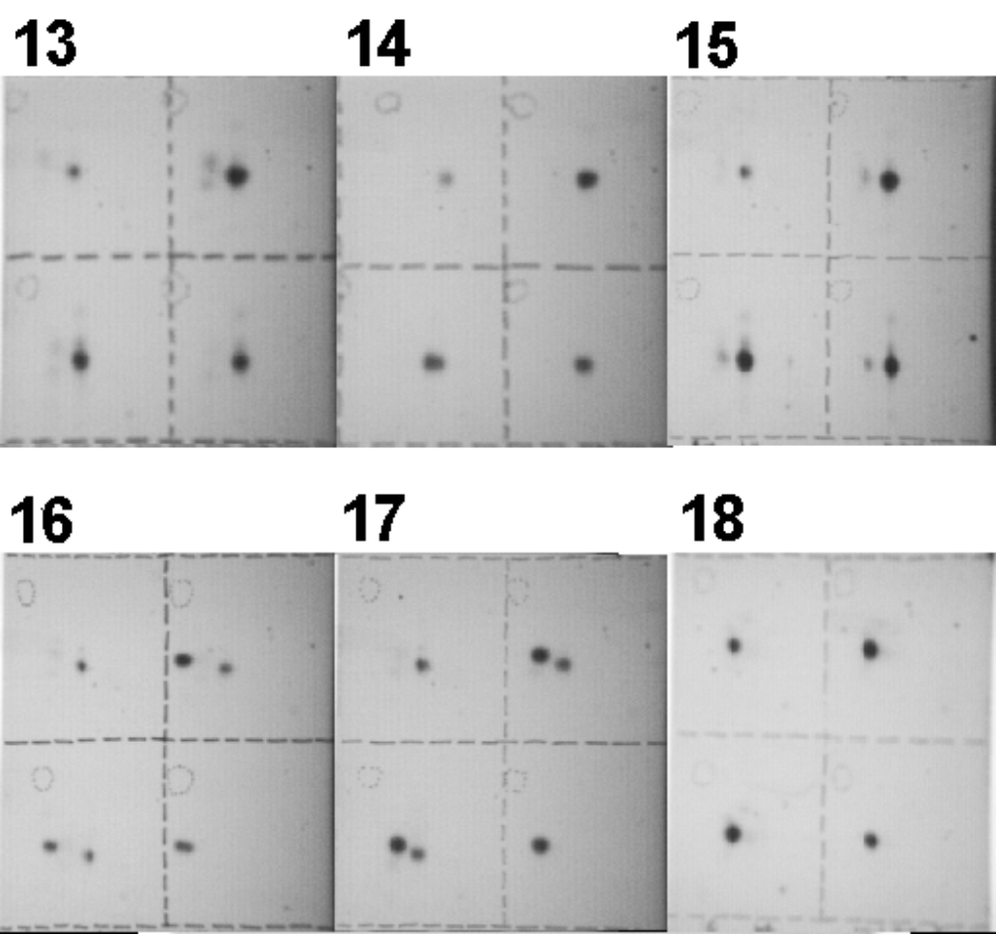
Figure 12 (cont.)
the retention times were different. As more time passed, it indeed became evident that four species were present as analyzed on HPLC (data not shown).
Attempts were made to ascertain whether the above assumptions were correct. It is predictable and known that methionine oxidation increases retention time of peptides since the molecular polarity is increased. As only one peptide had a retention time on the HPLC column longer than the predictably unmodified standard, it was treated with a mixture intended to restore the methionine residue to its reduced form and then analyzed on HPLC. One of the other peptides was treated with pyroglutamate aminopeptidase and also analyzed on HPLC.
Since each peak of the HPLC radiochromatogram may have contained more than a single phosphopeptide species, each of the HPLC peaks of the serine-31 kinase-treated TH was compared to selected HPLC peaks of the PK-A-treated TH and to the tryptic phosphopeptides of the synthetic standard using thin-layer electrophoresis/chromatography (TLE/C). Phosphopeptides were only compared if the peak to be compared fell within a ±20% time window of the peak retention time of the serine-31 kinase phosphopeptides. It is assumed that peaks outside that time window are clearly different species. Figure 12 shows the images of a panel of the eighteen TLE/C plates that were used in determining identity of the phosphopeptides from HPLC. Some of the plates are definitive in establishing the identity of peaks A and B as peptides containing only the serine-31 phosphorylation site. Peak A is likely a modified peptide, being the pyroglutamyl form. Peak C was not observed in the TLE/C plate analysis to be identical to a tryptic peptide of the synthetic standard, but did show identity with one of the major peaks of the PK-A-treated bovine TH. In view of the fact that PKI was present in amounts sufficient to inhibit PK-A activity present in either the TH or the serine-31 kinase preparations, it appears likely that a contaminating serine-40 protein kinase is present that is not inhibited by PKI.
Phosphoamino acid analysis indicated that all of the HPLC peaks of the digested human synthetic standard, as well as the tryptic peptides in serine-31 peptide kinase- and PK-A-treated bovine TH contained phosphoserine (data not shown). Under the conditions indicated for the phosphorylation, the incorporation of phosphate into the serine-31 site of bovine TH by the serine-31 peptide kinase was estimated to be 0.26 mol P/mol TH subunit.

Substrate Specificity of Mono Q- and Superose-purified TH Serine 31 kinase
Several substrates were tested using preparations of the chromaffin cell protein kinase purified at the Mono Q steps (both peaks A and B) and through the Superose 12 step. PDPK phosphorylates a single site in bovine brain synapsin (Error: Reference source not found) and four sites in human tau-2 (Error: Reference source not found). These proteins also appear to be phosphorylated by the chromaffin cell protein kinase as well (Figure 13). Under conditions in which PDPK phosphorylates synapsin to 0.78 mol P/mol synapsin, Mono Q peak A incorporate 0.35 mol P/mol protein, and Mono Q peak B incorporates 1.51 mol P/mol protein. The same PDPK preparation phosphorylates tau to 7.45 mol P/mol protein, while the same preparations of Mono Q peaks A and B incorporate 0.30 and 0.65 mol P/mol tau, respectively. The two Mono Q peaks contain significant levels of phosphorylating activity toward Kemptide and rTH³⁴⁻⁴⁶, which are used generally as indicators of the level of cAMP-dependent protein kinase activity, and toward the synthetic peptide rTH¹³⁻²⁶, which is used as an indicator of the calcium/calmodulin-dependent protein kinase activities (data not shown). Because of this potentially confounding presence of protein kinase activity, an additional chromatographic step (phenyl-Sepharose) is necessary.

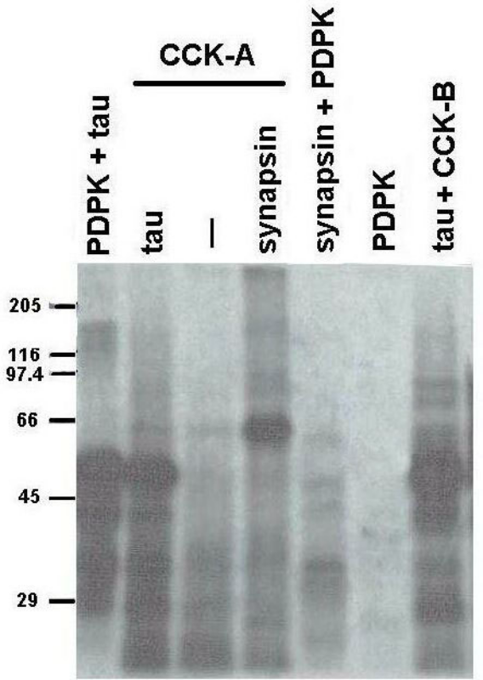
Figure 13. Autoradiogram of synapsin and tau as substrates for PDPK and Mono Q-purified chromaffin cell protein kinase.
Tau (~5 µg) and synapsin (~10 µg) are treated with either PDPK (purified from extracts of FM3A cells) or peak A or B from Mono Q-purified preparations of depolarized chromaffin cells with [γ-³²P]ATP and acid-precipitated pellets are analyzed on 10% SDS-polyacrylamide gel. The values of molecular weight markers in kDa are given.
Pooled fractions from Mono Q peaks A and B and to the peaks of Superose 12-purified Mono Q peaks A and B were analyzed for specific activity to various synthetic peptide substrates (Table 4). All protein kinase fractions show the greatest relative specific activity for the h31 peptide. The r31 and r8 peptides also contain the –XSPX–motif, but their relatively lower incorporation of phosphate indicates that factors other than a carboxyl proline are required. Peptides substituting the carboxyl proline for alanine corresponding to the r31 and r8 peptides were also tested; despite detectable phosphate incorporation into these synthetic peptides, the requirements for a carboxyl-side proline seem evident.

All peptides in the kinase assay were present at 200 µM under standard phosphorylating conditions.
Table 4. Substrate Specificity of Purified Chromaffin Cell Serine-31 Kinase
Peptide Substrate | Relative Specific Activity
Peptide Substrate | Mono Q  peak A | Mono Q  peak B | Superose 12-purified  Mono Q peak A | Superose 12-purified  Mono Q peak B
hTH²²⁻³⁸ | 100.0% | 100.0% | 100.0% | 100.0%
rTH²³⁻³⁸ | 28.7% | 26.3% | 42.5% | 30.5%
rTH²⁻¹⁶ | 37.0% | 37.5% | 49.3% | 38.4%
rTH²⁻¹⁶ [Ala9] | 7.1% | 1.7% | 11.9% | 3.4%
rTH²³⁻³⁸ [Ala32] | 2.6% | 1.3% | 4.5% | 1.4%

DISCUSSION
Rat PC12 cells are used routinely as a model for investigating the biochemical processes of chromaffin cells and sympathetic neurons since they are derived from and share phenotypic characteristics of adrenal chromaffin cells. This laboratory has previously reported that tyrosine hydroxylase isolated from PC12 cells treated with NGF or depolarizing concentrations of KCl incorporated a relatively greater amount of phosphate into the serine 31 phosphorylation site than into the other three known phosphorylation sites (serines 8,19, and 40) (Error: Reference source not found). In this study, nonmitotic bovine adrenal chromaffin cells were utilized to identify the serine 31 kinase in order to eliminate the possibility that proline-directed protein kinase (p58^{cyclin A}/p34^{cdc2}) or other cell cycle-controlling proline-directed protein kinases could complicate the search for physiologically relevant TH phosphorylation. This study identified a serine 31 protein kinase that was immunochemically and biochemically identical with MAP-2K/ERKl (44). This observation from nonmitotic cells is supported by the finding that an extracellularly regulated kinase (ERK1) purified from mitotically active PC12 cells was able to phosphorylate the serine 31 site of PC12 TH and cause catalytic activation (Error: Reference source not found).
Presence of the MAP-2K/ERKl proteins has been reported for chromaffin cells, and the activation of this proline-directed protein kinase by depolarizing concentrations of KCl is similar to that reported here (Error: Reference source not found). Moreover, a recent report confirms and extends this finding by showing that many other hormonal agents stimulate ERKl and ERK2 activity in chromaffin cells (Error: Reference source not found). The immunoblotting analysis for the serine 31 protein kinase demonstrated multiple isoenzymes at 43 and 45 kDa in the Mono Q-separated serine 31 peptide phosphorylating activities. This observation is consistent with results from PC12 cells which identify ERKl as a 43-kDa protein present in neuronal and neuronal-like tissues. ERK4 has also been identified as a 45-kDa protein in these tissues (Error: Reference source not found, Error: Reference source not found). It is known that activation of MAP-2K/ERK family members involves the phosphorylation of two virtually juxtaposed sites, a threonine and a tyrosine residue (in the case of the ERKl structure) (Error: Reference source not found). The peptide kinase activity eluting from Mono Q as peak B (largely the 45-kDa protein) is a MAP-2K/ERK1 protein in a more highly phosphorylated state, which accounts for its greater affinity to the ion exchange column.
The depolarization-dependent activation of the chromaffin cells MAP-2K/ERK reaches maximum after 2 to 3 min (fig. 9). Haycock (110) has reported that serine 19 and 40 phosphorylation is approaching a maximum within this time frame, indicating that activation of protein kinases dependent upon calcium, such as the calmodulin-dependent protein kinases, would be very rapid and may precede the activation of the serine 31 protein kinase. The activation of the serine 31 protein kinase may indeed be an event downstream in the cascade that involves activation of the calcium-dependent protein kinase C. In addition, the effects of NGF and KCl on PC12 cells, of KCl on chromaffin cells, and of phorbol ester treatments of both chromaffin and PC12 cells, cause significant increases in TH serine 31 phosphorylation associated with protein kinase C activation (109, 110, Error: Reference source not found). The activation of MAP-2K/ERK in PC12 cells by NGF treatment has kinetics similar to that shown for chromaffin cells (245).
It is important to note that differences in the primary structure within the regulatory region of the TH subunit may have functional importance. For all species, the sequence adjacent to serine 19 and 40, located in consensus sites for calcium- and calmodulin-dependent protein kinase and protein kinase A, respectively, remain relatively unchanged. In contrast, differential exon recruitment results in multiple human TH isoforms with changes in the primary sequence adjacent to the serine 31 phosphorylation site (Error: Reference source not found, -). In analyzing the substrate specificity of the bovine serine 31 protein kinase, it was found that the human TH²²⁻³⁸ peptide was a better substrate than the rat TH²³⁻³⁸ peptide. The rat peptide differs from the human and bovine TH peptide in the primary sequence upstream from the serine 31 site. While the human peptide has a -IMSP- structure identical with the bovine TH serine 31 site, the rat peptide has a -VTSP- structure. Since the identified phosphorylation sites on the amino-terminal of TH appear to be transiently phosphorylated during the depolarization-dependent activation of TH and their phosphorylations appear to have differential time courses, this suggests that each site might have a unique functional role. Since the phosphorylation of serine 31 has a longer time course, its role may be to maintain TH in a more persistent activated state.
The interspecific variation around the serine 31 site may be selective for a specific protein kinase modifying the site, or if it is modified by protein kinases existing in multiple isoforms, such as ERKl and ERK2, the change may select for ERKl rather than ERK2. Although attempts have been made to define precisely the substrate recognition sequence of the MAP-2K/ERK using synthetic peptide substrates (Error: Reference source not foundError: Reference source not found-Error: Reference source not found), little data exist for the selective criteria using native proteins. The sequence modification of the serine 31 site between species and, in the case of humans, between tissues, may be to effect a differential affinity of the serine 31 site as a substrate for a single protein kinase. Alternatively, the possibility that changes in the primary structure around the serine 31 site may control the dephosphorylation and activity of TH (Error: Reference source not found, Error: Reference source not found).
Several models have suggested that MAP-2K/ERK activation results from protein kinase C activation (). Protein kinase C can be activated by increased phospholipase C activity which is a result of G protein-mediated interactions with muscarinic acetylcholine receptors. In chromaffin cells, continued cholinergic stimulation would activate muscarinic receptors and this would initiate a cascade that produces activation of MAP-2K/ERK.
Alternatively, other paracrine factors secreted from the preganglionic nerve terminals of the adrenal medulla, such as IGF-I, which has been shown to activate MAP-2K/ERK in chromaffin cells (Error: Reference source not found), may provide the necessary tyrosine phosphorylation for activation of this kinase. Hence the evidence that MAP-2K/ERK mediates the phosphorylation of serine 31 in adrenergic tissues responding to a variety of extraneuronal stimuli is very compelling. This study demonstrates that the activation of MAP-2K/ERK clearly has a role in the control of tyrosine hydroxylase activity and the biological control of catecholamine biosynthesis.

FUTURE STUDIES
In the period since these experiments were completed, research efforts have been directed toward answering questions regarding structure-function relationships with enzymological characterizations. The mechanism of catalysis and the important elements of the active site have been elucidated (Error: Reference source not found). The role of a pair of positively charged residues on the arginines at positions 37 and 38 in the binding of dopamine is better understood (), showing how phosphorylation of serine 40 nearby may contribute at the very least to the ability to neutralize this charge effect and lead to TH activation.

Other Experimental Efforts
In the course of fulfilling the aims of this research proposal, many experimental efforts were undertaken in answering questions related to phosphorylation of TH.
Chromaffin cell cultures were treated with 12-O-tetradecanoylphorbol 13-acetate (TPA; also known as phorbol myristic acid or PMA), which is a known activator of protein kinase C (), and extracts were tested against synthetic peptide substrates corresponding to human and rat serine 31 and rat serine 8 over a time course. There was an indication that a serine 31 kinase was activated between 2- and 3-fold after 10 minutes, consistent with findings that enhanced synthesis were observed over that period (Error: Reference source not found). In a report published a couple of years after these experiments, serines 31 and 40 of TH in phorbol ester-treated bovine chromaffin cells were found to incorporate phosphate as much as 4- to 5-fold (Error: Reference source not found).
The mechanism of activation of TH in adrenal medullary tissue was an important question as well. The current study reports using potassium chloride-treated cultured chromaffin cells for activating the serine 31 protein kinase. An attempt was made to perfuse cannulated whole adrenal medulla with depolarizing solution, and then quickly extract the medulla in ice-cold buffers. Extracts of medullae treated with depolarizing and control solutions were then passed over DEAE-cellulose columns. Results showed the presence of hTH²²⁻³⁸ peptide kinase present to the same degree in both control and treated medullae. While notes recorded at the time of these experiments indicates that the “glands were not of the best quality” and that “glands were not used rapidly after slaughter,” it was probably better reasoning that the manipulation and handling the glands on the same day they were to be treated was alone sufficient to activate numerous kinases whose activities might overwhelm any effect of the treatment. The approach was taken that it was better to isolate the chromaffin cells from the gland and let them remain quiescent for a sufficient period prior to a treatment that would not be complicated by other variables such as the trauma of gland manipulation.
Several substrate specificity studies were done in addition to the study mentioned in the previous section with both proteins and synthetic peptides. One of these studies attempted to characterize the difference between the chromaffin cell protein kinase and PDPK, as it was not really understood if these enzymes were distinct. Table 5 shows data comparing the differences in phosphorylation toward synthetic peptides. While it is interesting that both the isoforms of the chromaffin cell kinase purified on Mono Q show greater reactivity toward the human serine-31 peptide and that PDPK shows greater activity toward serine-8 peptide (the substrate initially identifying it), the data are confounded by the fact that one or more of the protein kinases also showed high phosphorylation of peptides with no carboxyl-side prolines, which might be due to contaminating kinases in the preparation or perhaps technical error. Nonetheless, the experiment is worth repeating.
The decision to purify the TH substrate from the very same tissue (bovine adrenals)
Table 5. Substrate Specificity of TH Serine 31 Kinase
Peptide Substrate | Relative Specific Activity*
 | Serine 31 Kinase
 | Mono Q  peak A | Mono Q  peak B | PDPK
hTH²²⁻³⁸ | 100.0 ± 22.6% | 100.0 ± 17.5% | 27.4 ± 4.8%
rTH²³⁻³⁸ | 56.8 ± 9.2% | 77.8 ± 14.9% | 14.0 ± 1.1%
rTH²⁻¹⁶ | 43.1 ± 6.6% | 35.7 ± 15.5% | 100.0 ± 12.0%
rTH²⁻¹⁶ [Ala9] | 43.2 ± 5.9% | 27.9 ± 14.6% | 8.5 ± 0.9%
rTH²³⁻³⁸ [Ala32] | 3.5 ± 5.8% | 86.5 ± 15.6% | 2.9 ± 0.9%
* Expressed as relative to highest specific activity determined for the panel of synthetic peptides tested. The difference between the highest incorporated phosphate and the background (no substrate added) were as follows: for CCK-A, 2.2-fold; for CCK-B, 1.6-fold; for PDPK, 10.3-fold. Determinations are based on triplicate measurements for the proline-containing peptides, duplicate measurements for the proline-substituted peptides. All substrate concentrations are saturating at 200 µM. PDPK is purified from extracts of FM3A cells. The Mono Q peaks are from a different preparation of stimulated chromaffin cells than in Table 4.

as the protein enzyme kinase that phosphorylates it created many difficulties for the project. The protein kinase requires fewer steps to separate out other kinases that phosphorylate the synthetic TH peptides. However TH extracted from adrenal medullae contains many protein kinases that can confound the in vitro phosphorylation reaction, and many lots of extracts were prepared, often with low yields. Several recombinant TH subunits were available during the course of this work. A wild-type rat TH subunit was made available and could be expressed in baculovirus-infected Sf9 cells, then purified in virtually a single step with high yield. The limited amount of chromaffin cell kinase for phosphorylations did not permit testing this substrate however.

Unanswered Questions
Much about the structure-function relationships important to TH catalysis and regulation by the N-terminal domain through its post-translational modification by phosphorylation has been learned through mutagenesis, enzymological, crystallographic, and spectroscopic studies. There is still much to be learned. What is the significance of multiple isoforms of TH in species where they are found, and does alternative splicing serve to change the scheme of regulation by multiple protein kinases? Have all the protein kinases that control TH activation and function been identified? Does Ser19, Ser31, and Ser40 phosphorylation by their respective kinases occur in all tissues, or does one form predominate? What is the fold activation with Ser 31 phosphorylation of a TH mutant with Ser40 conservatively substituted with alanine to eliminate activation that may result from the slightest phosphorylation of that residue? Is there a biological role for the phosphorylation of Ser8? Hopefully all of these important questions will be answered in the next decade as improved analytical techniques are available.

BIBLIOGRAPHY

. Lehninger, A. L., Principles of Biochemistry, (Worth Publishers, Inc.: New York), 1982.
. Levitt, M., Spector, S., Sjoerdsma, A., Udenfriend, S. (1965) Elucidation of the rate-limiting step in norepinephrine biosynthesis in the perfused guinea pig heart. J. Pharmacol. Exp. Ther. 148, 1-8.
. Nagatsu, T., Levitt, M., Udenfriend, S. (1964) Tyrosine hydroxylase, the initial step in norepinephrine biosynthesis. J. Biol. Chem. 239, 2910-2917.
. Richtand, N. M., Inagami, T., Misono, K., Kuczenski, R. (1985) Purification and characterization of rat striatal tyrosine hydroxylase. J. Biol. Chem. 260, 8465-8473.
. Ikeda, M., Fahien, L. A., Udenfriend, S. (1966) J. Biol. Chem. 241, 4452-4456. A kinetic study of bovine adrenal tyrosine hydroxylase
. Numata(Sudo), Y., Kato, T., Nagatsu, T., Sugimoto, T., Matsuura, S. (1977) Effects of stereochemical structures of tetrahydrobiopterin on tyrosine hydroxylase. Biochim. Biophys. Acta 480, 104-112.
. Meyer, M. M., Fitzpatrick, P. F. (1992) The amino acid substrate of bovine tyrosine hydroxylase. Neurochem. Int. 21, 191-196.
. Fukami, M. H., Haavik, J., Flatmark, T. (1990) Phenylalanine as substrate for tyrosine hydroxylase in bovine adrenal chromaffin cell . Biochem. J. 268, 525-528.
. Dix, T. A., Benkovic, S. J. (1985) Mechanism of "uncoupled" tetrahydropterin oxidation by phenylalanine hydroxylase. Biochemistry 24, 5839-5846
. Adams, J. D. Jr., Klaidman, L. K., Ribeiro, P. (1997) Tyrosine hydroxylase: mechanisms of oxygen radical formation. Redox Rep. 3, 273-279.
. Udenfriend, S., Zaltzman-Nirenberg, P., Nagatsu, T. (1965) Inhibitors of purified beef adrenal tyrosine hydroxylase. Biochem. Pharmacol. 14, 837-845.
. Ames, M. M., Lerner, P. Lovenberg, W. (1978) Tyrosine hydroxylase. Activation by protein phosphorylation and end product inhibition. J. Biol. Chem. 253, 27-31.
. Michaud-Soret, I., Andersson, K. K., Que, L., Jr., Haavik, J. (1995) Resonance Raman studies of catecholate and phenolate complexes of recombinant human tyrosine hydroxylase. Biochemistry 34, 5504-5510.
. Haavik, J., Martinez, A., Olafsdottir, S., Mallet, J., Flatmark, T. (1992) The incorporation of divalent metal ions into recombinant human tyrosine hydroxylase apoenzymes studied by intrinsic fluorescence and 1H-NMR spectroscopy. Eur. J. Biochem. 210, 23-31.
. Lazar, M. A., Lockfeld, A. J., Truscott, R. J. W., Barchas, J. D. (1982) Tyrosine hydroxylase from bovine striatum: catalytic properties of the phosphorylated and nonphosphorylated forms of the purified enzyme. J. Neurochem. 39, 409-422.
. Bradford, H. F., Chemical Neurobiology: An Introduction to Neurochemistry, (New York: W. H. Freeman & Co.), 1986.
. Park, D. H., Goldstein, M. (1976) Purification of tyrosine hydroxylase from pheochromocytoma tumors. Life Sci. 18, 55-60.
. Markey, K. A., Kondo, S., Shenkman, L., Goldstein, M. (1980) Purification and characterization of tyrosine hydroxylase from a clonal pheochromocytoma cell line. Mol. Pharmacol. 17, 79-85.
. Okuno, S., Fujisawa, H. (1982) Purification and some properties of tyrosine 3-monooxygenase from rat adrenal. Eur. J. Biochem. 122, 49-55.
. Togari, A., Kano, H., Oka, K., Nagatsu, T. (1983) Simultaneous simple purification of tyrosine hydroxylase and dihydropteridine reductase. Anal. Biochem. 132, 183-189.
. Kojima, K., Mogi, M., Oka, K., Nagatsu, T. (1984) Purification and immunochemical characterization of human adrenal tyrosine hydroxylase. Neurochem. Int. 6, 475-480.
. Kuhn, D. M., Billingsley, M. L. (1987) Tyrosine hydroxylase: purification from PC12 cells, characterization and production of antibodies. Neurochem. Int. 11, 463-475.
. Nagatsu, T., Oka, K. (1987) Tyrosine 3-monooxygenase from bovine adrenal medulla. Meth. Enzymol. 142, 56-63.
. Fujisawa, H., Okuno, S. (1987) Tyrosine 3-monooxygenase from rat adrenals. Meth. Enzymol. 142, 63-71.
. Tank, A. W., Weiner, N. (1987) Tyrosine 3-monooxygenase from rat pheochromocytoma. Meth. Enzymol. 142, 71-83.
. Haavik, J., Andersson, K. K., Petersson, L., Flatmark, T. (1988) Soluble tyrosine hydroxylase (tyrosine 3-monooxygenase) from bovine adrenal medulla: large scale purification and physicochemical properties. Biochem. Biophys. Acta 953, 142-156.
. Gahn, L., Roskoski, R. (1991) Tyrosine hydroxylase purification from rat PC12 cells. Prot. Expr. Pur. 2, 10-14.
. Thibault, J., Vidal, D., Gros, F. (1981) In vitro translation of mRNA from rat pheochromocytoma tumors. Characterization of tyrosine hydroxylase. Biochem. Biophys. Res. Comm. 99, 960-968.
. Greene, L. A., Tischler, A. S. (1976) Establishment of a clonal line of rat adrenal pheochromocytoma cells which respond to nerve growth factor. Proc. Natl. Acad. Sci. USA 73, 2424-2428.
. Ichikawa, S., Nasrin, S., Nagatsu, T. (1991) Expression of mouse tyrosine hydroxylase in Escherichia coli. Biochem. Biophys. Res. Comm. 178, 664-671.
. Fitzpatrick, P. F., Chlumsky, L. J., Daubner, S. C., O'Malley, K. L. (1990) Expression of rat tyrosine hydroxylase in insect tissue culture cells and purification and characterization of the cloned enzyme. J. Biol. Chem. 265, 2042-2047.
. Kuczenski, R. (1973) Soluble, membrane-bound and detergent-solubilized rat striatal tyrosine hydroxylase: pH-dependent cofactor binding. J. Biol. Chem. 248, 5074-5080.
. Bonnefoy, E., Ferrara, P., Rohrer, H., Gros, F., Thibault, J. (1988) Role of the N-terminus of rat pheochromocytoma tyrosine hydroxylase in the regulation of the enzyme's activity. Eur. J. Biochem. 174, 685-690.
. Kuczenski, R., Mandell, A. J. (1972) Allosteric activation of hypothalamic tyrosine hydroxylase by ions and sulfated mucopolysaccharides. J. Neurochem. 19, 131-137.
. Katz, I. R., Yamauchi, T., Kaufman, S. (1976) Activation of tyrosine hydroxylase by polyanions and salts: an electrostatic effect. Biochim. Biophys. Acta 429, 84-95.
. Kiuchi, K., Kiuchi, K., Togari, A., Nagatsu, T. (1987) Effect of spermine on tyrosine hydroxylase activity before and after phosphorylation by cyclic AMP-dependent protein kinase. Biochem. Biophys. Res. Comm. 148, 1460-1467.
. Kuhn, D. M., Arthur, Jr., R., Yoon, H., Sankaran, K. (1990) Tyrosine hydroxylase in secretory granules from bovine adrenal medulla. J. Biol. Chem. 265, 5780-5786.
. Rittenhouse, A. R., Zigmond, R. E. (1990) Nerve stimulation in vivo acutely increases tyrosine hydroxylase activity in the superior cervical ganglion and its end organs. Brain Res. 524, 156-159
. Lamouroux, A., Faucon Biguet, N. Samolyk, D., Privat, A., Salomon, J. C., Pujol, J. F., Mallet, J. (1982) Identification of cDNA clones coding for rat tyrosine hydroxylase antigen. Proc. Natl. Acad. Sci. USA 79, 3881-3885., with a reactive species to hydroxylate tyrosine, if it is present
. Grima, B., Lamouroux, A., Blanot, F., Faucon Biguet, N., Mallet, J. (1985) Complete coding sequence of rat tyrosine hydroxylase mRNA. Proc. Natl. Acad. Sci. USA 82, 617-621.
. Grima, B., Lamouroux, A., Boni, C., Julien, J.-F., Javoy-Agid, F., Mallet, J. (1987) A single human gene encoding multiple tyrosine hydroxylases with different predicted functional characteristics. Nature 326, 707-711.
. Saadat, S., Stehle, A. D., Lamouroux, A., Mallet, J., Thoenen, H. (1988) Predicted amino acid sequence of bovine tyrosine hydroxylase and its similarity to tyrosine hydroxylases from other species. J. Neurochem. 51, 572-578.
. D'Mello, S. R., Weisberg, E. P., Stachowak, M. K., Turzai, L. M., Gioio, A. E., Kaplan, B. B. (1988) Isolation and nucleotide sequence of a cDNA clone encoding bovine adrenal tyrosine hydroxylase: comparative analysis of tyrosine hydroxylase gene products. J. Neurosci. Res. 19, 440-449.
. Ichikawa, S., Ichinose, H., Nagatsu, T. (1990) Multiple messenger RNAs of monkey tyrosine hydroxylase. Biochem. Biophys. Res. Comm. 173, 1331-1336.
. Ichikawa, S., Sasaoka, T., Nagatsu, T. (1991) Primary structure of mouse tyrosine hydroxylase deduced from its cDNA. Biochem. Biophys. Res. Comm. 176, 1610-1616.
. Fauquet, M., Grima, B., Lamouroux, A., Mallet, J. (1988) Cloning of quail tyrosine hydroxylase: amino acid homology with other hydroxylases discloses functional domains. J. Neurochem. 50, 142-148.
. Ledley, F. D., DiLella, A. G., Kwok, S. C. M., Woo, S. L. C. (1985) Homology between phenylalanine and tyrosine hydroxylases reveals common structural and functional domains. Biochemistry 24, 3389-3394.
. Daubner, S. C., Piper, M. M. (1995) Deletion mutants of tyrosine hydroxylase identify a region critical for heparin binding. Protein Sci. 4, 538-541.
. Haycock, J. W. (1991) Four forms of tyrosine hydroxylase are present in human adrenal medulla. J. Neurochem. 56, 2139-2142.
. Haycock, J. W. (1993) Multiple forms of tyrosine hydroxylase in human neuroblastoma cells: quantitation with isoform-specific antibodies. J. Neurochem. 60, 493-502.
. Ichinose, H., Ohye, T., Fujita, K., Yoshida, M., Ueda, S., Nagatsu, T. (1993) Increased heterogeneity of tyrosine hydroxylase in human. Biochem. Biophys. Res. Comm. 195, 158-165.
. Bodeau-Péan, S., Ravassard, P., Neuner-Jehle, M., Faucheux, B., Mallet, J., Dumas, S. (1999) A Human Tyrosine Hydroxylase Isoform Associated with Progressive Supranuclear Palsy Shows Altered Enzymatic Activity. J. Biol. Chem. 274, 3469-3475.
. Birman, S., Morgan, B., Anzivino, M., Hirsh, J. (1994) A novel and major isoform of tyrosine hydroxylase in Drosophila is generated by alternative RNA processing. J. Biol. Chem. 269, 26559-26567.
. Laniece, P., Le Hir, H., Bodeau-Pean, S., Charon, Y., Valentin, L., Thermes, C., Mallet, J., Dumas, S. (1996) A novel rat tyrosine hydroxylase mRNA species generated by alternative splicing. J. Neurochem. 66, 1819-1825.
. Daubner, S. C., Lohse, D. L., Fitzpatrick, P. F. (1993) Expression and characterization of catalytic and regulatory domains of rat tyrosine hydroxylase. Protein Sci. 2, 1452-1460.
. Abate, C., Smith, J. A., Joh, T. H. (1988) Characterization of the catalytic domain of bovine adrenal tyrosine hydroxylase. Biochem. Biophys. Res. Comm. 151, 1446-1453.
. Lohse, D. L., Fitzpatrick, P. F. (1993) Identification of the intersubunit binding region in rat tyrosine hydroxylase . Biochem. Biophys. Res. Comm. 197, 1543-1548.
. Vrana, K. E., Walker, S. J., Rucker, P., Liu, X. (1994) A carboxyl terminal leucine zipper is required for tyrosine hydroxylase tetramer formation. J. Neurochem. 63, 2014-2020.
. Kiuchi, K., Kiuchi, K., Titani, K., Fujita, K., Suzuki, K., Nagatsu, T. (1991) Limited proteolysis of tyrosine hydroxylase by Ca(2+)-activated neutral protease (calpain). Biochemistry 30, 10416-10419.
. Mockus, S. M., Yohrling, G. J. 4th, Vrana, K. E. (1998) Tyrosine hydroxylase and tryptophan hydroxylase do not form heterotetramers. J. Mol. Neurosci. 10, 45-51.
. Minami, M., Takahashi, T., Maruyama, W., Takahashi, A., Nagatsu, T., Naoi, M. (1991) Allosteric effect of tetrahydrobiopterin cofactors on tyrosine hydroxylase activity. Life Sci. 50, 15-20.
. Goodwill, K. E., Sabatier, C., Stevens, R. C. (1998) Crystal structure of tyrosine hydroxylase with bound cofactor analogue and iron at 2.3 A resolution: self-hydroxylation of Phe300 and the pterin-binding site. Biochemistry 37, 13437-13445.
. Almas, B., Toska, K., Teigen, K., Groehn, V., Pfleiderer, W., Martinez, A., Flatmark, T., Haavik, J. (2000) A kinetic and conformational study on the interaction of tetrahydropteridines with tyrosine hydroxylase. Biochemistry 39, 13676-13686.
. Ellis, H. R., Daubner, S. C., McCulloch, R. I., Fitzpatrick, P. F. (1999) Phenylalaline Residues in the Active Site of Tyrosine Hydroxylase: Mutagenesis of Phe300 and Phe309 to Alanine and Metal Ion-Catalyzed Hydroxylation of Phe300. Biochemistry 38, 10909-10914.
. Erlandsen, H., Flatmark, T., Stevens, R. C., Hough, E. (1998) Crystallographic analysis of the human phenylalanine hydroxylase catalytic domain with bound catechol inhibitors at 2.0 A resolution. Biochemistry 37, 15638-15646.
. Andersson, K. K., Cox, D. D., Que, L. Jr., Flatmark, T, Haavik, J. (1988) Resonance Raman studies on the blue-green-colored bovine adrenal tyrosine 3-monooxygenase (tyrosine hydroxylase). Evidence that the feedback inhibitors adrenaline and noradrenaline are coordinated to iron. J. Biol. Chem. 263, 18621-18626
. Daubner, S. C., Fitzpatrick, P. F. (1998) Mutation of Phenylalanine of Tyrosine 371 in Tyrosine Hydroxylase Increases the Affinity for Phenylalanine. Biochemistry 37, 16440-16444.
. Daubner, S. C., Fitzpatrick, P. F. (1999) Site-Directed Mutants of Charged Residues in the Active Site of Tyrosine Hydroxylase. Biochemistry 38, 4448-4454.
. Daubner, S. C., Melendez, J., Fitzpatrick, P. F. (2000) Reversing the Substrate Specificities of Phenylalanine and Tyrosine Hydroxylase: Aspartate 425 of Tyrosine Hydroxylase Is Essential for l-DOPA Formation. Biochemistry 39, 9652-9661.
. Ellis, H. R., Daubner, S. C., Fitzpatrick, P. F. (2000). Mutation of Serine 395 of Tyrosine Hydroxylase Decouples Oxygen-Oxygen Bond Cleavage and Tyrosine Hydroxylation. Biochemistry 39, 4174-4181.
. Daubner, S. C., Hillas, P. J., Fitzpatrick, P. F. (1997). Characterization of Chimeric Pterin-Dependent Hydroxylases: Contributions of the Regulatory Domains of Tyrosine and Phenylalanine Hydroxylase to Substrate Specificity. Biochemistry 36, 11574-11582
. Schünemann, V., Meier, C., Meyer-Klaucke, W., Winkler, H., Trautwein, A. X., Knappskog, P. M., Toska, K., Haavik, J. (1999) Iron Coordination Geometry in Full-Length, Truncated, and Dehydrated Forms of Human Tyrosine Hydroxylase Studied by Mössbauer and X-Ray Absorption Spectroscopy. J. Bio. Inorg. Chem. 4, 223-231.
. Ramsey, A. J., Daubner, S. C., Ehrlich, J. I., Fitzpatrick, P. F. (1995) Identification of iron ligands in tyrosine hydroxylase by mutagenesis of conserved histidinyl residues. Protein Sci. 4, 2082-2086.
. Haavik, J., Le Bourdelles, B., Martinez, A., Flatmark, T., Mallet, J. (1991) Recombinant human tyrosine hydroxylase isozymes. Reconstitution with iron and inhibitory effect of other metal ions. Eur. J. Biochem. 199, 371-378.
. Guroff, G., Levitt, M., Daly, J., Udenfriend, S. (1966) The production of meta-tritiotyrosine from p-tritiophenylalanine by phenylalanine hydroxylase. Biochem. Biophys. Res. Comm. 25, 253-259.
. Renson, J., Daly, J., Weissbach, H., Witkop, B., Udenfriend, S. (1966) Enzymatic conversion of 5-tritiotryptophan to 4-tritio-5-hydroxytryptophan. Biochem. Biophys. Res. Comm. 25, 504-512.
. Guroff G, Daly JW, Jerina DM, Renson J, Witkop B, Udenfriend S. (1967) Hydroxylation-induced migration: the NIH shift. Recent experiments reveal an unexpected and general result of enzymatic hydroxylation of aromatic compounds. Science 157, 1524-1530.
. Daly J, Levitt M, Guroff G, Udenfriend S. (1968) Isotope studies on the mechanism of action of adrenal tyrosine hydroxylase. Arch Biochem Biophys. 126, 593-598.
. Fitzpatrick, P. F. (1994) Kinetic isotope effects on hydroxylation of ring-deuterated phenylalanines by tyrosine hydroxylase provide evidence against partitioning of an arene oxide intermediate. J. Am. Chem. Soc. 116, 1133-1134.
. Fitzpatrick, P. F. (1991) Steady-state kinetic mechanism of rat tyrosine hydroxylase. Biochemistry 30, 3658-3662.
. Dix, T. A., Kuhn, D. M., and Benkovic, S. J. (1987) Mechanism of oxygen activation by tyrosine hydroxylase. Biochemistry 26, 3354-3361
. Ribeiro, P., Pigeon, D., Kaufman, S. (1991) The hydroxylation of phenylalanine and tyrosine by tyrosine hydroxylase from cultured pheochromocytoma cells. J. Biol. Chem. 266, 16207-16211.
. Fitzpatrick, P. F. (1991) Studies of the rate-limiting step in tyrosine hydroxylase reaction: alternate substrates, solvent isotope effects, and transition-state analogues. Biochemistry 30, 6386-6391.
. Martinez, A., Abeygunawardana, C., Haavik, J., Flatmark, T., Mildvan, A. S. (1993) Conformation and interaction of phenylalanine with the divalent cation at the active site of human recombinant tyrosine hydroxylase as determined by proton NMR . Biochemistry 32, 6381-6390.
. Hillas PJ, Fitzpatrick PF (1996) A Mechanism for Hydroxylation of Tyrosine Hydroxylase Based on Partitioning of Substituted Phenylalanines. Biochemistry 35, 6969-6975.
. Campbell, D. G., Hardie, D. G., Vulliet, P. R. (1986) Identification of four phosphorylation sites in the N-terminal region of tyrosine hydroxylase. J. Biol. Chem. 261, 10489-10492.
. Ramsey AJ, Fitzpatrick PF (2000) Effects of Phosphorylation on Binding of Catecholamines to Tyrosine Hydroxylase: Specificity and Thermodynamics. Biochemistry 39, 773-778.
. Haavik, J., Martinez, A., Flatmark, T. (1990) pH-Dependent release of catecholamines from tyrosine hydroxylase and the effect of phosphorylation of Ser40. FEBS Lett. 262, 363-365.
. Almas, B., LeBourdelles, B., Flatmark, T., Mallet, J., Haavik, J. (1992) Regulation of recombinant human tyrosine hydroxylase isozymes by catecholamine binding and phosphorylation: structure/activity studies and mechanistic implications. Eur. J. Biochem. 209, 249-255.
. Alousi, A., Weiner, N. (1966) The regulation of norepinephrine synthesis in sympathetic nerves: effect of nerve stimulation, cocaine, and catecholamine-releasing agents. Proc. Natl. Acad. Sci. USA 56, 1491-1496.
. Roth, R. H., Starjne, L., Von Euler, U. S. (1966) Acceleration of noradrenaline biosynthesis by nerve stimulation. Life Sci. 5, 1071-1075.
. Weiner, N., Rabadjija, M. (1968) The effect of nerve stimulation on the synthesis and metabolism of norepinephrine in the isolated guinea-pig hypogastric nerve-vas deferens preparation. J. Pharmacol. Exp. Ther. 160, 61-71.
. Morgenroth, V. H. III, Boadle-Biber, M., Roth, R. H. (1974) Tyrosine hydroxylase: activation by nerve stimulation. Proc. Natl. Acad. Sci. USA 71, 4283-4287.
. Weiner, N., Lee, F.-L., Dreyer, E., Barnes, E. (1978) The activation of tyrosine hydroxylase in noradrenergic neurons during acute nerve stimulation. Life Sci. 22, 1197-1216.
. Murrin, L. C., Morgenroth, V. H. III, Roth, R. H. (1976) Dopaminergic neurons: effects of electrical stimulation on tyrosine hydroxylase. Mol. Pharmacol. 12, 1070-1081.
. Zigmond, R. E., Ben-Ari, Y. (1977) Electrical stimulation of preganglionic nerve increases tyrosine hydroxylase activity in sympathetic ganglia. Proc. Natl. Acad. Sci. USA 74, 3078-3080.
. Zigmond, R. E., Chalazonitis, A., Joh, T. (1980) Preganglionic nerve stimulation increases the amount of tyrosine hydroxylase in the rat superior cervical ganglion. Neurosci. Lett. 20, 61-65.
. Ikeno, T., Dickens, G., Lloyd, T., Guroff, G. (1981) The receptor-mediated activation of tyrosine hydroxylase in the superior cervical ganglion of the rat. J. Neurochem. 36, 1632-1640.
. Cahill, A. L., Perlman, R. L. (1984) Electrical stimulation increases phosphorylation of tyrosine hydroxylase in superior cervical ganglion of rat. Proc. Natl. Acad. Sci. USA 81, 7243-7247.
. Cahill, A. L., Perlman, R. L. (1987) Preganglionic stimulation increases the phosphorylation of tyrosine hydroxylase in the superior cervical ganglion by both cAMP-dependent and calcium-dependent protein kinases. Biochim. Biophys. Acta 930, 454-462.
. Haycock, J. W., Wakade, A. R. (1992) Activation and multiple-site phosphorylation of tyrosine hydroxylase in perfused rat adrenal glands. J. Neurochem. 58, 57-64.
. Otten, U., Thoenen, H. (1976) Mechanisms of tyrosine hydroxylase and dopamine beta-hydroxylase induction in organ cultures of rat sympathetic ganglia by potassium depolarization and cholinomimetics. Naunyn-Schmiedebergs Archives of Pharmacology 292, 153-159.
. Haycock, J. W., Meligeni, J. A., Bennett, W. F., Waymire, J. C. (1982) Phosphorylation and activation of tyrosine hydroxylase mediate the acetylcholine-induced increase in catecholamine biosynthesis in adrenal chromaffin cells. J. Biol. Chem. 257, 12641-12648.
. Nose, P. S., Griffith, L. C., Schulman, H. (1985) Ca2+-dependent phosphorylation of tyrosine hydroxylase in PC12 cells. J. Cell Biol. 101, 1182-1190.
. Pocotte, S. L., Holz, R. W., Ueda, T. (1986) Cholinergic receptor-mediated phosphorylation and activation of tyrosine hydroxylase in cultured bovine adrenal chromaffin cells. J. Neurochem. 46, 610-622.
. Houchi, H., Oka, M., Misbahuddin, M., Morita, K., Nakanishi, A. (1987) Stimulation by vasoactive intestinal polypeptide of catecholamine synthesis in isolated bovine adrenal chromaffin cells. Biochem. Pharmacol. 36, 1551-1554.
. Griffith, L. C., Schulman, H. (1988) The multifunctional Ca2+/calmodulin-dependent protein kinase mediates Ca2+-dependent phosphorylation of tyrosine hydroxylase. J. Biol. Chem. 263, 9542-9549.
. Haycock, J. W., Browning, M. D., Greengard, P. (1988) Cholinergic regulation of protein phosphorylation in bovine adrenal chromaffin cells. Proc. Natl. Acad. Sci. USA 85, 1677-1681.
. Horwitz, J., Perlman, R. J. (1984) Activation of tyrosine hydroxylase in the superior cervical ganglion by nicotinic and muscarinic agonists. J. Neurochem. 43, 546-552.
. Haycock, J. W. (1990) Phosphorylation of tyrosine hydroxylase in situ at serine 8, 19,31, and 40. J. Biol. Chem. 265, 11682-11691.
. Haycock, J. W. (1993) Multiple signaling pathways in bovine chromaffin cells regulate tyrosine hydroxylase phosphorylation at Ser19, Ser31, and Ser40. Neurochem. Res. 18, 15-26.
. Ip, N. Y., Perlman, R. L., Zigmond, R. E. (1982) Both nicotinic and muscarinic agonists acutely increase tyrosine 3-monooxygenase activity in the rat superior cervical ganglion. J. Pharmacol. Exp. Ther. 223, 280-283.
. Cahill, A. L., Perlman, R. L. (1984) Phosphorylation of tyrosine hydroxylase in the superior cervical ganglion. Biochim. Biophys. Acta 805, 217-226.
. Horwitz, J., Tsymbalov, S., Perlman, R. L., (1984) Muscarine increases tyrosine 3-monooxygenase activity and phospholipid metabolism in the superior cervical ganglion of the rat. J. Pharmacol. Exp. Therap. 229, 577-582.
. Waymire, J. C., Weiner, N., Prasad, K. H. (1972) Regulation of tyrosine hydroxylase activity in cultured mouse neuroblastoma cells: elevation induced by analogs of adenosine 3’,5’-cyclic monophosphate. Proc. Natl. Acad. Sci. USA 69, 2241-2245.
. Guidotti, A., Costa, E. (1973) Involvement of adenosine 3’5’-monophosphate in the activation of tyrosine hydroxylase elicited by drugs. Science 179, 902-904.
. Harris, J. E., Morgenroth, V. H. III, Roth, R. H., Baldessarini, R. J. (1974) Regulation of catecholamine synthesis in the rat brain in vitro by cyclic AMP. Nature (London) 252, 156-158.
. Anagnoste., Goldstein, M. (1974) Effect of dibutyryl cyclic adenosine monophosphate on 14C-dopamine biosynthesis in rat brain striatal slices. J. Pharmacol. Exp. Ther. 191, 370-376.
. Taneda, F., Izumi, F., Oka, M. (1974) Effect of dibutyryl adenosine 3',5'-monophosphate on catecholamine synthesis in rat brain cortical slices and isolated vasa deferentia. Jap. J. Pharmacol. 24, 934-936.
. Meligeni, J. A., Haycock, J. W., Bennett, W. F., Waymire, J. C. (1982) Phosphorylation and activation of tyrosine hydroxylase mediate the cAMP-induced increase in catecholamine biosynthesis in adrenal chromaffin cells. J. Biol. Chem. 257, 12632-12640.
. Simon, J. R., Roth, R. H. (1979) Striatal tyrosine hydroxylase: comparison of the activation produced by depolarization and dibutyryl cAMP. Mol. Pharmacol. 16, 224-233.
. Harris, H. E., Baldessarini, R. J., Morgenroth, V. H. III, Roth, R. H. (1975) Activation by cyclic 3’:5’-adenosine monophosphate of tyrosine hydroxylase in rat brain. Proc. Natl. Acad. Sci. USA 72, 789-793.
. Raese, J. D., Edelman, A. M., Makk, G., Brunswick, E. A., Lovenberg, W., Barchas, J. D. (1979) Brain striatal tyrosine hydroxylase: activation of the enzyme by cyclic AMP-independent phosphorylation. Commun. Psychopharmacol. 3, 295-301.
. Lovenberg, W., Bruckwick, E. A., and Hanbauer, I. (1975) ATP, cyclic AMP, and magnesium increase the affinity of rat striatal tyrosine hydroxylase for its cofactor. Proc. Natl. Acad. Sci. USA 72, 2955-2958.
. Seamon, K. B., Daly, J. W. (1981) Forskolin: a unique diterpene activator of cyclic AMP-generating systems. J. Cyclic Nucleotide Res. 7, 201-224.
. El Mestikawy, S. E., Glowinski, J., Hamon, M. (1983) Tyrosine hydroxylase activation in depolarized dopaminergic terminals: involvement of calcium-dependent phosphorylation. Nature 302, 830-832.
. El Mestikawy, S. E., Gozlan, H., Glowinski, J., Hamon, H. (1985) Characteristics of tyrosine hydroxylase activation by K+-induced depolarization and/or forskolin in rat striatal slices. J. Neurochem. 45, 173-184.
. Tachikawa, E., Tank, A. W., Weiner, D. H., Mosimann, W. F., Yanagihara, N., Weiner, N. (1987) Tyrosine hydroxylase is activated and phosphorylated on different sites in rat pheochromocytoma PC12 cells treated with phorbol ester and forskolin. J. Neurochem. 48, 1366-1376.
. Cahill, A. L., Perlman, R. L. (1986) Nicotinic and muscarinic agonists, phorbol esters, and agents which raise cyclic AMP levels phosphorylate distinct groups of proteins in the superior cervical ganglion. Neurochem. Res. 11, 327-338.
. Waymire, J. C., Johnston, J. P., Hummer-Lickteig, K., Lloyd, A., Vigny, A., Craviso, G. L. (1988) Phosphorylation of bovine adrenal chromaffin cell tyrosine hydroxylase: temporal correlation of acetylcholine's effect on site phosphorylation, enzyme activation, and catecholamine synthesis. J. Biol. Chem. 263, 12439-12447.
. McTigue, M., Cremins, J., Halegoua, S. (1985) Nerve growth factor and other agents mediate phosphorylation and activation of tyrosine hydroxylase: a convergence of multiple kinase activities. J. Biol. Chem. 260, 9047-9056.
. Chalfie, M., Settipani, L., Perlman, R. L. (1979) The role of cyclic adenosine 3':5'-monophosphate in the regulation of tyrosine 3-monooxygenase activity. Mol. Pharmacol. 15, 263-270.
. Vaccaro, K. K., Liang, B. T., Perelle, B. A., Perlman, R. L. (1980) Tyrosine 3-monooxygenase regulates catecholamine synthesis in pheochromocytoma cells. J. Biol. Chem. 255, 6539-6541.
. Halegoua, S., and Patrick, J. (1980) Nerve growth factor mediates phosphorylation of specific proteins. Cell 22, 571-581.
. Wang, M., Cahill, A. L., Perlman, R. L. (1986) Phorbol 12,13-dibutyrate increase tyrosine hydroxylase activity in the superior cervical ganglion of rat. J. Neurochem. 46, 388-393.
. Walsh, D. A., Perkins, J. P., Krebs, E. G. (1968) An adenosine 3',5'-monophosphate-dependant protein kinase from rabbit skeletal muscle. J. Biol. Chem. 243, 3763-3765.
. Joh, T. H., Park, D. H., and Reis, D. J. (1978) Direct phosphorylation of brain tyrosine hydroxylase by cyclic AMP-dependent protein kinase: mechanism of enzyme activation. Proc. Natl. Acad. Sci. USA 75, 4744-4748.
. Yamauchi, T. Fujisawa, H. (1979) In vitro phosphorylation of bovine adrenal tyrosine hydroxylase by adenosine 3':5'-monophosphate-dependent protein. J. Biol. Chem. 254, 503-507.
. Vulliet, P. R., Langan, T. A., Weiner, N. (1980) Tyrosine hydroxylase: a substrate of cyclic AMP-dependent protein kinase. Proc. Natl. Acad. Sci. USA 77, 92-96.
. Ribeiro, P., Wang, Y., Citron, B. A., Kaufman, S. (1992) Regulation of recombinant rat tyrosine hydroxylase by dopamine. Proc. Natl. Acad. Sci. USA 89, 9593-9597.
. Roskoski, Jr., R., Ritchie, P. (1991) Phosphorylation of rat tyrosine hydroxylase and its model peptides in vitro by cyclic AMP-dependent protein kinase . J. Neurochem. 56, 1019-1023.
. Pigeon, D., Ferrara, P., Gros, F., Thibault, J. (1987) Rat pheochromocytoma tyrosine hydroxylase is phosphorylated on serine 40 by an associated protein kinase. J. Biol. Chem. 262, 6155-6158.
. McCulloch, R. I., Daubner, S. C., Fitzpatrick, P. F. (2001). Effects of Substitution at Serine 40 of Tyrosine Hydroxylase on Catecholamine Binding. Biochemistry 40, 7273-7278
. Citron, B. A., Davis, M. D., Kaufman, S. (1994) Electrostatic activation of rat phenylalanine hydroxylase. Biochem. Biophys. Res. Comm. 198, 174-180.
. Daubner, S. C., Lauriano, C., Haycock, J. W., Fitzpatrick, P. F. (1992) Site-directed mutagenesis of serine 40 of rat tyrosine hydroxylase. Effects of dopamine and cAMP-dependent phosphorylation on enzyme activity. J. Biol. Chem. 267, 12639-12646.
. Funakoshi, H., Okuno, S., Fujisawa, H. (1991) Different effects on activity caused by phosphorylation of tyrosine hydroxylase at serine 40 by three multifunctional protein kinases. J. Biol. Chem. 266, 15614-15620.
. Bowyer, J. F., Nakanishi, A., Houchi, H., Dreyer, E., Sterling, C., Masserano, J. S., Tank, A. W., Weiner, N. (1992) Phosphorylation and activation of tyrosine hydroxylase in PC18 cells: a cell line derived from rat pheochromocytoma PC12 cells. Brain Res. 591, 261-270.
. Lazar, M. A., Truscott, R. J. W., Raese, J. D., Barchas, J. D. (1981) Thermal denaturation of native striatal tyrosine hydroxylase: increased thermolability of the phosphorylated form of the enzyme. J. Neurochem. 36, 677-682.
. Roskoski, R. Jr., Roskoski, L. M. (1987) Activation of tyrosine hydroxylase in PC12 cells by the cyclic GMP and cyclic AMP second messenger systems. J. Neurochem. 48, 236-242.
. Roskoski, R. Jr., Vulliet, P. R., and Glass, D. B. (1987) Phosphorylation of tyrosine hydroxylase by cyclic GMP-dependent protein kinase. J. Neurochem. 48, 840-845.
. Morgenroth, V. H., III, Hegstrand, L. R., Roth, R. H., and Greengard, P. (1975) Evidence for involvement of protein kinase in the activation by adenosine 3':5'-monophosphate of brain tyrosine monooxygenase. J. Biol. Chem. 250, 1946-1948.
. George, R. J., Haycock, J. W., Johnston, J. P., Craviso, G. L., Waymire, J. C. (1989) In vitro phosphorylation of bovine adrenal chromaffin cell tyrosine hydroxylase by endogenous protein kinases. J. Neurochem. 52, 274-284.
. Roskoski, R. Jr., Roskoski, L. M. (1989) Adenosine receptor activation and the regulation of tyrosine hydroxylase activity in PC12 and PC18 cells. J. Neurochem. 53, 1934-1940.
. Erny, R., Wagner, J. A. (1984) Adenosine-dependent activation of tyrosine hydroxylase is defective in adenosine kinase-deficient PC12 cells. Proc. Natl. Acad. Sci. USA 81, 4974-4978.
. Erny, R. E., Berezo, M. W., Perlman, R. L. (1981) Activation of tyrosine 3-monooxygenase in pheochromocytoma cells by adenosine. J. Biol. Chem. 256, 1335-1339.
. Ip, N. Y., Ho, C. K., Zigmond, R. E. (1982) Secretin and vasoactive intestinal peptide acutely increase tyrosine 3-monooxygenase activity in the rat superior cervical ganglion. Proc. Natl. Acad. Sci. USA 79, 7566-7569.
. Ip, N. Y., Baldwin, C., Zigmond, R. E. (1985) Acute stimulation of ganglionic tyrosine hydroxylase activity by secretin, VIP, and PHI. Peptides 5, 309-312.
. Tischler, A. S., Perlman, R. L., Costopoulos, D., Horwitz, J. (1985) Vasoactive intestinal peptide increases tyrosine hydroxylase activity in normal and neoplastic rat chromaffin cell cultures. Neurosci. Lett. 61, 141-146.
. Schwarzschild, M. A., Zigmond, R. E. (1989) Secretin and vasoactive intestinal peptide activate tyrosine hydroxylase in sympathetic nerve endings. J. Neurosci. 9, 160-166.
. Roskoski, R. Jr, White, L., Knowlton, R., Roskoski, L. M. (1989) Regulation of tyrosine hydroxylase activity in rat PC12 cells by neuropeptides of the secretin family. Molec. Pharmacol. 36, 925-931.
. Schwarzschild, M. A., Zigmond, R. E. (1991) Effects of peptides of the secretin-glucagon family and cyclic nucleotides on tyrosine hydroxylase activity in sympathetic nerve endings. J. Neurochem. 56, 400-406.
. Waymire, J. C., Craviso, G. L., Lichteig, K., Johnston, J. P, Baldwin, C., Zigmond, R. E. (1991) Vasoactive intestinal peptide stimulates catecholamine biosynthesis in isolated adrenal chromaffin cells: evidence for a cyclic AMP-dependent phosphorylation and activation of tyrosine hydroxylase. J. Neurochem. 57, 1313-1324.
. Pasqualini, C., Guibert, B., Frain, O., Leviel, V. (1994) Evidence for protein kinase C involvement in the short-term activation by prolactin of tyrosine hydroxylase in tuberoinfundibular dopaminergic neurons. J. Neurochem. 62, 967-977.
. Miller, R. J. (1992) Voltage-sensitive Ca2+ channels. J. Biol. Chem. 267, 1403-1407.
. Harris, J. E., Roth, R. H. (1971) Potassium-induced acceleration of catecholamine biosynthesis in brain slices. I. Study on the mechanism of action. Mol. Pharmacol. 7, 593-604.
. Douglas, W. W., Poisner, A. M. (1961) Nature (London) 192, 1299.
. Schneeweiss, F., Naquira, D., Rosenheck, K., Schneider, A. S. (1979) Cholinergic stimulants and excess potassium ion increase the fluidity of plasma membranes isolated from adrenal chromaffin cells. Biochim. Biophys. Acta 555, 460-471.
. Holz, R. W., Senter, R. A., Frye, R. A. (1982) Relationship between Ca2+ uptake and catecholamine secretion in primary dissociation cultures of adrenal medulla. J. Neurochem. 39, 635-646.
. Haycock, J. W., Bennett, W. F., George, R. J., Waymire, J. C. (1982) Multiple site phosphorylation of tyrosine hydroxylase: differential regulation in situ by 8-bromo-cAMP and acetylcholine. J. Biol. Chem. 257, 13699-13703.
. Yanagihara, N., Tank, A. W., Weiner, N. (1984) Relationship between activation and phosphorylation of tyrosine hydroxylase by 56 mM K+ in PC12 cells in culture. Mol. Pharmacol. 26, 141-147.
. Yamauchi, T., Fujisawa, H. (1979) Regulation of bovine adrenal tyrosine 3-monooxygenase by phosphorylation-dephosphorylation reaction, catalyzed by adenosine 3',5'-monophosphate dependent protein kinase and phosphoprotein phosphatase. J. Biol. Chem. 254, 6408-6413.
. Cahill, A. L., Horwitz, J., Perlman, R. L. (1985) Low-Na+ medium increases the activity and the phosphorylation of tyrosine hydroxylase in the superior cervical ganglion of the rat. J. Neurochem. 44, 680-685.
. Atkinson, J., Richtand, N., Schworer, C., Kuczenski, R., Soderling, T. (1987) Phosphorylation of purified rat striatal tyrosine hydroxylase by Ca2+/calmodulin-dependent protein kinase II: effect of an activator protein. J. Neurochem. 49, 1241-1249.
. Niggli, V., Knight, D. E., Baker, P. F., Vigny, A., Henry, J. P. (1984) Tyrosine hydroxylase in "leaky" adrenal medullary cells: evidence for in situ phosphorylation by separate Ca2+ and cyclic AMP-dependent systems. J. Neurochem. 43, 646-658.
. Lee, K. Y., Seeley, P. J., Müller, T. H., Helmer-Matyjek, E., Sabban, E., Goldstein, M., and Greene, L. A. (1985) Regulation of tyrosine hydroxylase phosphorylation in PC12 pheochromocytoma cells by elevated K+ and nerve growth factor: evidence for different mechanisms of action. Molec. Pharmacol. 28, 220-228.
. Tachikawa, E., Tank, A. W., Yanagihara, N., Mosimann, W., Weiner, N. (1986) Phosphorylation of tyrosine hydroxylase on at least three sites in rat pheochromocytoma PC12 cells treated with 56 mM K+: determination of the sites on tyrosine hydroxylase phosphorylated by cyclic AMP-dependent and calcium/calmodulin-dependent protein kinases. Mol. Pharmacol. 30, 476-485.
. Houchi, H., Masserano, J. M., Weiner, N. (1988) Bradykinin activates tyrosine hydroxylase in rat pheochromocytoma PC-12 cells. FEBS Lett. 235, 137-140.
. Bunn, S. J., Sim, A. T., Herd, L. M., Austin, L. M., Dunkley, P. R. (1995) Tyrosine hydroxylase phosphorylation in bovine adrenal chromaffin cells: the role of intracellular Ca²⁺ in the histamine H1 receptor-stimulated phosphorylation of Ser8, Ser19, Ser31, and Ser40. J. Neurochem. 64, 1370-1378.
. O’Farrell, M., Marley, P. D. (1999) Different contributions of voltage-sensitive Ca²⁺ channels to histamine-induced catecholamine release and tyrosine hydroxylase activation in bovine adrenal chromaffin cells. Cell Calcium 25, 209-217.
. Yamauchi, T., Fujisawa, H. (1983) Purification and characterization of the brain calmodulin-dependent protein kinase (kinase II), which is involved in the activation of tryptophan 5-monooxygenase. Eur. J. Biochem. 132, 15-21.
. Yamauchi, T., Nakata, H., Fujisawa, H. (1981) A new activator protein that activates tryptophan 5-monooxygenase and tyrosine 3-monooxygenase in the presence of Ca2+-, calmodulin-dependent protein kinase: purification and characterization. J. Biol. Chem. 256, 5404-5409.
. Ishii, A., Kiuchi, K., Kobayashi, R., Sumi, M., Hidaka, H., Nagatsu, T. (1991) A selective Ca2+/calmodulin-dependent protein kinase II inhibitor, KN-62, inhibits the enhanced phosphorylation and the activation of tyrosine hydroxylase by 56 mM K+ in rat pheochromocytoma PC12h cells. Biochem. Biophys. Res. Comm. 176, 1051-1056.
. Vulliet, P. R., Woodgett, J. R., Cohen, P. (1984) Phosphorylation of tyrosine hydroxylase by calmodulin-dependent multiprotein kinase. J. Biol. Chem. 259, 13680-13683.
Vulliet, P. R., Woodgett, J. R., Ferrari, S., Hardie, D. G. (1985) Characterization of the sites phosphorylated on tyrosine hydroxylase by Ca2+- and phospholipid-dependent protein kinase, calmodulin-dependent multiprotein kinase and cyclic AMP-dependent protein kinase. FEBS Lett. 182, 335-339.
. Yanagihara, N., Uezono, Y., Koda, Y., Wada, A., and Izumi, F. (1987) Activation of tyrosine hydroxylase by micromolar concentrations of calcium in digitonin-permeabilized adrenal medullary cells. Biochem. Biophys. Res. Comm. 146, 530-546.
. Yamauchi, T., and Fujisawa, H. (1981) Tyrosine 3-monooxygenase is phosphorylated by Ca2+/calmodulin-dependent protein kinase, followed by activation by activator protein. Biochem. Biophys. Res. Comm. 100, 807-813.
. Ichimura, T., Isobe, T., Okuyama, T., Yamauchi, T., Fujisawa, H. (1987) Brain 14-3-3 protein is an activator protein that activates tryptophan 5-monooxygenase and tyrosine 3-monooxygenase in the presence of Ca2+,calmodulin-dependent protein kinase II. FEBS Lett. 219, 79-82.
. Ichinose, T., Isobe, T., Okuyama, T., Takahashi, N., Araki, K., Kuwano, Takahashi, Y. (1988) Molecular cloning of cDNA coding for brain-specific 14-3-3 protein, a protein kinase-dependent activator of tyrosine and tryptophan hydroxylases. Proc. Natl. Acad. Sci. USA 85, 7084-7088.
. Itagaki, C., Isobe, T., Taoka, M., Natsume, T., Nomura, N., Horigome, T., Omata, S., Ichinose, H., Nagatsu, T., Greene, L. A., Ichimura, T. (1999) Stimulus-coupled interaction of tyrosine hydroxylase with 14-3-3 proteins. Biochemistry 38, 15673-15680.
. Kleppe, R., Toska, K., Haavik, J. (2001) Interaction of phosphorylated tyrosine hydroxylase with 14-3-3 proteins: evidence for a phosphoserine 40-dependent association. J. Neurochem. 77, 1097-1107.
. Nishizuka, Y. (1984) The role of protein kinase C in cell surface signal transduction and tumour promotion. Nature 308, 693-698.
. Pocotte, S. L., Holz, R. W. (1986) Effects of phorbol ester on tyrosine hydroxylase phosphorylation and activation in cultured bovine adrenal chromaffin cells. J. Biol. Chem. 261, 1873-1877.
. Haycock, J. W., Haycock, D. A. (1991) Tyrosine hydroxylase in rat brain dopaminergic nerve terminals: multiple-site phosphorylation in vivo and in synaptosomes. J. Biol. Chem. 266, 5650-5657.
. Cremins, J., Wagner, J. A., Halegoua, S. (1986) Nerve growth factor action is mediated by cyclic AMP- and Ca²⁺/phospholipid-dependent protein kinases. J. Cell Biol. 103, 887-893.
. Lloyd, T. (1979) The effects of phosphatidylinositol on tyrosine hydroxylase: stimulation and inactivation. J. Biol. Chem. 254, 7247-7254.
. Pacheco, M. A., Jope, R. S. (1996) Phosphoinositide signaling in human brain. Prog. Neurobiol. 50, 255-273.
. Albert, K. A., Helmer-Matyjek, E., Nairn, A. C., Müller, T. H., Haycock, J. W., Greene, L. A., Goldstein, M., Greengard, P. (1984) Calcium/phospholipid-dependent protein kinase (protein kinase C) phosphorylates and activates tyrosine hydroxylase. Proc. Natl. Acad. Sci. USA 81, 7713-7717.
. Vyas, S., Biguet, N. F., Mallet, J. (1990) Transcriptional and post-transcriptional regulation of tyrosine hydroxylase gene by protein kinase C. EMBO J. 9, 3707-3712.
. Cahill, A. L., Horwitz, J., Perlman, R. L. (1989) Phosphorylation of tyrosine hydroxylase in protein kinase C-deficient PC12 cells. Neuroscience 30, 811-818.
. Haavik, J., Schelling, D. L., Campbell, D. G., Andersson, K. K., Flatmark, T., Cohen, P. (1989) Identification of protein phosphatase 2A as the major tyrosine hydroxylase phosphatase in adrenal medulla and corpus striatum: evidence from the effects of okadaic acid. FEBS Lett. 251, 36-42.
. Haycock, J. W., Lew, J. Y., Garcia-Espana, A., Lee, K.Y., Harada, K., Meller, E., Goldstein, M. (1998) Role of serine-19 phosphorylation in regulating tyrosine hydroxylase studied with site- and phosphospecific antibodies and site-directed mutagenesis. J. Neurochem. 71, 1670-1675.
. Houchi, H., Masserano, J. M., Bowyer, J. F., Weiner, N. (1990) Regulation of tyrosine hydroxylase activity in pheochromocytoma PC-12 cells by bradykinin. Mol. Pharmacol. 37, 104-110.
. Thoenen, H., Angeletti, P. U., Levi-Montalcini, R., Kettler, R. (1971) Selective induction by nerve growth factor of tyrosine hydroxylase and dopamine β-hydroxylase in rat superior cervical ganglion. Proc. Natl. Acad. Sci. USA 68, 1598-1602.
. Mitchell, J. P., Hardie, D. G., Vulliet, P. R. (1990) Site-specific phosphorylation of tyrosine hydroxylase after KCl depolarization and nerve growth factor treatment of PC12 cells. J. Biol. Chem. 265, 22358-22364.
. Greene, L. A., Seeley, P. J., Rukenstein, A., DiPiazza, M., Howard, A. (1984) Rapid activation of tyrosine hydroxylase in response to nerve growth factor. J. Neurochem. 42, 1728-1734.
. Vulliet, P. R., Hall, F. L., Mitchell, J. P., Hardie, D. G. (1989) Identification of a novel proline-directed serine/threonine protein kinase in rat pheochromocytoma. J. Biol. Chem. 264, 16292-16298.
Acheson, A., Thoenen, H. (1987) Both short- and long-term effects of nerve growth factor on tyrosine hydroxlase in calf adrenal chromaffin cells are blocked by S-adenosylhomocysteine hydrolase inhibitors. J. Neurochem. 48, 1416-1424.
. Hall, F. L., Braun, R. K., Mihara, K., Fung, Y.-K. T., Berndt, N., Carbonaro-Hall, D. A., Vulliet, P. R. (1991) Characterization of the cytoplasmic proline-directed protein kinase in proliferative cells and tissues as a heterodimer comprised of p34^{cdc2} and p58^{cyclinA}. J. Biol. Chem. 266, 17430-17440.
. Maller, J. L. (1990) Xenopus oocytes and the biochemistry of cell division. Biochemistry 29, 3157-3166.
. Rechler, M. M., Nissley, S. P. (1986) Insulin-like growth factor (IGF)/somatomedin receptor subtypes: structure, function, and relationships to insulin receptors and IGF carrier proteins. Horm. Res. 24, 152-159.
. Meakin, S. O., Shooter, E. M. (1992) The nerve growth factor family of receptors. Trends Neurosci. 15, 323-331.
. Dechant, G., Rodriguez-Tebar, A., Barde, Y. A. (1994) Neurotrophin receptors. Prog. Neurobiol. 42, 347-352.
. Dahmer, M. K., Hart, M., Perlman, R. L. (1991) Insulin-like growth factor I enhances tyrosine hydroxylase activation in bovine chromaffin cells. J. Neurochem. 57, 1347-1353.
. Dahmer, M. K. (1995) Down-regulation of protein kinase C activity preferentially attenuates high K⁺-stimulated tyrosine hydroxylase activity in adrenal chromaffin cells cultured with insulin-like growth factor-I. Neurosci. Lett. 201, 99-102.
. Weiner, N., Mosimann, W. (1970) The effect of insulin on the catecholamine content and tyrosine hydroxylase activity of cat adrenal glands. Biochem. Pharmacol. 19, 1189-1199.
. Ray, L. B., Sturgill, T. W. (1987) Rapid stimulation by insulin of a serine/threonine kinase in 3T3-L1 adipocytes that phosphorylates microtubule associated protein-2 in vitro. Proc. Natl. Acad. Sci. USA 84, 1502-1506.
. Ray, L. B., Sturgill, T. W. (1988) Insulin-stimulated microtubule-associated protein kinase is phosphorylated on tyrosine and threonine in vivo. Proc. Natl. Acad. Sci. USA 85, 3753-3757.
. Ray, L. B., Sturgill, T. W. (1988) Characterization of insulin-stimulated microtubule-associated protein kinase: rapid isolation and stabilization of a novel serine/threonine kinase from 3T3-L1 cells. J. Biol. Chem. 263, 12721-12727.
. Sturgill, T. W., Ray, L. B., Erikson, E., Maller, J. L. (1988) Insulin-stimulated MAP2K phosphorylates and activates ribosomal protein S6 kinase II. Nature 334, 715-718.
. Pelech, S. L., Sanghera, J. S. (1992) MAP kinases: charting the regulatory pathways. Science 257, 1355-6.
. Boulton, T. G., Gregory, J. S., Jong, S.-M., Wang, L.-H., Ellis, L., Cobb, M. H. (1990) Evidence for insulin-dependent activation of S6 and microtubule-associated protein-2 kinases via a human insulin receptor/v-ros hybrid. J. Biol. Chem. 265, 2715-2719.
. Boulton, T. G., Gregory, J. S., Cobb, M. H. (1991) Purification and properties of extracellular signal-regulated kinase 1, an insulin-stimulated microtubule-associated protein 2 kinase. Biochemistry 30, 278-286.
. Boulton, T. G., Yancopoulos, G. D., Gregory, J. S., Slaughter, C., Moomaw, C., Hsu, J., Cobb, M. H. (1990) An insulin-stimulated protein kinase similar to yeast kinases involved in cell cycle control. Science 265, 64-67.
. Her, J.-H., Wu, J., Rall, T. B., Sturgill, T. W., Weber, M. J. (1991) Sequence of pp42/MAP kinase, a serine/threonine kinase regulated by tyrosine phosphorylation. Nucl. Acids Res. 19, 3743.
. Boulton, T. G., Yancopoulos, G. D., Gregory, J. S., Slaughter, C., Moomaw, C., Hsu, J., Cobb, M. H. (1990) An insulin-stimulated protein kinase similar to yeast kinases involved in cell cycle control. Science 265, 64-67.
. Rossomando, A. J., Payne, D. M., Weber, M. J., Sturgill, T. W. (1989) Evidence that pp42, a major tyrosine kinase target protein, is a mitogen-activated serine/threonine protein kinase. Proc. Natl. Acad. Sci. USA 86, 6940-6943.
. Boulton, T. G., Nye, S. H., Robbins, D. J., Ip, N. Y., Radziejewska, E., Morgenbesser, S. D., DePinho, R. A., Panayotatos, N., Cobb, M. H., Yancopoulos, G. D. (1991) ERKs: a family of protein-serine/threonine kinases that are activated and tyrosine phosphorylated in response to insulin and NGF. Cell 65, 663-675.
. Silliman, C. J., Sturgill, T. W. (1989) Phosphorylation of microtubule-associated protein-2 by MAP kinase primarily involves the projection domain. Biochem. Biophys. Res. Comm. 160, 993-998.
. Hoshi, M., Ohta, K., Gotoh, Y., Mori, A., Murofushi, H., Sakai, H., Nishida, E. (1992) Mitogen-activated protein kinase-catalyzed phosphorylation of microtubule-associated proteins, microtubule-associated protein 2 and microtubule-associated protein 4, induces an alteration in their function. Eur. J. Biochem. 203, 43-52.
. Anderson, N. G., Maller, J. L., Tonks, N. K., Sturgill, T. W. (1990) Requirement for integration of signals from two distinct phosphorylation pathways for activation of MAP kinase. Nature 343, 651-653.
. Erickson, A. K,, Payne, D. M., Martino, P. A., Rossomando, A. J., Shabanowitz, J., Weber, M. J., Hunt, D. F., Sturgill, T. W. (1990) Identification by mass spectrometry of threonine 97 in bovine myelin basic protein as a specific phosphorylation site for mitogen-activated protein kinase. J. Biol. Chem. 265, 19728-19735.
. Gonzalez, F. A., Raden, D. L., Davis, R. J. (1991) Identification of substrate recognition determinants for human ERK1 and ERK2 protein kinases. J. Biol. Chem. 266, 22159-22163.
. Sanghera, J. S., Aebersold, R., Morrison, H. D., Bures, E. J., Pelech, S. L. (1990) Identification of the sites in myelin basic protein that are phosphorylated by meiosis-activated protein kinase p44mpk. FEBS Lett. 273, 223-226.
. Rossomando, A. J., Sanghera, J. S., Marsden, L. A., Weber, M. J., Pelech, S. L., Sturgill, T. W. (1991) Biochemical characterization of a family of serine/threonine protein kinases regulated by tyrosine and serine/threonine phosphorylations. J. Biol. Chem. 266, 20270-20275.
. Pollack, S., Ledbetter, J. A., Katz, R., Williams, K., Akerley, B., Franklin, K., Schieven, G., Nel, A. E. (1991) Evidence for involvement of glycoprotein-CD45 phosphatase in reversing glycoprotein-CD3-induced microtubule-associated protein-2 kinase activity in Jurkat T-cells. Biochem. J. 276, 481-485.
. Boulton, T. G., Cobb, M. H. (1991) Identification of multiple extracellular signal-regulated kinases (ERKs) with antipeptide antibodies. Cell Regulation 2, 357-371.
. Cohen, P. (1991) Classification of protein-serine/threonine phosphatases: identification and quantitation in cell extracts. Meth. Enzymol. 201, 389-398.
. Miyasaka, T., Miyasaka, J., Saltiel, A. R. (1990) Okadaic acid stimulates the activity of microtubule associated protein kinase in PC-12 pheochromocytoma cells. Biochem. Biophys. Res. Comm. 168, 1237-1243.
. Gotoh, Y., Nishida, E., Matsuda, S., Shiina, N., Kosako, H., Shiokawa, K., Akiyama, T., Ohta, K., Sakai, H. (1990) Okadaic acid activates microtubule-associated protein kinase in quiescent fibroblastic cells. Eur. J. Biochem. 193, 671-674.
. Payne, D. M., Rossomando, A. J., Martino, P., Erickson, A. K., Her, J.-H., Shabanowitz, J., Hunt, D. F., Weber, M. J., Sturgill, T. W. (1991) Identification of the regulatory phosphorylation sites in pp42/mitogen-activated protein kinase (MAP kinase). EMBO 10, 885-892.
. Seger, R., Ahn, N. G., Boulton, T. G., Yancopoulos, G. D., Panayotatos, N., Radziejewska, E., Ericcson, L., Bratlien, R. L., Cobb, M. H., Krebs, E. G. (1991) Microtubule-associated protein 2 kinases, ERK1 and ERK2, undergo autophosphorylation on both tyrosine and threonine residues: implications for their mechanism of activation. Proc. Natl. Acad. Sci. USA 88, 6142-6146.
. Wu, J., Rossomando, A. J., Her, J.-H., Del Vecchio, R., Weber, M. J., Sturgill, T. W. (1992) Autophosphorylation in vitro of recombinant 42-kilodalton mitogen-activated protein kinase on tyrosine. Proc. Natl. Acad. Sci. USA 88, 9508-9512.
. Ahn, N. G., Krebs, E. G. (1990) Evidence for an epidermal growth factor-stimulated protein kinase cascade in Swiss 3T3 cells. Activation of serine peptide kinase activity by myelin basic protein kinases in vitro. J. Biol. Chem. 265, 11496-11501.
. Ahn, N. G., Seger, R., Bratlien, R. L., Diltz, C. D., Tonks, N. K., Krebs, E. G. (1991) Multiple components in an epidermal growth factor-stimulated protein kinase cascade. In vitro activation of a myelin basic protein/microtubule-associated protein 2 kinase. J. Biol. Chem. 266, 4220-4227.
. Gotoh, Y., Nishida, E., Matsuda, S., Shiina, N., Kosako, H., Shiokawa, H., Akiyama, T., Ohta, K., Sakai, H. (1990) Microtubule-associated protein (MAP) kinase activated by nerve growth factor and epidermal growth factor. Eur. J. Biochem. 193, 661-669.
. Miyasaka, T., Chao, M. V., Sherline, P., Saltiel, A. R. (1990) Nerve growth factor stimulates a protein kinase in PC-12 cells that phosphorylates microtubule-associated protein-2. J. Biol. Chem. 265, 4730-4735.
. Sano, M., Nishiyama, K., Kitajima, S. (1990) A nerve growth factor-dependent protein kinase that phosphorylates microtubule-associated proteins in vitro: possible involvement of its activity in the outgrowth of neurites from PC12 cells. J. Neurochem. 55, 427-435.
. Landreth, G. E., Smith, D. S., McCabe, C., Gittinger, C. (1990) Characterization of a nerve growth factor-stimulated protein kinase in PC12 cells which phosphorylates microtubule-associated protein kinase 2 and pp250. J. Neurochem. 55, 514-523.
. Tsao, H., Aletta, J. M., Greene, L. A. (1990) Nerve growth factor and fibroblast growth factor selectively activate a protein kinase that phosphorylates high molecular weight microtubule-associated proteins. J. Biol. Chem. 265, 15471-15480.
. Cobb, M. H., Boulton, T. G., Robbins, D. J. (1991) Extracellular signal-regulated kinases: ERKs in progress. Cell Regulation 2, 965-978.
. Tobe, K., Kadowaki, T., Tamemoto, H., Ueki, K., Hara, K., Koshio, O., Momomura, K., Gotoh, Y., Nishida, E., Akanuma, Y., Yazaki, Y., Kasuga, M. (1991) Insulin and 12-O-tetradecanoylphorbol-13-acetate activation of two immunologically distinct myelin basic protein/microtubule-associated protein 2 (MBP/MAP-2) kinases via de novo phosphorylation of threonine and tyrosine residues. J. Biol. Chem. 266, 24793-24803.
. Stratton, K. R., Worley, P., Litz, J. S., Parsons, S. J., Huganir, R. L., Baraban, J. M. (1991) Electroconvulsive treatment induces a rapid and transient increase in tyrosine phosphorylation of a 40-kilodalton protein associated with microtubule-associated protein 2 kinase activity. J. Neurochem. 56, 147-152.
. Cahill, A. L., Perlman, R. L. (1991) Activation of a microtubule-associated protein-2 kinase by insulin-like growth factor-I in bovine chromaffin cells. J. Neurochem. 57, 1832-1839.
. Schanan-King, C., Nel, A., Williams, L. K., Landreth, G. (1991) Nerve growth factor stimulates the tyrosine phosphorylation of MAP2 kinase in PC12 cells. Neuron 6, 915-922
. Ahn, N. G., Robbins, D. J., Haycock, J. W., Seger, R., Cobb, M. H., Krebs, E. G. (1992) Identification of an activator of the microtubule-associated protein 2 kinases ERK1 and ERK2 in PC12 cells stimulated with nerve growth factor or bradykinin. J. Neurochem. 59, 147-156.
. Sano, M., Kitajima, S. (1992) Activation of microtubule-associated protein kinase in PC12D cells in response to both fibroblast growth factor and epidermal growth factor and concomitant stimulation of the outgrowth of neurites. J. Neurochem. 58, 837-844.
. Sano, M. (1992) Chromatographic resolution and characterization of a nerve growth factor-dependent kinase that phosphorylates microtubule-associated proteins 1 and 2 in PC12 cells. J. Neurochem. 59, 1263-1272.
. Ely, C. M., Oddie, K. M., Litz, J. S, Rossomando, A. J., Kanner, S. B., Sturgill, T. W., Parsons, S. J. (1990) A 42-kD tyrosine kinase substrate linked to chromaffin cell secretion exhibits an associated MAP kinase activity and is highly related to a 42 kD mitogen-stimulated protein in fibroblasts. J. Cell Biol. 110, 731-742.
. Pavlovic-Šurjancev, B., Cahill, A. L., Perlman, R. L. (1992) Nicotinic agonists, phorbol esters, and growth factors activate two extracellular signal-regulated kinases, ERK1 and ERK2, in bovine chromaffin cells. J. Neurochem. 59, 2134-2140.
. Griffiths, J., Marley, P. D. (2001) Ca²⁺-dependent activation of tyrosine hydroxylase involves MEK1. Neuroreport. 12, 2679-2683..
. Haycock, J. W., Ahn, N. G., Cobb, M. H., Krebs, E. G. (1992) ERK1 and ERK2, two microtubule-associated protein 2 kinases, mediate the phosphorylation of tyrosine hydroxylase at serine-31 in situ. Proc. Natl. Acad. Sci. USA 89, 2365-2369.
. Bobrovskaya, L., Odell, A., Leal, R. B., Dunkley, P. R. (2001) Tyrosine hydroxylase phosphorylation in bovine adrenal chromaffin cells: the role of MAPKs after angiotensin II stimulation. J. Neurochem. 78, 490-498.
. Alterio, J., Ravassard, P., Haavik, J., Le Caer. J.-P., Biguet, N. F., Waksman, G., Mallet, J. (1998) Human tyrosine hydroxylase isoforms: Inhibition by excess tetrahydropterin and unusual behavior of isoform 3 after cAMP-dependent protein kinase phosphorylation. J. Biol. Chem. 273, 10196-10201.
. Le Bourdellès, B., Horellou, P., Le Caer, J.-P., Denèfle, P., Latta, M., Haavik, J., Guibert, B., Mayaux, J.-F., and Mallet, J. (1991) Phosphorylation of human recombinant tyrosine hydroxylase isoforms 1 and 2: an additional phosphorylated residue in isoform 2, generated through alternative splicing. J. Biol. Chem. 266, 17124-17130.
. Sutherland, C., Alterio, J., Campbell, D. G., Le Bourdelles, B., Mallet, J., Haavik, J., Cohen P. (1993) Phosphorylation and activation of human tyrosine hydroxylase in vitro by mitogen-activated protein (MAP) kinase and MAP-kinase-activated kinases 1 and 2. Eur. J. Biochem. 217, 715-722.
. Nakashima, A., Mori, K., Suzuki, T., Kurita, H., Otani, M., Nagatsu, T., Ota, A. (1999) Dopamine inhibition of human tyrosine hydroxylase type 1 is controlled by the specific portion in the N-terminus of the enzyme. J Neurochem. 72, 2145-2153..
. Bevilaqua, L. R., Graham, M. E., Dunkley, P. R., von Nagy-Felsobuki, E. I., Dickson, P. W. (2001) Phosphorylation of Ser¹⁹ alters the conformation of tyrosine hydroxylase to increase the rate of phosphorylation of Ser⁴⁰. J. Biol. Chem. 276, 40411-40416.
. Salvatore, M. F., Waymire, J. C., Haycock, J. W. (2001) Depolarization-stimulated catecholamine biosynthesis: involvement of protein kinases and tyrosine hydroxylase phosphorylation sites in situ. J. Neurochem. 79, 349-360.
. Berresheim, U., Kuhn, D. M. (1994) Dephosphorylation of tyrosine hydroxylase by brain protein phosphatases: a predominant role for type 2A. Brain Res. 637, 273-276.
. Goedert, M., Cohen, E. S., Jakes, R., Cohen, P. (1992) p42 MAP kinase phosphorylation sites in microtubule-associated protein tau are dephosphorylated by protein phosphatase 2A1: implications for Alzheimer’s disease. FEBS Lett. 312, 95-99.
. Ribeiro, P., Kaufman, S. (1994) The effect of tetrahydrobiopterin on the in situ phosphorylation of tyrosine hydroxylase in rat striatal synaptosomes. Neurochem. Res. 19, 541-548.
. Zigmond, R. E., Schwarzschild, M. A., Rittenhouse, A. R. (1989) Acute regulation of tyrosine hydroxylase by nerve activity and by neurotransmitters via phosphorylation. Ann. Rev. Neurosci. 12, 415-461.
. Fitzpatrick, P. F. (1999) Tetrahydropterin-dependent amino acid hydroxylases. Annu. Rev. Biochem. 68, 355-381.
. Kaufman S (1995) Tyrosine Hydroxylase. Adv. Enzymol. Relat. Areas Mol. Biol. 70, 103-220.
. Reimann, E. M., Beeham, R. A. (1983) Catalytic subunit of cAMP-dependent protein kinase. Methods Enzymol. 99, 51-55.
. Reinhard, J. F. Jr., Smith, G. K., Nichol, C. A. (1986) Rapid and sensitive assay for tyrosine 3-monooxygenase based upon the release of ³H₂O and adsorption of [³H]tyrosine by charcoal. Life Sci. 39, 2185-2189.
. Roskoski, R. (1983) Assays of protein kinase. Methods Enzymol. 99, 3-6.
. Haavik, J., Andersson, K. K., Petersson, L., Flatmark, T. (1988) Soluble tyrosine hydroxylase (tyrosine 3-monooxygenase) from bovine adrenal medulla: large scale purification and physicochemical properties. Biochem. Biophys. Acta 953, 142-156.
. Waymire, J. C., Bennett, W. F., Boehme, R., Hankins, L., Gilmer-Waymire, K., Haycock, J. W. (1983) Bovine adrenal chromaffin cells: high-yield purification and viability in suspension culture. J. Neurosci. Meth. 7, 329-351.
. Wilson, S. P. (1987) Purification of adrenal chromaffin cells on Renografin gradients. J. Neurosci. Methods 19, 163-171.
. Livett, B. G. (1984) Adrenal medullary chromaffin cells in vitro. Physiol. Rev. 64, 1103-1161.
. Laemmli, U. K. (1970) Cleavage of structural proteins during the assembly of the head of bacteriophage T4. Nature (Lond.) 227, 680-685.
. Boyle, W. J., van der Geer, P., Hunter, T. (1991) Phosphopeptide mapping and phosphoamino acid analysis by two-dimensional separation on thin-layer cellulose plates. Methods Enzymol. 201, 110-149.
. Duclos, B., Marcandier, S., Cozzone, A. J. (1991) Chemical properties and separation of phosphoamino acids by thin-layer chromatography and/or electrophoresis. Methods Enzymol. 201, 10-21.
. George-Nascimento, C., Gyenes, A., Halloran, S. M., Merryweather, J., Valenzuela, P., Steimer, K. S., Masiarz, F. R., Randolph, A. (1988) Characterization of recombinant human epidermal growth factor produced in yeast. Biochemistry 27, 797-802.
. O'Malley, K. L., Anhalt, M. J., Martin, B. M., Kelsoe, J. R., Winfield, S. L., Ginns, E. I. (1987) Isolation and characterization of the human tyrosine hydroxylase gene: identification of 5' alternative splice sites responsible for multiple mRNAs. Biochemistry 26, 6910-6914.
. Kaneda, N., Kobayashi, K., Ichinose, H., Kishi, F., Nakazawa, A., Fujita, K., Nagatsu, T. (1987) Isolation of a novel cDNA clone for human tyrosine hydroxylase: alternative RNA splicing produces four kinds of mRNA from a single gene. Biochem. Biophys. Res. Comm. 146, 971-975.
. Kobayashi, K., Kaneda, N., Ichinose, H., Kishi, F., Nakazawa, A., Kurosawa, Y., Fujita, K., Nagatsu, T. (1988) Structure of the human tyrosine hydroxylase gene: alternative splicing from a single gene accounts for generation of four mRNA types. J. Biochem. 103, 907-912.
. Cobb, M. H., Xu, S., Hepler, J. E., Hutchison, M., Frost, J., Robbins, D. J. (1994) Regulation of the MAP kinase cascade. Cell Mol. Biol. Res. 40, 253-256.
. Nakashima A, Hayashi N, Mori K, Kaneko YS, Nagatsu T, Ota A (1999) Positive Charge Intrinsic to Arg37-Arg38 Is Critical for Dopamine Inhibition of The Catalytic Activity of Human Tyrosine Hydroxylase Type 1. FEBS Lett. 465, 59-63.
. Castagna, M., Takai, Y., Kaibuchi, K., Sano, K., Kikkawa, U., Nishizuka, Y. (1982) Direct activation of calcium-activated, phospholipid-dependent protein kinase by tumor-promoting phorbol esters. J. Biol. Chem. 257, 7847-7855.

