Distributions used to generate random data samples

Bernoulli
This is simply related to the probablity for two mutually exclusive events.

Binomial
The probability function is:
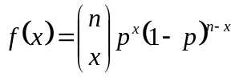
for all values x which are integers.

Poisson
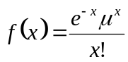
A probability distribution centered at μ.

Normal
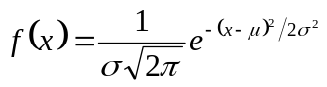
The standard normal has a μ = 0 and a σ = 1.

Uniform
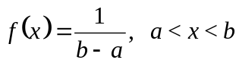

Student’s t
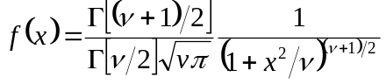
with ν degrees of freedom.

F
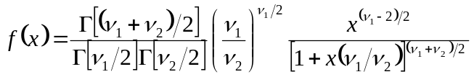
ν1 is the numerator degrees of freedom, ν2 is the denominator degrees of freedom. x must be greater than zero for all x.

Cauchy
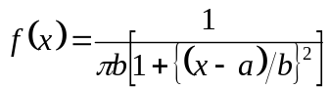

Laplace
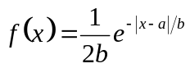
Also called the double exponential distribution.

Logistic
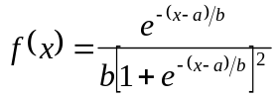

Log Normal
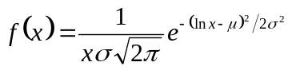
For all x > 0.

χ2 (chi-square)
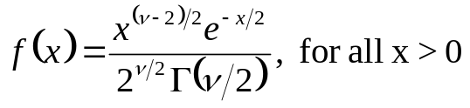
with ν degrees of freedom.

Exponential
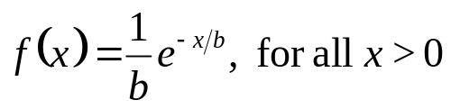

Gamma
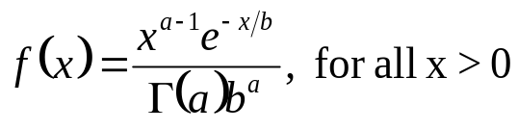

Weibull
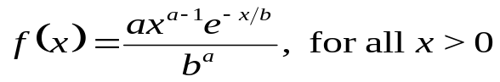

Beta
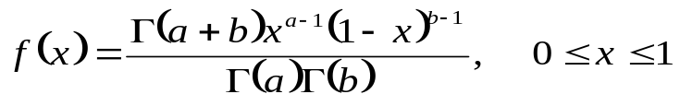

Hypothesis Testing

Hypotheses about population proportions
A study of the operative mortality of 32 patients surgically treated for aspergilloma was indicated to be 34%. Suppose some internist believes the proportion of deaths is much higher (= 0.60). Suppose that the internist justifies this proportion by saying only 3 patients sampled in another study showed a 0.33 death proportion (i.e., 1 out of the 3 died).
We first specify the test or null hypothesis:
H0: p = 0.60
In the event the null hypothesis is rejected, an alternative hypothesis is specified so that it is accepted. In this case, the logical hypothesis is that
H1: p 0.60
Note that in determing the probability of the hypothesis, we are interested in the possibility that p is neither >0.60 or <0.60. The statistical test must be two-sided. There are times when the null hypothesis tested might be p>0.60 or p<0.60, in which case the alternative hypothesis would be testing one-sidedness. However, one-sided hypothesis testing is rarely appropriate and is valid only when (i) the excluded possibility cannot occur (i.e. suppose H1 is p>p0, therefore p<p0 cannot possibly occur), and (ii) the excluded possibility is of absolutely no interest. One-sided testing should be critically assessed when presented in the data.
In the testing of proportions, the one-sample Z test is the appropriate test statistic. Choice of the Z test requires the following assumptions:
1) Although random sampling is preferable, it is not absolute. The sample must not be biased.
2) Independent observations are absolutely required. A good example is measuring a urine creatinine from one patient at one hospital and assaying another urine creatinine from a different patient at another hospital. These are independent. If we measure urine creatinine from the first patient the next day, this is not independent.
3) Sample size is important. The closer p0 or 1–p0 is to zero, the larger the sample required. In general np0 and n(1– p0) should be >5.
The Z value is assessed as
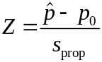
where is the sample proportion and sprop is defined as
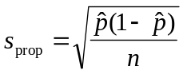
The numerator of the Z statistic tests the difference between the sample proportion and the test proportion. The denominator is the estimated standard deviation of the sample proportion. In general, either a large difference in the sample proportion from the test proportion, or a small estimated standard deviation will result in a large Z statistic, which makes it possible to reject the null hypothesis.
When the sample is large enough the one-sample Z statistic has an approximately normal standard distribution. When does one reject or accept the null hypothesis? It depend upon α, the level of significance. Generally significance levels of 0.10, 0.05, 0.01, and 0.001 are chosen. Now we calculate the example above:
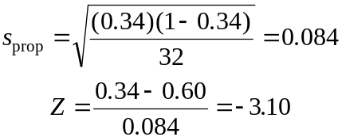
A search of a table of Z statistic indicates a two-tailed probability of p = 0.0019. If our level of significance is 0.01, we reject the null hypothesis: the probability that the test proportion is different from the sample proportion is < 0.01. The hypothesis of the internist is questionable. Suppose that having rejected the null hypothesis, we find we were wrong: we have made a Type I error. The null hypothesis was true. Suppose we accept the null hypothesis and find it was not true: we have made a Type II error. Making Type I errors results from our choice of the level of significance. Making Type II errors can be controlled by selection of the appropriate sample size.

Hypotheses about the differences in population proportions
In this case the two-sample Z test is used.
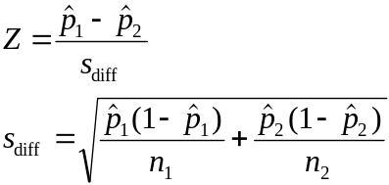
The following assumptions pertain:
1) As long as the samples are not biased, random sampling is not essential.
2) The observations within one sample must be independent of the observations of the other sample. Moreover, the observations within each sample must be independent of each other.
3) Sample size is important. The closer p1 or p2 is to 0 or 1, then a large sample may be necessary.
As an example of the two-sample Z test, suppose the stress of a parent is assessed after admission of parent’s child to an intensive care unit. 233 parents whose child was expected to ICU were compared to 262 parents whose child’s admission was unexpected. 56% of the planned admission parents and 75% of the unexpected-admission parents rated their child’s condition as “extremely severe upon admission.” Assuming the parents had no contact within and between each group, the observations are independent. A sdiff of 0.042 can be calculared from the data given, and a Z statistic of -4.52 is obtained. We find from this a p<0.0001. Being <0.01, we reject the hypothesis that these population proportions are equal: there is a significant difference.

Experimental Design

Concepts
The experiment--any process or activity that yields an outcome or observation.
The independent variable--the variable which the experimenter can manipulate
The dependent variable--the variable in an experiment reflecting the effects which result from manipulation of the independent variable.
The nuisance variable--any variable which produces unwanted or undesired effects on the response or dependent variable. They are generally controlled by sampling from a class of experimental units which keep constant the nuisance variable.
The treatment--used synonymously with independent variable.
The experimental unit--smallest entity to which the treatment is applied. Also called the subjects if the unit is an animal or person.
The measurement--the value of the dependent variable, representing the effect of a particular treatment in the experiment.
The experimental error--a representation (measurement) of the variation in response of the experimental units to a treatment. Because of the lack or uniformity inherent in the subjects and any lack of uniformity which may exist in the procedure, this error is possible.
Replication--reproduction of treatment to the subjects to make possible computation of experimental error, improvement of the precision of the experiment thereby, and generalization of the experimental results.
Randomization--the random assignment of experimental units to different treatments. Randomization may apply to initial selection of experimental units or to selection of treatments.
Power--refers to the power of hypothesis testing, but also to the power of any statistical test that is conducted.
External and internal validity--external validity refers to the ability of the results to be generalized, which depends upon the proper use of randomization and replication. Internal validity refers to results free from bias in the results

Designs

The Completely Randomized Experimental Design
For all treatments in the experiment, all experimental units have an equal probability of being assigned to the various treatment levels.

The Randomized Complete Block Design
If certain nuisance variables can not be ignored and it is necessary to partition experimental units into homogeneous subgroups for the purposes of keeping the nuisance variables constant for the treatments, this design is necessary. Treatments are then randomly assigned to units within the subgroups (blocks). The variable with defines the subgroup or block is called the blocking variable. The paired comparisons test is an example of the randomized complete block design.

The Latin Square
This design derives its name for assignment of subjects to treatments based on the fact that the levels of extraneous nuisance variables are equal to the number of levels of treatments. Suppose treatments A, B, and C are to used with time-of-day and age of the subjects to be blocked.

 | Age group of subject
Time of day | young | middle-aged | elderly
morning | A  (S1) | B  (S3) | C  (S9)
midday | C  (S5) | A  (S6) | B  (S2)
afternoon | B  (S4) | C  (S8) | A  (S7)

Analysis of Variance

One-Way Analysis of Variance

Display of the data
The table represents the production by employees when promised a different reward for increased production. The data should be displayed in this manner.

 | Money | Transfer to shift or department of choice | Time off with pay | Additional coffee break | Special recognition
 | 76 | 52 | 37 | 19 | 11
 | 70 | 52 | 26 | 21 | 15
 | 59 | 43 | 28 | 16 | 23
 | 77 | 48 | 38 | 23 | 15
 | 59 | 43 | 25 | 23 | 25
 | 69 | 56 | 30 | 23 | 18
 | 80 | 52 | 28 | 14 | 20
 | 78 | 53 | 25 | 15 | 18
 | 61 | 58 | 26 | 13 | 20
 | 66 | 50 | 25 | 16 | 16
Total | 695 | 507 | 288 | 183 | 181 | 1854
Mean | 69.5 | 50.7 | 28.8 | 18.3 | 18.1 | 37.08
Variance | 65.17 | 24.23 | 23.73 | 15.79 | 16.99 | 438.65

Partitioning of the sum of squares
In analyzing the total variation using the well-known variance formula,

the variation is found to be distributed between treatments, called the treatment sum of the squares (SSTR), and within treatments, called the error sum of squares (SSE). The total variation is now expressed as:

or SST = SSTR + SSE. The following practical equations may be used to calculate these sums:
SST =
where
C =
and n =
In addition,
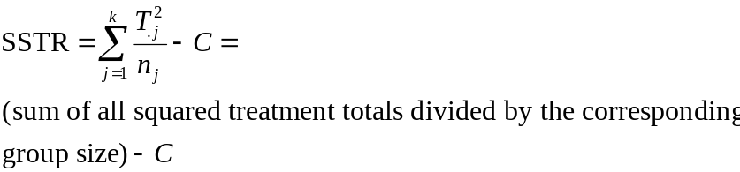
SSE is automatically calculated as the difference between SST and SSTR, namely
SSE = SST – SSTR. Calculations of SSE can be done directly, but are tedious.
From the example above, the following are computed:
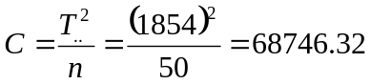
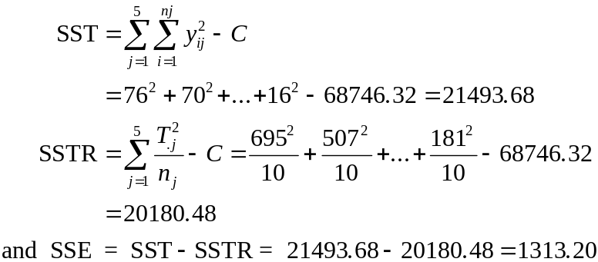

Partitioning of the degrees of freedom
Dividing the sum of squares by the appropriate degrees of freedom yields a variance. If we divide each of these sums of squares by its appropriate degree of freedom, we shall obtain a variance which is called the mean square (MS). The degrees of freedom for the set are the number of measurements (n) less 1, or n – 1, and this quantity is called the total degrees of freedom. Dividing the total sum of squares by its total degrees of freedom gives the total mean square (MST) or, SST/(n – 1) = MST.
We also divide the total treatment sum of squares (SSTR) by the total treatment degrees of freedom (k treatments – 1). This gives us the treatment mean square, or SSTR/(k – 1) = MSTR.
To obtain the error degrees of freedom, this is the difference between the total degrees of freedom and the treatment degrees of freedom, or (n – 1) – (k – 1) = n – k. The error mean square (MSE) is thus calculated: SSE/(n – k) = MSE.

The F test
Now consider the purpose of all the calculations to this point. ANOVA aims to test the null hypothesis (H0) whether all population (treatment) means of several populations are equal whereas the alternative states that not all means are equal.
H0: μ0 = μ1 ... = μk H1: Not all μj are equal
The test statistic is the variance ratio (VR), VR = MSTR/MSE. The use of this statistic requires numerous rigorous assumptions:
1. Each set of nj measurements is an independent simple random sample of measurements from a population of measurements, and each population is identified according to treatment designation.
2. Each population of measurements within a treatment group must be normally distributed with a mean within the treatment.
3. Each population of measurements must have the same variance.
There are several ways one can control unequal variances or rejection of ANOVA as a means of analysis. One might keep the sample sizes equal for all treatments, for example.
Now consider the use of the variance ratio (VR). If all the assumptions underlying ANOVA, are met, MSTR and MSE are both independent estimates of σ2, and we expect both estimates to be near equal to each other when H0 is true. Now if H0 is true (all treatment means equal), and populations are indeed normally distributed with homogeneous variances and independent error terms, the VR is distributed as F with ν1 and ν2 degrees of freedom. The F distribution is used to make inferences specifically regarding the ratio of variances. The value for ν1 is the degrees of freedom associated with the calculation of SSTR or with k treatments. It is ν1 = k – 1. The value for ν2 is the degrees of freedom associated with SSE. It is ν2 = n – k.
From the employee-reward example above, and using a level of significance α = 0.01, k = 5, n = 50, we find a critical value for F to be 3.78 (based on interpolation in the table). MSTR = 5045.12 and MSE = 29.18, if we apply the calculations. This means VR = 172.90.
Since 172.90 >> 3.78, H0 is rejected and we conclude that not all treatments are equal. Hence different awards have different effects. We find that on closer inspection, that p < 0.005.
By the way an ANOVA table is usually constructed which lists as headings (1) Sources of variation (being either treatment or error), (2) sums of the squares of the sources of variation (SS), (3) degrees of freedom (df), (4) the mean of the sum of squares (MS = SS/df), and then the (5) variance ratio (VR = MSTR/MSE).
Unequal sample sizes. Suppose we have unequal sample sizes. It is not actually necessary that all treatment groups have the same size, but one must be prepared to justify that the population variances are equal.

Comparison among treatment means
Having determined that not all treatment means are equal (i.e., rejecting H0), it is of interest to assess where differences occur. It is natural to make pairwise comparisons among the groups to see for these differences (what accounts for the rejection). Generally hypothesis testing regarding two means can be done, or confidence intervals constructed. In some cases, the experimenter may make comparisons among certain pairs of groups regardless of whether VR was significant; these are called planned or a priori comparisons. On the other hand, if VR was found significant, the experimenter may attempt to ascertain which differences accounted for the significance; since he is unlikely to be interested if H0 was accepted and only interested when H0 is rejected, these comparisons are called a posteriori or post hoc comparisons.
Tukey’s HSD test. This is a procedure for making all pairwise comparisons among means and is widely used. It is often called the HSD (honestly signficant difference) test or w procedure. A single value (HSD) against which all differences are compared is calculated:
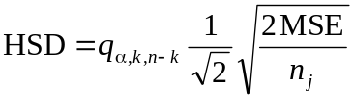
Now the value q is taken from a table called the percentage points for the Studentized range. Its value depends on the level of significance α, the number of treatments, and the error degrees of freedom. Any difference between a pair of means in the data which exceeds HSD is significant at level α.
Now consider the employee reward example. First one might construct a table of the difference in the means for each treatment group. This allows one to check all the differences at once. Now suppose the level of significance we choose is 0.05. q is read from the table to be 4.02 (necessary to interpolate this in the table). MSE we previously calculated was 29.18. Each treatment group had 10 subjects. From this we calculate HSD to be 6.87. Based on this value, we see that all pairwise comparisons of the treatment means (that is, all differences) are significant based on this HSD except for one: that is, we find the mean between production rewarded by an additional coffee break or by receiving special recognition to be not significantly different.
Indeed, Tukey’s value can be used to construct confidence intervals for the differences in means:
(mean of treatment 1 – mean of treatment 2) ± HSD
where the confidence interval 100(1 – α)% applies to the particular q value recorded in the table and used to calculate HSD. If we look at the employee-rewards example again, we can see that the confidence interval between the reward being given time off with pay vs. the reward for an additional coffee break is:
(28.8 – 18.3) ± 6.87 = 10.5 ± 6.87
That is we can be 95% confident that the true difference in the two treatment means is somewhere between 3.63 and 17.37.
Other (treatment) group comparisons are also possible and their use depends on the desired inference. Computation of confidence intervals for mean difference comparisons using other methods are shown (Tukey’s formula is shown once again):
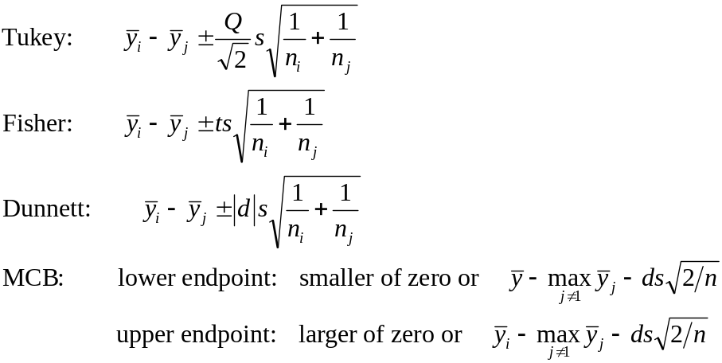
In these formulas, y-bar-sub-i is the sample mean for group i, s is the pooled standard deviation, which is the square root of MSE, n is the error degrees of freedom. Special to the Fisher formula, t is the upper α/2 point of Student’s t distribution with ν df. In the Dunnett formula, |d| is the two-sided upper α equicoordinate point of a central (k – 1) variate Student’s t distribution.
The MCB formula applies only when group sizes are equal. d is the one-sided upper α equicoordinate point of a central (k – 1) variate Student’s t distribution with correlation 0.5. Suppose you chose the best to be the largest mean, and you want the confidence interval for the ith mean minus the largest of the others. Then you would use this MCB. When the best is the smallest of the group means, the formulas are the same, except that max is replaced by min.
The critical value for Tukey, Dunnett, and MCB are found by solving 1 – α = F(x), where x is the critcal value on the F distribution. The critical value for Fisher is found using an approximation to the inverse of the Student t distribution.
Tukey’s confidence intervals are wider and the hypothesis testing less powerful for a given family error rate. Dunnett and MCB should be used in preference. The MCB is superior to Dunnett if you want to eliminate levels that are not the best and to identify those that are the best or close to the best. Choice of Tukey vs. Fisher depends on which error rate, family or individual, you wish to specify.
The individual group errors are exact in all cases here. The errors of the entire set of groups are exact where there are equal group sizes. However if group sizes are unequal, the error for the entire set of groups will be slightly smaller than the formula of Tukey, Fisher, and MCB indicate, while the Dunnett formula will be exact for unequal sample sizes.

Power of test and sample size
The power of a test is defined as the probability of rejecting a false null hypothesis. It is a consideration to be taken before an experiment is to be conducted. Often the usefulness of determining the power of a test is to determine if a proposed number of test subjects is greater than or less than that needed to achieve the desired goal of the project.
Calculating power in ANOVA is more complicated than that for hypothesis testing. First it is necessary to calculate the quantity
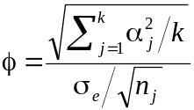
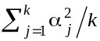 is the sum of the squared treatment effects, σe is the common standard deviation of the treatment populations, k is the number of treatment populations represented in the analysis, and nj is the size of the sample from the jth treatment population. All treatment sample sizes are assumed to be equal. In addition to φ, the level of significance α and the treatment (ν1) and error (ν2) degrees of freedom must be known.
The true value of will in truth be unknown. Rather this quantity can be estimated using the equation
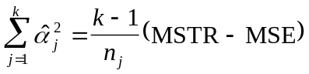
For proof that this equation is an unbiased estimator, see R. E. Kirk (Experimental Design: Procedures for the Behaviorial Sciences, Belmont, CA: Brooks/Cole, 1968). As for estimating σe, we can use √MSE.
For an example, suppose 24 subjects are assigned to one of four treatment groups in which different types of muscle tension on anxiety are studied. A standard one-way ANOVA table is constructed.

Source of variation | SS | df | MS | VR
Treatment | 230.4584 | 3 | 76.8195 | 5.88
Error | 261.4999 | 20 | 13.0750
 | 491.9583 | 23
For k = 4, nj = 6, MSTR = 76.8195, and MSE = 13.0750, we calculate 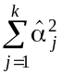 to be 31.87225. This value is now used to calculate φ, also using the other quantities. This value is now 1.91.
A special set of charts created by Pearson and Hartley in 1951 (Biometrika 38: 112-130) is now used to find the power associated with the F test. Particular charts for each ν1 (the numerator degrees of freedom for VR) have been created; its particular chart, ν1 = 3 in this case, should be located. At the bottom axis of this chart is the value for φ. Also on the chart are a set of hyperbolic (parabolic) lines which are grouped by significance α. Each line in the group represents a particular ν2, or denominator degree of freedom. From the bottom axis for φ for 1.91 and using the significance α = 0.05 with ν2 = 20, we can determine that the power of a test (1 – β) is about 0.80.
How does one increase the power of a test. By either (1) increasing the sample size, or (2) selecting an alternative design that reduces the error variance, which means reducing σe which in turn increases φ.
Suppose we know what power we want for the test and we wish to determine the sample size that will produce that power. First we must select a level of significance α keeping in mind that reduction of Type I error (the probability of rejecting the true null hypothesis). Then we select the power, or the probability of rejecting a false null hypothesis (which we want). Next we must estimate the error variance, σe, which of course is unknown, but may be estimated from previous work, pilot experiments, or reasonable assumptions. The number of treatment groups gives us the necessary numerator degrees of freedom. Then we must calculate the minimum value of Σ (μ.j – μ)2, which is our specification of the minimum differences among means we consider important.
Suppose the researchers of the experiment above want at least a power of 0.95 and will adjust the sample size to do it. Also they have considered that any difference of treatment means greater than 3 (μ.j – μ ≥ 3) worth detecting. They have the previous work in hand. Hence they know that α = 0.05, 1 – β = 0.95, MSE = 13.0750, k = 4 and Σ (μ.j – μ)2 = 32 + 32 + 32 + 32 = 36. Using some of these values, we calculate
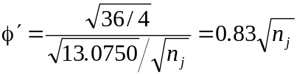
It is necessary to solve for nj. When using the chart, the solution is trial-and-error. We now select the chart for which ν1 = 3. One can find the value for which 1 – β = 0.95 and then proceed to select values for ν2 = nj – 1 and keeping in mind that φ′ must be calculated for each change and the true power calculated from φ′. When nj = 7, this will require (ν1 + 1)(nj – 1) =

ANOVA of the The Randomized Complete Block Design
Experimenters can reduce the error variance and increase the power of an analysis by using a design other than the completely randomized design. Suppose researchers want to know the effectiveness of four different drugs in relieving depression. The researchers want to eliminate the effects of the duration of illness, and they randomly select four patients from each of three types of categories regarding duration of illness: short, medium, and long. The patients are randomized for one of the four treatments.
Assumptions regarding the analysis will be that
1) Each observation is an independent random sample with size one from a population defined by a treatment-block combination.
2) The kn populations represented in the experiment are normally distrbuted.
3) Each of the kn populations has the same variance σ2.
4) Treatment and blocks do not interact, meaning that the combination of block effects and treatment effects should be ruled out as acting together to produce special effects. In the example, this assumption is no particular combination of a drug and a duration-of-illness category produces an effect different from other combinations of drug and duration-of-illness categories.
The null hypothesis is that the population means of each treatment block are equal to one another, that is no differences in the effects of the drugs. The alternative is that not all treatment means are equal. The test statistic will be as before: the ratio of the treatment mean square MSTR to the error mean square MSE. When the null hypothesis is true, the ratio follows the F distribution with ν1 = k – 1 and ν2 = (k – 1)(n – 1) degrees of freedom.
The data from the example is presented in the table.

Duration | Drugs
of illness | A | B | C | D | Total | Mean
Short | 12 | 11 | 16 | 15 | 54 | 13.50
Medium | 10 | 13 | 15 | 17 | 55 | 13.75
Long | 8 | 8 | 10 | 10 | 36 | 9.00
Total | 30 | 32 | 41 | 42 | 145
Mean | 10.00 | 10.67 | 13.67 | 14.00 |  | 12.08
First it is necessary to partition the total sum of the squares, and a new parameter is introduced to account for the effect of the blocks:
SST = SSBL + SSTR + SSE
Here SSBL is the sum of squares for the blocks, and SSTR and SSE are as before. The following formulae apply in making the calculation:
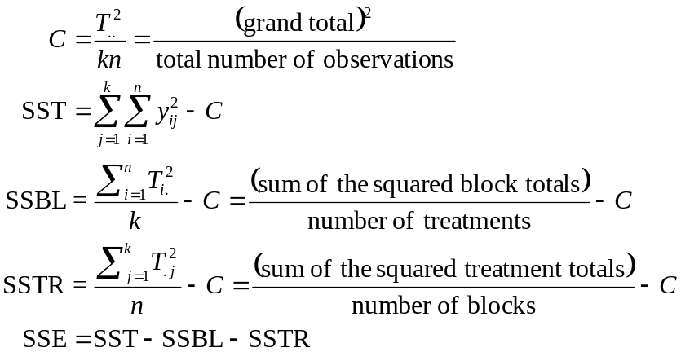
The ANOVA table for the example is constructed.

Source of variation | SS | df | MS | VR
Treatments | 37.5834 | 3 | 12.5278 | 7.394
Blocks | 57.1667 | 2 | 28.5834
Error | 10.1666 | 6 | 1.6944
 | 104.9167 | 11
Note that total degrees of freedom is kn – 1 and the error degrees of freedom are (k – 1)(n – 1) for k treatments divided into n blocks. The critical value for F with α = 0.05 and 3 numerator and 6 denominator degrees of freedom is 4.76. Since the variance ratio is greater than the critical value, H0 is rejected and we assume that there is a difference in the effects of drugs after accounting for the effects of duration of illness.

Analysis of the Latin square design
The Latin square design goes one step further than the randomized block by allowing elimination of two sources of variation in the error variance. Suppose an educator wants to know about the learning in 8th grade students of a mathematical concept taught five different ways. He wonders however how much different teachers contribute to the learning process, and the effect of the time of day on the learning process. For this to work, each teacher will five different methods during various times of the day.
In the table below, the columns represent the different times of day and the rows the different teachers. Each treatment is designated by a letter A through E, and in this experimental design, can appear only once in each row and column of the matrix. Next to each treatment are the scores (they may be means of the entire group) of the class. Note that treatments are assignedly randomly to teacher and time of day, with the limitation that a treatment can appear only once in each column or row of the matrix.

 | Time of day
Teacher | 8 a.m. | 10 a.m. | Noon | 2 p.m. | 4 p.m. | Total
1 | E, 80 | D, 90 | C, 66 | A, 64 | B, 58 | 358
2 | B, 75 | E, 91 | A, 71 | D, 90 | C, 67 | 394
3 | C, 75 | A, 79 | B, 74 | E, 78 | D, 80 | 386
4 | D, 99 | C, 79 | E, 91 | B, 81 | A, 73 | 423
5 | A, 62 | B, 85 | D, 96 | C, 61 | E, 85 | 389
Total | 391 | 424 | 398 | 374 | 363 | 1950
 | Treatment Totals and Means
 | A | B | C | D | E
Total | 349 | 373 | 348 | 455 | 425
Mean | 69.8 | 74.6 | 69.6 | 91.0 | 85.0
The following assumptions must obtain when using the Latin square:
1) The observation yij(k) must be an independent random sample of size one drawn from a population that is defined by the row-block-treatment combination ij(k). In a given population, r2 populations will be represented, where r happens to equal the number of treatments, the number of columns, and the number of rows in the data table, all at once.
2) Each population in the distribution must be normally distributed.
3) The variances of all represented populations must be equal.
4) The rows, columns, and treatments must not interact.
The total sum of squares SST is partitioned as
SST = SSR + SSC + SSTR + SSE
in which SSR is the sum of the squares of the rows, SSC are the sums of the squares of the columns, and the others are previously defined. Note that SSR and SSC will remove the effects of the two sources of variation from SSE. The following formulae and the calculations for each based on the table data will be as follows:
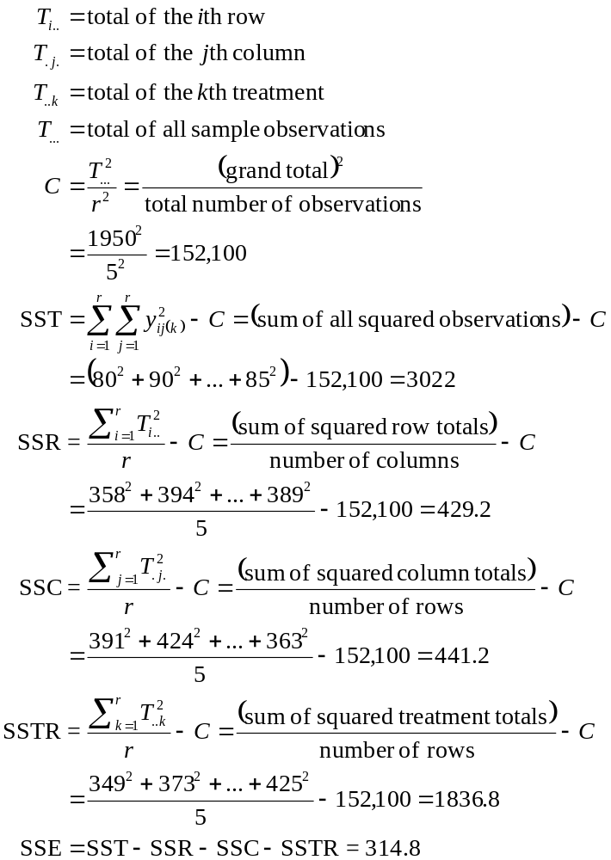
The ANOVA table for this design is represented thusly:

Source of variation | SS | df | MS | VR
Rows | 429.2 | 4 | 107.3
Columns | 441.2 | 4 | 110.3
Treatments | 1836.8 | 4 | 459.2 | 17.51
Error | 314.8 | 12 | 26.23
 | 3022.0 | 24
Note that the degrees of freedom for both nuisance variables (rows and columns variances) as well as for the treatment block is r – 1. The error degrees of freedom will be (r – 1)(r – 2), and the total degrees of freedom will be r2 – 1. When H0 is true, the variance ratio of MSTR/MSE will be distributed as F with r – 1 and (r – 1)(r – 2) degrees of freedom. In the present example, we find that, when H0 is true, observing a VR = 17.51 or larger is less than 0.005, and so we reject H0 at α = 0.005 and conclude there are differences in teaching methods after accounting for (eliminating) the effects of teachers and time of day.

Bivariate or Multivariate ANOVA
Univariate ANOVA measure only one observable, and the treatment groups can have unequal sample sizes. Multivariate ANOVA on the other hand requires particular experimental designs (Randomized block, Latin square, etc). A good example of where this kind of testing would be done is a study on potato rot, wherein both temperature and percentage oxygen in the atmosphere are tested, and the number of rotten potatoes counted. Look at the table:

 | Oxygen
Temp. | 2% | 6% | 10%
10° | 13 | 10 | 15
 | 11 | 4 | 2
 | 3 | 7 | 7
16° | 26 | 15 | 20
 | 19 | 22 | 24
 | 24 | 18 | 8
Temperature has two groups, oxygen tension three. The ANOVA is shown below:

Source of variation | df | SS | MS | F | p
Temp. | 1 | 600.89 | 600.89 | 20.64 | 0.000
Oxygen | 2 | 44.44 | 22.22 | 0.76 | 0.487
Temp*Oxygen | 2 | 16.44 | 8.22 | 0.28 | 0.759
Error | 12 | 349.33 | 29.11
Total | 17 | 1011.11
We see from the data that effects of temperature appear to be significant while effects of oxygen nor effects taken together.

Correlation coefficient
The Fisher statistic for developing a confidence interval for r is best. First we transform to the Fisher’s z transformation:
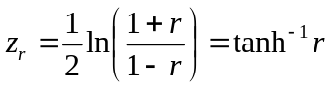
It can be shown that zr is approximately normally distributed with mean of zρ = (1/2) ln [(1+ρ)/(1–ρ)], where ρ is the correlation coefficient for the population. The variance is approximately 1/√(n-3), no matter the value of ρ. A table presents the transformation values. To construct a 100(1–a)% confidence interval, convert observed r to zr using the table, then steup up the confidence interval for zρ:
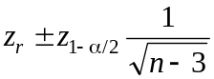
Reconvert the resulting limits back to r to obtain the confidence interval.

Nonparametric Statistics
Estimation and hypothesis tests conducted on population parameters are called parametric tests. Inferential procedures not concerned with population parameters (e.g., chi-square test of independence) are nonparametric procedures. Many statistical procedures have been developed which do not assume populations are normally distributed. This is unlike the use of the t test, analysis of variance, and inferential procedures regarding regression and correlation analysis. Procedure which are nonparametric and do not depend on the functional form of the parent population distribution are called distribution-free.
What are the advantages and disadvantages of using nonparametric statistics?
Advantages
1. Usually based on minimum of assumptions, reducing the chance of being improperly used.
2. Arithmetic computations are quick and dirty, often saving time.
3. Procedures are easily understood by novices using statistics.
4. Can be used on a wider array of data.
Disadvantages
1. Often used in cases where use of parametric procedures is not only possible but appropriate.
2. Some calculations are tedious and laborious (especially true of interval-estimation procedures).
When should you use nonparametric procedures?
1. When hypothesis testing does not involve a population parameter.
2. When the data consists of objects such as frequency counts or ranks rather than measured data such as height, weight, test scores.
3. When assumptions necessary for the valid use of parametric procedures are not met. The discernment of whether all assumptions are met for a procedure is the hardest thing to determine.
4. When results are needed in a hurry. These tests are often easy to apply.

Types of Measurements
1. Nominal scale. A very weak (the weakest of the four here) measurement. This involves distinguishing objects by an arbitrarily assigned name, which is really to class things into a group. Assignments are often very subjective. Examples include classifying mental illness into categories of schizophrenia, manic-depressive psychosis, psychoneurosis, etc. Numerals may be used as well; a good example is the assignment of numbers to members of an athletic team.
2. Ordinal scale. When an object has more or less of some characteristic of interest, we relate that object on an ordinal scale. Objects may be ordered or ranked relative to this characteristic. Examples include ranking families by socioeconomic status, students on exam scores. The order does not really measure how much objects differ from one another, so we do not know how far apart the first was from the second, the second from the third, as so on.
3. Interval scale. As discussed in the ordinal scale, this scale allows us to determine the magnitude of difference between objects or events rather than just their rank.
4. Ratio scale. This is the strongest of the four measurement types shown here. Use of this type of value allows us to determine difference or fold-difference between values, as for the interval scale, but this scale requires a true zero or reference point as well. The zero point is not a value of zero, but the absence of the character. For example, 0° F does not indicate the absence of temperature, but a weight value of 0 indicates the absence of weight.

Binomial Test
Based on a binomial distribution and therefore does testing on population proportions. Good examples where this test may apply are testing a null hypothesis about proportion of college students with right-wing attitudes, proportion of high school students who smoke. The key word in these studies is proportion, a fraction of a population. Both one- and two-sided hypothesis tests apply.
(a) H0: p = p0 H1: p ≠ p0 (two-sided)
(b) H0: p ≥ p0, H1: p < p0 (one-sided)
(c) H0: p ≤ p0, H1: p > p0 (one-sided)
To apply the test, the following assumptions must be met:
1. The observations for all n must be classified as either having or not having the characteristic.
2. The n observations must be independent.
3. The probability p of an observation having or not having a characteristic remains constant during the sampling procedure.
Note that the last assumption usually means you have to have a large population from which you are sampling so the probability does not change signficantly.
If a high school physical education director wants to conclude that less than 40% of athletes participate in sports because of health and physical fitness, he needs to set up a test with H0: p ≥ 0.40 and H1: p < 0.40. He thinks α = 0.05 is acceptable. He now interviews 16 student athletes and found only two (in his judgment) participated for health reasons. What is the probability that 2 or fewer athletes drawn from n = 16 athletes and assuming the probability is 0.40? If we consult a table for that purpose, the probability is 0.0183, and since 0.0183 < 0.05, we reject H0 and accept the alternative that fewer than 40% of students participate in sports for health reasons.
Note that when n is large and neither p or 1 – p is close to zero or one that the binomial sample is approximately normally distributed. This is true when np and n(1 – p) are both greater than 5.

One-Sample Runs Test
A run can be defined as a sequence of like observations preceded and followed by a different type of observation or by none at all. Suppose that on a Monday morning, male and female applicants for drivers’ licenses present themselves to the issuer of licenses in this order:

FF M FF M FF MM F MMM FFFF

Nine runs are found in this sequence (separated by spaces for clarity). The null hypothesis will be that the sequence is random. In truth if there are too few or too many runs, the sequence is not likely to be considered random. Look at an example of too few runs:

FFFFFFFFFFF MMMMMMM

Here is the same 18 females and males, but in only two runs. This is clearly not random.

FF M FF M FF M F M F M F M F M F

Here, there is a question about the randomness as well, for the alternating nature indicates that too many runs is something controlled.
The only assumption regarding the valid use of this test is that each observation be classifiable as belonging to one of two types of observation.
The test is performed as follows:
1. Designate observations of one type as n1 and the other type as n2. The total sample size is n = n1 + n2.
2. Determine the number of runs r.
3. Now consult the appropriate table of testing the randomness of runs using the appropriate level of significance. The table in the book presents the significance only for a level of significance α = 0.05.
In the example above, n1 = number of females = 11, n2 = number of males = 7, and r = 9. The critical values from the runs table are 5 and 14, meaning that r must be 5 < r < 14. Since 5 < 9 < 14, H0 can not be rejected and we accept the finding that the sequence is random.
The table is for small sample sizes of n1 or n2. When either n1 or n2 are larger than 20, the table can not be consulted. Instead signficance can be determined as approximately normally distributed.
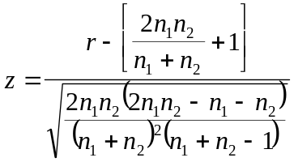
It should be noted that
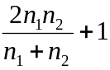
is the mean and
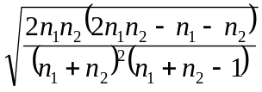
is the standard deviation of the sampling distribution of r.
For an example, the win-loss record of a basketball team having a 60 game schedule is:
WWWWWW L WWWWWW L WWWWWWW LLL WW LLLL W LLLL W LLLL WW LL WWWW L WWWW L WWWWWW
The null H0 hypothesis as always should be that the sequence is random, while the alternative H1 will be that it is not random. The number of wins is 39, the number of losses is 21, and the number of runs was 19. We apply the equation:
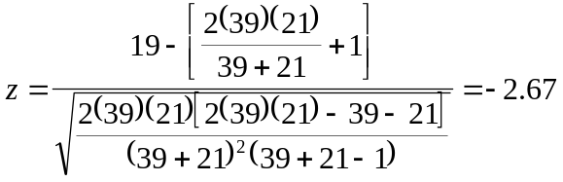
Since –2.67 < –1.96, H0 is rejected and the sequence is not random.

Spearman Rank Correlation Coefficient
This test generally used when we cannot use the normal correlation methods because certain assumptions regarding parametric correlation are not met. For a case where we observe a seeming correlation between two variables, X and Y, but where we can not use standard correlation analysis, the sample values X and Y are assigned ranks, if the original data is itself not already ranked. The null hypothesis and its alternative must be expressed in this fashion:
(a) H0: X and Y are mutually independent
H1: Either large values of X tend to be paired with large values of Y, or large values of X tend to be paired with small values of Y.
(b) H0: X and Y are mutually independent
H1: Large values of X tend to be paired with large values of Y
(c) H0: X and Y are mutually independent
H1: Large values of X tend to be paired with small values of Y.
The first of these is two-sided, the others one-sided. Note that in order to use this test, X and Y must meet the test of independence and both must be continuous.
Method. (1) To use the test, the pairs of X and Y must be assigned ranks of 1 to the smallest to n for the largest. Ranking is done within the variable’s class. (2) For each pair, the difference in rank is calculated: di = rank of Xi – rank of Yi. (3) The square of each di is taken and Σ di2 is calculated. (4) From the sum of the squares of the differences, the test statistic is calculated:
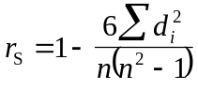
(5) For n between 4 and 30, the computed rS is compared to a critical value rS* given in an appropriate table. When a two-sided test is done, the table allows one to determine the level of significance and to reject H0 when rS > rS* or rS < –rS*. rS* in the table must be found keeping in mind that α/2 should be used. In case of hypothesis (b), reject H0 when rS > rS* for α and n. For (c) reject H0 when rS < –rS*.
(6) When n ≥ 10, the test statistic
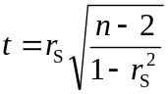
can be used with Student’s t distribution and using n – 2 degrees of freedom. The test statistic
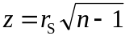
and can be compared for significance with appropriate values on the standard normal distribution; approximation is good for values as small as n = 10.
When observations of X and Y are tied—for this test can only be done on untied observations—if the number of ranks are small, one can assign the mean of the ranks for which they are tied. If the number of ties is large relative to n, one can compute
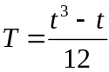
Next compute rS:
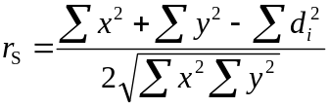
where:
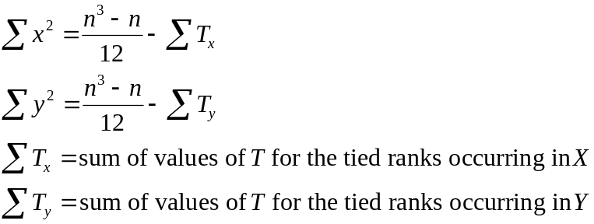
Note that using the rS equation used only for a large number of ties when the number of ties is small will not differ much from the computation of the rS statistic when ties are small.
Consider the following example: A biologist has 10 aminals in captivity and wants to compare an activity index and data she has on metabolic rates. The hypotheses are:
H0: activity index and metabolic rates are independent
H1: metabolic rates increase as activity index increases
The data and ranking of data are given in the tables below:

Animal | Activity Index, X | Metabolic Rate, Y | Rank of X | Rank of Y | di | di2
1 | 50 | 0.16 | 1 | 1 | 0 | 0
2 | 300 | 0.20 | 7 | 6 | 1 | 1
3 | 225 | 0.19 | 5 | 4.5 | 0.5 | 0.25
4 | 600 | 0.25 | 10 | 10 | 0 | 0
5 | 450 | 0.23 | 8 | 8 | 0 | 0
6 | 275 | 0.19 | 6 | 4.5 | 1.5 | 2.25
7 | 200 | 0.21 | 4 | 7 | –3 | 9
8 | 150 | 0.18 | 3 | 3 | 0 | 0
9 | 500 | 0.24 | 9 | 9 | 0 | 0
10 | 100 | 0.17 | 2 | 2 | 0 | 0
 |  |  |  |  |  | 11.50 = Σ di2
Note that animals 3 and 6 were tied with respect to metabolic rate, so the mean of 4 and 5 was used.
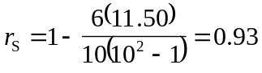
The table is consulted for n = 10 and α = 0.05, and the critical value (rS*) for a one-sided test is 0.5515. Since 0.93 > 0.5515, H0 is rejected and we accept H1, that is, there is a correlation between metabolic rate and activity index.
We consider a case with several ties in the data. Twenty new employees take an aptitude test regarding their ability to do a job, and six months later, their supervisors were asked to rate the employees’ performance. The hypotheses are:
H0: Aptitude scores and supervisor ratings are independent (do not correlate)
H1: High aptitude scores get high supervisor ratings

Employee | Aptitude Score, X | Rank of X | Supervisor’s rating, Y | Rank of Y | di | di2
1 | 79 | 12 | 86 | 13 | –1 | 1
2 | 80 | 14 | 96 | 20 | –6 | 36
3 | 51 | 1 | 53 | 1 | 0 | 0
4 | 76 | 9 | 77 | 8.5 | 0.5 | 0.25
5 | 99 | 20 | 90 | 17.5 | 2.5 | 6.25
6 | 78 | 11 | 85 | 11.5 | –0.5 | 0.25
7 | 76 | 9 | 88 | 14.5 | –5.5 | 30.25
8 | 80 | 14 | 85 | 11.5 | 2.5 | 6.25
9 | 52 | 2.5 | 55 | 3 | –0.5 | 0.25
10 | 55 | 4 | 56 | 4 | 0 | 0
11 | 90 | 18 | 88 | 14.5 | 3.5 | 12.25
12 | 62 | 6 | 66 | 6 | 0 | 0
13 | 81 | 16 | 90 | 17.5 | –1.5 | 2.25
14 | 52 | 2.5 | 54 | 2 | 0.5 | 0.25
15 | 69 | 7 | 58 | 5 | 2 | 4
16 | 76 | 9 | 77 | 8.5 | 0.5 | 0.25
17 | 58 | 5 | 68 | 7 | –2 | 4
18 | 90 | 18 | 89 | 16 | 2 | 4
19 | 80 | 14 | 84 | 10 | 4 | 16
20 | 90 | 18 | 95 | 19 | –1 | 1
 |  |  |  |  |  | 124.50 = Σ di2
Calculating rS without assuming a large number of ties:
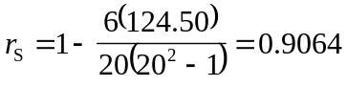
The critical value is therefore 0.3789 from the table, and because 0.9064 > 0.3789, we conclude there is a relationship between supervisor’s ratings and aptitude scores. Now assume the large number of ties (in variable X, there are three sets of 3-way ties, and one set of 2-way ties; in variable Y, there four sets of 2-way ties):
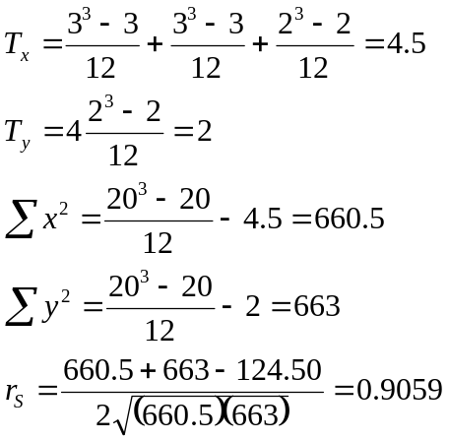
This value for rS is very close to the one where we assume no ties. Because of the large number of ties, use of the table is not strictly valid. If we calculate the t statistic, t = 9.08, and this is significant at 0.05. When the standard normal is used, z = 3.95, and this is also significant at 0.05.

Median Test
Often the question is whether the means of two populations are equal. The median can also be used as a measure of the central tendency, for when the mean and median coincide, inferences about the mean apply to the median as well.
To use this test, sampling must be random and observations independent of one another. Data must be measured on an ordinal scale, at the minimum.
Two samples of unequal sizes from each population are obtained. We basically construct a 2x2 contingency table to see how values lie around the median independently and when samples are combined.

Number of | Sample
observations | 1 | 2 | Total
Greater than median | a | b | a + b
Less than or equal to median | c | d | c + d
 | a + c = n1 | b + d = n2 | N = n1 + n2
As an example, suppose an educator wants to decide if freshman students of a given high school coming from rural elementary schools differ with students coming from urban elementary schools insofar as their median verbal reasoning scores. A random sample of 15 students from rural schools and a similar sample of 18 students from urban schools is tested for verbal reasoning. The following scores are obtained:

School type | Raw verbal reasoing scores
rural | 66 73 63 65 80 74 69 80 63 54 42 80 57 79 52
urban | 68 91 89 60 73 90 79 97 64 62 91 69 64 89 99 76 77 96
The hypotheses are set up:
H0: The medians of the two populations are equal
H1: The medians are not equal
The median of the combined scores is 73.

Number of | Sample
observations | Rural | Urban | Total
Greater than 73 | 5 | 11 | 16
Less than or equal to 73 | 10 | 7 | 17
 | 15 | 18 | 33
We compute the chi-square test value and test for one degree of freedom using α = 0.05.
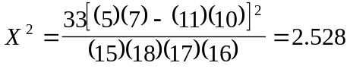
The table for the χ2 distribution indicates X2 = 2.528 is not significant and so the median test suggest the medians may possibly be equal.

Sign Test
With the median test, there must be two independent samples with both samples measuring the same characteristic. When samples are not independent but related, such as when the investigator attempts to eliminate one or more extraneous sources of variation (e.g., taking “before” and “after” measurements in relation to a treatment or matching subjects to eliminate a source of bias), and assumptions are not met for comparing groups using the t test, the researcher may consider the sign test. The sign test is like the median test in that it measures the central tendency to the median rather than the mean.
For this test to be valid, the data must be on at least an ordinal scale and the related pairs of observations must be mutually independent.
The sign test is usually used to see if the median difference is zero. Data pairs are collected: (x1, y1), (x2, y2), ...(xi, yi),..., (xn, yn). Differences between the data are then calculated: x1– y1, x2– y2, ..., xn– yn. When xi is smaller than yi, the difference is noted as minus (–); when xi is greater than yi, the difference is plus (+).
If it is true that a sample is normally distributed, its median difference is likely zero. The null hypothesis is:
H0: P(+) = P(–) = 0.5
This should be a simple case of the binomial test. When applying the test, the sign occurring less is the object of the hypothesis. Note that where xi – yi = 0, the pair is eliminated from the sample and not included in the sample size total.
As an example, suppose the mental health status of retired persons is assessed by giving some sort of test two years before and one year after a retirement date. 15 subjects are analyzed, and their scores are: (76, 70), (80, 75), (86, 84), (87, 90), (85, 81), (95, 95), (97, 87), (75, 72), (87, 92), (96, 85), (98, 88), (77, 76), (80, 85), (87, 81), (89, 84). Evaluation of the differences shows 11 pluses (+), 3 minuses (–), and 1 zero difference.
Again it is assumed the probability of a plus or minus is 0.5, and that is the null hypothesis. Since there are many more pluses than minuses in this sampling, the alternative hypothesis is that the probability of a plus is greater than a minus (in which case, mental health status declines after retirement).
Using a binomial distribution table with n = 14 and p = 0.5,
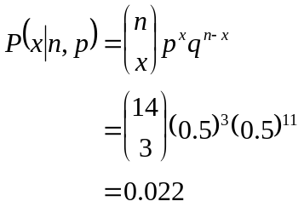
This value is less than α = 0.05, the chosen level of significance, so we reject the idea that the median difference is zero and accept that it is positive.
For n ≥ 12, the binomial distribution is approximately normal, and we may use the z statistic to compute significance.
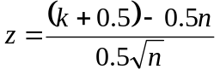
Here k is the number of occurrences of the less frequent sign. Note that if we use it for the present data, z = –1.87. Since this is not less than –1.96, we cannot reject H0, and therefore the median difference may be zero.

Wilcoxon Matched-Pairs Signed-Ranks Test
This test also compares related (non-independent) samples of data. This test goes beyond the sign test in that it examines the magnitude of the differences inasmuch as their direction (plus or minus). The Wilcoxon test should be used in preference to the sign test because it provides more information about the relationship.
The following assumptions hold for the valid use of this test:
1. Observed matched pairs are a random (bivariate) sampling of the variables X and Y.
2. Differences between matched pairs are mutually independent values of a continuous random variable.
3. The distribution of differences is symmetric.
4. The differences are measured on at least an interval scale.
The following sets of null and alternative hypotheses explain the proper form for understanding this test:
(a) H0: E(X) ≥ E(Y) (or μX ≥ μX)
H1: E(X) < E(Y) (or μX < μX)
(b) H0: E(X) ≤ E(Y) (or μX ≤ μX)
H1: E(X) > E(Y) (or μX > μX)
(c) H0: E(X) = E(Y) (or μX = μX)
H1: E(X) ≠ E(Y) (or μX ≠ μX)
To perform the test,
1. Determine the difference di = yi – xi, where yi is the data item matched to an xi. Do not include pairs for which the difference is zero, i.e., xi = yi. Reduce n accordingly.
2. Rank the absolute value of the differences di, in other words, ignore the sign during ranking. When two or more di are tied, then assign the mean of the rank as the rank. Hence, if the third, fourth, and fifth ranks would be assigned to a three-way tie, the mean of that rank (3 + 4 + 5)/3 = 4 would be assigned to all three di.
3. Now assign to each rank the sign (+ or –) of the di giving rise to that rank.
4. Compute T = sum of the positively signed ranks.
5. Compare the computed T with critical values provided in a table of the quantiles of the Wilcoxon matched-pair signed-ranks test. Once you have the critical value and a given level of significance (α), check the following situations for deciding whether to reject H0.
For (a) H0: E(X) ≥ E(Y), sufficiently large T will lead to rejection of H0. This is reasonable since large T means the differences are larger. Reject H0 if T is greater than w1−α. w1−α = n(n + 1)/2 – wα. wα is a critical value taken from the table using the desired level of significance and the T value.
For (b) H0: E(X) ≤ E(Y), sufficiently small T will lead to rejection of H0. This is also reasonable since small T means the differences are large as well, but that the other variable is just smaller than the other variable. Reject H0 if T is less than wα. wα is the critical value taken from the table.
For (c) H0: E(X) = E(Y), either small or large T values will lead to rejection. H0 is rejected either when T exceeds w1−α/2 = n(n + 1)/2 – wα/2 or when T is less than wα/2.
For an instance, consider the example in the section on the signed test regarding the mental health status of people before and after retirement. Recall there were 15 subjects. The table below shows how to compute the T value for this data.

 | Mental Health Status Score
Subject | Before, X | After, Y | di = yi – xi | Rank of |di| | Signed ranks
1 | 76 | 70 | –6 | 10.5 | –10.5
2 | 80 | 75 | –5 | 7.5 | –7.5
3 | 86 | 84 | –2 | 2 | –2
4 | 87 | 90 | +3 | 3.5 | +3.5
5 | 85 | 81 | –4 | 5 | –5
6 | 95 | 95 | 0
7 | 97 | 87 | –10 | 12.5 | –12.5
8 | 75 | 72 | –3 | 3.5 | –3.5
9 | 87 | 92 | +5 | 7.5 | +7.5
10 | 96 | 85 | –11 | 14 | –14
11 | 98 | 88 | –10 | 12.5 | –12.5
12 | 77 | 76 | –1 | 1 | –1
13 | 80 | 85 | +5 | 7.5 | +7.5
14 | 87 | 81 | –6 | 10.5 | –10.5
15 | 89 | 84 | –5 | 7.5 | –7.5
 |  |  |  |  | T = 18.5
The critical value (wα) for a = 0.05 and n = 14 is 26 for the one-sided test. In this case, T is less than wα, and so H0 is rejected, meaning we accept that mental health scores are better before retirement than after (or E(X) > E(Y)). This is the same conclusion that was reached using the sign test.
For large samples where n > 20, the quantile table can not be used. In this case the distribution approximates the standard normal:
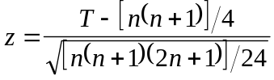

The Mann-Whitney Test
The sign test and Wilcoxon matched-pairs signed-rank tests are used for related samples. The Mann-Whitney test is used for inferential procedures based on two independent samples. The test is a nonparametric alternative to the two-sample t test regarding the testing of a null hypothesis that the means of two populations are equal, and used when assumptions regarding the t test can not be met.
To use the Mann-Whitney test, the following assumptions must apply.
1. Sampling from a population is random.
2. The observations within a sample and between the two samples must be independent.
3. The random variable is continuous in both populations.
4. The data represent measurements on an ordinal scale (at the least).
5. The two population distribution coefficients differ only with respect to location, if they differ at all.
Suppose population 1 has a sample size n with ordinal values of x1, x2, x3, ..., xi,...,xn, and population 2 with sample size m has values y1, y2, ..., yi, ...,ym. If X and Y represent the values of interest, the following hypotheses are possible:
(a) H0 : E(X) = E(Y), H1: E(X) ≠ E(Y)
(b) H0 : E(X) ≥ E(Y), H1: E(X) < E(Y)
(c) H0 : E(X) ≤ E(Y), H1: E(X) > E(Y)
The test statistic is:
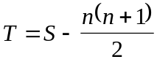
where S is the sum of the ranks assigned to the xi. Ranks are assigned as follows: after combining both groups of values, the smallest is assigned a rank of 1, the next smallest a rank of 2 and so on until all n + m values are assigned ranks. For tied observations, the mean of the rank positions they would have occupied had there been no ties is assigned.
A decision to reject H0 is based on the level of significance (α) and depends on the value of T. For the case of
(a) H0 : E(X) = E(Y), either certain small or large values of T lead to its rejection. H0 is rejected when T < wα/2 or T > w1−α/2. wα/2 is a critical value of T found in tables for the test, and w1−α/2 is calculated as w1−α/2 = nm – wα/2.
(b) H0 : E(X) ≥ E(Y), small values of T will likely cause rejection. Reject H0 when T < wα. Obtain wα from a table for the test using n, m, and α.
(c) H0 : E(X) ≤ E(Y), large values of T will lead to rejection. If T is greater than w1−α, reject H0. For w1−α, use w1−α = nm – wα
The example of the educator’s question in the section on the median test will be used here.
First a table of ranks needs to be created from this data:

Rural, X | Urban, Y | Rank | Rural, X | Urban, Y | Rank | Rural, X | Urban, Y | Rank
42 |  | 1 | 66 |  | 12 | 80 |  | 24
52 |  | 2 |  | 68 | 13 | 80 |  | 24
54 |  | 3 | 69 |  | 14.5 | 80 |  | 24
57 |  | 4 |  | 69 | 14.5 |  | 89 | 26.5
 | 60 | 5 | 73 |  | 16.5 |  | 89 | 26.5
 | 62 | 6 |  | 73 | 16.5 |  | 90 | 28
63 |  | 7.5 | 74 |  | 18 |  | 91 | 29.5
63 |  | 7.5 |  | 76 | 19 |  | 91 | 29.5
 | 64 | 9.5 |  | 77 | 20 |  | 96 | 31
 | 64 | 9.5 | 79 |  | 21.5 |  | 97 | 32
65 |  | 11 |  | 79 | 21.5 |  | 99 | 33
The null hypothesis is H0: E(X) = E(Y) and the alternative H1: E(X) ≠ E(Y). α = 0.05.
The sum of the ranks (S) is calculated to be 190.5. Our test statistic is therefore:
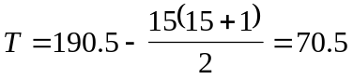
The critical values of T for the two-sided test will be 81 and 189, determined from a table in which m = 18, n = 15, and α/2 = 0.025. Note that although the table provides only wα/2 (= 81), w1−α/2 = nm – wα/2, or (15)(18) – 81 = 189.
Since 70.5 < 81, we reject H0, and we assume there is a difference in the mean scores of the students. If we had applied the median test, we would have come to the opposite conclusion. In truth the Mann-Whitney test is more powerful than the median test.
Note that some tables have a limitation on the maximal sample size, namely if n or m are greater than a certain value (say 20). In order to arrive at the critical value, a normal approximation of the hypothesis testing procedure may be adopted.
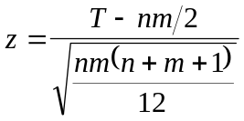
This is because, when n or m are large, they approximate a standard normal distribution.

The Kruskal-Wallis Test
A nonparametric alternative to one-way ANOVA. Samples are combined and then ranked, with ties being the average of an assigned rank as usual. The test statistic is\
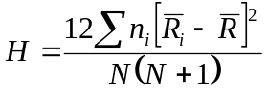
ni is the number of observations in group i, N is the total sample size, Ri-bar is the average of the ranks of group i, and R-bar is the average of all ranks. The distribution of H is approximately similar to a χ2 distribution with k – 1 degrees of freedom, reasonable if no group has fewer than five observations. Where H is large, this would indicate that differences are to be significant.
Some have suggested adjusting the value of H where the number of tied data scores are significant. The correction is as follows:
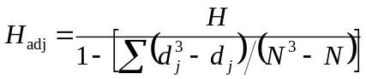
If there are j distinct values among the N observations and, for the jth distinct value, there are dj tied observations (dj = 1 when there are no ties), the above formula is applied. Naturally when there are no ties, Hadj should equal H. The distribution of Hadj is similar to H itself. When samples are small, exact tables should be used rather than formula.
A z-value calculated for each group can be obtained with the following formula:
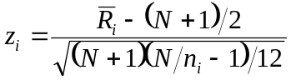
This z-value should be used to assess the significance for the differences between the group mean ranks (Ri-bar) and the overall mean rank (R-bar).

The Friedman Test
This is the nonparametric for ANOVA of a randomized block design experiment, which is a bivariate ANOVA. Randomized block designs are generalizations of paired experiments, and the Friedman test is a generalization of the paired sign test. The null hypothesis to the Friedman test is that treatment has no effect.
The test statistic is
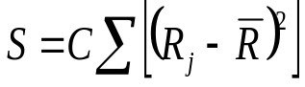
C is a constant and Rj is the sum of the ranks within a particular treatment group j. R-bar is the average of all Ri-bar. When there are many ties, the computation of S is complicated and Hollander and Wolfe (Nonparametric Statistical Methods, J. Wiley & Sons, 1973) should be consulted.
Treatment effects are calculated by first finding the median difference between pairs of treatments. Gather all the median differences together. The effect for each treatment is the average of the median differences of that treatment with all other treatments (including itself). Hence, (effect of treatment i) = Σ (median difference between treatment pairs) / number of treatments.
Now the difference between each observation in a group and the calculated treatment effect above is calculated (subtract the observation value using the calculated treatment effect). The adjusted group/block medians are simply the medians in treatment block which are now adjusted for the effect of the treatment. The grand median is calculated as the median of these adjusted block medians. The estimated median for each treatment group is the effect of the treatment + grand median. Note that the average of the treatment medians is the grand median. A residual is calculated as the observation value adjusted for the effect of treatment subtracted by the adjusted block median. The fitted value will be the effect of treatment plus the adjusted block median, or the observation minus the residual.

The Walsh average
This is simply the average of all possible pairs of data/observations/value in a set, including the pairing of a value with itself. For a set of n observations, there should be a matrix with
n (n + 1)/2 Walsh averages.

