Report on additional Data

Data on the activation of TH by CCK (chromaffin cell kinase)

Activation of purified TH by the serine-31 protein kinase from KCl-depolarized chromaffin cells was studied for its time and dose dependence.

 | 0 |  | Δ time - 30° | 20 min - 37°
 |  | Phosphorylation |  |  | TH activity
 |  | protein kinase  TH substrate  MgATP  HEPES, pH 6.8 |  |  | phosphorylation portion  6-MPH4 substrate  labeled tyrosine substrate  catalase + FeAmSO4  HEPES, pH 6.8
The mechanics of the assay are such that there are two phases (diagrammed above). In the first phase, unlabeled ATP is used to start the phosphorylation of the TH substrate with the protein kinase. Besides addition of the purified protein kinase preparation and of the purified TH substrate preparation, unlabeled ATP to 0.1 mM, magnesium acetate to 10 mM, HEPES-NaOH to 40 mM, and dithiothreitol to 4 mM are present at pH 6.8. Total volume of each assay is 50 µl. After the specified phosphorylation time at 30°, 40 µl (80%) of the phosphorylation mixture is removed and added to a mixture which will have the following components at the final concentrations: HEPES-NaOH (40 mM) at pH 6.8, bovine liver catalase (1.8 µg/µl), [3,5-3H]l-tyrosine (100 µM), dithiothreitol (4 mM), and ferrous ammonium sulfate (10 µM). The radiolabeled tyrosine must be prepared by sampling the stock vial for the appropriate radioactivity of tyrosine necessary, streaming nitrogen to dry the sample and remove tritium label which may have exchanged with solvent, and the resuspending in cold tyrosine (the cpm/pmol tyrosine value can be calculated here for determination of product formation once the assay is done). The TH activity assay is initiated with addition of the tetrahydropterin analogue, 6-MPH4, to 0.5 mM, for a final volume of 100 µl, and each assay is kept at 37° for exactly 20 min. The assay is stopped with the addition of 1.0 ml of acidified charcoal (7.5% Darco G-60 in 1 M HCl kept in suspension by rapid stirring), the assay tubes are microfuged for 3 min, and 600 µl of supernatant is added to 4.5-5.0 ml of aqueous-compatible scintillation cocktail (RPI Safety-Solve). The vials are counted by liquid scintillation spectrometry. Theoretically, the unreacted labeled tyrosine should adsorb to the acidified charcoal (the report describing this assay indicates near 100% binding). The product, 3H2O, ideally partitions to the liquid phase (supernatant): the report describes that when using a tritiated water standard in this charcoal separation, 94% of the counts are recovered from the supernatant. This value is used to correct for the product formation expressed in terms of nmol tyrosine converted (note 2 mol tritium formed=1 mol tyrosine converted) per unit time (minute) per mg total protein. In general, control (zero activity) values are obtained by omitting the 6-MPH4 substrate for this activity assay.
The figures below show the change in TH activity due to addition of different amounts of protein kinase for the same period and due to different incubation times for the same volume of protein kinase. As controls, TH was incubated in the first phosphorylation phase for 30 min without protein kinase but in the presence of MgATP, and then assayed in the second phase but without 6-MPH4. This follows the general protocol for the control value of the TH enzyme product. Another control was the incubation of 5 µl of CCK with MgATP in the first phase, and then assayed for TH activity normally. This is designed to check for the presence of activatable TH activity which may endogenously be present in the chromaffin cell kinase preparation. A third control was like the first control, but 6-MPH4 is added to the second phase. This control shows the presence of endogenous protein kinases within the purified TH preparation which may activate the TH. The value of this assay was assigned as the 100% control value (1.63 ± 0.17 nmol/min/mg) for the purpose of comparing it to tubes in which the kinase was added.
The figures showing the significant activation of TH by the added protein kinase are shown below. Note that the purified CCK preparation used in these studies contained no endogenous serine-40 peptide phosphorylating ability, which would indicate strongly the presence of cAMP-dependent protein kinase, or serine-19 peptide phosphorylating ability, which would suggest the presence of a calcium-/calmodulin-regulated protein kinase. (Purified bovine heart PK-A catalytic subunit, which both phosphorylates serine-40 of TH and activates the holoenzyme with ease, has tremendous difficulty in phosphorylating serine-19 synthetic peptide and does not incorporate phosphate into serine-19 in intact TH.)
Although the increase in activation with time is not apparently linear for the incubation times tested, this may possibly be explained by a recent report that shows that CCK, which has been shown to be identical to MAP-2 kinase by its immunological and biochemical properties, may phosphorylate its substrates in “fits and starts.” This report shows that the ERK protein (equivalent to MAP-2) caused the incorporation of several moles of phosphate into one mole of microtubule-associated protein tau in a continuous but irregular fashion (nonlinear and nonhyperbolic) up to 24 hour period after addition of the enzyme. The time course chosen here was practical for the purpose of obtaining stable, activated TH.
The point of the figures is such that TH activation is nonetheless observed when a purified preparation of CCK free of endogenous kinases is added to the substrate.
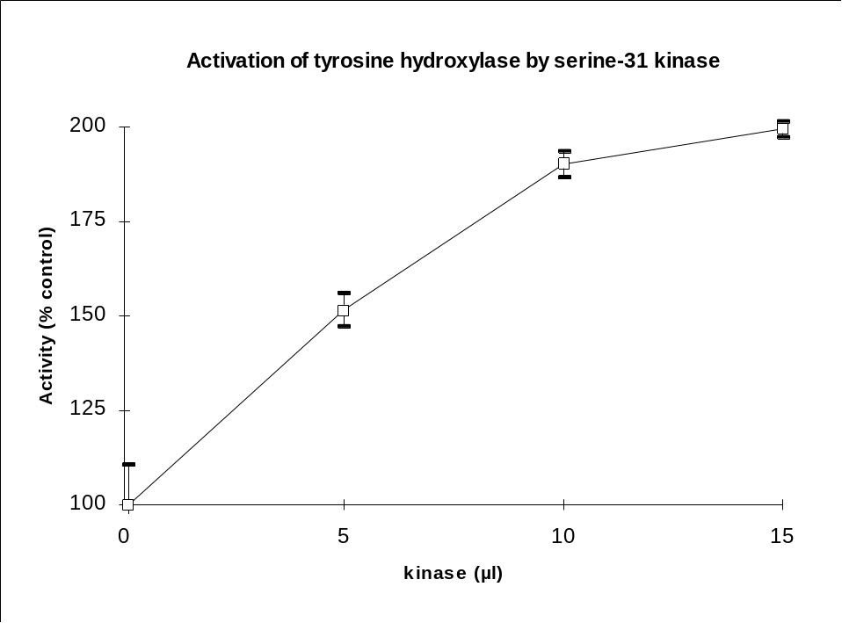
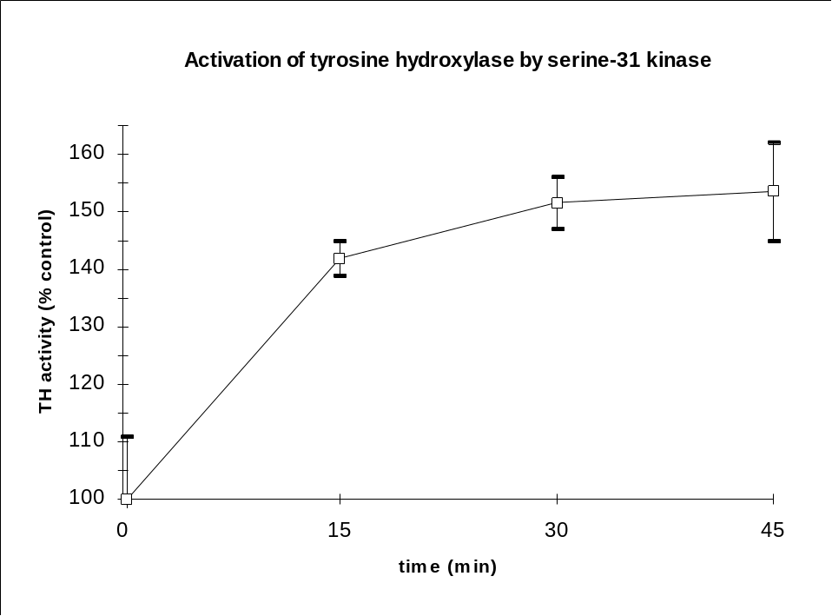
Determination of the amount of incorporation of phosphate into TH by the kinase
SDS sample buffer was added to the reaction mixture in which TH had been mixed with the kinase and labeled ATP for 1 hour at 30° with PKI(6-22)amide present in 100 nM concentrations {protocol was 100 µl chromaffin cell kinase/250 µl of TH substrate/10 µl of 4.5 µM PKI(6-22)amide/45 µl of 0.4 M HEPES-NaOH, pH 6.8 + 40 mM DTT/45 µl of 100 µM γ-[32P]ATP (11,000 Cerenkov cpm/pmol) + 10 mM magnesium acetate}. The material was boiled. The cooled material was centrifuged and the supernatant loaded on top of the stacking gel of a preparative SDS gel. After running, the gel, was fixed and stained with Coomassie Brilliant Blue R-250, the gel was dried to Whatman 3MM, and a Polaroid photograph was taken of the stained gel (backlit with fluorescent lamp to improve contrast). Two exposures were taken (both 1/125 s with one a f/16 and other at f/22) which produced reproductions with different contrasts.
A video image of the more highly exposed photograph was acquired (with adjustments of the camera to optimize contrast and sharpness). The images were improved through sequential high- and low-pass filtering to define the borders of the stained pattern, and an image analysis utility was used to obtain optical density data along the electrophoretic path, much in the same way as a linear densitometric device collects optical density data along the scanned path. The image analysis utility works by averaging the gray level (optical density) of all gray level values along the user-specified width of the analyzed region, then plots the averaged optical density values along the length of the region analyzed. Several different regions of the preparative gel stain image, evaluated with different analyzed region widths, were taken to arrive at an average value for the optical density for each image of stained bands. The optical density data obtained from each of the “scans” was converted for reading into a spreadsheet, and selected optical density values corresponding to well-defined peaks of the stained band images were summed. The relative percentage was obtained by dividing the sum of optical density values of the peak of specific interest to the sum of all other summed peaks. The baseline was fixed as the average of a large number of optical density values not assigned as optical density values of identified
peaks. The relative amount of specific (TH) protein to total protein is approximately 10%.
The band corresponding to TH (the stained band at 60 kDa) was excised from the dried gel in its entirety and counted Cerenkov. The amount of all incorporated activity in that region was 505,000 cpm. Since there was 11,000 cpm/pmol P of specific radioactivity, this corresponds to 46 pmol P present.
The material was analyzed on reversed-phase HPLC in three injections. The first injection was to get an idea of the pattern: about 15,000 cpm were loaded, representing a little less than 10% of the material. The second and third injections divided the material in half, and both radiochromatographic patterns were identical, with minor shifts in retention times between the chromatograms. The radiochromatograms did not really look anything like the 1st injection, insofar as peak shapes, but the cluster came out with the same time range. Five peaks were considered present: A through E. Subsequent analysis shows that peaks A, B, and E all belong to the serine-31 peptide, which are peptides with modified amino acids (pyroglutamyl form of the tryptic peptide as well as peptide having oxidized methionyl form). Its possible that a very minor peak labeled D was is also serine-31, but it was not further analyzed because it was so poor in quantity and did not resolve well from the major peptides eluting from HPLC. A total of about 90,000 cpm were loaded for the 2nd and 3rd injections. The total added recovery for the 2nd injection was 80,000 cpm, for the 3rd, 77,000 cpm. Of this total radioactivity, the sum of radioactivity for peaks A, B, and E made up 68.2% and 68.8% of the radioactivity relative to the sum of all radioactivity in the major and minor radioactive peaks eluted from the columns of the 2nd and 3rd injection, resp. This shows that serine-31 made up about 68% of the HPLC-injected radioactivity. If serine-31 phosphorylation makes up 68% of the radioactivity, then of the 46 pmol phosphate in the gel band, 31.2 pmol of that was serine-31. This number is more than like a very conservative estimate of the amount of serine-31 most likely to be present.
An estimated 8 µg of TH was present as the total amount in the stained band on the gel. This corresponds to a mass of 133 pmol, assuming 60,000 Da for the TH subunit. With 31.2 pmol P in serine-31 incorporated into the 133 pmol TH, the incorporation is estimated to be 0.23 mol P/mol TH subunit.
Determination of the nature of the peptides from
tryptic digestion of labeled synthetic human TH 22-38
As was observed in both the IEF and the 2-D TLE/C analyses of the HPLC-purified tryptic peptides of serine-31 kinase-treated bovine TH, of the 5 or 6 radioactive peaks which eluted, two major ones and one minor one appeared to be different peptides all containing phosphate-labeled serine-31. Another of the minor peaks was not analyzed (peak D), but subsequent work would suggest it contained serine-31.
Haycock has just published results of work he has done with bovine TH in which he notes that the serine-31 peptide can undergo two modifications when exhaustively trypsinized. The peptide from rat TH can undergo one of the modifications: when exhaustively trypsinized, the new amino terminal has a glutamine (Gln), which is notorious for undergoing a nonenzymatic transamidation reaction amounting to cyclization, forming pyroglutamate.
In bovine TH, whose exhaustively trypsined phosphate-labeled serine-31 peptide (bTH25-33) is identical in sequence to the human peptide (hTH25-33), the amino acid at position 30, adjacent to serine-31, is methionine. Sulfur-containing amino acids create many difficulties in the analysis of peptide structure, which explains why the sulfhydryl-containing cysteine residues are reduced and either alkylated with iodoacetamide or oxidized with performic acid prior to further work-up of the peptide. CNBr cleavage can eliminate problem-creating methionines, but in the case of hTH25-33, combined trypsin and CNBr treatment theoretically yields a labeled serine-31 tripeptide (SPR), which is not amenable to HPLC analysis.
Using a C18 column equilibrated with 0.1% TFA (1 ml/min) and a gradient program of increasing acetonitrile (5 min at 0.5%/min then 55 min at 0.15%min, then 5 min at 10%/min), Haycock found that the completely unmodified (no Met oxidation, no pyroglutamate formation) serine-31 peptide, QAEAIMSPR, eluted at 46 min in his program. Another peptide eluted at 29 min, but when he treated it with methylmercaptoacetamide (this apparently serves to reduce oxidized methionines), he found the peptide shifted to 46 min. He reported that an acid environment (how acidic was not mentioned) caused shifting of the 29 min peptide to elute at 41 min, and the 46 min peptide eluted at 58 min (note that both peptides increased at the same 12 min time). [The literature says that equilibrium conditions favor the formation of the cyclized glutamine at neutral and mildly alkaline and acidic (namely pH 4-10) conditions, and that strong acid and base actually hydrolyzes the cyclic amide bond, as well as the other amide bonds too.] When he treated both his 41 and 58 min new peptides with pyroglutamate aminopeptidase, which specifically hydrolyzes pyroglutamyl residues from the amino terminal, these peptides shifted their retention times to 27 and 44 min, resp., just slightly faster than the original uncyclized peptides.
Human TH22-38 was labeled with phosphate using MgATP and purified PDPK activity (from extracts of Sf9 cells coinfected with baculovirus recombinants p34cdc2 and p58cyclinA). Although the incorporation was weak because of the very low activity of the enzyme, sufficient amounts were obtained and purified on SepPak cartridge, exhaustively trypsined (two additions over 12 hr period), and prepared for HPLC. Two tubes had been prepared, in which one tube contained peptide dissolved with DTT to maintain a reductive environment. Subsequent HPLC analysis of the heavily manipulated peptides indicated that there seemed to be no difference between keeping a peptide dissolved in DTT or merely in water.
Initial HPLC analyses of the trypsinized peptide standard showed at least four radiolabeled peaks (see figs. A and B as representative injections of the mixture), indicating that if the tryptic peptide could partially undergo two modifications to generate a distribution of four products (some modified, some not), then these were at least separable by reversed-phase HPLC. The HPLC program was changed from the program which had been used to analyze the tryptic peptides of the chromaffin cell kinase-treated bovine TH: whereas the earlier typical analysis used a gradient of 0.5%/min starting from 0%, this program used a shallower 0.25%/min starting in some instances at 2.5%, and later at 3%. The separation of the four peaks was generally improved to a baseline resolution, which was not achieved with the earlier program.
With initial injection, the relative heights (amounts) of all four peaks kept varying between injections. Eventually, the second of the four peaks disappeared altogether, even though all samples were kept only in water. The mixture used for analysis showed three peaks eluting at 30-31 min, 39-40 min, and 43 min representing peaks 1, 2, and 3 (fig. B). When this mixture was subjected for 1 and 3 hours to conditions (0.3 M dimethyl sulfide in 4 M HCl) which cause the reduction of methionine, it appeared that the relative height of the peak at 39-40 min increased while the peak at 30-31 min decreased (figs. F-H). When the reduction was extended to 13 h, peaks at 27, 30-31 min and 39 min, were evident, with the peak at 43-4 min missing: but reduction carried out for this long at such a high acidity may distort the true chemistry, and a significant amount of radioactivity eluted with the mobile phase void indicating free phosphate.
When the mixture was treated with 0.1 M dimethyl sulfoxide in 0.5 M HCl (which causes methionine oxidation) for 1 and 3 h, the peak at 43 min was completely eliminated by 3 h (figs. C-E). The HPLC chromatogram at 12 h of oxidation looked the same as the 3 h period.
The mixture was also treated with 1 U (1 nmol/min) of pyroglutamate aminopeptidase (PAase) for 30 min at 32°. Upon HPLC analysis, two major peaks at 28 and 40-1 min were evident, with poorly resolved peaks (shoulders) at leading the 28 min peak in the range of 24-27 min (fig. I). A very small peak at 30 min could be observed. It is reasoned that the peaks 2 and 3 are pyroglutamyl forms of the peptide, representing the oxidized and unoxidized methionyl forms resp. Peak 1 may represent the oxidized, noncyclized form of the peptide.
Peaks 1, 2, and 3 were isolated as individual peaks apart from the mixture and treated to reducing and oxidizing conditions to examine their effect. Control injections were done to make sure the peptides eluted at the same time as they did in the mixture (except for peak 1) . Peak 1 (eluting at 32 min; in previous runs at 30-31 min) did not show a peak on oxidation, but did show one at 37 min during reduction (figs. J, K). Peak 2 (control at 38 min, previous runs at 40-41 min) show a new peak with oxidation but not with reduction (figs. L-N). Peak 3, which in earlier runs elutes after peak 2 at 43-44 min, eluted upon oxidation at 29 min (figs. O-P). When the control was injected, it too eluted at 28-9 min, which was not expected. Clearly the process of purifying peak 3 through the HPLC and preparing it for re-analysis caused a chemical change in the peptide, presumably complete oxidation of its methionine, as it was expected to have a reduced methionine. No further analysis was possible.
Conclusions: peak 3 is the reduced and pyroglutamyl form of the bovine TH25-33 peptide. Peak 2 is the normal form, reduced and noncyclized. Peak 1 is the oxidized and pyroglutamyl form. The oxidized, nonpyroglutamyl form is probably present at undetectable (undiscernable) levels. This should account for why the standard tryptic peptide did not elute as one HPLC peak rather than the four observed.

