TexAssist Requirement Analysis

Requirements:

Login Template:

[Texas Workforce Commission's Unemployment Tax Services - Logon](https://apps.twc.texas.gov/UITAXSERV/security/logon.do)

Sign Up Template:

[Texas Workforce Commission's Unemployment Tax Services - Sign Up for User ID](https://apps.twc.texas.gov/UITAXSERV/security/selfRegister.do)

User Profile:

Secure, Able to see any requests/services sent and track their status.

Service Catalogue:

Allow users to choose from predefined categories (e.g., Unemployment Benefits, Job search assistance, Employer serviced. Etc) while submitting tickets.

[Unemployment Benefits **Services** - Texas Workforce Commission](https://twc.texas.gov/jobseekers/unemployment-benefits-services)

[Vocational Rehabilitation **Services** - Texas Workforce Commission](https://twc.texas.gov/jobseekers/vocational-rehabilitation-services)

[Child Care & Early Learning **Services** - Program Overview - Texas ...](https://twc.texas.gov/programs/childcare)

[Independent Living **Services** for Older Individuals Who Are Blind ...](https://twc.texas.gov/programs/independent-living-services-older-individuals-who-are-blind-program-overview)

[Employer Benefits **Services** - Texas Workforce Commission](https://twc.texas.gov/businesses/employer-benefits-services)

* Record the ticket details such as user contact details, ticket subject and detailed description of the issue or inquiry.

Ticket Management Dashboard:

* It is for the agents to view and manage incoming tickets.

Employee Training Resources:

[Upskill Texas | Texas Workforce Commission](https://www.twc.texas.gov/businesses/upskill-texas)

[Train Your Workforce | Texas Workforce Commission](https://www.twc.texas.gov/businesses/train-your-workforce)

AI chat bot:

Allows Users to answer common questions about the Services. User can type in a question. Provide set options that could possibly answer the user’s questions.

Example of buttons within the chatbot:

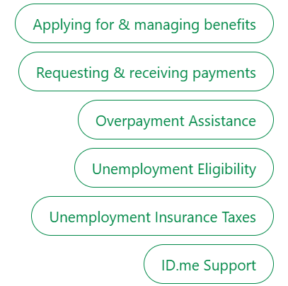

Integrated Secure Payment System:

Users can enter their bank account details for payment

Users can request payment for lost wages.

Section to show user their last recent payment total

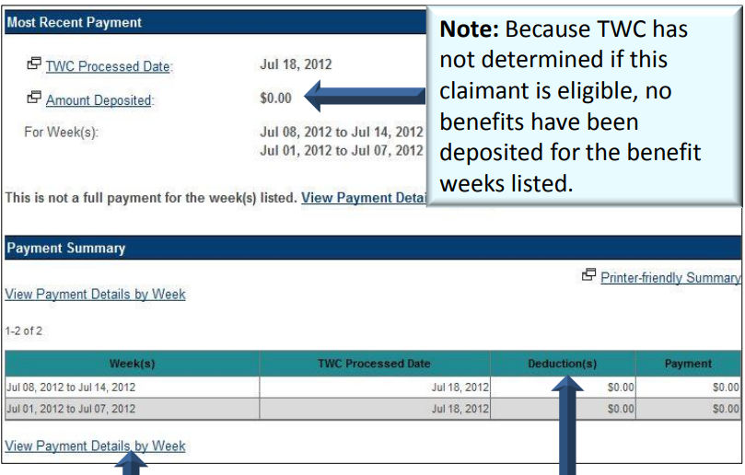

Feedback system:

System to provide feedback after the use of any service

* Picture not necessarily a feedback system but can be used as a template for it.

