Peer to Peer Messaging App

Data Analysis

Connor Cuffe

Beaumaris Secondary College

Table of Contents

Data Analysis 3

Legal Considerations 3

Survey 4

Interview 7

Observation 8

References 10

## Data Analysis

The following is an analysis of the collected data with the intent of finding out what the users expect from the software solution.

### Legal Considerations

For all the following data collection methods the Australian Information Privacy Principles 2014 (IPP) were closely followed to minimise possible harm that any data leaks could cause survey participants. The IPPs were addressed as follows;

* IPP 1 (Collection)
  + Before any data collection began it was ensured that the data collected was actually necessary and that the data collection methods would not be too intrusive, especially in the case of the observations which if not approached correctly could have been unnecessarily disruptive to the participant.
* IPP 2 (Use and disclosure)
  + Before any data was collected it was made clear to all participants the intended use of the data
* IPP 3 (Data Quality)
  + After the data was collected it was assessed for any fallibility’s so that the highest data quality standards could be upheld.
* IPP 4 (Data Security)
  + All the data was stored under pseudo names and no personal information was kept rendering this IPP irrelevant to this study.
* IPP 5 (Openness)
  + Before any data was collected it was made sure that all participants were fully aware of how their data would be used
* IPP 6 (Access and correction)
  + All data is open to participants access and correction to ensure up to date and correct data.
* IPP 7 (Unique Identifiers)
  + The data collected from each participant was stored with pseudo names unique to that participant allowing all their data to be referenced together.
* IPP 8 (Anonymity)
  + All data was collected anonymously to protect the anonymity of all participants.
* IPP 9 (Transborder data flows)
  + No data will flow across borders therefore rendering this IPP irrelevant to this study.
* IPP 10 (Sensitive information)
  + Prior to data collection it was made certain that no sensitive information would be collected during data collection, rendering this IPP irrelevant to this study.

### Survey

A survey is great for collecting quantitative data as it is quick and easy for the surveyor and surveyed allowing for a large collection pool. Unfortunately, a survey is incapable of gathering in-depth and personalised data.

#### Source

Microsoft forms: (Cuffe, Microsoft forms, 2024)

#### Summary

##### Error analysis

Analysis of the survey revealed that most participants were students in years 10-12 at Beaumaris Secondary College (see Figure 1). This limited sample group may prove to result in biases in the data collection. Any bias is hoped to be offset by the reports and observation which should provide some unbiased data allowing for the overall analysis to correct for these issues. Another possible error in the data collection is the reliability of the data, due to the large amount of “troll” responses which would likely have caused serious discrepancies in the data. However troll responses were combated by the introduction of an “other” option in the age question (see Figure 1) this allowed for fast and efficient removal of troll responses as no legitimate response would use the “other” option, and no “troll” response could resist the temptation of having an age of “-45” participant 6. This resulted in the near total eradication of troll responses from the analysis (they have been kept in the survey for posterity where not considered).

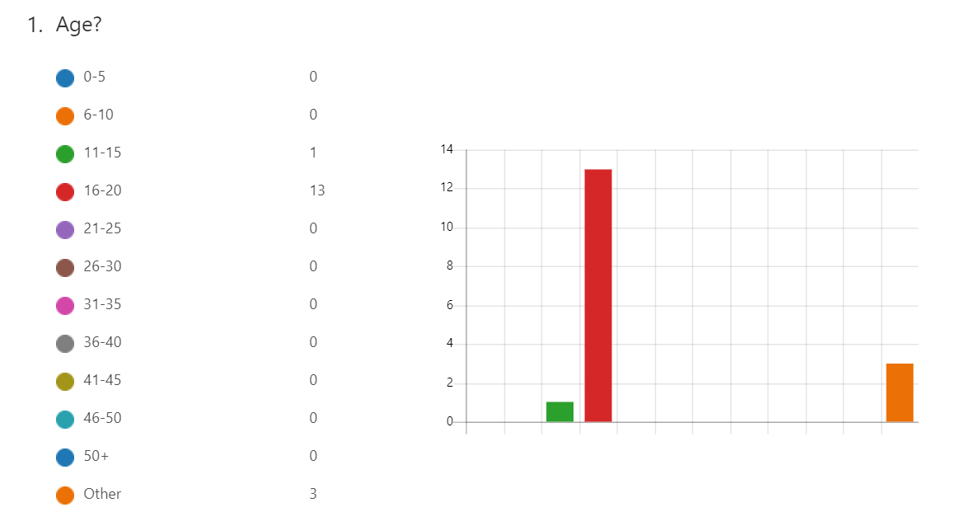

Figure 1 The age of survey participant (Cuffe, Microsoft forms, 2024)

##### General analysis

The survey demonstrated that the majority of participants value a low cost secure and easy to use system, over a cross platform and reliable one (see Figure 2) The low ranking of reliability may be due to bad structuring of the question and will be further addressed in the interviews to assess whether this was really the case.

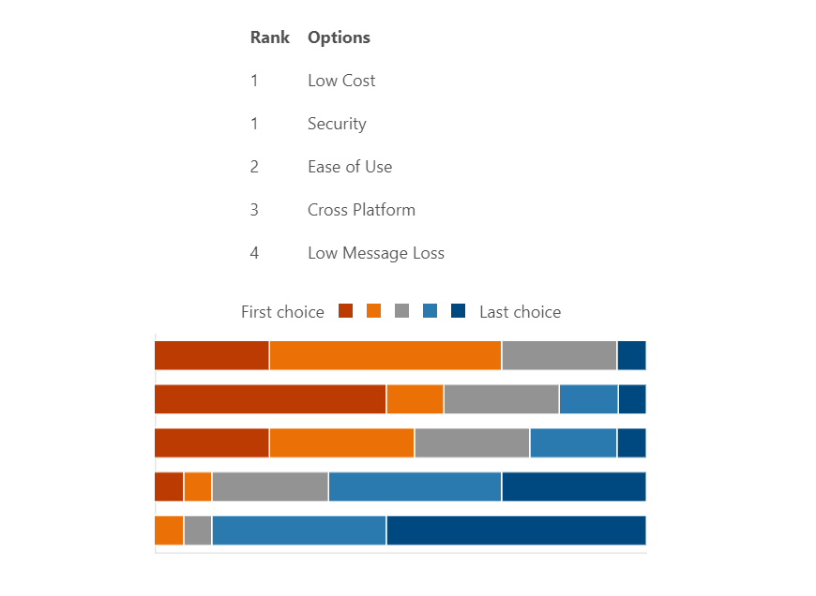

Survey participants

Figure 2 Survey ranking of key issues and their importance to a messaging app (Cuffe, Microsoft forms, 2024)

Most survey participants found the issue of increased ease of teacher-student communication to be important (see Figure 3). However, the majority of participants also rated their current messaging app to be good (see Figure 4) which would be seen as confusing until you consider the fact that most student-teacher communication is not on those platforms, as the majority of participants outlined. Participant 14 responded that the “biggest barrier I face is only being able to email them cuz they removed dms on teams.” (Cuffe, Microsoft forms, 2024)participant 14 question 9 This is further expanded on by participant 9`s response that “no one checks emails and teams []” (Cuffe, Microsoft forms, 2024)participant 9 question 9  most participants also identify the addition of a direct messaging system to be a viable solution.

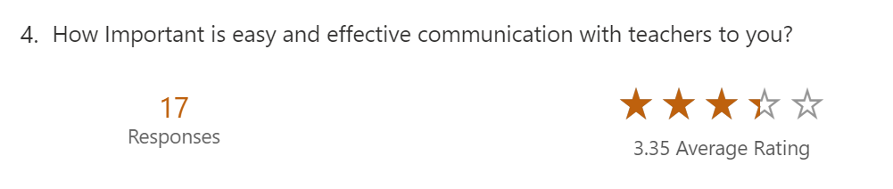

Figure 3 The importance of easy and effective communication with teachers (Cuffe, Microsoft forms, 2024)

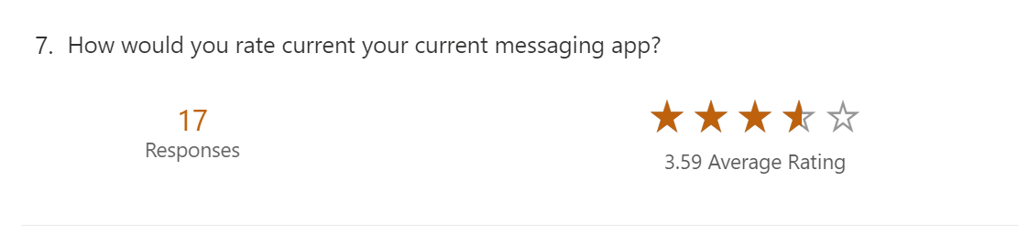

Figure 4 The quality of the participants current messaging app (Cuffe, Microsoft forms, 2024)

### Interview

An interview can collect personalised and in-depth data as the interviewer can tailor the question to the interviewed allowing for much more detailed data. However, the one on one aspect of interviews makes them much more time consuming to use, usually resulting in a smaller and therefore a less diverse sample group.

#### Source

Word Doc: (Cuffe, Interview.docx, 2024)

#### Summary

The interview shed light on some of the user’s recent experiences with student-teacher communication. It was outlined during the interview that some major barriers to successful student-teacher communication was the lack of information about who to contact and also the low reliability of the current communication methods. Students are required to send an email to the teacher, which mostly results in large delays between first sending the message and a response being received. In some cases, a response may not even be received. This is due to the nature and volume of email received by teachers. Email is used for a wide variety of communication, mostly of a non-time dependent nature, resulting in it being hard for teachers to keep up to date, even the most dedicated individual. Whereas, most student-teacher queries are short messages requiring immediate or short time frame response. This is what appears to be the case with the interviewee who has currently waited for more than three weeks for his request to be processed, within which his request was forwarded though two different teachers. This abstraction from student to target body likely results in these long delays. The student also specified that the delay between the first two teachers was relatively minimal, only a couple of days where as the final communication was delayed by more than a week and a half, thus showing how unreliable the current communication methods are. The interviewee when asked, stated that the three weeks delay negatively affected his ability to learn by “[giving] [him] less time to prepare for the general math’s SAC when [he] eventually transfers.” (Cuffe, Interview.docx, 2024) This shows that the reliability and directness of a student-teacher messaging app is very important. This contradicts the data collected in the survey and points to possible flaws in the survey’s data.

### Observation

An observation is an analysis of the potential user’s behaviors in situations similar to your targeted deployment environment. This analysis helps to give a deeper understanding of the end user’s needs. This understanding tends to be deeper than what an interview provides as the observer is able to see the unconscious behaviors of the target audience. However, as the observed tends to be aware of the data collection this tends to lead to a slight shift in the behavior of the participant and must be considered during data analysis.

#### Source

Word Doc (Cuffe, Observation.docx, 2024)

#### Summary

The observation showed that most of the student teacher communication was held back by email correspondence being slow and unreliable, this ultimately results in the eventual response, if at all, being unhelpful as the question is no longer relevant due to changing circumstances or the time sensitive nature of some queries. This was particularly clear in the case of participant 1 (Cuffe, Observation.docx, 2024) where he attempted to ask the teacher for the due date and requirements of part of his SAT yet due to the indirect nature of emails the message was either not received or not seen for a prolonged period of time. By the time a response was received the due date had already passed and the student was forced to find other ways to obtain the requirements of the task. This could be easily fixed if there was a more reliable and direct method of student-teacher communication thus demonstrating the strong need for reliability in the eventual software solution. This indicates that there may have been flaws with the survey as the survey showed reliability as one of the least important features.

## Use Cases

#### High school Student

High school Students would likely have a consistent medium to high expertise in messaging apps. This is due to their age group’s high exposure to technology and the internet. Students would mostly use this software solution to ask teachers for clarification on due dates, task requirements, class changes along with many other queries. Therefore, the most important aspect for students is the ability to quickly and easily find the correct teacher for the query for example if a student wanted to change class they should be able to easily find which teacher to contact and be able to easily message them.

#### Teacher

Teachers due to the larger range of age and experience would have variable levels of expertise in messaging apps ranging from low to high levels of expertise this results in their need for a simple and intuitive user interface that can at the same time have complex feature for the more experienced to utilise. Teachers would mostly use this software solution to receive queries from students and either respond to them or find the student in person. Therefore, the most important feature for teachers is the ability to quickly and easily know if a student has messaged them as well as the ability to find relevant information about the student such as their student ID so as to most efficiently be able to look them up in the student database to find more relevant information that can help the teacher answer the query.

#### Personal use

Private users would have a wide variety of expertise in messaging apps ranging from low to high. This results in their need for a simple and intuitive user interface that can at the same time have complex feature for the more experienced to utilise. Private users would likely use this software solution to privately communicate with friends or family, the private nature of this communication results in the need for effective encryption of the data to protect against leaks of potentially sensitive information. Unlike students and teachers, private users do not need the extra features such as the ability to search for the correct person to contact for various issues, yet more experienced users may find these features beneficial.

#### Summary

For this software solution to effectively provide a reliable way to communicate with teachers the software solution must be used by at least ninety percent of teachers using it to promote its use. The software solution must be easy to use for the lowest level of user expertise.

References

Cuffe, C. (2024). Interview.docx. In C. Cuffe, *Interview.docx.* Melbuorne.

Cuffe, C. (2024, 05 15). *Microsoft forms*. Retrieved from Messaging App Requirements Survey: https://forms.office.com/Pages/AnalysisPage.aspx?AnalyzerToken=hbDpNRSDAVWm4lfjAn6cW6AQmoSyKHML&id=N7Ns2Ycaz0S2mzzsM0pMHxYHQ3E9MxZMnR7eSNlzPBFURjNVVTRUWVkwOUNSVks2Q1JPTzdDMkw3Vi4u

Cuffe, C. (2024). Observation.docx. In C. Cuffe, *Observation.docx.* Melbourne.

Victorian Goverment. (2023, Dec 11). *vic.gov*. Retrieved from email-and-instant-messaging: https://www.vic.gov.au/email-and-instant-messaging