Graphical user interface Mockups

Connor Cuffe

Beaumaris secondary college

Table of Contents

User interface Mockup 3

Mockup 1 4

Evaluation 4

Mockup 2 5

Evaluation 5

Mockup 3 7

Evaluation 7

Final Decision 8

# Graphical user interface Criterion

1. Easy to read text
   1. Large clear font size
   2. Simple font to maximize readability
2. Large buttons
   1. Easy to click
   2. Easy to read text
   3. Clear purpose
3. Minimal scrolling required
4. Minimal button clicks required to navigate the UI
5. Similar to other messaging apps to reduce the learning curve

# User interface Mockup

## Mockup 1

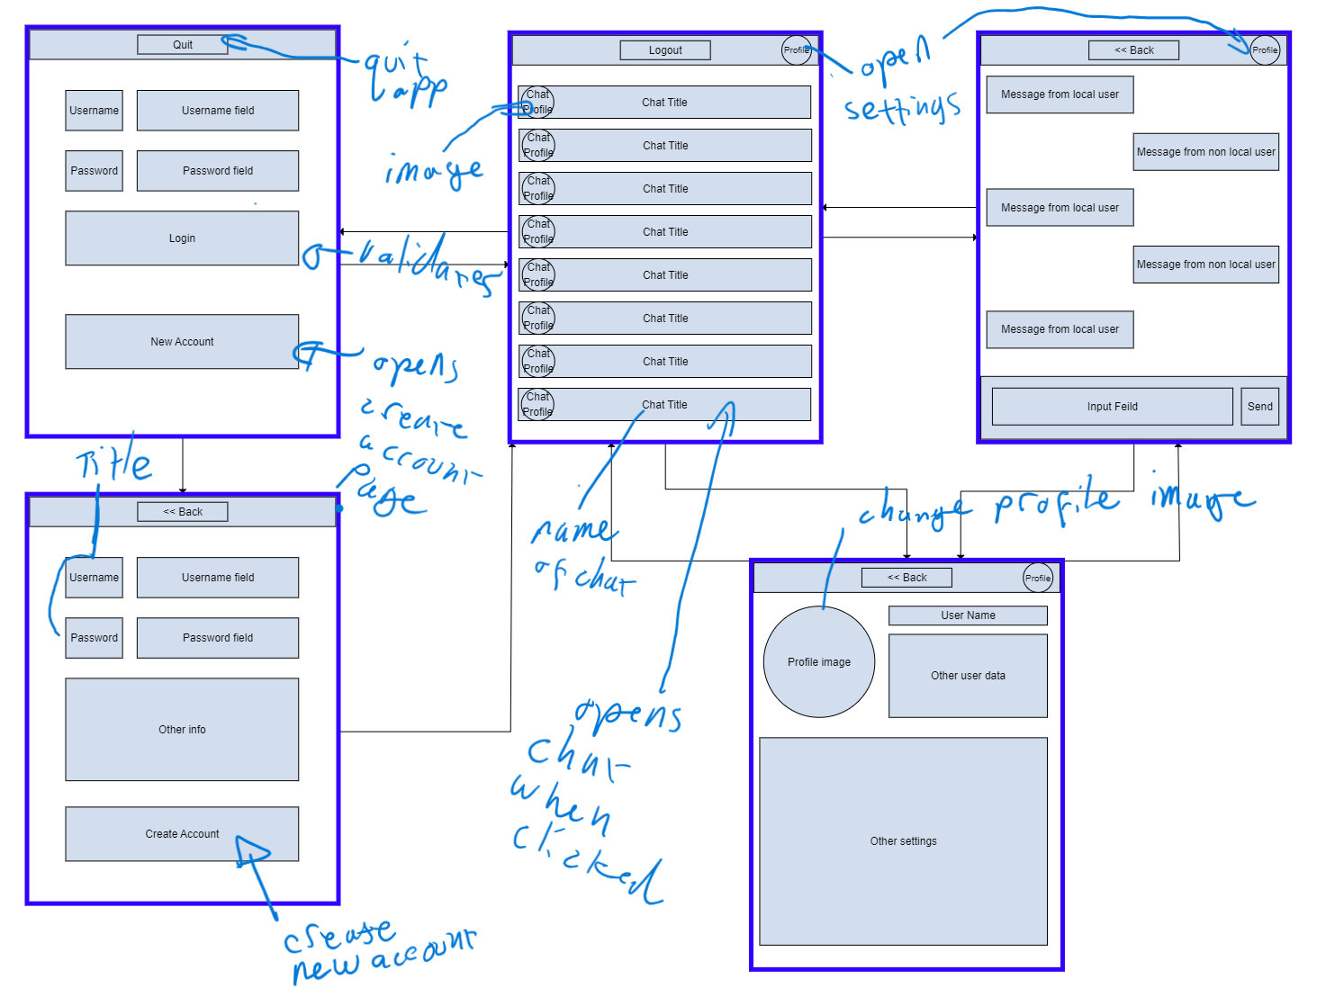

### Evaluation

#### Pros

* Similar to other messaging apps
  + Therefore, easy for users to migrate to.
* Lots of screen space for both the chat select and message screens

#### Cons

Require a large amount of button clicks to get to messages.

## Mockup 2

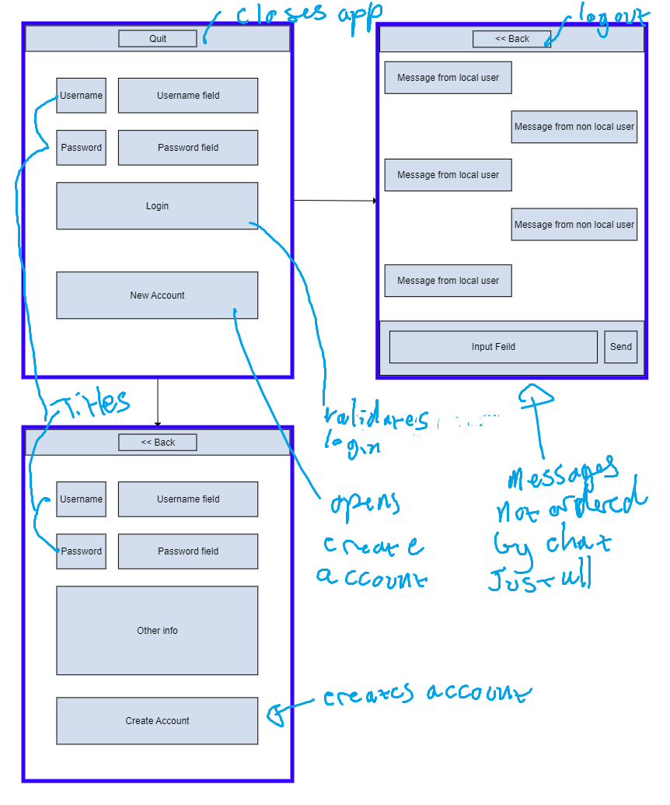

### Evaluation

#### Pros

* Simple interface small number of button clicks to get to messages

#### Cons

* Hard to read message – jumbled
* Would have to have a drop down to select who to send to
  + Which would be hard to navigate and use

## Mockup 3

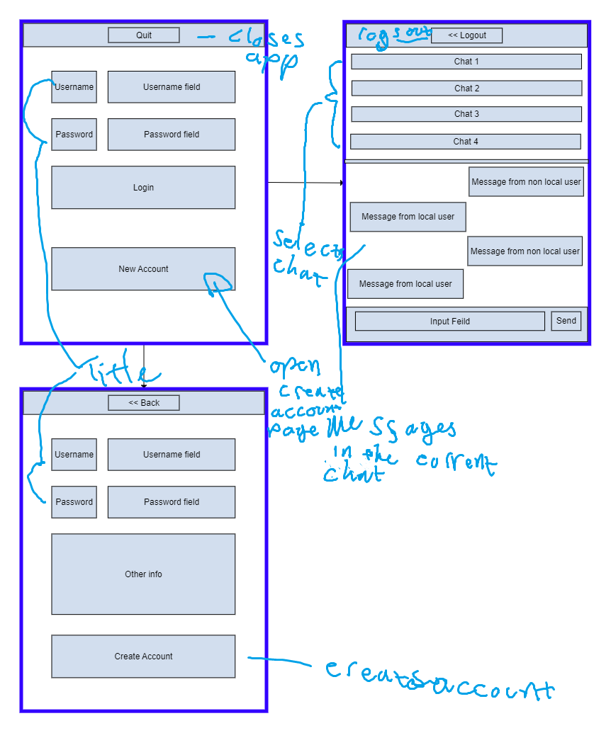

### Evaluation

#### Pros

* can easily switch between chats with few button clicks

#### Cons

* limited space for both the chat select and message screens resulting in it being hard to read.

## Final Decision

In conclusion based on the evaluation criteria identified from the data collection and analysis the first user interface (UI) mockup has been identified to conform to the specified criteria the best. The criteria identified as the most relevant to the UI mockups are as follows:

* User experience: easy to learn UI
* Functionality: meets the functional requirements
* Functionality: meets half the non-functional requirements

The second UI mockup seems to best meets the first criterion as minimal button clicks are required, however it the messiness of the messages screen renders it almost completely useless ultimately not meeting any of the evaluation criteria. The first and third UI mockups are quite similar with the major difference being the shared messages and chat select screen seen in the third design, which is aimed to make it easier to navigate between chats as you do not have to back out of one to enter another however this feature limits the size of the chat select and message screens this makes the need to scroll to see other chats or message more likely which in most cases would prove to be more annoying than clicking a back arrow. This overall makes the first UI mockups the best suit for the software solution