Peer to Peer Messaging App Documentation

Connor Cuffe

Beaumaris Secondary College

Table of Contents

Journal 3

Week 1 3

Key Decisions 3

Challenges 3

Week 2 3

Key Decisions 3

Challenges 3

Week 3 3

Key Decisions 3

Challenges 4

Week 4 4

Key Decisions 4

Challenges 4

# Journal

This section documents the decisions and challenges faced along the development of the project.

# Week 1

15 April 2024

|  |  |
| --- | --- |
| To Do List | Completed Tasks |
|  | 1. Find need or opportunity |

## Key Decisions

1. Found a need or opportunity
2. Decided on project

## Challenges

None

## Gant

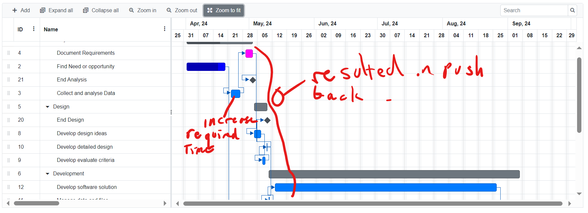

# Week 2

22 April 2024

|  |  |
| --- | --- |
| To Do List | Completed Tasks |
|  | 1. Create Gannt Chart |

## Key Decisions

1. Found a need or opportunity
2. Decided on project

## Challenges

1. Gannt chart software being bad. (online gannt, ????)

## Gant

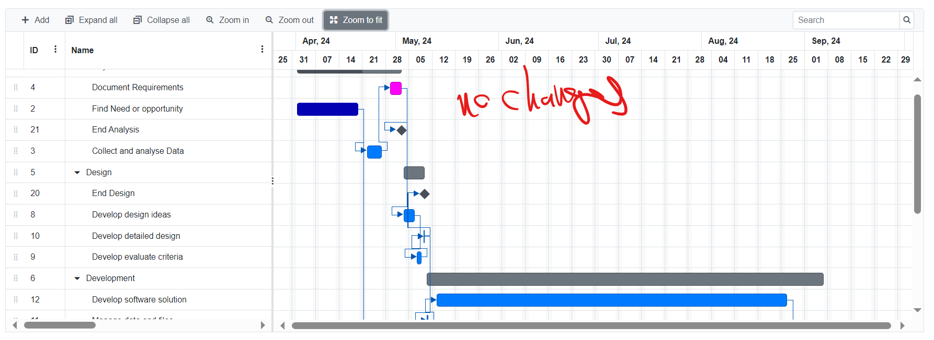

# Week 3

29 April 2024

|  |  |
| --- | --- |
| To Do List | Completed Tasks |
|  | 1. Choose Development model |

## Key Decisions

1. Decided on a development model for the project – waterfall
2. Wrote a document outlining the reason for the decision.

## Challenges

1. None

## Gant

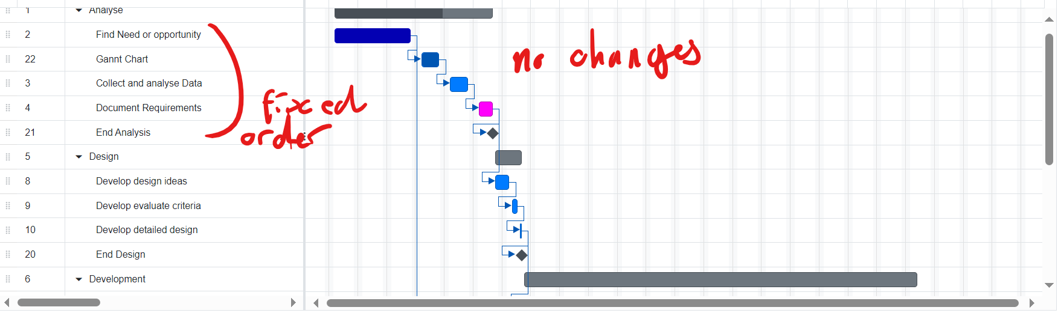

# Week 4

6-May 2024

|  |  |
| --- | --- |
| To Do List | Completed Tasks |
|  | 1. Draft Use case diagram 2. Distribute survey 3. Collect survey responses 4. Complete observation 5. Complete interview 6. Complete Report |

## Key Decisions

1. Report target
2. Interview group
3. Observation target
4. Survey distribution methods

## Challenges

1. Distributing survey to a large audience
2. Validating the authenticity of survey responses

## Gant

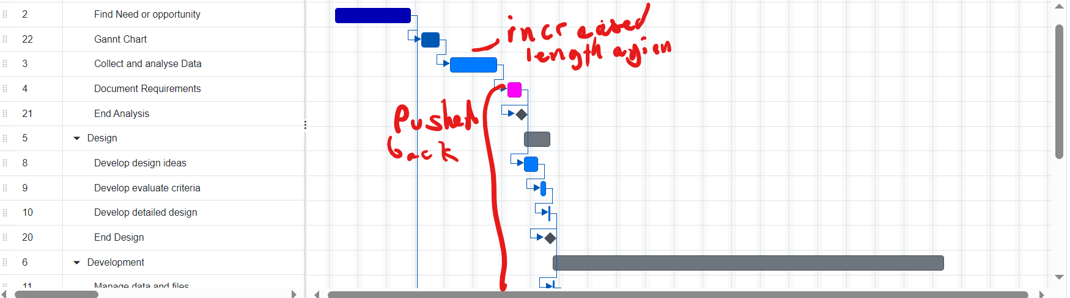

# Week 5

13-May 2024

|  |  |
| --- | --- |
| To Do List | Completed Tasks |
|  | 1. Survey Analysis 2. Interview Analysis 3. Observation Analysis |

## Key Decisions

1. Users major requirements

## Challenges

1. None

## Gant

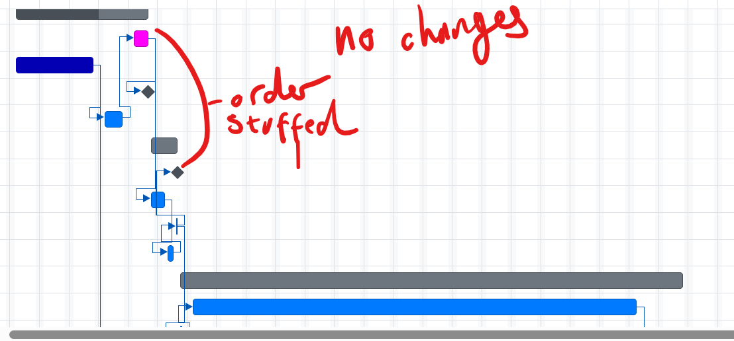

# Week 6

20-May 2024

|  |  |
| --- | --- |
| To Do List | Completed Tasks |
|  | 1. Survey Analysis 2. Software requirements documents |

## Key Decisions

1. Technical requirements

## Challenges

1. OneDrive deleting work

## Gant

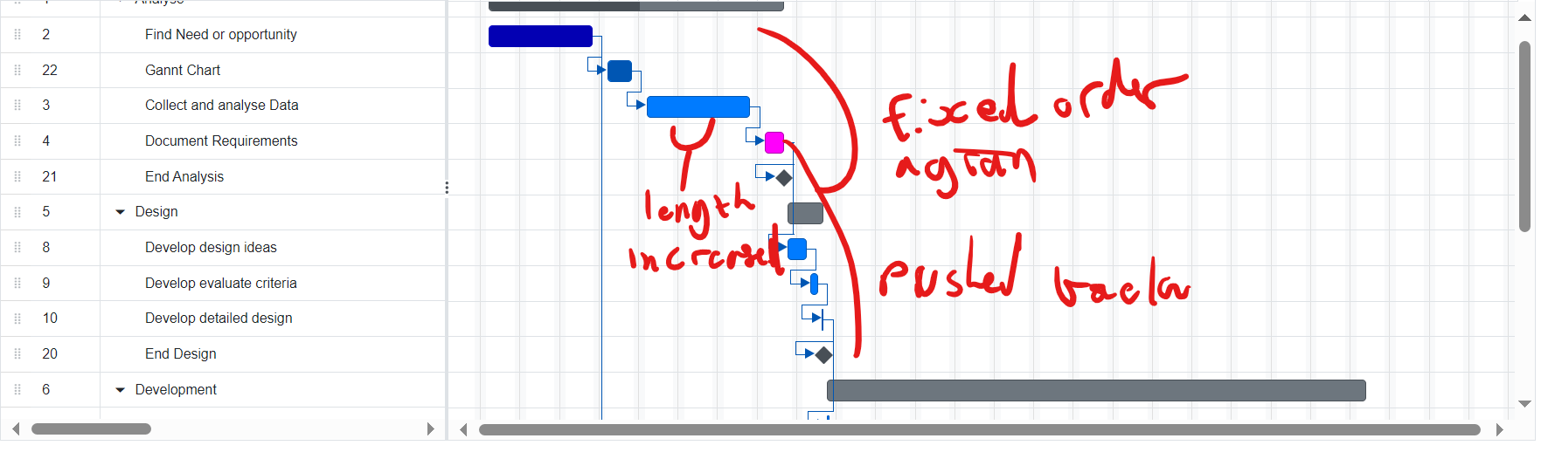

# Week 7

27-May 2024

|  |  |
| --- | --- |
| To Do List | Completed Tasks |
|  | 1. Finish software requirements |

## Key Decisions

Use cases

## Challenges

None

## Gant

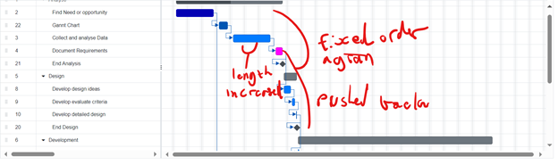

# Week 8

3-May 2024

|  |  |
| --- | --- |
| To Do List | Completed Tasks |
|  | 1. Mockup 1 2. Start of evaluation criteria 3. Data flow diagram |

## Key Decisions

* Mockup 1 design

## Challenges

None

## Gant



# Week 9

10-May 2024

|  |  |
| --- | --- |
| To Do List | Completed Tasks |
|  | 1. Finish evaluation criteria 2. Finish user interface mockup |

## Key Decisions

1. User interface mockup design 2
2. User interface mockup design 3
3. Mockup evaluation
4. Evaluation criteria

## Challenge

Failing to install git properly

## Gant



# Week 10

17-May 2024

|  |  |
| --- | --- |
| To Do List | Completed Tasks |
|  |  |

## Key Decisions

## Challenges

## Gant

# Week 12

24-May 2024

|  |  |
| --- | --- |
| To Do List | Completed Tasks |
|  | 1. Survey Analysis 2. Software requirements documents |

## Key Decisions

1. Technical requirements

## Challenges

1. OneDrive deleting work

## Gant

# References

online gannt. (????, ?? ??). *gantt*. Retrieved from onlinegantt: https://www.onlinegantt.com/#/gantt