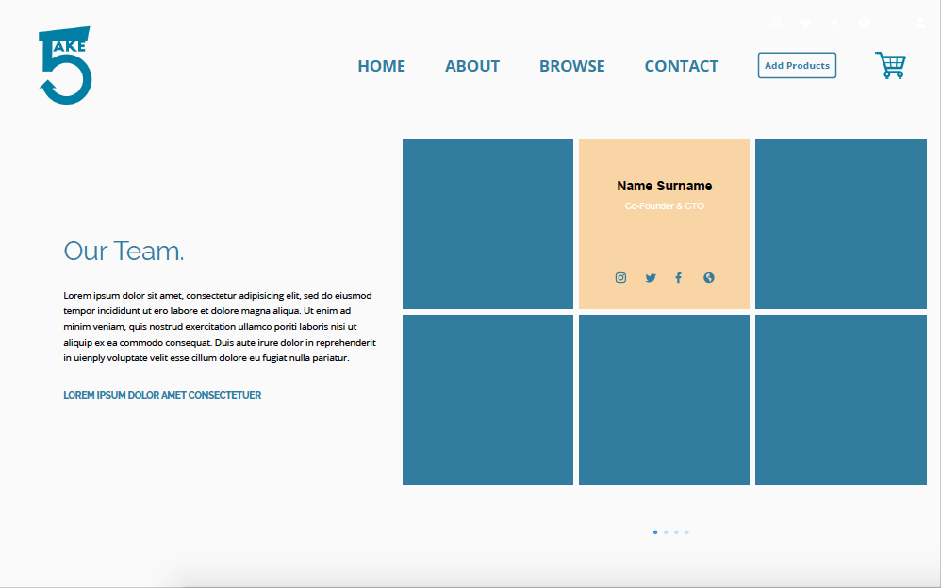

1. Our Team
   1. <h1>Meet The Team<h1/>
      1. <p>Here in Take5, we strive to provide the </p>
   2. Tagline: Be Smart, Be Resourceful
      1. <h3>Be Smart, Be Resourceful</h3>
   3. <h4>Our Mission<h4/>
      1. <p>Take5’s vision is to build an ecosystem of everlasting learners, a community that allows limitless and accessible learning opportunities for everyone.<p/>
   4. <h4>Our Vision<h4>
      1. <p>Our mission is to provide accessibility for everyone to useful and quick resources for education<p>
2. Meet The Team Bio [Flexbox]
   1. Mavis Lim
      1. <H3><b>Mavis Lim</b></H3>
      2. <H4>Co-founder & Head of Creative</H4>
      3. <p>Born and bred in Singapore, Mavis is a true example of versatility. With a strong creative and technical background, this allows her to build and create new solutions that would benefit the society through technology.</p>
   2. Jairus Sim
      1. <H3><b>Jairus Sim</b></H3>
      2. <H4>Co-founder & Head of Product</H4>
      3. <p>With up to 10 years of experience in the education and recruitment industry, Jairus’ expertise lies in the product development segment of the team, ensuring the products are well suited for the market and also meeting the industry needs.</p>
   3. Irfan
      1. <H3><b>Irfan</b></H3>
      2. <H4>Co-founder & Head of Business Development</H4>
      3. <p>With his knowledge in the education sector and up to 10 years of experience in sales & marketing. Irfan heads the company’s business development arm, ensuring the expectations of the customers serviced are always met, concurrently exploring newer avenues for the business.</p>
   4. Daniel Ang
      1. <H3><b>Daniel Ang</b></H3>
      2. <H4>Founder & Head of Marketing</H4>
      3. <p>When it comes to content creation and marketing, Daniel’s experience in the digital & social media marketing space is nothing new to the team. He currently heads the marketing department, securing partnerships with important organisations and also developing strategies for growth.</p>