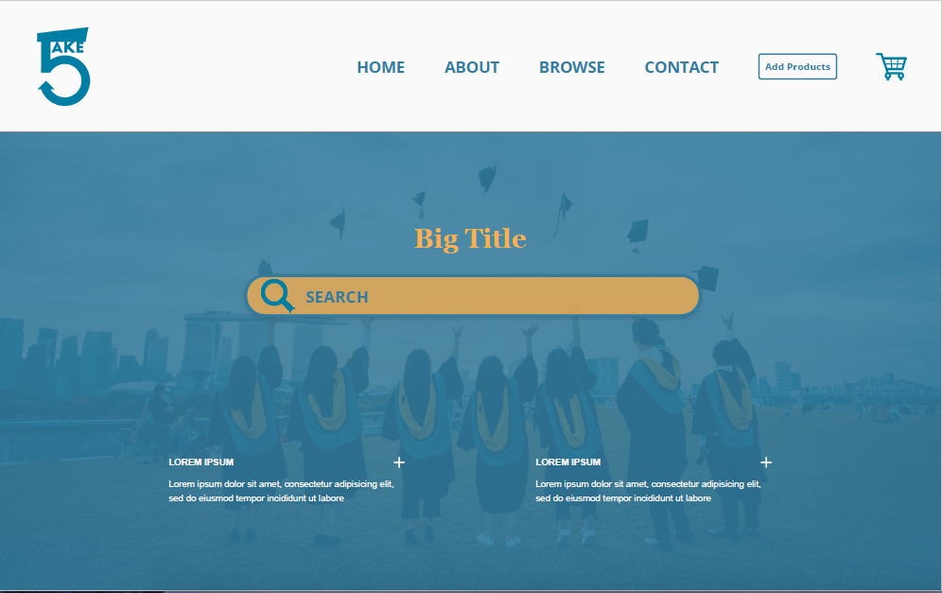

1. Home Page
   1. Top Bar (from left to right)
      1. Home
      2. About [Redirect to product page]
      3. Browse [can be “feed”?]
      4. Contact [simple contact us form]
      5. Add products [the one with the fieldset and this redirects to login page]
2. Big Title
   1. <h2>ARE YOU READY TO TAKE5?<h2/>
   2. [placeholder="search by keywords: books, study materials, research papers"]
3. Reviews on Carousell [Javascript]
   1. Review #1
      1. <b>Header:<b/> Christopher Columbus
      2. <i>Writeup:<i/> I love Take5!!! It is such an informational platform and I can just get anything I need here. Will definitely recommend to my friends for their kids
   2. Review #2
      1. <b>Name of client/partner<b/>: Lilian Balakrishnan
      2. <i>Writeup<i/>: Very easy and fast! Got my favorite study chair and it was delivered promptly post-payment.
   3. Review #3
      1. <b>Name of client/partner<b/>: Dr Joseph, Murdoch University
      2. <i>Writeup<i/>: Take5 has one of the most useful study materials for educators. My class has provided a very positive feedback ever since I’ve started implementing more materials from this platform.
   4. Review #4
      1. <b>Name of client/partner<b/>: Zack Tan
      2. <i>Writeup<i>: The study materials that was provided really helped me to ace my O levels exams and to prepare me beforehand
   5. Review #5
      1. <b>Name of client/partner<b/>: Evergreen Secondary
      2. <i>Writeup<i>: The stationary materials bought for the students are well durable and sturdy. They are a quality product for mass purchase!
   6. Review #6
      1. <b>Name of client/partner<b/>: Jean looi
      2. <i>Writeup<i/>: Not only the portable speaker sounds good but the usability is good as well, it is also a quality product and aesthetically pleasing as well!

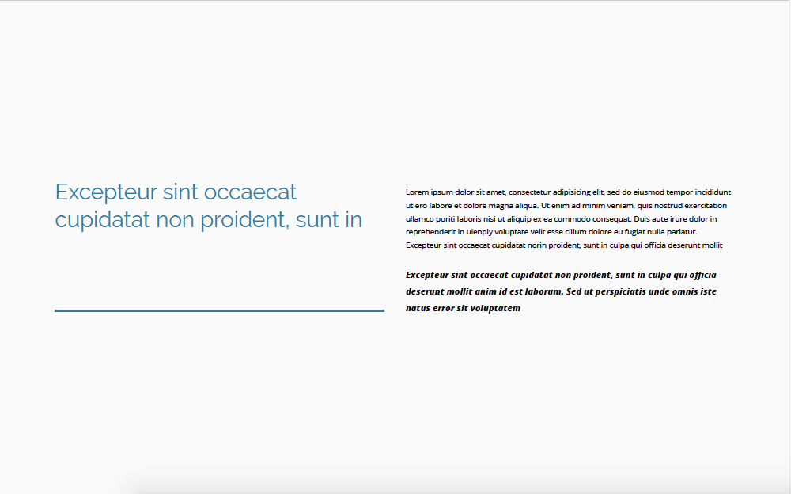

1. <h2>Take your future to greater heights<h2>
   1. [placeholder="study materials, table, kid toys"]
2. <!-- Mission Statement & Vision Statement -->
   1. <h4>Our Mission<h4/>
      1. <p>Take5’s vision is to build an ecosystem of everlasting learners, a community that allows limitless and accessible learning opportunities for everyone.<p/>
   2. <h4>Our Vision<h4>
      1. <p>Our mission is to provide accessibility for everyone to useful and quick resources for education<p>
   3. <p>

<i>Founded in 2021 by 4 passionate individuals with a great purpose in improving the lives of people in the education sector, Take5 serves as a zone for everyone to connect and find suitable solutions to enhance academic journeys. The 4 pillars established by the founders comprises: passion, motivation, perseverance and resources. <br/>

With a fast-paced world with every avenues deemed as competitive, Take5 aims to guide you and provide you a meaningful learning experience, to give you a greater sense of purpose in learning.<i>

<p/>

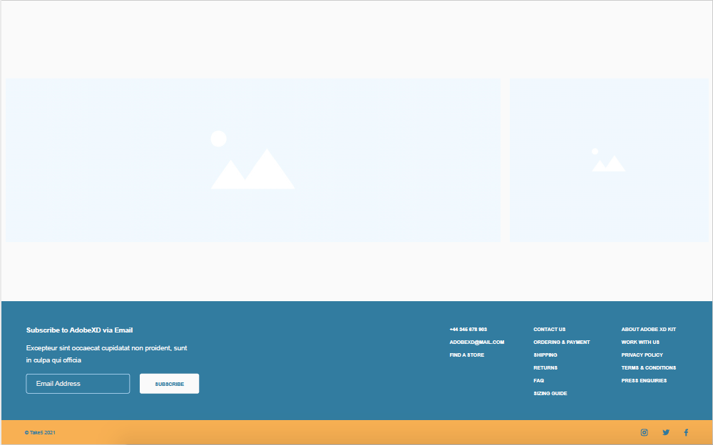

1. <!-- Images, requires javascript, recommend 6 product images -->
   1. <img src”#” width=”400” height=”300”>
   2. <img src”#” width=”400” height=”300”>
2. <!-- Subscription FlexBox?? Is this flex box →
   1. <h4>Subscribe to our mailing list<h4/><br/>

Enjoy the latest updates in the educational world and check out our latest products <br/>

[placeholder="email address"]

<button class=”Subscribe”><b>Subscribe<b/><button/>

1. <!-- contact details -->
2. <!-- CTA buttons -->
3. <!-- CTA buttons -->