Anaconda prompt

1. Open Anaconda prompt
2. Activate the environment where you want to install the Jupiter extensions
3. Execute conda install -c conda-forge jupyter_contrib_nbextensions
4. Go to Anaconda navigator and activate your environment
5. Launch Jupiter notebook
6. 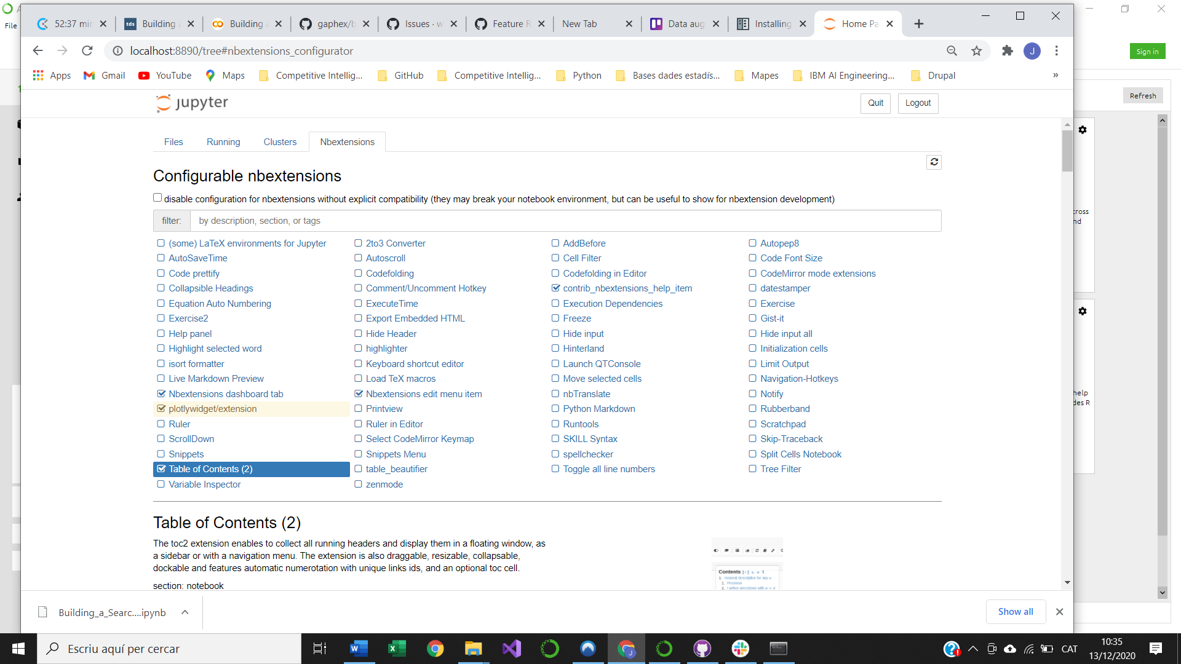Now you will see a new tab called NBextensions
7. As in the previous image, uncheck the “disable configuration…” option
8. Check the “Table of contents (2)” extension
9. Now you can open a notebook and use the TOC generator. Here you have the instructions on how to use it:  
   <https://jupyter-contrib-nbextensions.readthedocs.io/en/latest/nbextensions/toc2/README.html>