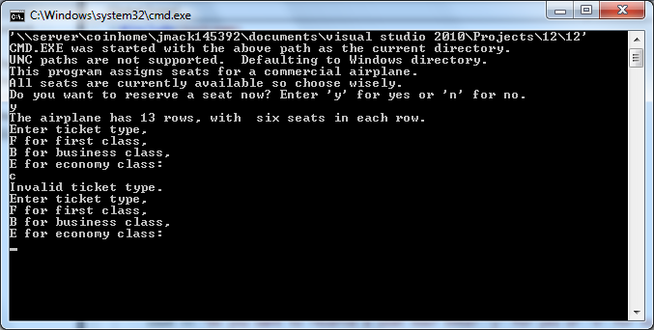

In the screen shot above as you see if you enter the wrong ticket type the program will tell you invalid ticket type and ask the user again for the ticket type. The code only has tickets for first business and economy classes so entering in the wrong class will be an invalid choice.

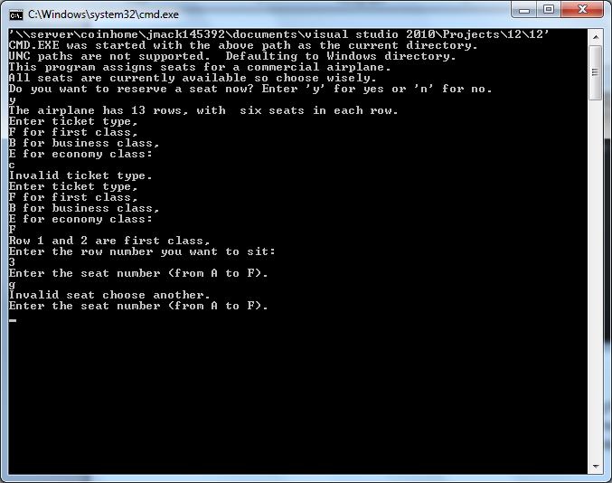

In this screen shot the user choose row 3 seat number G which the program presented to the user it was an invalid seat choice and asked for another selection.

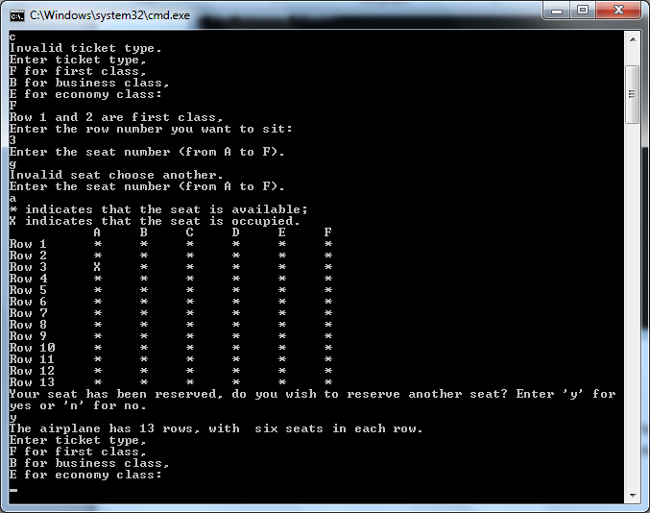

This screen shot presents that the seat the user choice is reserved row 3 se at A has an X in its column.

Improvements

- First launching the program we listed our troubleshooting variables, the correct ticket type variables was listed and we selected an invalid ticket type the program reminded us that was invalid ticket choice.
- The second test consisted of choosing the seat, the seat choices are from A to F we chose the letter G the program then stated that was an invalid seating choice and asked for another valid selection.
- The last test we conducted was whether the chart would show the seat selection even with the wrong seating choice at which the program did and put an “X” in the reserved seat requested.

