Dataset: PIGRGB-Weight

Complete data download address:
Link: https://pan.baidu.com/s/13uHbg-_B3-EaJFVanqYY9A?pwd=mawh
Password: mawh

Dataset Overview
This dataset consists of two parts: RGB_9579 and RGB_MASK_3394.
- The RGB_9579 dataset contains RGB images of pigs' backs taken at a height of 1.88 meters in a free-ranging state.
- The RGB_MASK_3394 dataset contains RGB images of pigs' backs taken at a height of 1.78 meters, along with corresponding manually labeled mask images.
Both datasets include weight annotations for the pigs, providing support for research on pig weight estimation. The RGB_9579 dataset is used for image feature extraction and weight prediction model training, while the RGB_MASK_3394 dataset is useful for studies involving mask image processing.

Dataset Structure

PigRGB-Weight
PigRGB-Weight/
├── RGB_9579/
│ └── fold1/
│ └── 73.36_124/
│ └── 73.36kg_1.png
├── RGB_MASK_3394/
│ ├── MASK_3394/
│ │ └── 33.1_34/
│ │ └── 33.1kg_1.png
│ └── RGB_3394/
│ └── 33.1_34/
│ └── 33.1kg_1.png
- RGB_9579: Contains 9579 RGB images taken at 1.88 meters in height, with weight annotations in PNG format.
- RGB_MASK_3394: Contains RGB images and corresponding mask images, taken at 1.78 meters in height. The image naming convention includes weight information (e.g., "33.1kg" indicates the pig's weight is 33.1kg).

Directory Structure Explanation
- RGB_9579: This subdirectory contains a total of 9579 RGB images.
- fold1: A subset of the dataset, used for cross-validation or other purposes.
- 73.36_124: This subset indicates the weight range (e.g., 73.36kg to 124kg) and dataset numbering.
- 33.1_34: This subset indicates the weight range (e.g., 33.1kg to 34kg) and dataset numbering.
- Mask images: Each image has a corresponding mask image in the MASK_3394 directory, matching the RGB image filenames and containing the areas of interest (such as the pig's back and contour).

Dataset Contents
- RGB images: Each PNG image corresponds to a pig's back image, captured when the pig is freely active.
- Mask images: Each RGB image has a corresponding manually labeled mask image, indicating the region of interest.

Display
(a) Stand Upright | (b) Feeding | (c) Walking
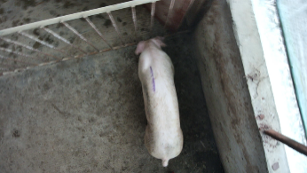 | 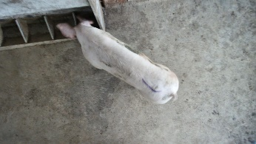 | 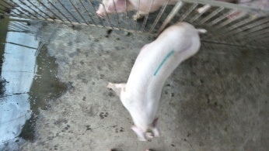
(d) Drinking | (e) Standing Abnormally | (f) Standing with Head Down
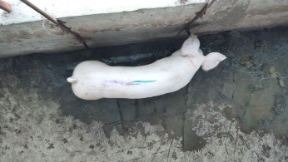 | 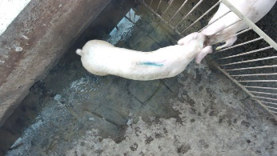 | 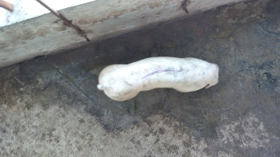
(g) Partially Obscured Multiple | (h) Fully Visible Multiple
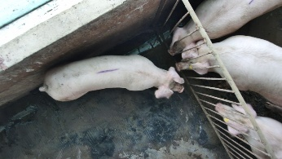 | 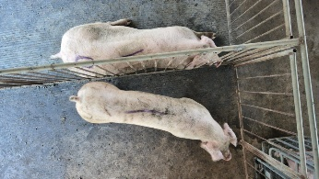
  - Stand Upright: This behavior describes the pig standing upright. The pig typically supports its body with all four limbs, standing on the ground, maintaining an upright posture.
  - Feeding: This state indicates that the pig is feeding. It can be recognized through the pig's posture or mouth movements, usually observed as the pig foraging or eating from a food trough.
  - Walking: This state describes the pig's walking behavior. It is characterized by the pig moving within an activity area, with its limbs alternately touching the ground in a regular, rhythmic pattern.
  - Drinking: This indicates that the pig is drinking water, typically shown by the pig lowering its head toward a water dispenser or trough, with its mouth in contact with the water source.
  - Standing Abnormally: This behavior describes the pig standing in an abnormal posture, typically with its body twisted or in an irregular stance.
  - Standing with Head Down: This behavior describes the pig standing while lowering its head. Typically, the pig’s body remains in a standing position, but its head is lowered.
  - Partially Obscured Multiple: This state refers to multiple pigs in the image whose parts are obscured or incomplete. This may be due to the viewing angle or other pigs or objects blocking part of their body, resulting in incomplete visibility of each pig’s details.
  - Fully Visible Multiple: This state indicates that multiple pigs are clearly visible in the image, and each pig is fully presented without any occlusion or distortion.

Usage Instructions
- After downloading the dataset, you can directly load these PNG images.
- The weight data for each image is provided in the image filename, with the unit in kilograms (kg).
- This dataset can be used for machine learning model training and testing, particularly for research on image features and weight prediction.

Usage License
This dataset will be publicly shared for use by researchers in machine learning, computer vision, and image processing fields. Please cite the relevant research work when using this dataset.

Notes
- The images in the dataset are RGB images, and the filenames include weight information.
- The dataset includes both RGB images and corresponding mask images.
- RGB_9579 was collected at a height of 1.88 meters, while RGB_MASK_3394 was collected at a height of 1.78 meters.
- Users can choose different subsets for training and validation as per their needs.

数据集：PIGRGB-Weight

完整数据下载地址：
Link: https://pan.baidu.com/s/13uHbg-_B3-EaJFVanqYY9A?pwd=mawh
Password: mawh

数据集概述
该数据集包含两部分内容：RGB_9579 和 RGB_MASK_3394。其中：
- RGB_9579 数据集包含在1.88米高度下采集的自由活动猪只背部RGB图像。
- RGB_MASK_3394 数据集包含在1.78米高度下采集的自由活动猪只背部RGB图像，以及对应的人工标注的掩码图像（mask图）。
这两个数据集均标注了对应猪只的体重信息，旨在为猪只体重估算研究提供数据支持。RGB_9579 数据集用于图像特征提取与体重预测模型训练，RGB_MASK_3394 数据集则可以用于掩码图像处理的研究与实验。

数据结构

PigRGB-Weight
markdown
复制编辑
PigRGB-Weight/
├── RGB_9579/
│ └── fold1/
│ └── 73.36_124/
│ └── 73.36kg_1.png
├── RGB_MASK_3394/
│ ├── MASK_3394/
│ │ └── 33.1_34/
│ │ └── 33.1kg_1.png
│ └── RGB_3394/
│ └── 33.1_34/
│ └── 33.1kg_1.png
- RGB_9579: 数据集包含9579张图像，采集于1.88米高度，图像包含体重信息，采用PNG格式。
- RGB_MASK_3394: 数据集包含RGB图像和对应的掩码图像（mask），采集于1.78米高度。图像命名规则包含体重信息（例如“33.1kg”表示图像对应的猪只体重为33.1kg）。

目录结构说明
- RGB_9579: 该子目录包含总计9579张RGB图像。
- fold1: 数据集的子集，可能用于交叉验证等。
- 73.36_124: 该子集表示猪只体重范围（如73.36kg到124kg）和数据编号。
- 33.1_34: 该子集表示体重范围（如33.1kg到34kg）和数据编号。
- mask图像: 每个图像在MASK_3394目录下，名称与RGB图像一一对应，包含猪只的掩码信息。

数据集内容
- RGB图像: 每张PNG图像对应一张猪只的背部图像，采集时猪只处于自由活动状态。
- 掩码图像: 对应每个RGB图像，人工标注的掩码图像包含图像的感兴趣区域（如猪只的背部、轮廓等）。

使用说明
- 下载数据集后，您可以直接加载这些PNG格式的图像。
- 每张图像的体重数据通过文件名提供，单位为公斤（kg）。
- 本数据集可用于猪只体重估算的机器学习模型训练和测试，尤其是图像特征与体重预测的研究。

使用许可
本数据集将公开共享，供科研人员用于机器学习、计算机视觉和图像处理等相关领域的研究。在使用本数据集时，请引用相关研究工作。

注意事项
- 数据集中的图像为RGB图像，文件名包含体重信息。
- 本数据集包含RGB图像和对应的掩码图像。
- RGB_9579 数据集在1.88米高度下采集，RGB_MASK_3394 数据集在1.78米高度下采集。
- 用户可以根据实际需求选择不同的子集进行训练和验证。

