**Hermoine Potions**

The implementation for this task was very straightforward using the timer.h library. We have 4 tasks that need to be registered and they are all triggered by a button press.

**The circuit:**

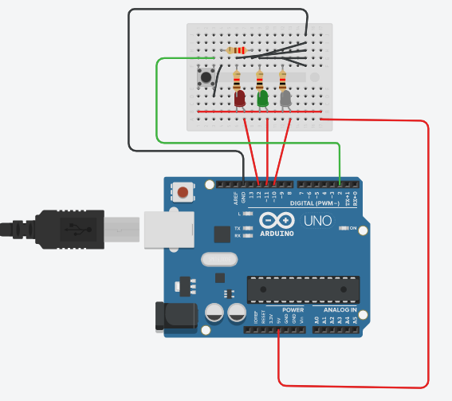

It’s a very simple circuit where we have 3 LEDS connected to the Arduino along with one button. Each component is connected to a current limiting resistor and then to ground. The button is connected to an interrupt pin as that will be very important in the code.

**The code:**



First thins was creating the timer object that can store up to 5 concurrent tasks.

The start routine function is where everything is connected. Once the button is pressed, an interrupt occurs, and the timer object cancels all previous tasks. It then adds the 4 tasks that are given as follows: turn on the red LED and turn it off in 15 minutes, blink green led every 2 minutes, blink white led at 5 minutes and 8 minutes of the routine.

All there is in the setup is the pin modes for the LEDs as well as the interrupt for the button.

The only thing in the loop is the timer.Tick() function that updates the timer.