Matthew Wills

Compiler used: mingw

System Specs:

Windows 10 64bit

AMD Phenom II X4 970 Processor 3.50 GHz

10.0 GB RAM

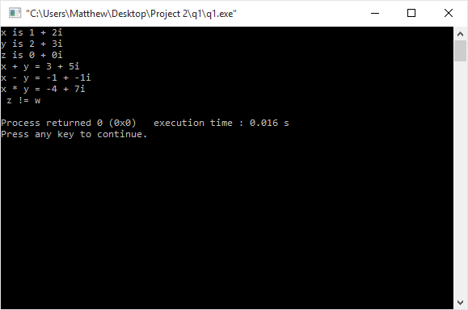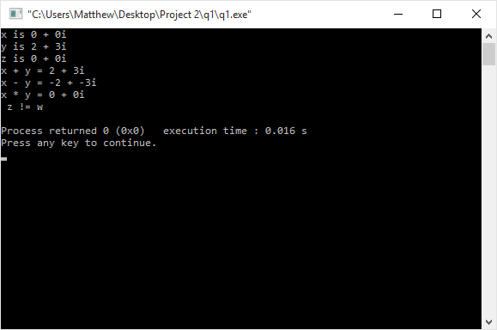

#include<iostream>

class Complex

{

double real;

double imaginary;

public:

//Overloaded constructors

Complex(double realPart, double imaginaryPart)

{

real = realPart;

imaginary = imaginaryPart;

}

Complex(double realPart)

{

real = realPart;

imaginary = 0;

}

Complex()

{

real = 0;

imaginary = 0;

}

//Overloaded operators

//Adds the real values together and the imaginary values together of two complex numbers

Complex operator+(const Complex& c)

{

Complex newComplex;

newComplex.real = this->real + c.real;

newComplex.imaginary = this->imaginary + c.imaginary;

return newComplex;

}

//Finds the difference of the real and imaginary values respectively of two complex numbers

Complex operator-(const Complex& c)

{

Complex newComplex;

newComplex.real = this->real - c.real;

newComplex.imaginary = this->imaginary - c.imaginary;

return newComplex;

}

//Checks to see if two complex numbers are the same

bool operator==(const Complex& c)

{

if(this->real == c.real &&

this->imaginary == c.imaginary)

return true;

else

return false;

}

//Multiply two complex numbers together

Complex operator\*(const Complex& c)

{

Complex newComplex;

newComplex.real = ((this->real \* c.real)-(this->imaginary \* c.imaginary));

newComplex.imaginary = ((this->real \* c.imaginary)+(this->imaginary \* c.real));

return newComplex;

}

void printComplex()

{

std::cout << real << " + " << imaginary << "i" << std::endl;

}

};

#include <iostream>

#include "complex.h"

using namespace std;

int main()

{

Complex x(1,2);

Complex y(2,3);

Complex z,w,v;

cout << "x is "; x.printComplex();

cout << "y is "; y.printComplex();

cout << "z is "; z.printComplex();

z = x + y;

cout << "x + y = "; z.printComplex();

w = x - y;

cout << "x - y = "; w.printComplex();

v = x \* y;

cout << "x \* y = "; v.printComplex();

if (z == w)

cout << " z = w" << endl;

else

cout << " z != w" << endl;

}