TDM Insight — Complete Code Walkthrough

A teach-yourself guide to your own Android application
Project: TDM Insight — Vancomycin Therapeutic Drug Monitoring Package / Application ID: com.aiu.tdminsight Course: CDE2313 · Albukhary International University (AIU) Language: Kotlin · UI toolkit: Jetpack Compose (Material 3) Backend: Supabase (PostgreSQL) · Auth: Clerk

How to use this document
Read it top-to-bottom once. Every section has three parts:
- 📸 A screenshot of your real code — the exact file and line numbers.
- What it does — in plain English.
- 💬 If the teacher asks… — a one-or-two-sentence answer you can say out loud.
At the very end there is a Quick Answer Cheat Sheet (Part 12) and 20 exam questions with model answers (Part 13).
The single most important thing to know before you start: This app has no XML layout files. There is no res/layout/activity_main.xml. The layout is written in Kotlin, using Jetpack Compose, inside the files in ui/screens/. If your teacher asks "where is the layout?" and you point at res/, you will be wrong. Point at ui/screens/. Part 8 explains exactly why.

PART 1 · The big picture

1.1 What the app actually does
A pharmacist enters a fictional patient case (weight, age, sex, serum creatinine), the vancomycin dose that was given, and one or two measured blood concentrations. The app then calculates the patient's pharmacokinetic (PK) parameters — elimination rate constant (Ke), half-life (t½), volume of distribution (Vd), clearance (CL) and AUC₂₄ — and recommends a new dose that would put AUC₂₄ in the therapeutic target band of 400–600 mg·h/L (Rybak 2020 guideline).
It supports three sampling workflows:
Workflow | Samples needed | Mathematical method
PRE | trough only | Cockcroft–Gault CrCl → population clearance
POST | peak only | Newton–Raphson numerical fit for Ke
PRE + POST | trough + peak | Sawchuk–Zaske two-point log-linear regression

Every successful calculation is saved to a cloud PostgreSQL database and can be re-opened later and exported as a PDF report.

1.2 The architecture in one picture
This app follows MVVM (Model–View–ViewModel), the architecture Google recommends for Android. Data flows down, events flow up.
┌──────────────────────────────────────────────────────────────────────┐
│ VIEW (Jetpack Compose) ui/screens/ ui/components/│
│ HomeScreen, NewCaseScreen, InputFormScreen, ResultsScreen … │
│ - draws the pixels │
│ - has NO calculation logic inside it │
└───────────────┬──────────────────────────────────▲───────────────────┘
events │ vm.updatePatient(...) │ state
(up) │ vm.runCalculation() │ (down, as StateFlow)
▼ │
┌──────────────────────────────────────────────────┴───────────────────┐
│ VIEWMODEL viewmodel/ │
│ CaseViewModel · AuthViewModel · HistoryViewModel │
│ - holds the screen state in a MutableStateFlow │
│ - survives screen rotation │
│ - decides WHEN to call the engine and the repository │
└───────┬──────────────────────────────────────────────┬───────────────┘
│ │
▼ ▼
┌───────────────────────────┐ ┌────────────────────────────────┐
│ DOMAIN (business logic) │ │ DATA (storage + network) │
│ domain/engine/ │ │ data/model/ data/supabase/ │
│ VancoEngine │ │ data/validation/ auth/ │
│ - pure Kotlin │ │ SupabaseRepository │
│ - zero Android imports │ │ ClerkAuthManager │
│ - unit-testable │ │ InputValidator │
└───────────────────────────┘ └───────────────┬────────────────┘
▼
┌──────────────────────────────────┐
│ CLOUD │
│ Supabase PostgreSQL (2 tables) │
│ Clerk identity service │
└──────────────────────────────────┘
💬 If the teacher asks "what architecture did you use?"
"MVVM. The Compose screens are the View, the three ViewModels hold state as StateFlow, the calculation engine is a pure-Kotlin domain layer with no Android dependencies, and the data layer wraps Supabase and Clerk. The View never talks to the database directly — it always goes through a ViewModel."

1.3 The five layers and which folder each one lives in
Layer | Folder | What is in it
App entry | com/aiu/tdminsight/ | MainActivity.kt, TdmApplication.kt
UI / View | ui/screens/, ui/components/, ui/theme/, ui/navigation/ | All Composable screens, shared widgets, colours, the nav graph
ViewModel | viewmodel/ | CaseViewModel, AuthViewModel, HistoryViewModel
Domain (logic) | domain/engine/ | VancoEngine.kt — all the pharmacokinetic maths
Data | data/model/, data/validation/, data/supabase/, auth/ | Models, validator, Supabase repository, Clerk auth

PART 2 · Project structure — where every file lives
Kotlin_app/
├── settings.gradle.kts ← declares the :app module, project name
├── build.gradle.kts ← top-level Gradle build file
├── gradle/libs.versions.toml ← VERSION CATALOG: every library version
├── local.properties ← your secret API keys (NOT in git)
│
├── supabase/ ← ★ THE DATABASE SECTION
│ ├── schema.sql ← creates the 2 tables + seed data
│ ├── update_v2.sql ← removes demo data, tightens security
│ ├── update_v3.sql ← adds Clerk identity columns
│ └── update_v4.sql ← per-user Row Level Security
│
└── app/
├── build.gradle.kts ← ★ module build: SDK versions + dependencies
└── src/
├── main/
│ ├── AndroidManifest.xml ← ★ APP ENTRY POINT declaration
│ ├── res/ ← Android resources (NO layout folder!)
│ │ ├── values/strings.xml, colors.xml, themes.xml
│ │ ├── values-night/colors.xml
│ │ ├── drawable/, mipmap-anydpi-v26/ ← app icon
│ │ └── xml/file_paths.xml ← FileProvider config
│ └── java/com/aiu/tdminsight/
│ ├── MainActivity.kt ← ★ THE MAIN ACTIVITY
│ ├── TdmApplication.kt ← Application class (singletons)
│ │
│ ├── auth/ ← Clerk authentication
│ │ ├── AuthState.kt ← sealed class: who is signed in
│ │ ├── AuthRepository.kt ← session persistence
│ │ └── ClerkAuthManager.kt ← raw HTTP calls to Clerk API
│ │
│ ├── data/
│ │ ├── model/ ← plain data classes
│ │ │ ├── InputModels.kt ← PatientInput, DosingInput, samples
│ │ │ ├── ResultModels.kt ← PkResults, CalculationResult
│ │ │ ├── HistoryEntry.kt ← one saved case
│ │ │ └── UserProfile.kt
│ │ ├── validation/ ← input rules
│ │ │ ├── InputValidator.kt
│ │ │ └── ValidationResult.kt
│ │ └── supabase/ ← ★ DATABASE ACCESS CODE
│ │ ├── SupabaseClientProvider.kt
│ │ ├── SupabaseModels.kt ← DTOs = table columns
│ │ └── SupabaseRepository.kt ← insert / select / delete
│ │
│ ├── domain/engine/
│ │ └── VancoEngine.kt ← ★ THE LOGIC SECTION (all maths)
│ │
│ ├── viewmodel/ ← ★ STATE + EVENT HANDLERS
│ │ ├── CaseViewModel.kt
│ │ ├── AuthViewModel.kt
│ │ └── HistoryViewModel.kt
│ │
│ └── ui/ ← ★ THE LAYOUT SECTION
│ ├── UserPrefs.kt ← theme + disclaimer prefs
│ ├── navigation/NavGraph.kt ← routes + NavHost
│ ├── components/Banners.kt ← reusable button/banner widgets
│ ├── export/ ← PDF generation + sharing
│ │ ├── CaseReportPdf.kt
│ │ └── ShareCaseReport.kt
│ ├── theme/ ← colours, typography, shapes
│ │ ├── Color.kt, Theme.kt, Type.kt, Shape.kt
│ └── screens/ ← ★ ALL 20 MAIN SCREENS
│ ├── SplashScreen.kt
│ ├── AuthScreens.kt ← Login/SignUp/Verify/Welcome
│ ├── HomeScreen.kt ← dashboard + bottom nav bar
│ ├── CaseWizardScreens.kt ← the 5-step wizard
│ ├── ResultScreens.kt ← calculating/results/explanation
│ ├── HistoryScreen.kt
│ ├── HistoryDetailScreen.kt
│ ├── SettingsScreens.kt
│ ├── ProfileScreen.kt
│ └── ScreenComponents.kt ← shared form widgets
│
└── test/java/com/aiu/tdminsight/ ← ★ UNIT TESTS
├── domain/engine/VancoEngineTest.kt
└── data/validation/InputValidatorTest.kt

PART 3 · The Manifest and the build files

3.1 AndroidManifest.xml — how Android knows this app exists
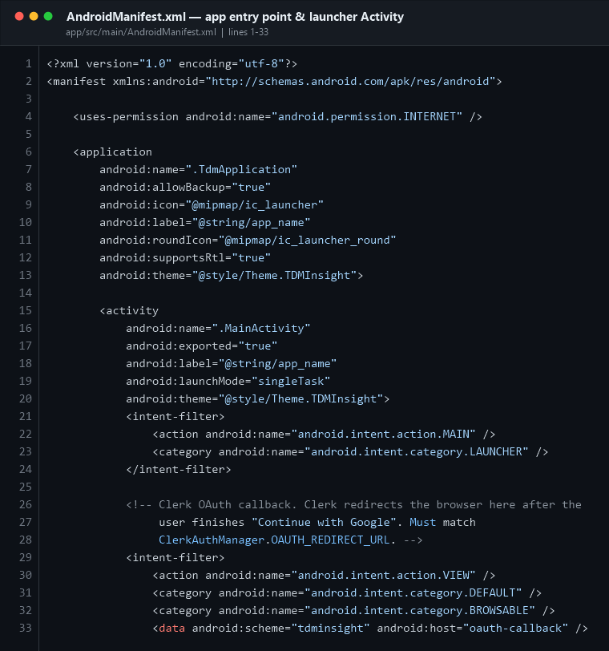
AndroidManifest activity
What it does, line by line:
Line | Meaning
4 | INTERNET is the only permission the app requests. It needs it to reach Supabase and Clerk. No camera, no storage, no location.
6–13 | The <application> tag. android:name=".TdmApplication" tells Android to use your custom Application class instead of the default one.
15–20 | Declares MainActivity. exported="true" is required because it is the launcher. launchMode="singleTask" means the OAuth browser returns to the same instance instead of opening a second copy.
21–24 | This is what makes the app appear in the launcher. action.MAIN + category.LAUNCHER = "this is the icon the user taps".
29–33 | A second intent filter: a deep link. When Clerk finishes Google sign-in in the browser it redirects to tdminsight://oauth-callback, and Android routes that URL back into MainActivity.

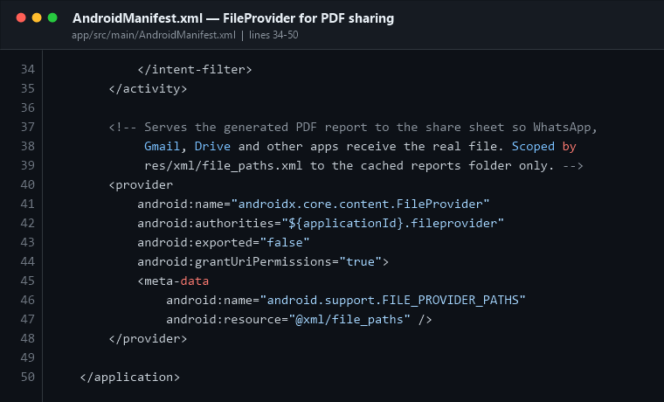
AndroidManifest FileProvider
The <provider> block registers a FileProvider. When the user shares a PDF report, Android is not allowed to hand another app a raw file path — it must hand over a content:// URI. file_paths.xml (shown in Part 11) limits what can be shared to exactly one cache folder.
💬 If the teacher asks "what is the entry point of your app?"
"AndroidManifest.xml declares MainActivity with the MAIN/LAUNCHER intent filter, so when the user taps the icon Android creates MainActivity and calls its onCreate(). Before that, TdmApplication.onCreate() runs, because it is registered as the application class."

3.2 app/build.gradle.kts — SDK versions and secret keys
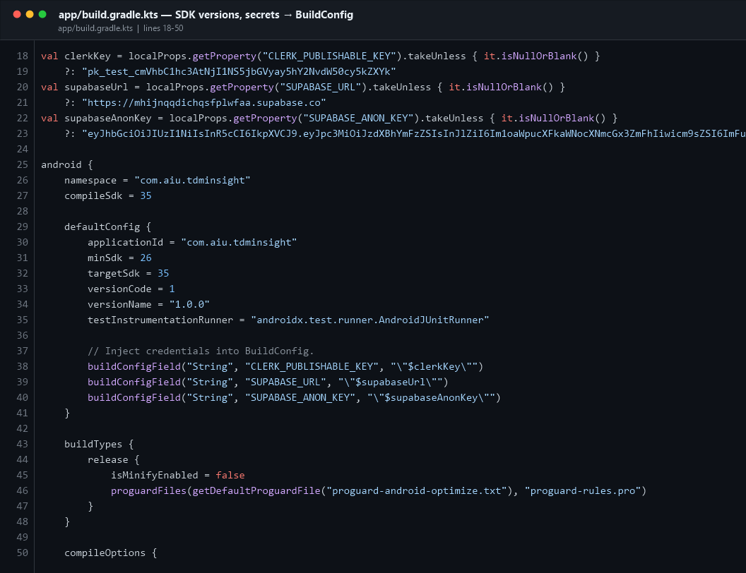
Gradle config
Key facts to memorise:
Setting | Value | Meaning
namespace / applicationId | com.aiu.tdminsight | The unique ID of the app on the Play Store and on the device
compileSdk / targetSdk | 35 | Built and tested against Android 15
minSdk | 26 | Runs on Android 8.0 Oreo and newer
versionCode / versionName | 1 / "1.0.0" | Release numbering
buildConfigField | 3 fields | Injects the Clerk and Supabase keys into a generated BuildConfig class so they are readable from Kotlin

Lines 22–27 read the keys from local.properties (which is git-ignored), and fall back to a hard-coded default if the file is missing.
⚠️ Honest note you should be ready to defend: those fallback keys are real and currently committed in the file. They are publishable/anon keys — they are designed to be visible in a client app — but the safe practice is to keep only a placeholder in the fallback and require local.properties. If the teacher raises it, say: "Yes — the anon key is public by design, but row-level security in update_v4.sql is what actually protects the data, and the fallback should ideally be blank."
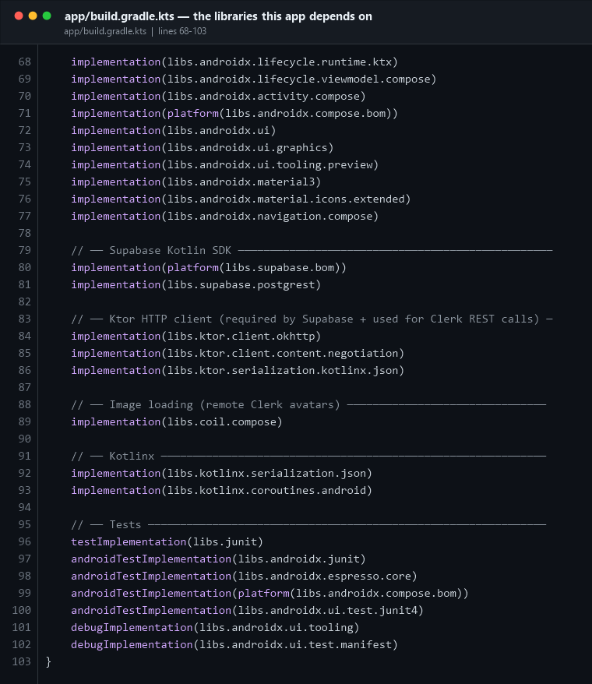
Gradle dependencies
Every library and why it is here:
Dependency | Why
androidx.activity:activity-compose | Lets ComponentActivity host Compose via setContent { }
compose-bom | A "bill of materials" that pins all Compose libraries to one compatible set
androidx.compose.material3 | Material Design 3 components: Scaffold, Button, Surface, TopAppBar
material-icons-extended | The icon set (Icons.Filled.Home, Icons.Outlined.Science, …)
androidx.navigation:navigation-compose | The NavHost / NavController used in NavGraph.kt
lifecycle-viewmodel-compose | The viewModel() function that gives a Composable its ViewModel
supabase-postgrest | Talks to the PostgreSQL REST API
ktor-client-okhttp | The HTTP engine; used by Supabase and directly by ClerkAuthManager
kotlinx-serialization-json | Converts Kotlin data classes ↔ JSON
kotlinx-coroutines-android | suspend functions, viewModelScope, background threads
coil-compose | Loads the user's Google profile picture from a URL
junit | Unit tests

💬 "Which libraries did you use?"
"Jetpack Compose with Material 3 for the UI, Navigation-Compose for screen routing, Lifecycle-ViewModel for state, the Supabase Kotlin SDK on top of Ktor for the database, kotlinx-serialization for JSON, Coroutines for async work, Coil for images, and JUnit for tests. Versions are centralised in gradle/libs.versions.toml."

PART 4 · The Application class and the MAIN ACTIVITY

4.1 TdmApplication — created before anything else
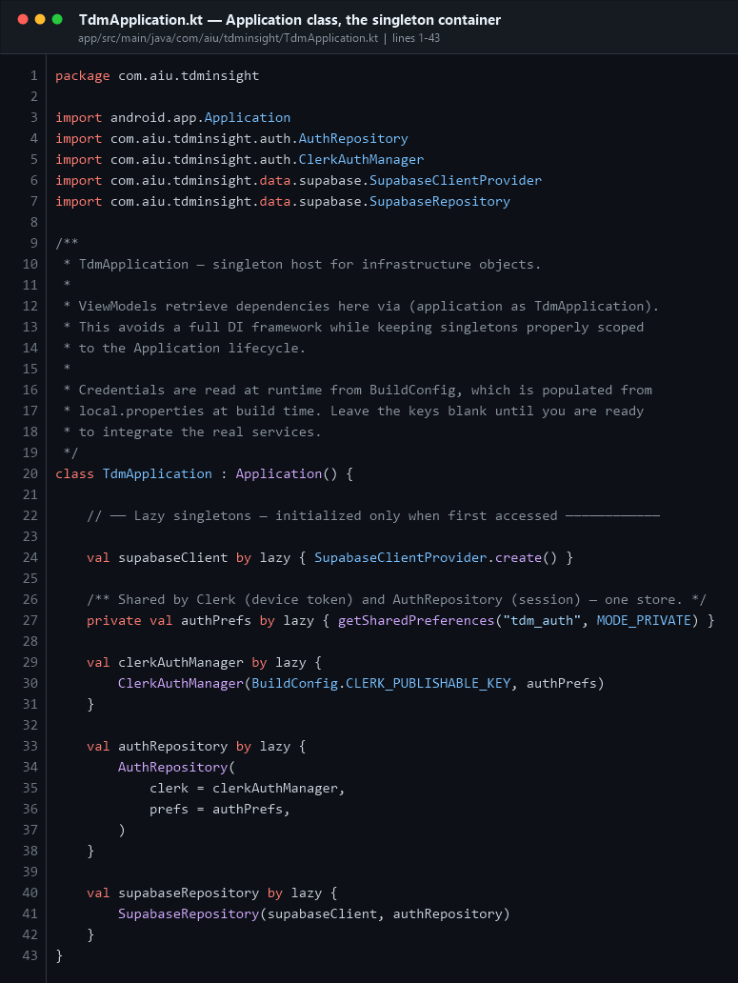
TdmApplication
This class exists once for the whole process. It creates the shared objects (SupabaseClient, ClerkAuthManager, AuthRepository, SupabaseRepository) as by lazy singletons — meaning each one is built the first time it is used, and never built twice.
This is manual dependency injection. A bigger app would use Hilt or Koin; here the ViewModels simply do (application as TdmApplication).supabaseRepository.
💬 "Why is there an Application class?"
"So the Supabase client and the Clerk auth manager exist once for the whole app lifetime instead of being recreated on every screen. It is lightweight dependency injection without adding a DI framework."

4.2 ★ MainActivity — THE MAIN ACTIVITY
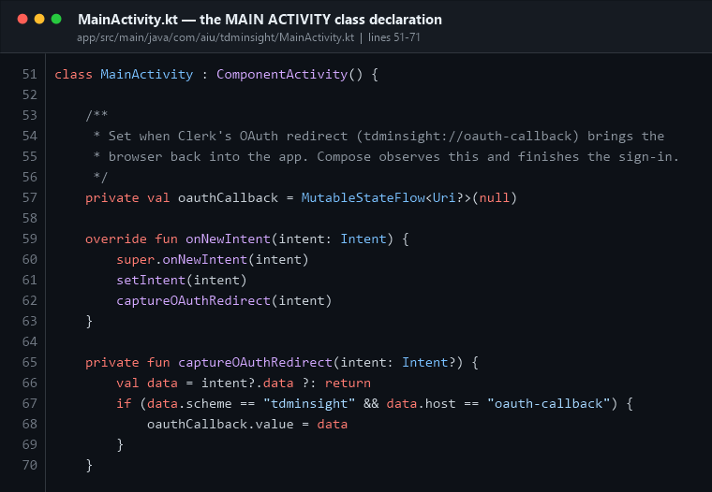
MainActivity class
`MainActivity` is the one and only Activity in this app. This is a single-Activity architecture: every "screen" you see is a Composable function, not a separate Activity or Fragment.
It extends `ComponentActivity` (not AppCompatActivity) because Compose does not need the AppCompat theme machinery.
Lines 59–70 handle the OAuth deep link: when the browser returns to tdminsight://oauth-callback, Android calls onNewIntent(), and the URL is pushed into a MutableStateFlow that Compose is watching.

4.3 onCreate() and setContent — where the UI begins
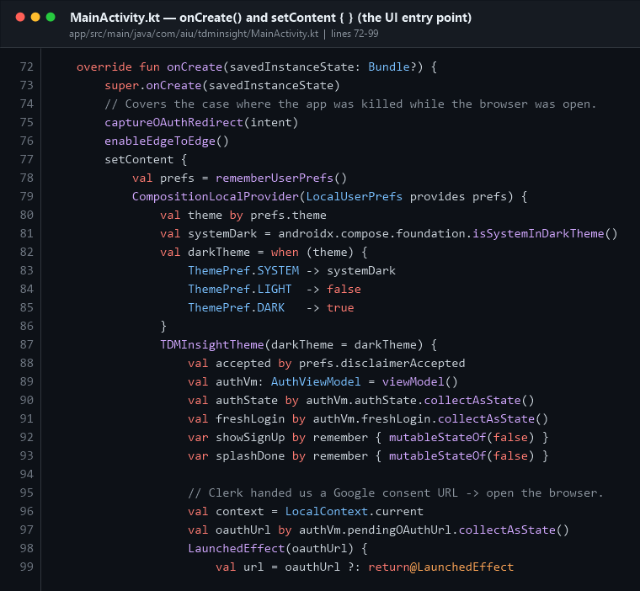
MainActivity onCreate
This is the most important function in the whole app. Read it step by step:
Line | What happens
72 | onCreate() — the Android lifecycle callback that runs when the Activity is created.
73 | super.onCreate() — always call the parent first.
76 | enableEdgeToEdge() — lets the app draw behind the status and navigation bars.
77 | `setContent { }` — this replaces setContentView(R.layout.…) from the old XML world. Everything inside this block is the app's UI.
78–79 | Loads saved preferences and publishes them through a CompositionLocalProvider so any screen can read the theme.
82–86 | Decides dark vs light: follow the system, or force one.
87 | TDMInsightTheme { } wraps everything in the Material 3 theme.
89 | viewModel() creates (or reuses) the AuthViewModel scoped to this Activity.
90–93 | collectAsState() converts the ViewModel's StateFlows into Compose state — when the flow emits, the UI recomposes automatically.

4.4 The top-level screen gate
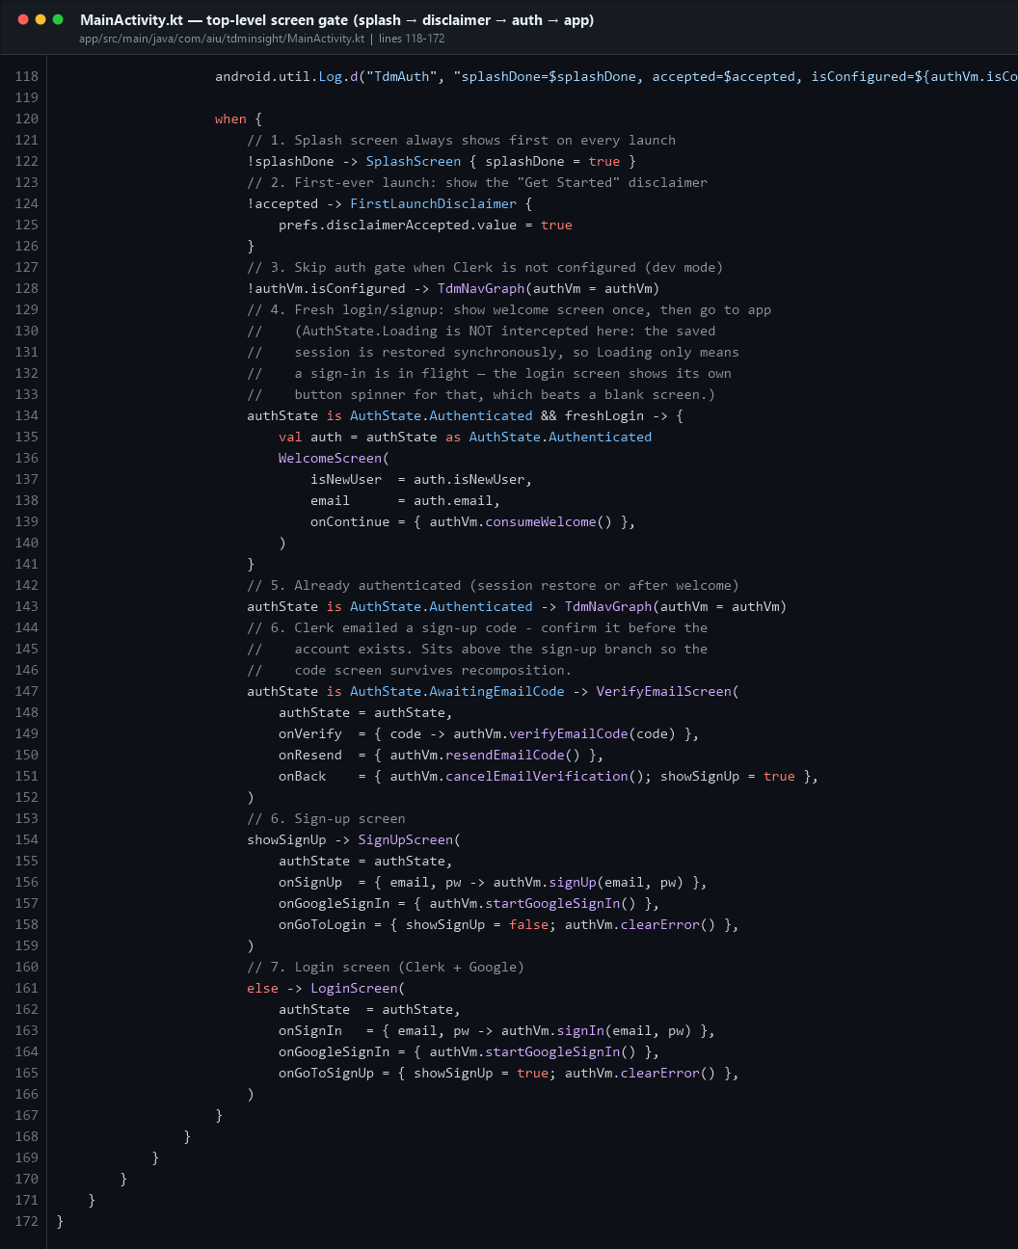
MainActivity routing
This when { } block decides which of six "pre-app" screens the user sees before the real navigation graph starts. It is evaluated top-to-bottom and the first true branch wins:
- !splashDone → SplashScreen (always, 1.8 seconds)
- !accepted → FirstLaunchDisclaimer ("I understand — get started")
- !authVm.isConfigured → straight into the app (developer mode with no Clerk key)
- Authenticated and just logged in → WelcomeScreen (shown once)
- Authenticated → `TdmNavGraph(authVm)` ← the real app starts here
- Awaiting email code → VerifyEmailScreen
- showSignUp → SignUpScreen
- otherwise → LoginScreen
💬 "What is your MainActivity and what does it do?"
"MainActivity is the only Activity. In onCreate() it calls setContent, which hosts the whole Compose UI. Inside, it applies the theme, observes the AuthViewModel, and uses a when block to choose between splash, disclaimer, login, sign-up, email verification, welcome, or the main navigation graph. It also catches the Clerk OAuth deep-link redirect."

PART 5 · Navigation — how screens are connected

5.1 Routes — every screen address
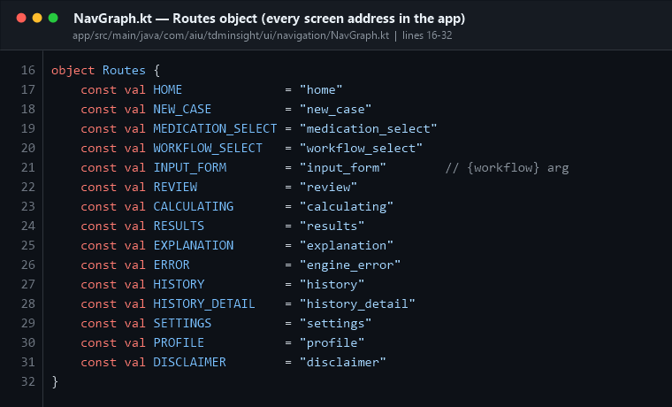
NavGraph routes
Routes is a plain Kotlin object holding 15 const val strings. Using constants instead of typing "home" everywhere means a typo becomes a compile error rather than a crash at runtime.

5.2 NavHost — the route → screen table
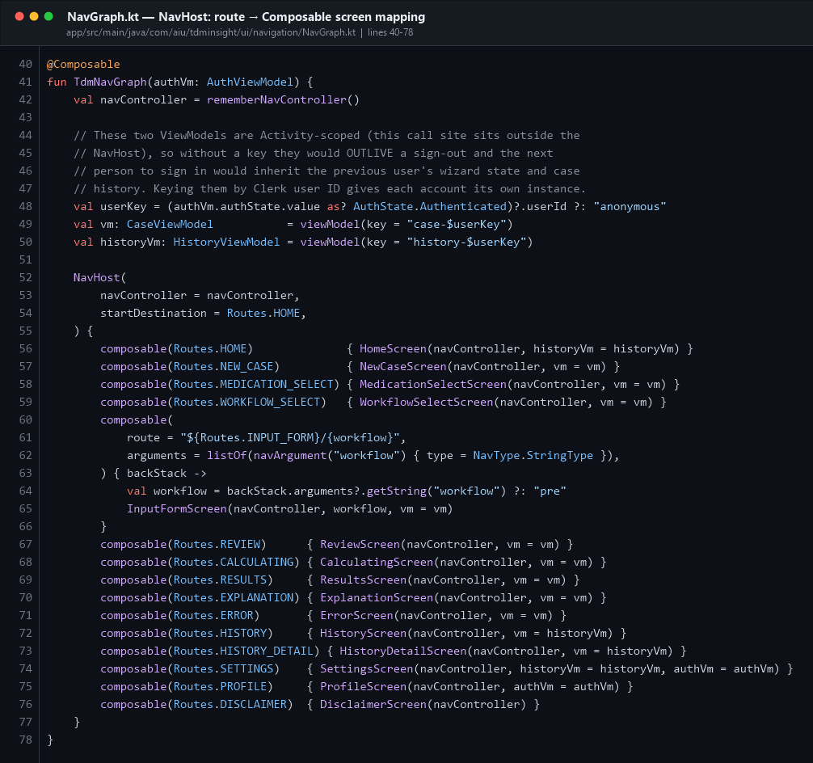
NavGraph host
Concept | Where | Explanation
rememberNavController() | line 42 | Creates the controller that owns the back stack
viewModel(key = "case-$userKey") | 49–50 | The ViewModels are keyed by Clerk user ID, so when one user signs out the next user does not inherit their wizard state or history
NavHost(startDestination = Routes.HOME) | 52–55 | Home is the first screen after login
composable(Routes.X) { Screen(...) } | 56–76 | One line per screen — this is the routing table
composable("input_form/{workflow}") | 60–66 | The only route with an argument. The workflow name (pre, post, pre_post) travels in the URL and is read back with backStack.arguments?.getString("workflow")

Navigation is triggered from a screen with nav.navigate(Routes.RESULTS) and the back button is nav.popBackStack().
💬 "How do you move between screens?"
"Navigation-Compose. NavGraph.kt declares a NavHost that maps a route string to a Composable. Screens call nav.navigate(Routes.X) to go forward and nav.popBackStack() to go back. One route, the input form, carries the chosen workflow as a path argument."

PART 6 · The data models

6.1 Input models — what the user types
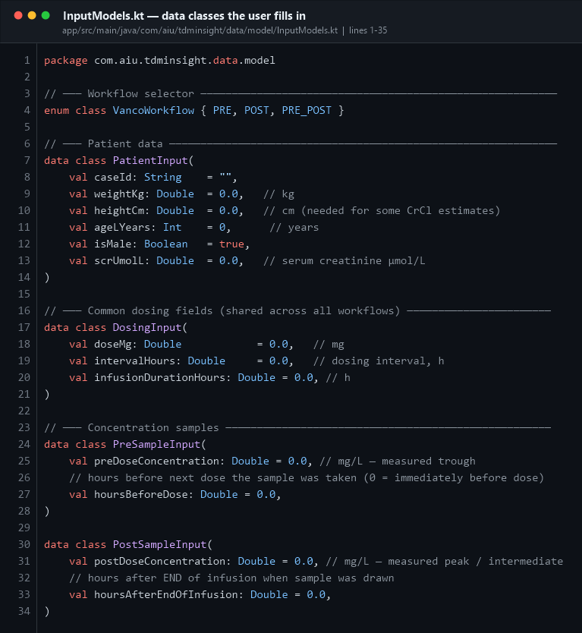
Input models
Five small data classes and one enum:
- VancoWorkflow — PRE, POST, PRE_POST
- PatientInput — caseId, weight, height, age, sex, serum creatinine
- DosingInput — dose (mg), interval τ (h), infusion duration (h)
- PreSampleInput — trough concentration + time
- PostSampleInput — peak concentration + time
- Three wrapper classes (PreWorkflowInput, …) that bundle exactly what each engine
function needs
Kotlin data class gives you equals(), hashCode(), toString() and — crucially for this app — `copy()`, which is how the UI updates one field without mutating state (see Part 9.2).

6.2 Result models — what the engine produces
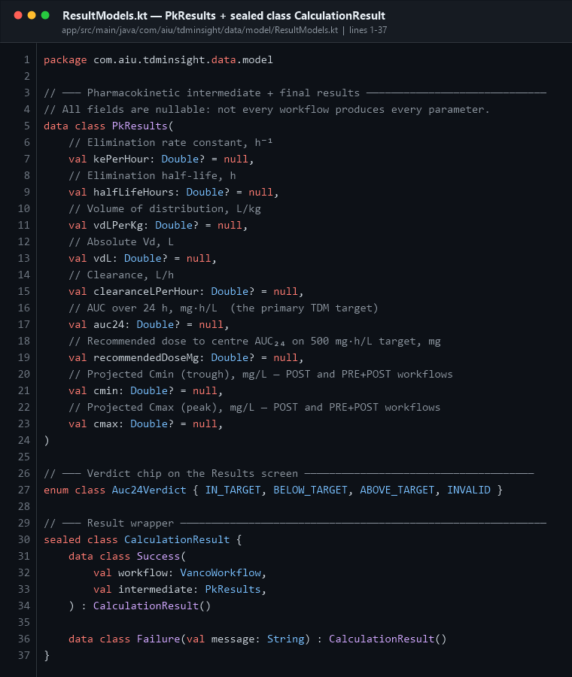
Result models
- PkResults — every derived number, all nullable, because not every workflow
produces every parameter (e.g. the PRE workflow cannot give a Cmax).
- Auc24Verdict — IN_TARGET / BELOW_TARGET / ABOVE_TARGET / INVALID
- CalculationResult — a sealed class with exactly two subtypes: Success and
Failure.
A sealed class is a closed set of types. Because the compiler knows there are only two, a when over it is exhaustive and you can never forget to handle the error case.

6.3 HistoryEntry — one saved case
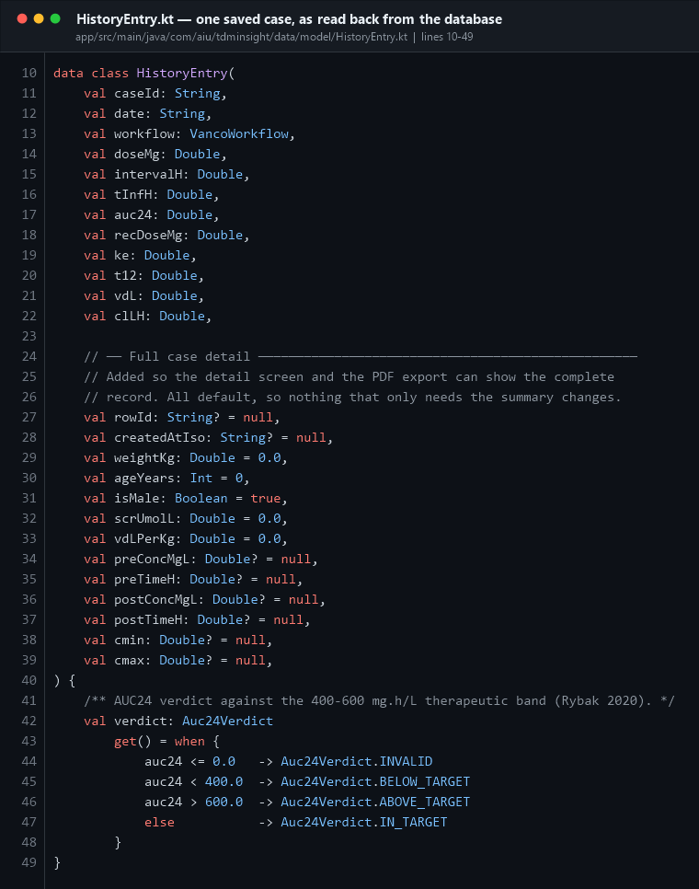
History entry
This is the domain model for a row read back from the database. Note the computed property verdict at lines 41–48: it is not stored anywhere — it is recalculated from auc24 every time it is read, comparing against the 400–600 band.

PART 7 · Validation — stopping bad data before the maths
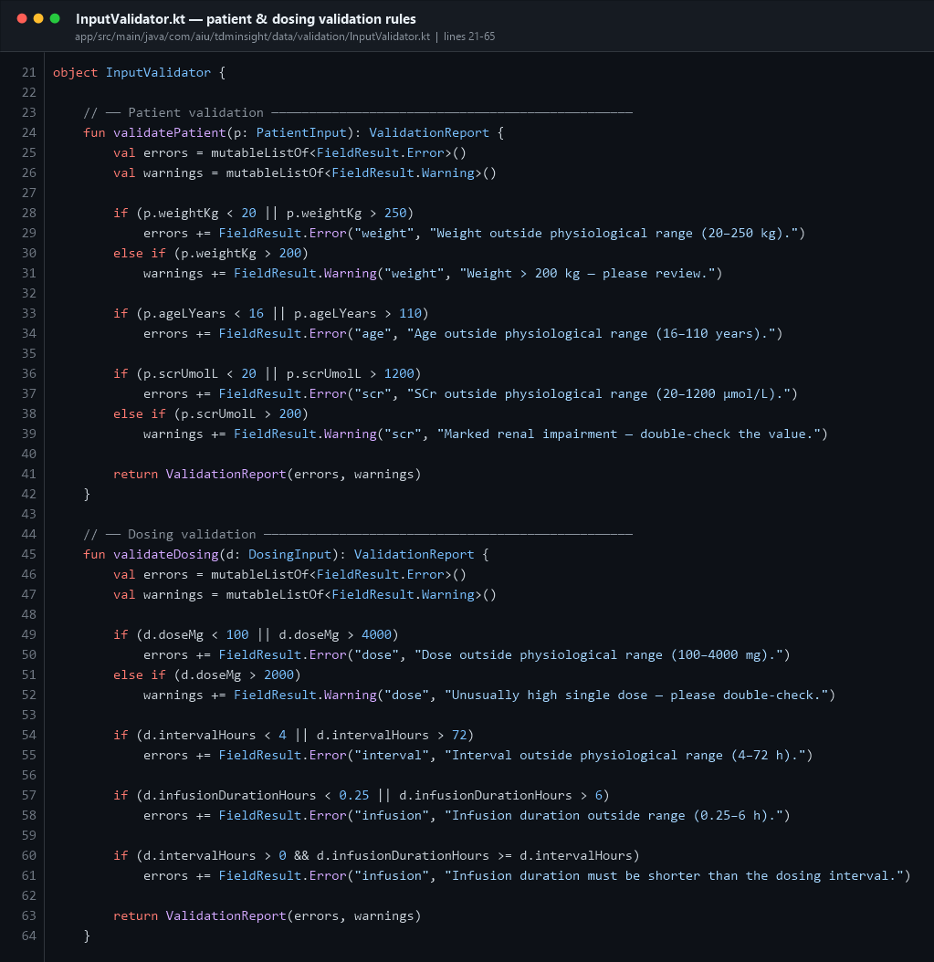
Validator patient/dosing
InputValidator is a Kotlin object (a singleton) with no Android imports, so it can be unit-tested on a plain JVM.
It distinguishes two severities:
- `FieldResult.Error` — blocking. The "Review inputs" button stays disabled.
- `FieldResult.Warning` — advisory. Amber banner, but you can continue.
Field | Hard range (error) | Soft limit (warning)
Weight | 20–250 kg | > 200 kg
Age | 16–110 years | —
Serum creatinine | 20–1200 µmol/L | > 200 µmol/L
Dose | 100–4000 mg | > 2000 mg
Interval τ | 4–72 h | —
Infusion duration | 0.25–6 h, and must be < τ | —
Trough concentration | 0.1–80 mg/L | > 25 mg/L
Peak concentration | 0.1–120 mg/L | > 60 mg/L

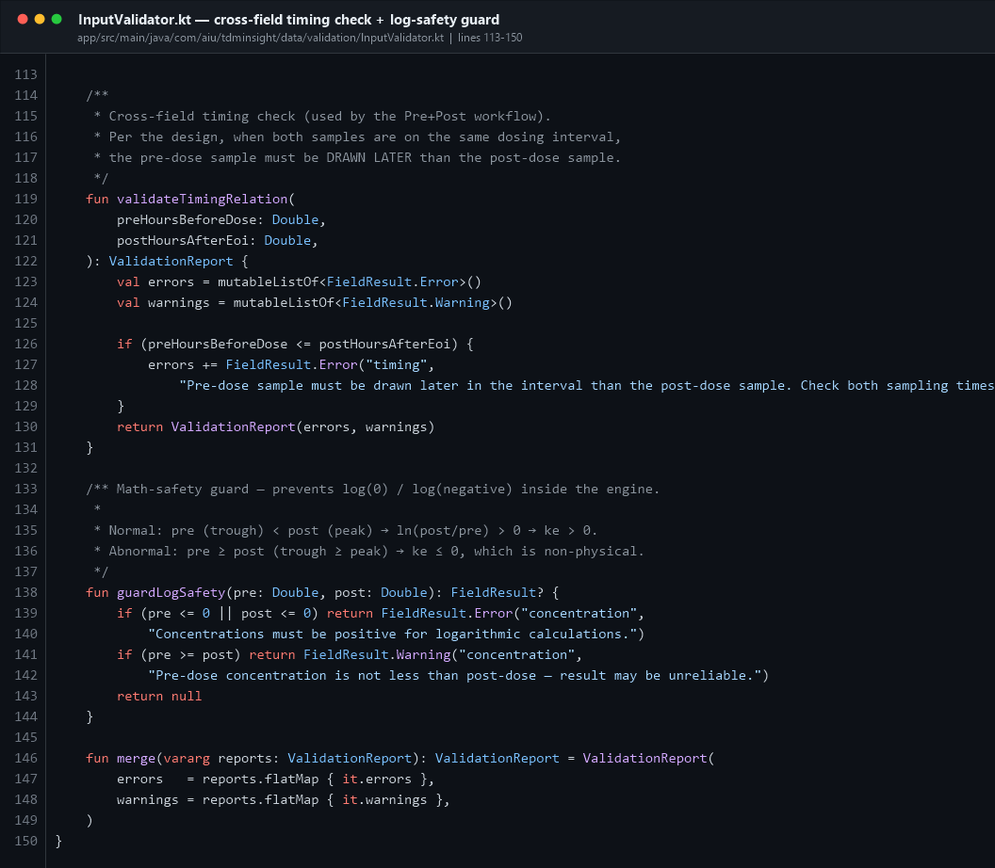
Validator timing
Two special checks:
- `validateTimingRelation` — in the PRE+POST workflow the trough must be drawn
later in the interval than the peak, otherwise the regression slope is backwards.
- `guardLogSafety` — the Sawchuk–Zaske formula takes ln(Cpeak / Ctrough). If
either value is ≤ 0 you get NaN or -Infinity. This guard catches it before the engine runs.
merge(vararg reports) combines several reports into one so the UI can show all errors at once.
💬 "How do you handle invalid input?"
"InputValidator runs on every keystroke via a LaunchedEffect. It returns a ValidationReport with blocking errors and non-blocking warnings. Blocking errors disable the Continue button and show a red banner. The engine also re-validates defensively, and there is a maths-safety guard so we never take the log of zero."

PART 8 · ★ THE LOGIC SECTION — VancoEngine
This is the answer to "where is your logic written?" app/src/main/java/com/aiu/tdminsight/domain/engine/VancoEngine.kt
VancoEngine is a Kotlin object — a singleton with no state. It imports only kotlin.math and your own models. Zero Android imports. That is deliberate: it means the maths can be unit-tested without an emulator, and it can never crash because of a UI problem.

8.1 Constants and shared formulas
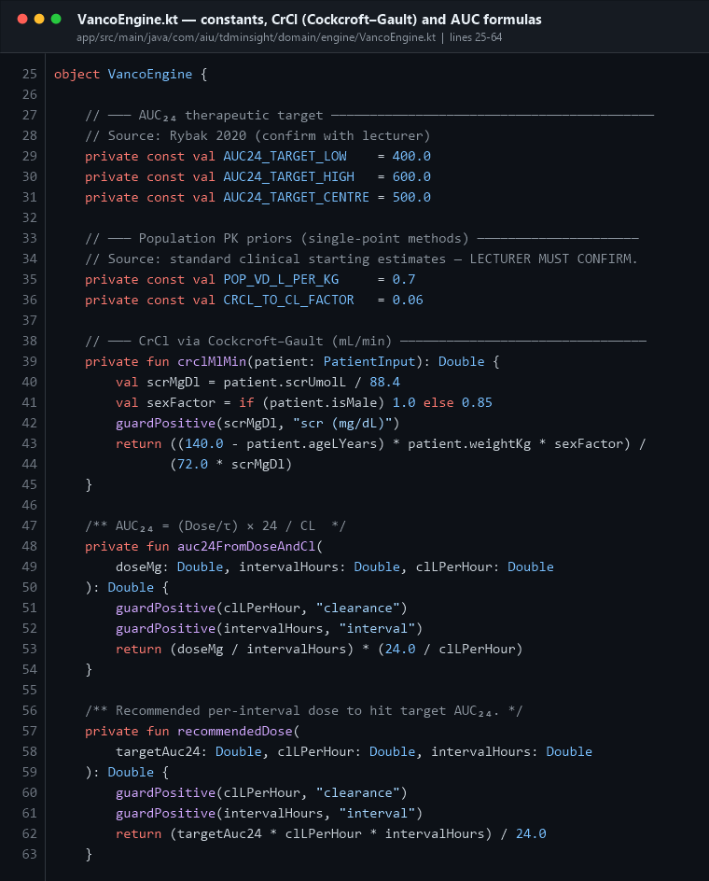
Engine header
Constant | Value | Source
AUC24_TARGET_LOW / HIGH | 400 / 600 mg·h/L | Rybak 2020
AUC24_TARGET_CENTRE | 500 mg·h/L | the dose recommendation aims here
POP_VD_L_PER_KG | 0.7 L/kg | population prior for volume of distribution
CRCL_TO_CL_FACTOR | 0.06 | converts CrCl (mL/min) to vancomycin CL (L/h)

Three private helper functions:
CrCl (Cockcroft–Gault) = (140 − age) × weight × sexFactor / (72 × SCr_mg/dL)
sexFactor = 1.0 male, 0.85 female
SCr_mg/dL = SCr_µmol/L ÷ 88.4
AUC₂₄ = (Dose / τ) × 24 / CL
Recommended dose = AUC_target × CL × τ / 24

8.2 The PRE workflow
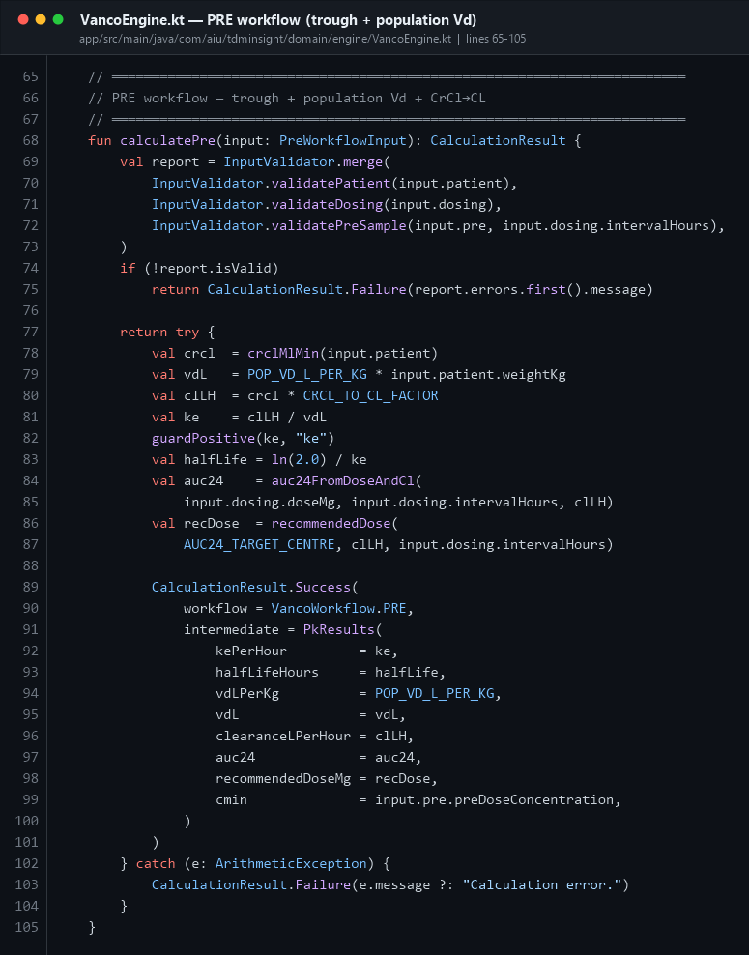
Engine PRE
Used when only a trough is available.
- Estimate creatinine clearance with Cockcroft–Gault.
- Estimate Vd from the population prior: Vd = 0.7 × weight.
- Estimate clearance: CL = CrCl × 0.06.
- Derive ke = CL / Vd, then t½ = ln(2) / ke.
- Compute AUC₂₄ and the recommended dose.

8.3 The POST workflow — Newton–Raphson
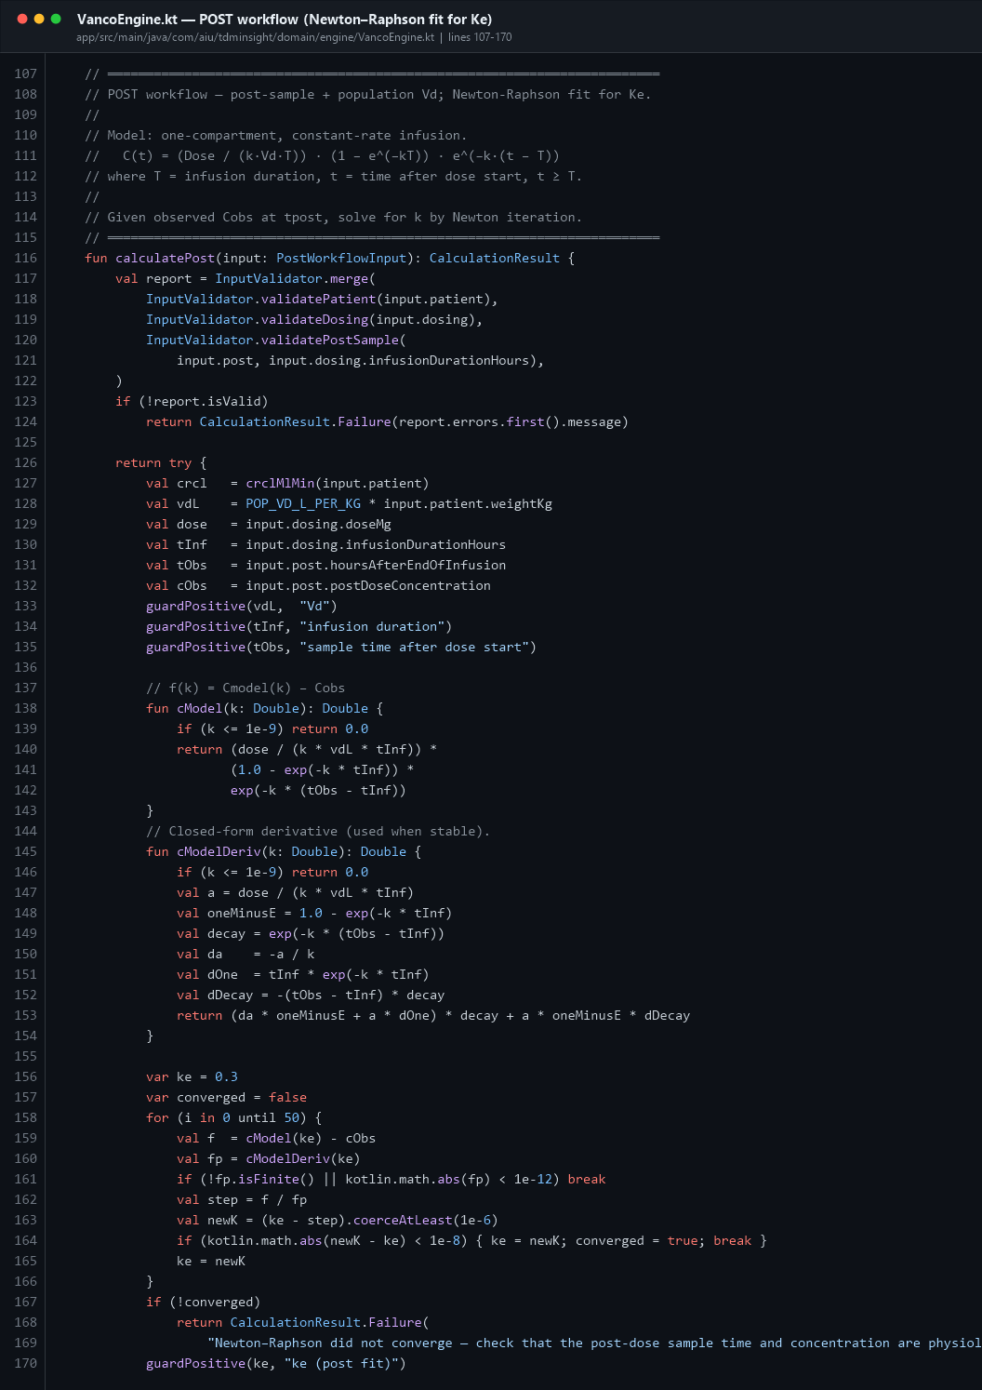
Engine POST
Used when only a peak is available. There is no closed-form solution for ke here, so the engine solves it numerically.
The one-compartment constant-rate infusion model is:
C(t) = (Dose / (ke · Vd · T)) × (1 − e^(−ke·T)) × e^(−ke·(t − T))
We know C(t) (the measured concentration) and want ke. The code:
- defines cModel(k) — the predicted concentration for a candidate k (line 138)
- defines cModelDeriv(k) — the analytic derivative (line 145)
- iterates up to 50 times from a starting guess of ke₀ = 0.3 h⁻¹ (line 156–166)
- each step: k_new = k − f(k)/f'(k), clamped to stay positive
- stops when the change is smaller than 1e-8 and sets converged = true
- **if it never converges, it returns CalculationResult.Failure with a readable
message** instead of returning nonsense (lines 167–169)
💬 "What is Newton–Raphson doing here?"
"The peak-only workflow has one equation with one unknown, ke, but you cannot rearrange it algebraically. Newton–Raphson starts at 0.3 h⁻¹ and repeatedly steps k − f(k)/f′(k) until the answer stops moving. If 50 iterations are not enough it reports a failure rather than guessing."

8.4 The PRE+POST workflow — Sawchuk–Zaske
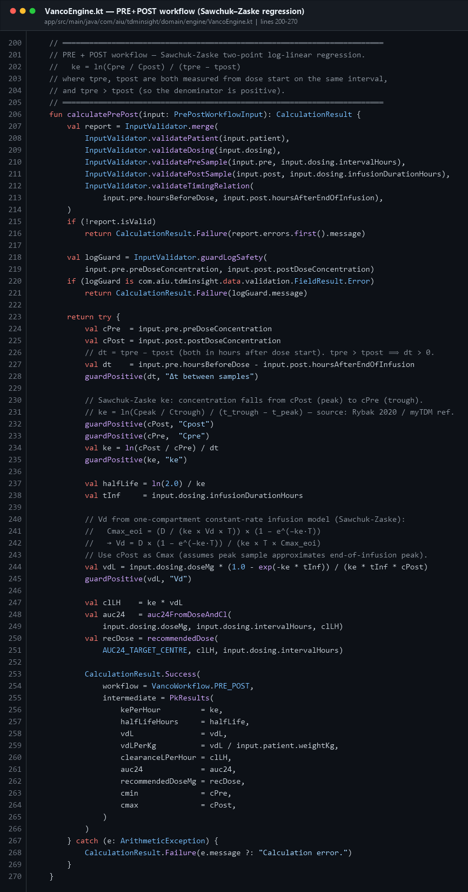
Engine PRE+POST
The most accurate method, because both parameters come from the patient's own blood:
ke = ln(C_peak / C_trough) / (t_trough − t_peak)
t½ = ln(2) / ke
Vd = Dose × (1 − e^(−ke·T)) / (ke × T × C_peak)
CL = ke × Vd
Note the defensive ordering at lines 207–235: validate → log-safety guard → guard each derived value is positive → only then compute. guardPositive() (line 272) throws an ArithmeticException that the surrounding try/catch converts into a clean CalculationResult.Failure.
💬 "How do you prevent divide-by-zero and log-of-zero errors?"
"Three layers. InputValidator blocks physiologically impossible values. guardLogSafety checks the concentrations before any logarithm. And inside the engine every derived quantity — Δt, ke, Vd, CL — passes through guardPositive(), which throws an ArithmeticException that is caught and returned as a Failure. The app shows an error screen; it never crashes."

PART 9 · ViewModels — state and event handling

9.1 CaseUiState and the update functions
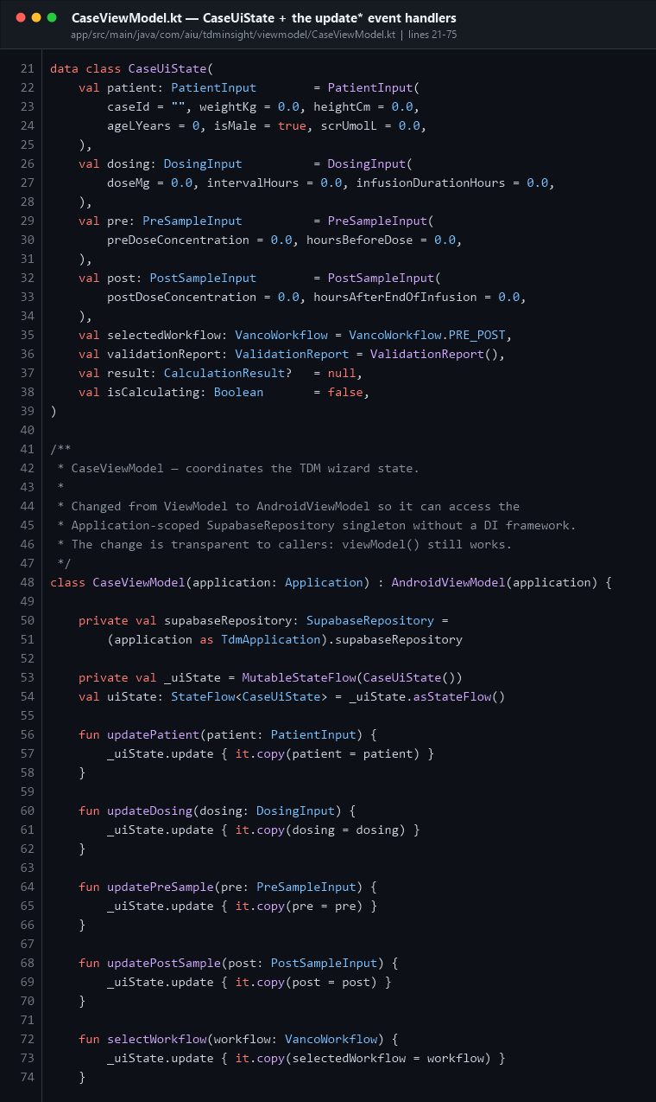
CaseViewModel state
CaseUiState is one immutable object holding the entire wizard state: patient, dosing, both samples, the chosen workflow, the validation report, the result, and an isCalculating flag.
CaseViewModel extends AndroidViewModel (not plain ViewModel) so it can reach TdmApplication and get the SupabaseRepository.
The state pattern:
private val _uiState = MutableStateFlow(CaseUiState()) // private, writable
val uiState: StateFlow<CaseUiState> = _uiState.asStateFlow() // public, read-only
This is encapsulation: the UI can read the state but only the ViewModel can change it. Each updateX() function does _uiState.update { it.copy(field = newValue) } — never mutating the old object, always producing a new one. Compose compares the old and new state and redraws only what changed.

9.2 ★ validate() and runCalculation() — the event handlers
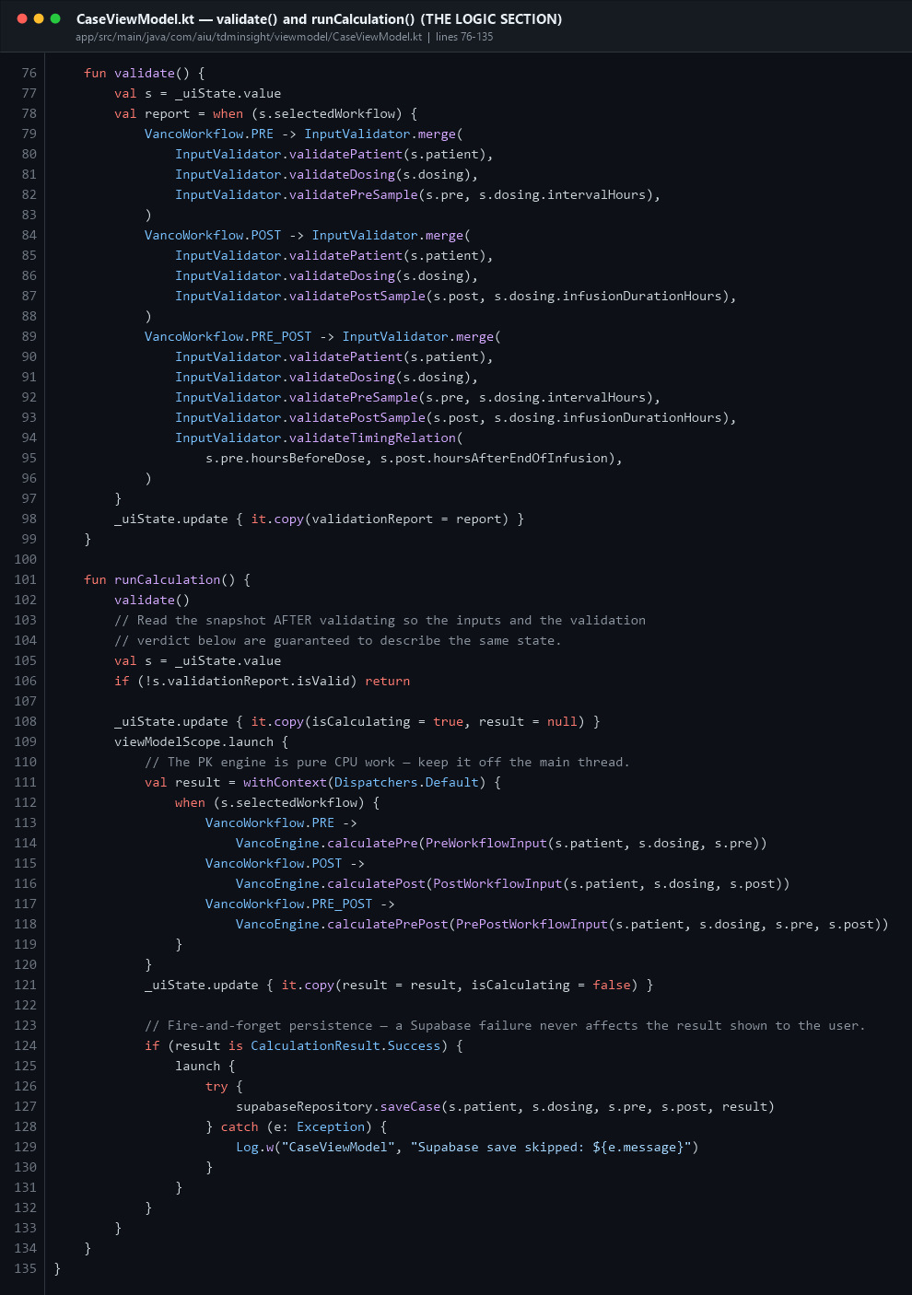
CaseViewModel calc
`validate()` (line 76) picks the right set of validators for the chosen workflow and stores the merged report in state.
`runCalculation()` (line 101) is the function that the "Run calculation" button fires. Trace it:
Line | What happens
102 | validate first
105–106 | take a snapshot of state after validating, and bail out if invalid
108 | flip isCalculating = true so the UI can show the spinner
109 | viewModelScope.launch { } — a coroutine tied to the ViewModel's lifetime; if the user leaves, it is cancelled automatically
111 | withContext(Dispatchers.Default) — the maths runs on a background thread, keeping the UI at 60 fps
112–119 | when on the workflow → call the matching VancoEngine function
121 | publish the result and clear the spinner
124–131 | fire-and-forget save: a nested launch writes to Supabase in a try/catch, so a network failure is logged but never affects the result the user already sees

💬 "Where does the calculation happen and on which thread?"
"The button calls CaseViewModel.runCalculation(). It validates, then launches a coroutine in viewModelScope and runs VancoEngine inside withContext(Dispatchers.Default) so the main thread is never blocked. The result is pushed back into the StateFlow, and Compose recomposes the Results screen."

9.3 AuthViewModel
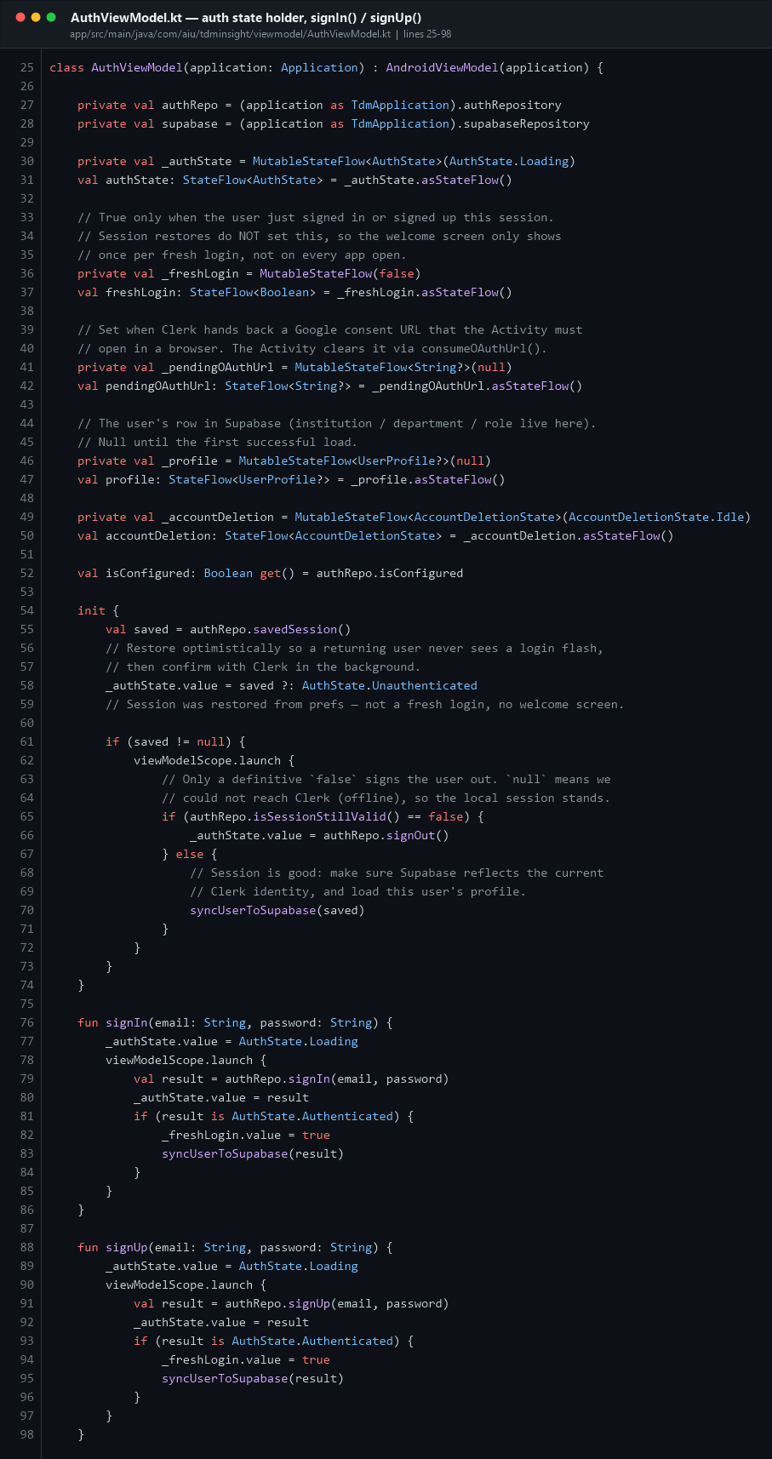
AuthViewModel
Single source of truth for who is signed in. Notes:
- It is created once per Activity in MainActivity, then passed down. The comment
at lines 16–24 explains why: calling viewModel() inside a NavHost would silently create a second instance, and signing out of one would not update the other.
- init { } (line 54) restores the saved session optimistically so a returning
user never sees a login flash, then confirms with Clerk in the background. Only a definitive false signs them out — null means "offline", and the local session stands.
- _freshLogin makes the Welcome screen appear only after an actual sign-in, not on
every app restart.

9.4 HistoryViewModel
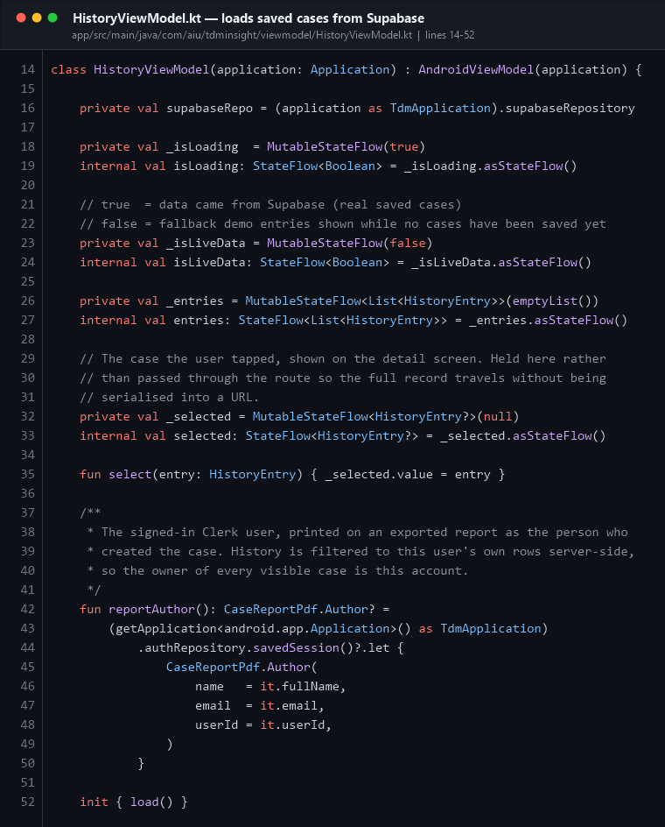
HistoryViewModel
Holds the list of saved cases, a loading flag, and the currently selected entry. The selected entry is held here rather than passed through the navigation route, because a full case record would be ugly and lossy to serialise into a URL string.

PART 10 · ★ THE DATABASE SECTION
This is the answer to "which section is the database?" Two places: the SQL that defines the tables lives in Kotlin_app/supabase/*.sql, and the Kotlin code that reads and writes them lives in data/supabase/ (three files).

10.1 The SQL schema — table 1: cases
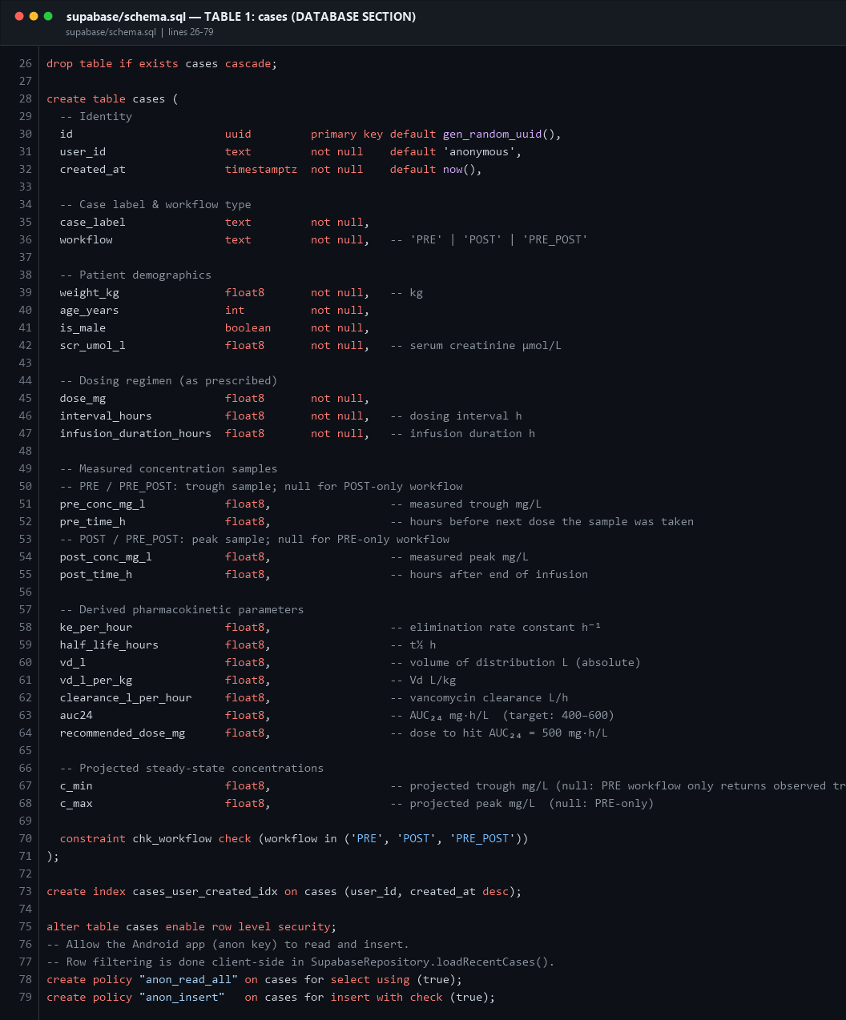
SQL cases
One row per completed calculation. Column groups:
Group | Columns
Identity | id (uuid primary key, auto-generated), user_id (Clerk ID), created_at
Case | case_label, workflow (constrained to PRE/POST/PRE_POST)
Patient | weight_kg, age_years, is_male, scr_umol_l
Dosing | dose_mg, interval_hours, infusion_duration_hours
Samples | pre_conc_mg_l, pre_time_h, post_conc_mg_l, post_time_h (nullable)
PK results | ke_per_hour, half_life_hours, vd_l, vd_l_per_kg, clearance_l_per_hour, auc24, recommended_dose_mg
Projections | c_min, c_max

Three things worth pointing out:
- `constraint chk_workflow check (workflow in ('PRE','POST','PRE_POST'))` — the
database itself refuses an invalid workflow value.
- `create index cases_user_created_idx on cases (user_id, created_at desc)` — a
composite index that makes "the 20 newest cases for this user" a fast lookup.
- `alter table cases enable row level security` — RLS is turned on, then policies
decide who may read what.

10.2 The SQL schema — table 2: user_profiles
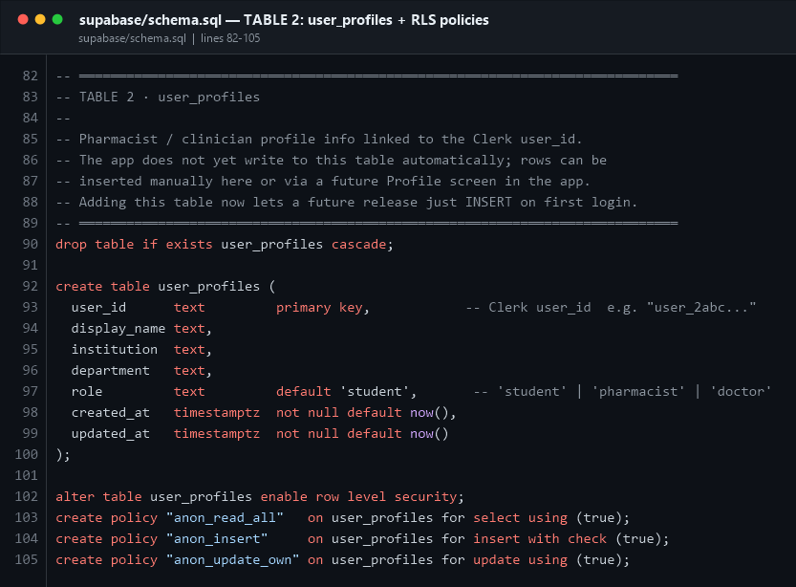
SQL profiles
user_id (the Clerk user ID) is the primary key. That single design decision is what guarantees "repeated logins never create duplicate users" — an upsert keyed on a primary key can only ever produce one row.
Columns the app owns and Clerk must not overwrite: institution, department, role.

10.3 The migration files
File | What it changes
schema.sql | Creates both tables, the index, open RLS policies, and 12 seed demo cases
update_v2.sql | Deletes the demo seed rows; prepares per-user RLS (Option A) with an open fallback (Option B)
update_v3.sql | Adds Clerk identity columns (email, first_name, last_name, avatar_url) + an updated_at trigger
update_v4.sql | Drops the 'anonymous' default on user_id and documents the strict per-user RLS lock-down, commented out until the app sends Clerk JWTs to Supabase

💬 "Is the data secure?"
"Right now filtering is done with eq("user_id", userId) on every query, plus RLS is enabled on both tables. update_v4.sql contains the strict per-user policies that read the Clerk sub claim from the JWT; they are deliberately commented out until the Clerk→Supabase JWT template is configured, because switching them on before that would make every user's history look empty."

10.4 The Supabase client
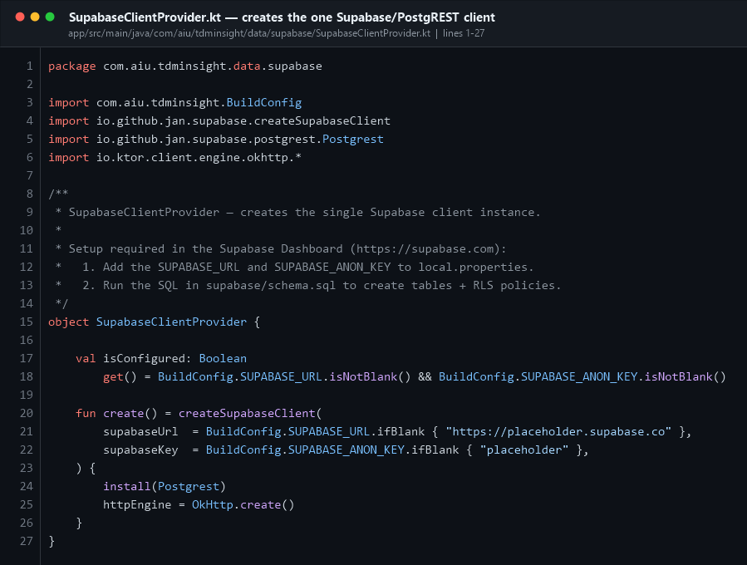
Supabase client
One object, one function: create() builds the SupabaseClient from the URL and anon key in BuildConfig, installs the Postgrest plugin (the PostgreSQL REST layer) and uses OkHttp as the transport.

10.5 DTOs — mapping Kotlin names to SQL columns
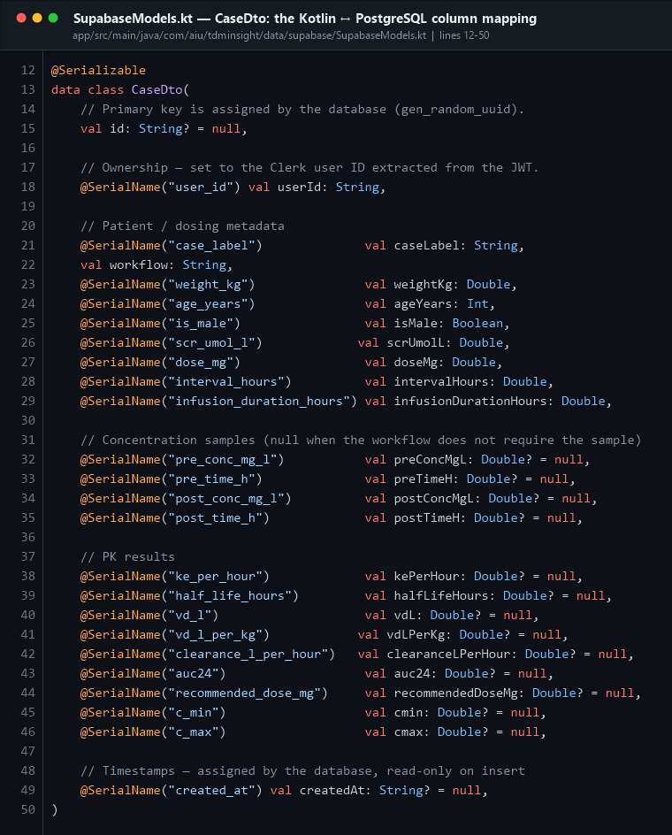
Supabase DTO
CaseDto is annotated @Serializable. Each field carries a @SerialName("snake_case") annotation because Kotlin uses camelCase and PostgreSQL uses snake_case. Without these the JSON keys would not match the column names.
Note val id: String? = null — the primary key is null on insert because the database generates it with gen_random_uuid().
Below the DTO, toHistoryEntry() is the mapper that converts a database row into the domain model the UI understands. This keeps the UI independent of the database schema.

10.6 saveCase() — INSERT
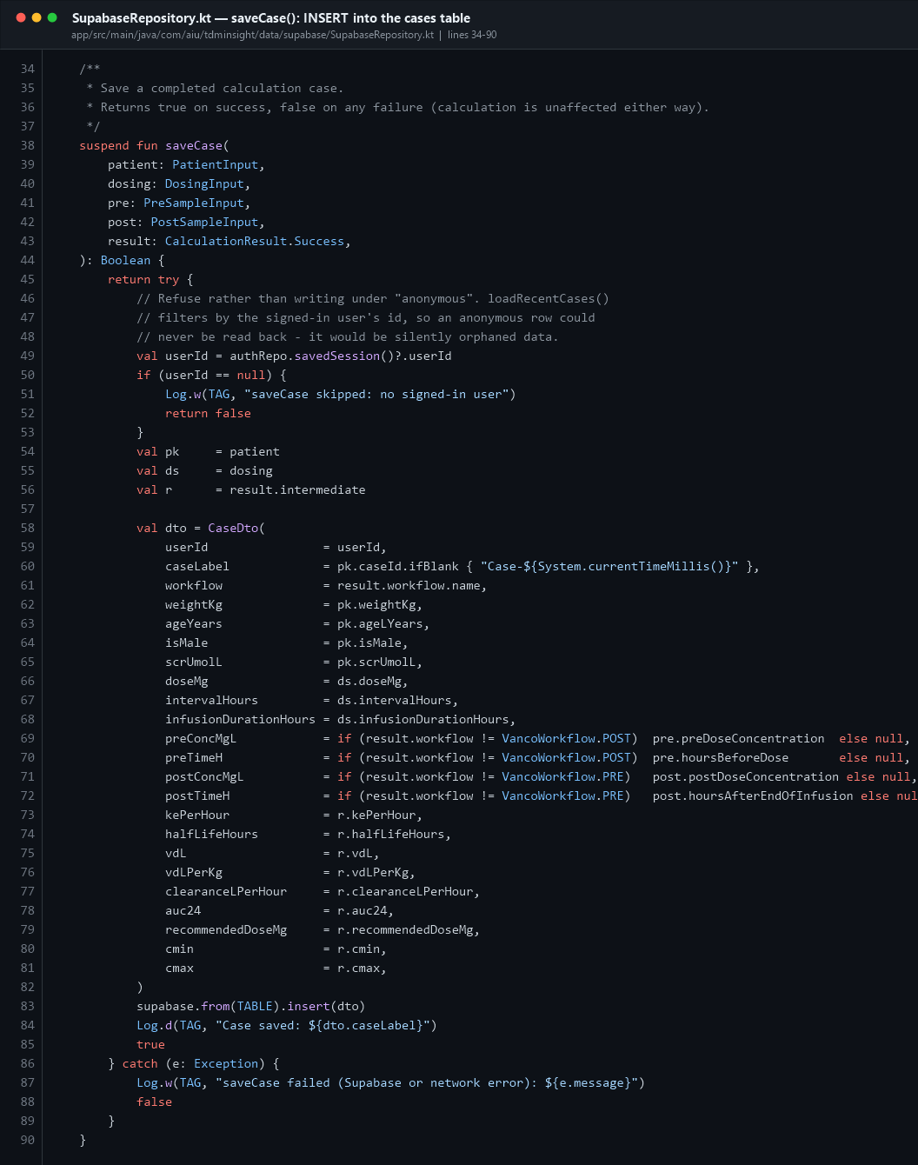
Supabase save
Line | What happens
49–53 | Refuse to save without a signed-in user. An "anonymous" row could never be read back, so it would be orphaned data.
58–82 | Build the DTO. The conditional expressions on 69–72 send null for samples the chosen workflow did not use.
60 | If the user left the Case ID blank, generate one from the timestamp.
83 | supabase.from("cases").insert(dto) — the actual INSERT.
86–89 | Catch any exception, log it, return false. The calculation the user is looking at is never affected.

10.7 loadRecentCases() — SELECT
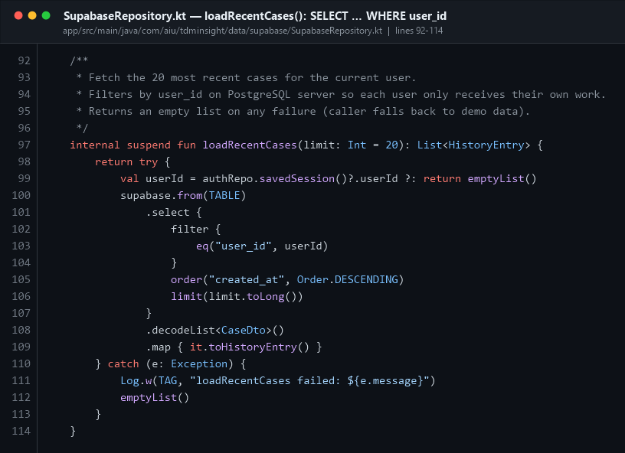
Supabase load
This is a SELECT expressed in Kotlin:
supabase.from("cases")
.select {
filter { eq("user_id", userId) } // WHERE user_id = ?
order("created_at", Order.DESCENDING) // ORDER BY created_at DESC
limit(20) // LIMIT 20
}
.decodeList<CaseDto>() // JSON → List<CaseDto>
.map { it.toHistoryEntry() } // DTO → domain model

10.8 syncUserProfile() — UPSERT (no duplicate users)
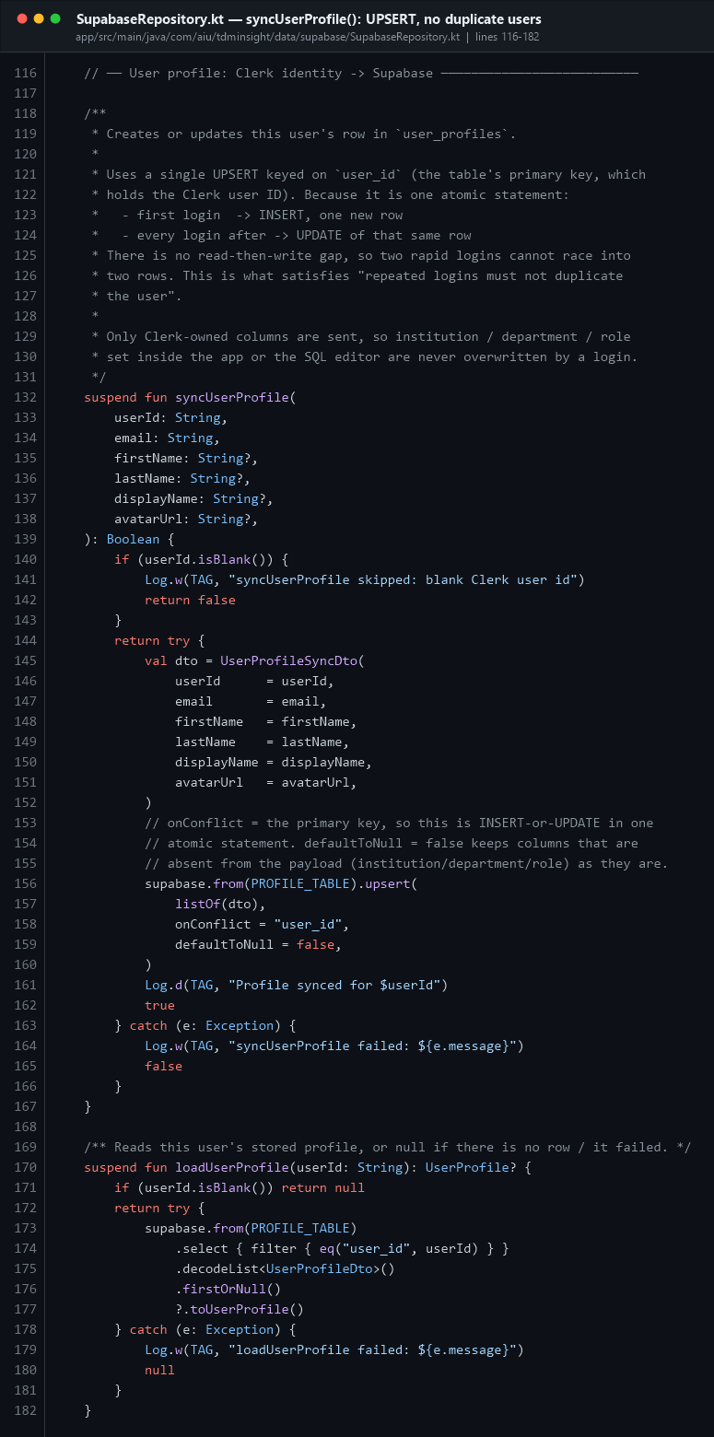
Supabase upsert
The comment at lines 118–131 is worth reading in full — it is the answer to a likely exam question.
upsert(listOf(dto), onConflict = "user_id", defaultToNull = false) means:
- first login → INSERT, one new row
- every login after → UPDATE of that same row
- it is one atomic statement, so there is no read-then-write gap where two rapid
logins could race into two rows
- defaultToNull = false means columns absent from the payload
(institution, department, role) are left untouched — a login never wipes data the user or an administrator set

10.9 Deleting data
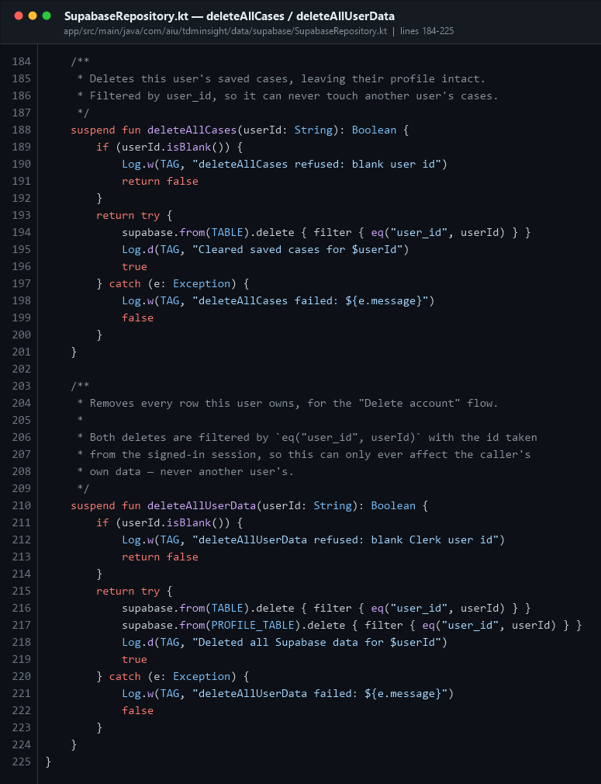
Supabase delete
- deleteAllCases(userId) — "Clear saved cases" in Settings.
- deleteAllUserData(userId) — the "Delete account" flow: cases first, then profile.
Both refuse a blank user ID and both filter by eq("user_id", userId), so they can never touch another user's rows.
In AuthViewModel.deleteAccount() the order matters: Supabase rows are keyed by the Clerk user ID, so they must be deleted while that ID is still known, before the Clerk account itself is removed.

PART 11 · Authentication (Clerk)

11.1 AuthState — a sealed class
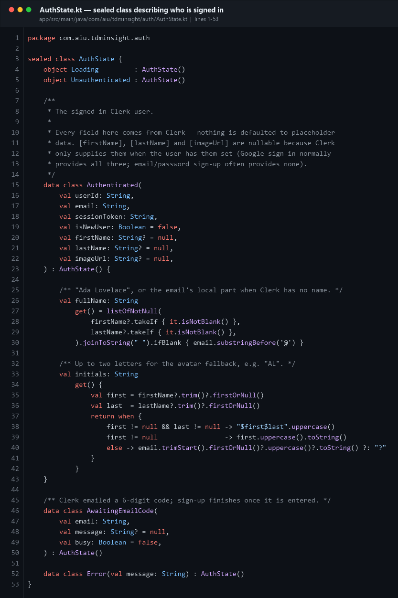
AuthState
Five possible states: Loading, Unauthenticated, Authenticated, AwaitingEmailCode, Error. Because it is sealed, the when in MainActivity is exhaustive.
Authenticated has two computed properties: fullName (falls back to the email's local part) and initials (for the avatar circle when there is no photo).

11.2 AuthRepository — staying logged in
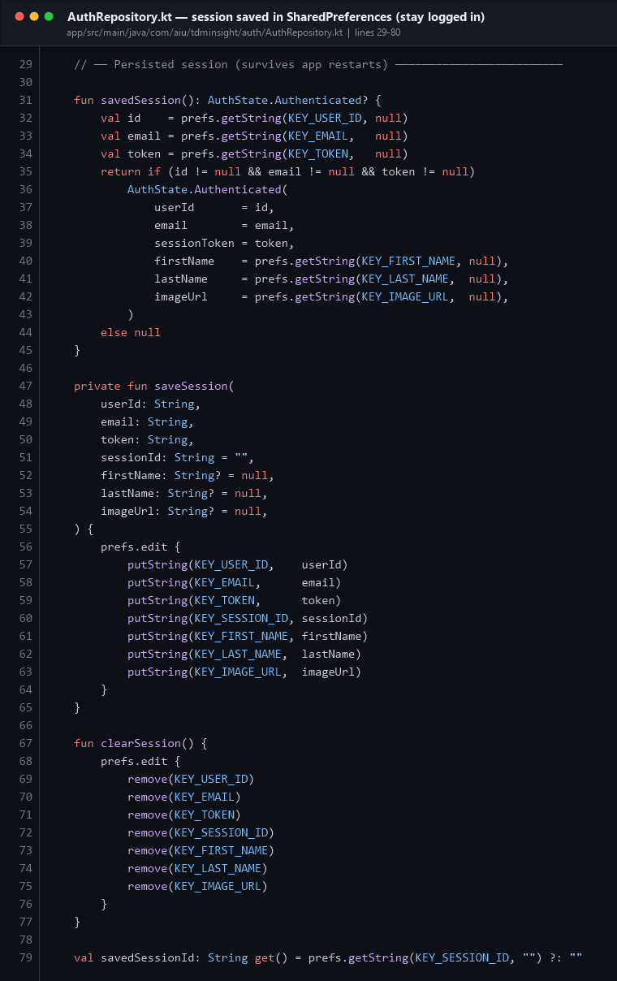
Auth repository
The session (user ID, email, token, name, avatar) is written to private SharedPreferences under the name tdm_auth. That is why closing the app does not log you out.
savedSession() reads it back; clearSession() wipes it on sign-out.

11.3 ClerkAuthManager — the raw HTTP layer
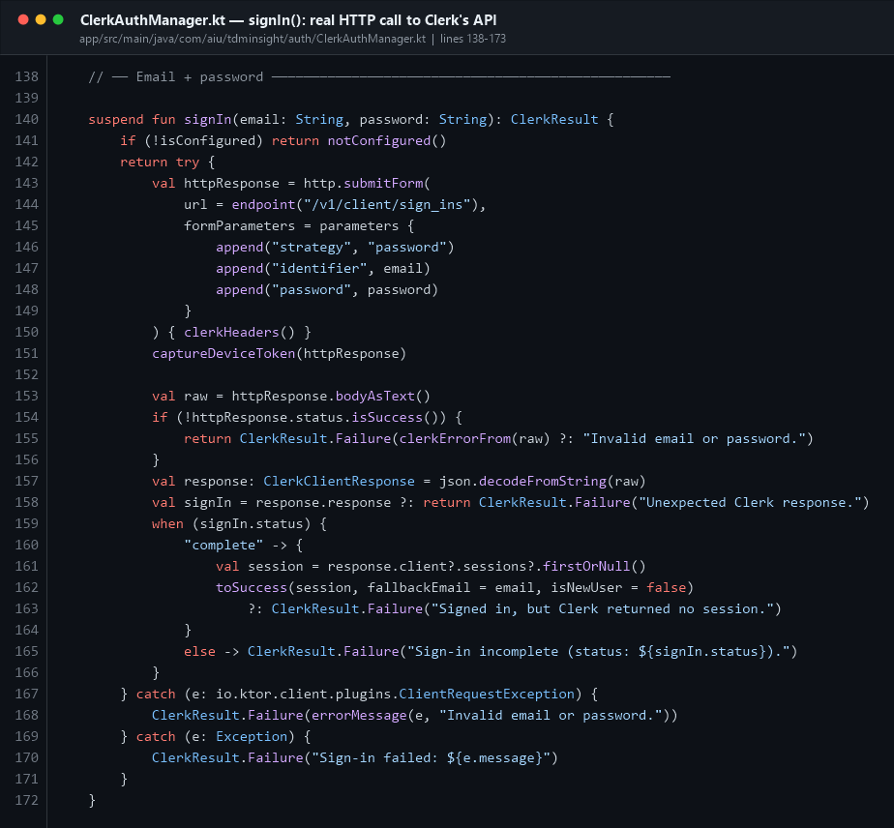
Clerk signIn
This class talks to Clerk's Frontend API directly with Ktor, rather than using Clerk's Android SDK. signIn() posts identifier and password as a form to /v1/client/sign_ins?_is_native=1.
The _is_native=1 parameter matters: normally Clerk tracks the device with a cookie, but there is no cookie jar here, so Clerk returns a device token in the Authorization response header instead. That token is saved and replayed, which is what lets the Google OAuth browser round-trip resolve back to the same Clerk client.
The full Google flow:
- startGoogleSignIn() → Clerk returns a consent URL
- MainActivity opens it with Intent.ACTION_VIEW (the system browser)
- The user approves on Google's page
- Clerk redirects to tdminsight://oauth-callback?...
- The manifest's deep-link intent filter routes it back to MainActivity.onNewIntent()
- completeGoogleSignIn(url) finishes the session

11.4 UserPrefs — theme and disclaimer
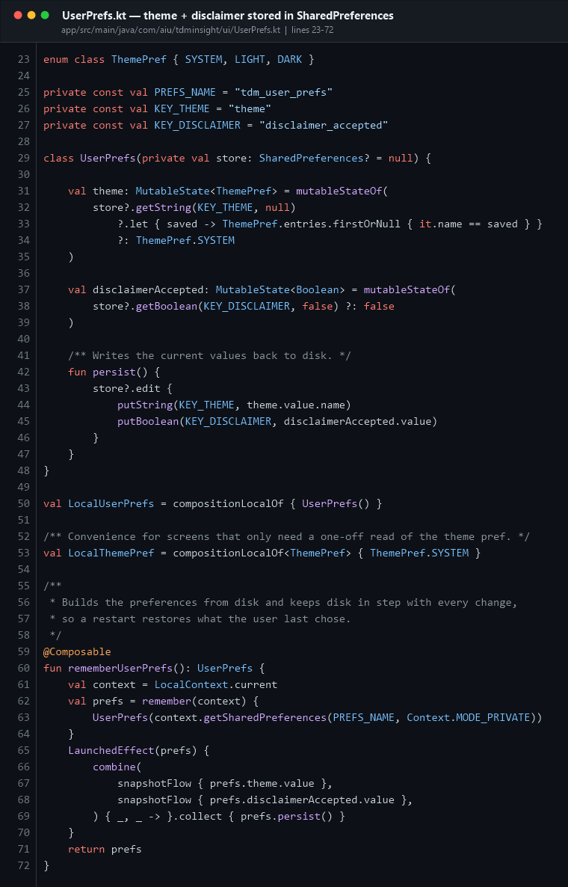
UserPrefs
A second SharedPreferences store (tdm_user_prefs) holds the theme choice (SYSTEM / LIGHT / DARK) and whether the first-launch disclaimer was accepted. rememberUserPrefs() builds it and uses snapshotFlow + combine to write to disk automatically whenever either value changes.

PART 12 · ★ THE LAYOUT SECTION — how the UI is built
This is the answer to "where is your layout?" There is no XML layout. The layout is Kotlin code in app/src/main/java/com/aiu/tdminsight/ui/screens/ — 10 files holding 20 screens, plus the shared widgets in ui/components/Banners.kt and ui/screens/ScreenComponents.kt. (The 21st screen, the first-launch disclaimer, lives in MainActivity.kt.)

12.1 XML layouts vs Jetpack Compose
Old way (XML) | This app (Compose)
res/layout/activity_main.xml | a @Composable fun in ui/screens/
setContentView(R.layout.x) | setContent { … }
LinearLayout (vertical) | Column
LinearLayout (horizontal) | Row
FrameLayout / RelativeLayout | Box
RecyclerView + Adapter | LazyColumn, or forEach inside a scrolling Column
findViewById(R.id.btn) | not needed — you have the object directly
btn.setOnClickListener { } | Button(onClick = { }) or Modifier.clickable { }
android:layout_width="match_parent" | Modifier.fillMaxWidth()
android:padding="16dp" | Modifier.padding(16.dp)
android:layout_weight="1" | Modifier.weight(1f)
<include> a sub-layout | just call another Composable function

💬 "Where is the layout section?"
"This app uses Jetpack Compose, so there are no XML layout files — the res folder has values, drawable, mipmap and xml, but no layout. Every screen is a @Composable function in ui/screens/. For example the Home screen layout is HomeScreen.kt: a Scaffold with a bottomBar, containing a scrollable Column of Surface cards."

12.2 The theme
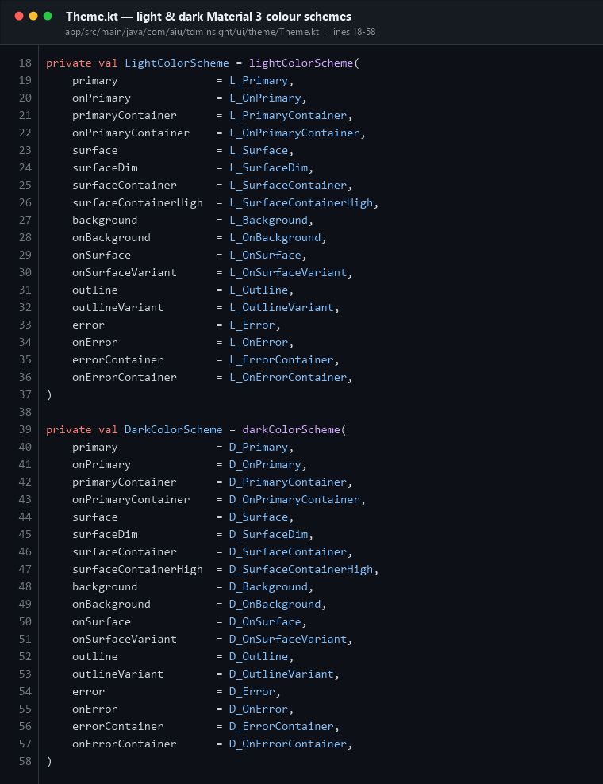
Theme colours
Two complete Material 3 colour schemes — LightColorScheme and DarkColorScheme — built from named constants in Color.kt.
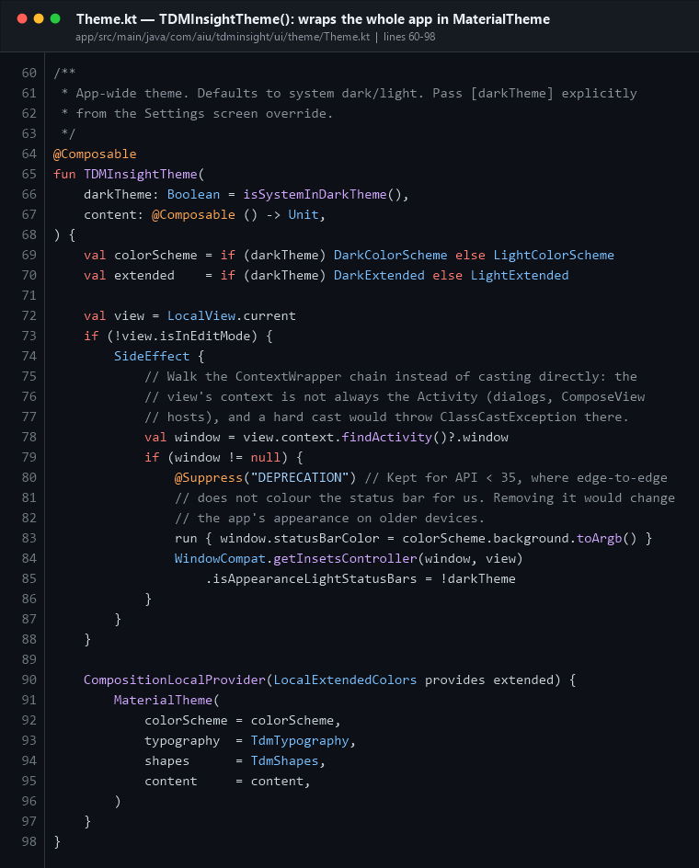
Theme function
TDMInsightTheme picks the scheme, applies it along with TdmTypography and TdmShapes, and uses a SideEffect to tint the system status bar. The findActivity() helper walks the ContextWrapper chain instead of hard-casting, because the view's context is not always the Activity.

12.3 Home screen — a complete layout, read top to bottom
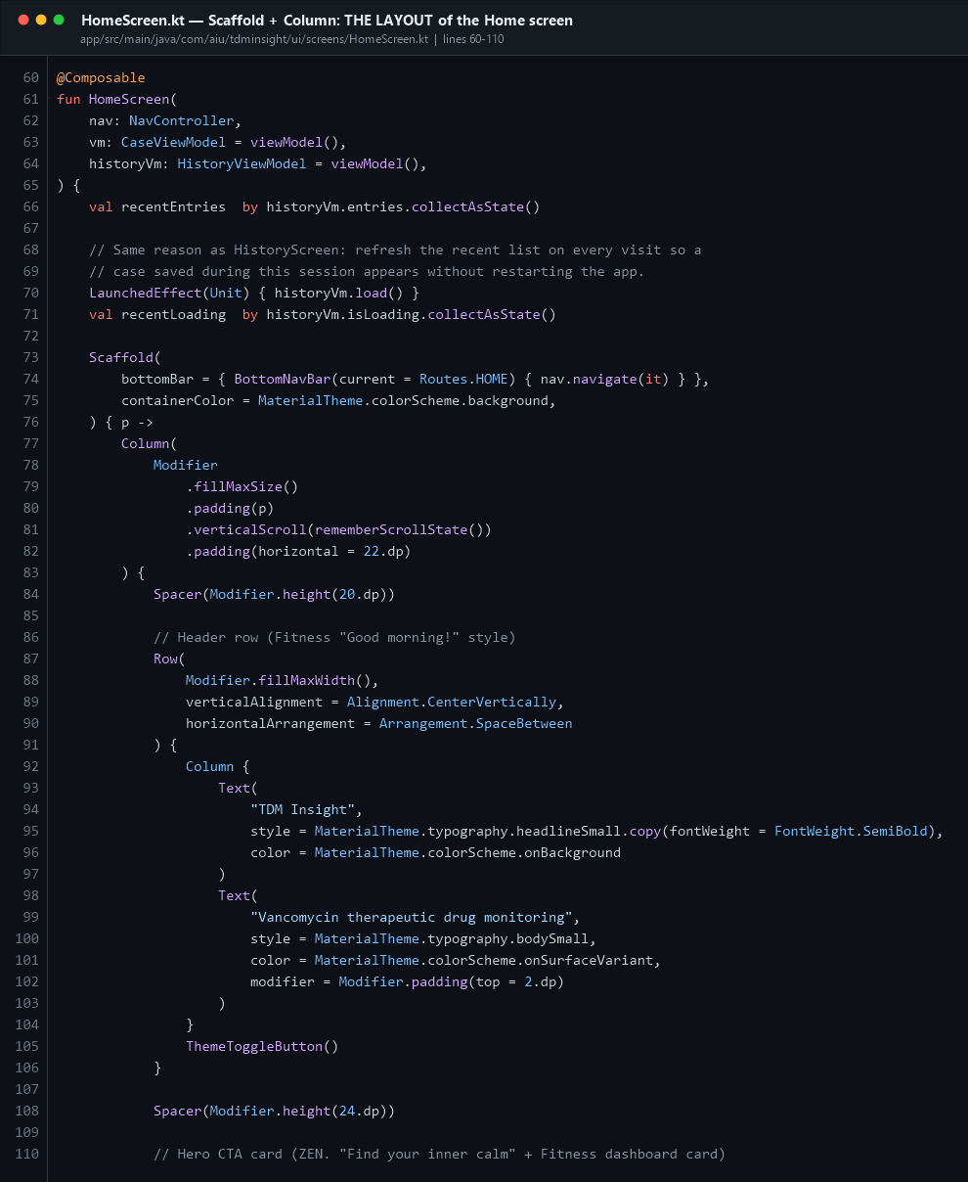
Home layout
The structure:
Scaffold(bottomBar = { BottomNavBar(...) })
└── Column(
.fillMaxSize()
.padding(innerPadding) ← keeps content clear of the nav bar
.verticalScroll(rememberScrollState()) ← makes it scrollable
.padding(horizontal = 22.dp)
)
├── Row ─ "TDM Insight" title + ThemeToggleButton
├── Surface ─ the big primary "Start a new calculation" card
├── Row ─ two HomeShortcutTile(Modifier.weight(1f)) side by side
├── Row ─ "RECENT CALCULATIONS" + "See all"
└── when { loading → spinner; empty → RecentCasesEmpty(); else → 3 rows }
LaunchedEffect(Unit) { historyVm.load() } on line 70 re-fetches the recent list every time the screen is entered — without it, a case saved during the session would not appear until the app restarted.

12.4 Where the buttons are — the Home CTA
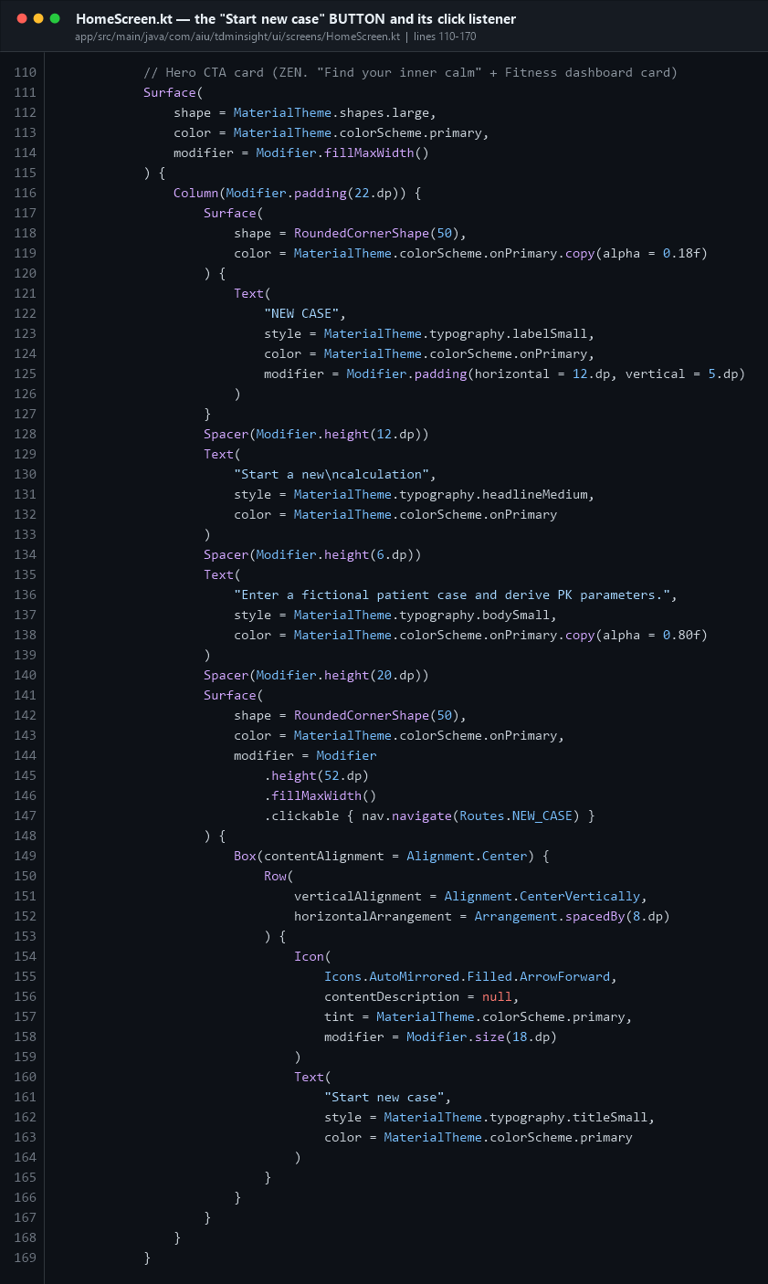
Home CTA button
Look at lines 141–167. This is a custom button: a Surface with RoundedCornerShape(50) and `.clickable { nav.navigate(Routes.NEW_CASE) }`.
That clickable lambda is the event listener. In Compose you do not call setOnClickListener — you pass the behaviour in as a parameter, and Compose wires up the touch handling, the ripple, and accessibility for you.

12.5 Conditional rendering
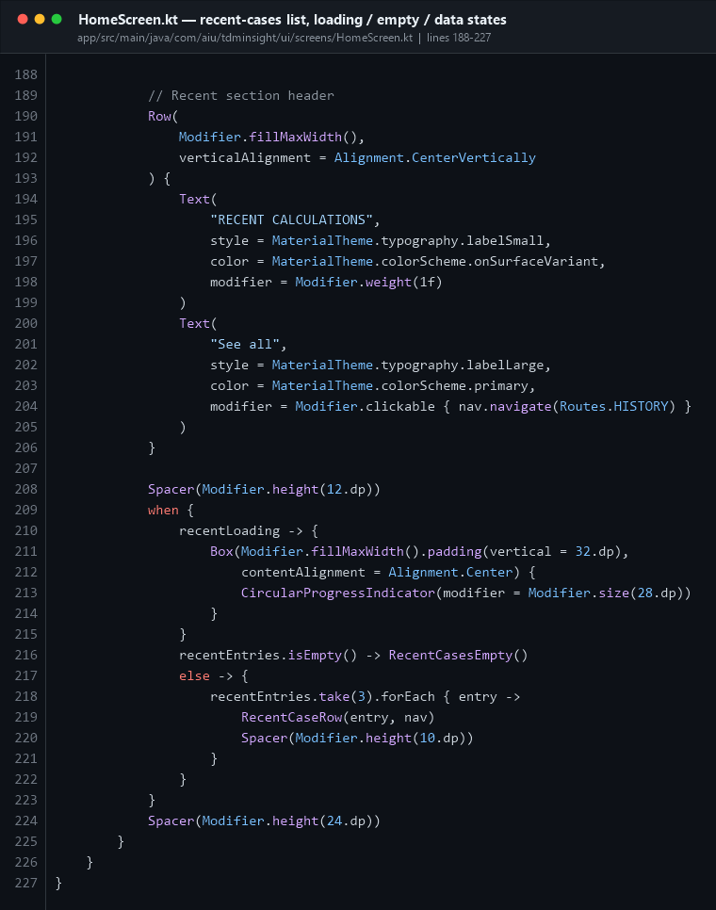
Home recent list
Lines 209–223 show the three-state pattern used everywhere in this app:
when {
recentLoading -> CircularProgressIndicator()
recentEntries.isEmpty() -> RecentCasesEmpty()
else -> recentEntries.take(3).forEach { RecentCaseRow(it, nav) }
}
Loading, empty, and data — always all three.

12.6 The bottom navigation bar
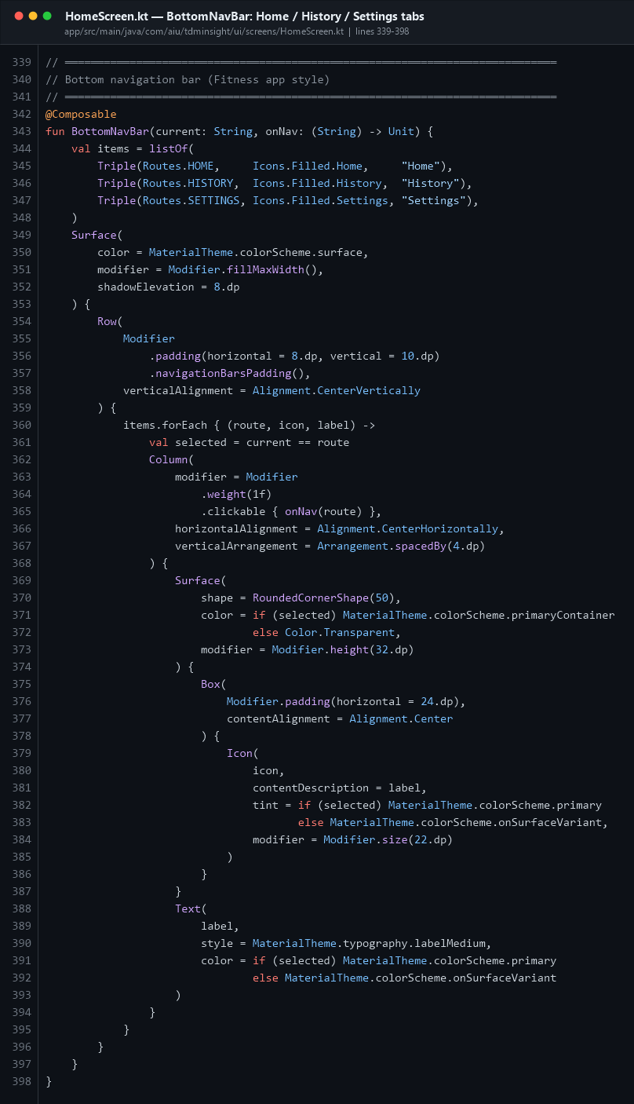
Bottom nav
Not the Material NavigationBar component — a hand-built one, so the pill-shaped selected indicator could be styled exactly as designed.
- items is a listOf(Triple(route, icon, label)) — three tabs
- items.forEach { } builds one Column per tab
- Modifier.weight(1f) gives each tab an equal third of the width
- .clickable { onNav(route) } is the event listener
- val selected = current == route drives the highlight colour

12.7 The 5-step wizard — form fields and their listeners
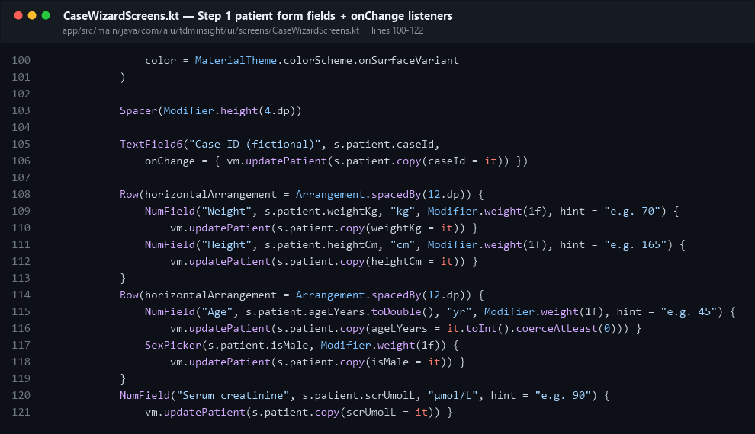
Wizard patient form
This is Step 1 of 5. Every field follows the same pattern:
NumField("Weight", s.patient.weightKg, "kg", Modifier.weight(1f), hint = "e.g. 70") {
vm.updatePatient(s.patient.copy(weightKg = it))
}
Read it as: show the current value from state; when the user types, copy the state object with one field changed and hand it to the ViewModel. This is unidirectional data flow — the field does not own its value, the ViewModel does.
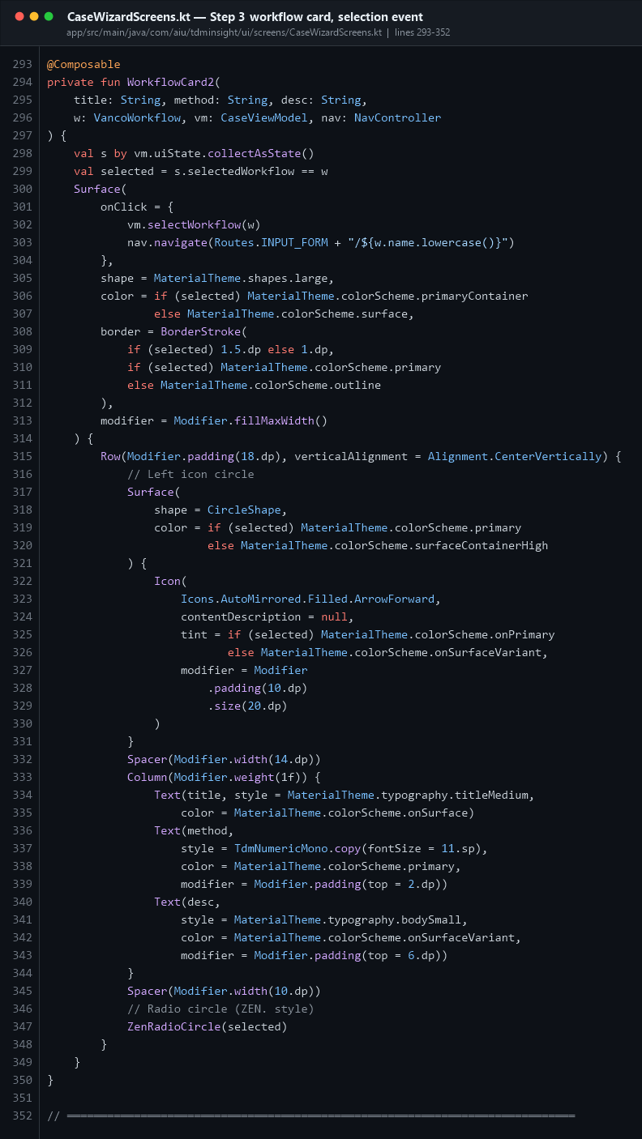
Workflow select
Step 3. The WorkflowCard2 composable takes onClick that does two things: records the choice in the ViewModel and navigates, passing the workflow name as a route argument:
vm.selectWorkflow(w)
nav.navigate(Routes.INPUT_FORM + "/${w.name.lowercase()}")
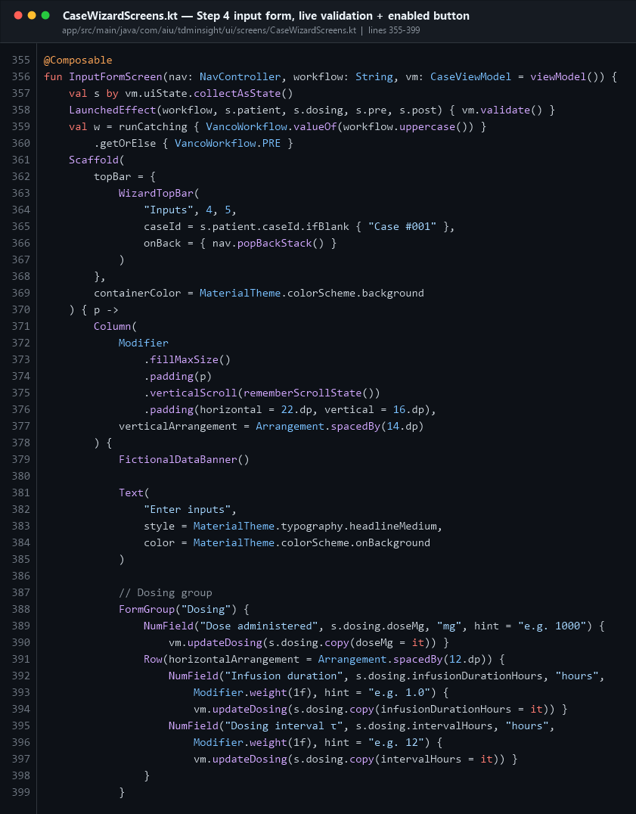
Input form
Step 4. Line 358: `LaunchedEffect(workflow, s.patient, s.dosing, s.pre, s.post) { vm.validate() }` — re-validate automatically whenever any input changes. This is what makes the errors appear live as you type.
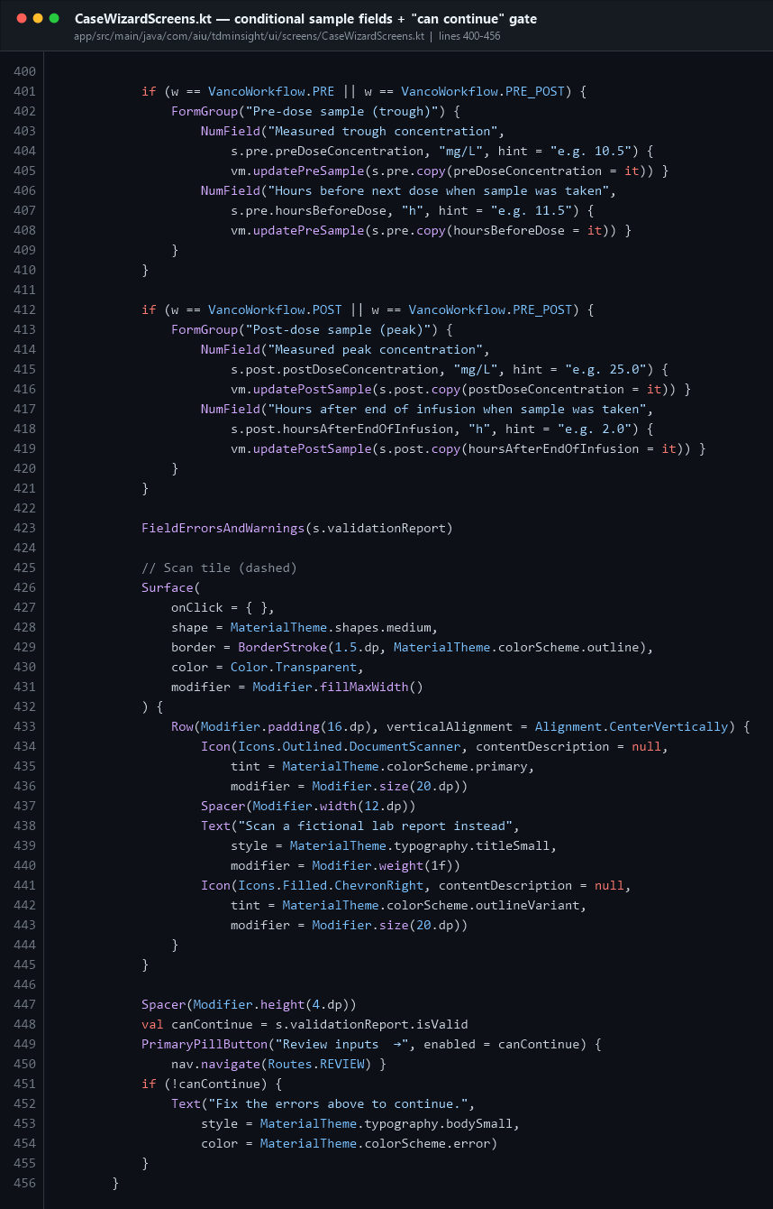
Input form gate
Lines 401–421 show conditional fields: the trough group only renders for PRE and PRE+POST; the peak group only for POST and PRE+POST. Lines 447–455 are the gate:
val canContinue = s.validationReport.isValid
PrimaryPillButton("Review inputs →", enabled = canContinue) { nav.navigate(Routes.REVIEW) }
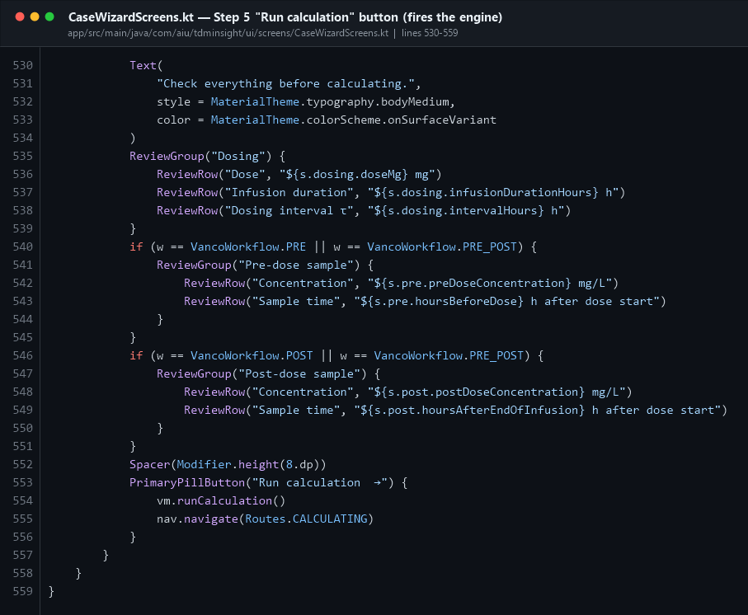
Review run button
Step 5 — the most important button in the app (lines 553–556):
PrimaryPillButton("Run calculation →") {
vm.runCalculation()
nav.navigate(Routes.CALCULATING)
}

12.8 The reusable components
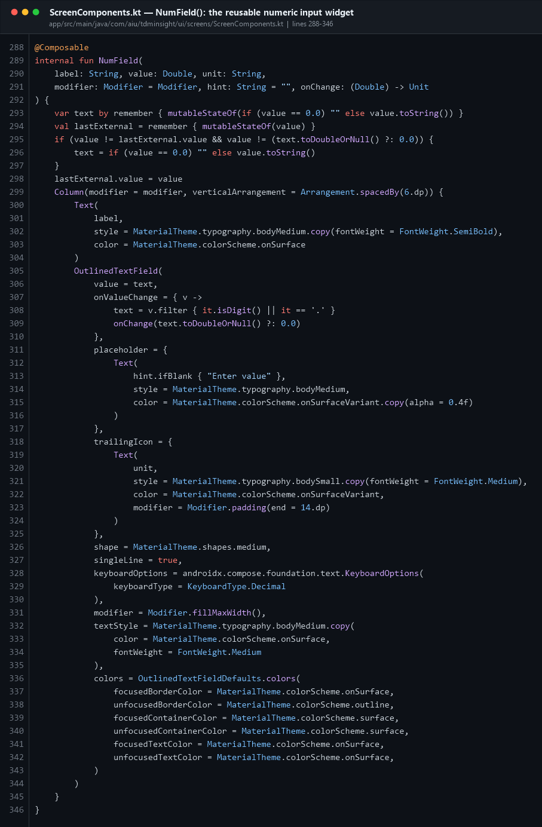
NumField
NumField wraps a Material 3 OutlinedTextField. Points worth explaining:
- onValueChange (line 307) is the text-change listener. It filters out anything
that is not a digit or a dot, then converts to Double and calls back up.
- keyboardOptions = KeyboardOptions(keyboardType = KeyboardType.Decimal) pops the
numeric keypad.
- trailingIcon renders the unit (kg, mg, h, mg/L) inside the field.
- Lines 293–298 keep the local text in sync when the ViewModel changes the value from
outside, without fighting the user while they type.
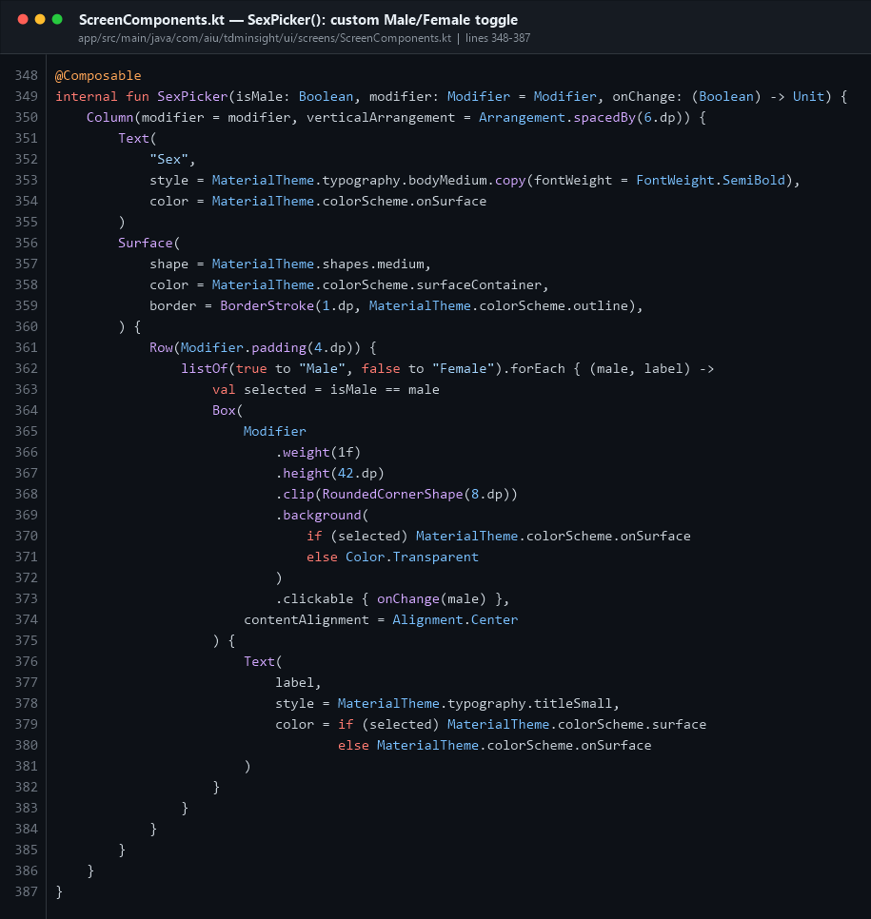
SexPicker
A custom segmented Male/Female control — two Boxes with .clickable { onChange(male) }, each taking weight(1f), with the selected one filled.
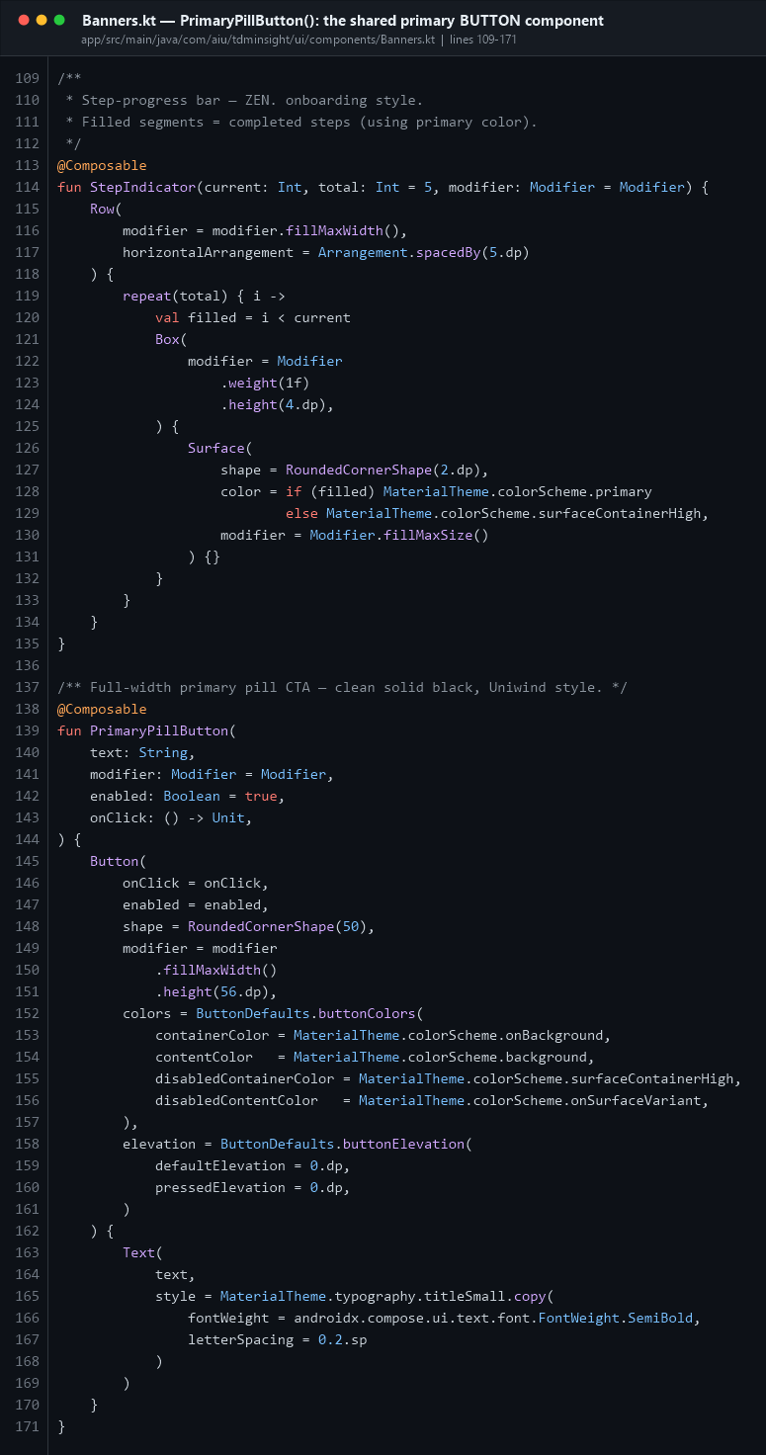
Pill button
PrimaryPillButton is the app's standard call-to-action, used on every wizard step. It is a Material 3 Button with RoundedCornerShape(50), a fixed 56 dp height, and explicit disabled colours so a blocked button visibly looks blocked.
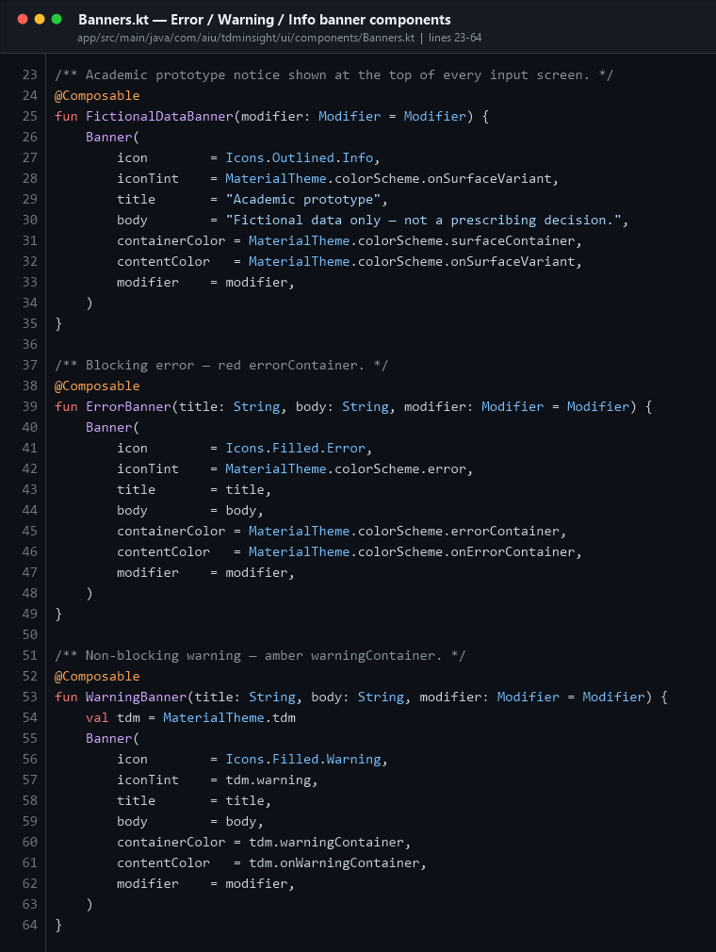
Banners
Three banner variants sharing one private Banner implementation: FictionalDataBanner (grey, academic notice), ErrorBanner (red, blocking) and WarningBanner (amber, advisory).

12.9 Calculating and Results
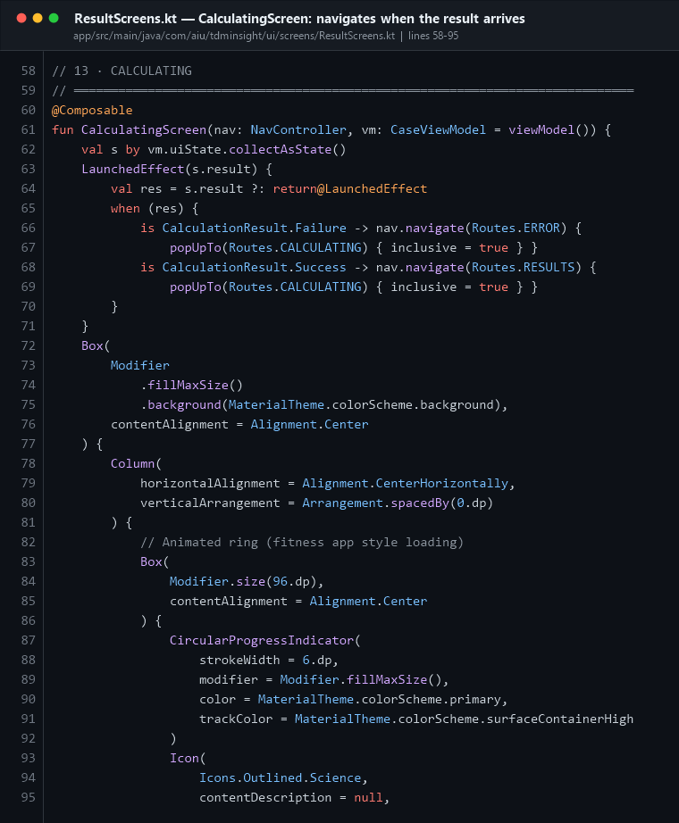
Calculating screen
CalculatingScreen shows a spinner and does nothing else — except for the LaunchedEffect(s.result) at line 62. When the result arrives in state, it navigates to Results (on success) or Error (on failure), and uses popUpTo(CALCULATING) { inclusive = true } so pressing Back does not return to the loading spinner.
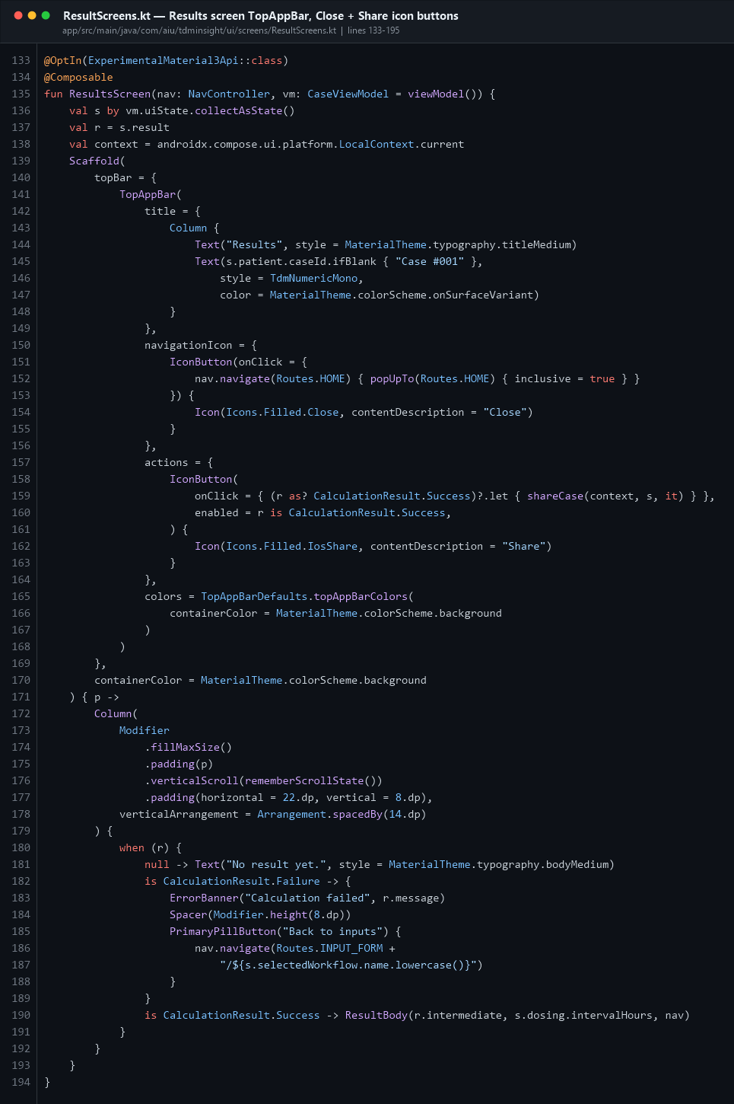
Results top bar
The Results screen uses a Material 3 `TopAppBar` with:
- navigationIcon — a Close IconButton that navigates home and clears the back stack
- actions — a Share IconButton, `enabled = r is CalculationResult.Success`, so
you cannot share a failed calculation
Below it, the body renders one of three things depending on the sealed-class result: no result / Failure (error banner + retry) / Success (ResultBody).

12.10 History and the drawn graph
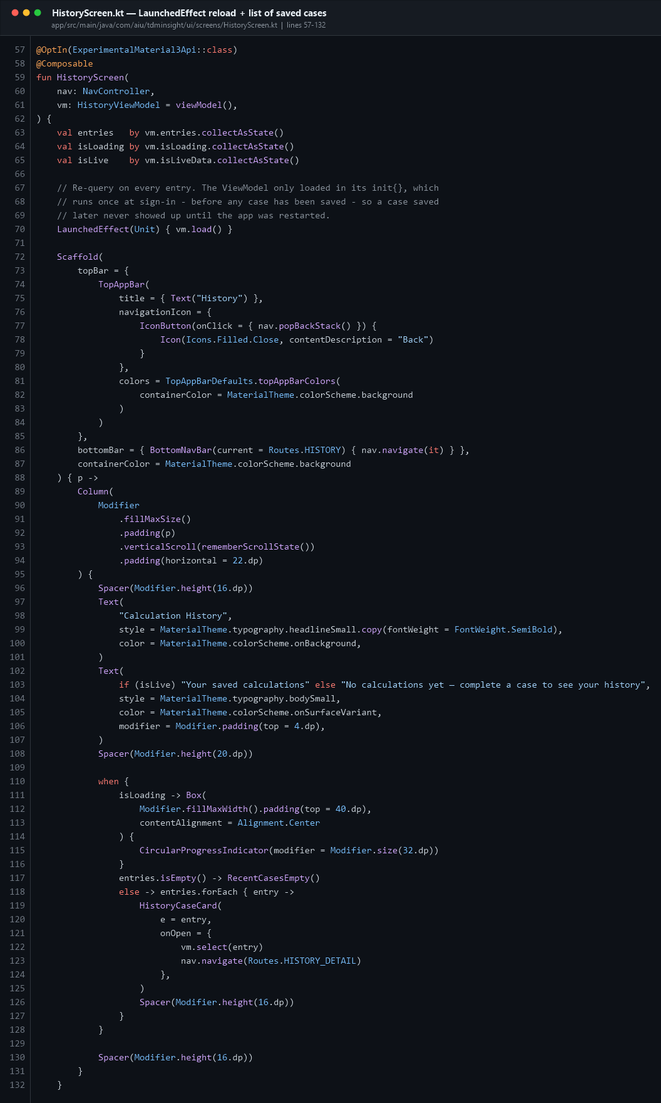
History screen
Same LaunchedEffect(Unit) { vm.load() } refresh pattern, the same loading/empty/data when, and a BottomNavBar. Tapping a card calls vm.select(entry) then nav.navigate(Routes.HISTORY_DETAIL).
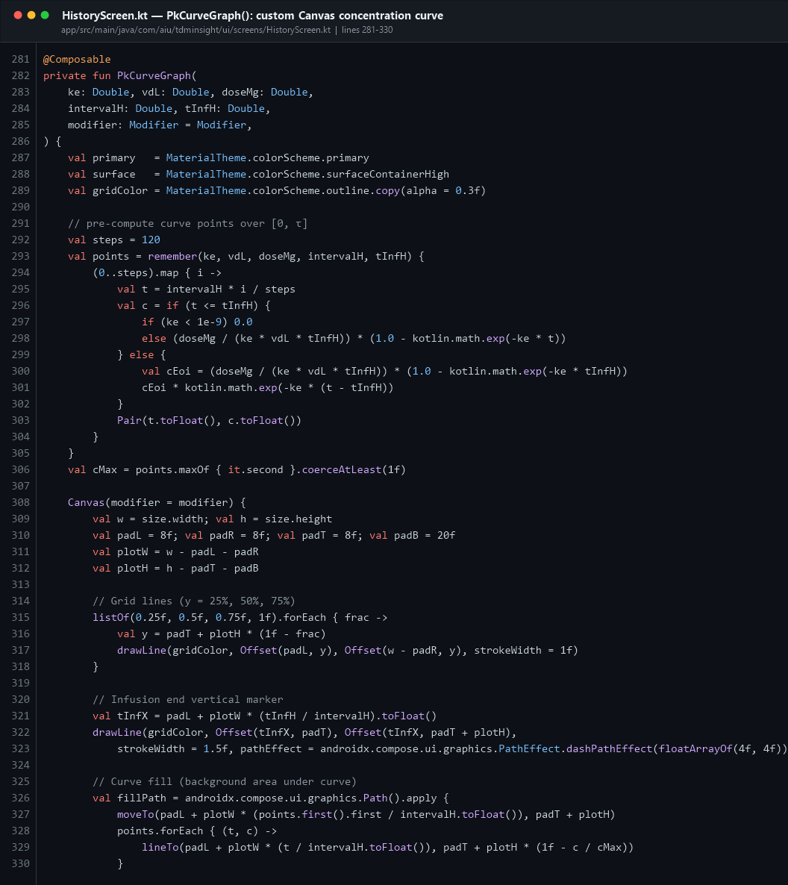
PK curve canvas
PkCurveGraph draws the concentration-vs-time curve by hand on a Compose Canvas:
- 120 points are computed from the one-compartment model and cached with
remember(ke, vdL, doseMg, intervalH, tInfH) so they are not recalculated on every frame
- during the infusion (t ≤ T) concentration rises; after it, it decays exponentially
- it draws grid lines, a dashed vertical marker at end-of-infusion, a translucent
filled area, then the curve itself with Stroke(width = 2.5f, cap = StrokeCap.Round)
💬 "Did you use a charting library?"
"No — the graph is drawn directly on a Compose Canvas using drawLine and drawPath. The curve points come from the same one-compartment model the engine uses, and they are cached with remember so they are only recomputed when the PK parameters change."

12.11 Settings
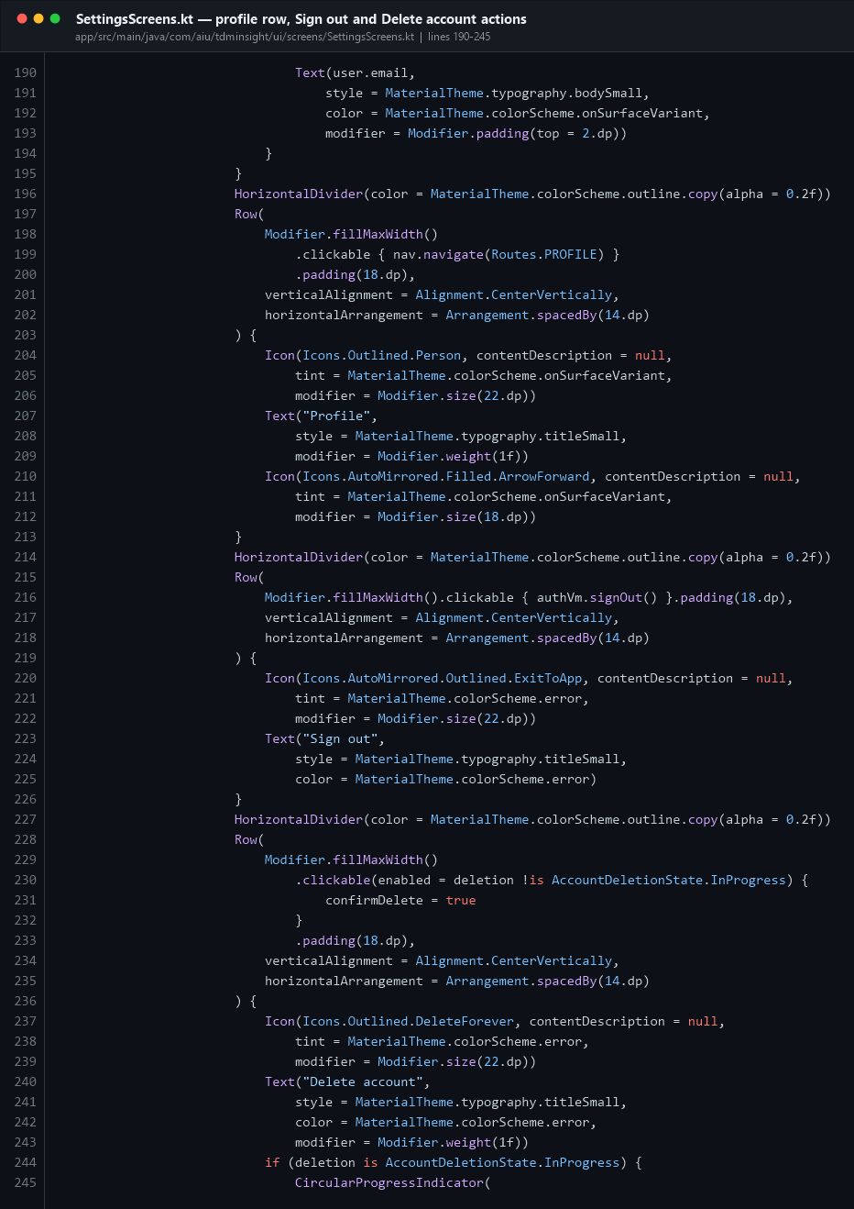
Settings sign out
The account section: a profile row that navigates to Routes.PROFILE, a Sign out row (.clickable { authVm.signOut() }), and a Delete account row that opens an AlertDialog confirmation before calling authVm.deleteAccount().

12.12 The splash screen
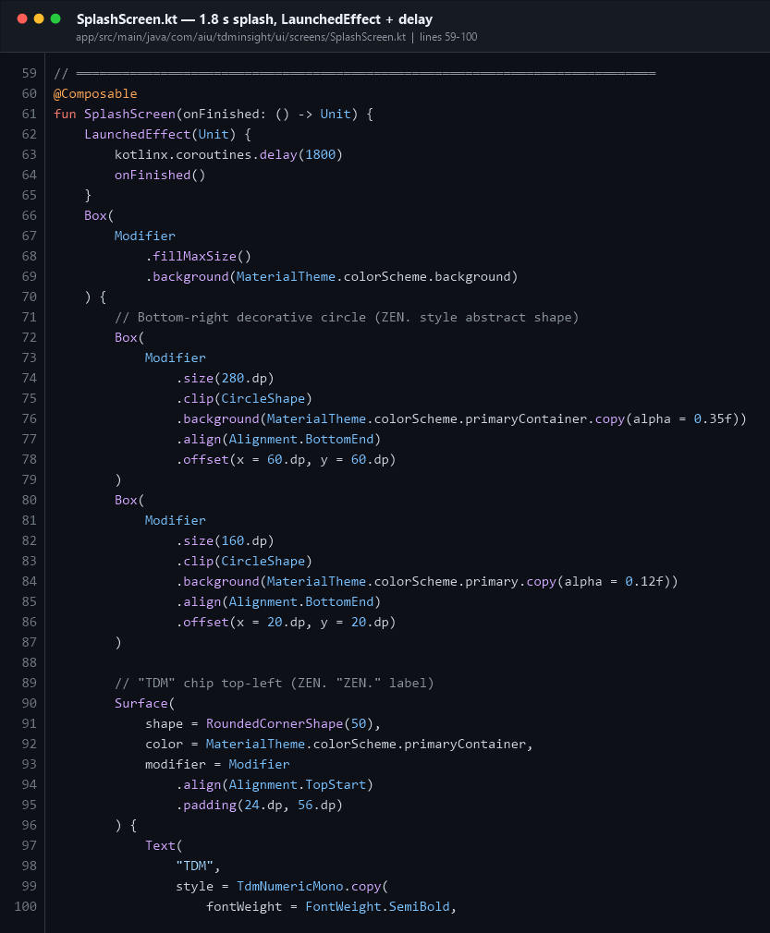
Splash
LaunchedEffect(Unit) { delay(1800); onFinished() } — a coroutine that waits 1.8 seconds then flips splashDone in MainActivity. The rest is decorative Boxes and a LinearProgressIndicator.

PART 13 · PDF export and sharing
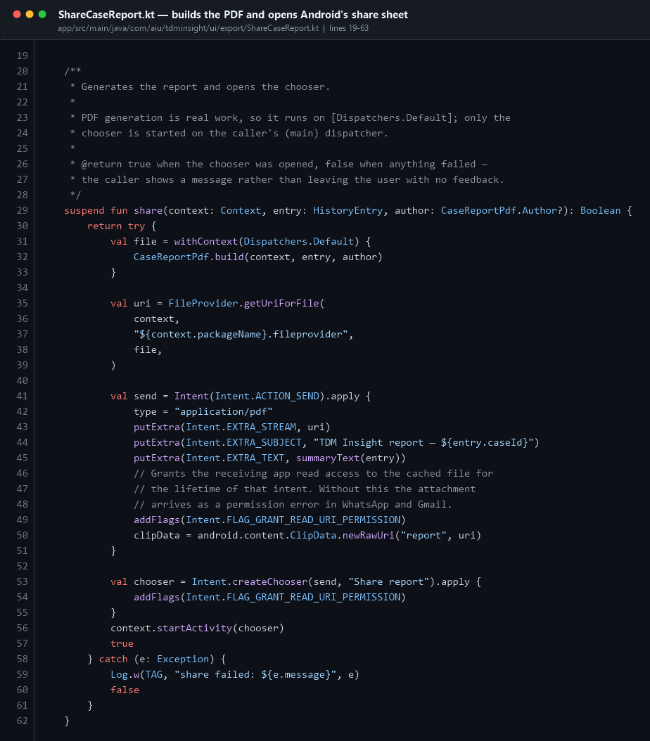
Share PDF
ShareCaseReport.share():
- Builds the PDF on Dispatchers.Default (real work — keep it off the main thread).
- Converts the file to a content:// URI with
FileProvider.getUriForFile(context, "${packageName}.fileprovider", file).
- Creates an ACTION_SEND intent with type = "application/pdf", the URI in
EXTRA_STREAM, and `FLAG_GRANT_READ_URI_PERMISSION` — without that flag the attachment arrives in WhatsApp or Gmail as a permission error.
- Wraps it in Intent.createChooser() and starts it.
CaseReportPdf.kt (657 lines) builds the document page by page using Android's android.graphics.pdf.PdfDocument.

PART 14 · Tests and resources

14.1 Unit tests
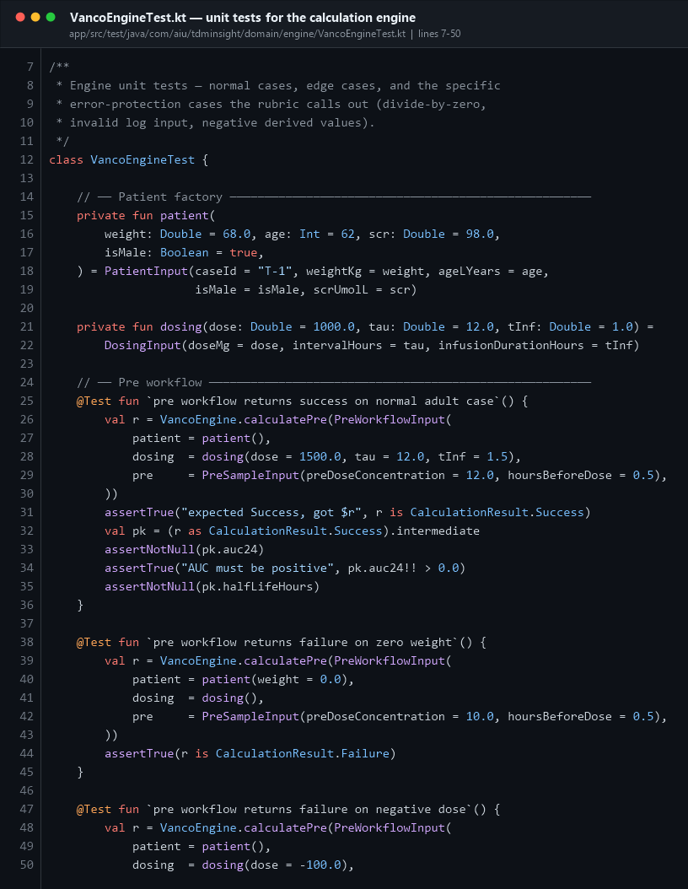
Engine tests
VancoEngineTest covers normal adult cases, the elderly/renal-impairment edge case, and the error-protection cases the rubric asks for: zero weight, negative dose, divide-by-zero, invalid logarithm input.
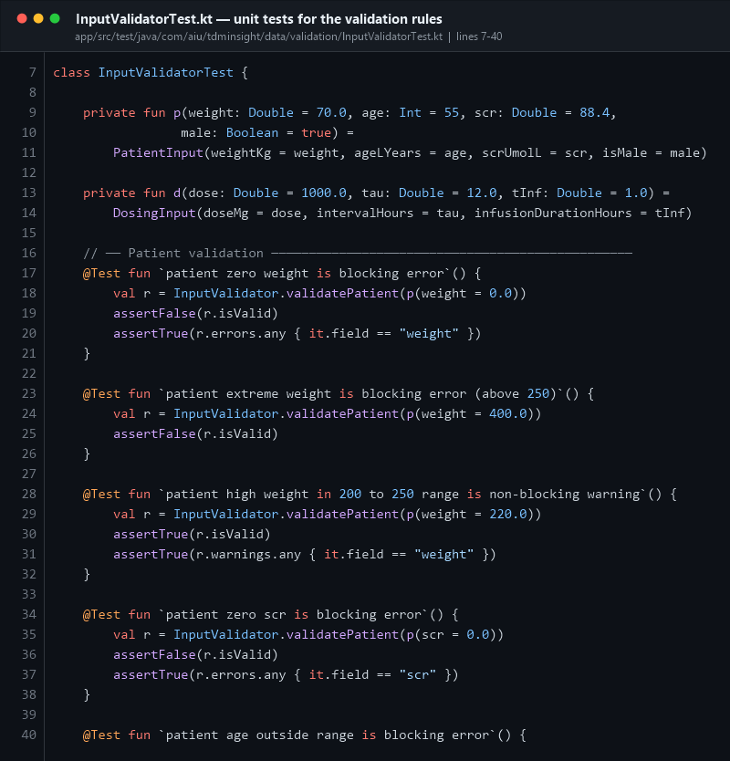
Validator tests
InputValidatorTest checks that each rule produces the right severity — a blocking Error for out-of-range values and a non-blocking Warning for merely unusual ones.
Both test classes run on a plain JVM (no emulator) because neither VancoEngine nor InputValidator imports anything from Android. Run them with:
gradlew test

14.2 Resources
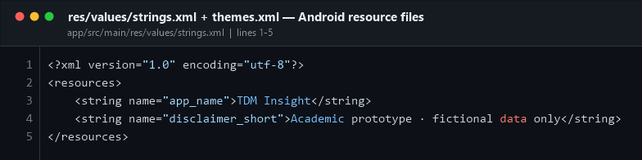
Resources
File | Contents
values/strings.xml | app_name = "TDM Insight", plus a short disclaimer string
values/themes.xml | A minimal XML theme — only so the launcher and the window background are not a white flash before Compose takes over. The real theme is ui/theme/Theme.kt.
values/colors.xml, values-night/colors.xml | The window background for light and dark
drawable/ic_launcher_foreground.xml, mipmap-anydpi-v26/ | The adaptive app icon
xml/file_paths.xml | Restricts the FileProvider to cache/shared_reports/ only
`layout/` | Does not exist — by design. This is a Compose app.

PART 15 · Following one tap all the way through
This is the story to tell if the teacher asks you to "explain how your app works".
1. User taps "Run calculation →" CaseWizardScreens.kt : 553
↓ the onClick lambda runs
2. vm.runCalculation() CaseViewModel.kt : 101
↓
3. validate() CaseViewModel.kt : 76
→ InputValidator.validatePatient / validateDosing / validatePreSample …
→ if any Error: return immediately, button was already disabled
↓
4. _uiState.update { isCalculating = true }
↓ Compose sees the state change and the spinner appears
5. nav.navigate(Routes.CALCULATING) → CalculatingScreen
↓
6. viewModelScope.launch {
withContext(Dispatchers.Default) { ← BACKGROUND THREAD
VancoEngine.calculatePrePost(...) ← domain/engine/VancoEngine.kt : 206
ke = ln(Cpeak / Ctrough) / Δt
t½ = ln(2) / ke
Vd = D(1 − e^(−ke·T)) / (ke·T·Cpeak)
CL = ke × Vd
AUC = (D/τ) × 24 / CL
recommended dose = 500 × CL × τ / 24
}
}
↓ returns CalculationResult.Success(workflow, PkResults)
7. _uiState.update { result = …, isCalculating = false }
↓
8. CalculatingScreen's LaunchedEffect(s.result) fires
→ nav.navigate(Routes.RESULTS) with popUpTo(CALCULATING, inclusive)
↓
9. ResultsScreen recomposes and draws the AUC₂₄ verdict + PK cards
↓ (in parallel, fire-and-forget)
10. supabaseRepository.saveCase(...) SupabaseRepository.kt : 38
→ builds CaseDto with @SerialName column mappings
→ supabase.from("cases").insert(dto)
→ POST to PostgREST → INSERT INTO cases
→ any failure is caught and logged; the user's result is unaffected
↓
11. Next time History opens, loadRecentCases() does
SELECT * FROM cases WHERE user_id = ? ORDER BY created_at DESC LIMIT 20

PART 16 · ★ QUICK ANSWER CHEAT SHEET
Print this page. These are the exact answers to the questions you listed.
Teacher's question | Your answer | File
What is the main activity? | MainActivity — the only Activity. It extends ComponentActivity, and onCreate() calls setContent { } which hosts the entire Compose UI. It is declared in AndroidManifest.xml with the MAIN/LAUNCHER intent filter. | MainActivity.kt:51
Where is the logic written? | VancoEngine — a pure-Kotlin singleton with all pharmacokinetic maths and no Android imports. The ViewModel decides when to call it; the engine decides what the answer is. | domain/engine/VancoEngine.kt
What is the layout? | There is no XML layout. The app uses Jetpack Compose: every screen is a @Composable function. Column replaces vertical LinearLayout, Row replaces horizontal, Box replaces FrameLayout, and Modifier replaces the XML attributes. | —
Where is the layout section? | ui/screens/ — 10 files holding 20 screens. Shared widgets are in ui/components/Banners.kt and ui/screens/ScreenComponents.kt. Colours/typography are in ui/theme/. | ui/screens/
What key components did you use? | Scaffold, TopAppBar, Surface, Column, Row, Box, Button, IconButton, OutlinedTextField, Icon, Text, CircularProgressIndicator, LinearProgressIndicator, AlertDialog, Canvas, NavHost, ViewModel, StateFlow. | throughout
Where are the buttons? | Three kinds: (1) PrimaryPillButton — the shared CTA, a Material Button; (2) IconButton — back/close/share in top bars; (3) custom Surface + Modifier.clickable — the Home hero card, the bottom-nav tabs, the selection cards. | ui/components/Banners.kt:139, screens
Where is the event listener? | Compose has no setOnClickListener. The listener is the lambda you pass in: Button(onClick = { … }), Modifier.clickable { … }, OutlinedTextField(onValueChange = { … }). They all call a ViewModel function. | e.g. CaseWizardScreens.kt:553
Which section is the database? | Two halves: the SQL in Kotlin_app/supabase/*.sql defines the cases and user_profiles tables; the Kotlin in data/supabase/ (client, DTOs, repository) reads and writes them. | supabase/, data/supabase/
How does the API work? | Two APIs. Supabase/PostgREST via the Supabase Kotlin SDK over Ktor+OkHttp for the database. Clerk Frontend API called directly with Ktor for sign-in, sign-up, email verification and Google OAuth. Both authenticate with keys injected through BuildConfig. | data/supabase/, auth/ClerkAuthManager.kt
Where do you handle errors? | Four levels: InputValidator blocks bad input; guardPositive/guardLogSafety protect the maths; the engine returns CalculationResult.Failure instead of throwing; every network call is wrapped in try/catch and returns a safe default. | everywhere
How is state managed? | Each ViewModel owns a private MutableStateFlow and exposes a read-only StateFlow. Screens call .collectAsState(). Updates use copy() on an immutable data class, so Compose can diff old vs new. | viewmodel/

PART 17 · 20 EXAM QUESTIONS WITH MODEL ANSWERS

Q1. What is the entry point of your application, and what runs first?
A. AndroidManifest.xml declares MainActivity with an intent filter containing android.intent.action.MAIN and android.intent.category.LAUNCHER, which is what puts the icon in the launcher. But TdmApplication runs first — it is registered as android:name=".TdmApplication" on the <application> tag, and Android creates it before any Activity. It sets up the shared Supabase client and Clerk auth manager as lazy singletons. Then MainActivity.onCreate() runs and calls setContent { }.

Q2. Why is there only one Activity? Where are the other screens?
A. This is a single-Activity architecture, which is Google's current recommendation for Compose apps. All 21 screens are @Composable functions, not Activities or Fragments. Fifteen of them are registered as routes in NavGraph.kt and swapped by the NavHost; the six pre-login screens (splash, disclaimer, login, sign-up, verify, welcome) are selected by a when block in MainActivity. One Activity means no Intent plumbing between screens and much faster transitions.

Q3. Where is the layout defined? Why is there no res/layout folder?
A. Because this is a Jetpack Compose app. In Compose the UI is described in Kotlin functions annotated @Composable, not in XML. My layout code lives in ui/screens/ (10 files, 20 screens) — for example HomeScreen.kt defines a Scaffold with a bottom bar, containing a scrollable Column of Surface cards. Column replaces a vertical LinearLayout, Row replaces a horizontal one, Box replaces FrameLayout, and Modifier.fillMaxWidth(), .padding(), .weight() replace the XML layout attributes. The res folder still exists for strings, colours, the app icon and the FileProvider config — just not for layouts.

Q4. Where is your business logic, and why is it separated from the UI?
A. In domain/engine/VancoEngine.kt. It is a Kotlin object containing the three workflow functions and all the pharmacokinetic formulas. It imports only kotlin.math and my own data models — no Android imports at all. That separation means (1) I can unit-test the maths on a plain JVM with no emulator, which VancoEngineTest.kt does, (2) the logic cannot break because of a UI change, and (3) the same engine could be reused in a different app or on the desktop.

Q5. Explain the MVVM pattern as you implemented it.
A. The View is the Compose screens — they only draw and forward events. The ViewModel (CaseViewModel, AuthViewModel, HistoryViewModel) holds the state in a MutableStateFlow and exposes it read-only as a StateFlow. The Model is the data layer: the data classes, InputValidator, VancoEngine and SupabaseRepository. Data flows down (ViewModel → state → UI), events flow up (UI → vm.updatePatient(...) → new state). The View never touches the database.

Q6. Where are your buttons and where are the event listeners?
A. There are three kinds of button. The shared call-to-action is PrimaryPillButton in ui/components/Banners.kt — a Material 3 Button with a pill shape. Top bars use IconButton for back, close and share. Cards like the Home hero CTA and the bottom-nav tabs are a Surface with Modifier.clickable { }. There is no setOnClickListener anywhere, because Compose has no such method: the listener is the lambda you pass in. For example PrimaryPillButton("Run calculation →") { vm.runCalculation(); nav.navigate(Routes.CALCULATING) } in CaseWizardScreens.kt line 553 — that trailing lambda is the click handler.

Q7. What happens, step by step, when the user taps "Run calculation"?
A. The lambda calls vm.runCalculation(). That validates the inputs, returns early if anything is invalid, sets isCalculating = true, then launches a coroutine in viewModelScope. Inside, withContext(Dispatchers.Default) moves the maths to a background thread and calls the matching VancoEngine function. The result is written back into the StateFlow. Meanwhile the UI navigated to CalculatingScreen, whose LaunchedEffect(s.result) notices the result arriving and navigates to Results or Error. Separately, a nested launch saves the case to Supabase in a try/catch, so a network failure never affects what the user sees.

Q8. How do you keep the UI responsive during the calculation?
A. viewModelScope.launch { withContext(Dispatchers.Default) { … } }. Dispatchers.Default is the CPU-work thread pool, so the main thread stays free to draw. viewModelScope ties the coroutine to the ViewModel's lifetime, so if the user leaves the screen the work is cancelled automatically and there is no memory leak.

Q9. Describe your database schema.
A. Two PostgreSQL tables in Supabase, defined in supabase/schema.sql. `cases` holds one row per completed calculation: a uuid primary key generated by gen_random_uuid(), the Clerk user_id, created_at, the case label and workflow, the patient demographics, the dosing regimen, the measured samples (nullable, because not every workflow uses both), and all the derived PK results including auc24 and recommended_dose_mg. There is a check constraint restricting workflow to 'PRE', 'POST' or 'PRE_POST', and a composite index on (user_id, created_at desc) for fast history queries. `user_profiles` holds the Clerk identity plus app-owned fields — institution, department and role — with the Clerk user_id as the primary key.

Q10. How do you prevent duplicate user rows when someone logs in repeatedly?
A. user_id is the primary key of user_profiles, and SupabaseRepository.syncUserProfile() uses a single upsert(listOf(dto), onConflict = "user_id", defaultToNull = false). Because it is one atomic SQL statement, the first login inserts and every login afterwards updates the same row — there is no read-then-write window where two rapid logins could race into two rows. defaultToNull = false also means columns not in the payload (institution, department, role) are left untouched, so a login never wipes data an administrator set.

Q11. How does the app talk to the database? Is it raw SQL?
A. No raw SQL from the app. It uses the Supabase Kotlin SDK's Postgrest plugin, which is a typed wrapper over Supabase's PostgREST HTTP API, running on Ktor with the OkHttp engine. For example, loadRecentCases() writes from("cases").select { filter { eq("user_id", userId) }; order("created_at", DESCENDING); limit(20) }, which PostgREST turns into SELECT * FROM cases WHERE user_id = ? ORDER BY created_at DESC LIMIT 20. The rows come back as JSON and decodeList<CaseDto>() deserialises them with kotlinx-serialization.

Q12. What is a DTO and why did you need @SerialName?
A. A DTO — Data Transfer Object — is the wire format: a class whose shape matches the database table, not the app's domain model. CaseDto is mine. I need @SerialName("weight_kg") on each field because Kotlin convention is camelCase (weightKg) but PostgreSQL convention is snake_case (weight_kg); the annotation maps between them. The function toHistoryEntry() then converts the DTO into the domain model HistoryEntry, which keeps the UI independent of the database schema — if a column were renamed, only the DTO and the mapper would change.

Q13. How is authentication implemented?
A. With Clerk, called through its Frontend API directly over Ktor rather than the Android SDK. ClerkAuthManager handles email+password sign-in and sign-up, the 6-digit email verification code, and Google OAuth. AuthRepository persists the session in private SharedPreferences so the user stays logged in across restarts, and AuthViewModel exposes it as an AuthState sealed class that MainActivity observes. On success the Clerk identity is upserted into the Supabase user_profiles table.

Q14. Explain the Google sign-in flow and the deep link.
A. Six steps. (1) AuthViewModel.startGoogleSignIn() asks Clerk for a Google consent URL. (2) MainActivity opens it with Intent(ACTION_VIEW, url) in the system browser. (3) The user approves. (4) Clerk redirects to tdminsight://oauth-callback. (5) The second <intent-filter> in AndroidManifest.xml — scheme tdminsight, host oauth-callback — routes that URL back into MainActivity.onNewIntent(), and because launchMode="singleTask" it goes to the same instance rather than a new one. (6) completeGoogleSignIn(url) hands the whole URL to Clerk, because its query string carries the rotated device token for the session.

Q15. What is a sealed class and where did you use one?
A. A sealed class defines a closed set of subtypes — the compiler knows every one of them, so a when over it is exhaustive and you cannot forget a case. I used three: CalculationResult (Success | Failure), AuthState (Loading, Unauthenticated, Authenticated, AwaitingEmailCode, Error) and FieldResult (Valid, Error, Warning). It is how the app models "this operation either worked or gave a reason why not" without throwing exceptions across layers.

Q16. How do you validate input, and what is the difference between an error and a warning?
A. InputValidator — a pure-Kotlin object — checks each field against a physiological range and returns a ValidationReport containing a list of FieldResult.Error and a list of FieldResult.Warning. An Error is blocking: it shows a red banner and the Continue button stays disabled, because canContinue = report.isValid. A Warning is advisory: an amber banner, but the user can proceed — for example a weight above 200 kg or a trough above 25 mg/L is unusual but not impossible. Validation runs on every keystroke via LaunchedEffect(workflow, patient, dosing, pre, post) { vm.validate() }.

Q17. How do you protect against divide-by-zero and invalid logarithms?
A. Three layers. First InputValidator rejects zero or negative weights, concentrations and intervals before anything else runs. Second guardLogSafety(pre, post) checks both concentrations are positive before the Sawchuk–Zaske ln(Cpeak/Ctrough). Third, inside the engine, every derived quantity — Δt, ke, Vd, CL — passes through guardPositive(), which throws an ArithmeticException if the value is non-finite or ≤ 0. The surrounding try/catch converts that into a CalculationResult.Failure with a readable message, and the app shows the Error screen. It never crashes. The POST workflow adds a fourth: if Newton–Raphson does not converge in 50 iterations, it returns a Failure explaining that the sample time or concentration is implausible.

Q18. Which Jetpack Compose components did you use, and what does Modifier do?
A. Layout: Scaffold, Column, Row, Box, Spacer, Surface. Content: Text, Icon, Image. Input: OutlinedTextField, Button, IconButton, TextButton. Feedback: CircularProgressIndicator, LinearProgressIndicator, AlertDialog. Structure: TopAppBar, NavHost. Custom drawing: Canvas. Modifier is a chainable decorator that replaces XML layout attributes — it sets size (fillMaxWidth, size, weight), spacing (padding), appearance (background, clip, border) and behaviour (clickable, verticalScroll). Order matters: .padding().background() paints the background inside the padding, while .background().padding() paints it outside.

Q19. How does state work in Compose, and what are remember, LaunchedEffect and collectAsState?
A. Compose is declarative: when state changes, the affected functions re-run — that is recomposition. remember { mutableStateOf(...) } keeps a value across recompositions (I use it for local UI state like showSignUp or a text field's raw string). collectAsState() subscribes a Composable to a StateFlow from a ViewModel and turns each emission into a recomposition. LaunchedEffect(key) runs a coroutine as a side effect, restarting only when the key changes — I use it to refresh history on screen entry (LaunchedEffect(Unit)), to re-validate when inputs change, and in CalculatingScreen to navigate once the result appears.

Q20. What would you improve if you continued this project?
A. Five things, in priority order. (1) Security: finish the Clerk→Supabase JWT template so the strict per-user RLS policies in update_v4.sql can be enabled, making row filtering server-enforced rather than client-side, and remove the hard-coded key fallbacks from build.gradle.kts. (2) Offline support: add a Room database so cases save locally and sync later, instead of being lost when the network is down. (3) Features already stubbed in the UI: the "Scan lab report" tile and the Gentamicin/Amikacin workflows are placeholders. (4) Testing: add Compose UI tests with createComposeRule — the dependency is already declared — and test the repository with a fake Supabase client. (5) Dependency injection: replace the manual singletons in TdmApplication with Hilt, which would make the ViewModels properly testable.

Appendix · Numbers you should be able to quote
Fact | Value
Kotlin source files | 39 (37 main + 2 test)
Total Kotlin lines in app/src/main | ~9,050
SQL lines across the 4 migration files | ~665
Activities | 1 (MainActivity)
Composable screens | 21 (20 in ui/screens/ + FirstLaunchDisclaimer in MainActivity.kt)
Navigation routes | 15
ViewModels | 3
Database tables | 2 (cases, user_profiles)
SQL migration files | 4
Calculation workflows | 3 (PRE, POST, PRE+POST)
Unit test classes | 2
Android permissions requested | 1 (INTERNET)
minSdk / targetSdk | 26 / 35
AUC₂₄ therapeutic target | 400–600 mg·h/L (centre 500)

Generated for CDE2313 · TDM Insight · Albukhary International University. Every screenshot in this document is taken from the actual source files in `Kotlin_app/`, with the real file path and line numbers shown in each image header.

