$${\left(x+a\right)}^{n}=\sum_{k=0}^{n}{\left(\frac{n}{k}\right)x^{n−k}a^{k}}$$

下面是图片
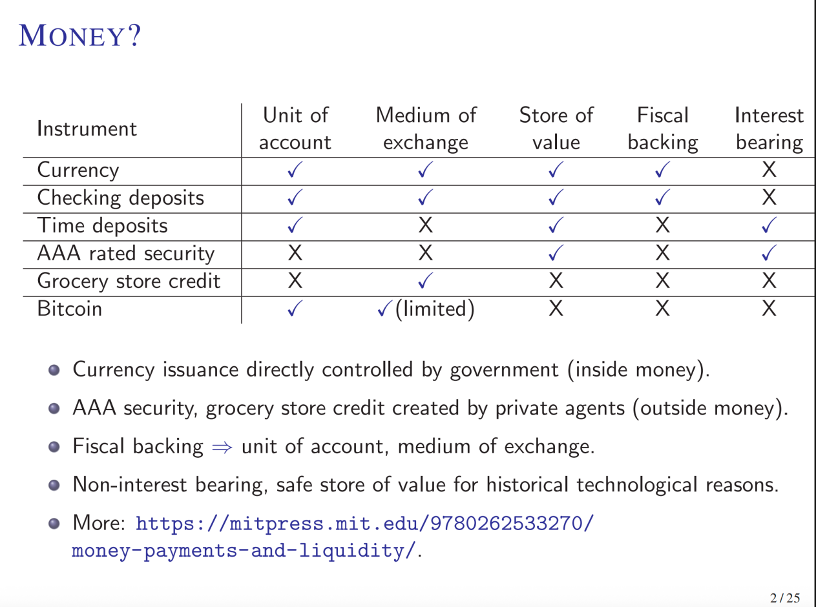
$${\left(x+a\right)}^{n}=\sum_{k=0}^{n}{\left(\frac{n}{k}\right)x^{n−k}a^{k}}$$

