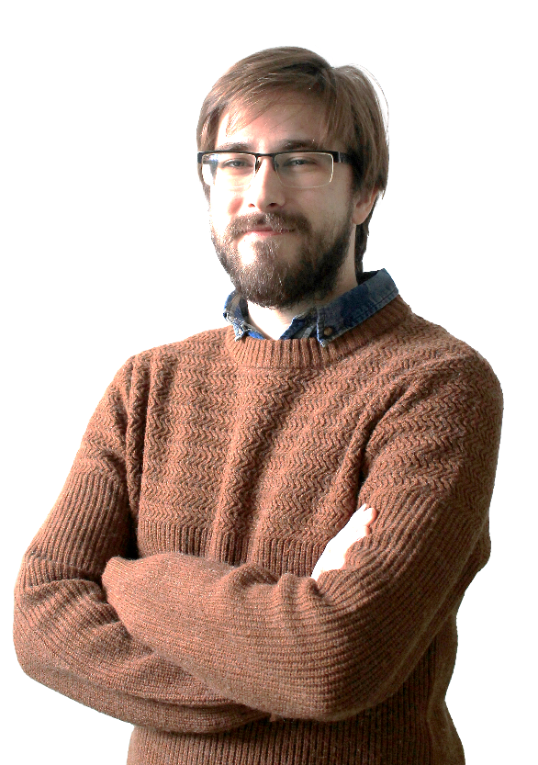**PERSONAL INFORMATION**

**Phone**: +385 (98) 921 0125 | **e-mail**: max.marschhauser@gmail.com

**Address**: Osijek, Gundulić street 118 | **Date of birth**: 11. 05. 1994.

**Citizenship**: Croatian

**WEB DEVELOPMENT**

**web page**: maxdev.com.hr

**LinkedIn**: linkedin.com/in/max-marschhauser-a8b9791a6/

**GitHub**: github.com/max-marschhauser | **CodePen**: codepen.io/max-marschhauser

**WEB DEVELOPMENT SKILLS**

I have learned the basics of programming in secondary school. The first language I uses was C. Also, in secondary school I learned how to use HTML, CSS, PHP, and MySQL. In university I attended two courses about web design and have learned how to use SASS and JavaScript. On my own I have learned how to use TypeScript and React.

|  |  |
| --- | --- |
| **Skill** | **I have used it since:** |
| HTML, CSS, C | 2009 |
| PHP, MySQL | 2012 |
| Sass, JavaScript | 2018 |
| React, TypeScript | 2022 |

**FORMER PROJECTS**

I am determined to perfect and develop my web development skills daily, whether it is by creating new projects, improving existing code or studying innovations in web design. It is best seen in my daily contributions on GitHub and CodePen pages.

I am trying to create projects that are interesting to my potential clients. My web pages are responsive and developed with special regard to successful UI/UX.

My projects show that I am familiar with developing eCommerce pages, brochures for various firms or subjects, simpler browser games and my ability to use various external information ( for example API data ) and apply them to my web pages.

**WORK EXPERIENCE**

**IT teacher ( 2 years )** – improved my knowledge about programming ( Python ), internet and computers as well as provided me with the experience of teaching young students computer science.

**school counselor ( 5 years )** – team-leading skills ( from managing a team of 50 people ), ability to work both individually and in team, taking responsibility, punctuality, speed, experience in supervising and leading bigger projects and simultaneous work on multiple projects.

**EDUCATION**

**2020 – today.** Multiple online courses and self-education in web design ( for example: freeCodeCamp course, pages like w3schools, Mdn Web Docks, Frontend Mentor, youtube tutorials… )

**2013 – 2018** Faculty of humanities and Social Sciences in Osijek ( Major in Pedagogy and History )

* Passed two courses dealing with contemporary web design ( Sass and JavaScript )

**2009 – 2013** Mathematics and Natural Sciences Grammar School in Osijek

- the basics on programming and web design ( C, HTML, CSS, PHP, MySQL )

**PERSONALITY**

**About me**: responsibility, discipline, creativity in problem solving, reliability, punctuality, motivated to work in IT industry.

**Working with people**: experience in leading and managing a team of about 50 employees, developed communication and interpersonal skills.

**Work on projects**: experience in leading and implementing bigger projects, experience in individual work and team-work, successful completion of tasks withing a given deadline, experience in presenting results, fast and professional response to unexpected situations, ability to work under pressure, successful in simultaneous work on multiple projects.

**Development**: able to learn fast, adaptability to new situations, improvement of the existing system in former workplace, oriented towards learning and developing to achieve better results.

**OTHER**

**Languages:**

**Croatian –** mother tongue

**English** – individual user both in writing and in speech ( C1 )

**German** – Ability to lead simple conversation ( B1 )

**Hungarian** – Ability to lead simple conversation ( B1 )

**Other:** driving license B category