Team Name:

Team Members & contact info:
Ben Robertson,
Joshua Hindley, (joshua.hindley2222@gmail.com)
Max McMurray,
Penny Peneueta,
Toby Stayner,

Primary communication tool: Facebook

Roles:
• Darren: project lead and hardware support (organising team meetings, reporting regularly on progress, CAD designing components)
• Bonnie: software development (writing core code and extending functionality)
• Tyler: software testing and documentation (debugging software and committing to git, writing test cases and documenting performance against milestones)
• Leo: hardware (building the chassis, testing components, connecting sensors, debugging hardware)

An up to date version of our team’s goals are available at https://github.com/max-mcmurray/AVC which includes all code, designs and a README.

Team Agreement
By signing below, all team members are acknowledging that they have read and committed to their part in the AVC. They acknowledge that they will attempt to complete the tasks agreed on by the group each week and document this on the team github account. They acknowledge that failure to meet these goals can result in the team recommending any member receives a lesser grade for their AVC report. In the event that a team member is unable to complete their task due to circumstances beyond their control (i.e. sickness, bereavement etc) that they will inform the team at the earliest possible time. Finally, the team acknowledges that a member going a week without contact with other team members (except when discussed with the team in advance) will constitute the member in question being considered AWOL. In this instance the team agrees to inform the ENGR101 course co-ordinator immediately. The penalty this for this can range from a reduction in the final grade to immediate failure of the AVC (and thus the ENGR101 course). Should the team unanimously agree that a member (or members) have failed to contribute to the AVC sufficiently for other reasons, on the day of robot testing the team will be given the opportunity to anonymously vote for a team member to receive 0% for the robot part of the AVC. Should the team choose this option they MUST be able to show that the member in question had been assigned tasks that they failed to complete and that the team had afforded them an opportunity to make up for past mistakes.

Signed by all team members:
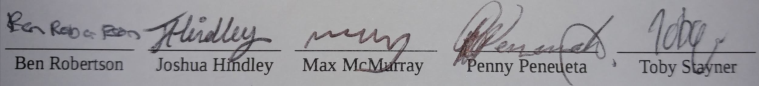

Plan

Week | Dates | Team Objectives | Items Due | Conflicting Commitments | Tasks
Week 1 | 30th April
Week 2 | 7th May |  | AVC Project Plan | CYBR171 Test
Week 3 | 14th May |  |  | COMP112 Test
Week 4 | 21st May |  | AVC Progress Report | ENGR121 Test
Week 5 | 28th May |  | AVC Testing
Week 6 | 4th June |  |  | ENGR101 Test
Week 7 | 11th June |  | AVC Final Report

