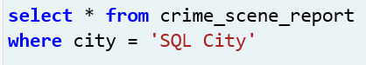

I wanted to see a list of all types of crimes in SQL City.

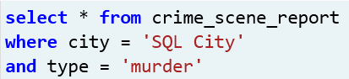

The description specified a murder occurred, so I narrowed my search down to murder specifically.

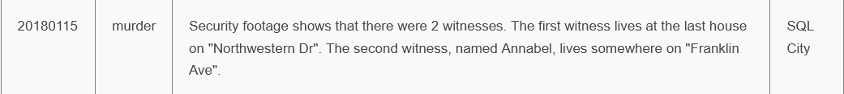

This is most likely the case that I should investigate. Now I need to find more detailed witness information so I can talk to them.

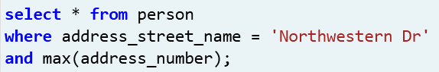

I tried to use max() to get the biggest number, but that didn’t work.

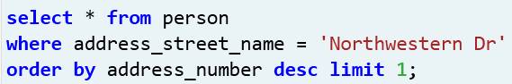

This gave me the highest number, and I limited it to 1 after I received every person who lived on that street.

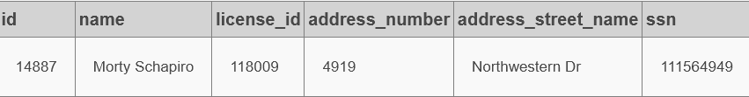

I got my first witness, now I just need to get the second one.

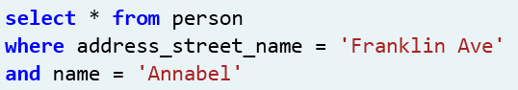

This returned no data.
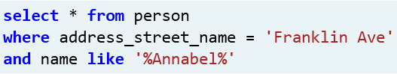

It looks like I needed to make the name vaguer to find the specific person.

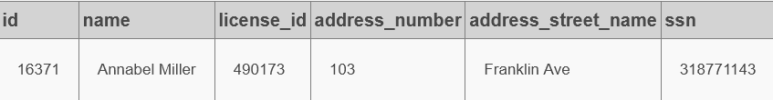

Now I need to know what these witnesses saw. I can probably find this information in the interview table, and I’m assuming that “person_id” ties to “id” in the person table.

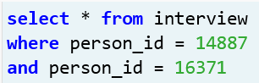

This returned no data. I’ll try one at a time.

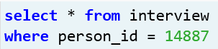

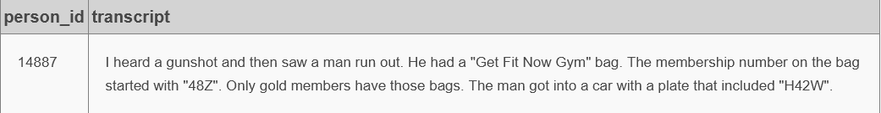

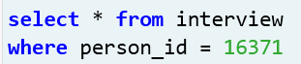

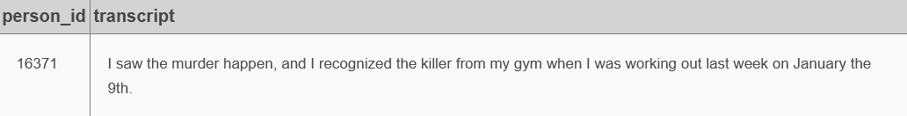

Note from future me: I could’ve gotten both witness statements simultaneously in the “where” statement.

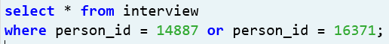

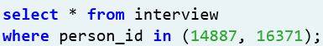

Based on both witness statements, I need to check the get_fit_now_member, drivers_license tables, and check in time.



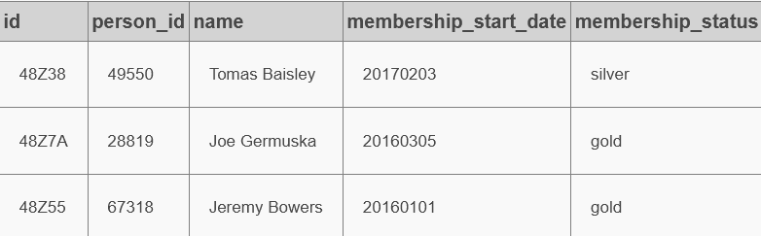

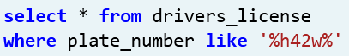

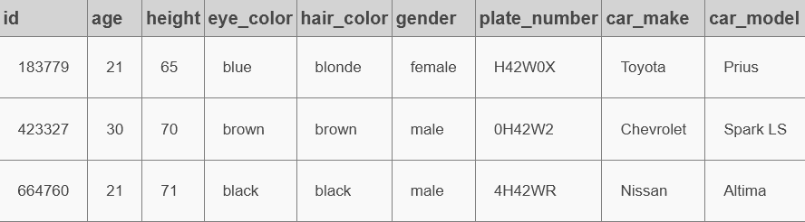

It looks like I’ll need to join these tables to get all the information I need consolidated into one table, and I’ll need to narrow down my results.

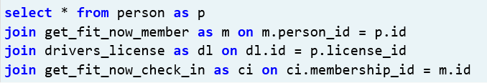

Yielded too many results; forgot to add “where” statement, and I’ll further narrow my search results.

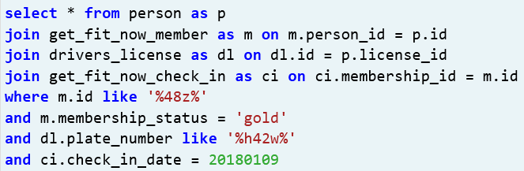

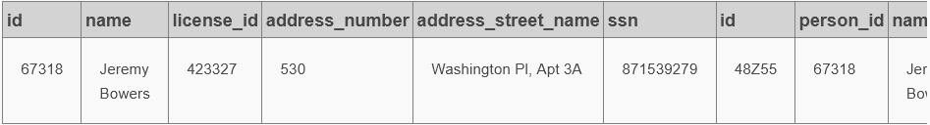

I got what I needed, but the table had more information than what I needed.

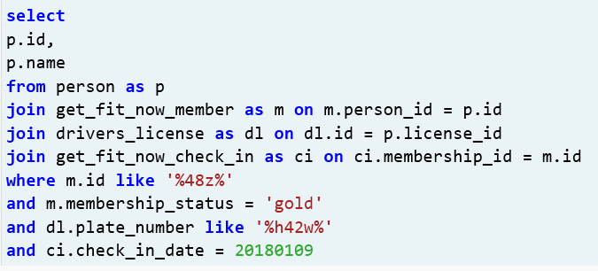

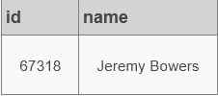

Much better, but I want to see the data that matches the witness statements.

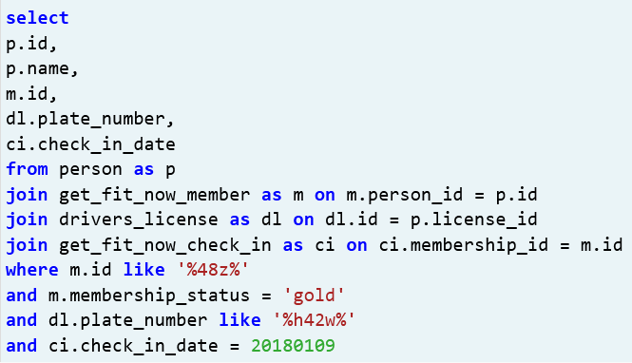

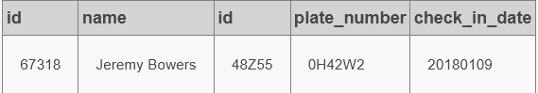

I should’ve specified p.id as person_id and m.id as membership_id, but I thankfully know that the membership ID contains a letter and the person ID is an integer.

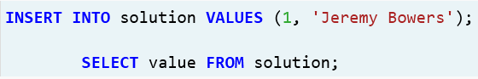

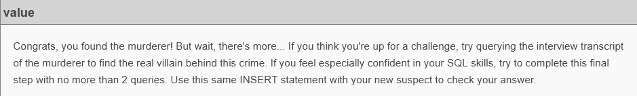

He must’ve been a hitman. Time to find and charge the mastermind behind the crime with solicitation and conspiracy to commit murder. Will the hitman fess up?

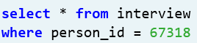

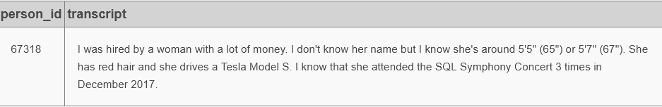

It’s weird that Mr. Bowers knows this woman attended a concert 3 times in December. Anyway, I think I have enough information to find the real culprit behind this heinous crime.

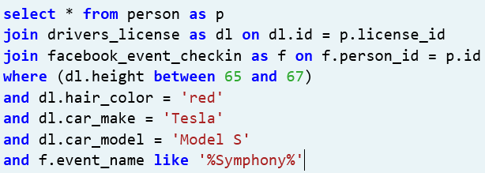

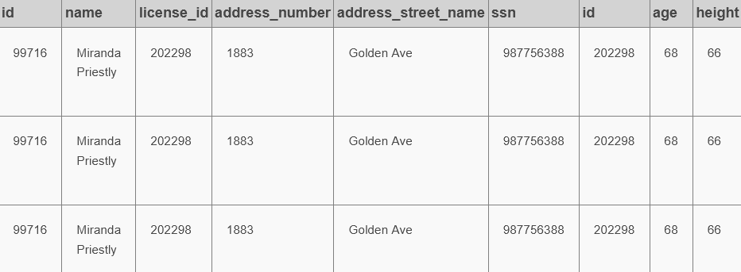

I’m confident in who the mastermind is, but I don’t need her information 3 times.

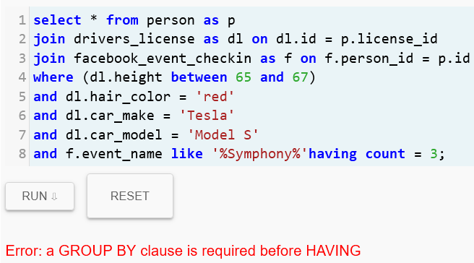

Let’s try again.

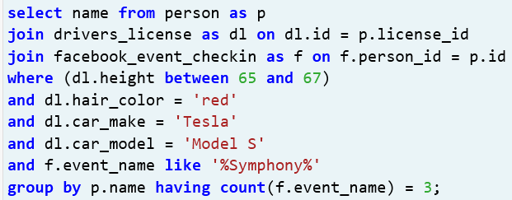

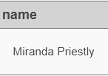

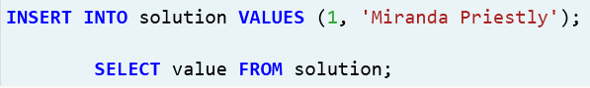

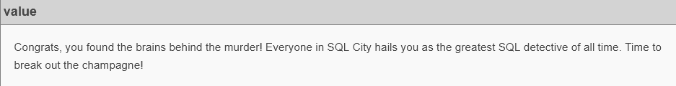

Bingo.

Completing this assignment helped me learn that 1) you can write queries in different ways and achieve the same results 2) it’s crucial to have “keys” that tie multiple related tables together for easier future analysis 3) and the titles you give these “keys” don’t have to be identical, but the data itself must be identical (even data type, like strings and integers) for SQL joins to work. I was initially quite confused and overwhelmed looking at the schema structure and it took a little while to finally get my bearings straight so I could start the assignment. It wasn’t too bad after I figured out how the tables connected together!

