Title: CPG simulation .. [will add later]

Max Talanov1, Alina Suleimanova1, Constantine Menshenin1, Carlos A. Cuellar4, Riazul Islam4, Igor Lavrov1, 4, 5, 6*.

Affiliations

1Kazan (Volga Region) Federal University, Kazan, Russia

4Department of Neurologic Surgery, Mayo Clinic, Rochester, MN, USA

5Department of Physiology and Biomedical Engineering, Mayo Clinic, Rochester, MN, USA

6Department of Neurology, Mayo Clinic, Rochester, MN, USA

*Corresponding author

**Running title:**

**Key words**: CPG; computational simulation; spinal cord injury; spinal cord stimulation; spinal cord motor-evoked responses.

# Introduction

The modeling of biological neural circuits is an important direction in developing of bio-plausible artificial neural network [Bekka et al., 2002] via neuro-simulations. At the same time, the computer simulations of neuronal circuits require information regarding physiological and anatomical organization of the nervous system, which is not accessible by direct neurobiological measurements [Prentice et al., 2001]. Precise values of many basic parameters of neurons and networks, as well as neuronal interactions are usually not available and commonly substituted by theoretical models (Soares and Cortez, 1999; Cruz, et al., 2000; [Bizzi et al., 1991] and in fact all currently available computer simulations of biological circuits are developed with a great level of approximation. Important applications of biological circuitry modeling primary related to development of motor and sensorial neuroprosthesis, including the simulation of biological circuits with increasing degrees of complexity and automation [Donaldson et al., 1997](#bookmark5), [Lauer et al., 1999].

Previously we successfully implemented spinal cord stimulation techniques to identify components of spinal cord circuitry involved in recovery of stepping in complete spinal rats and we found that electrical epidural stimulation (EES) can induce four types of motor evoked electrical responses in the hind limb muscles [Gerasimenko et al., 2006](#bookmark6), [Lavrov et al., 2006]. Observed correlation between restoration of spinal cord polysynaptic responses after spinal cord injury (SCI) and recovery of stepping facilitated with epidural stimulation [Lavrov et al., 2006](#bookmark101), [Lavrov et al., 2008] provides new options for identification of specific parts of spinal circuitry and mechanisms involved in the spinal cord plasticity after injury. Accounting the complicity of changes in the spinal cord and in synaptic or- ganization after injury, we proposed a novel model, which systemizes our previous experimental findings and provides insight on functional organization of spinal locomotor networks. Comparing *in vivo* and *in silico* results we investigated the effect of (1) modulation in sensory input (modulation of parameters of EES, i.e. frequency, amplitude, and geometry of stimulation; modulation of sensory input from treadmill, i.e. speed, direction, and load; surgical elimination of sensory input, etc), (2) electrical and pharmacological modulation of the spinal circuitry (spinal networks reorganization at different time after injury, modulation of synaptic activity with pharmacological pretreatment with strychnine and quipazine), and (3) modulation in supraspinal input (comparison between control, anesthetized animals, spinal cord injured animals).

# Methods

Data for this study were collected during previously published works (2006-2018) on Sprague Dawley rats, 270- 300 g body weight and evaluated in regards of circuitry organization and modulation of spinal cord motor evoked potentials. The experimental procedures in these studies comply with the guidelines of National Institute of Health Guide for the Care and Use of Laboratory Animals. Surgical procedures, injury model, implantation techniques, stimulation and recording procedures, and animal care was described else were [Roy et al., 1991](#bookmark12),[Talmadge et al., 2002,](#bookmark13)Ic[hiyama et al., 2005,](#bookmark7) [Lavrov et al., 2006](#bookmark102),[Lavrov et al., 2008].

## Data collection and analysis

## All recordings were collected at stimulation intensities between 0.5 to 10 V. Comparisons of the responses at different voltages were used to identify the onset and amplitude of the ER, MR, LR, and PC. These three responses were modulated during each test session, and were clearly voltage- dependent. All electrophysiological recordings from the muscles were analyzed within a 27 ms period after the stimulus artifact and were divided into four windows based on the onset latencies of the four types of responses, i.e., 1.5 to 6.5 ms for the ER, 6.5 to 10.5 ms for the MR, 10.5 to 13.5 ms for the LR, and 13.5 to 27 ms for the PC. The maximum peak-to-peak amplitude for each response was calculated as an average of 10 responses and reported as a percentage of the control value. Modulation of mono- and polysinaptic components were assessed in vivo freely moving rats and in silico on designed hypothetical spinal circuitry model (see below). Motor activity from *in vivo* animals was induced by a combinations of sensory input, supraspinal input, and the state of the spinal circuitry, and was correlated with the input and output in computer model, to evaluate proposed organization of spinal circuitry.

# Circuitry model

In this work we propose a novel neuronal model of spinal cord circuitry to explain the multiple experimental findings and particularly modulation of MR, LR, and PC components during stepping facilitated with EES or pharmacology and during different functional tests. To design the circuitry model we used a "black box" approach where hypothetical structure of circuitry was identified based on changes in inputs and outputs to the "black box". Changes in inputs, i.e. changes in speed of treadmill, body weight support, changes in supraspinal input, etc, were analyzed in relation to observed output. The structure of hypothetical circuitry was further adjusted based on changes in input-output during modulation of internal circuitry activity, such as reorganization after SCI, changes after adding pharmacological agents. In proposed model, each level from motoneurons to interneurons adds functional flexibility and complexity to the final motor output. Initial circuitry model was design based on our previous observations and consist of multilevel scheme with four main components:

1. Monosynaptic level with motorneurons, Ia, Ib interneurons, and Renshaw cells. This level functionally corresponds to the activation of Ia afferent and modulation of monosynaptic reflexes (MR).
2. Polysinaptic level (or pattern formation) for muscles antagonists involved in movements of ankle joint organized with several mutually inhibited bineuronal modules. This level func- tionally corresponds to polysinaptic responses (LR and PC).
3. Initiation level (or pattern generator) that process supraspinal input from MLR (eliminated in this model).
4. Independent components that specify a motion against the gravity processed through the biomechanical structure: bone, tendons, and muscles. These components cannot be completely defined in presented model due to complicity and described as F1 and F2 that pri- F1 and explains the modulation of sensory input and motor output by misbalance, external F2 force, weight bearing features of the limbs, body weight in relation to the gravity.

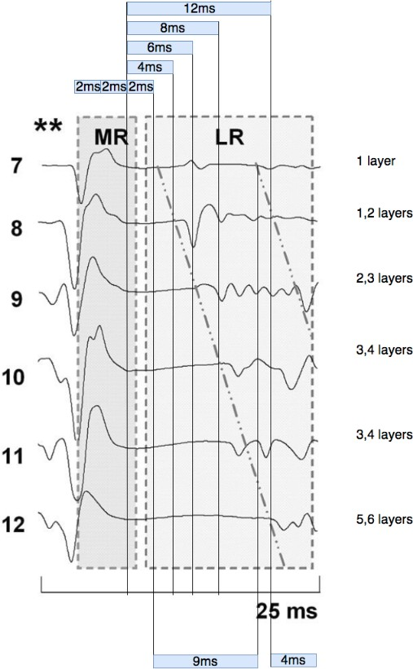

Figure: The myogram recorded from foot extensor during stepping facilitated with EES.

## Neuron Protocol

We used updated CPG topology in this simulation in the Neuron simulator see Figure6.

* + 1. **Neuron parameters: Model:** Hodgkin–Huxley **Refractory period** : 3ms

### Initial membrane potential: -70mV

* + 1. **Inhibitory connection parameters: Model:** synapse with STDP

**Learning function:** "Sombrero"

**Initial weight:** default for 100% inhibition *−*0*.*08

* + 1. **EES parameters: Type:** NetStim

**Interval:** default for 40Hz – 25ms

### Noise: 0

* + 1. **1a afferent parameters: Type:** SpikeGenerator

**Noise:** 0.2 (20%)

## Nest Protocol

We used updated CPG topology in this simulation in the NEST simulator, see Figure6. Figures below depict an average membrane potential of all motorneurons.

Neuron parameters:

**Model:** "hh_cond_exp_traub";

**Refractory Period** : 2ms[Bor84];

**Initial membrane potential "V_m":** -70mV; **Leak reversal potential "E_L":** -70.0mV; **Leak conductance:** 75.0ns;

### Time constant of the excitatory synaptic exponential function "tau_syn_ex": 0.2ms;

**Time constant of the inhibitory synaptic exponential function "tau_syn_in":** 3.0ms; Connection parameters:

**Model:** "static_synapse";

**Delay:** 1ms;

**Rule:** "fixed_outdegree"; **"multapses":** True; **"autapses":** True;

**Statistical analyses.**

All data reported as means ± SE. Statistically significant differences were determined using a one-way repeated-measure ANOVA (Student-Newman-Keuls). Values that were not normally distributed were analyzed using the nonparametric Wilcoxon sign-rank test. The statistical significance was set at p˂0.05.

**[We have to add here analysis for simulation data and comparison between in silico and in vivo results.**

**Results**

## Spinal cord motor evoked responses induced by ES

As we described earlier, spinal cord epidural stimulation produces four types of responses in hindlimb muscles. In standing position, single electrical shock of S1 spinal segment provokes direct early response (ER), monosynaptic middle response (MR) and polysynaptic late response (LR) as described in control [Gerasimenko et al., 2006] and spinal [Lavrov et al., 2006] animals (Fig.1A). The same three responses are observed during rhythmic activity on a moving belt of the treadmill induced by epidural stimulation. In addition to the ER, MR, and LR responses, however, during stepping on a treadmill we observed a polysynaptic complex with a latency >13.5 ms (PC) (Fig.1B). The LR in spinal rats can be attributed to the short polysynaptic networks with 2 to 3 interneurons. These circuits recover slowly after a spinal cord injury and appears to be related closely to the restoration of the ability to step when facilitated by ES [Lavrov et al., 2006]. The polysynaptic complex (PC) has more complex features: it has a relatively long latency of >13.5 ms and includes several, usu- ally about 6, spikes. Consistent number of spikes in PC and stable latencies of these spikes (Fig. 1C) may suggest activation of polysynaptic circuits with the different combination of interneurons (Fig.1D). PC responses are commonly observed during stepping facilitated by ES and not during passive standing, which may reflect activation of spinal circuits. *Based on these observations, we hypothesize that information about modulation of the SC motor evoked responses during different functional states can provide insight into the mechanisms of the functional organization of spinal locomotor networks.*

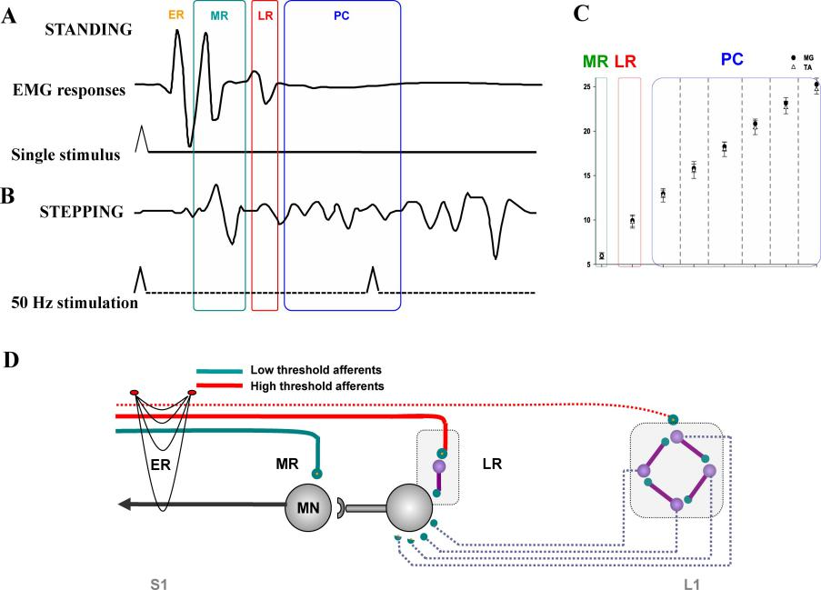

Figure 1: A. Example of spinal cord responses to EES during standing (single shock) and during stepping (50Hz) at 7 cm/s on a treadmill. B. Latency of MR, LR, and PC responses in the MG and TA muscles during stepping on treadmill. Latencies of spinal cord responses are statistically different (p<0.001) for MG and TA respectively (n=9). C. Numbers of picks (1-6) in PC in A and B correspond to the latency for each pick in PC in C. from [Lavrov et al., 2008]. D. Schematic organization of simple hypothetic spinal circuitry, representing modulation of MR, LR, and PC with ES.

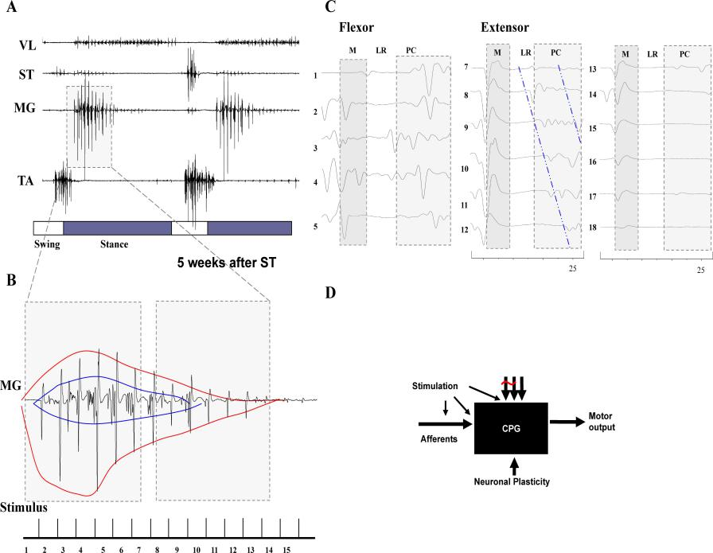

Figure 2: A. Formation of EMG bursts in MG and TA muscles from MR, LR and responses of PC during stepping. B. Organization of EMG burst from MR and LR in MG muscle. C. Different modulation of MR and LR in TA and MG muscles, correspondingly. D. Generated by computer model modulation of monosynaptic responses in flexor and extensor muscles. E. Generated by computer model modulation of polysynaptic activity in extensor muscle. D and E represent different presets of synaptic configurations.

**CPG computational model**

**Model organization**

**[please look other papers, like Rybak et al, and try to describe basic stracture of CPG computational model.**

**This needs to be done for both Neuron and Nest, later in results we have to compare both outcomes.]**

According to Fig.2(C Extensor) the neuronal activity of the extensor muscle divided into 25*ms* slices identified via EES frequency 40*Hz* more than that we identify 6 periods of intensive neu- ronal activity, according to this we assumed the following 6 layers neuronal structure of the CPG presented in Fig.3. Each layer of the proposed CPG model creates the neuronal activity during corresponding slice and overall neuronal activity of interneuronal pool is the result of summation of neuronal activity of active layers. Each layer is triggered via EES and sensory projections starting from Layer 1 the EES signal is propagated each time towards next layer. Higher layers inhibit lower layers and the higher layer more inhibitory projections it has to lower layers. This way layer 1 is triggered via first EES pulse and produce weak activity of the slice number 7 in the Fig.2 (C Extensor). The 2nd EES triggers layer 2 that produces long and intensive activity of the slice 8 possibly combined with activity of the layer 1. The 3rd EES triggers layer 3 that produces the shorter than previous but still intensive neuronal activity possibly combined with the activity of the layer 2 inhibiting layer 1. The 4th EES triggers shorter than previous with high amplitude neuronal activity of the slice 10 similar to the slice 11 produced by layer 5 right after the 5th EES. The slice 12 is produced via 6th EES and activity of the layer 6 that inhibits all lower layers and provides very short and intensive neuronal activity. There are three main parameters of the neuronal activity we could select: delay after the EES pulses, amplitude and duration. We assume that the delay is identified by synaptic delays of layers through which the EES triggered spikes are propagated to an active layer. The amplitude is identified by number of nuclei of layers active at the same moment and their activity is combined via the IP. The duration of the neuronal activity is defined via number of nuclei activated sequentially or recursively in an active layer.

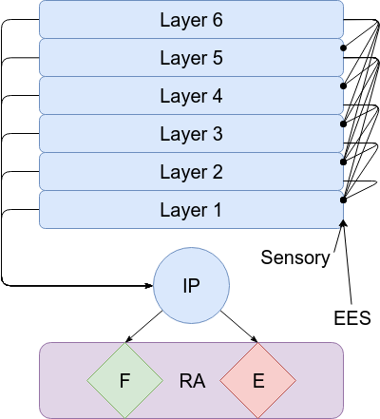

Figure 3: The high level structure of the CPG with 6 layers that create the neuronal response presented in Fig.2(C Extensor) where: RA – reflex arc, F – flexor motorneurons, E – extensor motorneurons, IP – interneuronal pool, Layer [1. . . 6] – layers of CPG that modulates the monosynaptic response of the reflex.

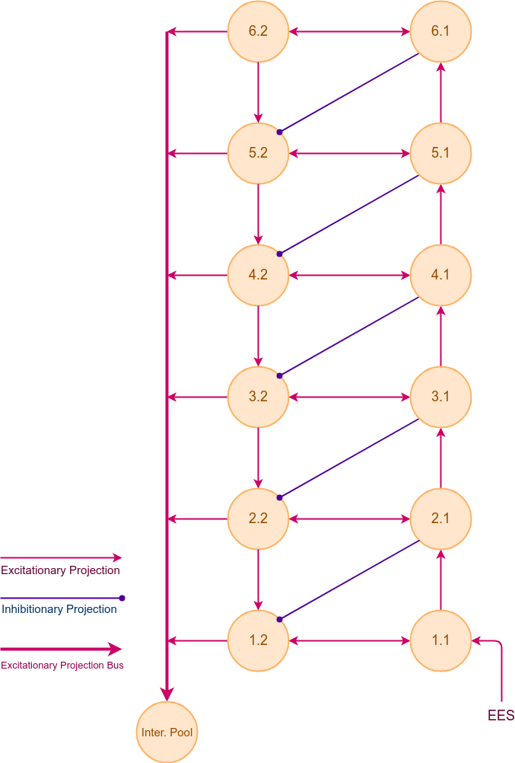

The basic proposed 6 layers CPG topology

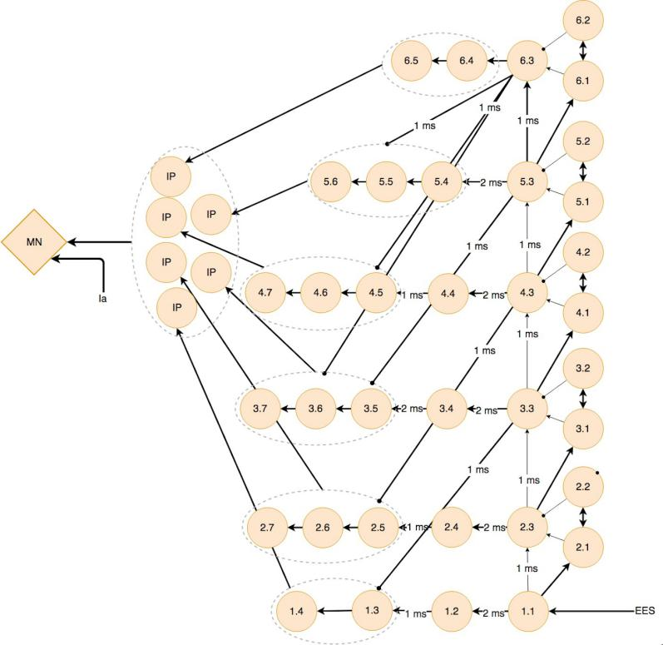**Topology**

**[we need to describe a logical approach of progression from topology 1 to topology n]**

Figure : The proposed 6 layers topology of a mammalian CPG, where: 1.1-6.5 – nuclei of the CPG, IP – nuclei of the interneuronal pool, MN –motor neuron nucleus, EES the afferents projections with EES.

## Different percentages of inhibition (Neuron)

We updated the value of weight of inhibitory connections. Half of the initial weight is an inhibition 50%. One fifth of the initial weight is an inhibition 20%. If there is no inhibition the weight is 0%.

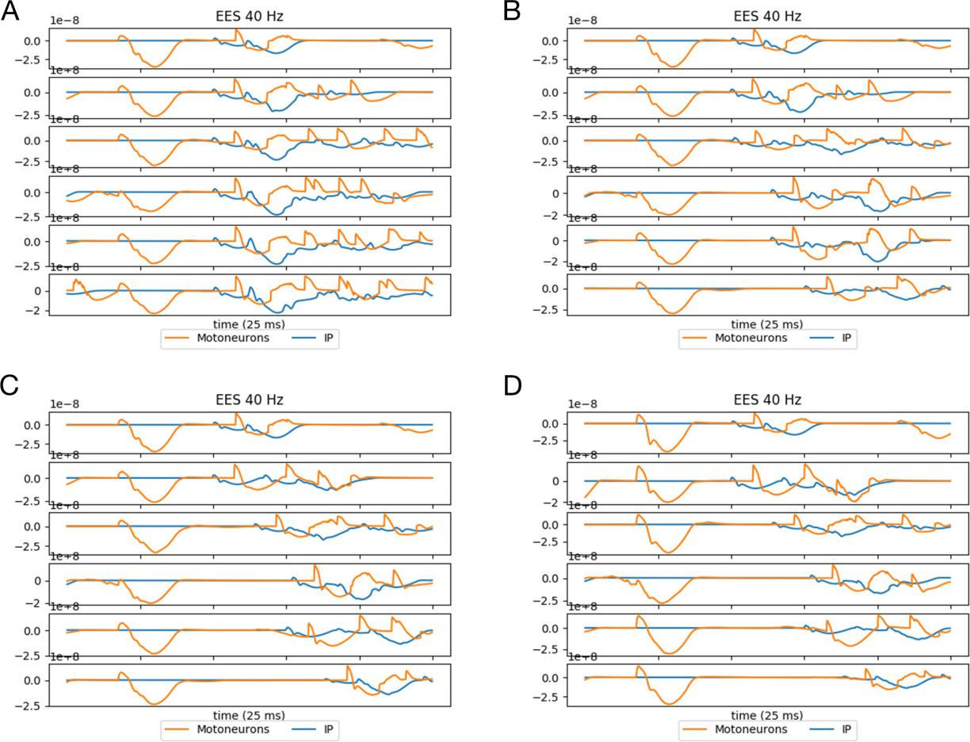

Figure 8: The result of CPG simulation with 40Hz of EES and different percentages of inhibition. The orange graph is motorneurons’ extracellular potential. A – The spiking activity with the 40Hz ESS and 0% inhibition. B – The spiking activity with the 40Hz ESS and 20% inhibition. C – The spiking activity with the 40Hz ESS and 50% inhibition. D – The spiking activity with the 40Hz ESS and 100% inhibition.

**[Please add average data here.]**

## Different inhibitory impact (Nest)

We ran the simulation with different inhibitory coefficient from 0 to 1 and observed the same results while coefficient is over 0.25. It means 25% of inhibition strength is a threshold value for our simulation, and we defined this value as an upper bound for the coefficient. A panel timescale is fixed and equals 25*ms* for the all figures. Different layers response with an increasing delay. The delay between MR and LR on the myogram (Figure11) occurs due to inhibiting lower layers. For example: in the Figure11(A) the response on the third panel occurs later than on the second one due to the first layer was inhibited. By decreasing inhibitory strength we expect layer will be inhibited lesser and fire after every EES, we observe same delays between MR and LR in all panels. Moreover, if layers are not inhibited and fire after every pulse the result amplitude have to be higher than case of several layers are inhibited due to merging layers activity.

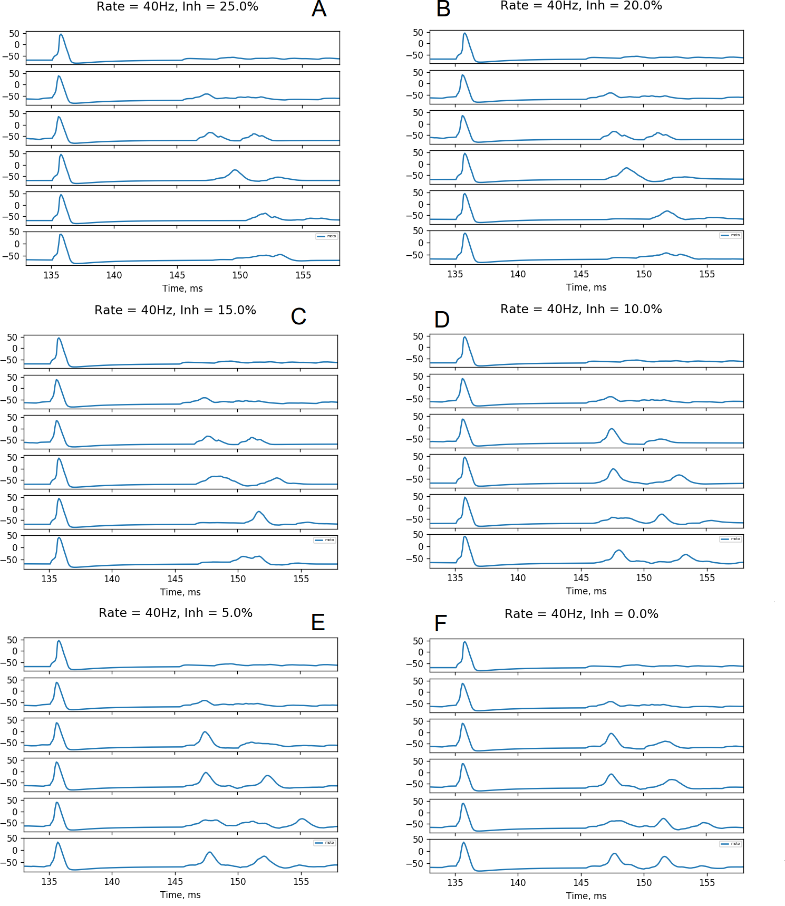

Figure 11: Results of the CPG simulation with 40Hz of EES and 0-25% of inhibition via NEST simulator. *A* - 25%, the base level of inhibition to reproduce the Figure3-like results *B* - 20%, 5-th and 6-th panels layers start firing with minimal delay but with lower amplitude in comparison to 25% due to 1-st layer stays active. *C* - 15%, similar to 20% but with higher amplitude due to less inhibition. *D* - 10%, minimal delays between MR and LR, with higher overall amplitude than 15% due to the low inhibition. *E* - 5%, minimal delay and higher amplitude compared to 10% inhibition. *F* - 0%, minimal delay, the highest amplitude due to no inhibition.

[We need to come with some comparison between results from Neuron and Nest]

## Different EES frequency (Neuron)

We updated the value of interval of EES stimulation. The value is 50*ms* for 20*Hz*, 33*ms* for 30*Hz*, 20*ms* for 50*Hz*, 17*ms* for 60*Hz*.

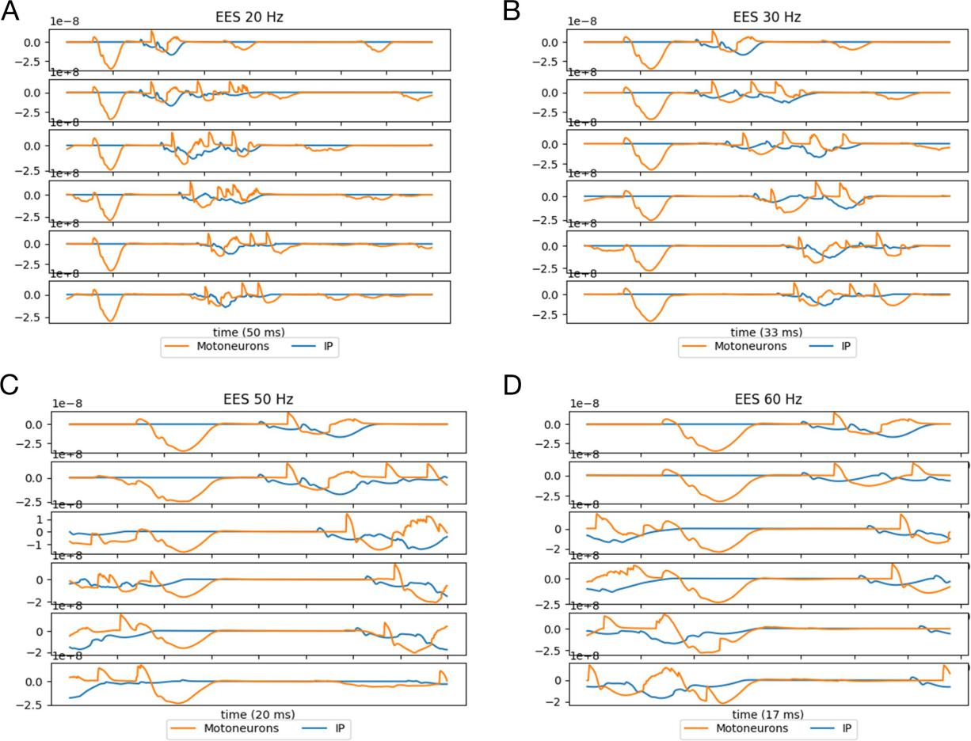

Figure 9: The result of CPG simulation with different EES frequency and 100% of inhibition. The orange graph is motoneurons’ extracellular potential. A – The spiking activity with the 20Hz ESS and 100% inhibition. B – The spiking activity with the 30Hz ESS and 100% inhibition. C – The spiking activity with the 50Hz ESS and 100% inhibition. D – The spiking activity with the 60Hz ESS and 100% inhibition.

**[Need an average]**

## Different EES frequency (Nest)

We run simulation with different stimulation rates from 20Hz to 80Hz. Panel timescale isn’t fixed and corresponds the period between MRs. For example, the period equals 25*ms* for 40Hz and 50*ms* for 20Hz.

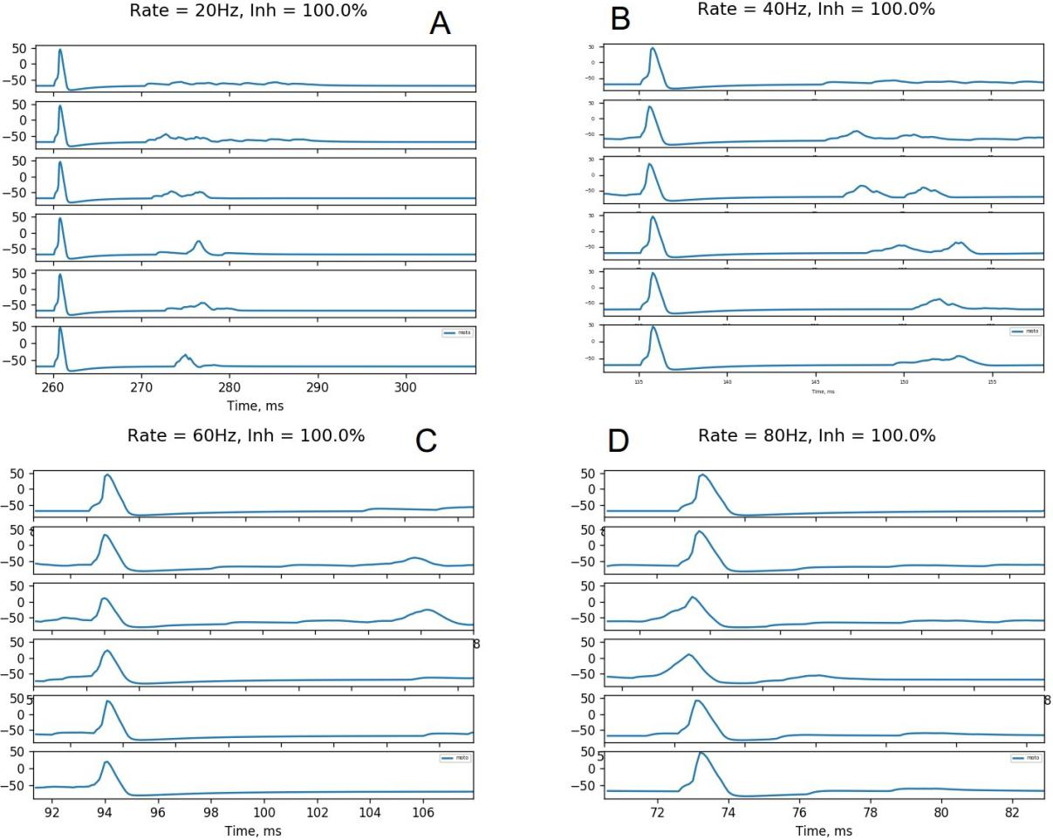

Figure 12: The result of CPG simulation with different frequency of EES from 20Hz to 80Hz and 100% of inhibition via NEST simulator. *A* - 20Hz, all LRs are short relatively to panel width. *B*

- 40Hz. *C* - 60Hz, stimulation periods become shorter, many LRs fill several panels due to fixed response duration. *D* - 80Hz, panels too short, fixed responses fill all the space of panels.

**[Same, need comparision]**

# References

[Bekka et al., 2002]Bekka, R., Boudaoud, S., and Chikouche, D. (2002). The use of a neural network system in the identification of motor unit characteristics from surface detected action potentials: a simulation study. *Journal of neuroscience methods*, 116(1):89–98.

[Bizzi et al., 1991]Bizzi, E., Mussa-Ivaldi, F. A., and Giszter, S. (1991). Computations underlying the execution of movement: a biological perspective. *Science*, 253(5017):287–291.

[Donaldson et al., 1997]Donaldson, N., Rushton, D., and Tromans, T. (1997). Neuroprostheses for leg function after spinal-cord injury. *The Lancet*, 350(9079):711.

[Gerasimenko et al., 2006]Gerasimenko, Y. P., Lavrov, I. A., Courtine, G., Ichiyama, R. M., Dy,

C. J., Zhong, H., Roy, R. R., and Edgerton, V. R. (2006). Spinal cord reflexes induced by epidural spinal cord stimulation in normal awake rats. *Journal of neuroscience methods*, 157(2):253–263.

[Ichiyama et al., 2005]Ichiyama, R., Gerasimenko, Y. P., Zhong, H., Roy, R., and Edgerton, V. R. (2005). Hindlimb stepping movements in complete spinal rats induced by epidural spinal cord stimulation. *Neuroscience letters*, 383(3):339–344.

[Lauer et al., 1999]Lauer, R. T., Peckham, P. H., and Kilgore, K. L. (1999). Eeg-based control of a hand grasp neuroprosthesis. *Neuroreport*, 10(8):1767–1771.

[Lavrov et al., 2008]Lavrov, I., Dy, C. J., Fong, A. J., Gerasimenko, Y., Courtine, G., Zhong, H., Roy, R. R., and Edgerton, V. (2008). Epidural stimulation induced modulation of spinal locomotor networks in adult spinal rats. *Journal of Neuroscience*, 28:6022–6029.

[Lavrov et al., 2006]Lavrov, I., Gerasimenko, Y. P., Ichiyama, R. M., Courtine, G., Zhong, H., Roy, R. R., and Edgerton, V. R. (2006). Plasticity of Spinal Cord Reflexes After a Com- plete Transection in Adult Rats: Relationship to Stepping Ability. *Journal of Neurophysiology*, 96(4):1699–1710.

[Prentice et al., 2001]Prentice, S., Patla, A., and Stacey, D. (2001). Artificial neural network model for the generation of muscle activation patterns for human locomotion. *Journal of elec- tromyography and kinesiology*, 11(1):19–30.

[Roy et al., 1991]Roy, R. R., Hutchison, D. L., Pierotti, D. J., Hodgson, J. A., and Edgerton,

V. R. (1991). Emg patterns of rat ankle extensors and flexors during treadmill locomotion and swimming. *Journal of applied physiology*, 70(6):2522–2529.

[Talmadge et al., 2002]Talmadge, R. J., Roy, R. R., Caiozzo, V. J., and Edgerton, V. R. (2002). Mechanical properties of rat soleus after long-term spinal cord transection. *Journal of Applied Physiology*, 93(4):1487–1497.