Get Current Weather 2
1.Requirement 2
2.Design Flow 3
3. Development tools 3
4.Web Interface Design 3
5.Third Party weather API Design 4
Config design 4
Openweathermap Description 4
By city name 4
6.Response data design 5

Get Current Weather
1.:
We need to build a web application to display current weather for 3 Australian cities: Sydney, Melbourne and Wollongong. There should be a dropdown list on web page for city selection, when city is changed corresponding real-time weather information should be displayed dynamically like below:
City | Melbourne
Updated time | Thursday 11:00 AM
Weather | Mostly Cloudy
Temperature | 9°C
Wind | 32km/h

2.Design Flow
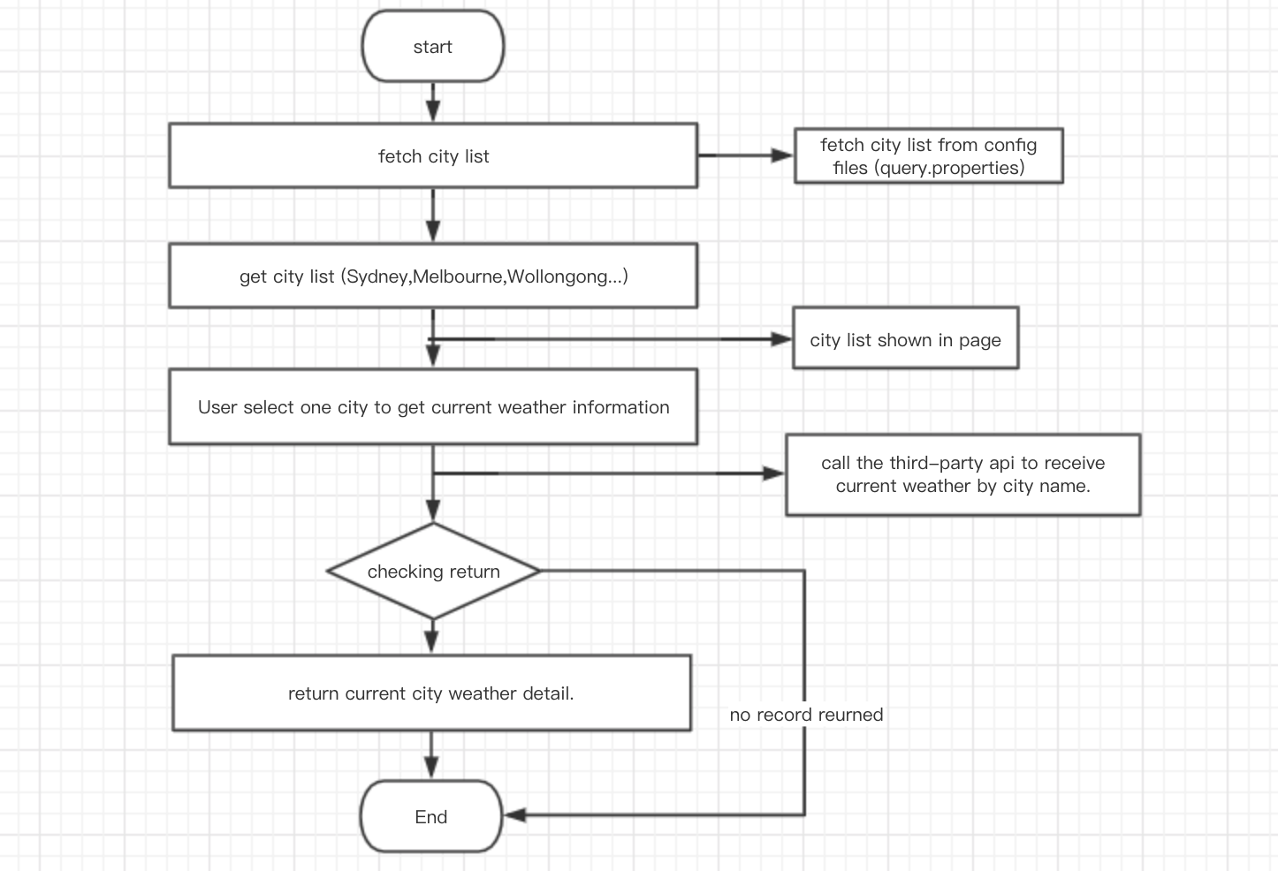

Development tools
Language | Java
Framework | Spring boot, thymeleaf
Software | IntelliJ IDEA, maven, github.

4.Web Interface Design
Interface number | A01
Interface name | Get
Description | To get city drop down list.
Request URL | http://127.0.0.1:8080/city/list
Request method | GET
Response format | JSON
Request parameter | None

Interface number | A02
Interface name | Get
Description | Get real time weather information by city name.
Request URL | http://127.0.0.1:8080/weather/current?city={city}
Request method | GET
Response format | JSON
Request parameter | city

5.Third Party weather API Design

Config design
Third-party API should be configured in the properties and we should consider that one more API can also be include in the properties as the back up.
Once the first one is down and back up API should be used for some urgent situation.

openweathermap.api.url = http://api.openweathermap.org/data/2.5/weather
openweathermap.api.param.unit.Fahrenheit = imperial
openweathermap.api.param.unit.Celsius = metric
openweathermap.api.param.appId = 9274ad675be3d8e517e8b57906ea2c4b

Openweathermap Description
1.Access current weather data for any location including over 200,000 cities.
2.Current weather is frequently updated based on global models and data from more than 40,000 weather stations
3.Data is available in JSON, XML, or HTML format
4.Available for Free and all other paid accounts
You can refer to this link https://openweathermap.org/current

By city name
Description:
You can call by city name or city name and country code. API responds with a list of results that match a searching word.
API call:
api.openweathermap.org/data/2.5/weather?q={city name}
api.openweathermap.org/data/2.5/weather?q={city name},{country code}
Parameters:
q city name and country code divided by comma, use ISO 3166 country codes

6.Response data design
We should use the common format response in our system for different third-party API if we used at least one third-party API to get the weather report.
So that it can keep the uniformity response and will not cause unnecessary changes.

Example of open weather map API response:
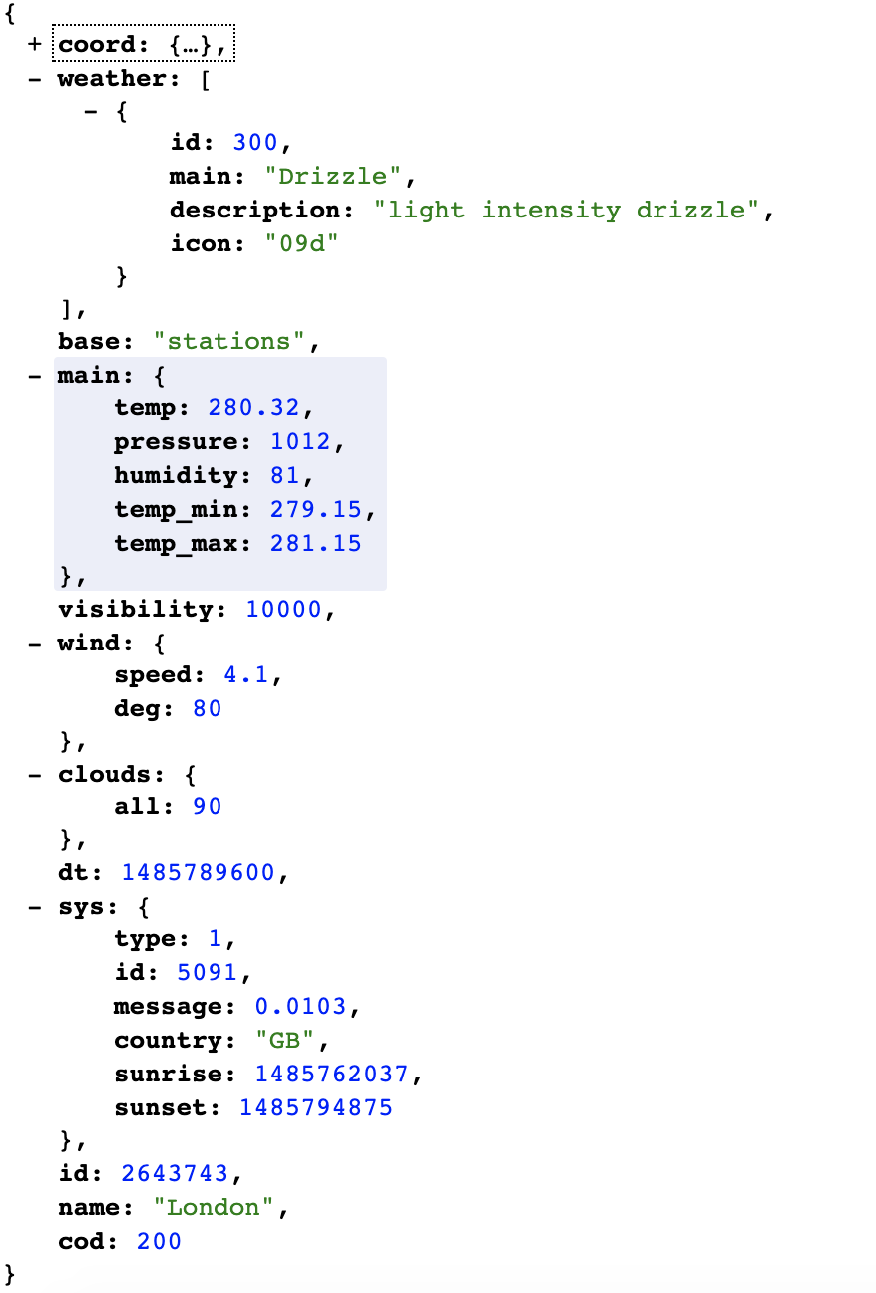

Parameters:
- coord
  - coord.lon City geo location, longitude
  - coord.lat City geo location, latitude
- weather (more info Weather condition codes)
  - weather.id Weather condition id
  - weather.main Group of weather parameters (Rain, Snow, Extreme etc.)
  - weather.description Weather condition within the group
  - weather.icon Weather icon id
- base Internal parameter
- main
  - main.temp Temperature. Unit Default: Kelvin, Metric: Celsius, Imperial: Fahrenheit.
  - main.pressure Atmospheric pressure (on the sea level, if there is no sea_level or grnd_level data), hPa
  - main.humidity Humidity, %
  - main.temp_min Minimum temperature at the moment. This is deviation from current temp that is possible for large cities and megalopolises geographically expanded (use these parameter optionally). Unit Default: Kelvin, Metric: Celsius, Imperial: Fahrenheit.
  - main.temp_max Maximum temperature at the moment. This is deviation from current temp that is possible for large cities and megalopolises geographically expanded (use these parameter optionally). Unit Default: Kelvin, Metric: Celsius, Imperial: Fahrenheit.
  - main.sea_level Atmospheric pressure on the sea level, hPa
  - main.grnd_level Atmospheric pressure on the ground level, hPa
- wind
  - wind.speed Wind speed. Unit Default: meter/sec, Metric: meter/sec, Imperial: miles/hour.
  - wind.deg Wind direction, degrees (meteorological)
- clouds
  - clouds.all Cloudiness, %
- rain
  - rain.1h Rain volume for the last 1 hour, mm
  - rain.3h Rain volume for the last 3 hours, mm
- snow
  - snow.1h Snow volume for the last 1 hour, mm
  - snow.3h Snow volume for the last 3 hours, mm
- dt Time of data calculation, unix, UTC
- sys
  - sys.type Internal parameter
  - sys.id Internal parameter
  - sys.message Internal parameter
  - sys.country Country code (GB, JP etc.)
  - sys.sunrise Sunrise time, unix, UTC
  - sys.sunset Sunset time, unix, UTC
- timezone Shift in seconds from UTC
- id City ID
- name City name
- cod Internal parameter

