# Get current weather Guide

## Import project

Please load project from <https://github.com/max-zp/weatherForecast>

Import into your eclipse, IDEA or any other SDK.

## Run app

Please make sure JDK installed in you current computer. Version 8 was suggested.

Run AppStart.java.main() once build successfully with maven.

Open your browser just like chrome or IE and so on...

Open <http://127.0.0.1:8080/city/list>

Then you will see below screen. Sydney, Melbourne, Wollongong will be shown in the drop down list.

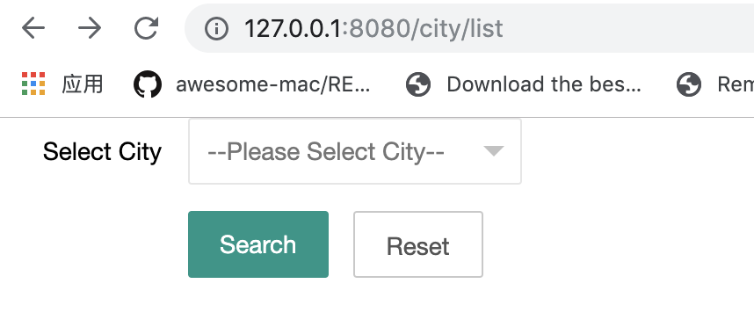

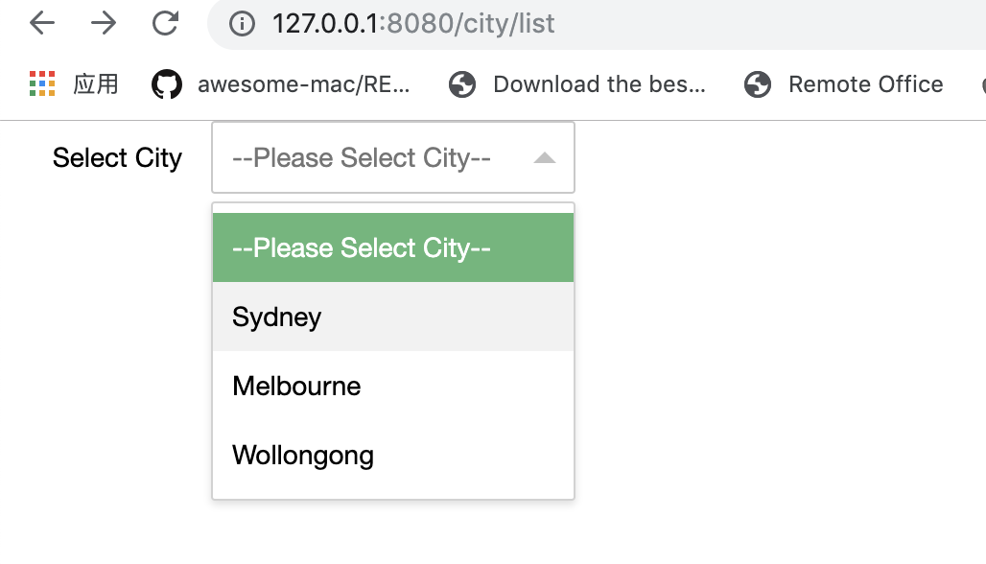

Select one city and click search button. Current weather will be shown in the table.  
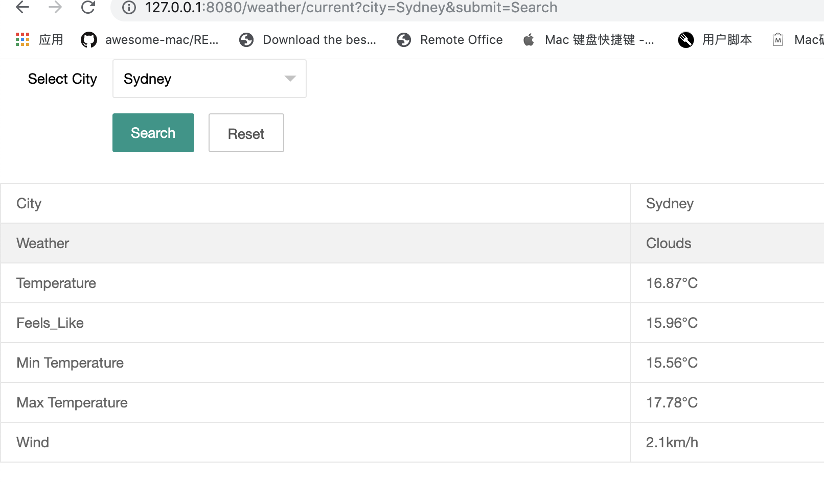

## More

We could add more city name in /weatherForecast/src/main/resources/query.properties If we want to add more cities.

query.condition.cities=Sydney,Melbourne,Wollongong

/weatherForecast/src/main/resources/data/city.list.json contains almost cities for the whole world, contains the city id, city name, zip code, coord and country.These information also could be queried for future requirements.(some was not implemented during I do not have enough time, so sorry about that.)

We could load the city.list.json into database or cache, so that we could use to search bar with some JS auto-complete function in the future (not implement...)

We could change the third-party API configuration in weatherForecast/src/main/resources/thirdAPICondig.properties

openweathermap.api.url = http://api.openweathermap.org/data/2.5/weather  
openweathermap.api.param.unit.Fahrenheit = imperial  
openweathermap.api.param.unit.Celsius = metric  
openweathermap.api.param.appId = 9274ad675be3d8e517e8b57906ea2c4b

appId should be registered in the open weather map web.

Junit test  
please find test case in /weatherForecast/src/test folder.

Junit test report stored in weatherForecast/report/unitTest-Report

