1. 아래 Script를 수행한 후 아래와 같이 seq 기준으로 위로 연속으로 col1,col2 동일한 값을 가진 row수를 구하시요.

create table test_0707

(seq number not null,

col1 varchar2(10),

col2 varchar2(10));

select * from test_0707 ;

insert into test_0707 values (1,'TEST',null);

insert into test_0707 values (2,'TEST','P');

insert into test_0707 values (3,'TEST','P');

insert into test_0707 values (4,'TEST1',null);

insert into test_0707 values (5,'TEST','U');

insert into test_0707 values (6,'TEST','P');

insert into test_0707 values (7,'TEST','P');

insert into test_0707 values (8,'TEST','P');

insert into test_0707 values (9,'TEST2','P');

commit;

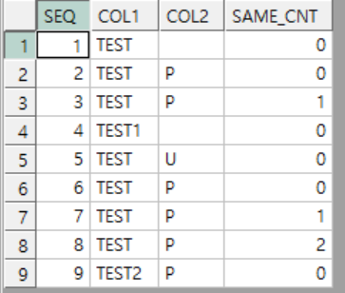

select seq,col1,col2,sum(same_cnt)over(partition by same_cnt order by seq) as same_cnt

from(

select seq,col1,col2,same_cnt2 same_cnt,seq-part_temp from

(

select

nullif( sum(same_cnt2) over (partition by same_cnt2 order by seq) ,0) as part_temp,t1.*

from(

select seq,col1,col2,same_cnt2

from (

select seq,

col1,

col2,

col1_lag,

col2_lag,

(CASE WHEN col1_lag=col1 and col2_lag=col2 then

same_cnt+1

ELSE same_cnt

END)

as same_cnt2

from

(

select seq,

col1,

col2,

lag(col1) over (order by seq) col1_lag,

lag(col2) over (order by seq) col2_lag,

0 as same_cnt

from test_0707

)

)

) t1

order by seq

)

)

order by seq

2. 아래와 같이 Table 생성 및 Data를 입력한 후 아래 화면과 같이 주별로 overtime 합을 구하시요. 단 한주는 일요일부터 토요일까지로 한다.

create table overtime

(

sabun varchar2(10) not null,

start_date date not null,

time number

);

insert into overtime values ('1',to_date('20210628 18:00:00','yyyymmdd hh24:mi:ss'),4);

insert into overtime values ('1',to_date('20210702 18:00:00','yyyymmdd hh24:mi:ss'),2);

insert into overtime values ('1',to_date('20210703 10:00:00','yyyymmdd hh24:mi:ss'),6);

insert into overtime values ('1',to_date('20210704 10:00:00','yyyymmdd hh24:mi:ss'),8);

insert into overtime values ('1',to_date('20210707 18:00:00','yyyymmdd hh24:mi:ss'),4);

insert into overtime values ('1',to_date('20210710 10:00:00','yyyymmdd hh24:mi:ss'),5);

insert into overtime values ('1',to_date('20210711 09:00:00','yyyymmdd hh24:mi:ss'),10);

insert into overtime values ('1',to_date('20210715 18:00:00','yyyymmdd hh24:mi:ss'),3);

commit;

­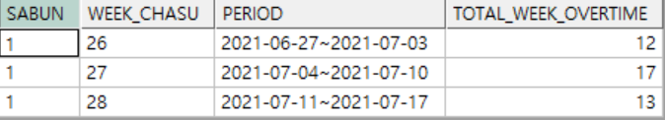

답:

select *

from

(

select

sabun,

week as week_chasu,

starts||'~'||fins as period,

sum(time)over(partition by week) as total_week_overtime

from

(

select sabun,starts,start_date,fins,week,time

from

overtime basic,

(

select

to_char(yymmdd,'yyyy-mm-dd') as starts,

to_char(nvl(lead(yymmdd-1)over (order by yymmdd),yymmdd+6) ,'yyyy-mm-dd')fins,

week

from

(

select yymmdd ,rownum week

from

(

select yymmdd

from(

select

(trunc(md,'YY') + level )-1 as yymmdd --

from

(

select max(start_date) as md -- overtime의 최댓 날짜 출력

from overtime

)

connect by level <= (trunc(md,'HH')+1) - trunc(md,'YY')-- level <= (yyyy-mm-dd 최대값) - (yyyy-01-01 ) +1

)

where to_char(yymmdd,'dy')='일'

)sunday_list-- 일요일인 날짜 목록후 몇주차인지 출력

)

) period --일요일 날짜 범위

where to_date(starts,'yyyy-mm-dd')<= trunc(start_date,'D')

and trunc(start_date,'D')<= to_date(fins,'yyyy-mm-dd')

)

)

group by period,total_week_overtime,sabun,week_chasu

order by week_chasu;