1. 아래와 같이 DEPT Table,EMP Table을 참조하여/ 직원이 존재하지 않은 부서(DEPTNO) 관련 정보가 하시요.

( not exists, not in, outer join 을 이용하여 3개 작성)

**<Outer join>**

select d.deptno,dname,loc

from dept d left outer join emp e

on (e.deptno=d.deptno)

where e.empno is null

**<not exists>**

select deptno,dname,loc

from dept D

where not exists (select * from emp e where e.deptno=d.deptno);

**<not in>**

select deptno,dname,loc

from dept d

where deptno not in (select deptno from emp e );

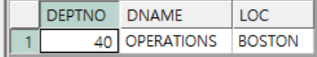

2. 아래와 같이 EMP Table의 상급자(MGR)의 이름이 조회되도록 하시요.

단 JOB이 PRESIDENT,MANAGER,SALESMAN,ANALYST,CLERK 순으로 조회되도록 하시요.

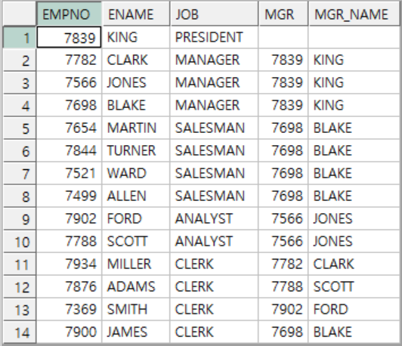

select empno,ename,job,mgr,(select ename from emp e2 where e.mgr=e2.empno) mgr_name

from emp e

ORDER BY DECODE(job, 'PRESIDENT', 1),

DECODE(job, 'MANAGER', 2),

DECODE(job, 'SALESMAN', 3),

DECODE(job, 'ANALYST', 4),

DECODE(job, 'CLERK', 5),

job asc;

3. 아래와 같이 SALGRADE Table ,EMP Table을 참조하여 GRADE별 몇 명인지 조회하는 SQL을 작성하시요.

select grade,count(e.empno) per_grade_count

from SALGRADE s right outer join emp e

on e.sal between s.losal and s.hisal

group by s.grade

order by grade;

