1. 아래와 같이 EMP Table을 사용하여 /부서별 MAX SAL,MIN SAL,AVG SAL(소수점 절삭),건수 / 그리고 전체 MAX SAL,MIN SAL,AVG SAL(소수점 절삭),건수를 구하시요.

( 1개는 Inline View를 통해 작성하고/ 1개는 Analytic Function을 사용하여 EMP Table 한번만 조회하도록 작성)

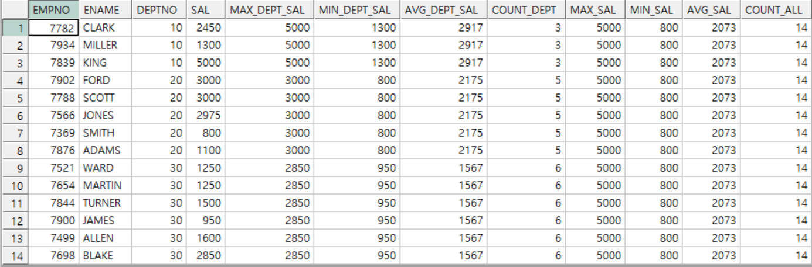

**<Inline View>**

select a.empno,

a.deptno,

a.sal,

d_max max_dept_sal,

d_min min_dept_sal,

d_avg avg_dept_sal,

d_cnt count_dept,

a_max max_sal,

a_min min_sal,

a_avg avg_sal,

cemp count_all

from (select max(sal) a_max,min(sal) a_min,round(avg(sal)) a_avg ,count(empno) cemp from emp ) ,

(select deptno ,max(sal) d_max,min(sal) d_min,round(avg(sal)) d_avg,count(deptno) d_cnt from emp group by deptno) d,emp a

where

a.deptno=d.deptno;

**<Analytic Function>**

select

empno,

ename,

deptno,

sal,

max(sal) over(partition by deptno) max_dept_sal,

min(sal) over(partition by deptno) min_dept_sal,

round(avg(sal) over(partition by deptno)) avg_dept_sal,

max(sal) over(partition by deptno) count_dept,

max(sal) over() max_sal,

min(sal) over() min_sal,

round(avg(sal) over()) avg_sal,

count(empno) over()count_all

from

emp;

2. 아래와 같이 EMP Table을 사용하여/ 부서별 SAL,HIREDATE 순 /Numbering, 누적 SAL을 Analytic Function을 사용하여 구하시요.

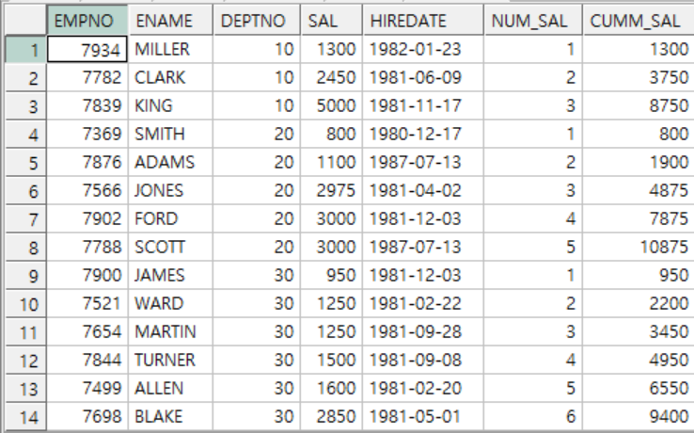

select

empno,

ename,

deptno,

sal ,

hiredate,

count(sal) over(partition by deptno order by sal,hiredate) num_sal,

sum(sal) over(partition by deptno order by sal,hiredate)cumm_sal

from EMP

order by deptno;

3. 아래와 같이 2번 SQL을 참조하여 부서별로 SAL,HIREDATE 순으로 ENAME을 나열하는 SQL을 작성하시요.

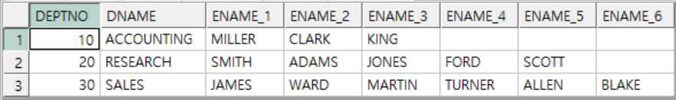

select

t.deptno deptno,

dname,

MAX( DECODE( num_sal, 1, ename,null )) ename_1,

MAX( DECODE( num_sal, 2, ename,null )) ename_2,

MAX( DECODE( num_sal, 3, ename ,null)) ename_3,

MAX( DECODE( num_sal, 4, ename,null )) ename_4,

MAX( DECODE( num_sal, 5, ename ,null)) ename_5,

MAX( DECODE( num_sal, 6, ename ,null)) ename_6

from

(

select

empno,

ename,

deptno,

sal ,

hiredate,

count(sal) over(partition by deptno order by sal,hiredate) num_sal,

sum(sal) over(partition by deptno order by sal,hiredate)cumm_sal

from EMP

order by deptno;

) t,

dept d

where t.deptno=d.deptno

group by t.deptno,dname

order by t.deptno;