1. 아래와 같이 각 empno 당 2개씩 row가 생성되도록 만든 후 각 empno 당 1건만 남기고 삭제시키는 문을 작성하시요.

(최소 2개 이상)

create table emp_dup

as

select a.*

from emp a,

(select 1 from emp where rownum <= 2) b;

(정답1.)

delete from emp_dup e1

where rowid < (select max(rowid) from emp_dup e2 where e1.empno=e2.empno);

;

-------------------------------------------------------------------------

(정답2)

delete from emp_dup

where rowid in (

select rowid from (

select * from (

select row_number()over(partition by empno order by empno) cnt

from emp_dup

)

where cnt > 1

)

);

2. 아래와 같이 SAL_HIST Table을 생성한 후 아래와 같이 기간이 조회되도록 하시요.

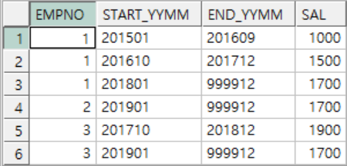

CREATE TABLE SAL_HIST

(

EMPNO NUMBER (4) NOT NULL,

START_YYMM CHAR(6),

SAL NUMBER (7,2)

);

INSERT INTO SAL_HIST VALUES (1,'201501',1000);

INSERT INTO SAL_HIST VALUES (1,'201610',1500);

INSERT INTO SAL_HIST VALUES (1,'201801',1700);

INSERT INTO SAL_HIST VALUES (2,'201901',1700);

INSERT INTO SAL_HIST VALUES (3,'201710',1900);

INSERT INTO SAL_HIST VALUES (3,'201901',1700);

commit;

<정답>

select

empno,

start_yymm,

(

nvl

(

to_char

(

add_months

(

to_date((LEAD(start_yymm) OVER (partition by empno ORDER BY empno)) ,'yyyymm'),-1

)

,'yyyymm'

),

999912

)

) as end_yymm

from sal_hist

3. 아래와 같이 EMP Table을 참조하여 부서별,기간별 소속된 직원수를 구하는 SQL을 작성하시요.

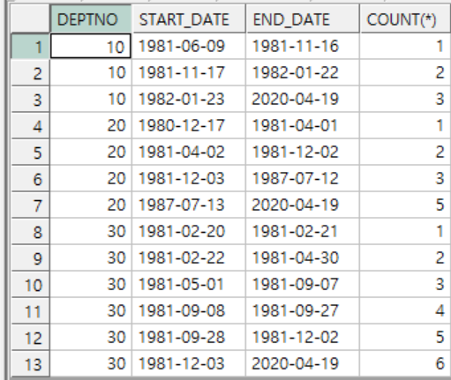

select

deptno,

to_char(hiredate,'yyyy-mm-dd') as start_date,

nvl(

to_char(

lead(hiredate) over (partition by deptno order by deptno)-1

,'yyyy-mm-dd'

)

,to_char(sysdate,'yyyy-mm-dd')

)as end_date,

sum(cnt) over (partition by deptno order by deptno,hiredate) as "COUNT(*)"

from

(select deptno,hiredate,count(*) cnt from emp group by deptno,hiredate order by deptno);