**AlaaHawsawi 27 #1 lab 11**

Ex1

//alaa Hawsawi,27, counts and prints to screen the number of words

#include<fstream>

#include<iostream>

#include<cstdlib>

#include<cctype>

int main ()

{

usingnamespacestd;

ifstream fin;

fin.open("input.txt") ;

if(fin.fail())

{

cout<<"Input file opening failed.\n";

exit(1);

}

char next;

fin.get(next);

int count=0;

int c=0,s=0;

int all=0,non_al=0,word=0;

while (!fin.eof())

{

if(isupper(next))

c++;

if (islower(next))

s++;

if (isdigit(next))

all++;

if (!isalpha(next))

non_al++;

if (isspace(next))

word++;

fin.get(next);

}

cout<<"capital leters: "<<c<<endl;

cout<<"samll letters: "<<s<<endl;

cout<<"digit charcters: "<<all<<endl;

cout<<"non-alpha letters: "<<non_al<<endl;

cout<<"word: "<<word<<endl;

fin.close();

cout<<"end of editing files.\n";

return 0;

}

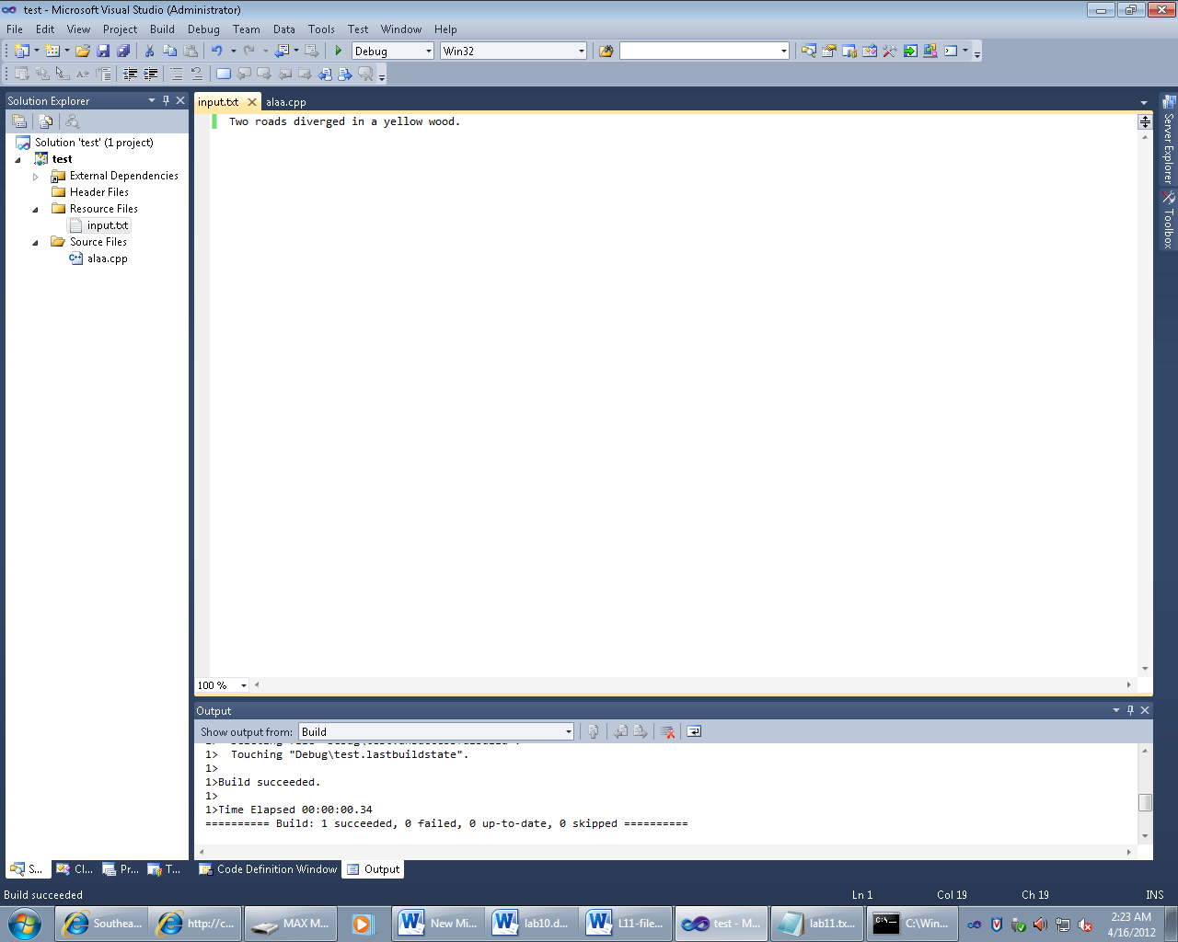

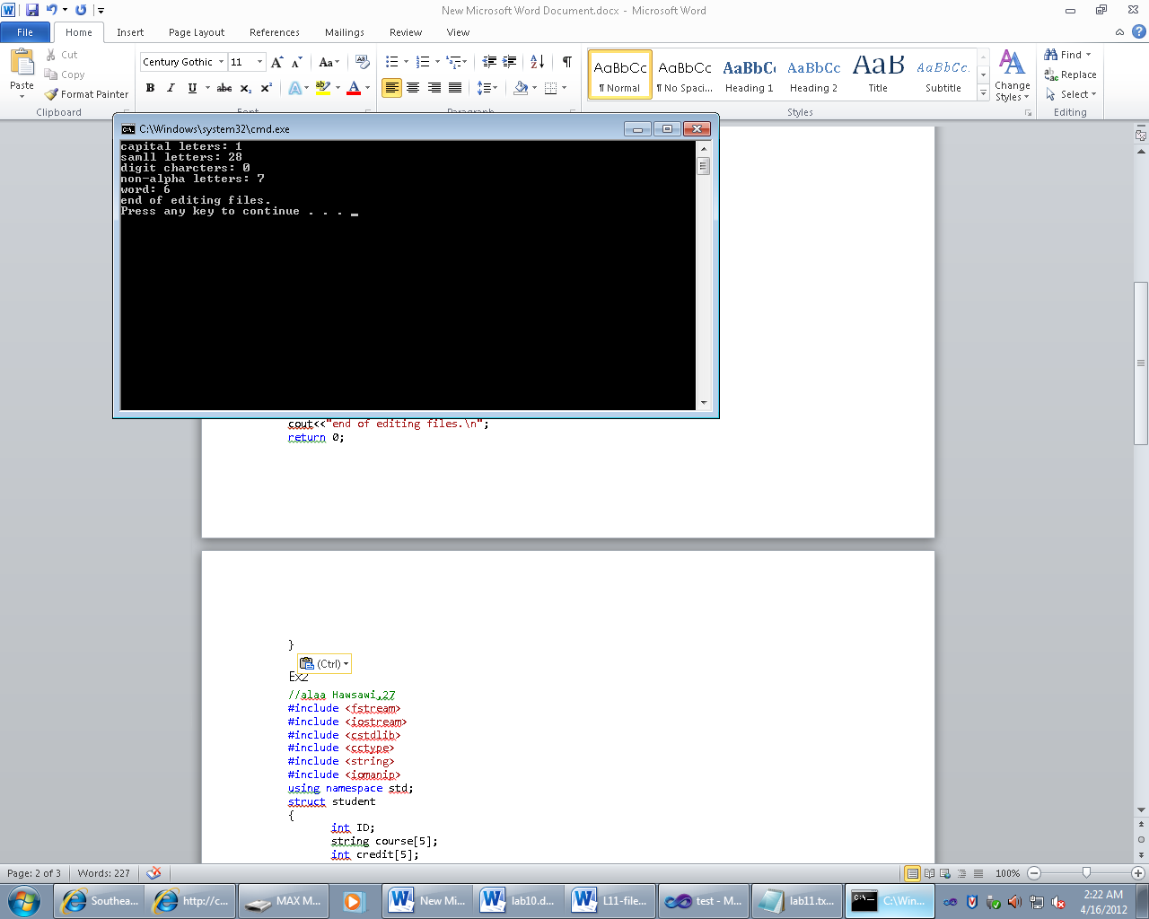

Ex2

//alaa Hawsawi,27, information for that student ID.

#include<fstream>

#include<iostream>

#include<cstdlib>

#include<cctype>

#include<string>

#include<iomanip>

usingnamespacestd;

struct student

{

int ID;

string course[5];

int credit[5];

char grade[5];

};

int main ()

{

ifstream fin;

ofstreamfout;

fin.open("insf.txt") ;

if(fin.fail())

{

cout<<"Input file opening failed.\n";

exit(1);

}

fout.open("outsf.txt");

if(fout.fail())

{

cout<<"output file opening failed.\n";

exit(1);

}

student info[5];

for(int i=0;i<5;i++)

{

fin>>info[i].ID;

for (int t=0;t<5;t++)

{

fin>>info[i].course[t];

fin>>info[i].credit[t];

fin>>info[i].grade[t];

}

}

for(int i=0;i<5;i++)

{

fout<<"student Id: "<<info[i].ID<<endl;

fout<<"Course \t Credit-Hours \t Grade\n";

for ( int t=0;t<5;t++)

{

fout<<info[i].course[t]<<"\t\t\t";

fout<<info[i].credit[t]<<"\t\t\t";

fout<<info[i].grade[t]<<endl;

}

fout<<"-----------------------------"<<endl;

inttol=0;

intgpa=0;

doublegra=0;

for ( int t=0;t<5;t++)

{

tol += info[i].credit[t];

if (info[i].grade[t]=='A')

gpa=4;

if (info[i].grade[t]=='B')

gpa=3;

if (info[i].grade[t]=='C')

gpa=2;

if (info[i].grade[t]=='D')

gpa=1;

gra+=(gpa*info[i].credit[t]);

}

gra=gra/tol;

fout<<"Total credit hours:\t";

fout<<tol<<endl;

fout<<"GPA is: \t"<<gra;

fout<<endl;

}

fin.close();

fout.close();

cout<<"end of editing files.\n";

return 0;

}

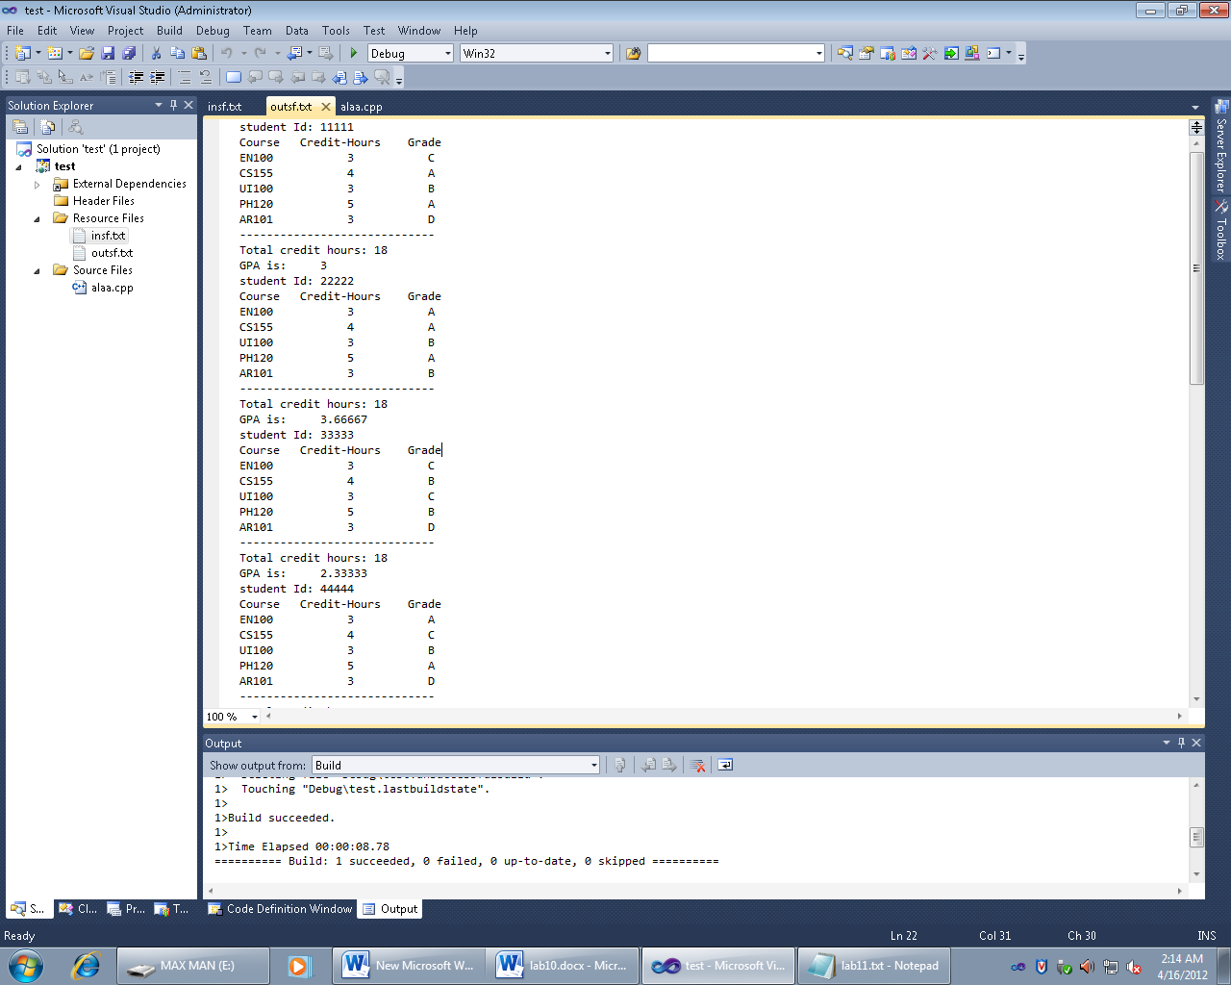

**Ex3**

//alaa Hawsawi,27, the numbers in two files

#include<fstream>

#include<iostream>

#include<cstdlib>

#include<cctype>

usingnamespacestd;

int main ()

{

int sum=0;

int next;

ifstream fin1,fin2;

fin1.open("input1.txt");

fin2.open("input2.txt");

ofstreamfout;

fout.open("output.txt");

if(fin1.fail()||fin2.fail()||fout.fail())

{

cout<<"file opening failed.\n";

exit(1);

}

while (!fin1.eof() ||!fin2.eof())

{

fin1>>next;

fout<<next<<endl;

sum+=next;

fin2>>next;

fout<<next<<endl;

sum+=next;

}

fout<<"Sum= "<<sum<<endl;

fin1.close();

fin2.close();

fout.close();

cout<<"end of editing files.\n";

return 0;

}

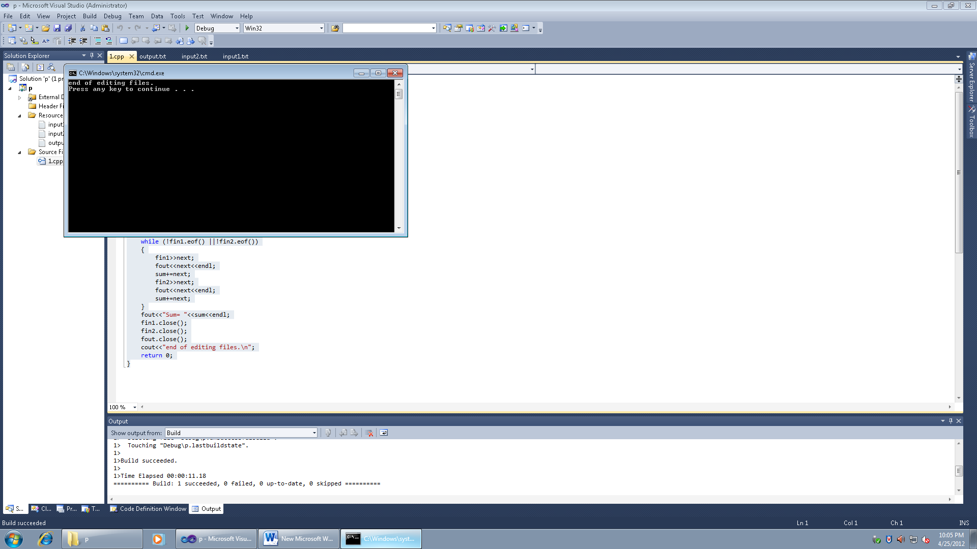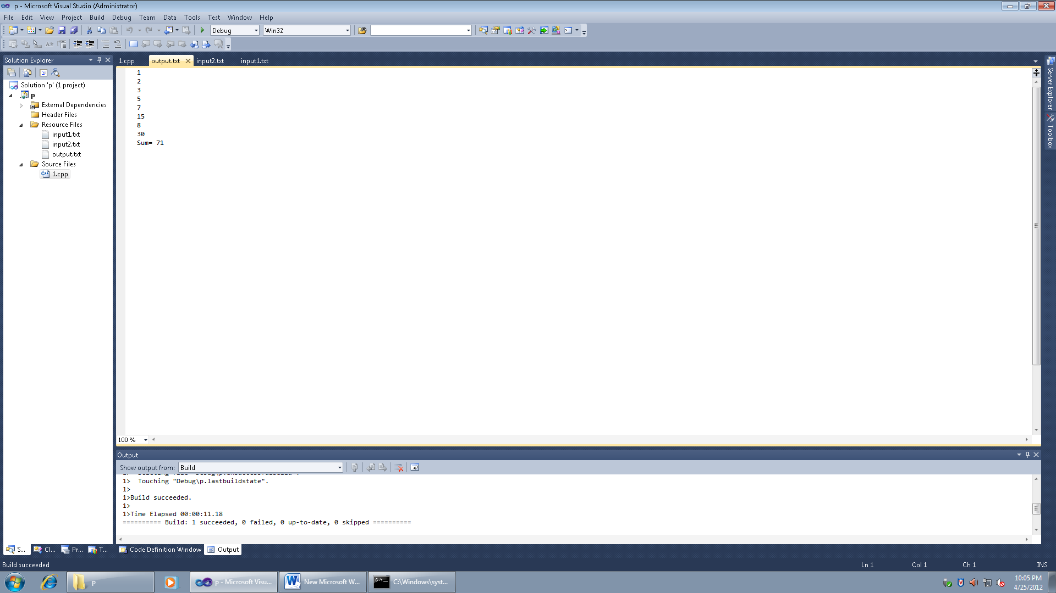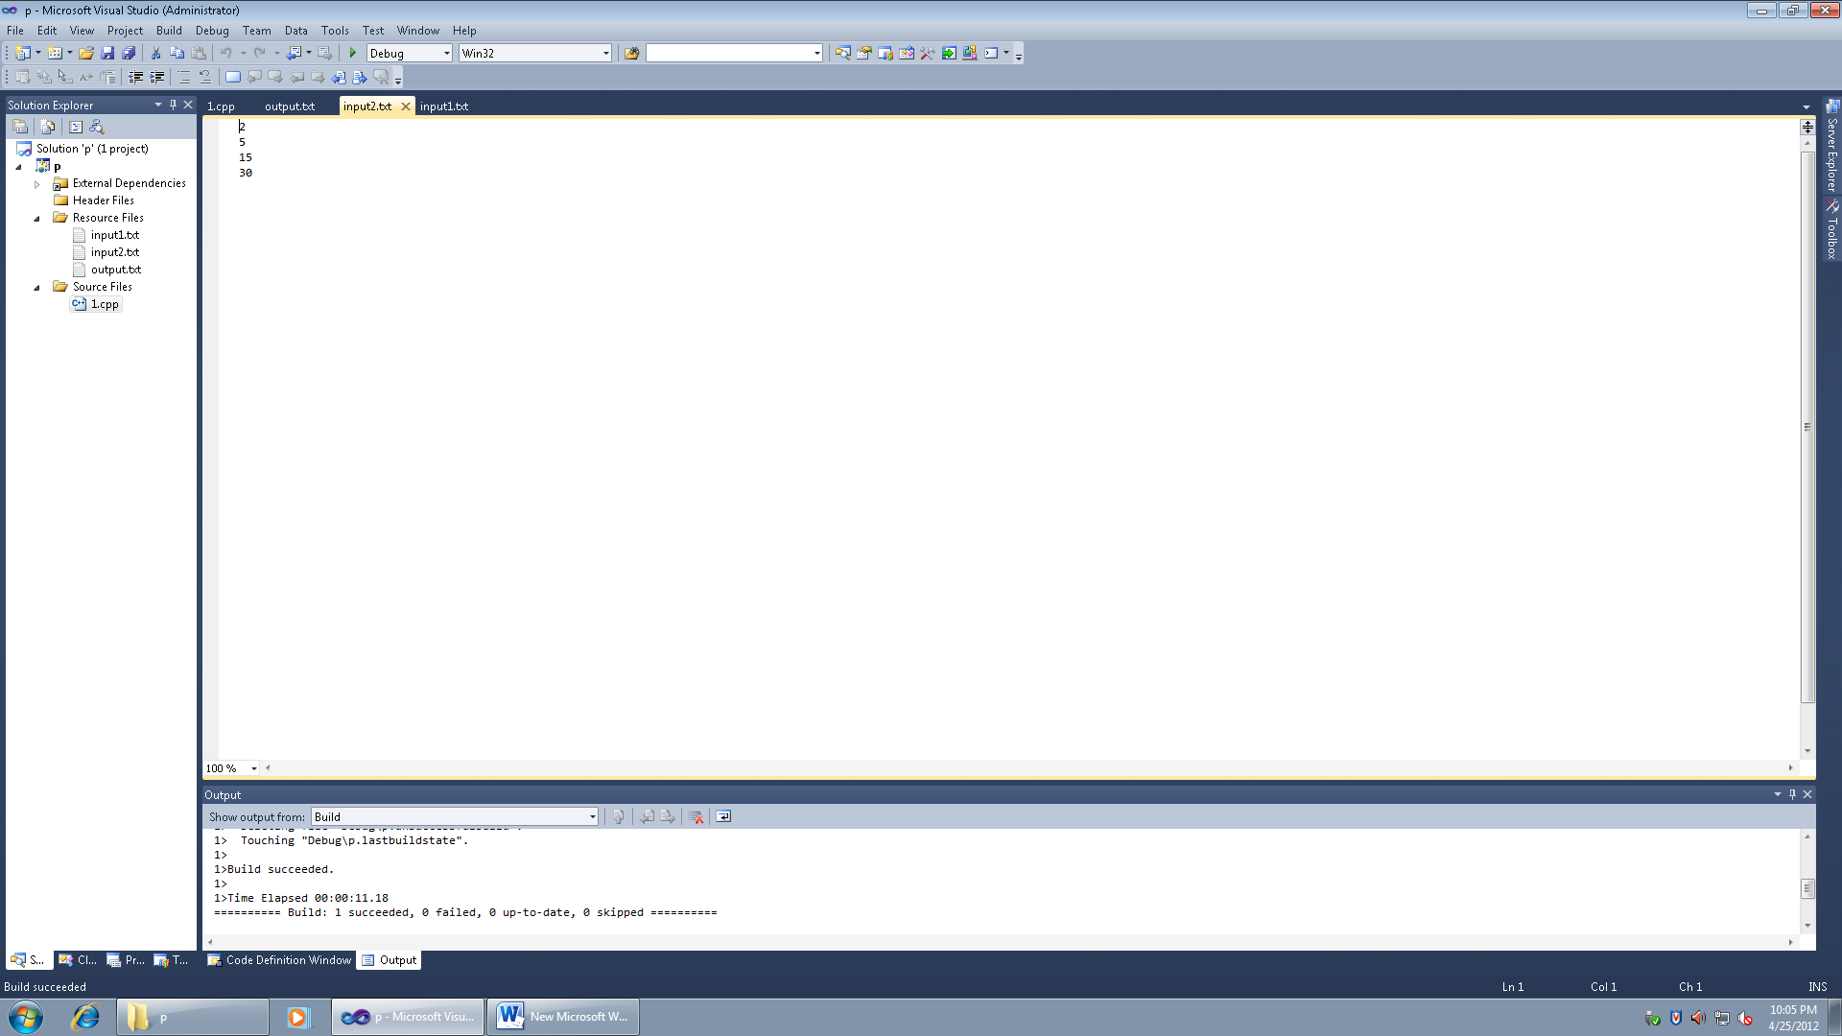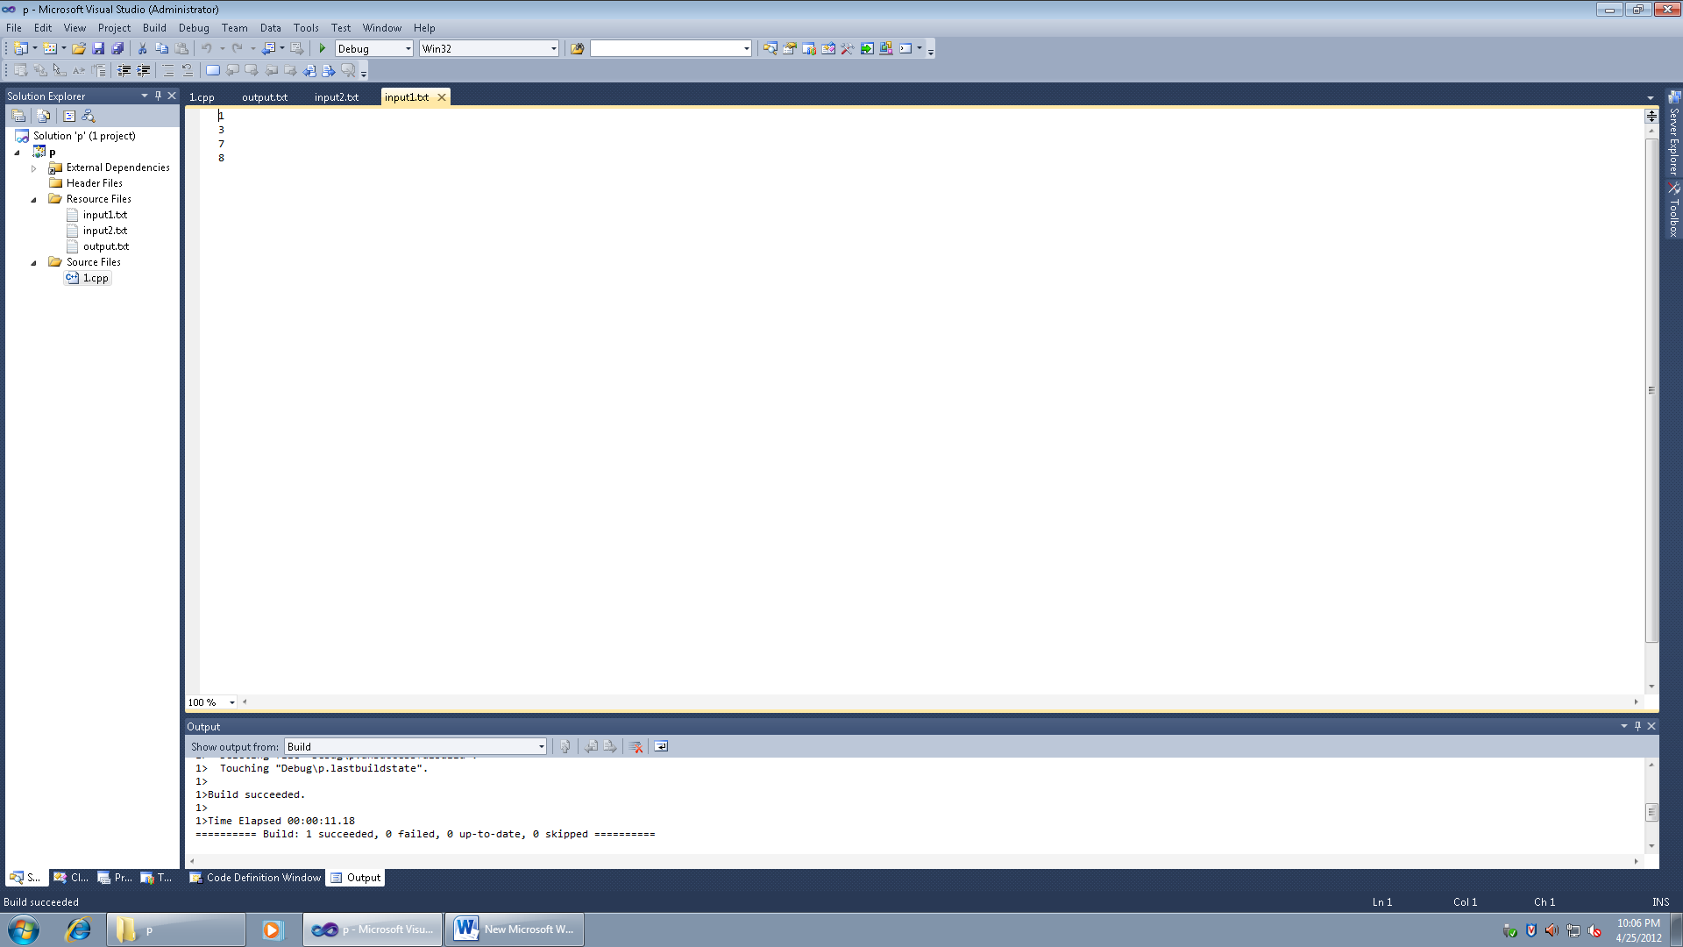

**Ex4**

//alaa Hawsawi,27, calculate the sum and the average

#include<fstream>

#include<iostream>

#include<cstdlib>

#include<cctype>

usingnamespacestd;

int main ()

{

int sum=0,next,n=0;

doubleavg;

ifstream fin;

ofstream fout1,fout2;

fin.open("input.txt") ;

if(fin.fail())

{

cout<<"Input file opening failed.\n";

exit(1);

}

fout1.open("output.txt");

fout2.open("output2.txt");

if(fout1.fail()||fout2.fail())

{

cout<<"output file opening failed.\n";

exit(1);

}

while (!fin.eof())

{

fin>>next;

sum+=next;

n++;

}

avg=(sum*(1.0))/n;

cout<<"sum: "<<sum<<endl;

cout<<"avg: "<<avg<<endl;

fin.ignore();

fin.close();

fin.clear();

fin.open("input.txt");

while(!fin.eof())

{

fin>>next;

if (next<avg)

fout1<<next<<endl;

elseif (next>avg)

fout2<<next<<endl;

}

fin.close();

fout1.close();

fout2.close();

cout<<"end of editing files.\n";

return 0;

}

