Alaa Hawsawi, 27, lab 5

Ex1

//Alaa Hawsawi, 27, multiplication table

#include <iostream>

using namespace std;

int main()

{

int m, n;

cout<<"\t1\t2\t3\t4\t5\t6\t7\t8\t9"<<endl;

for (n=1; n<=9;n++)

{

m=n;

cout<<m<<"\t";

for (m=1; m<=9;m++)

cout<<m*n<<"\t";

}

cout<<endl;

return 0;

}

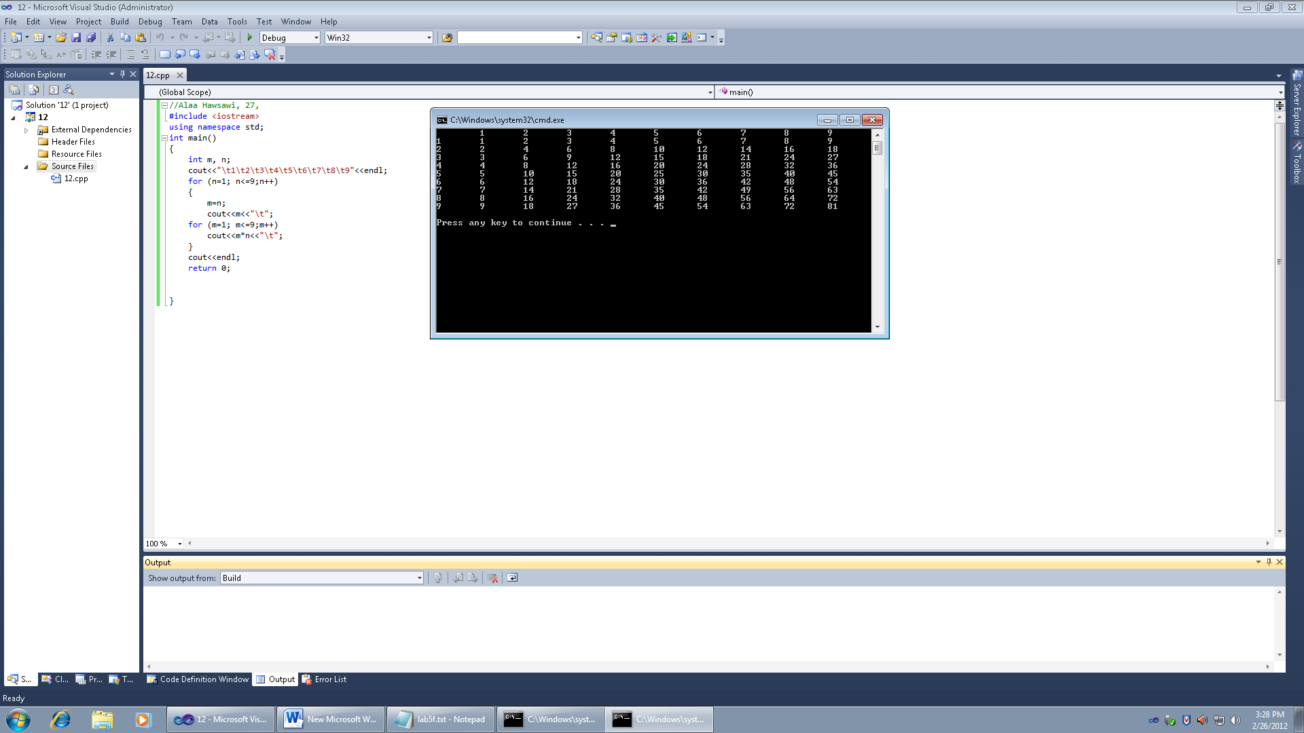

Ex2

//Alaa Hawsawi, 27,Euclidean Algorithm

#include <iostream>

using namespace std;

int main()

{

int l=532, s=112,r=l%s;

int i;

for (i=l; s>0;i--)

{

cout<<"("<<l<<","<<s<<")"<<endl;

cout<<l<<"/"<<s<<"="<<l/s<<endl;

r=l%s;

cout<<l<<"%"<<s<<"="<<r<<endl;

l=s;

s=r;

}

cout<<"Stop"<<endl;

return 0;

}

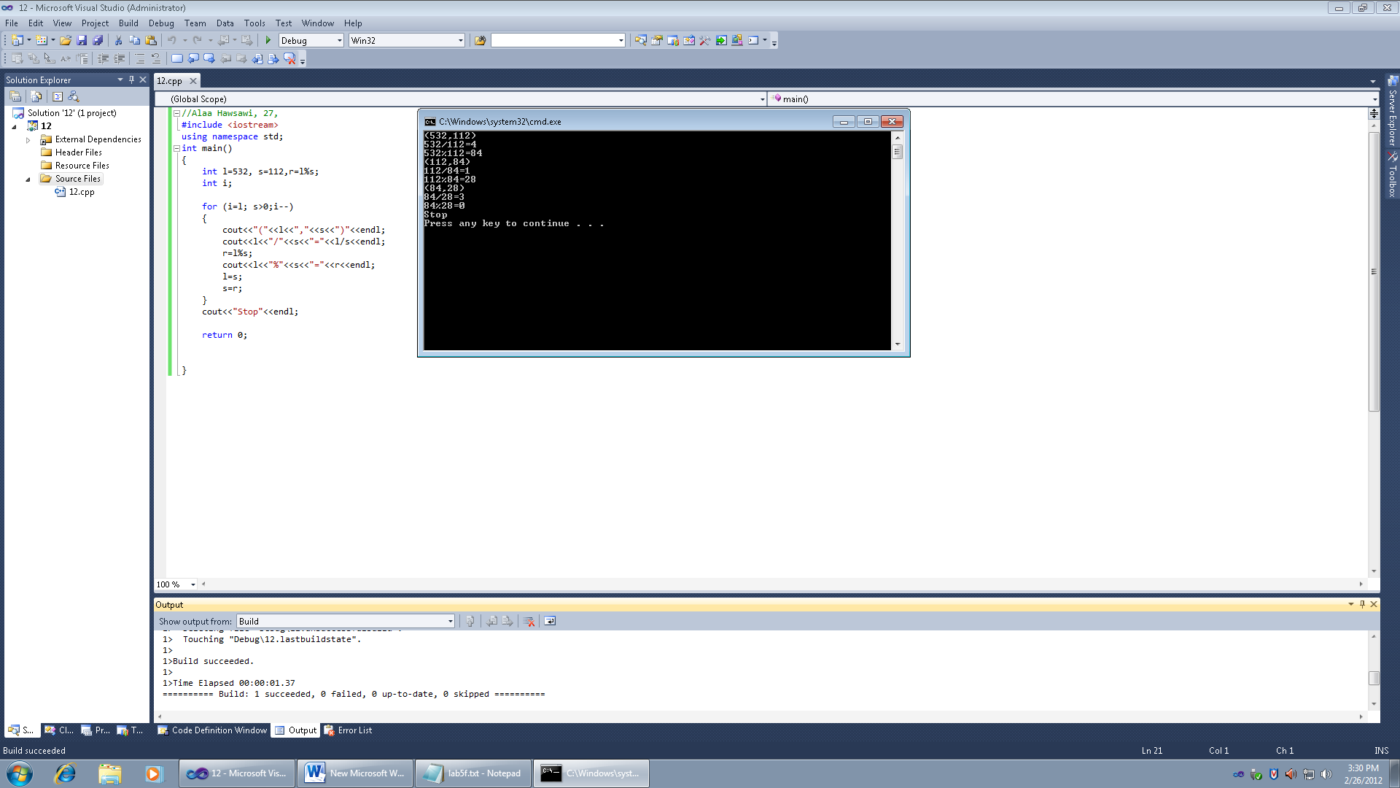

Ex3

//Alaa Hawsawi, 27,stars

#include <iostream>

using namespace std;

int main()

{

int stars;

cout<<"Enter the numbers of stars"<<endl;

cin>>stars;

if (stars%2==0)

cout<<"ERROR"<<endl;

else

{

int count=0;

int half=stars/2;

int num_of_lines = (stars / 2) + 1;

for (int i=1; i<=num_of_lines;i++)

{

for (int space=half;space>=1;space=space-1)

cout<<" ";

for (int t=1;t<=1+count;t=t+1)

cout<<"*";

count=count+2;

cout<<endl;

half--;

}

cout<<endl;

}

return 0;

}

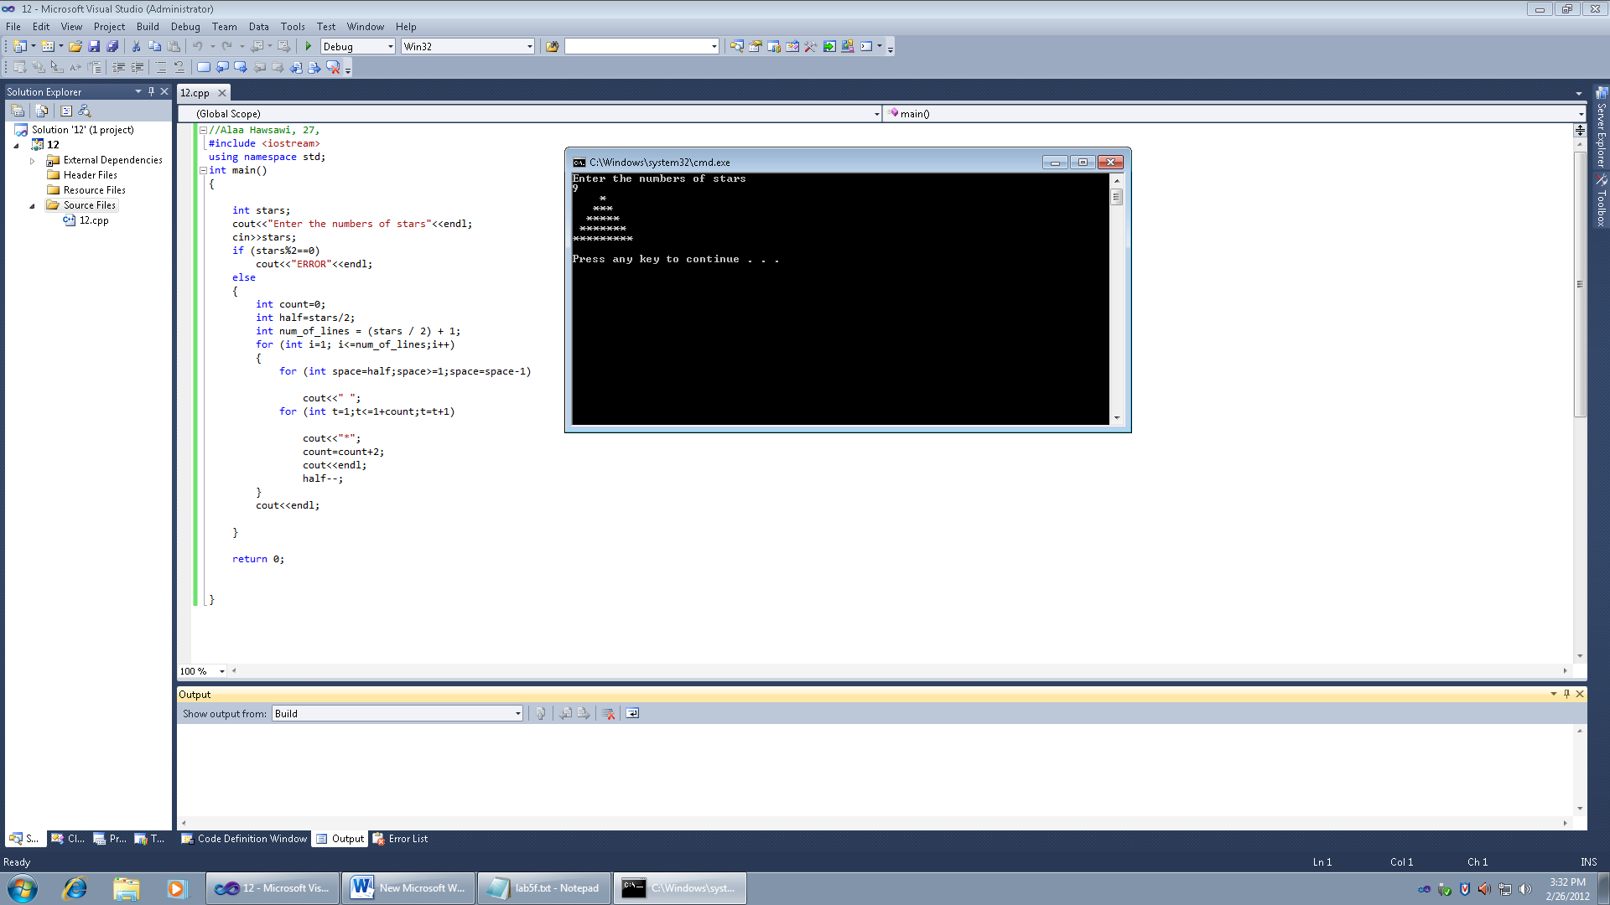

Ex4

//Alaa Hawsawi, 27,prime numbers

#include <iostream>

using namespace std;

int main()

{

int n;

for (n=3;n<=100;n++)

{

bool prime = true;

for (int x=2;x <n-1 ;x++)

{

if (n%x == 0)

prime = false;

}

if (prime == true )

cout<<n<<",";

}

cout<<endl;

return 0;

}

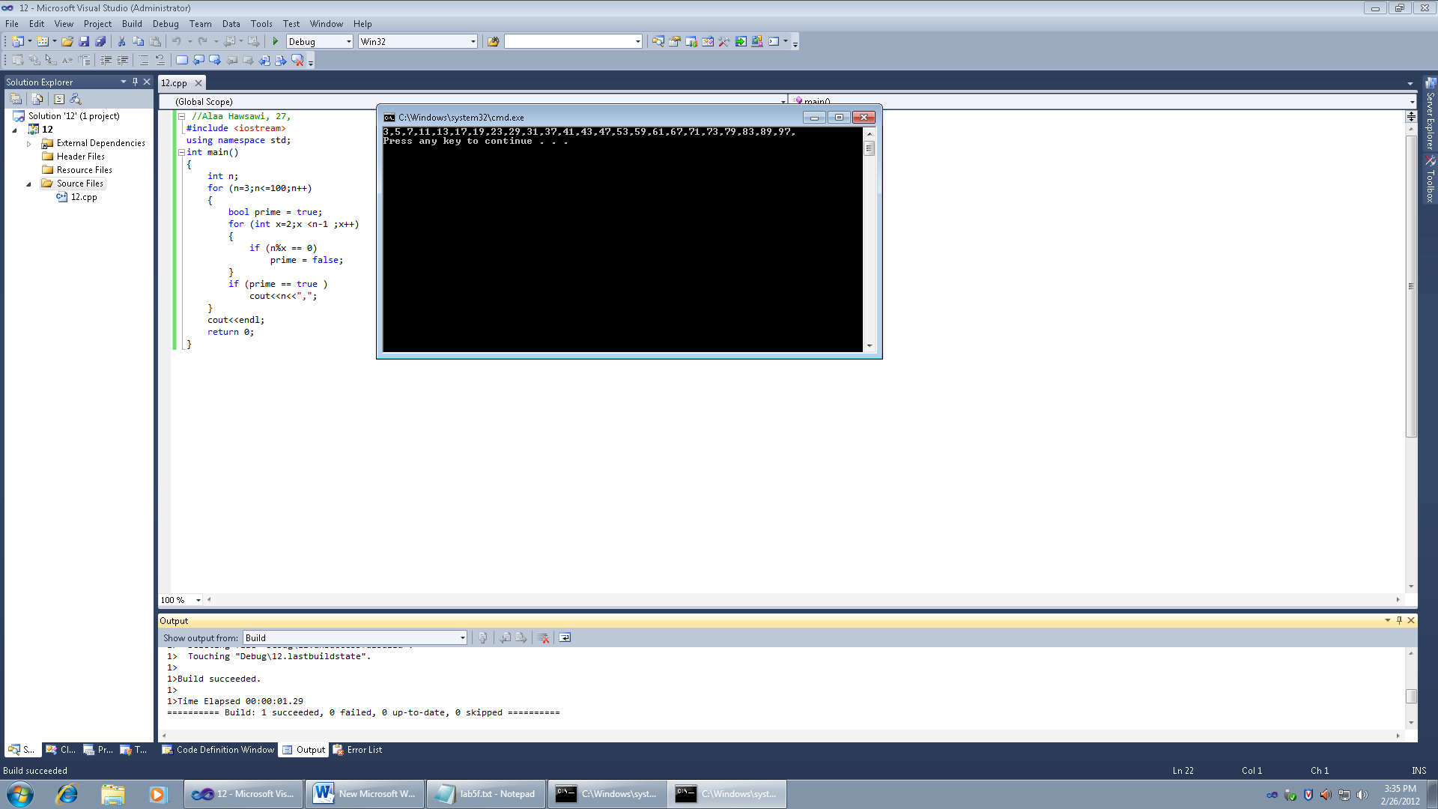

Ex5

//Alaa Hawsawi, 27,calculator

#include <iostream>

using namespace std;

double ADD(double num1, double num2);

double SUB(double num1, double num2);

double MUL(double num1, double num2);

double DIV(double num1, double num2);

int main ()

{

int code;

double n1, n2, t;

cout<<"1.Add \n";

cout<<"2.Subtract\n";

cout<<"3.Multiply \n";

cout<<"4.Divide \n";

cout<<"enter the two double numbers\n";

cin>>n1>>n2;

do

{

cout<<"choise 1,2,3 or 4"<<endl;

cin>>code;

switch (code)

{

case 1:

t=ADD (n1, n2) ;

cout<<n1<<"+"<<n2<<"="<<t<<endl;

break;

case 2:

t=SUB (n1, n2) ;

cout<<n1<<"-"<<n2<<"="<<t<<endl;

break;

case 3:

t=MUL (n1, n2) ;

cout<<n1<<"*"<<n2<<"="<<t<<endl;

break;

case 4:

t=DIV (n1, n2) ;

cout<<n1<<"/"<<n2<<"="<<t<<endl;

break;

}

}while (code < 4);

return 0;

}

double ADD(double num1, double num2)

{

return (num1+num2);

}

double SUB(double num1, double num2)

{

return (num1-num2);

}

double MUL(double num1, double num2)

{

return (num1*num2);

}

double DIV(double num1, double num2)

{

return (num1/num2);

}

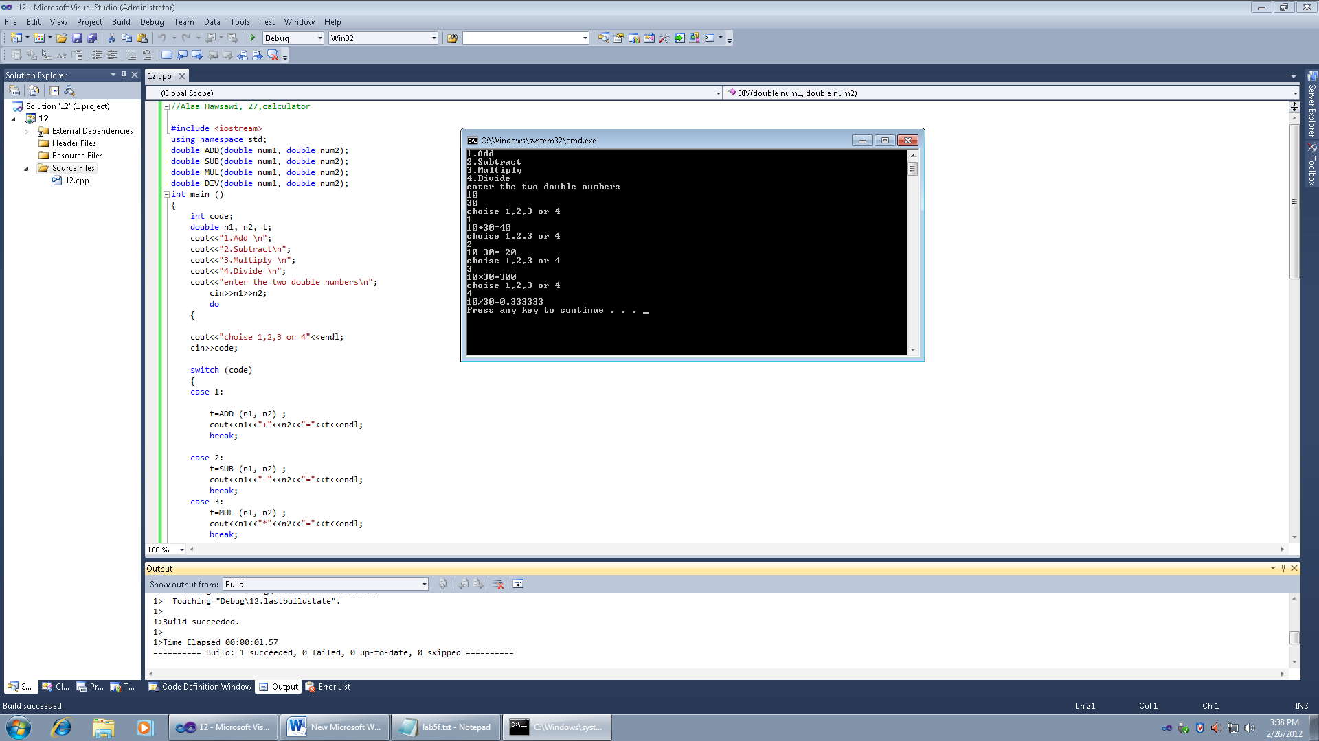

Ex6

//Alaa Hawsawi, 27,calculator change

#include <iostream>

using namespace std;

int cal_dollars (double num);

int cal_quarters (double num);

int cal_dimes (double num);

int cal_nickels (double num);

int cal_pennies (double num);

int main ()

{

double change ;

int dollars ;

int quarters;

int dimes ;

int nickels ;

int pennies ;

cout<<"Enter the amount of money\n";

cin>>change;

if (change>0)

{

dollars= cal_dollars(change);

quarters = cal_quarters(change);

dimes = cal_dimes(change);

nickels = cal_nickels(change);

pennies = cal_pennies(change);

cout<<"Dollars: "<<dollars<<endl;

cout<<"Quarters: "<<quarters<<endl;

cout<<"Dimes: "<<dimes<<endl;

cout<<"Nickels: "<<nickels<<endl;

cout<<"Pennies: "<<pennies<<endl;

}

else

cout<<endl;

return 0;

}

int cal_dollars (double num)

{

int dollars=100;

int cha=100*num;

return (cha/dollars);

}

int cal_quarters (double num)

{

int quarters=25;

int cha=100*num;

return (cha%100/quarters);

}

int cal_dimes (double num)

{

int dimes=10;

int cha=100*num;

return (cha%100%25/dimes);

}

int cal_nickels (double num)

{

int nickels=5;

int cha=100*num;

return (cha%100%25%10/nickels);

}

int cal_pennies (double num)

{

int pennies=1;

int cha=100*num;

return (cha%100%25%10%5/pennies);

}

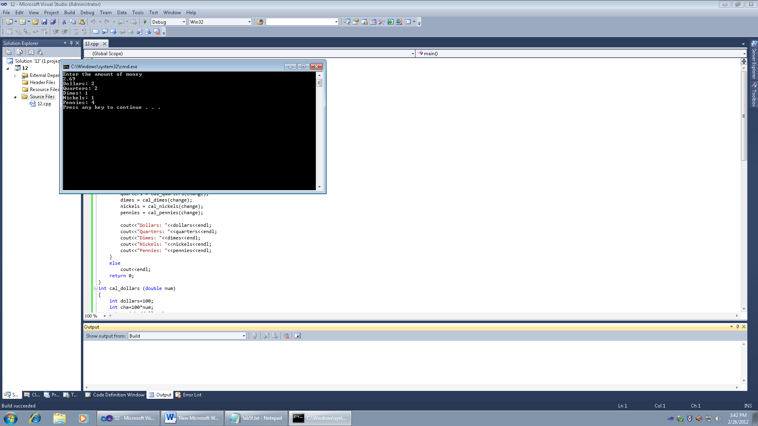

Ex7

//Alaa Hawsawi, 27,calculator area of triangle

#include <iostream>

#include <cmath>

int area (int num1, int num2, int num3);

bool check (int num1, int num2, int num3);

using namespace std;

int main ()

{

int a,b,c,calc_area;

cout<<"enter two sides"<<endl;

cin>>a>>b;

cout<<"The sum of two sides is "<<a+b<<endl;

cout<<"Enter the 3rd side it must be less than the sum\n";

cin>>c;

bool t= check(a,b,c);

if(t)

{

double s=0.5*(a+b+c);

calc_area= area (a,b,c);

cout<<"The area = "<<calc_area<<endl;

}

if(!t)

{

cout<<"ERROR\n";

}

return 0;

}

int area (int num1, int num2, int num3)

{

double s=0.5*(num1+num2+num3);

return (sqrt(s*(s-num1)*(s-num2)*(s-num3)));

}

bool check (int num1, int num2, int num3)

{

return ((num1+num2)>num3);

}

. 