//AlaaHawsawi, 27

#include<iostream>

intfilp (intnum);

usingnamespacestd;

int main ()

{

int toss;

cout<<"How many times would you like the program to toss the coin?\n";

cin>>toss;

filp(toss);

return 0;

}

intfilp (intnum)

{

int head=(num/2)+1;

int tails=(num/2)-1;

cout<<"Number of heads: "<<head<<endl;

cout<<"Number of tails: "<<tails<<endl;

return (head,tails);

}

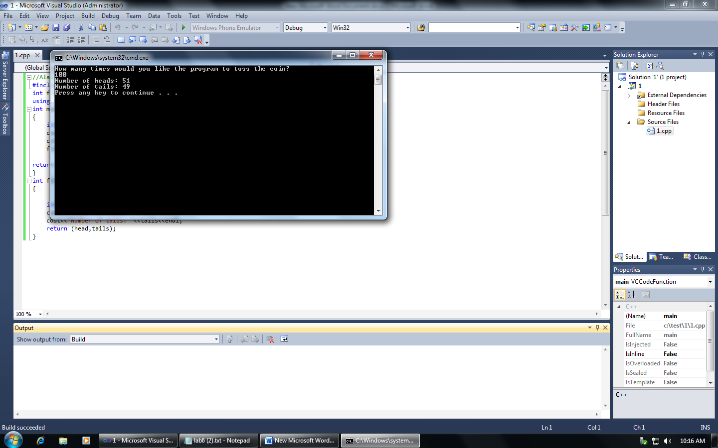

EX2

//AlaaHawsawi, 27

#include<iostream>

#include<time.h>

bool check (intnum, int guess);

usingnamespacestd;

int main ()

{

intram,ge=-5;

srand (time(0));

ram=rand()%100+1;

cout<<"I have a number between 1 to 100\n"<<"Can you guess my number\n";

cout<<"Please Type your guess\n";

while (ge !=ram)

{

cin>>ge;

boolans = check(ram,ge);

}

return 0;

}

bool check (intnum, int guess)

{

if (num==guess)

{

cout<<"Excellent! You guessed the number!\n";

returntrue;

}

if (num>guess)

{

cout<<"too Low. try Again\n";

returnfalse;

}

if (num<guess)

{

cout<<"too High. try Again\n";

returnfalse;

}

return (true, false);

}

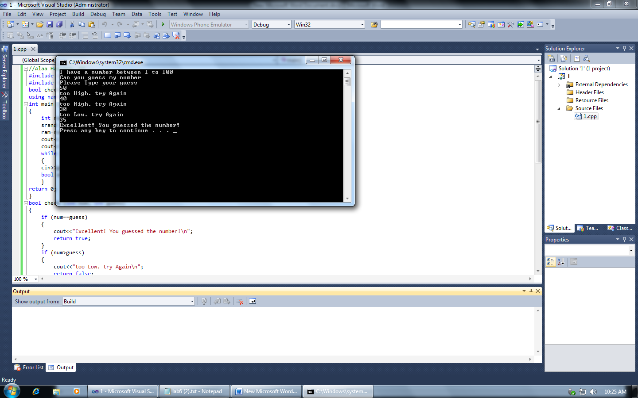

EX3

//AlaaHawsawi, 27

#include<iostream>

voidsawp_day(int& d1, int& d2);

voidsawp_month(int& m1, int& m2);

boolvalid_date(intday,int month);

intcalc_days(int day1,int day2,int month1,int month2);

usingnamespacestd;

int main ()

{

int d1,m1,d2,m2;

cout<<"Enter the first date: Day and Month\n";

cin>>d1>>m1;

boolch=valid_date(d1,m1);

while (ch == false)

{

cout<<"Try again"<<endl;

cin>>d1>>m1;

ch=valid_date(d1,m1);

}

if (ch == true )

{

cout<<"Enter the second date: Day and Month\n";

cin>>d2>>m2;

bool ch1=valid_date(d2,m2);

while (ch1 == false)

{

cout<<"Try again"<<endl;

cin>>d2>>m2;

ch1=valid_date(d2,m2);

}

if (ch1 ==true)

{

boolvalid_date=true;

calc_days(d1,d2,m1,m2);

}

}

return 0;

}

boolvalid_date(intday,int month)

{

if (day<=28 && month==2)

{

returntrue;

}

if (day<32 && month<2)

{

returntrue;

}

if (day<32 &&month<13 && month !=2)

{

returntrue;

}

else

{

returnfalse;

}

}

voidsawp_day(int& d1, int& d2)

{

int tamp=d1;

d1=d2;

d2=tamp;

}

voidsawp_month(int& m1, int& m2)

{

int tamp2=m1;

m1=m2;

m2=tamp2;

}

intcalc_days(int day1,int day2,int month1,int month2)

{

if (day1<day2)

sawp_day(day1, day2);

if (month1<month2)

sawp_month (month1,month2);

int day;

int month;

int total;

boolvalid_date= true;

if ( valid_date == true)

{

day=day1-day2;

if ((month1 ==2)|| (month2==2))

{

month=(month1-month2)*28;

}

else

month=(month1-month2)*30;

total=day+month;

cout<<"m"<<month<<endl;

cout<<"d"<<day<<endl;

cout<<"days= "<<total<<endl;

}

return (total);

}

Ex4

//Alaa Hawsawi, 27

#include <iostream>

int cur_hr (int&ch);

int cur_min (int&cm);

int wait_hr (int&wh);

int wait_min (int&wm);

void calc (int&ch,int&cm,int&wh,int&wm);

using namespace std;

int main ()

{

int ch,cm,wh,wm;

calc (ch,cm,wh,wm);

return 0;

}

int cur_hr (int&ch)

{

cin>>ch;

return (ch);

}

int cur_min (int&cm)

{cin>>cm;

return (cm);}

int wait_hr (int&wh)

{

cin>>wh;

return ( wh);}

int wait_min (int&wm)

{

cin>>wm;

return (wm);}

void calc (int&ch,int&cm,int&wh,int&wm)

{

int th=0,tm=0;

cout<<"Enter the current time: hour and minutes\n";

cur_hr (ch);

cur_min(cm);

cout<<"Enter the number of : hours and minutes to wait\n";

wait_hr ( wh);

wait_min (wm);

th=ch+wh;

if (th>24)

{

th=th-24;

}

tm=cm+wm;

if (tm>60)

{

tm=tm-60;

th=th+1;

}

cout<<"Arrival Time: "<<th<<": "<<tm<<endl;

}