Inverse Kinematics using MLP
Maxim Lakhter
Last updated 8/4/26

Summary
This is a self-study project inspired by the course I took last semester Modern Robotics and the will to practice ML on real world problems.
The standard approach to Inverse Kinematics is numerical, typically Newton-Raphson root-finding. The method converges quickly when the initial guess is close to the solution. In cases where the guess is poor — due to robot restarts, large configuration jumps, or NR failures — convergence degrades significantly because the solver is iterative and sensitive to initialization.
In this project, a Multilayer Perceptron (MLP) is trained using PyTorch to serve as a warm-start provider for a Newton-Raphson (NR) Inverse Kinematics solver. The key contribution is robustness to large, discontinuous configuration-space jumps — precisely the scenario where using the previous joint solution (q_prev) as a cold start fails. When the robot makes a large move (e.g. pick → home → place), q_prev is a poor initialization for the next target, leading to slow convergence or failure. The MLP provides a pose-informed warm start. In a simulated pick-and-place cycle, the MLP warm start reduced average NR iterations by 6× and reduced maximum positional error from over 1 m to under 2 mm compared to the cold start.

Robot specification
I’ve chosen the Torsen Viper x300 6DOF robotic arm it is complex enough to make the problem interesting with 6 joints and accuracy of 5-8mm. The screw axis of the joints and Home position for the POE can be found in the link

Definition of the problem and suggested solutions

Problem
It is important to state the problem clearly as it helps to understand the steps you need to take in order to solve it.
The problem is as follows: Given a transformation matrix $T_{sd}=\left[R_{sd} P_{sd} 0 1 \right]$
and the current joint configuration $Θ_{sb}=[θ_{1},…,θ_{6}]$ find the joint configuration that will bring the robot to $T_{sd}$ i.e. find $Θ_{sd}$ from the current configuration
To solve this I will train a MLP to act as a hot start for a Newton Raphson based Inverse Kinematic solver. The NN feature are the position of the end effector position $P_{sd}$ , the first two rows of the rotation matrix $R_{sd}$ as there is no extra information in the third row that cannot be created from the first two and the current position of the robot. The output of the network is a prediction of $Θ_{sd}$.
After the prediction is used as the starting point of the Newton Raphson solver

Dataset Creation
The good part about this problem is that you can create as many data points as you like .
The dataset is created in the following way:
- Sample the configuration space uniformly → a list of $Θ_{init,k },k∈\{1,...n\}$ seeds which will be used as the initial configuration of the robot
- For each seed randomly select m points in different distances(L2 in configuration space) from the seed where the distance is L2(close,medium,far,very far) → $Θ_{target,k},k∈\{1,...m\}$. The different distances will help the network to learn a variety of movements, some small, some large .
- For each $Θ_{target,k}$ Apply forward kinematics using product of exponential $T_{sd}={{{{∏^{6}}_{i=1}}^{}}^{}}_{}e^{[s_{i}]θ_{i }}M$
- From Tsd extract the position and the first 2 rows of the rotation matrix add to them $Θ_{init}$ and this is the features
- The label is the corresponding $Θ_{target}$
- To get more samples without much extra work you call flip the roles and $Θ_{init}$ and $Θ_{target}$ and calculated the Transformation from the target to the init configuration gaining another n*m samples . Note: these flipped samples are not statistically independent from the originals — they share the same seed/target pairs. The train/val/test gaps are small enough that this likely did not cause overfitting, but it is worth acknowledging.
- Because the feature and the label are bounded I chose to use Min Max scaling
- Split into training(80%),validation(10%),test(10)

Set up
To create the NN I used pytorch . The network consists of :
- input layer with 15 nodes
- 4 hidden layers with 256 nodes per layer
- output layer with 6 nodes .
- Leaky RELU as activation function
- Batch size of 512,Adam optimizer, optimizer:ReduceLROnPlateau with patience of 30 epochs
- The loss function is $α||P_{predicted}-P_{label}|{{|_{2}+β||{R(first 2 rows)}_{predicted }-R_{label}(first 2 rows)||_{2}}^{}}_{}$ .where $P_{predicted}$ and $R_{predicted }$are obtained by running Forward Kinematics on the network’s predicted joint angles: FK($Θ_{predicted}$) → ($P_{predicted}$, $R_{predicted }$). The loss is therefore computed in task space (meters / rotation matrix units), not in joint space.
The weighting $α=1$, $β=0.1$ were tuned empirically to balance the gradient contributions from each term rather than derived from physical units.
I've tried several combinations of smaller\ larger networks as well as using only position ,position+initial configuration as input , different loss function, several ways of creating the dataset and so on.
For now this has been reached . It's by no means the final version i still have a lot to improve and try

Results
The model was trained with adaptive learning rate and was stopped when the loss stopped improving . followed are the loss on the different data splits

 | Total error | Positional error[m] | Rotation error [frobenius norm]
Train | 0.009440947956509061 | 0.004752549443890651 | 0.046883984201484256
Validation | 0.009708235007193353 | 0.0048848291100727186 | 0.0482340577893787
test | 0.009769581218560537 | 0.004911218308409055 | 0.04858362811472681

Hot vs cold start for NR IK solver
The numerical Newton raphson algorithm was taken from the modern robotics package . a small modification to the original function was made to allow returning the number of iterations until convergence. The tolerance was set to 1e-3 for the linear and angular parts of the screw axis Followed are the results:
Hot:initial guess is taken from the prediction of the NN
Cold : initial guess is set to $Θ_{init}$

Average iterations (hot): 1.87
Percentage of convergence (hot): 100.00%
Average iterations (cold): 4.51
Percentage of convergence (cold): 99.78%

Large jumps test
The following test simulated a pick and place cycle:
M→A→M→B where M is the home position , and A,B are randomly chosen . because you pass thM between A and B you guarantee to have a large jump in the configuration space.the cold start uses the previous solution for the initial condition while the hot uses the mlp each time

NR cold (q_prev)
─────────────────────────────────────────────
mean iterations : 12.17
converged : 99.3%
mean pos err (m): 0.0042
max pos err (m): 1.0504

─────────────────────────────────────────────
NR warm (MLP)
─────────────────────────────────────────────
mean iterations : 1.98
converged : 100.0%
mean pos err (m): 0.0001
max pos err (m): 0.0011

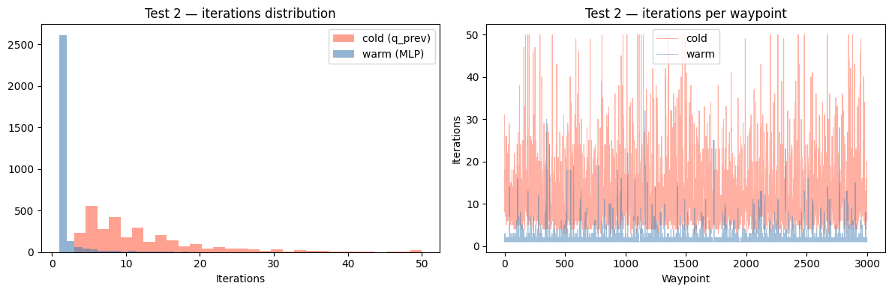In large discontinuous moves (pick → home → place), the MLP warm start outperforms the cold start (q_prev) by 6× fewer iterations on average and reduces maximum positional error from 1.05 m to 0.001 m.

MLP on its own without Newton raphson
The final for now is to see how good the MLP is on its own without running a numerical solver afterwards
The initial and destination configuration are randomly chosen

mean pos err (m) : 0.0118
median pos err (m) : 0.0064
max pos err (m) : 0.3427
mean rot err (deg) : 5.17
median rot err (deg): 2.96

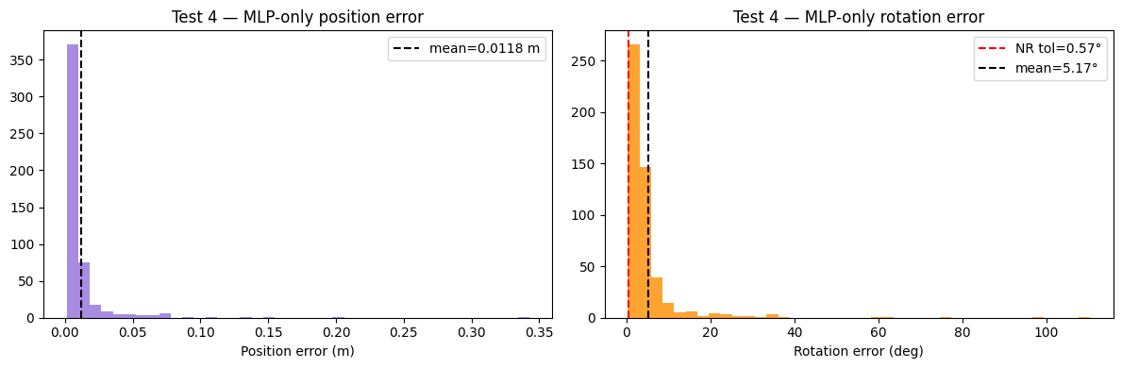On its own the MLP is not able to reach sufficient accuracy yet the rotation error is rather large with median of 2.96 deg the position is better with 6 mm especially when the manufacturer stated that the accuracy of the robot is between 5-8 mm.

